

© 2013 Quest Software, Inc. ALL RIGHTS RESERVED.
This guide contains proprietary information protected by copyright. The software described in this guide is furnished under a software license or nondisclosure agreement. This software may be used or copied only in accordance with the terms of the applicable agreement. No part of this guide may be reproduced or transmitted in any form or by any means, electronic or mechanical, including photocopying and recording for any purpose other than the purchaser’s personal use without the written permission of Quest Software, Inc.

The information in this document is provided in connection with Quest products. No license, express or implied, by estoppel or otherwise, to any intellectual property right is granted by this document or in connection with the sale of Quest products. EXCEPT AS SET FORTH IN QUEST'S TERMS AND CONDITIONS AS SPECIFIED IN THE LICENSE AGREEMENT FOR THIS PRODUCT, QUEST ASSUMES NO LIABILITY WHATSOEVER AND DISCLAIMS ANY EXPRESS, IMPLIED OR STATUTORY WARRANTY RELATING TO ITS PRODUCTS INCLUDING, BUT NOT LIMITED TO, THE IMPLIED WARRANTY OF MERCHANTABILITY, FITNESS FOR A PARTICULAR PURPOSE, OR NON-INFRINGEMENT. IN NO EVENT SHALL QUEST BE LIABLE FOR ANY DIRECT, INDIRECT, CONSEQUENTIAL, PUNITIVE, SPECIAL OR INCIDENTAL DAMAGES (INCLUDING, WITHOUT LIMITATION, DAMAGES FOR LOSS OF PROFITS, BUSINESS INTERRUPTION OR LOSS OF INFORMATION) ARISING OUT OF THE USE OR INABILITY TO USE THIS DOCUMENT, EVEN IF QUEST HAS BEEN ADVISED OF THE POSSIBILITY OF SUCH DAMAGES. Quest makes no representations or warranties with respect to the accuracy or completeness of the contents of this document and reserves the right to make changes to specifications and product descriptions at any time without notice. Quest does not make any commitment to update the information contained in this document.

If you have any questions regarding your potential use of this material, contact:
Quest Software World Headquarters
LEGAL Dept
5 Polaris Way
Aliso Viejo, CA 92656
www.quest.com
email: legal@quest.com

Refer to our Web site for regional and international office information.

Trademarks Quest, Quest Software, the Quest Software logo, AccessManager, ActiveRoles, Aelita, Akonix, Benchmark Factory, Big Brother, BridgeAccess, BridgeAutoEscalate, BridgeSearch, BridgeTrak, BusinessInsight, ChangeAuditor, CI Discovery, Defender, DeployDirector, Desktop Authority, Directory Analyzer, Directory Troubleshooter, DS Analyzer, DS Expert, Foglight, GPOADmin, Help Desk Authority, Imceda, IntelliProfile, InTrust, Invirtus, iToken, JClass, JProbe, LeccoTech, LiteSpeed, LiveReorg, LogADmin, MessageStats, Monosphere, NBSpool, NetBase, NetControl, Npulse, NetPro, PassGo, PerformaSure, Point, Click, Done!, Quest vToolkit, Quest vWorkSpace, ReportADmin, RestoreADmin, ScriptLogic, SelfServiceADmin, SharePlex, Sitraka, SmartAlarm, Spotlight, SQL Navigator, SQL Watch, SQLab, Stat, StealthCollect, Storage Horizon, Tag and Follow, Toad, T.O.A.D., Toad World, vAutomator, vConverter, vEcoShell, VESI, vFoglight, vPackager, vRanger, vSpotlight, vStream, vToad, Vintela, Virtual DBA, VizionCore, Vizioncore vAutomation Suite, Vizioncore vEssentials, Vizioncore vWorkflow, WebDefender, Webthority, Xaffire, and XRT are trademarks and registered trademarks of Quest Software, Inc in the United States of America and other countries. For a complete list of Quest Software’s trademarks, see
http://www.quest.com/legal/trademark-information.aspx. Other trademarks and registered trademarks used in this guide are property of their respective owners. Other trademarks and registered trademarks are property of their respective owners.

Third Party Contributions
JClass ServerViews contains some third party components (listed below). Copies of their licenses may be found on our website at www.quest.com/legal/third-party-licenses.aspx.

Component | License or Acknowledgement
Apache Tomcat | Apache Foundation License version 2.0
GifEncoder | Copyright 1996 by Jef Poskanzer (www.acme.com).
JDOM | Copyright 2002–2002 Brett McLaughlin & Jason Hunter, all rights reserved.

Programmer’ Guide
January 10, 2013
Version 6.2

Table of Contents
Preface 10
Introducing JClass ServerGauge 10
Examples and Demos 13
1 16
JClass ServerChart Designer Basic 16
1.1 Types of Gauges 16
1.2 Graph Component for Gauges 18
1.3 Displaying a Gauge or Graph in a Browser 19
1.4 Key Concepts for Circular and Linear Gauges 20
1.5 Containment Hierarchies 23
1.6 Internationalization 26
2 28
Creating Indicator Gauges and Panels 28
2.1 Overview of the Indicator Gauge Objects 29
2.2 Summary of Properties Used 30
2.3 A Sample Standalone Indicator Gauge 31
2.4 Creating a Standalone Indicator Gauge 35
2.5 Configuring the Behavior of Your Indicator Gauge 37
2.6 A Sample Indicator Gauge Panel 40
2.7 Creating an Indicator Gauge Panel 45
2.8 Configuring the Behavior of Your Panel 47
2.9 Configuring the Appearance of Gauges and Panels 55
3 60
Creating Graphs 60
3.1 Overview of the Graph Object 60
3.2 Summary of Properties Used 61
3.3 A Sample Gragh 61
3.4 Creating a Graph 64
3.5 Configuring the Graph 67
3.6 Layering a Graph on Top of a Gauge 70
4 72
Creating Circular and Linear Gauges 72
4.1 Overview of the Gauge Objects 72
4.2 Creating a Circular Gauge 73
4.3 Creating a Linear Gauge 77
4.4 Assigning Values to a Gauge 79
4.5 Configuring the Gauge Container 79
5 81
Defining the Scale 81
5.1 Overview of the Scale Objects 81
5.2 Summary of Properties Used 82
5.3 Defining a Circular Scale 83
5.4 Configuring A Circular Scale 84
5.5 Defining a Linear Scale 89
5.6 Configuring a Linear Scale 91
5.7 Enabling User Interaction for Scale Values 95
6 96
Defining Ticks and Tick Labels 96
6.1 Overview of Tick Objects 96
6.2 Summary of Properties Used 97
6.3 Defining Ticks 97
6.4 Configuring Tick Marks 99
6.5 Configuring Tick Labels 106
7 109
Defining Indicators and Needles 109
7.1 Overview of the Indicator and Needle Objects 109
7.2 Summary of Properties Used 110
7.3 Defining Indicators 111
7.4 Defining Needles 112
7.5 Configuring Indicators and Needles 113
7.6 Adding User Interaction to Needles 116
8 118
Defining Text Components 118
8.1 Overview of Text-based Objects 118
8.2 Summary of Properties Used 120
8.3 Defining Headers and Footers 121
8.4 Defining Legends 122
8.5 Defining Labels 127
8.6 Understanding the Constraint Mechanism 129
8.7 Positioning Elements on the Gauge Object 131
9 132
Defining Ranges 132
9.1 Overview of the Range Objects 132
9.2 Summary of Properties Used 133
9.3 Defining a Range 133
9.4 Configuring a Range 135
9.5 Creating an Offset Range in a Circular Gauge 137
10 139
Defining the Center Object in a Circular Gauge 139
10.1 Overview of the Center Object 139
10.2 Summary of Properties Used 140
10.3 Defining the Center 140
10.4 Configuring the Center 141
11 144
Defining Background Fill Styles 144
11.1 Setting the Component’s Background Color 144
11.2 Creating a Background Fill with JCFillStyle 144
11.3 Specifying a Pattern 147
11.4 Specifying an Image 148
11.5 Specifying a Gradient Fill 152
11.6 Specifying a Custom Paint 154
12 156
Adding Hyperlinks to 156
Gauge Components 156
12.1 Overview 156
12.2 Adding URL and Extra Tag Information to Components 156
12.3 Generating the Gauge 158
12.4 Creating the Image Map 158
13 159
Encoding a Gauge or Graph 159
13.1 Selecting an Image Format 159
13.2 Encoding a Component 160
13.3 Making an Image Object from a Component 163
14 165
Creating Gauges and Graphs with XML 165
14.1 Overview of XML for JClass ServerGauge 165
14.2 Creating a Gauge or Graph From XML 166
14.3 Updating a Gauge or Graph From XML 173
14.4 Saving a Gauge or Graph to XML 175
14.5 Preparing to Save Information About Images to XML 177
14.6 Internationalizing Your XML-based Gauge 180
15 187
XML DTDs 187
15.1 IndicatorGauge DTD 187
15.2 JCGauge DTD 193
16 230
Creating Gauges for JSF or JSP 230
16.1 The JClass Service 230
16.2 JClass ServerGauge for JavaServer Faces 233
16.3 JClass ServerGauge for JavaServer Pages 241

Preface

Introducing JClass ServerGauge ■ Assumptions ■ Typographical Conventions
How to Use This Guide ■ Examples and Demos ■ API Documentation (Javadoc)
Related Documents ■ Licensing ■ About Quest Software, Inc.

Introducing JClass ServerGauge
JClass ServerGauge is a set of class libraries that you can use to add gauges to your web applications. They are 100% Java, highly configurable, and scalable. There are three types of gauges – indicator, linear, and circular – and a graph. The indicator gauges can be used to highlight a fluctuating value in your application in a visually meaningful way. Linear and circular gauges give you the flexibility to present data in terms of a graduated scale. For example, you can create a linear gauge that looks like a thermometer or a circular gauge that simulates an airplane cockpit gauge. The graph shows relative changes in a value over time. The graph can be used on its own or layered on top of a gauge.

Feature Overview.
- JClass ServerGauge offers the following scalable gauge components:
- indicator gauge that can be used standalone or replicated within a panel
- circular gauge that can be shown as a full circle, half circle, or as a quadrant
- linear gauge that can be displayed horizontally or vertically
- light-weight graph component
Circular and linear gauges offer the following highly-customizable features:
- scale
- tick marks and tick labels
- needles and indicators
- header and footer titles
- labels
- legend
- ranges
- center disk (for circular gauges)
- hyperlinks on gauge components via an image

JClass ServerGauge components support the use of images, patterns, and gradient fills in the background of components, as well as in the background of some of the circular and linear gauge subcomponents, such as the scale and ranges.
JClass ServerGauge can be used in conjunction with the other products in JClass ServerViews, as well as with ordinary Swing components. You can freely distribute the images generated with JClass ServerGauge according to the terms of the License Agreement that appears during the installation.

Who Uses JClass ServerGuage

JClass ServerGuage is designed to offer ease-of-use for the following Jave developers:
Java component users can create gauges and set properties programmatically.
- JavaBean developers can add gauges and set properties using the JClass ServerGauge Beans within their Integrated Development Environment (IDE).
- XML developers can create gauges using the JClass ServerGauge factory and set properties using the XML elements defined in the JClass ServerGauge DTDs.
- Object-oriented developers can extend JClass ServerGauge objects using the interfaces provided.

Assumptions

This manual assumes that you have some experience with the Java programming language. You should have a basic understanding of object-oriented programming and Java programming concepts such as classes, methods, and packages before proceeding with this manual. If you want to use JClass ServerGauge with XML, servlets, JSP, or JSF, or if you want to use the Enterprise JavaBean components, you should already be familiar with the technology before attempting to add a gauge. For a selection of reference documents, see Related Documents later in this section.

Typographical Conventions
The following typographical conventions are used throughout this guide:
Typewriter Font ■ Java language source code and examples of file contents.
■ JClass ServerGauge and Java classes, objects, methods, properties, constants, and events.
■ HTML documents, tags, and attributes.
■ Commands that you enter on the screen.
Italic Text ■ Pathnames, filenames, and programs.
■ New terms as they are introduced, and to emphasize important words.
■ Figure and table titles.
■ The names of other documents referenced in this manual, such as Java in a Nutshell.
Bold ■ Keyboard key names and menu references.

How to Use This Guide

Everyone should review the first section of Chapter 1, “Learning JClass ServerGauge Basics,” to understand the types of gauges available. After you select the kind of gauge that you want to add your interface, you can focus on the relevant chapters. If you are using XML, there is some supplementary material to review as well.

Indicator Guages
If you want to create an indicator gauge, you should review Chapter 2, “Creating Indicator Gauges and Panels.” It describes how to create and customize a standalone indicator gauge and a panel of gauges.

Graph Component
If you want to create a JCGraph component beside or on top of your gauge, you should review Chapter 3, “Creating Graphs.”

Circular and Linerar Guages
If you want to create a circular or linear gauge, Part II of the guide describes how to create and customize a gauge. In particular, you should review the following chapters:
- Chapter 4, “Creating Circular and Linear Gauges,” describes how to create a gauge and assign a value to it.
- Chapter 5, “Defining the Scale,” describes how to set the scale properties.
- Chapter 6, “Defining Ticks and Tick Labels,” describes how to display tick marks and/or tick labels on your gauge and set their properties
- Chapter 7, “Defining Indicators and Needles,” describes how to display needles and/or indicators on your gauge and set their properties. Needles and indicators are used to point to values on your scale.
- Chapter 8, “Defining Text Components,” describes how to display a header, footer, legend, or other labels on the gauge.
- Chapter 9, “Defining Ranges,” describes how you can use ranges to highlight values.
- If you selected a circular gauge, Chapter 10, “Defining the Center Object in a Circular Gauge,” describes how to customize the center disk in a circular scale.
- Chapter 11, “Defining Background Fill Styles,” describes how to add color, patterns, gradient fills, and images to the background of components and subcomponents.
- If you want to add hyperlinks to your gauge, see Chapter 12, “Adding Hyperlinks to Gauge Components,”.
- Chapter 13, “Encoding a Gauge or Graph,” covers all the different encoding options for outputting charts, including Flash and Scalable Vector Graphics.

XLM Developers
In addition to the chapters outlined above, review the following material.
- Chapter 14, “Creating Gauges and Graphs with XML,” describes how to create and update gauges and graphs from XML and how to save gauges and graphs to XML.
- Chapter 15, “XML DTDs,” is a reference chapter that describes the DTDs.

JavaBean Developers
Refer to your IDE documentation for information on how to add third-party beans to your environment.

Examples and Demos
JClass ServerGauge ships with examples and demos. The examples show you how to create and customize a single JClass ServerGauge component. Demos demonstrate how to use one or more JClass ServerGauge components within the context of a larger application. Many of the JClass ServerGauge examples and demos are referenced in this guide.
The quickest way to run the examples and demos is to use the Jakarta Tomcat application server that is installed with JClass ServerViews.
- Start the server by selecting tomcat-startup from the JCLASS_SERVER_HOME/bin/ directory.
Note: Microsoft Windows users can launch the Tomcat server from the JClass ServerViews program group off the Start menu.
- In a web browser, go to: http://localhost:8686/server-samples/
- Select the link for JClass ServerGauge.
A list of examples and demos is displayed
- Click the name of an example or demo to run it.
Most examples and demos provide a direct link to their source code. The source code is installed with the compiled classes in the JCLASS_SERVER_HOME/examples/sgauge/ and JCLASS_SERVER_HOME/demos/sgauge/ directories.

API Documentation (Javadoc)

The Javadocs for the JClass ServerGauge API are part of the JClass ServerViews API
Documentation. The API documentation is installed automatically when you install
JClass ServerViews. It is located in the JCLASS_SERVER_HOME/docs/api/ directory.

The following packages are particularly relevant for JClass ServerGauge:
- com.klg.jclass.gauge
- com.klg.jclass.sgauge
- com.klg.jclass.util.io
- com.klg.jclass.util.legend
- com.klg.jclass.util.server
- com.klg.jclass.util.style
- import com.klg.jclass.util.swing.encode
- import com.klg.jclass.util.swing.encode.swf
On Microsoft Windows installations, you can find a link to the API documentation from the Start menu under the JClass ServerViews program group.

Related Documents

The following resources may be useful:
- “Java Platform Documentation” at http://java.sun.com/docs/index.html
- “Java Tutorial” at http://java.sun.com/docs/books/tutorial/index.html
- For an introduction to creating enhanced user interfaces, see “Creating a GUI with JFC/Swing” at http://java.sun.com/docs/books/tutorial/uiswing/index.html
- Java in a Nutshell, 2nd Edition from O’Reilly & Associates Inc. See the O’Reilly Java Resource Center at http://java.oreilly.com.
- For a tutorial on XML, visit http://www.w3schools.com/xml/.
- Resources for using JavaBeans are at http://java.sun.com/beans/resources.html

Licensing

You need a valid license to use JClass ServerGauge. Information about licensing is outlined in the JClass ServerViews Installation Guide, which is automatically installed when you install JClass ServerGauge. You can find a PDF version and an HTML version in the JCLASS_SERVER_HOME/docs/getstarted/ directory.

About Quest Software, Inc.

Quest Software (now a part of Dell) simplifies and reduces the cost of managing IT for more than 100,000 customers worldwide. Our innovative solutions make solving the toughest IT management problems easier, enabling customers to save time and money across physical, virtual and cloud environments. For more information about Quest go to www.quest.com.

Contacting Quest Software

Email info@quest.com

Mail Quest Software, Inc.
World Headquarters
5 Polaris Way
Aliso Viejo, CA 92656
USA
Web site www.quest.com

See our web site for regional and international office information.

Contacting Quest Software

Quest Support is available to customers who have a trial version of a Quest product or
who have purchased a Quest product and have a valid maintenance contract. Quest Support provides unlimited 24x7 access to Support Portal at http://support.quest.com.

From our Support Portal, you can do the following:
- Retrieve thousands of solutions from our online Knowledgebase
- Download the latest releases and service packs
- Create, update and review Support cases

View the Global Support Guide for a detailed explanation of support programs, online services, contact information, policies and procedures. The guide is available at: http://support.quest.com.

Quest Communities

Get the latest product information, find helpful resources, and join a discussion with the JClass Quest team and other community members. Join the JClass community at http://jclass.inside.quest.com/.

1

JClass ServerChart Designer Basic
Types of Gauges ■ Graph Component for Gauges
Displaying a Gauge or Graph in a Browser ■ Key Concepts for Circular and Linear Gauges
Containment Hierarchies ■ Internationalization

JClass ServerGauge provides highly customizable gauges that you can use to implement some very effective user interface metaphors. A user interface metaphor maps your data on to a generally known environment. When done well, metaphors can make your application easier to learn and use. For example, with JClass ServerGauge you can create web interfaces that use gauges to mimic an airplane cockpit or a car dashboard.

This chapter introduces each of the gauge types and the graph component for gauges. The gauge containment hierarchies are included here as well as key concepts that you should know before building gauges.

1.1 Types of Gauges
There are three types of gauges: indicator gauges, circular gauges, and linear gauges. The circular and linear gauges share a common code base, and it is easy to convert from one to the other.

1.1.1 Indicator Gauge and Indicator Gauge Pannel

Indicator gauges are used to show a value within the context of a range of values. When the value assigned to the gauge enters a new range, the icon changes to reflect the color, image, and/or text associated with that range. For example, you may have an indicator gauge that you want to use to highlight a poor, fair, and good result. You can tie poor results to an image showing a frowning face, fair results to a smiling face, and good to a laughing face. Or use red, yellow, and green to implement a traffic light metaphor.
For example, the Dungeon Game demo (see “Examples and Demos” on page 18) uses a triangular indicator gauge to show the health status of the character in the game. Green is good, yellow is fair, red is poor, and black means the character is dead.

Figure 1 Four states of an indicator gauge that uses color to highlight health status: good, fair, poor, dead

You can also create a panel of indicator gauges. A panel lets you represent the value as a binary number, an integer, or as magnitude in a scale. For example, the following figure shows the value 7 displayed in four different ways in a horizontal indicator gauge panel.

Binary

Decimal

Unichrome (magnitude)

Multichrome (magnitude)
Figure 2 Indicator gauge panels showing the value 7 in binary, decimal, and magnitude-type formats

1.1.2 Circular Guage

Circular gauges present a value in the context of a circular graduated scale. The gauge can be an entire circle or a partial circle. You use indicators or needles to point out values on the scale. You can use circular gauges to give your application the flavor of an automobile instrument cluster, airline cockpit, control room, old time radio, or any other metaphor suitable for circular gauges.

Figure 3 Sample circular gauge

1.1.3 Linear Guage

Linear gauges present a value in the context of a vertical or horizontal graduated scale. You use an indicator or needle to point to values on the scale. Linear gauges can be made to look like thermometers (for hot and not-so-hot stock opportunities as well as temperature measurement), jazzed-up progress meters, and level and volume indicators.

Figure 4 Sample linear guage

1.2 Graph Component for Gauges
JClass ServerGauge also comes with a light-weight graph called JCServerGraph. The graph displays the relative fluctuations in a changing value. The graph is a JComponent. It can be placed in a JPanel or layered on top of a gauge. For more information, see Chapter 3, “Creating Graphs.”
Figure 5 Gragh

1.3 Displaying a Gauge or Graph in a Browser
After you create a gauge or graph, you specify how you want it sent to the browser. You can encode it as a PNG, GIF, JPEG, SVG, or Flash (SWF) image format or save it as a java.awt.Image object. For more information, see Chapter 13, “Encoding a Gauge or Graph.”

For example, in the following code block (taken from BasicSCircularGaugeServlet.java), when a circular gauge is requested by the browser, a new circular gauge instance is created. A Stream object is created to send an image of the gauge to the browser. Then the programmer specifies the type of image to create, in this case a PNG, and uses the PNG encoder to create the image. The image of the new gauge is returned to the browser.

import com.klg.jclass.sgauge.JCServerCircularGauge;
import com.klg.jclass.gauge.*;
import com.klg.jclass.util.JCNumberUtil;
import com.klg.jclass.util.server.JCServerUtilities;
import com.klg.jclass.util.swing.encode.EncoderException;
import com.klg.jclass.util.swing.encode.JCEncodeComponent;
…

public void doGet(HttpServletRequest request, HttpServletResponse response)
{
// Create an instance of the server-side circular gauge
myGauge = createCircularGauge(JCCircularGauge.GaugeType.FULL_CIRCLE,
0, 270, 325, 275);
try
{
// Create a Stream through which to pass the image
ServletOutputStream out = response.getOutputStream();

// Set the content type of the response
response.setContentType("image/png");

// Encode the gauge
myGauge.encode(JCEncodeComponent.PNG, out);

// Deliver the image
out.flush();
}
catch (IOException e) {
e.printStackTrace();
}
catch (EncoderException e)
{
e.printStackTrace();
}
}

You can substitute any type of gauge or a graph for the circular gauge used in the preceding example.

Note: If you are creating an indicator gauge or indicator gauge panel that blinks, you need to encode it as an animated GIF using the encodeAsSingleLoopAnimatedGif() method from JCIndicatorGauge or JCIndicatorGaugePanel. For more information, see Section 2.9.6, “Making Gauge Icons Blink,” on page 67.

JSP/JSF Developers: If you are working with JSP or JSF, you will use a different approach.
For more information, see Chapter 16, “Creating Gauges for JSF or JSP.”

1.4 Key Concepts for Circular and Linear Gauges
The circular and linear gauges offer the following components:
- Header. The header provides a title for the gauge. A header is a JComponent, and by default a JCLabel.
- Footer. The footer provides another option for titling a gauge. It is a JComponent, and by default a JCLabel.
- Placeable Labels. Any component may be placed on a gauge at a specified position. The gauges have add() methods that take a LinearConstraint or RadialConstraint as a parameter. The constraints make it possible for you to position labels based on a linear extent and a pixel value (for linear gauges), or a specified angle and radial distance (for circular gauges). For more information, see Section 8.6, “Understanding the Constraint Mechanism,” pn page 137.
- Scale. A gauge contains one scale. The scale has minimum and maximum values and specifies the direction in which scale values increase. The circular scale also has start and stop angles that determine the portion of a full circle occupied by the scale. The scale can have associated JCTick, JCNeedle, JCIndicator, and JCRange objects.
- Tick Marks and Tick Labels. A tick object is used to show the scale values. It is a collection of uniformly spaced marks and/or labels.
- Ranges. A range specifies a range of values on the scale and associates color or other attributes with that range.
- Indicators and Needles. An indicator is a static marker placed at a particular scale value. A needle is a dynamic marker whose value can be changed programmatically or by user interaction. The length of an indicator or needle is specified by setting its inner extent and its outer extent. For more information, see Section 1.4.2, “Sizing Components Using Extent Parameters,” on page 29.
- Gauge Constraint and Gauge Layout. These classes assist in placing some of the above components on the gauge.

The following figure shows the components in a gauge. Note that the gauge area (JCGaugeArea) contains the scale and its objects, but not the header, footer, or legend.

Figure 6 Components of a JClass ServerGauge
You have considerable flexibility in designing the appearance of your gauge. Interfaces for indicators, needles, ranges, scales, and ticks let you replace the built-in objects with those you design yourself. As well, it is easy to add additional items like numerical counters and images to the gauge.

1.4.1 How Components are Rendered on a Gauge
A render list, which in Java is often called the z-order of the components, is effectively created by the order in which components are added at execution time. This list determines in what order child objects are to be drawn. Components added last are drawn first. For example, in a circular scale, adding a needle and then a center allows the center object to be drawn first, then a needle, making the needle fully visible from center to tip instead of being partially covered by the center object. There are ways of manipulating the list so that a different drawing order can be specified. By drawing a needle first, it can appear to be attached to the edge of the center object rather than beginning at the center of the circle.

Caution: When setting a scale on a gauge, a center on a circular gauge, or adding indicators, needles, ranges, and ticks to a gauge, you must use the set() and add() methods provided in JCGauge; the standard java.awt.Container methods do not fulfill JCGauge’s requirements. When using the gauge’s add() method, you are still able to include an optional index that specifies the rendering order.

A gauge may have multiple instances of indicators, needles, ranges, and tick marks. In this case, the gauge maintains a collection for each of the object groups. The gauge has indicator and needle lists for marking one or more scale values, a range list for keeping track of the ranges used to mark regions of the scale, and a tick list to keep track of the different tick objects.

Labels, which may be any JComponent, not just a JCLabel, are created and manipulated individually rather than being stored in a list. There are special-purpose methods called addLabel(label, radialConstraint) and addLabel(label, linearConstraint) for placing labels at a specified location on the gauge. For more information, see Section 8.6, “Understanding the Constraint Mechanism,” on page 137.

1.4.2 Sizing Components Using Extent Parameters
Some components can be sized by specifying two object parameters, called the inner extent and the outer extent. Extents are defined as ratios based on the underlying scale used for the gauge. This means that if the gauge is resized, the components that use extent parameters will adjust proportionately to suit the size of the gauge. The way that extents are measured differs depending on the type of gauge that you are creating.

Circular Gauge Extents
In the circular case, inner and outer extents refer to locations in a radial direction, with the center defined as 0.0. Thus, an object with an inner extent of 0.0 means that it is drawn from the center outwards to the position defined by the outer extent. If this outer extent is 0.8, the object extends out from the center a distance equal to 80% of the radius of the circular scale.
For example, the following images show the same circular gauge. The outer extent of the needle in the left-hand image is set to 1.0, which means that the needle stretches from the origin to the circumference of the scale. The right-hand image shows a needle with an outer extent of 0.5; the needle extends only halfway to the circumference.

Figure 7 Comparing needle outer extents in a circular gauge:
Left: outer extent of 1.0 Right: outer extent of 0.5

Linear Gauge Extents

In the linear case, extents are measured in the direction transverse to the direction in which scale values increase. In a horizontal scale, extents are therefore measured from the top edge of the scale, while in a vertical scale, they are measured from the left edge. For example, an indicator on a vertical linear scale whose inner extent is 0.15 and whose outer extent is 0.75 is drawn beginning at 15% of the gauge’s width from the left edge to 75% of the gauge’s width.

Figure 8 Comparing needle extents in a linear gauge:
Left: inner extent of 0.0 and outer extent of 1.0
Right: inner extent of 0.15 and outer extent of 0.75

1.4.3 Hyperlinks and the Image Map

For circular and linear gauges, you can add hyperlinks to subcomponents in your gauge. For more information, see Chapter 12, “Adding Hyperlinks to Gauge Components.”

1.5 Containment Hierarchies
All the gauges and the graph are derived, directly or indirectly, from JComponent. This section outlines the containment hierarchies for each type of gauge. The circular and linear gauges are treated together because they derive from a common object and share other objects.

1.5.1 Indicator Gauge Containment Hierarchy

The indicator gauge is founded upon JCBaseIndicatorGauge, which is a JComponent. JCServerIndicatorGauge is extended via JCIndicatorGauge from JCBaseIndicatorGauge and contains a JCIndicatorIcon object.
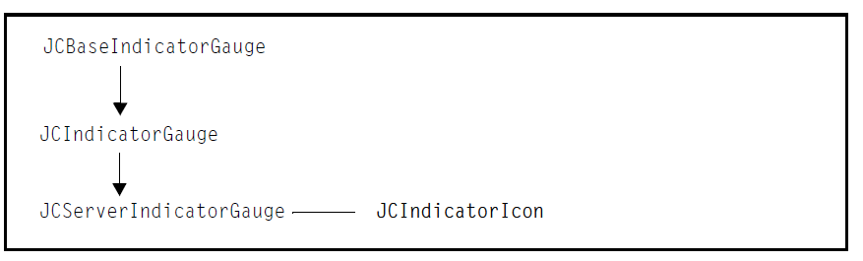
Figure 9 JCServerIndicatorGauge containment hierarchy

The indicator gauge panel, called JCServerIndicatorGaugePanel (extended from JPanel), contains one or more instances of a JCBaseIndicatorGauge object.
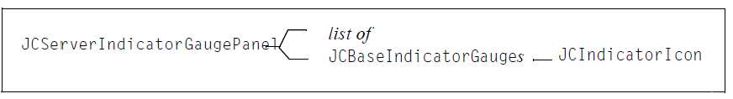
Figure 10 JCServerIndicatorGaugePanel containment hierarchy

1.5.2 Circular and Linear Gauges Containment Hierarchy

In keeping with the goal of making the circular and linear gauges as configurable as possible, classes inherit from an abstract class JCGauge, which is itself a JComponent. JCGauge creates a header, footer, and legend whenever a circular or linear gauge is instantiated, and it has methods for adding or removing indicators, needles, ranges, and ticks. The following diagram shows the containment hierarchy for JCGuage.

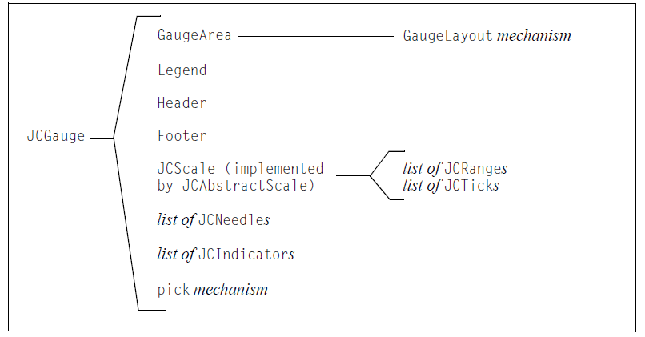
Figure 11 JCGauge containment hierarchy
The following diagram shows the containment hierarchy for JCServerCircularGauge. The JCCircularGauge object on the left side of the containment is the client-side circular gauge that is also shipped with JClass DesktopViews. JCServerCircularGauge extends JCCircularGauge, which in turn extends JCGauge.

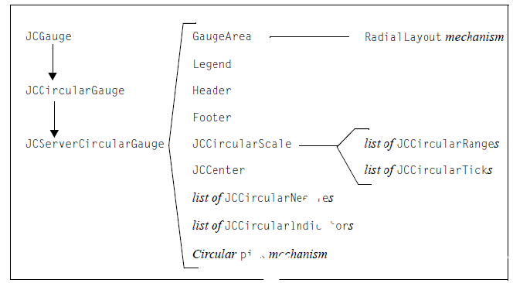
Figure 12 JCServerCircularGuage containment hierarchy

The following diagram shows the containment hierarchy for JCServerLinearGauge. The JCLinearGauge object on the left side of the containment is the client-side linear gauge available with JClass DesktopViews. JCServerLinearGauge extends JCLinearGauge, which in turns extends JCGuage.

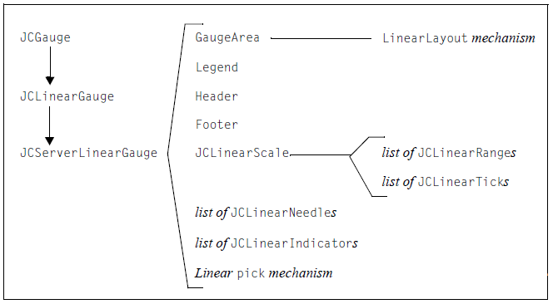
Figure 13 JCServerLinearGauge containment hierarchy

1.6 Internationalization
Internationalization is the process of making software that is ready for adaptation to various languages and regions without engineering changes. JClass ServerViews products have been internationalized.
Localization is the process of making internationalized software run appropriately in a particular environment.
In JClass ServerViews, all Strings that may be seen by a typical user have been internationalized and are ready for localization. These Strings are in resource bundles in every package that requires them. You need to create additional resource bundles for each of the locales that you want to support.
Note: Localizations that are built into the Java platform – such as number and date formatting – are handled by JClass ServerGauge, without the need for you to do any extra work.
To localize your JClass ServerGauge, you need the JClass ServerGauge source code (requires a source code license). The packages that require localization have a resources subdirectory that contains the resource bundles, called LocaleInfo (or some similar variation, such as LocaleBeanInfo). You may want to perform an automated search of the package structure to find all the resource bundles.
To create a new resource bundle, copy the LocaleInfo.java file (staying within the same resources directory) and change its name to include standard language and country identifiers for the locale that you want to support. For example, if you want to support French as spoken in France, rename the copy of LocaleInfo.java to LocaleInfo_fr_FR.java. You can then replace the Strings in the copied file with the French translations.
To use a localized resource bundle, you pass the language and country identifiers to the setLocale() method. For example, setLocale(new Locale(fr, FR)) means that the Strings will be read from LocaleInfo_fr_FR.java.
For more information, including standard language and country identifiers, see http://java.sun.com/j2se/1.5.0/docs/guide/intl/index.html.
If you are creating XML-based gauges, you can internationalize the text on the gauge using variables and a resource bundle. For more information, see Section 14.6, “Internationalizing Your XML-based Gauge.”

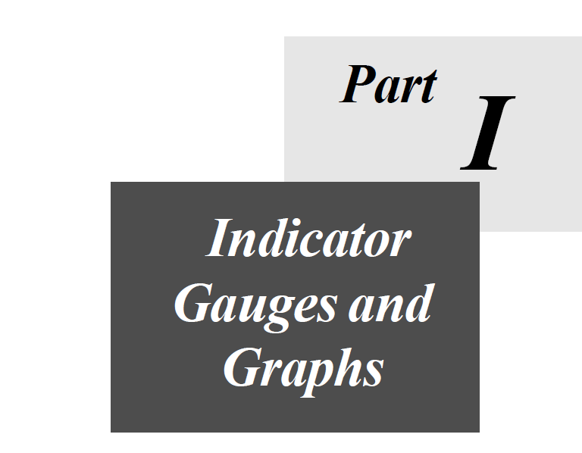

2

Creating Indicator Gauges and Panels
Overview of the Indicator Gauge Objects ■ Summary of Properties Used
A Sample Standalone Indicator Gauge ■ Creating a Standalone Indicator Gauge
Configuring the Behavior of Your Indicator Gauge ■ A Sample Indicator Gauge Panel
Creating an Indicator Gauge Panel ■ Configuring the Behavior of Your Panel
Configuring the Appearance of Gauges and Panels

An indicator gauge is an effective way to draw your end-user’s attention to an important value. The standalone indicator gauge has a single gauge, which can be a rectangle, oval, or a triangle. You can enhance the gauge by defining ranges with attributes such as color, images, and text. When the value represented by the gauge enters a new range, the gauge changes to reflect the attributes associated with that range. You can also configure the appearance of the gauge to suit your application.
In addition to the standalone indicator gauge, you can create a panel of indicator gauges. You create and replicate a gauge on a specialized indicator gauge panel. The value is tied to the panel (rather than a gauge) and ranges are defined for the panel depending on the value type. The value type means that you can use the gauges to display a value as a binary number, a decimal, or as magnitude in a scale.
This chapter describes how to add standalone indicator gauges and indicator gauge panels to your interface and describes how to configure them.

2.1 Overview of the Indicator Gauge Objects
The following diagram shows the inheritance for indicator gauge objects.

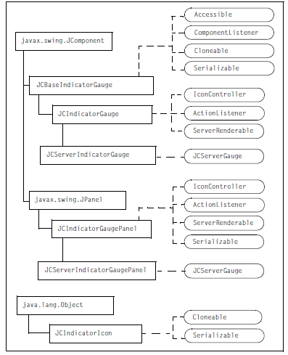
Figure 14 Indicator gauge object inheritance

JCBaseIndicatorGauge extends JComponent and implements Accessible, ComponentListener, Cloneable, and Serializable. The JCBaseIndicatorGauge constructor creates an indicator gauge that can be replicated within an instance of JCServerIndicatorGaugePanel. The class provides properties and methods to define some elements of the gauge, including the icon to display (which is an instance of JCIndicatorIcon), and background elements. Other gauge elements are controlled by the panel, JCServerIndicatorGaugePanel.
JCServerIndicatorGaugePanel extends JCIndicatorGaugePanel and implements JCServerGauge. JCIndicatorGaugePanel contains properties and methods to define the size and orientation of the panel, its background, the number of copies of the gauge (created with JCBaseIndicatorGauge), the value type (for example, binary format), the direction in which the gauge values increase, value ranges with text and color attributes, and the value that the panel of gauges represents.
JCServerIndicatorGauge extends JCIndicatorGauge and implements JCServerGauge. The JCServerIndicatorGauge constructor creates an indicator gauge as a standalone component (that is, without using the panel). The classes provides properties and methods to define the gauge, including the icon to display (an instance of JCIndicatorIcon), value ranges with text and color attributes, and the value that the gauge represents.
IconController is a JClass interface that specifies the methods required to control the icon’s appearance. This interface is implemented by the gauge; you do not need to implement it.
JCServerGauge is a JClass interface that specifies the methods required to define a server-side gauge or graph component. It also marks the gauge as a server-side gauge. This interface is implemented by the server-side gauges; you do not need to implement it.
JCIndicatorIcon implements Cloneable and Serializable. It encapsulates attributes of the icon to be displayed in the gauge such as shape, color, image, text, and value. In general, you do not use the public methods in JCIndicatorIcon directly. JCServerIndicatorGauge and JCServerIndicatorGaugePanel use these methods (via the methods provided by the IconController interface) to draw an icon that reflects the current value

2.2 Summary of Properties Used
The following table summarizes the properties (grouped where appropriate) used in this chapter and provides links to the associated procedures. For a list of all the properties and methods available for indicator gauge objects, see the API documentation.

Properties used with gauges and panels

Properties Used | Procedures
basaeValue | Section 2.5.2, “Setting the Base Value for a StandalongGauge”  Section 2.8.4, “Setting the Base Value for a Panel”
blinkInterval  startBlinking  stopBlinking | Section 2.9.6, “Making Gauge Icons Blink”
background  opaque  fillStyle | Section 2.9.4, “Setting the Background Color and Fill”
iconFont  iconForeground | Section 2.9.5, “Setting the Font and Color for Text”
iconShape | Section 2.9.1, “Setting the Icon Shape”
padding | Section 2.9.3, “Setting the Padding”
preferredSize | Section 2.9.2, “Setting the Gauge Size”
rangeValues  rangeDisplays  rangeText  rangeToolTips  textValueDisplayed | Section 2.5.1, “Definning Ranges for a Standalong Gauge”  Section 2.8.1, “Setting the Value Type and Defining Ranges for a Panel”

Properties used with panels only

Properties Used | Procedures
direction | Section 2.8.2, “Setting the Panel Direction”
gauge | Section 2.8.5, “Changing the Gauge on the Panel”
numGauges | Section 2.8.6, “Changing the Number of Gauges Displayed”
orientation | Section 2.8.3, “Setting the Panel Orientation”
valueType | Section 2.8.1, “Setting the Value Type and Defining Ranges for a Panel”

2.3 A Sample Standalone Indicator Gauge
This section contains a sample indicator gauge and the code used to create it. When you create a standalone indicator gauge, the gauge uses default values for all its properties. You can assign a value to the gauge after it is constructed. After you set up this very basic gauge, you can choose to configure the gauge so that its appearance changes when the current value changes.

For general instructions on creating your own gauge, see these sections:
- Section 2.4, “Creating a Standalone Indicator Gauge,” on page 44
- Section 2.5, “Configuring the Behavior of Your Indicator Gauge,” on page 46
- Section 2.9, “Configuring the Appearance of Gauges and Panels,” on page 63

2.3.1 Sample Gauge

The following images show a sample indicator gauge that implements a traffic light metaphor. As the value goes down, the status message and background color changes.
Figure 15 Four images of the sample indicator gauge representing its range attributes

2.3.2 Sample Code

The following program creates the sample indicator gauge. The image is returned to the browser as an animated gif.
This is a modified version of BasicServerIndicatorGaugeServlet.java located in JCLASS_SERVER_HOME/examples/sgauge/servlet/.

package examples.sgauge.servlet;
importcom.klg.jclass.sgauge.indicator.JCServerIndicatorGauge;
import com.klg.jclass.util.swing.encode.JCEncodeListener;
import com.klg.jclass.util.swing.encode.JCEncodeEvent;
import com.klg.jclass.gauge.indicator.JCIndicatorIcon;

import javax.servlet.ServletOutputStream;
import javax.servlet.http.HttpServlet;
import javax.servlet.http.HttpServletRequest;
import javax.servlet.http.HttpServletResponse;
import java.io.IOException;
import java.awt.*;
/**

* This servlet example returns a JCServerIndicatorGauge to the browser.
* The gauge is encoded as an animated GIF image.
*/public class BasicServerIndicatorGaugeServlet extends HttpServlet implements JCEncodeListener
{
protected JCServerIndicatorGauge myGauge;
protected ServletOutputStream out;
protected boolean complete = false;

/**
* Service method of servlet answers requests from browser.
* Calls for the creation of a serverside indicator gauge,
* encodes it, and sends the image of the gauge to the browser.
*/
public void doGet(HttpServletRequest request, HttpServletResponse response)
{
try
{
// Create a Stream to pass the image through
out = response.getOutputStream();

// Set the content type of the response
response.setContentType("image/gif");

// Create the gauge (specifying a size) and then make it blink JCServerIndicatorGauge myGauge = createIndicatorGauge(100, 80);myGauge.startBlinking();

// Encode the gauge as an animated gif
myGauge.encodeAsSingleLoopAnimatedGif(out);
while (!complete)
{
try
{
Thread.sleep(500);
} catch (InterruptedException e)
{
e.printStackTrace();
}
}

// Stop blinking and clean up threads
myGauge.stopBlinking();
myGauge = null;
complete = false;
out.flush();
} catch (IOException e)
{
e.printStackTrace();
}
}

/**

* This method creates and defines the gauge
*/
protected JCServerIndicatorGauge
createIndicatorGauge(int width, int height)
{
// Create an oval gauge
JCServerIndicatorGauge myGauge = new
JCServerIndicatorGauge(JCIndicatorIcon.SHAPE_OVAL);
// Define the gauge
// Set gauge characteristics
myGauge.setBackground(Color.white);
myGauge.setPadding(5);
myGauge.setSize(width, height);
myGauge.addEncodeListener(this);
// Set the ranges and their attributes
myGauge.setRangeValues(new Integer[]{new Integer(-1),
new Integer(3),
new Integer(6),
new Integer(10)});
myGauge.setRangeDisplays(new Color[]{Color.gray,
Color.red,
Color.yellow,
Color.green});
myGauge.setRangeText(new String[]{"No Status",
"Urgent",
"Monitor",
"Good"});
myGauge.setRangeToolTips(new String[]{"No status",
"Urgent action required",
"Monitor performance",
"Good"});
// Set the base value (lowest value that can be displayed)
myGauge.setBaseValue(new Integer(-1));
// Set a starting value
myGauge.setValue(new Integer(7));
// Set how often the gauge blinks (interval in milliseconds)
myGauge.setBlinkInterval(1500);
// Choose to display text (defined by myGauge.setRangeText())
// instead of the value on the icon
myGauge.setTextValueDisplayed(false);
// Set a font and color for icon text
myGauge.setIconFont(new Font("Dialog", Font.BOLD, 18));
myGauge.setIconForeground(Color.black);
return myGauge;
}
/**

* Empty implementation of encode begin
*/
public void encodeBegin(JCEncodeEvent event)
{
}
/**
* Sets the finished flag to true, so we know we are done and can return
* the image to the browser.
*/
public void encodeEnd(JCEncodeEvent event)
{
complete = true;
}
}

2.4 Creating a Standalone Indicator Gauge
This section describes how to create a standalone indicator gauge and assign a value to it:

- Constructing a JCServerIndicatorGauge Object
- Assigning a Value to Your Indicator Gauge
- Next Steps

2.4.1 Constructing a JCServerIndicatorGauge Object
The JCServerIndicatorGauge constructor creates a gauge that can be displayed as a standalone component. You can use the constructor with no arguments to create an indicator gauge with the default rectangular shape:

// Create a standalone gauge with default icon shape
JCServerIndicatorGauge myGauge = new JCServerIndicatorGauge();
The constructor in turn creates the icon that appears on the gauge as an instance of JCIndicatorIcon. The icon y default, a rectangle that extends to within one pixel of the borders of its container.
Figure 16 Default standalone indicator gauge

Alternatively, you can specify the shape of the icon in the constructor. For more information, see Section 2.9.1, “Setting the Icon Shape,” on page 63.

// Specify a shape for the icon when creating a gauge
JCServerIndicatorGauge myGauge =
new JCServerIndicatorGauge(JCIndicatorIcon.SHAPE_OVAL);
Figure 17 Standalone indicator gauge using SHAPE_OVAL

2.4.2 Assigning a Value to Your Indicator Gauge
To set the current value of the gauge, set the value property and specify an Integer object.
For example:

// Create a gauge and set the value explicitly
JCServerIndicatorGauge myGauge = new JCServerIndicatorGauge();
myGauge.setValue(new Integer(7));
By default, the gauge contains no text. You can, however, choose to display either the current value or some other text on the gauge. For more information, see Section 2.5.1, “Defining Ranges for a Standalone Gauge,” on page 46.

2.4.3 Next Steps
After you complete the necessary tasks of constructing the gauge and assigning a value to it, you can decide how you want the gauge to behave and look.
To configure how the gauge behaves, you can choose from the following tasks:
- Section 2.5.1, “Defining Ranges for a Standalone Gauge”
- Section 2.5.2, “Setting the Base Value for a Standalone Gauge”
To configure the appearance of the gauge, you can choose from the following tasks:
- Section 2.9.1, “Setting the Icon Shape”
- Section 2.9.2, “Setting the Gauge Size”
- Section 2.9.3, “Setting the Padding”
- Section 2.9.4, “Setting the Background Color and Fill”
- Section 2.9.5, “Setting the Font and Color for Text”
- Section 2.9.6, “Making Gauge Icons Blink”
To display the finished gauge a the browser, see Section 1.3, “Displaying a Gauge or Graph in a Browser” .

2.5 Configuring the Behavior of Your Indicator Gauge
This section describes how to define ranges and change the base value of the gauge. To learn how to change the appearance of the gauge, see Section 2.9, “Configuring the Appearance of Gauges and Panels,” on page 63.

2.5.1 Defining Ranges for a Standalone Gauge
You can define ranges of values for your gauge and then associate different icon attributes with each range. The icon attributes are display object, text, and tooltips. The display object can be a color or an image. The text can be the current value or some other text that you specify. The tooltips display the RGB value of the fill color by default, but you can specify your own text instead. When you run your application and the current value falls into a new range, the gauge redraws the icon with the attributes specified for that range.
To set range values, set the rangeValues property to an array of values of the same type as the value property used by the icon. To set the icon display object, set the rangeDisplays property to an array of Color, URL, or PortableImage objects (or a mix thereof), where the URL or PortableImage objects reference images. To specify tooltips, set the rangeToolTips property to a String[] object with an array of text strings.

You have two choices for displaying text on the icon. To display the current value, set the textValueDisplayed property to true. To specify custom text, set the rangeText property to a String[] object with an array of text strings. If you want to change the font used for icon text, see Section 2.9.5, “Setting the Font and Color for Text,” on page 66.
For example, the following table outlines the ranges and range attributes used in the sample indicator gauge:

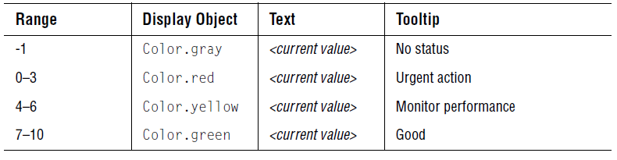
When the current value is 4, the icon is yellow, displays the numeral 4, and the tooltip says “Monitor performance.” If the value becomes 5, the numeral changes but the other icon attributes remain the same. When the current value enters a new range, all the icon attributes change accordingly. So if the value becomes 7, the gauge redraws the icon in green, with the numeral 7, and the tooltip “Good.”

Figure 18 Gauge attributes change when the value enters a new range
In the preceding figure, the default font used to display the value on the gauge is hard to read. To change the font style and size, see Section 2.5.1.1, “Specifying Custom Text on the Icon,” on page 47.
The following code implements the ranges used in the preceding example.

// Define ranges
myGauge.setRangeValues(new Integer[]{
new Integer(-1), new Integer(3), new Integer(6), new Integer(10)});
// Set Colors for each range
myGauge.setRangeDisplays(new Color[]{
Color.gray, Color.red, Color.yellow, Color.green});
// Set tooltip text
myGauge.setRangeToolTips(new String[]{
"No status", "Urgent action required",
"Monitor performance", "Good"});
// Display the current value on the icon
myGauge.setTextValueDisplayed(true);

2.5.1.1 Specifying Custom Text on the Icon
If you want to display text other than the current value, change the textValueDisplayed property to false and set the rangeText property to a String[] object with an array of text strings.

// Set the font and color to use for icon text
myGauge.setIconFont(new Font("Dialog", Font.BOLD, 18));
myGauge.setIconForeground(Color.black);
// Specify the text
myGauge.setTextValueDisplayed(false);
myGauge.setRangeText(new String[]{
"No Status", "Urgent", "Monitor", "Good"});
See Figure 15 to view the results of specifying text, font, and font color.

2.5.1.2 Specifying Images on the Icon
If you want to use an image instead of a color on the icon, set the rangeDisplays property to an array of URL or PortableImage objects. PortableImage objects are describe at the end of this subsection under About the PortableImage Object.
For example, the following code snippet sets the rangeDisplays property to an array of URL objects and uses the actual size of the image (does not scale it):

// Use Images instead of Colors for each range
myGauge.setRangeDisplays(new URL[]{
this.getClass().getResource("star_silver.gif"),
this.getClass().getResource("star_red.gif"),
this.getClass().getResource("star_yellow.gif"),
this.getClass().getResource("star_green.gif")});
// Do not scale the image on the icon
myGauge.getIcon().setImageScaled(false);
Figure 19 Using an image for the icon
Alternatively, you can specify an array of Objects that contains a mix of Color, URL, and PortableImage objects.

About the PortableImage Object
The PortableImage object is a wrapper object in JClass ServerViews that stores an image and properties related to that image. A PortableImage object has as its properties the name of the image, whether or not the image is scaled, and how information about the image is saved to XML. For more information, look up com.klg.jclass.io.PortableImage in the JClass ServerViews API documentation.
The following code snippet shows how to specify a PortableImage object:

// Create a simple PortableImage object (it is scaled by default)
PortableImage image1 = new PortableImage(
New URL(“http://www.my_site.com/smallcircles.jpg”));
When you specify an array of PortableImage objects for the icon, the icon’s setImageScaled() method is ignored. The imageScaled property for each PortableImage object is used instead.
Note: In JClass ServerViews 5.5.0, PortableImage objects were used to define background and foreground images. This usage is deprecated in favor of JCFillStyle objects, which also provide for patterns and gradient fills in addition to images. For more information, Chapter 11, “Defining Background Fill Styles.”

2.5.2 Setting the Base Value for a Standalone Gauge
The base value is the default value of the gauge. It is also the lowest value that the gauge can display. By default, the baseValue property is set to Integer(0).
To change the base value, set the baseValue property to an Object of the same type used for the value property, usually an Integer object. You need to set the baseValue property before setting the rangeValues property. For more information, see Section 2.4.2, “Assigning a Value to Your Indicator Gauge,” on page 45.
For example:
// Set a minimum value of -1
myGauge.setBaseValue(new Integer(-1));
If the current value ever becomes less than the base value, the current value is ignored and the gauge continues to display the last valid value. For example, the base value used for the sample indicator gauge is -1. Assume a current value of 7. If the current value becomes -2, that is setValue(-2), the value is ignored and the gauge does not change. Calling getValue() at this point would return 7.

2.6 A Sample Indicator Gauge Panel
This section contains a sample indicator gauge panel and the code used to create it. When you create an indicator gauge panel, you specify the number of gauges to display in the JCServerIndicatorGaugePanel constructor. All other properties are assigned default values. This means that, by default, you see a horizontal panel containing the specified number of gauges. The gauges are displayed as black rectangles and represent zero in binary format. When you assign a value to the panel, the gauges change to reflect to the new value in binary format.

After you set up the basic panel, you can choose to configure how the value is displayed, so that instead of having the value represented as a binary number, you could represent it in decimal format (whole, positive numbers only) or as magnitude on a scale (using a single color or multiple colors).

For general instructions on creating your own indicator gauge panel, see these sections:
- Section 2.7, “Creating an Indicator Gauge Panel”
- Section 2.8, “Configuring the Behavior of Your Panel”
- Section 2.9, “Configuring the Appearance of Gauges and Panels”
Note: You can also create a panel of indicator gauges using a standard JPanel. In this case, you set the value of each indicator gauge separately.

2.6.1 Sample Panel
The following figure shows how an indicator gauge panel can be used to implement a five-star rating system. The sample indicator gauge panel is implemented with five gauges in a horizontal orientation. The direction of the panel is backward, which means that the values associated with the gauges increase from left to right.
The value displayed by the panel is 4, hence the four stars. The top image shows a unichrome implementation, which means the stars are the same color. The bottom image shows the same indicator gauge panel using a multichrome implementation. Figure

Figure 20 Five star rating system implemented in unichrome (left) and multichrome (right)

2.6.2 Sample Code
The following code creates the unichrome version of the sample indicator gauge panel.

Import com.klg.jclass.sgauge.indicator.JCServerIndicatorGaugePane;
import com.klg.jclass.util.swing.encode.JCEncodeListener;
import com.klg.jclass.util.swing.encode.JCEncodeEvent;
import com.klg.jclass.gauge.indicator.JCIndicatorIcon;
import com.klg.jclass.gauge.indicator.JCBaseIndicatorGauge;

import javax.servlet.ServletOutputStream;
import javax.servlet.http.HttpServlet;
import javax.servlet.http.HttpServletRequest;
import javax.servlet.http.HttpServletResponse;
import java.io.IOException;
import java.awt.*;

/**
* This servlet example returns a JCServerIndicatorGaugePanel to the
* browser. The gauge is encoded as an animated GIF image.
*/

public class BasicServerIndicatorGaugePanelServlet extends HttpServlet
implements JCEncodeListener

{

protected JCServerIndicatorGaugePanel myPanel;
protected ServletOutputStream out;
protected boolean complete = false;

/**
* Service method of servlet answers requests from browser.
* Calls for the creation of a serverside indicator gauge panel,
* encodes it, and sends the image of the gauge to the browser.
*/
public void doGet(HttpServletRequest request, HttpServletResponse response)
{
try
{
// Create a Stream to pass the image through
out = response.getOutputStream();
// Set the content type of the response
response.setContentType("image/gif");
// Create the panel (specifying a size) and turn on blinking
JCServerIndicatorGaugePanel myPanel =
createIndicatorGaugePanel(150, 250);
myPanel.startBlinking();
// Encode the indicator gauge panel
myPanel.encodeAsSingleLoopAnimatedGif(out);
while (!complete)
{
try
{
Thread.sleep(500);
} catch (InterruptedException e)
{
e.printStackTrace();
}
}
// Turn off blinking and clean up threads
myPanel.stopBlinking();
myPanel = null;
complete = false;
out.flush();
} catch (IOException e)
{
e.printStackTrace();
}
}
/**
* Creates a myPanel of a specified type
*/
protected JCServerIndicatorGaugePanel
createIndicatorGaugePanel(int width, int height)
{
// Create a gauge of type JCBaseIndicatorGauge
JCBaseIndicatorGauge myGauge =
new JCBaseIndicatorGauge(JCIndicatorIcon.SHAPE_RECTANGLE);
// Scale the image on the gauge’s icon when the container scales
myGauge.getIcon().setImageScaled(true);
// Create the indicator gauge panel and display five gauges
JCServerIndicatorGaugePanel myPanel = new JCServerIndicatorGaugePanel(
5, myGauge);
// Set the value type: UNICHROME or MULTICHROME
myPanel.setValueType(
JCIndicatorGaugePanel.VALUE_MAGNITUDE_UNICHROME);
// Configure the panel attributes
myPanel.setOrientation(
JCServerIndicatorGaugePanel.ORIENTATION_HORIZONTAL);
myPanel.setDirection(JCServerIndicatorGaugePanel.DIRECTION_BACKWARD);
myPanel.setPadding(4);
myPanel.setBackground(Color.white);
myPanel.setSize(width, height);
myPanel.addEncodeListener(this);
// Configure the range attributes for the five-star rating system
myPanel.setRangeValues(new Integer[]{
new Integer(0),
new Integer(1),
new Integer(2),
new Integer(3),
new Integer(4),
new Integer(5)});
myPanel.setRangeDisplays(new URL[]{
this.getClass().getResource("star_none.gif"),
this.getClass().getResource("star_cyan.gif"),
this.getClass().getResource("star_blue.gif"),
this.getClass().getResource("star_bronze.gif"),
this.getClass().getResource("star_silver.gif"),
this.getClass().getResource("star_gold.gif")});
myPanel.setRangeToolTips(new String[]{
"",
"Poor",
"Okay",
"Good",
"Great",
"Exceptional"});

// Do not display text on the gauge
myPanel.setTextValueDisplayed(false);
// Set the base value (lowest value that can be displayed)
myPanel.setBaseValue(new Integer(0));
// Set how often the panel blinks (interval in milliseconds)
myPanel.setBlinkInterval(1500);
// Set the initial value of the panel
myPanel.setValue(new Integer(4));
return myPanel;
}

/**
* Empty implementation of encode begin
*/
public void encodeBegin(JCEncodeEvent event)
{
}
/**
* Sets the finished flag to true, so we know we are done and can return
* the image to the browser.
*/
public void encodeEnd(JCEncodeEvent event)
{
complete = true;
}
}

2.7 Creating an Indicator Gauge Panel
The JCBaseIndicatorGauge constructor creates a gauge that can be replicated in a specialized panel. You create the panel using the JCServerIndicatorGaugePanel constructor and specify how many copies of the gauge to place in the panel.

This section walks you through creating a panel of gauges and assigning a value to it:

- Constructing a JCBaseIndicatorGauge Object
- Constructing a JCServerIndicatorGaugePanel Object
- Assigning a Value to Your Indicator Gauge Panel
- Next Steps

Note: You can also create a panel of indicator gauges using a standard JPanel. In this case, you set the value of each indicator gauge separately.

2.7.1 Constructing a JCBaseIndicatorGauge Object

The following code snippet creates a gauge that can be replicated in the indicator gauge panel. As with the standalone gauge component, the constructor creates the icon that appears on the gauge as an instance of JCIndicatorIcon. By default, the shape of the icon is a rectangle.

// Create a gauge with default rectangular icon shape
JCBaseIndicatorGauge myGauge = new JCBaseIndicatorGauge();
Alternatively, you can specify the icon shape in the constructor:

// Specify a shape for the icon when creating a gauge
JCBaseIndicatorGauge myGauge =
new JCBaseIndicatorGauge(JCIndicatorIcon.SHAPE_TRIANGLE);

For more information, see Section 2.9.1, “Setting the Icon Shape,” on page 63.

2.7.2 Constructing a JCServerIndicatorGaugePanel Object
When you create the panel, you specify the number of gauges and the JCBaseIndicatorGauge object that you created. The panel replicates the base gauge the specified number of times. The number parameter is required. If you omit the JCBaseIndicatorGauge object, a default one is created and used.

// Create a panel with eight instances of the gauge myGauge
JCServerIndicatorGaugePanel myPanel = new
JCServerIndicatorGaugePanel(8, myGauge);

2.7.3 Assigning a Value to Your Indicator Gauge Panel
To set the current value of the panel, set the value property to an Integer object. The value must be greater than or equal to the base value, which is zero by default.
Note: For binary and decimal representations, the base value is always zero even if the baseValue property has been set to a different value. Note that this means that negative integers are not supported for these value types. For more information, see Section 2.8.4, “Setting the Base Value for a Panel,” on page 61. For example:
// Create the gauge and panel and assign a value to the panel
JCBaseIndicatorGauge myGauge = new JCBaseIndicatorGauge();
JCServerIndicatorGaugePanel myPanel = new
JCServerIndicatorGaugePanel(8, myGauge);
myPanel.setValue(new Integer(7));

The preceding example creates a default horizontal panel displaying the value 7 as a binary number. The size of the gauge used in the panel is calculated so that the instances of the gauge fill the panel container, leaving a one pixel padding all around. The color of the gauges is controlled by two default ranges. The first range represents zero and is assigned the color black, while the second range represents the value one (or greater) and uses white.
Figure 21 Default indicator gauge panel showing the value 7 in binary format on a gray background

2.7.4 Next Steps
After you complete the necessary tasks of constructing the panel and assigning a value to it, you can decide how you want the panel of gauges to behave and look.

To configure how the panel behaves, you can choose from the following tasks:

- Section 2.8.1, “Setting the Value Type and Defining Ranges for a Panel”
- Section 2.8.2, “Setting the Panel Direction”
- Section 2.8.3, “Setting the Panel Orientation”
- Section 2.8.4, “Setting the Base Value for a Panel”
- Section 2.8.5, “Changing the Gauge on the Panel”
- Section 2.8.6, “Changing the Number of Gauges Displayed”
To configure the appearance of the panel and its gauges, you can choose from the following tasks:
- Section 2.9.1, “Setting the Icon Shape”
- Section 2.9.2, “Setting the Gauge Size”
- Section 2.9.3, “Setting the Padding”
- Section 2.9.4, “Setting the Background Color and Fill”
- Section 2.9.5, “Setting the Font and Color for Text”
- Section 2.9.6, “Making Gauge Icons Blink”
To display the finished panel in a browser, see Section 1.3, “Displaying a Gauge or Graph in a Browser.”

2.8 Configuring the Behavior of Your Panel
This section describes how to change the value type of the panel, define ranges, set the orientation of the panel, reverse the direction in which values increase across the panel, set the base value, change the gauge used, and specify the number of gauges on the panel. To learn how to change the appearance of the panel and gauge, see Section 2.9, “Configuring the Appearance of Gauges and Panels.”.

2.8.1 Setting the Value Type and Defining Ranges for a Panel
Your panel of gauges can display the current value in binary form, as a decimal value, or as magnitude in a scale. To set the value type, set the valueType property to one of the predefined constants. The valid constants are:
- JCIndicatorGaugePanel.VALUE_MAGNITUDE_UNICHROME
      - JCIndicatorGaugePanel.VALUE_MAGNITUDE_MULTICHROME
      - JCIndicatorGaugePanel.VALUE_DECIMAL
- JCIndicatorGaugePanel.VALUE_BINARY (default)
Ranges are applied differently, depending on the value type selected. The value types and their use of ranges are described in the subsections that follow.
For background information on ranges, see Section 2.5.1, “Defining Ranges for a Standalone Gauge,” and the API documentation.

2.8.1.1 Magnitude
The VALUE_MAGNITUDE_UNICHROME and VALUE_MAGNITUDE_MULTICHROME value types show the current value within the context of a scale. The scale is created by assigning the first gauge the value of baseValue+1 and incrementing the value by one for each consecutive gauge. For example, if a panel has ten gauges and the base value is zero, the gauges are assigned values consecutively from one through ten. The current value is represented in the scale by turning on the gauges with values equal to or less than the current value. A gauge is turned on when its display is different than the one used for null and zero values.
Note: You must define ranges and colors to show meaningful information in this type of indicator gauge panel. For background information on ranges, see Section 2.5.1, “Defining Ranges for a Standalone Gauge,” on page 46.
For example, the following table outlines the ranges and attributes for the sample indicator gauge panel (Figure 20):

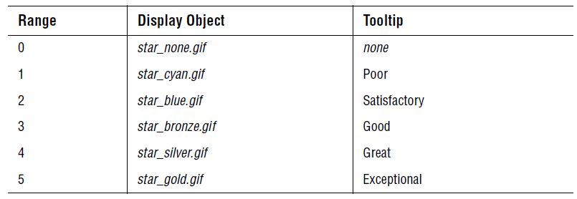
The following code snippet implements the unichrome version of magnitude and the ranges and attributes used in the preceding example. Note that no text is specified.

// Set the value type
myGauge.setValueType(
JCIndicatorGaugePanel.VALUE_MAGNITUDE_UNICHROME);
// Configure the range attributes for the five-star rating system
myPanel.setRangeValues(new Integer[]{
new Integer(0),
new Integer(1),
new Integer(2),
new Integer(3),
new Integer(4),
new Integer(5)});
myPanel.setRangeDisplays(new URL[]{
this.getClass().getResource("star_none.gif"),
this.getClass().getResource("star_cyan.gif"),
this.getClass().getResource("star_blue.gif"),
this.getClass().getResource("star_bronze.gif"),
this.getClass().getResource("star_silver.gif"),
this.getClass().getResource("star_gold.gif")});
myPanel.setRangeToolTips(new String[]{
"",
"Poor",
"Okay",
"Good",
"Great",
"Exceptional"});
Figure 22Unichrome indicator panel

Difference Between Unichrome and Multichrome
Ranges are defined in the same way for both magnitude value types. However, the range attributes are applied to the gauges differently, depending on the value type. For VALUE_MAGNITUDE_UNICHROME, the gauges that are turned on display the range attributes associated with the current value. For VALUE_MAGNITUDE_MULTICHROME, the gauges display the range attributes associated with the individual gauge values.
The following images show the sample indicator gauge panel in unichrome and in multichrome when the current value is 4.

Figure 23 Value of 4 in UNICHROME (top) and MULTICHROME (bottom)
In both images, gauges one through four are turned on. The VALUE_MAGNITUDE_UNICHROME version displays all silver stars, which is the star associated with the range value 4. In the VALUE_MAGNITUDE_MULTICHROME version, the cyan, blue, bronze, and silver stars correspond to the range values 1, 2, 3, and 4 respectively. The inactive gauges are white, because an empty image with a white background is assigned to the zero range.

2.8.1.2 Decimal
When the value type is VALUE_DECIMAL, you can display the current value as a whole number in decimal format. Negative values cannot be displayed using this value type. If a negative value is set, it is ignored and the last valid value continues to be displayed.
Each gauge in the panel represents a place value holder, that is, ones, tens, hundreds, and so on, from right to left. Each number in the current value is assigned to the gauge holding its place value.
By default, the gauges are black with no numerals. To show meaningful information, you must define ranges, one for each number from zero to nine. You can then associate the numerals with the ranges and, if you like, colors as well.
For example, the following code creates an indicator gauge panel with the value type VALUE_DECIMAL. Range values are defined using a convenience array called DECIMAL_VALUES that sets up the values zero through nine. Colors are specified for each range. The current value is set to 204157.

// Create a panel with 10 default gauges of type JCBaseIndicatorGauge
myPanel = new JCServerIndicatorGaugePanel(10);
// Set the value type
myPanel.setValueType(JCIndicatorGaugePanel.VALUE_DECIMAL);
// Set the current value
myPanel.setValue(new Integer(204157));
// Assign range colors to range values 0-9
myPanel.setRangeDisplays(new Color[]{
Color.white, Color.cyan, Color.blue, Color.magenta, Color.green,
Color.yellow, Color.orange, Color.red, Color.pink, Color.gray});
myPanel.setRangeValues(JCIndicatorGaugePanel.DECIMAL_VALUES);
myPanel.setTextValueDisplayed(true);
// Set the font and color to use for icon text
myPanel.setIconFont(new Font("Dialog", Font.BOLD, 18));
myPanel.setIconForeground(Color.black);
Figure 24 Value displayed as a decimal

Recall that the default direction is forward, which means right to left, so the first gauge is on the far right. The first gauge is the ones place value holder and displays the 7. The number seven has the color red associated with it, so the gauge is red. The next gauge is the tens place value and holds the value 5; the gauge is yellow because that is the color associated with the number five. The third gauge is hundreds and holds the value 1; the number one is associated with cyan. The remaining numerals are treated similarly. The extra gauges display the color associated with zero (white).

You can specify text or tooltips by setting the rangeText and rangeToolTips properties. Both take a String[] object with an array of text strings. When setting the rangeText property, you need to set the textValueDisplayed property to false.

// Define custom tooltips
myPanel.setTextValueDisplayed(false);
myPanel.setRangeText(new String[]{
"zero", "one", "two", "three", "four"
"five", "six", "seven", "eight", "nine"});
myPanel.setRangeToolTips(new String[]{
"zero", "one", "two", "three", "four"
"five", "six", "seven", "eight", "nine"});

For background information on ranges, see Section 2.5.1, “Defining Ranges for a Standalone Gauge,” on page 46.

Changing the Number of Gauges
If you like, you can eliminate the leading, empty gauges and display the example number 204157 in six gauges. You need to set up the panel to change the number of gauges dynamically, allowing you to show only the number of gauges necessary to display the value. For more information, see Section 2.8.6, “Changing the Number of Gauges Displayed,” on page 62.

2.8.1.3 Binary
When the value type is set to VALUE_BINARY (the default value type), the current value is displayed as a binary number. Negative values cannot be displayed using this value type. If a negative value is set, it is ignored and the last valid value continues to be displayed.
Each gauge in the panel can represent a one (1) or a zero (0). The zeros are represented as black gauges and the ones are white gauges. If you like, you can change these colors and add text.
For example, the following code displays the current value in binary format and changes the default colors. Conveniently, gauges are created with two default ranges that have the values 0 and 1. In this example, the zero gauges are set to blue, while the ones gauges are set to yellow.

// Display the current value as a binary number
myPanel.setValueType(JCIndicatorGaugePanel.VALUE_BINARY);
// Change the color of the gauges
myPanel.setRangeDisplays(new Color[]{Color.blue, Color.yellow});
myPanel.setValue(new Integer(157));
Figure 25 Value 157 displayed as binary
You can specify different text or tooltips by setting the rangeText and rangeToolTips properties. Both properties take a String[] object with an array of text strings.
Note: setTextValueDisplayed() takes precedence over setRangeText(). When using rangeText, set the textValueDisplayed property to false.

// Specify text and tooltips for binary format
myPanel.setTextValueDisplayed(false);
myPanel.setRangeText(new String[]{"zero", "one"});
myPanel.setRangeToolTips(new String[]{"off", "on"});

For background information on ranges, see Section 2.5.1, “Defining Ranges for a Standalone Gauge,” on page 46. If you want to change the font used for text, see Section 2.9.5, “Setting the Font and Color for Text,” on page 66.

2.8.2 Setting the Panel Direction

By default, the right-most gauge in a horizontal panel represents the least significant range value (excluding zero). For example, in decimal format, the right-most gauge represents the ones place. The range values of the gauges increase from right to left, with the next gauges representing tens, hundreds, and so on. If the panel is vertical, the values increase from bottom to top. You can change the direction in which the range values increase.

To set the direction, set the direction property to one of the following constants: JCIndicatorGaugePanel.DIRECTION_FORWARD (default) or JCIndicatorGaugePanel.DIRECTION_BACKWARD. In a horizontal panel, DIRECTION_FORWARD causes values to increase from right to left; for a vertical panel, values increase from bottom to top. DIRECTION_BACKWARD reverses the direction for each of the orientations.

Figure 26 FORWARD is from right to left (top)
BACKWARD is from left to right (bottom)

For example:
// Increase values from left to right in a horizontal panel
// (or from top to bottom in a vertical panel)
myPanel.setDirection(JCIndicatorGaugePanel.DIRECTION_BACKWARD);

Caution: If you reverse the direction of a panel that is meant to show a binary or decimal value type (where order is important), the result is likely to be misleading. For example, the current value 000157 displayed as a decimal on a reversed panel would show 751000!

2.8.3 Setting the Panel Orientation
You can specify whether the gauges are displayed horizontally or vertically within the panel. To set the orientation, set the orientation property to one of the following constants:

JCIndicatorGaugePanel.ORIENTATION_HORIZONTAL (default) or JCIndicatorGaugePanel.ORIENTATION_VERTICAL.

Figure 27 HORIZONTAL (left) and VERTICAL (right) orientations

For example:

// Make the panel vertical
myPanel.setOrientation(JCIndicatorGaugePanel.ORIENTATION_VERTICAL);

If the orientation is changed, you may need to resize the panel’s container to see the entire array of gauges.

2.8.4 Setting the Base Value for a Panel
The base value is the lowest value that the panel can display. When the current value is equal to the base value, it is equivalent to turning off all the gauges. By default, the baseValue property is set to null, which is interpreted as zero.
When the value type of the gauge is VALUE_MAGNITUDE_UNICHROME or VALUE_MAGNITUDE_MULTICHROME, you can specify a different base value. The first gauge on the panel takes the value of baseValue+1. So, if you set a base value of 2, the first gauge has a value of 3. If the current value falls below the base value, it cannot be displayed; the base value is used and all the gauges are turned off.
To change the base value, set the baseValue property to an Object of the same type as the value property, usually an Integer object. For more information, see Section 2.7.3, “Assigning a Value to Your Indicator Gauge Panel,” on page 54.

For example:

// Set a base value of 2 for the VALUE_MAGNITUDE value types
myPanel.setBaseValue(new Integer(2));

To see the results of changing the base value, consider the sample indicator gauge using a value of 4 and a VALUE_MAGNITUDE_UNICHROME value type. The direction of the indicator gauge panel is backwards, which means that the gauges increase from left to right. With a base value of 2, the left-most gauge represents 3 and the next gauge is 4. These two gauges are silver, which is the color associated with the value 4. The remaining gauges display the color associated with the value 2 (the base value), that is, blue.

Figure 28 Sample indicator gauge panel with a base value of 2 and a current value of 4

As you can see, the end result of changing the base value for this application is accurate but non-intuitive. Take care when adjusting the base value in your own applications that the result is meaningful to your end-user.

When the value type of the panel is set to VALUE_BINARY or VALUE_DECIMAL, the baseValue property is ignored. It is always assumed to be zero.

2.8.5 Changing the Gauge on the Panel

When you created the indicator gauge panel, you had the opportunity to specify the gauge that you wanted replicated on the panel. If you chose not to create and specify a gauge at that time, a default gauge was created and used instead.

You can choose to use a different gauge after the panel is constructed. To change the indicator gauge displayed, set the gauge property to a gauge of type JCBaseIndicatorGauge.

For example:

// Change the gauge used
myPanel.setGauge(myOtherGauge);

2.8.6 Changing the Number of Gauges Displayed

When you created the indicator gauge panel, you specified how many copies of the gauge to display on the panel. You can choose to change the number of gauges used on the panel after the panel is constructed. For example, you may want to increase the number of gauges for a large value and decrease them to display a small value. To change the number of gauges, set the numGauges property to a positive int.

For example:

// Change the number of gauges on the panel from 3 to 10
myPanel.setNumGauges(10);

To test whether or not you need to update the number of gauges dynamically, you can query for the current number of gauges. For example, the following code (taken from the JClass Dungeon Game demo) increases the number of gauges to match the length of the value that represents character points:
// Get the number of character points
Integer pts = new Integer(character.getPoints());
if (pts.toString().length() > ptsGauge.getNumGauges()){
ptsGauge.setNumGauges(pts.toString().length());
}
ptsGauge.setValue(pts);

You can use the same approach to reduce the number of gauges.

2.9 Configuring the Appearance of Gauges and Panels
This section contains procedures for changing the shape of the icon and Configuring some of the container characteristics, such as gauge size, padding, and background attributes. You can also make the gauge icon blink.

2.9.1 Setting the Icon Shape

The iconShape property specifies the shape of the icon. To set the shape, you can either specify it in the gauge constructor or set the iconShape property from JCBaseIndicator. The setIconShape() method enables you to change the shape of the icon when the value of the icon changes. The valid constants are: JCIndicatorIcon.SHAPE_RECTANGLE (default), JCIndicatorIcon.SHAPE_TRIANGLE, and JCIndicatorIcon.SHAPE_OVAL.

Figure 29 Sample icons shapes in indicator gauges

Figure 30 Sample icon shapes in indicator gauge panels

For example:

// Change the icon shape after the gauge is constructed
myGauge.setIconShape(JCIndicatorIcon.SHAPE_OVAL);

To set the shape in the gauge constructor, see Section 2.4.1, “Constructing a JCServerIndicatorGauge Object,” and Section 2.7.1, “Constructing a JCBaseIndicatorGauge Object” .

2.9.2 Setting the Gauge Size

You can control the initial size of the gauge. If the end-user changes the size of the container, the gauge is resized to fill it. To set the initial size of the gauge, set the preferredSize property from JComponent.

For example:

// Set the initial size (component can be resized by end-user)
myGauge.setPreferredSize(new Dimension(100, 100));

2.9.3 Setting the Padding

You can set the padding for a gauge and, if you are creating a panel of gauges, for the panel. In this context, padding is the gap around the edges and between the contents of the container. By default, the padding is one pixel wide. If you increase the padding property to be greater than one, more of the container background is exposed around the contents, achieving a border-like effect. For more information, see Section 2.9.4, “Setting the Background Color and Fill,” on page 65.

To set the padding, set the padding property to a positive int that represents the size of the padding in pixels.

Gauge example:

// Set the padding for the gauge
myGauge.setPadding(10);

Figure 31 Gauge padding increases space around the icon

Panel example:

// Set the padding for the panel
myPanel.setPadding(10);

Figure 32 Panel padding increases space between gauges

2.9.4 Setting the Background Color and Fill

To set the background color of a gauge or panel, set the background and opaque properties inherited from JComponent. The amount of the background that is exposed is controlled by the padding property. For more information, see Section 2.9.3, “Setting the Padding,” on page 64.

Figure 33 Gauge background set to white

Figure 34 Four out of a possible five stars in a panel with a white background

You can create different results by setting the gauge background and panel background to different colors. For example, in the following figure the panel background is set to yellow with a padding of 15 pixels, and the gauge background is set to red with a padding of 10 pixels. The white area is part of the image used on the icon. For more information, see Section 2.5.1.2, “Specifying Images on the Icon,” on page 48

Figure 36 Gauge background set to an image

Note: If you want to place an image on the icon rather than in the background, you need to associate images with ranges by setting the rangeDisplays property. Do not use the method described in this section. For more information, see Section 2.5.1.2, “Specifying Images on the Icon,” on page 48.

2.9.5 Setting the Font and Color for Text

If you add text to your gauge, you can configure the font used. To configure the font, set the iconFont and iconForeground properties. For example:

// Specify font and font color
myGauge.setIconFont(new Font(“Helvetica”, Font.BOLD, 12));
myGauge.setIconForeground(new Color(255, 128, 0));

To specify the actual text, you need to associate Strings with each of the ranges using the rangeText property. For more information, see Section 2.5.1, “Defining Ranges for a Standalone Gauge,” on page 46 and Section 2.8.1, “Setting the Value Type and Defining Ranges for a Panel,” on page 55.

2.9.6 Making Gauge Icons Blink

By default, a gauge icon does not blink. If you want the icon to blink, you need to specify the interval between blinks in milliseconds and then start the blink timer. For example, you could make the icon blink every ten seconds by setting the blinkInterval to 10000 milliseconds.

Note: Avoid setting a very small blink interval; the gauge icon will blink too fast to be useful and may violate accessibility requirements.

To set a blink interval, set the blinkInterval property to a positive int that represents the interval in milliseconds (a value of zero means that the gauge does not blink). The setBlinkInterval() method creates a timer, which is used to start and stop the blinking. To start the blink timer, use the startBlinking() method. To stop the timer, use the stopBlinking() method. In a panel of gauges, these methods cause the icons in all the gauges to start and stop blinking as a group.

To ensure that blinking gauges or panels are displayed correctly in a browser, use the encodeAsSingleLoopAnimatedGif() method. Other methods may or may not display the icons.

The following code (taken from JCServerIndicatorGauge.java in JCLASS_SERVER_HOME/examples/sgauge/indicator/) sets an indicator gauge blinking every ten seconds and encodes it as an animated GIF:

// Create the encode listener
myGauge.addEncodeListener(new JCEncodeListener()
{
public void encodeBegin(JCEncodeEvent e)
{
}
public void encodeEnd(JCEncodeEvent e)
{
System.exit(0);
}
});
// Encode the gauge as an animated gif
try {
FileOutputStream fos = new FileOutputStream(new File("sig.gif"));
myGauge.encodeAsSingleLoopAnimatedGif(fos);
}
catch (FileNotFoundException e) {
e.printStackTrace();
}
// Start the gauge blinking
myGauge.startBlinking();
...
// Stop the gauge blinking
myGauge.stopBlinking();

3

Creating Graphs
Overview of the Graph Object ■ Summary of Properties Used ■ A Sample Gragh
Creating a Gragh ■ Configuring the Gragh ■ Layering a Gragh on Top of a Guage

JCServerGraph is a light-weight component that you can use to represent fluctuations in a changing value. This graph is not intended as a scientific tool; it does not display scale values nor does it store a history of the values used in plotting the graph. Rather, the graph is useful as a guidepost to how much or how little a value fluctuates. For example, you could place a graph beside or on top of a standalone indicator gauge. As the gauge value changes during the session, the graph line marks the relative change. This chapter describes how to create and configure a JCServerGraph component.

3.1 Overview of the Graph Object
The following diagram shows the inheritance for the graph object.

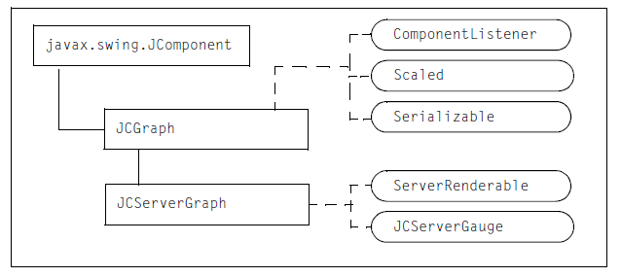
Figure 37 Graph object inheritance

JCServerGraph extends JCGraph and implements ServerRenderable and JCServerGauge. JCGraph extends JComponent and implements the ComponentListener, Scaled, and Serializable interfaces. JCServerGraph provides properties and methods to create and define a graph.

3.2 Summary of Properties Used
The following table summarizes the properties (grouped where appropriate) used in this chapter and provides links to the associated procedures. For a list of all the properties and methods available for graph objects, see the API documentation

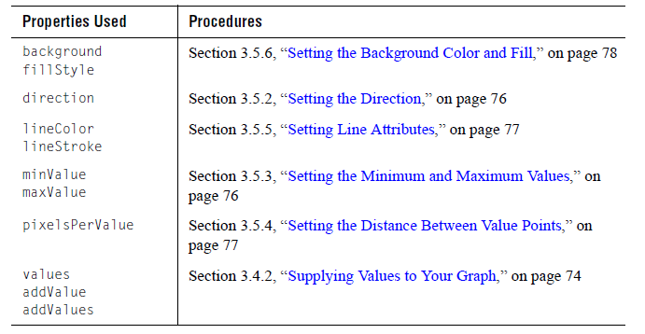

3.3 A Sample Gragh
This section contains a sample graph and the code used to create it. Values are added to the graph by setting an initial array. The appearance of the graph is configured by setting properties that control the line and background attributes of the graph.

For general instructions on creating your own graph, see these sections:
- Section 3.4.1, “Constructing a JCServerGraph Object”
- Section 3.4.2, “Supplying Values to Your Graph”
- Section 3.5, “Configuring the Graph”

3.3.1 Sample Graph

The following figure shows an implementation of a sample graph. The graph line is red and three pixels wide. An image of lungs is displayed in the background of the graph.

Figure 38 Sample graph

3.3.2 Sample Code

The following program creates the sample graph. The code is modified from BasicServerGraphServlet.java.

package examples.sgauge.servlet;

import com.klg.jclass.util.swing.encode.JCEncodeListener;
import com.klg.jclass.util.swing.encode.JCEncodeEvent;
import com.klg.jclass.util.swing.encode.JCEncodeComponent;
import com.klg.jclass.util.swing.encode.EncoderException;
import com.klg.jclass.sgauge.indicator.JCServerIndicatorGaugePanel;
import com.klg.jclass.sgauge.graph.JCServerGraph;
import com.klg.jclass.gauge.indicator.JCBaseIndicatorGauge;
import com.klg.jclass.gauge.indicator.JCIndicatorIcon;

import javax.servlet.http.HttpServlet;
import javax.servlet.http.HttpServletRequest;
import javax.servlet.http.HttpServletResponse;
import javax.servlet.ServletOutputStream;
import javax.swing.*;
import java.io.IOException;
import java.awt.*;

/**
* This an example which demonstrates using JCServerGraph in a servlet
* to return a png image to the browser.
*/

public class BasicServerGraphServlet extends HttpServlet
{

protected ServletOutputStream out;

/**
* Service method of servlet, answers requests from browser.
* Call the creation of a server graph, encode it as a png,
* and send it back to the browser
*/
public void doGet(HttpServletRequest request, HttpServletResponse response)
{
try
{
// create a Stream to pass the image through
out = response.getOutputStream();
// set the content type of the response

response.setContentType("image/png");
JCServerGraph myGraph = createGraph(150, 75);

// encode the gaugePanel
myGraph.encode(JCEncodeComponent.PNG, out);
out.flush();
} catch (IOException e)
{
e.printStackTrace();
}
catch (EncoderException e)
{
e.printStackTrace();
}
}
/**
* Creates a gaugePanel of a specified type
*/
protected JCServerGraph
createGraph(int width, int height)
{
// Create the graph and set the direction
JCServerGraph myGraph = new JCServerGraph(JCServerGraph.LEFT);

// Set the size and attributes of the graph
myGraph.setSize(new Dimension(width, height));
myGraph.setOpaque(false);
myGraph.setBorder(BorderFactory.createLineBorder(Color.black));

// Set the line attributes
myGraph.setLineColor(Color.red);
myGraph.setLineStroke(new BasicStroke(2));
myGraph.setPixelsPerValue(3);

// Create a JCFillStyle object and specify an image
// Note the color parameter must be set, but it is ignored
JCFillStyle fs = new JCFillStyle(Color.black, JCFillStyle.IMAGE);
URL resource = this.getClass().getResource("lungs.gif");
fs.setImage(new ImageIcon(resource).getImage());
// Set the JCFillStyle object on the graph
myGraph.setFillStyle(fs);

// Assign some values to the graph
myGraph.addValues(new double[]{
15.0, 20.0, 30.0, 25.0, 27.0, 30.0, 38.0,45.0, 35.0, 33.0, 66.0, 56.0, 68.0, 80.0,83.0, 70.0, 60.0, 72.0, 80.0, 89.0, 3.5, 1.3, 1.7, 2.9, 5.6, 2.7, 0.3, 4.7, 5.6,2.8, 3.6, 2.9, 1.5, 2.6, 0.7, 1.7, 3.9, 5.2,3.5, 2.4, 3.6, 1.3, 4.7, 0.2, 5.8, 4.1, 3.4,5.0, 1.0, 2.2, 3.3, 4.4, 5.5, 1.9, 2.8, 3.7});
return myGraph;
}
}

3.4 Creating a Graph
This section describes how to create a graph and assign values to it.
- Constructing a JCServerGraph Object
- Supplying Values to Your Graph
- Next Steps

Constructing a JCServerGraph Object

The JCServerGraph constructor creates a graph component that can be encoded and displayed as an image on a web page. You can use the constructor with no arguments to create a graph with default properties.

// Create a graph with default values
JCServerGraph myGraph = new JCServerGraph();

There are other JCServerGraph constructors that can be used to set the direction of the graph, provide an initial set of values to the graph, and set initial minimum and maximum boundaries for the graph. These constructors are described in the following subsections.

3.4.1.1 Specifying the Direction
By default, the graph travels from left to right. You can change this behavior by specifying the direction parameter in the constructor.

// Specify the direction of the graph
JCServerGraph myGraph = new JCServerGraph(JCGraph.DOWN);

For a list of valid constants for the direction parameter, see Section 3.5.2, “Setting the Direction.”

3.4.1.2 Specifying Initial Values

You can provide an initial array of values in the constructor. The values are specified as an array of doubles. The graph is plotted using these values.

// Specify an array of values
myGraph = new JCServerGraph(new double[]{
15.0, 20.0, 30.0, 25.0, 27.0, 30.0,
38.0, 45.0, 35.0, 33.0, 66.0, 56.0, 68.0,
80.0, 83.0, 70.0, 60.0, 72.0, 80.0, 89.0});

Figure 39 Graph with default properties and an initial array of values

If you have an updating application, new values may be added during a session and you will need to update the graph. For more information, see Section 3.4.2, “Supplying Values to Your Graph,” on page 74.

3.4.1.3 Specifying Direction, Values, and Boundaries

You can set the direction of the graph, its initial set of values, and its initial minimum and maximum boundaries using this constructor. The direction and values parameters are set as described in the preceding sections. The minimum and maximum boundary values are specified as doubles, where the minimum value must be less than the maximum value.

// Specify a complete constructor
double[] myValues = [-3.0, 5.0, 2.0, 9.0, -10.0];
JCServerGraph myGraph = new JCServerGraph(
JCGraph.LEFT, myValues, -10.0, 10.0);

During run time, if a value is added to the graph that exceeds a boundary, that value becomes the new boundary value. For more information, see Section 3.5.3, “Setting the Minimum and Maximum Values,” on page 76.

3.4.2 Supplying Values to Your Graph

After you create a graph, you can add values as an array of values or one at a time.

3.4.2.1 Setting an Array of Values

To set an array of values, set the values property to a double[] object. These values replace any existing graph values.

For example:

// Create a graph with default values
JCServerGraph myGraph = new JCServerGraph();
// Specify an array of values
myGraph.setValues(new double[] {15.0, 20.0, 30.0, 100.0, 30.0});

3.4.2.2 Appending a Value

To append one value at a time, pass a double to the addValue() method. If the value is valid, the new value is appended to the graph’s current list of values. For more information on valid values, see Section 3.4.2.4, “Defining Acceptable Values,” on page 75.

For example:
// Add a value
myGraph.addValue(75.0);

If the graph area is full, that is, the graph values span the entire display area, the oldest value is discarded so that the new value can be displayed.

3.4.2.3 Appending an Array of Values

To append an array of values, pass an array of type double[] to the addValues() method. If the values are valid, the new values are appended to the graph’s current list of values. For more information on valid values, see Section 3.4.2.4, “Defining Acceptable Values,” on page 75.

For example:

// Add an array of value
myGraph.addValues(new double[] {3.0, 7.0, -10.0, -3.0});

If the graph area is full, that is, the graph values span the entire display area, the oldest values are discarded so that the new values can be displayed.

3.4.2.4 Defining Acceptable Values

If you want, you can define what constitutes a valid value for your graph. When values are added to the graph, the value is checked against your criteria before it is added.

To accomplish this check, JCServerGraph uses two events to track the state of the value: valueChangingEvent and valueChangedEvent. The valueChanging event is fired whenever the addValue() or addValues() method is called. If the value passes your criteria, the value is added and the valueChangedEvent is fired. If the value does not pass your check, the value is not added to the graph and the valueChangedEvent is not fired.

3.4.3 Next Steps

After you complete the necessary tasks of constructing the graph and supplying values to it, you can decide how you want the graph to behave and look.

To configure the graph, you can choose from the following tasks:

      - Section 3.5.1, “Setting the Initial Size of the Graph,” on page 76
      - Section 3.5.2, “Setting the Direction,” on page 76
      - Section 3.5.3, “Setting the Minimum and Maximum Values,” on page 76
      - Section 3.5.5, “Setting Line Attributes,” on page 77
      - Section 3.5.4, “Setting the Distance Between Value Points,” on page 77
      - Section 3.5.6, “Setting the Background Color and Fill,” on page 78

To display the finished graph in a browser, see Section 1.3, “Displaying a Gauge or Graph in a Browser,” on page 26.

3.5 Configuring the Graph
You can change the direction in which the graph line travels and the graph’s upper and lower boundary values. The line color and other properties are also customizable, as well as the distance between value points in the graph. In the background of the graph, you can specify a color or a fill.

You can customize a graph in the following ways:
- Setting the Initial Size of the Graph
- Setting the Direction
- Setting the Minimum and Maximum Values
- Setting the Distance Between Value Points
- Setting Line Attributes
- Setting the Background Color and Fill

3.5.1 Setting the Initial Size of the Graph

A graph’s size is determined by the size of its container. You can set the initial size of the container using its size or preferredSize property. Graphs may be resized as long as the container layout manager permits it.

3.5.2 Setting the Direction

By default, the graph travels from left to right. To set a different direction, specify it in the constructor or set the direction property. Valid values are: JCServerGraph.RIGHT (default),
JCServerGraph.LEFT, JCServerGraph.UP, and JCServerGraph.DOWN.

For example:

// Make the line travel upwards, from bottom to top
myGraph.setDirection(JCServerGraph.UP);

Figure 40 Directions (from left to right): RIGHT, LEFT, UP, and DOWN

3.5.3 Setting the Minimum and Maximum Values

The minimum and maximum boundary values for the graph are set dynamically based on the values passed to the graph. If no initial boundaries are set in the constructor, the graph takes the first valid value it receives and uses it as a basis to set both boundary values.

You can choose to set initial boundary values on the graph. To set initial boundary values, specify them in the constructor or set the minValue and maxValue properties. Both properties are of type double. The minimum value must be less than the maximum value.

// Set the minimum and maximum values
myGraph.setMinValue(1.0);
myGraph.setMaxValue(25.0);

During run time, if a value falls outside one of the initial boundary values, the graph resets that boundary so that the value falls within the new bounds.

3.5.4 Setting the Distance Between Value Points
By default, values are drawn on the graph every two pixels. For example, a value is drawn at pixel 0, 2, 4, 6, 8, and so on. You can draw the value points closer together or farther apart. To specify the distance from one value point to the next, set the pixelsPerValue property to a positive int.

For example:

// Draw a value every 4 pixels
myGraph.setPixelsPerValue(4);

Figure 41 Drawing value points farther apart

3.5.5 Setting Line Attributes

By default, the graph line is 1 pixel wide and is displayed in the color defined for the foreground of the graph. You can change the line properties and the line color.

To change the line properties, such as width, cap style, and join style, you define a new BasicStroke object and then pass it to the setLineStroke() method. You can also create a dashed line by supplying a dash array. For more information, look up java.awt.BasicStroke in the Java API documentation.

For example:

// Make the line thicker and specify cap and join
myGraph.setLineStroke(new BasicStroke(3, BasicStroke.CAP_ROUND,
BasicStroke.JOIN_ROUND));
Figure 42 Setting line properties

To change the line color, set the lineColor property to a Color object.

For example:

// Make the line red
myGraph.setLineColor(Color.red);

Figure 43 Changing the line color

3.5.6 Setting the Background Color and Fill

To set the background color, set the background and opaque properties inherited from JComponent.

Figure 44 Change the background color to black

You can add patterns, images, and gradient fills to the background by setting the fillStyle property. For more information, see Chapter 11, “Defining Background Fill Styles.”

Figure 45 Add an image as a background fill

3.6 Layering a Graph on Top of a Gauge
You can layer a JCServerGraph component on top of another component in the same way that you do with a standard JComponent.

Figure 46 A graph on top of an indicator gauge

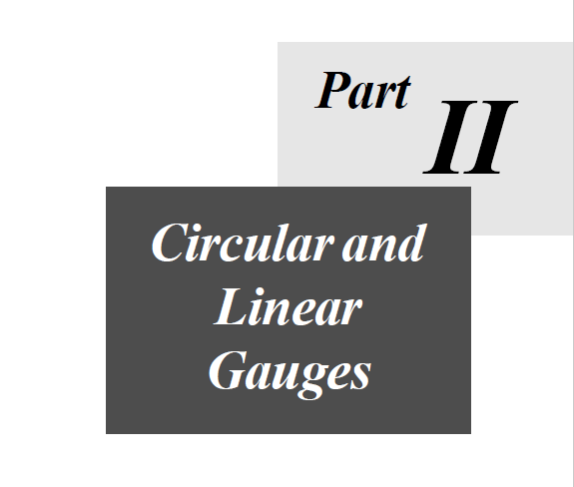

4

Creating Circular and Linear Gauges
Overview of the Guage Objects ■ Creating a Circular Guage ■ Creating a Linear Guage
Assigning Value to a Guage ■ Configuring the Guage Container

Circular and linear gauges are derived from the same code base and share many of the same classes and interfaces. Once you learn how to create one type of gauge, it is a simple matter to create the other type. This chapter describes how to create circular and linear gauges. The remaining chapters in Part II of this guide show how to configure a gauge.

4.1 Overview of the Gauge Objects
The following diagram shows the inheritance for JCServerGauge objects.

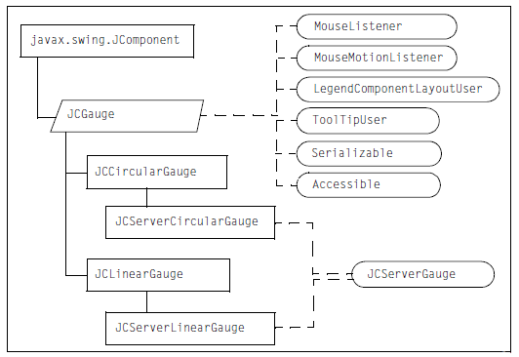
Figure 47 Object inheritance for circular and linear gauges

JCGauge is an abstract class that encapsulates the properties and methods required to set up a generic gauge, including adding a header, footer, legend, as well as indicators, needles, ranges, and tick objects. It implements the following interfaces: MouseListener, MouseMotionListener, LegendComponentLayoutUser, ToolTipUser, Serializable, and Accessible.

JCCircularGauge extends JCGauge. JCServerCircularGauge in turn extends JCCircularGauge and implements the JCServerGauge interface. JCServerCircularGauge defines the properties and methods required to create a circular gauge.

JCLinearGauge extends JCGauge. JCServerLinearGauge in turn extends JCLinearGauge and implements the JCServerGauge interface. JCServerLinearGauge defines the properties and methods required to create a linear gauge.

JCServerGauge is a JClass interface that specifies the methods required to define a server-side gauge or graph component. It also marks the gauge as a server-side gauge. This interface is implemented by the server-side gauges; you do not need to implement it.

4.2 Creating a Circular Gauge
When you create a circular gauge, the gauge uses default values for all its properties. To use the gauge to show values from your application, you set the value on a needle object or an indicator object. This value can be static, dynamically calculated by your application, or chosen by the user. A gauge can have multiple needles and indicators displaying different values.

After you set up a basic circular gauge, you can choose to configure its behavior and appearance. This section describes how to create a circular gauge object.

Figure 48 Circular gauge created by BasicSCircularGaugeServlet.java

4.2.1 Constructing a JCServerCircularGauge Object

The JCServerCircularGauge constructor can be used without arguments to create a gauge that contains a scale object, as well as some of the objects that can populate the gauge, that is the center, a needle, and a set of tick marks.

// Create a circular gauge
JCServerCircularGauge myGauge = new JCServerCircularGauge();

To access the default objects created with the gauge, use the following syntax:

// Access the default circular scale
JCCircularScale cscale = (JCCircularScale) myGauge.getScale();

// Access the default tick marks
JCCircularTick tick = (JCCircularTick)
myGauge.getScale().getTicks().elementAt(0);

// Access the default needle
JCCircularNeedle needle = ((JCCircularNeedle)
myGauge.getNeedles().firstElement());

// Access the default center
JCCenter center = myGauge.getCenter();

You can set the value to which the needle points on the scale and you can configure the default objects. You can also add other objects to the gauge. For more information, see Section 4.2.2, “Next Steps,” on page 87.

The JCServerCircularGauge constructor can also be used with one of two possible parameters: createScale or gaugeType. These parameters are described in the following sections.

4.2.1.1 Controlling Object Creation

The no-arguments constructor creates a set of default objects. If you would rather create a gauge with only the default scale object, you can specify the createScale parameter in the JCServerCircularGauge constructor. The createScale parameter is a boolean that determines whether or not a scale object is created. When in use, no other default objects are constructed.

For example:

// Create a circular gauge with a scale object only
JCServerCircularGauge myGauge = new JCServerCircularGauge(true);

If the value is false, an empty gauge object is constructed.

4.2.1.2 Specifying the Type of Circular Gauge

By default, a circular gauge is a complete circle. If you want to use only a portion of a circle, you can specify the gaugeType parameter in the JCServerCircularGauge constructor. The values for the gaugeType parameters are listed in the table that follows the code examples. When this parameter is in use, no default objects are constructed with the gauge.

For example:

// Create a circular gauge that spans degrees 0 through 180
JCServerCircularGauge myGauge = new JCServerCircularGauge
(JCCircularGauge.GaugeType.TOP_HALF_CIRCLE);

Alternatively, you can first create a gauge with the default objects, and then set the gaugeType property. For example:

// Create a circular gauge with default objects
JCServerCircularGauge myGauge = new JCServerCircularGauge();

// Set the gauge type
myGauge.setGaugeType(JCCircularGauge.GaugeType.TOP_HALF_CIRCLE);

The gaugeType property takes an enumeration. The following table shows the start and stop degrees, the enumeration, and a picture of how the gauge might look.
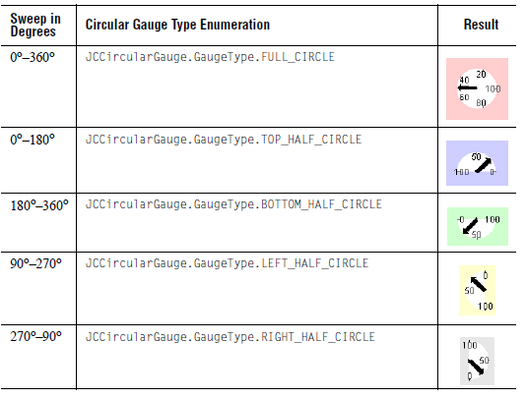
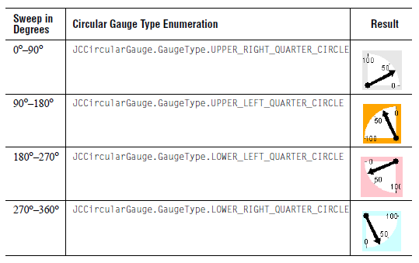
You can create a circular gauge with a different sweep than the predefined types. To create a custom sweep, specify a scale with a start and stop angle for the range you need. For more information, see Section 5.4.2, “Setting Start and Stop Angles,” on page 97.

4.2.2 Next Steps

After you create a gauge, you can assign a value to its default needle (if created). You can also add additional needles and indicators, each with their own value. See Section 4.4, “Assigning Values to a Gauge.”

To configure the default components of a circular gauge or to add these components, you can choose from the following tasks:

- Chapter 5, “Defining the Scale”
- Chapter 6, “Defining Ticks and Tick Labels”
- Chapter 7, “Defining Indicators and Needles”
- Chapter 10, “Defining the Center Object in a Circular Gauge”

To display optional components on the gauge, you can choose from the following tasks:

- Chapter 8, “Defining Text Components”
- Chapter 9, “Defining Ranges”
- Chapter 12, “Adding Hyperlinks to Gauge Components”

To display the finished gauge in a browser, see Section 1.3, “Displaying a Gauge or Graph in a Browser.”

4.3 Creating a Linear Gauge
When you create a linear gauge, the gauge uses default values for all its properties. To show values from your application in the gauge, you set a value on a needle object or an indicator object. This value can be static, dynamically calculated by your application, or chosen by the user. A gauge can have multiple needles and indicators displaying different values.

After you set up a basic linear gauge, you can choose to configure its behavior and appearance. This section describes how to create a linear gauge object.

Figure 49 Linear gauge

4.3.1 Constructing a JCServerLinearGauge Object

The JCServerLinearGauge constructor can be used without arguments to create a linear gauge that contains a scale object, as well as some of the objects that populate the gauge, that is a needle and a set of tick marks.

// Create a linear gauge
JCServerLinearGauge myGauge = new JCServerLinearGauge();

To access the default objects created, use the following syntax:

// Access the default linear scale
JCLinearScale scale = (JCLinearScale) myGauge.getScale();

// Access the default tick marks
JCLinearTick tick = (JCLinearTick)
myGauge.getScale().getTicks().elementAt(0);

// Access the default needle
JCLinearNeedle needle = ((JCLinearNeedle)
myGauge.getNeedles().firstElement());

You can set the value to which the needle points on the scale and you can configure the default objects. You can also add other objects to the gauge. For more information, see Section 4.3.2, “Next Steps,” on page 89.

Alternatively, you can provide a createScale parameter to the JCLinearGauge constructor. See the next section, “Controlling Object Creation.”

4.3.1.1 Controlling Object Creation

The no-arguments constructor creates a set of default objects. If you would rather create a gauge with only the default scale object, you can specify the createScale parameter in the JCServerLinearGauge constructor. The createScale parameter is a boolean that determines whether or not a scale object is created. When in use, no other default objects are constructed.

For example:

// Create a linear gauge with a scale object only
JCServerLinearGauge myGauge = new JCServerLinearGauge(true);

If the value is false, an empty gauge object is constructed.

4.3.2 Next Steps

After you create a gauge, you can assign a value to its default needle (if created). You can also add additional needles and indicators, each with their own value. See Section 4.4, “Assigning Values to a Gauge,” on page 89.

To configure the default components of a linear gauge or to add these components, you can choose from the following tasks:

- Chapter 5, “Defining the Scale”
- Chapter 6, “Defining Ticks and Tick Labels”
- Chapter 7, “Defining Indicators and Needles”

To display optional components on the gauge, you can choose from the following tasks:

- Chapter 8, “Defining Text Components”
- Chapter 9, “Defining Ranges”
- Chapter 12, “Adding Hyperlinks to Gauge Components”

To display the finished gauge in a browser, see Section 1.3, “Displaying a Gauge or Graph in a Browser,” on page 26.

4.4 Assigning Values to a Gauge
You assign values by setting the value property for each needle object or indicator object associated with your gauge.

Note: This section uses JCAbstractNeedle, which is the superclass of JCCircularNeedle and JCLinearNeedle. In your own code, you should use JCAbstractNeedle where possible and cast to the appropriate subclass (JCCircularNeedle with circular gauges and JCLinearNeedle with linear gauges) where needed. This makes it easier to reuse code for both types of gauges.

Recall that the no-arguments constructor for the gauge objects automatically creates a needle. By default, the initial value of the needle is the minimum value on the scale. To specify the value of the needle, set the value property from JCAbstractNeedle and specify the value as a double.

For example, the following code points the needle at the value 4 on some scale.

// Get the preconstructed needle and set its value
JCAbstractNeedle needle =
((JCAbstractNeedle)myGauge.getNeedles().firstElement());
needle.setValue(4);

If you used one of the other gauge constructors, you first need to create a needle or indicator object. You can set the value as above, or you can include the initial value of the needle or indicator as a parameter in its constructor. For more information, see Chapter 7, “Defining Indicators and Needles,” particularly Section 7.5.1, “Updating the Value,” on page 123.

Needles and indicators point to their values on the scale. If you prefer the needles and indicators to point to the closest discrete integral value on the scale, set the gauge’s snapToValue property to true.

// Snap to closest integral value
myGauge.setSnapToValue(true);

4.5 Configuring the Gauge Container
You can specify the size and background properties of the container.

4.5.1 Setting the Initial Size of the Gauge

A gauge’s size is determined by the size of its container. You can set the initial size of the container using its size or preferredSize property. Gauges may be resized as long as the container layout manager permits it.

4.5.2 Setting the Background Color and Fill

To set the background color, set the background and opaque properties inherited from JComponent. You can also add an image, pattern, or gradient fill to the background by setting the fillStyle property. For more information, see Chapter 11, “Defining Background Fill Styles.”

Figure 50 Gauge with an image in background

5

Defining the Scale
Overview of the Scale Objects ■ Summary of Properties Used
Defining a Circular Scale ■ Configuring a Circular Scale
Defining a Linear Scale ■ Configuring a Linear Scale
Enabling User Interaction for Scale Values

A circular or linear gauge can have one scale object. The job of the scale object is to hold the information required to construct a scale – displaying the scale is the responsibility of the tick, range, indicator, needle, and text-based objects such as labels. These objects are described elsewhere in this guide. The only pieces of visual information in a scale object are the color and image (if any) used for the background of the scale. This chapter introduces the scale objects and describes how to create and configure a circular or linear scale.

5.1 Overview of the Scale Objects
The following diagram shows the inheritance for the scale objects. Each object is summarized below the diagram.

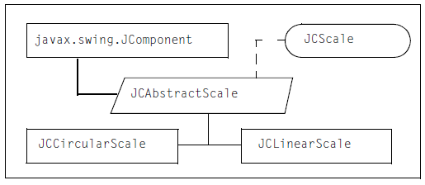
Figure 51Scale object inheritance

JCScale is the interface that represents a graduated scale. If you create a custom gauge object, you can use this interface to define a custom scale.

JCAbstractScale extends JComponent and implements JCScale. It encapsulates the minimum and maximum values for the scale, the direction in which the values on the scale increment, lists of ticks and ranges, and the zoom factor. Its pick() method is used for processing a scale value corresponding to the point at which a mouse click occurred.

JCCircularScale inherits the encapsulated values from JCAbstractScale and provides the implementation details required to create a circular scale from these properties. In addition, it defines a start angle, stop angle, and radius.

JCLinearScale inherits the encapsulated values from JCAbstractScale and provides the implementation details required to create a linear scale from these properties. In addition, it defines the orientation of the scale, that is, whether it is vertical or horizontal.

5.2 Summary of Properties Used
The following table summarizes the properties (grouped where appropriate) used in this chapter and provides links to the associated procedures. For a list of all the properties and methods available for scale objects, see the API documentation.

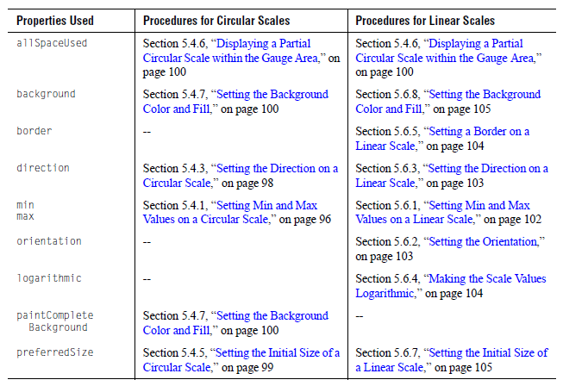
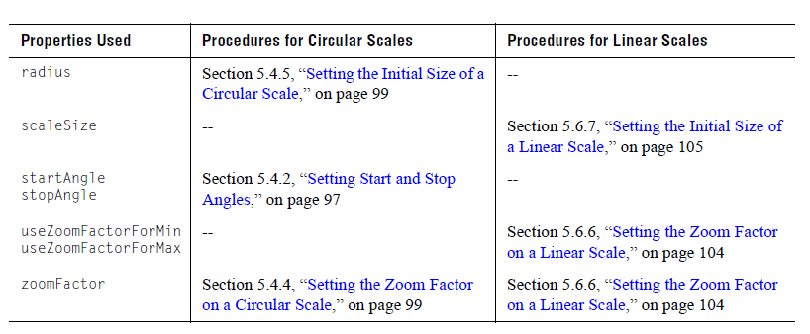

5.3 Defining a Circular Scale
This section describes how to get or create a circular scale.

Figure 52 A circular scale showing representative values for its properties

5.3.1 Accessing the Preconstructed Circular Scale Object

If you created your gauge using the no-arguments gauge constructor, you already have a scale object associated with the gauge.

The following example shows how to access the scale for a circular gauge.

// Access the default circular scale object
JCCircularScale scale = (JCCircularScale) myGauge.getScale();

The scale object has default values for all properties. You can change the value of any of the properties. For more information, see Section 5.4, “Configuring a Circular Scale.”

5.3.2 Constructing a JCCircularScale Object

If your gauge object does not have a scale object, you can create one using the JCCircularScale constructor. The constructors require the gauge parameter, that is, the scale needs to know its parent gauge object. All other properties are assumed to be default values.

// This scale belongs to the circular gauge called ‘myGauge’
JCAbstractScale scale = new JCCircularScale(myGauge);

The following example shows a complete constructor with default values for all the properties. To learn how to configure these properties, see Section 5.4, “Configuring a Circular Scale,” on page 96.

// Create a scale object and set its propertiesJCAbstractScale scale = new JCCircularScale(
myGauge,// the parent circular gauge object
JCAbstractScale.Direction.FORWARD, // direction (to increase values)
0,// min
100,// max
0,// startAngle (zero degree line)
360,// stopAngle (scale is a complete circle)
Color.yellow);// background

Now you need to set the scale on the gauge.

// Set the scale on the gauge called ‘myGauge’
myGauge.setScale(scale);

5.4 Configuring A Circular Scale
The following procedures describe the ways in which you can configure a circular scale:

- Setting Min and Max Values on a Circular Scale
- Setting Start and Stop Angles
- Setting the Direction on a Circular Scale
- Setting the Zoom Factor on a Circular Scale
- Setting the Initial Size of a Circular Scale
- Displaying a Partial Circular Scale within the Gauge Area
- Setting the Background Color and Fill

5.4.1 Setting Min and Max Values on a Circular Scale

The min and max properties specify the beginning and ending values for the scale. To set the values, you can either specify them in the JCCircularScale constructor or set the min and max properties.

For example:

// Set the minimum and maximum values for the scale
scale.setMin(5.0);
scale.setMax(25.0);

Multi-turn functionality (multiple turns required to move from min to max) is not supported.

5.4.2 Setting Start and Stop Angles

The start and stop angles specify the compass positions at which the min and max values are located. The convention for angular measurement in a circular scale defines east as the zero degree line. Angles increase in a counterclockwise direction, so that 90° is north, 180° is west, and 270° is south. Figure 53 shows these four main compass points.

Caution: The JCCircularScale start angle and stop angle replace the traditional start angle and sweep angle used in Java. For example, a scale that occupies a lower half circle has a start angle of 180° and a stop angle of 360°. Avoid specifying these angles as 180° with a sweep of 180°!

Figure 53 Diagram of a circular scale’s reference plane

To set the angles, you can either specify them in the JCCircularScale constructor or set the startAngle and stopAngle properties. Both properties are of type double.

For example:

// Set the start and stop angles of the scale
scale.setStartAngle(0);
scale.setStopAngle(180);

Figure 52 shows the start and stop angles used in the above example. The startAngle is zero degrees with a min value of zero, while the stopAngle is 180° with a max value of100. The values on the scale increment from zero to 100 in the same direction that the compass angle increases, that is, a counterclockwise direction. If you want, you can reverse the location of the minimum and maximum values and the direction in which the values increment on your scale. For more information, see Section 5.4.3, “Setting the Direction on a Circular Scale,” on page 98.

Note that a start angle may be greater than a stop angle. For example, Figure 54 shows a scale that begins at 90° (startAngle=90) and ends at zero degrees (stopAngle=0).

Figure 54 A case where the start angle is greater than the stop angle

5.4.3 Setting the Direction on a Circular Scale

By default, the values on the scale increment in the same direction as the angles, that is, counterclockwise. You can reverse the direction to display values incrementing in a clockwise direction.

To set the direction, you can either specify it in the JCCircularScale constructor or set the direction property. The valid constants are:

JCAbstractScale.Direction.FORWARD | Values increase counterclockwise, the min value is displayed at the startAngle, and the max value is displayed at the stopAngle. (default)
JCAbstractScale.Direction.BACKWARD | Values increase clockwise, the min value is displayed at the stopAngle, and the max value is displayed at the startAngle.
For example, to increment values in a clockwise direction, you could use the following code:

scale.setDirection(JCAbstractScale.Direction.BACKWARD);

Using Figure 52 as a point of reference, setting the direction to BACKWARD means that the values on the scale would be reversed, with zero displayed at the stopAngle of 180° and 100 displayed at the startAngle of zero degrees, and the values would increment clockwise across the scale.

Note: The constants COUNTERCLOCKWISE and CLOCKWISE can be used in place of FORWARD and BACKWARD, respectively. However, using FORWARD and BACKWARD enables you to switch between circular and linear gauge types without potential confusion in terminology.

5.4.4 Setting the Zoom Factor on a Circular Scale

By default, the scale is drawn so that it fills the gauge area. If labels, ticks, or other components need to be placed outside the scale, they may be cropped. To prevent cropping, set the setZoomFactor property.

For example, the following code places tick marks and their labels seemingly well outside a circular scale’s boundary:

// Sets the scale factor
scale.setZoomFactor(0.4);

// Places the tick marks and labels
tick.setInnerExtent(1.85);
tick.setOuterExtent(2.0);
tick.setLabelExtent(1.75);

In Figure 55, the left-side image shows a circular gauge with the zoom factor and tick settings used in the above example. Shrinking the scale to 40% of its original size has left room in the gauge container for the tick labels to be displayed. Otherwise, the labels would have been cropped out entirely.

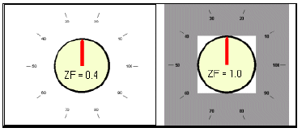
Figure 55 Placing ticks and their labels well outside the scale

For comparison, the right-side image shows a similar result obtained without setting a zoom factor (that is, with the default zoom factor of 1.0) and implementing a border instead. The white rectangle is the gauge area and the border is shown in gray. Note that the tick labels would have been cropped if no border were specified.

While the above results appear similar, if you intend to allow end users to resize the gauge, you should use a zoom factor rather than a border. When a gauge is resized, a border remains at its fixed number of pixels. Therefore there is a chance that components may be clipped at some sizes. Setting the zoom factor avoids clipping problems because the components are all resized proportionately.

5.4.5 Setting the Initial Size of a Circular Scale

To set the initial size of the scale container, set the preferredSize property from JComponent. The size of the scale relative to its container is controlled by the zoomFactor property. For more information, see Section 5.4.4, “Setting the Zoom Factor on a Circular Scale,” on page 99.

To get the current size of the scale, use the getRadius() method from JCCircularScale. If the scale has a zoom factor applied, the method returns the radius of the zoomed scale.

5.4.6 Displaying a Partial Circular Scale within the Gauge Area

By default, the center (origin) of the circular scale is anchored in the center of the gauge area. The origin is used as the anchor point even when part of the circular scale is not visible, such as when the scale is a half circle or quadrant. As a result, the scale may not appear to be centered in the gauge area.

To reduce the amount of extra space, set the scale’s allSpaceUsed property to true. In this case, the center of the drawing rectangle (that is, the rectangle that holds the partial scale) is anchored in the center of the gauge area.

// Use the center of the drawing rectangle to position the scale
scale.setAllSpaceUsed(true);

5.4.7 Setting the Background Color and Fill

To set the color of the scale, you can either define it in the constructor or set the scale’s background and opaque properties inherited from JComponent.

// Specify a background color and make it opaque
scale.setBackground(Color.blue);
scale.setOpaque(true);

You can also add an image, pattern, or gradient fill to the background by setting the fillStyle property. For more information, see Chapter 11, “Defining Background Fill Styles.”

Figure 56 Scale with background image of a stopwatch

By default, only the portion of the scale between its start and stop angles is filled. Any remaining portion retains the background color or fill specified for the gauge. If you want to fill the entire scale, set the scale’s paintCompleteBackground property to true.

For example:

scale.setPaintCompleteBackground(true);

Figure 57 Using paintCompleteBackground to determine how much of the scale is filled

5.5 Defining a Linear Scale
This section describes how to instantiate a linear scale.
Figure 58 Linear Scale

Figure 58 shows a simple linear scale in the context of a linear gauge. The scale has a minimum value of zero and a maximum value of 100, and it increments from left to right. In addition to the scale, the gauge in the figure has a triangularly-shaped indicator, a needle, two colored ranges, a set of labeled tick marks, and a collection of labels. Creating these additional components is described in the appropriate sections of this guide. To understand how to accommodate these components relative to the scale without losing information, see the discussion under Section 5.6.5, “Setting a Border on a Linear Scale.”

5.5.1 Accessing the Preconstructed Linear Scale Object

If you created your gauge using the no-arguments gauge constructor, you already have a scale object associated with the gauge. The following examples show how to access the scale for a linear gauge.

// Access the default linear scale object
JCLinearScale scale = (JCLinearScale) myGauge.getScale();

The scale object has default values for all properties. You can change the value of these properties. For more information, see Section 5.6, “Configuring a Linear Scale.”

5.5.2 Constructing a JCLinearScale Object

If your gauge object does not have a scale object, you can create one using either the JCLinearScale constructor. The constructor requires the gauge parameter, that is, it needs to know its parent linear gauge object. All other properties are assumed to be default values.

// This scale belongs to the linear gauge called ‘myGauge’
JCAbstractScale scale = new JCLinearScale(myGauge);

The following example shows a complete constructor with default values for all the properties. To learn how to configure these properties, see Section 5.6, “Configuring a Linear Scale.”

JCAbstractScale scale = new JCLinearScale(
myGauge,// the parent linear gauge object
JCAbstractScale.Direction.FORWARD, // direction (to increase values)
0,// min
100,// max
JCLinearScale.Orientation.HORIZONTAL, // orientation
Color.yellow);// background

5.6 Configuring a Linear Scale
The following procedures describe the ways in which you can configure a linear scale:
- Setting Min and Max Values on a Linear Scale
- Setting the Orientation
- Setting the Direction on a Linear Scale
- Making the Scale Values Logarithmic
- Setting a Border on a Linear Scale
- Setting the Zoom Factor on a Linear Scale
- Setting the Initial Size of a Linear Scale
- Setting the Background Color and Fill

5.6.1 Setting Min and Max Values on a Linear Scale

The min and max properties specify the beginning and ending values for the scale. To set the values, you can either specify them in the JCLinearScale constructor or set the min and max properties. Both properties are of type double.

For example:

// Specify the beginning and ending values for the scale
scale.setMin(5.0);
scale.setMax(25.0);

5.6.2 Setting the Orientation

A linear scale is oriented either horizontally (default) or vertically. To set the orientation, you can either specify it in the JCLinearScale constructor or set the orientation property. The valid constants are:

JCLinearScale.Orientation.HORIZONTAL | Scale is drawn horizontally. (Default)
JCLinearScale.Orientation.VERTICAL | Scale is drawn vertically.

For example:

// Specify that the scale is vertical
scale.setOrientation(JCLinearScale.Orientation.VERTICAL);

Figure 59 Linear scale in VERTICAL orientation

5.6.3 Setting the Direction on a Linear Scale

By default, values increase from left to right on a horizontal scale, and top to bottom on a vertical scale. If you want, you can reverse the direction. To set the direction, you can either specify it in the JCLinearScale constructor or set the direction property. Valid constants are:

JCAbstractScale.Direction.FORWARD | Values increase from left to right. (Default)
JCAbstractScale.Direction.BACKWARD | Values increase from right to left.

For example:

// Increment values from left to right
scale.setDirection(JCAbstractScale.Direction.FORWARD);

See Figure 58 for a linear scale in the forward direction.

5.6.4 Making the Scale Values Logarithmic

You can specify that this scale is logarithmic by setting the scale’s logarithmic property.

// Specify logarithmic values
scale.setLogarithmic(true);

5.6.5 Setting a Border on a Linear Scale

While a border is not mandatory, elements within the scale may appear to be clipped by the edges of the container if a border is not applied. To set a border, use the BorderFactory class to define the border and the setBorder() method to apply the border to the scale.

For example:

// Create and use a border around the scale object
Border border =
BorderFactory.createLineBorder(new Color(247, 255, 206), 20);
scale.setBorder(border);

You can also use createEmptyBorder() to assign different widths to all four sides. For more information, look up the BorderFactory class in the Java API documentation.

Figure 58 (the sample image in the section introduction) shows a linear gauge that uses the scale border defined in the above example. In the figure, the scale has a border 20 pixels wide in the same color as the scale background, which means the border is indistinguishable from the scale itself. Parts of the Direction, Orientation, Min, Max, and Ranges labels are in the scale’s border area. Note that the visible dark border in the image is part of the gauge, not the scale.

5.6.6 Setting the Zoom Factor on a Linear Scale

Your design may require that indicators, labels, and other elements be displayed outside of the scale area. You may be able to use a large border to accomplish this task, however, a more flexible approach is to use the zoomFactor property. A zoomFactor less than one applied to a horizontal scale compresses the height of the scale while leaving the width unchanged. Similarly, a vertical scale is compressed through the width, but not the height. To set the zoom factor, set the zoomFactor property.

For example:

// Compress the scale to 60% of its size
scale.setZoomFactor(0.6);

Figure 60 shows a linear gauge with the zoom factor used in the example. The scale is compressed to 60% of its original height, leaving room totalling 40% of the scale height evenly above and below the scale. Needles or ticks with inner extents less than one or with outer extents greater than one will display nicely even when the component is resized.
Figure 60 Linear gauge with zoom factor of 0.6

Note: Setting a zoom factor does not remove the necessity of setting a border to avoid the clipping of tick labels at the extremities of the scale. For more information, see Section 5.6.5, “Setting a Border on a Linear Scale,” on page 104.

For even more control, two boolean properties, useZoomFactorForMin and useZoomFactorForMax are available. By default, both of these are true, but if one of these is set to false, the zoom factor will not be applied to the appropriate min and max extent portions of the scale. If both useZoomFactorForMin and useZoomFactorForMax are set to false, the zoom factor is ignored. The zoom factor is not cumulative. If the zoom factor is later reset, it is applied to the original size of the scale, not the previously zoomed size.

5.6.7 Setting the Initial Size of a Linear Scale

To set the initial size of the scale container, set the preferredSize property inherited from JComponent. The size of the scale relative to its container is controlled by the zoomFactor property. For more information, see Section 5.6.6, “Setting the Zoom Factor on a Linear Scale,” on page 104.

To get the current size of the scale, use the getScaleSize() method from JCLinearScale. If the scale has a zoom factor applied, the method returns the size of the zoomed scale.

5.6.8 Setting the Background Color and Fill

To set the color of the scale, you can either define it in the constructor or set the scale’s background and opaque properties inherited from JComponent.

// Specify a background color and make it opaque
scale.setBackground(Color.blue);
scale.setOpaque(true);

You can also add an image, pattern, or gradient fill to the background by setting the fillStyle property. For more information, see Chapter 11, “Defining Background Fill Styles.”

5.7 Enabling User Interaction for Scale Values

Given a screen position in pixels (corresponding to an end-user’s mouse click), the pick() method returns the closest scale value wrapped in a JCGaugePickEvent object.

Events and Listeners in JCGauge

A pick event occurs when a JCGaugePickListener is installed on a gauge and the mouse button is pressed over a JCGauge object.

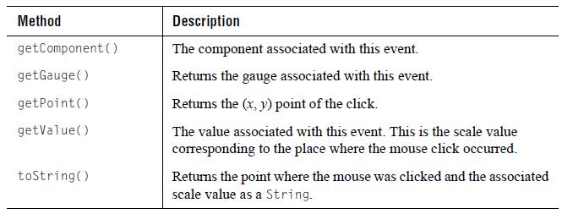

Interface JCGaugePickListener has one method, pick(). It is called on the object that has installed itself as a listener by invoking gauge.addPickListener().

6

Defining Ticks and Tick Labels
Overview of Tick Objects ■ Summary of Properties Used
Defining Ticks ■ Configuring Tick Marks ■ Configuring Tick Labels

Ticks are the graduations found on measuring devices. In the context of the JClass ServerGauge circular and linear gauges, a tick object describes how the ticks on the scale are generated, what they look like, how far apart they are, and how they are labelled. This chapter describes the tick objects and discusses how to configure tick marks and labels.

6.1 Overview of Tick Objects
The following diagram shows the inheritance for tick objects.

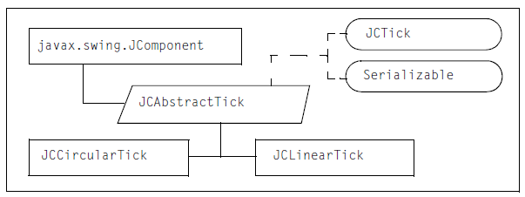
Figure 61 Tick object inheritance

JCTick is the interface that defines a tick object. If you create a custom gauge object, you could implement this interface to define a custom tick object.

JCAbstractTick implements JCTick and extends JComponent. It encapsulates values for tick properties such as start, stop, and increment values, precision and draw properties, extents, and style information. It has methods that automatically calculate reasonable values for start, stop, and increment properties based on the associated scale, as well as the default precision value.

JCCircularTick inherits the encapsulated values from JCAbstractTick and provides the implementation details required to draw ticks on a circular scale.

JCLinearTick inherits the encapsulated values from JCAbstractTick and provides the implementation details required to draw ticks on a linear scale.

6.2 Summary of Properties Used
The following table summarizes the properties (grouped where appropriate) used in this chapter and provides links to the associated procedures. For a list of all the properties and methods available for tick objects, see the API documentation.

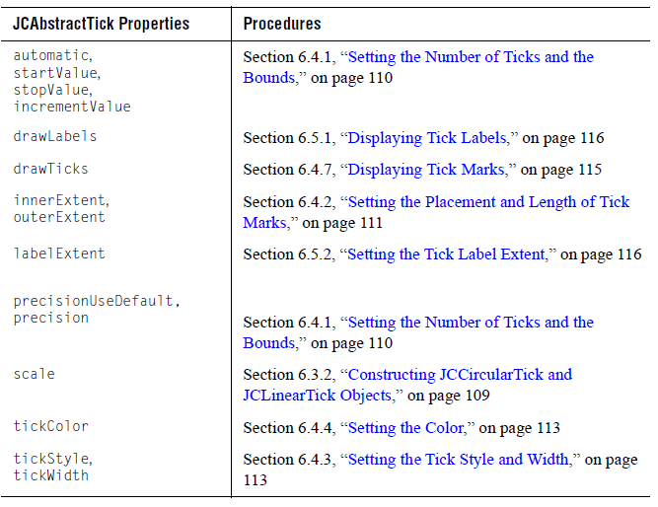

6.3 Defining Ticks
This section describes how to instantiate a tick object for a circular or linear scale. The examples use the tick object for circular scales, JCCircularTick. If you are creating a tick for a linear scale, substitute JCLinearTick. The properties for each are the same, only the implementation details differ.

6.3.1 Accessing the Preconstructed Tick Object

If you created a gauge using a no-arguments gauge constructor, you already have a tick object associated with the scale. The following example shows how to access the tick.

// Access the default tick object
// For a linear gauge, substitute JCLinearTick for JCCircularTick
JCCircularTick tick = (JCCircularTick)
myGauge.getScale().getTicks().elementAt(0);
The tick object has default values for all properties. You can change the value of any of the properties using the methods described under Section 6.4, “Configuring Tick Marks,” on page 110 and Section 6.5, “Configuring Tick Labels.”

6.3.2 Constructing JCCircularTick and JCLinearTick Objects

You can use a tick constructor when there is no preconstructed tick object or when you want to add additional tick objects. For example, using two tick objects means that you can have major and minor graduations on your scale, as shown in the gauges displayed on the right in Figure 62. To create tick objects, use the constructor appropriate for the type of gauge that you are creating and then add the tick to the scale.

The following example shows a complete tick constructor with the values specified for all properties. To learn how to configure these properties, see Section 6.4, “Configuring Tick Marks,” on page 110 and Section 6.5, “Configuring Tick Labels,” on page 116.

// Get the scale for the gauge "myGauge"
JCAbstractScale scale = myGauge.getScale();

// Create a tick object and associate it with the scale
// For a linear scale, substitute JCLinearTick for JCCircularTick
JCAbstractTick tick = new JCCircularTick(
scale,// the associated scale
true,// automatic (tick generation)
0,// startValue (taken from scale min value)
100,// stopValue (taken from scale max value)
10,// incrementValue (ignored unless automatic = false)
true,// precisionUseDefault
0,// precision (ignored unless precisionUseDefault=false)
2,// tickWidth
true,// drawLabels
true,// drawTicks
0.8,// labelExtent
0.85,// innerExtent
1.0,// outerExtent
Color.black, //tickColor (foreground)
JCTickStyle.LINE, // tickStyle
new Font("Helvetica", Font.BOLD, 18), // font
Color.black); // fontColor

Now add the tick object to the scale specified in the constructor.

// Add the tick to the scale associated with ‘myGauge’
scale.add(tick);

The tick is added to the list of tick objects maintained by the scale object. Recall that components are drawn on the gauge in the reverse order in which they are added. For more information, see Section 1.4.1, “How Components are Rendered on a Gauge,” on page 28.

6.4 Configuring Tick Marks
This section describes how to configure the marks used on the scale, including how many and what they look like. The following figures illustrate a variety of tick styles (with labels) displayed on circular and linear gauges.

Figure 62 Tick objects and associated labels on an assortment of circular (left) and linear (right) gauges

The following sections describe how you can configure tick marks:
      - Setting the Number of Ticks and the Bounds
      - Setting the Placement and Length of Tick Marks
      - Setting the Tick Style and Width
      - Setting the Color
      - Creating a Custom Tick Style
      - Connecting Tick Marks
      - Displaying Tick Marks

6.4.1 Setting the Number of Ticks and the Bounds

Tick marks are normally required at constant increments along a scale. The tick object uses the minimum and maximum values from the associated scale, plus the value of the precision property in the tick object, to determine how many marks to display on the scale and where the marks start and stop. You can choose to specify these values yourself. For example, in Figure 62 the bottom left gauge in both the circular and linear gauge examples show tick marks limited to a portion of the entire scale.
To set the number of ticks, you need to set the automatic property to false and then specify values (as doubles) for the startValue, stopValue, and incrementValue properties. You can either specify these properties in the tick constructor or set the properties after the tick is created.

For example:

// Tell the tick object that you will define the number of ticks
tick.setAutomatic(false);

// Specify the values on the scale where the marks start and stop
tick.setStartValue(0.0);
tick.setStopValue(100.0);

// Specify the value between ticks
tick.setIncrementValue(10.0);

If you are also displaying labels, you should verify that the default precision value is still suitable for the number of tick marks that you are displaying. The precision property affects the number of labels that can be displayed because it affects the width of the label. For example, a precision that allows for three decimal places to be displayed on the tick labels creates wider labels than when integers are displayed. Wider tick labels will be fewer in number compared to the same scale with narrower tick labels.

To recalculate a reasonable precision value based on your specified startValue, stopValue, and incrementValue, you can use the nicePrecision() method from the JCNumberUtil class, which resides in com.klg.jclass.util. Alternatively, you can set the precision property. For more information, see Section 6.5.3, “Setting the Precision Used for Values in Tick Labels,” on page 117.

6.4.2 Setting the Placement and Length of Tick Marks

The tick object has methods to calculate automatically the placement and length of the tick marks. You can configure the placement or length using the extent properties of the tick object. The values for the extent properties are doubles that represent fractions of the size of the scale. This means that if the gauge is resized, the tick marks will adjust proportionately to suit the size of the scale. For background information on extents, see Section 1.4.2, “Sizing Components Using Extent Parameters,” on page 29.

To specify the placement (that is, where to start drawing the marks), you set the innerExtent property. The length is specified indirectly using the outerExtent property, which sets where to stop drawing the marks. You can either specify these extent properties in the tick constructor or set the innerExtent and outerExtent properties.

For example:

// Start drawing the mark at 90% (see below for explanation)
tick.setInnerExtent(0.9);
// Stop drawing the mark at 100% (the edge of the scale)
tick.setOuterExtent(1.0);

For circular scales, the extent values represent fractions of the radius of the scale. Tick marks are drawn radially outward from the center of the scale to the circumference. Using the above example, a mark is placed at a distance away from the center of the scale that represents 90% of the scale’s radius (inner extent). The mark ends at 100% of the scale radius (outer extent), which is the circumference of the scale. The length of the mark is inferred to be 10% of the radius of the scale (100-90=10).

Figure 63 Tick marks in a circular scale

For horizontal linear scales, the extent values represent fractions of the scale’s height. Tick marks are drawn from top to bottom. Using the extents values in the above example, a mark is placed at a distance away from the top edge that represents 90% of the scale’s height (inner extent). The mark ends at 100% of the scale’s height (outer extent), which is the bottom edge of the scale. The length of the mark is inferred to be 10% of the height of the scale (100-90=10). The following image has two sets of tick marks with different inner extents.
Figure 64 Two sets of tick marks in a linear scale with different inner extents

On a vertical linear scale, the extent values are fractions of the scale’s width. Tick marks are drawn from left to right.

If the value of innerExtent greater than or equal to the outerExtent, no ticks are drawn. However, the preferred way of hiding tick marks is to set the drawTicks and drawTicks properties to false. For more information, see Section 6.4.7, “Displaying Tick Marks,” on page 115.

Tick Marks that Extend Outside the Scale

If your tick marks extend outside the scale, that is, at extents less than 0 or greater than 1.0, and you allow the scale to be resized, the outer extents of the tick marks may be clipped. To avoid clipping the marks, you can set the zoomFactor property of your scale object to be less than 1.0. For more information, see Section 5.4.4, “Setting the Zoom Factor on a Circular Scale,” on page 99 or Section 5.6.6, “Setting the Zoom Factor on a Linear Scale,” on page 104.

Alternatively, you can increase the dimensions of the scale’s borders to ensure that there is enough space to hold the tick marks. For more information, see Section 5.6.5, “Setting a Border on a Linear Scale,” on page 104.

6.4.3 Setting the Tick Style and Width

You can choose from a selection of predefined tick styles or create your own. By default, the tick style is LINE and the width is 2 pixels. You can adjust the width to make the line thinner or thicker. If you choose a style other than LINE, you need to set the width to a value that is greater than the default so that the shape displays well.

To set a tick style, you can either specify it in the tick constructor or set the tickStyle property. The valid constants are: JCTickStyle.CIRCLE, JCTickStyle.DIAMOND, JCTickStyle.LINE (default), JCTickStyle.RECTANGLE, JCTickStyle.REVERSE_TRIANGLE, and JCTickStyle.TRIANGLE.

To set the width, you can either specify it in the tick constructor or set the tickWidth property, which takes a double.

For example:

// Set the tick style and adjust the width of the mark
tick.setTickStyle(JCTickStyle.TRIANGLE);
tick.setTickWidth(3);

To define your own tick style, see Section 6.4.5, “Creating a Custom Tick Style,” on page 114.

6.4.4 Setting the Color

By default, tick marks are black. To change the color, you can either set it in the tick constructor or set the tickColor property. Specify the value as a Color object.

For example:

// Set the color of the tick
tick.setTickColor(Color.white);

6.4.5 Creating a Custom Tick Style

You can specify your own tick style in the same way that you create any Rectangle, that is, you use two arrays to define the shape, one for the x coordinates and one for the y coordinates. The layout algorithm assumes that the center of the tick mark’s bounding rectangle is at (0, 0). To set a custom tick style, you can either subclass the JCTickStyle object, which creates a named style, or use the JCTickStyle constructor to define your (x,y) coordinate pairs.

Subclassing JCTickStyle

The following code snippet creates a style called NOTCHED_RECTANGLE by creating a subclass of JCTickStyle and defining the shape using arrays of int values. You can see this custom tick mark in Figure 62; refer to the bottom right gauge in the circular gauge examples.

// Create a custom tick style by extending JCTickStyle
import com.klg.jclass.gauge.JCTickStyle;
public class MyTickStyle extends JCTickStyle {
public static final JCTickStyle NOTCHED_RECTANGLE = new JCTickStyle(
new int[] {-10, -2, 0, 2, 10, 10, 2, 0, -2, -10},
new int[] { 3, 3, 1, 3, 3, -3, -3, -1, -2, -2},
10);
}

To use the new tick style, pass the custom tick style to the setTickStyle() method.

// Use the custom tick style MyTickStyle.NOTCHED_RECTANGLE
tick.setTickStyle(MyTickStyle.NOTCHED_RECTANGLE);

Using the JCTickStyle Constructor

You can use the JCTickStyle constructor to define your own (x, y) coordinate pairs. First create arrays of ints for the coordinates, and then pass these arrays to the JCTickStyle constructor together with an int specifying the number of points. You can see this custom tick mark in Figure 62; refer to the bottom right gauge in the linear gauge examples.

// Create a custom tick style using the JCTickStyle constructor
int xpoints[] = {-100, 0, 100, 100, 0, -100};
int ypoints[] = { 0, 100, 100, -100, -100, 0};
int numpoints = 6;
tick.setTickStyle(new JCTickStyle(ypoints, xpoints, numpoints));

Note: The style is not named, so it is not as convenient to reuse as the custom style that was created by subclassing JCTickStyle.

6.4.6 Connecting Tick Marks

You can connect all the tick marks with a line. The line can connect the marks at their inner extent, outer extent, or run through some point in the marks. To draw a line through the tick marks, you need to create a range. The innerExtent and outerExtent properties of the range need to overlap one of the same extents provided for the tick object or fall between those extents. If you want all marks connected, the startValue and stopValue of the range need to be the same as those specified for the tick object.

For example, the following lines of code get the scale associated with a circular gauge, configure some of the properties of its default tick object, and then create a range that draws an arc that connects all the tick marks at their outer extents.

// Get the scale for the circular gauge ‘myGauge’
JCAbstractScale scale = myGauge.getScale();

// Get the default tick object for this scale
JCCircularTick tick = (JCCircularTick)scale.getTicks().elementAt(0);

// Tick marks extend from 80% of scale radius to its circumference
tick.setInnerExtent(0.8);
tick.setOuterExtent(1.0);

// Set the scale values at which the tick marks begin and end
tick.setStartValue(0.0);
tick.setStopValue(100.0);
tick.setIncrementValue(10.0);
tick.setAutomatic(false);

// Create a range to connect the tick marks at their outerExtent
JCAbstractRange range = new JCCircularRange(
Color.black,// background color of range
scale,// scale (same as tick)
0.98,// innerExtent (breadth is 2%)
1.0,// outerExtent (same as tick)
0,// startValue (same as tick)
100);// stopValue (same as tick)
// Add the range to the scale
scale.add(range);

For more information, see Section 9.4.1, “Setting the Breadth and Location of a Range,” on page 144.

6.4.7 Displaying Tick Marks

By default, tick marks are shown. To set the visibility of the tick marks, you can either specify it in the tick constructor or set the drawTicks property. The value is a boolean.

For example:

// Hide the tick marks
tick.setDrawTicks(false);

6.5 Configuring Tick Labels

By default, a tick label is displayed at each tick mark. These labels are the tick values formatted according to the tick’s precision. You can choose to hide these labels, adjust the precision, or create your own custom labels.

The following sections describe how you can configure tick labels:
- Displaying Tick Labels
- Setting the Tick Label Extent
- Setting the Precision Used for Values in Tick Labels
- Creating Custom Labels
- Placing Labels Outside of the Scale Bounds

6.5.1 Displaying Tick Labels

By default, tick labels are displayed on the scale. You can choose to hide labels on some or all of your tick objects. For example, in a scale with multiple tick objects, you can reduce clutter and improve comprehension by hiding labels for minor graduations.

To set the visibility of the tick labels, you can either specify this property in the tick constructor or set the drawLabels property. The value is a boolean.

For example:

// Hide the tick labels for the ‘minorTick’ tick object
minorTick.setDrawLabels(false);

6.5.2 Setting the Tick Label Extent

The labelExtent defines the position of the label. It works like a normal extent (see the discussion of innerExtent and outerExtent in Section 6.4.2, “Setting the Placement and Length of Tick Marks,” on page 111). By default, the labelExtent is 0.8, which for circular ticks is 80% between the center and the outside edge of the scale. For linear ticks in a horizontal scale, it is 80% between the top of the scale and the bottom of the scale. For linear ticks in a vertical scale, it is 80% between the left and right boundaries of the scale.

For example, the following code sets the label outside of the scale, 120% away from the center:

// Change the tick label extent
tick.setLabelExtent(1.2);

6.5.3 Setting the Precision Used for Values in Tick Labels

You can set the precision with which scale values are displayed on the tick labels. This is a formatting option only, the actual scale values are not affected.

Precision is controlled using the precisionUseDefault and precision properties of the tick object. The precisionUseDefault property is true by default, which means that the value of the precision property is automatically calculated.

Caution: You should be aware that changing the precision may introduce rounding issues that make the scale markings confusing. To avoid rounding issues, set the precision to a value appropriate for the range of values that the tick object represents.

To change the precision, set the precision parameter in the tick constructor to the desired value and also set the precisionUseDefault parameter to false. To set the precision after the tick object is constructed, set the precision property. This method automatically changes the precisionUseDefault property to false.

The precision property takes an int. The following table describes your options:

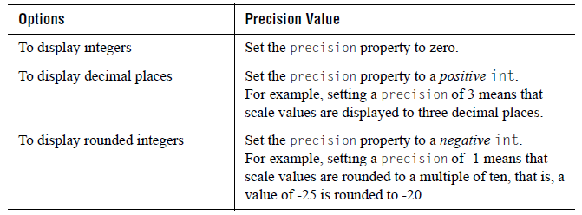

For example:

// Use only integers on the labels
tick.setPrecision(0);

If the precisionUseDefault property is subsequently set to true, the precision is recalculated and the result replaces the previously set precision value.

The precision property also controls how many ticks are generated. For more information, see Section 6.4.1, “Setting the Number of Ticks and the Bounds,” on page 110.

6.5.4 Creating Custom Labels

If you have labels that do not match scale values or textual labels such as “zero” or “hot,” you can use the JCLabelGenerator interface. It contains a single method, makeLabel(), which takes three parameters: a JCTick-based object, a scale value, and a GaugeConstraint1.

To create a custom tick labeling mechanism, you need to use the setLabelGenerator() method from JCAbstractTick and implement your own version of JCLabelGenerator.

For example, the following code creates a custom label generator that produces temperature values that include the unit of measurement, such as 20° C. The programmer uses an anonymous inner class to add an implementation of JCLabelGenerator to a tick object. The makeLabel() method is passed a reference to the tick object, the scale value for the tick mark, and a reference to the tick’s RadialConstraint; however, only the value parameter is illustrated in this example. The code adds the text “° C” to each generated value except 0°, where it supplies the word “zero” instead.

// create a label generator to mark
// the temperature values with their units
tick.setLabelGenerator(new JCLabelGenerator() {
public JComponent makeLabel(JCTick tick, double value,
GaugeConstraint constraint) {
String s = (value != 0) ? String.valueOf((int)value)
: "zero";
JCLabel label = new JCLabel(s + "\u00B0 C");
label.setToolTipText(s + "\u00B0 C");
return label;
}
});

6.5.5 Placing Labels Outside of the Scale Bounds

If your tick marks are close to or exceed the bounds of the scale, the associated labels may be clipped unless you take steps to accommodate them. You can either set the scale’s zoomFactor property or increase the scale border . For details, see the discussion under “Tick Marks that Extend Outside the Scale” in Section 6.4.2, “Setting the Placement and Length of Tick Marks,” on page 111.

7

Defining Indicators and Needles
Overview of the Indicator and Needle Objects ■ Summary of Properties Used
Defining Indicators ■ Defining Needles ■ Configuring Indicators and Needles
Adding User Interaction to needles

An indicator is a static marker that points to a single value on a scale. A needle is a type of indicator that allows user interaction. You can have multiple indicators and/or needles on a scale. This chapter describes the indicator and needle objects and explains how to configure them.

Note: In this chapter, wherever the word indicator is used, the information also applies to needles. When the word needle is used, the information is restricted to needle objects.

7.1 Overview of the Indicator and Needle Objects
The following diagram shows the inheritance for indicator and needle objects.

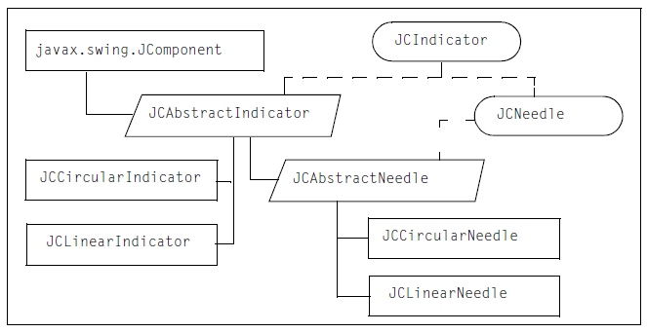
Figure 65 Indicator and needle object inheritance

Indicator Objects

JCIndicator is the interface that defines an indicator object. If you create a custom gauge object, you could implement this interface to define a custom indicator.

JCAbstractIndicator implements JCIndicator and extends JComponent. It encapsulates values for indicator properties such as the value it points to on the scale, style, width, and color of the indicator, as well as extents.

JCCircularIndicator inherits the values from JCAbstractIndicator and provides the implementation details required to draw indicators on a circular scale.

JCLinearIndicator inherits the values from JCAbstractIndicator and provides the implementation details required to draw indicators on a linear scale.

Needle Objects

JCNeedle extends the JCIndicator interface to define a needle object. It adds length, width, and style parameters for needles, and, more importantly, user interaction parameters. If you create a custom gauge object, you could implement this interface to define a custom needle.

JCAbstractNeedle extends JCAbstractIndicator and implements JCNeedle. It inherits the values from JCAbstractIndicator and encapsulates additional values for needle properties such needle-specific length, width, and style, as well as user interaction properties. It also provides methods for handling user interaction.

JCCircularNeedle inherits the values from JCAbstractNeedle and provides the implementation details required to draw needles on a circular scale.

JCLinearNeedle inherits the values from JCAbstractNeedle and provides the
implementation details required to draw needles on a linear scale.

7.2 Summary of Properties Used
The following table summarizes the properties (grouped where appropriate) used in this chapter and provides links to the associated procedures. For a list of all the properties and methods available for indicator and needle objects, see the API documentation.
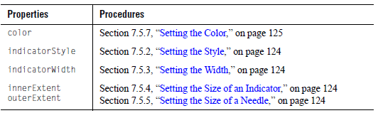

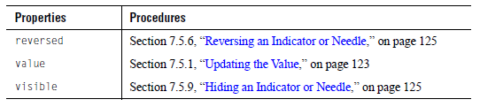

7.3 Defining Indicators
You can add one or more indicators to your gauge.

7.3.1 Constructing JCCircularIndicator or JCLinearIndicator Objects

You can an indicator using the JCCircularIndicator or JCLinearIndicator constructor; use the one that matches the type of gauge you are creating. The constructor requires the scale parameter, that is, it needs to know the scale to which it belongs. All other properties are assumed to be default values.

// Get the scale for the gauge "myGauge"
JCAbstractScale scale = myGauge.getScale();

// Create an indicator object and associate it with the scale. For a
// linear gauge, substitute JCLinearIndicator for JCCircularIndicator.
JCAbstractIndicator indicator = new JCCircularIndicator(scale);

The following example shows a complete indicator constructor with the default values for all properties. As you may recall, the properties are encapsulated in JCAbstractIndicator, so values are the same for circular and linear indicator objects.

// Create an indicator object and associate it with the scale
// For a linear gauge, substitute JCLinearIndicator
// for JCCircularIndicator
JCAbstractIndicator indicator = new JCCircularIndicator(
Color.black, // color (foreground)
15, // indicatorWidth
scale, // associatedScale
true, // visible
0.0, // innerExtent
1.0, // outerExtent
JCIndicatorStyle.RECTANGLE,// indicatorStyle
0); // value (default is min value of scale)

When you create a new indicator object, you need to add it to your gauge.

// Add the indicator to the gauge
myGauge.addIndicator(indicator);

The gauge manages its list of indicators by keeping them in a Vector.

7.4 Defining Needles
You can add one or more needles to your gauge. Recall that a needle object is created by default when you use one of the no-arguments gauge constructors.

7.4.1 Accessing the Preconstructed Needle Object

If you created your gauge using a no-arguments gauge constructor, you already have a needle object associated with the gauge. The following example shows how to access it.

// Access the default needle object
JCAbstractNeedle needle =
((JCAbstractNeedle)myGauge.getNeedles().firstElement());

The needle object has default values for all properties. For more information, see Section 7.5, “Configuring Indicators and Needles,” on page 123.

7.4.2 Constructing JCCircularNeedle or JCLinearNeedle Objects

If your gauge does not have a needle object, or if you want additional needles, you can create needles using the JCCircularNeedle or JCLinearNeedle constructor; use the one that matches the type of gauge you are creating. The constructor requires the scale parameter, that is, it needs to know the scale to which it belongs. All other properties are assumed to be default values.

// Get the scale for the gauge "myGauge"
JCAbstractScale scale = myGauge.getScale();

// Create a needle object and associate it with the scale
// For a linear gauge, substitute JCLinearNeedle for JCCircularNeedle
JCAbstractNeedle needle = new JCCircularNeedle(scale);

The following example shows a complete needle constructor with the default values for all properties. As you may recall, the properties are encapsulated in JCAbstractNeedle, so the values are the same for circular and linear needle objects.

// Create a needle object and associate it with the scale
// For a linear gauge, substitute JCLinearNeedle for JCCircularNeedle
JCAbstractNeedle needle = new JCCircularNeedle(
Color.black, // color (foreground)
10, // needleWidth
scale, // scale
JCAbstractNeedle.InteractionType.NONE, // interactionType
true, // visible
0.0, // innerExtent
1.0, // outerExtent
JCIndicatorStyle.ARROW, // needleStyle
0); // value (default is min value of scale)
When you create a new needle object, you need to add it to your gauge.

// Add the needle to the gauge at position zero
myGauge.addNeedle(needle, 0);

Specifying the position ensures that the needle is on top as the children are drawn in reverse order. The gauge manages its list of needles by keeping them in a Vector.

7.5 Configuring Indicators and Needles
You can update the value of an indicator or needle. You can also configure the style, color, length, width, and direction.

The following sections describe how you can configure tick marks:
- Updating the Value
- Setting the Style
- Setting the Width
- Setting the Size of an Indicator
- Setting the Size of a Needle
- Reversing an Indicator or Needle
- Setting the Color
- Hiding an Indicator or Needle
- Creating a Custom Indicator Style

7.5.1 Updating the Value

The value property specifies the value on the scale to which an indicator or needle points. By default, the initial value is the minimum value on the scale. Recall that you can specify the initial value of an indicator or needle in its constructor. To update the value after the object is constructed, set the value property inherited from JCAbstractIndicator, which takes a double.

For example, the following code changes the value of an existing indicator to 10.

// Change the value that the indicator points to
indicator.setValue(10);

Needle Values and Change Listeners

When a needle value changes, either programmatically or by user interaction, the needle notifies any change listeners that have been registered with the needle. Change listeners need to implement the javax.swing.event.ChangeListener interface and are registered with the needle using the addChangeListener() method. You can disable this mechanism by setting the needle’s sendEvents property to false. See also Section 7.6, “Adding User Interaction to Needles,” on page 126.

7.5.2 Setting the Style

The indicatorStyle property controls the style used for indicators and needles. There are seven possible built-in shapes, as shown in the following figure:

Figure 66 The built-in indicator shapes

To specify the indicator style, set it in the constructor or set the indicatorStyle property. The valid values are: JCIndicatorStyle.ARROW (needle default), JCIndicatorStyle.CIRCLE, JCIndicatorStyle.POINTER, JCIndicatorStyle.RECTANGLE (indicator default), JCIndicatorStyle.TAILED_ARROW, JCIndicatorStyle.TAILED_POINTER, and JCIndicatorStyle.TRIANGLE.

7.5.3 Setting the Width

The width of an indicator is measured in pixels. The width is controlled using the indicatorWidth property, or the needleWidth property in the case of a needle. To specify the width, set it in the constructor or set the indicatorWidth or needleWidth properties (as appropriate). Both properties are of type double.

7.5.4 Setting the Size of an Indicator

The indicator’s length is based on the associated scale and is set as a decimal fraction of the scale’s dimensions using its innerExtent and outerExtent properties. In the circular case, an indicator begins at the center of the circular scale and extends outwards. For example, if its outerExtent property is set to 1.0, the indicator’s tip lies on the circumference of the associated circular scale. In the linear case, an indicator’s extents are measured from the top of the gauge area when the orientation is horizontal, or from the left-hand edge when the scale is vertical.

7.5.5 Setting the Size of a Needle

As a subclass of JCAbstractIndicator, a needle has inner and outer extents, and because it is a subclass of JCAbstractNeedle, it has a length property as well. Setting the needle’s length is equivalent to setting its outer extent. If you want to have the needle begin away from the center of a circular gauge, set its inner extent to some positive value. The value is expressed as a ratio based on the radius. Likewise, you can offset a linear needle from the top of a linear horizontal scale by setting its inner extent. For a linear needle, the inner extent can be positive or negative, but if it is negative, you may need to set a border on the scale to prevent the needle from being clipped.

7.5.6 Reversing an Indicator or Needle

An indicator or needle that has longitudinal symmetry can be reversed. For example, the default JCIndicatorStyle.ARROW points outwards on a circular scale. To reverse the direction of an indicator, set the reversed property to true. The arrow points toward the center rather than to the circumference.

7.5.7 Setting the Color

By default, indicators and needles are black. To change the color, you can either specify it in the indicator or needle constructor or set the color property. The value is a Color object. For example:

// Set the color of an indicator
indicator.setColor(Color.green);

7.5.8 Setting the Background Fill

You can add an image, pattern, or gradient fill to the background by setting the fillStyle property. For more information, see Chapter 11, “Defining Background Fill Styles.”

7.5.9 Hiding an Indicator or Needle

By default, indicators and needles are displayed on the gauge. To hide a needle or indicator, set its visibility property to false.

7.5.10 Creating a Custom Indicator Style

You can provide your own indicator style if you require a custom shape. The method is the same as that used in Section 6.4.5, “Creating a Custom Tick Style,” on page 114. The simplest way is to use the JCIndicatorStyle constructor that allows you to define a new shape. If you want to keep your new indicator styles for general reuse as class constants, extend JCIndicatorStyle and define a shape as arrays of coordinate points using the same format as you would for java.awt.Rectangle. Here is an example:

import com.klg.jclass.swing.gauge.JCIndicatorStyle;

public class MyIndicatorStyle extends JCIndicatorStyle {
// Create a needle in the form of a diamond using these array values
public static final JCIndicatorStyle DIAMOND = new JCIndicatorStyle(
new int[] {0, 100, 200, 100},
new int[] {0, 100, 0, -100},
4);
}

The JCIndicatorStyle constructor that allows you to define a new shape has been used here to define the class constant.

The indicator is positioned so that the origin of the polygon is drawn at the indicator’s inner extent position and that the largest x direction extent projected onto the x-axis is drawn at the indicator’s outer extent position. The polygon is scaled accordingly.

Indicators can be sized however you want, but if the inner or outer extent specification causes the indicator to be drawn outside the component’s boundary the indicator will be clipped. You may increase the border size to compensate, but borders are not scaled when components are resized. Since the indicator’s length is defined as a fraction of its associated scale’s radius, it may still elongate past the border if the component is expanded too much. An alternative approach is to use the scale’s zoomFactor property, set to some value less than one. This has the effect of shrinking the scale so that its boundary is less than its true radius. An indicator whose length is greater than 1.0 appears to extend beyond the scale. Because it is really inside the scale’s actual boundary it can be resized without clipping.

7.6 Adding User Interaction to Needles
By default, interaction is disabled. If you set the needle’s interaction type, an end-user can select a new value on the gauge by mouse click. The first needle in the list responds. The needle value is updated to match the value selected by the user. For more information, see Section 7.5.1, “Updating the Value,” on page 123.

To add interaction to a needle, set the interactionType property of the needle. The following table summarizes the valid values:

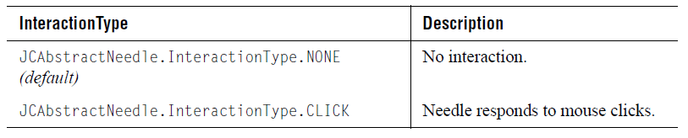
When user interaction is enabled, a mouse click on the gauge generates a pick event. For more information, see Section 5.7, “Enabling User Interaction for Scale Values.”

8

Defining Text Components
Overview of Text-based Objects ■ Summary of Properties Used
Defining Headers and Footers ■ Defining Legends ■ Defining Labels
Understanding the Constraint Mechanism

You can annotate your circular or linear gauge by adding a header, footer, legend, and labels. The header and footer can be used to add titles or other explanatory text to your gauge. The legend identifies elements displayed within a gauge.You can use labels to annotate anything else in a gauge. This chapter describes the behavior of these objects and explains how to configure them.

8.1 Overview of Text-based Objects
This section describes the object inheritance for the header, footer, labels, and legend.

Header, Footer, and Labels

By default, the header, footer, and labels are JCLabel objects, but they can be any JComponent. The following diagram shows the object inheritance for JCLabel.

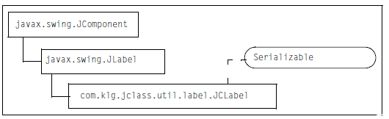
Figure 67 JCLabel object inheritance

A JCLabel object can display text, an image, or both. By default, labels are vertically centered in their display area. Text-only labels are left-aligned, while image-only labels are horizontally centered by default.

JCLabel extends JLabel and optionally makes it threadsafe by defining its own threadsafe user interface layer, JCLabelUI. By default, JCLabel uses the normal non-threadsafe JLabel UI. To use the threadsafe UI, set the system variable jclass.server.useAlternativeLabelUI to true. This tells JCLabel to use the threadsafe JCLabelUI instead of the default JLabel UI.

If you need a particular look-and-feel, you can define your own UI class and tell JCLabel to use it instead. To set a custom UI class, set the static property alternativeLabelUIClass to the appropriate class. The specified class must be a subclass of javax.swing.plaf.LabelUI.

JCLabel supports HTML text. However, when using the threadsafe JCLabelUI, occasionally the text may render in the wrong font or be positioned incorrectly because the HTML viewer itself is not thread-safe.

Labels and Constraints

The size and position of the header and footer are controlled by properties. Labels, however, are positioned on the gauge using a constraints mechanism. The following diagram shows the object inheritance for the constraint and layout objects.

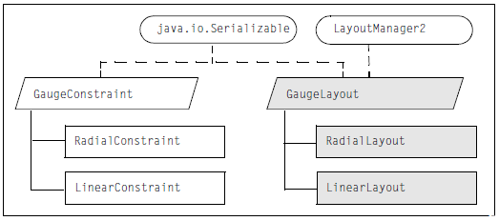
Figure 68 Constraint and layout objects inheritance for label placement

GaugeConstraint is an abstract class that outlines the properties and methods required to describe how components can be placed on a gauge relative to the gauge. It implements the Serializable interface.

RadialConstraint extends GaugeConstraint and provides the properties and methods required to describe how a component should be placed in relation to a circular gauge.

LinearConstraint extends GaugeConstraint and provides the properties and methods required to describe how a component should be placed in relation to a linear gauge.

GaugeLayout is an abstract class that outlines properties and methods to place a label that uses a constraint. It implements the LayoutManager2 and Serializable interfaces. RadialLayout extends GaugeLayout and is used for components that lay out their child components in a circular manner, such as JCCircularScale, JCCircularTick and JCGaugeArea (when it is a child of JCCircularGauge). LinearLayout extends GaugeLayout and is used for components that lay out their child components in a linear fashion, such as JCLinearScale, JCLinearTick and JCGaugeArea (when it is a child of JCLinearGauge). Constraints are used in conjunction with a layout manager and are supplied when adding child components to a parent with the corresponding layout. For example, when adding a label to JCCircularScale, you use a RadialConstraint to position the label within the scale because JCCircularScale uses a RadialLayout. For more information, see Section 8.6, “Understanding the Constraint Mechanism,” on page 137.

Legend

The following diagram shows the inheritance for the legend objects.

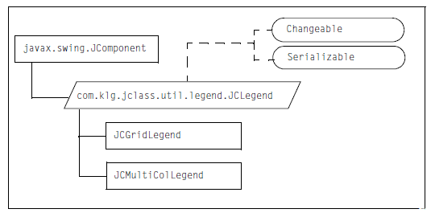
Figure 69 Legend objects inheritance

JCLegend is an abstract class that outlines the properties and methods required to create a legend. It implements the Changeable and Serializable interfaces.

JCGridLegend extends JCLegend and provides properties and methods to create a single column legend.

JCMultiColLegend extends JCLegend and provides properties and methods to create a legend with multiple columns.

8.2 Summary of Properties Used
The following table summarizes the properties (grouped where appropriate) used in this chapter and provides links to the associated procedures. For a list of all the properties and methods available for text components, see the API documentation.

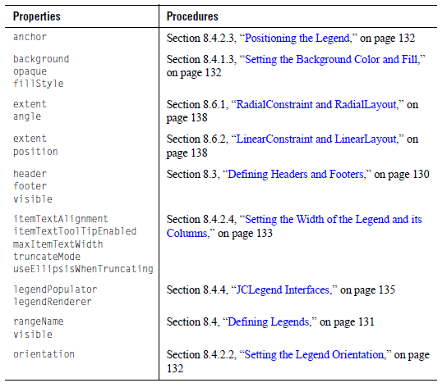

8.3 Defining Headers and Footers
When you create an instance of a gauge object, the gauge creates a header and a footer as JCLabel objects. By default, the header and footer are hidden and contain no text.

To show the header and footer, set their Visible properties to true.

// Show the header and the footer
myGauge.getHeader().setVisible(true);
myGauge.getFooter().setVisible(true);

To add text, set the text property of the JCLabel.

// Supply the header with text
JCLabel label= (JCLabel)myGauge.getHeader();
label.setText("Header text");

The gauge calculates the size and position of the header and footer automatically. You can override the default size or position. For more information, see Section 8.7, “Positioning Elements on the Gauge Object.”

If you want to create a custom header or footer, use the methods setHeader() and setFooter() and specify which JComponent to use.

8.4 Defining Legends
When you create an instance of a gauge object, a legend object is created automatically. The default legend is a JCGridLegend object. By default, the legend is hidden.

To show the default legend, set its visible property to true.

// Show the legend
myGauge.getLegend().setVisible(true);

The default legend uses a DefaultLegendPopulatorRenderer to populate and render the legend. The legend items of the default legend correspond to the current list of ranges within the gauge scale.

Ranges have default names like range 0, range 1, and so on, which is what is displayed in the legend if the ranges are not named.

To specify a range name, set the range’s rangeName property to a String. For more information, see Chapter 9, “Defining Ranges.”

// Name a range
range.setRangeName("Danger zone");

8.4.1 Types of Legends

There are two types of legend objects: JCGridLegend (the default) for a single-column layout and JCMultiColLegend for a multiple-column layout. If these legends do not provide the desired functionality, you can configure the legend using the JCLegend Toolkit. For more information, see Section 8.4.3, “Creating Custom Legends,” on page 135.

8.4.1.1 Single-Column Legends

The classic single-column legend layout is provided by JCGridLegend. This is the default legend class used by JClass ServerGauge.

8.4.1.2 Multi-Column Legends

Multi-column legend layout is available using JCMultiColumnLegend. To use this class, follow these steps:

- Create an instance.
- Set the number of rows and columns.
- Set the legend property of the gauge to this instance.

For example:

JCMultiColLegend mcl = new JCMultiColumnLegend();
mcl.setNumColumns(2);
myGauge.setLegend(mcl);

This example creates a legend for the current gauge that has two columns. The number of rows depends on the number of items in the legend. To fix the number of rows, set the NumRows property. Both the number of rows and the number of columns are variable by default. To reset the number of rows and columns to a variable state after they have been fixed, call the appropriate set method with a negative value. If both the NumRows and NumColumns properties are set to fixed values, the legend will be of that exact size and will ignore any extra items.

8.4.1.3 Setting the Background Color and Fill

To set the background color, set the background and opaque properties inherited from JComponent.You can also add an image, pattern, or gradient fill to the background by setting the fillStyle property. For more information, see Chapter 11, “Defining Background Fill Styles.”

8.4.2 Configuring Legends

The legend is a JComponent, and all properties such as border, colors, font, and so on, apply.

8.4.2.1 Displaying Range Labels in the Legend

The default legend displays the current list of ranges. To omit a range from the legend, set the range’s visibleInLegend property to false.

8.4.2.2 Setting the Legend Orientation

Use the legend orientation property to lay out the legend horizontally or vertically.

8.4.2.3 Positioning the Legend

You can use the legend anchor property to specify where to position the legend relative to the JCGaugeArea. Valid values are: JCLegend.NORTH, JCLegend.SOUTH, JCLegend.EAST, JCLegend.WEST, JCLegend.NORTHWEST, JCLegend.SOUTHWEST, JCLegend.NORTHEAST, and JCLegend.SOUTHEAST. The default value is JCLegend.EAST.

To specify an absolute position for the legend, you set the LayoutHints property (inherited from JCGauge) and provide coordinates. For more information, see Section 8.7, “Positioning Elements on the Gauge Object.”

8.4.2.4 Setting the Width of the Legend and its Columns

If the legend text is very long, you may find that by default the legend becomes very wide, leaving proportionally less room for the gauge itself. You can improve the balance between gauge and legend by controlling the width of the legend. You have two choices for setting the width. You can set the width of the legend explicitly and allow the columns within the legend to be sized automatically, or you can set the column widths and allow the legend width to be calculated.

Specifying the Legend Width

To set the width of the entire legend, you set the LayoutHints property (inherited from JCGauge) and provide the width of the legend rectangle. For example, the following code snippet sets the width of the legend to 200 pixels:
myGauge.setLayoutHints(chart.getLegend(),
new Rectangle(Integer.MAX_VALUE, Integer.MAX_VALUE,
200, Integer.MAX_VALUE));

Integer.MAX_VALUE means that the dimension is dynamic. In the above example, there are no restrictions on the positioning of the legend or on the height dimension. For more information, see Section 8.7, “Positioning Elements on the Gauge Object.”

Specifying Column Widths

To set the width of columns within the legend, you set the maxItemTextWidth property from JCLegend and specify the width in pixels as a non-negative int. By default, the value is Integer.MAX_VALUE, which means the width is dynamic.

For example, the following code sets the width of each of the columns in the legend to be 100 pixels.
legend.setMaxItemTextWidth(100);

To specify different widths for columns in a multicolumn legend, you need to provide an
additional parameter that specifies the column number. For example, the following code
specifies column widths of 50, 100, and 75 pixels for consecutive columns in a three-column legend:
legend.setMaxItemTextWidth(50, 0);
legend.setMaxItemTextWidth(100, 1);
legend.setMaxItemTextWidth(75, 2);

Handling Truncated Text

Whichever way you choose to restrict the width of a legend, you can set properties to control what happens when the length of the text exceeds the width of a column. By default, column text is aligned with the leading edge of the column (for example, it is aligned left in a left-toright orientation). When text is truncated, the trailing text (the rightmost text in a left-to-right orientation) is hidden and an ellipsis is displayed in its place. You can modify this behavior by setting the JCLegend properties described below.

To change the text alignment, you set the itemTextAlignment property and specify the value using one of the following enumerations: SwingConstants.LEFT, SwingConstants.RIGHT, SwingConstants.CENTER, SwingConstants.LEADING (default), or SwingConstants.TRAILING. For example, the following code causes text to be right aligned for all columns except the second column (column 1), where the text is centered:

legend.setItemTextAlignment(SwingConstants.RIGHT);
legend.setItemTextAlignment(SwingConstants.CENTER, 1);

To change how the text is truncated, you set the truncateMode property. The following table shows the possible values followed by how the text would appear:
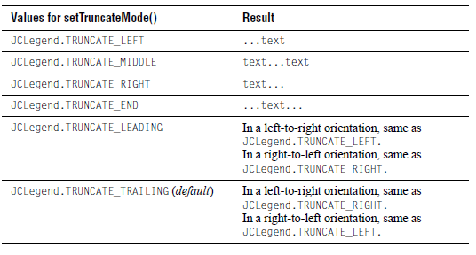

For example, the following code causes text to be truncated on the right for all columns, except for the third column (column 2), where the ends are truncated:

legend.setTruncateMode(JCLegend.TRUNCATE_RIGHT);
legend.setTruncateMode(JCLegend.TRUNCATE_END, 2);

To stop the ellipsis from being displayed, you set the UseEllipsisWhenTruncating property to false. There will be no visual indication that text is hidden. This property always applies to all columns.

You can also choose to display the entire legend item text in a tooltip whenever the mouse hovers over a legend item. The tooltip appears whether or not the legend text is truncated. To activate the tooltips, set the ItemTextToolTipEnabled property to true. This property always applies to all columns.

8.4.3 Creating Custom Legends

If you need a legend that itemizes other things, like needles or ticks, you can use the JCGaugeLegendEntry interface. Each item to be included in the legend is wrapped in an object that implements this interface. These items are then aggregated into a List. You can then create a new instance of DefaultLegendPopulatorRenderer with the list.

For example:

List items = ...//create your list of items
JCLegend legend = myGauge.getLegend();
DefaultLegendPopulatorRenderer legPop =
new DefaultLegendPopulatorRenderer(legend, items);
legend.setLegendPopulator(legPop);
legend.setLegendRenderer(legPop);

The JCGaugeLegendEntry interface includes methods for getting the legend color, legend label, and visibility properties. For more information, look up JCGaugeLegendEntry in the API documentation.

Note: JCAbstractRange implements JCGaugeLegendEntry and therefore the scale’s list of ranges is a valid legend item list.

8.4.4 JCLegend Interfaces

There are two interfaces associated with JCLegend. JCLegendPopulator is an interface implemented by classes that want to populate a legend with data, and JCLegendRenderer is an interface implemented by a class that wants to help render the legend.

DefaultLegendPopulatorRenderer implements both interfaces and provides a built-in mechanism for itemizing range objects in a legend.

8.4.5 Enabling User Interaction in Legends

You can use the pick mechanism to react to user clicks on legend items. The JCGaugePickEvent passed to the pick() method of a pick listener has an info property that gets filled with extra information when the situation warrants it. When a user clicks on a legend term, the info field is filled in with the legend item object. You can query this info object to detect which item has been selected.

Note: The legend title cannot be picked; its info property remains null.

For more information, see Section 5.7, “Enabling User Interaction for Scale Values,” on page 106.

8.5 Defining Labels
You can place any number of labels anywhere within the boundaries of the gauge area using a gauge’s addLabel() method, which in turn uses a RadialConstraint or a LinearConstraint. By default, a label is a JCLabel object. Labels have user-controllable text, position, background and foreground color, images, and borders.

The RadialConstraint class, whose constructor is RadialConstraint(JCGauge gauge, double extent, double angle), lets you specify a label’s position by giving a distance from the center of the scale and an angle. The constructor for a linear constraint is LinearConstraint(JCGauge gauge, double extent, int position), which lets you specify a label’s position by giving the extent in the transverse direction to the scale and a position along the scale in pixels. For more information, see Section 8.6, “Understanding the Constraint Mechanism,” on page 137.

Note that there is an automatic mechanism for providing numeric labels on tick objects or for specifying labeled ticks in user-specified formats. For more information, see Section 6.5, “Configuring Tick Labels,” on page 116.

You can choose a location within the gauge area by specifying the location of the center of the rectangle containing the RadialConstraint or LinearConstraint class.

You can use HTML tags to display text with mixed fonts and multiple lines of text. Set a font
using the <font> tag and the color using color = HTMLcolorValue within the tag. If you are adding text to a circular gauge, you can do the following:
JCLabel l1 = new JCLabel("<html><font color=black>
Start Angle = 90\u00B0");
l1.setToolTipText("Start Angle = 90\u00B0");
gauge.addLabel(l1, new RadialConstraint(gauge, 0.60, 15), 0);

You can also control whether a label is drawn using its visible property, set a border, or set other properties inherited from JLabel.

Even though the method is called addLabel(), the method actually allows for any JComponent to be added in this fashion.

8.5.1 Aligning Text

The lines of text within a label can be either left-justified or centered. If text is not centered, it may appear that RadialConstraint is not positioning the text at the correct angle. In Figure 70 both text areas are aligned vertically, but it appears that the lower label is not vertically aligned. Here is the code that produces this layout:

JCLabel l1 = new JCLabel("<html><font color=black>
<P ALIGN=CENTER>Start Angle <br>= 0\u00B0");
l1.setToolTipText("Start Angle = 0\u00B0");
l1.setBorder(new BevelBorder(BevelBorder.RAISED));
myGauge.getGaugeArea().add(l1,
new RadialConstraint(gauge, 0.50, 90), 0);
JCLabel l2 = new JCLabel(
"<html><font color=black><P>Stop Angle <br>= 360\u00B0");
l2.setToolTipText("Stop Angle = 360\u00B0");
l2.setBorder(new BevelBorder(BevelBorder.RAISED));
myGauge.getGaugeArea().add(l2,
new RadialConstraint(gauge, 0.50, 270), 0);
Figure 70 If text is not centered it may appear to be placed at the wrong angle

The center of the label is place at the position indicated by the constraint.

8.5.2 Sample Code

The following code snippet shows the addition of a label positioned halfway from the center of a gauge to its circumference at an angle of 45°.

RadialConstraint rConstraint = new RadialConstraint(gauge, 0.50, 45)
JCLabel label = new JCLabel("Start Angle = 0");
label.setToolTipText("Start Angle = 0\u00B0");
myGauge.getGaugeArea().add(label, rContstraint, 0);

Usage is the same for a linear constraint. This one puts a label at (0, 0) on a linear scale:

JCLabel l0 = new JCLabel("<html><font color=black>0");
l0.setToolTipText("0 marks the spot!");
myGauge.getGaugeArea().add(l0, new LinearConstraint(gauge, 0.0, 0));

8.6 Understanding the Constraint Mechanism
JClass ServerGauge uses a constraint mechanism to place labels and other components on a gauge. RadialConstraint is used for circular gauges, while LinearConstraint is for linear gauges.

8.6.1 RadialConstraint and RadialLayout

Class RadialLayout uses an instance of RadialConstraint to position a component at a given angle and at a specified proportional distance from the center of the associated circular gauge. Thus, the gauge employs RadialConstraint classes to facilitate laying out gauge objects in such a way that the objects’ angular positions are maintained as the gauge is resized, as well as maintaining their proper radial proportions.

RadialConstraint supports the placement of any component on the gauge area, not just indicators, needles, ranges, and ticks. Usually these are labels used to annotate a circular gauge, but they can be any JComponent.

Constructors

RadialConstraint has a single constructor to which is passed a gauge, an extent, and an angle.
- The extent parameter specifies the radial distance for the placement of the component.
- The angle parameter specifies the angle.

The center of component’s bounding rectangle is placed on the gauge at the point defined by the two parameters. Typically an instance of RadialConstraint is passed via the addLabel() method in JCCircularGauge, which passes it to an add() method that knows how to use RadialLayout to position the component.

Here’s an example:

JCCircularGauge gauge = new JCCircularGauge();
JCLabel label = new JCLabel("<html>Pressure (lbs/in&sup2;)");
myGauge.addLabel(label, new RadialConstraint(gauge, 0.35, 90));

8.6.2 LinearConstraint and LinearLayout

Class LinearLayout uses an instance of LinearConstraint to position a component at a given extent and at a specified pixel distance from the origin of the linear gauge. Thus, the gauge employs LinearConstraint classes to facilitate laying out gauge objects in such a way that the objects’ relative positions are maintained as the gauge is resized.

It supports the placement of any component on the gauge area, not just indicators, needles, ranges, and ticks. Usually these are labels used to annotate a linear gauge, but they may be any JComponent, even another gauge.

Constructors

LinearConstraint has a single constructor which is passed a gauge, an extent, and a position. The extent parameter specifies the proportional distance from the top left of the rectangle enclosing the gauge. The distance is vertical for horizontal scales and horizontal for vertical scales, and is specified as a ratio of this distance to the height or width of the scale. The position parameter specifies the distance as an integer representing a percentage of the height or width from the top or left of the scale.

The center of the positioned component’s bounding rectangle is placed on the gauge at the point defined by these two parameters. Typically an instance of LinearConstraint is passed via the addLabel() method in JCLinearGauge, which passes it on an add() method that knows how to use LinearLayout to position the component.

Here’s an example:

JCLinearGauge gauge = new JCLinearGauge();
JCLabel label = new JCLabel("Pressure Point");
myGauge.addLabel(label, new LinearConstraint(gauge, 0.35, 90));

8.7 Positioning Elements on the Gauge Object
Each of the main gauge elements (header, footer, legend, and gauge area) has properties that control its position and size. While the gauge can automatically control these properties, you can also configure the following:
- positioning of any element
- size of any element

When the gauge controls positioning, it first allows space for the header, footer, and legend, if they exist (size is determined by contents, border, and font). The gauge area is sized and positioned to fit into the largest remaining rectangular area. Positioning adjusts when other gauge properties change.

Changing the Location and Size

To specify the absolute location and size of a gauge element, call setLayoutHints()
(inherited from JCGauge) with the object you wish to move and a rectangle containing its desired X and Y location, width, and height. If you desire any of those values to be calculated rather than set, make them equal to Integer.MAX_VALUE.

For example, the following code sets the legend to be 200 pixels wide and 300 pixels high and places the top-left corner of the legend at the x,y coordinate (0,150):

myGauge.setLayoutHints(legend, newRectangle(0,150,200,300));

Whereas this code allows the legend size to be dynamic, but places the legend at (0,150):

myGauge.setLayoutHints(legend, Rectangle(0,150,Integer.MAX_VALUE,Integer.MAX_VALUE, Integer.MAX_VALUE));

9

Defining Ranges
Overview of the Range Objects ■ Summary of Properties Used
Defining a Range ■ Configuring a Range ■ Creating an Offset Range in a Circular Gauge

You can add range objects to your circular and linear gauges. Ranges enable you to highlight sections of the scale that hold some meaning, such as a range of values that represents expected results. On circular scales, ranges are represented as slices (as in a pie chart) or arcs. On linear scales, a range is a rectangular bar that encompasses a set of consecutive values on the scale. This section describes the range objects, and then shows you how to add ranges and configure them.

9.1 Overview of the Range Objects
The following diagram shows the inheritance for range objects.

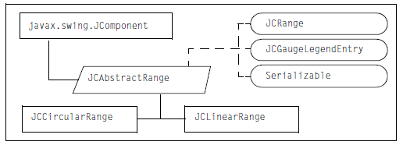
Figure 71 Range object inheritance

JCRange is the interface that represents a range. If you create a custom gauge object, you can use this interface to define a custom range.

JCAbstractRange extends JComponent and implements JCRange, JCGaugeLegendEntry, and Serializable. JCAbstractRange encapsulates the properties associated with a range, including the scale, the stop and start values of the range, the extents required to draw the range, the range name, and whether or not to include the range name in the legend. It also defines methods to set and get the values of these properties.

JCCircularRange extends JCAbstractRange. It inherits the properties encapsulated in JCAbstractRange and includes methods to draw a range on a circular scale.

JCLinearRange extends JCAbstractRange. JCLinearRange inherits the properties encapsulated in JCAbstractRange and includes methods to draw a range on a linear scale. It also enables the use of an image in the background of the range area.

9.2 Summary of Properties Used
The following table summarizes the properties (grouped where appropriate) used in this chapter and provides links to the associated procedures. For a list of all the properties and methods available for text components, see the API documentation.

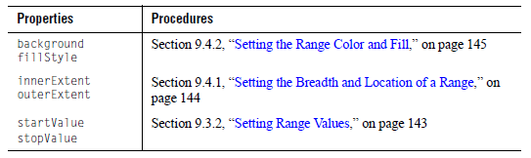

9.3 Defining a Range
This section describes how to create a range object. Figure 72 shows two range objects on a circular scale. The thinner one spans the entire scale and appears as the circumference of the scale. The thicker one spans the region between tick marks 20 and 80.

Figure 72 Using ranges to show the scale circumference and to highlight a portion of the scale

9.3.1 Constructing a JCCircularRange or JCLinearRange Object

The constructors require the scale parameter, that is, a range object needs to know the parent scale to which it belongs. All other properties are assigned default values.

// Create a range object and associate it with the scale
// For a linear gauge, substitute JCLinearRange for JCCircularRange
JCAbstractRange range = new JCCircularRange(myGauge.getScale());

The following example shows a complete constructor with default values for all the properties. To learn how to configure these properties, see Section 9.4, “Configuring a Range,” on page 144.

// Create a range object and associate it with the scale
// For a linear gauge, substitute JCLinearRange for JCCircularRange
JCAbstractRange range = new JCCircularRange(
Color.black, // background color of range
scale, // associated scale
0.0, // innerExtent of range area
1.0, // outerExtent (at the radius)
0, // startValue to begin the range
0); // stopValue (set > 0 to show the range)

Now you need to add the range to the scale specified in the constructor.

// Add the range to the scale associated with ‘myGauge’
scale.add(range);

Recall that components are drawn on the gauge in the reverse order in which they are added. Figure 73 shows the result of one such ordering. The circumference range is drawn first, followed in succession by the 20–80 range, the tick marks, the needle, and finally the center. For more information, see Section 1.4.1, “How Components are Rendered on a Gauge,” on page 28.

9.3.2 Setting Range Values

The startValue and stopValue properties control where the range begins on the scale and where it ends. By default, a range begins at the scale’s minimum value and ends at the scale’s maximum value.

To specify the span of the range, set the values in the constructor or set the startValue and stopValue properties. Both properties are of type double. The values should fall within the scale’s minimum and maximum values, unless you are purposely creating an offset range. For more information, see Section 9.5, “Creating an Offset Range in a Circular Gauge,” on page 146.

For example,

// Specify the start and end values of the range
range.setStartValue(20);
range.setStopValue(80);

9.4 Configuring a Range
You can change the color and breadth of the range. You can also choose to specify a fill for a range area.

9.4.1 Setting the Breadth and Location of a Range

The innerExtent and outerExtent properties control the breadth of the range, that is, the thickness of the band that represents the range, and for circular ranges, where that band is located in relation to the scale. As with indicators and needles, the values for the range extent properties are specified as a percentage of the scale’s radius; if the gauge is resized, the range retains its size proportionate to the scale.

In a linear range, the default values for the innerExtent and outerExtent properties cause the breadth of the range to cover the width of the scale in a vertical orientation or the height of the scale in a horizontal orientation.

In a circular range, the default inner extent is 0.0 and the default outer extent is 1.0. The following figure shows a circular range that spans the values 20 to 80 and uses the default extents.

Figure 73 A circular gauge with two ranges: a 20–80 range and a range marking the scale’s circumference

To specify different extent values, set the values in the constructor or set the innerExtent and outerExtent properties. Both properties are of type double. The values represent a percentage of the scale’s radius expressed as a decimal fraction.

For example, in Figure 73 the arc that marks the circumference of the scale is a range. The following code snippet shows how the range is defined.

// Specify the extents of the range after it has been instantiated
range.setInnerExtent(0.99);
range.setOuterExtent(1.01);

This range straddles the circumference (1.0) of the circular scale, starting just before the circumference (0.99) and extending the same distance past it (1.01). The breadth of the range is calculated to be 1.01 - 0.99 = 0.02, which means that the arc represents 2% of the scale’s radius.

9.4.2 Setting the Range Color and Fill

To set the color of the range, you can either define it in the constructor or set the background property inherited from JComponent. The opaque property is ignored for ranges.

// Specify a background color
range.setBackground(Color.blue);

You can also add an image, pattern, or gradient fill to the background by setting the fillStyle property. For more information, see Chapter 11, “Defining Background Fill Styles.”

Figure 74 Range that sets an image in the background using a JCFillStyle object

9.4.3 Specifying a Foreground Color and Fill in a Linear Range

For linear gauges only, you can use a foreground fill in the range. A foreground fill is useful when you want to show coverage. For example, in a linear gauge that looks like a thermometer, you can use a background image of an empty thermometer and a foreground image of a full thermometer. You can then set, as a percentage, how much of the foreground image covers the background image.

To set a foreground fill, you create a JCFillStyle object and then set it on the linear range using the foregroundFillStyle property.

To specify the how much of the foreground fill covers the background fill, you set the foregroundCoverage property using a decimal fraction that represents percentage of coverage. The default is 0.0. If you specify a coverage but no fill, a rectangle is used instead. The rectangle is filled with the foreground color.

By default, the foreground image covers the background image in a horizontal orientation from left to right. To change the orientation, you set the maskOrientation property. Valid values are: JCLinearScale.Orientation.Horizontal (default) and JCLinearScale.Orientation.Vertical. When the orientation is vertical, the image covers the background image from top to bottom.

For example, the following code snippet sets up a foreground image that covers 75% of the background image from top to bottom.

// Create the foreground image cat.gif
range.setForegroundImage(this.getClass().getResource("cat.gif"));

// Set the coverage and orientation
range.setForegroundCoverage(0.75);
range.setMaskOrientation(JCLinearScale.Orientation.Vertical);

Figure 75 Foreground image (cat) overlaying a background image (dog) by 75%

9.5 Creating an Offset Range in a Circular Gauge
If you want to offset a range from the scale markings, you can create a circular scale spanning all the values that you need to display, but supply tick marks for one portion of the scale and a range for another portion.

Figure 76 An offset range extends beyond the scale’s tick marks

As shown in Figure 76, an offset appears to begin before the start of the scale. The thick, offset range has a startValue of -20 and a stopValue of 40. The scale’s settings are max=120, min=- 20, startAngle=-36°, stopAngle=216°. These were calculated to be consistent with the offset given to the range, and to maintain a semicircular appearance for the labeled part of the scale.

10

Defining the Center Object in a Circular Gauge
Overview of the Center Object ■ Summary of Properties Used
Defining the Center ■ Configuring the Center

The center of a circular gauge is a disc that is displayed at the origin of the circle ((0,0) in a coordinate system), whether the gauge is a full circle or a partial one. There can be one center object per gauge. This chapter describes how to create and configure a center object.

Figure 77Center object displaying an image

10.1 Overview of the Center Object
The following diagram shows the inheritance for the center object.

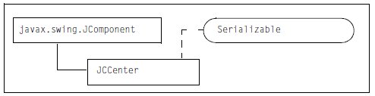
Figure 78 Center object inheritance

JCCenter extends JComponent and implements Serializable. It contains the properties and methods required to define the center of a circular gauge.

10.2 Summary of Properties Used

The following table summarizes the properties (grouped where appropriate) used in this chapter and provides links to the associated procedures. For a list of all the properties and methods available for text components, see the API documentation.

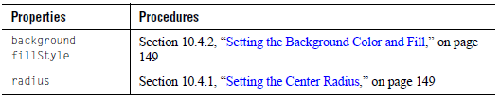

10.3 Defining the Center
This section describes how to access the default center object and how to create a new center object.

10.3.1 Accessing the Preconstructed Center Object

If you created your gauge using the no-arguments circular gauge constructor, you already have a center object associated with the scale. The following example shows how to access the center.

// Access the default center object
JCCenter center = myGauge.getCenter();

The center object has default values for all properties. You can change the value of any of the properties. For more information, see Section 10.4, “Configuring the Center,” on page 149.

10.3.2 Constructing a JCCenter Object

If your gauge does not have a center object, you can create one using the JCCenter constructor. The constructor requires the scale parameter, that is, it needs to know its parent scale. All other properties are assumed to be default values.

// Get the scale for the circular gauge "myGauge"
JCAbstractScale scale = myGauge.getScale();

// Create the center object and associate it with the scale
JCCenter center = new JCCenter(scale);

If you want to change the default values, you can use one of the other constructors provided. The following example shows how to create a object as a colored disc.

// Create the center object and set the color and radius
JCCenter center = new JCCenter(
scale, // the parent scale
Color.black, // background color
0.1); // radius expressed as a
fraction of the scale radius

The following example shows how to create a JCCenter object with a background image.

// Create the center object and specify an image
Image image = Toolkit.getDefaultToolkit().getImage("stopwatch.gif");
JCCenter center = new JCCenter(
scale, // the parent scale
Color.black, // background color
image); // the image to use in the center

When you create a new JCCenter object, you need to set it as the center of your gauge.

// Set the object as the center of the gauge
myGauge.setCenter(center);

10.4 Configuring the Center

After a center has been created, you can change the background color and radius used for the center object. You can also choose to add a background image for the center.

10.4.1 Setting the Center Radius

The size of the center object is controlled by the radius property. To change the radius, set the radius property to a new double value. The value needs to be expressed as a decimal fraction of the scale’s radius. Using a fraction allows the center to retain its size proportionate to the scale when the gauge is resized. For example, if you want the center radius to be one-fifth the size of the scale radius, you would set the value as 0.2.

// Set the center radius to be one-fifth of the scale radius
myGauge.getCenter().setRadius(0.2);

Recall that, if you are not using an image, you can also specify the radius in the JCCenter constructor. For more information, see Section 10.3.2, “Constructing a JCCenter Object,” on page 148.

10.4.2 Setting the Background Color and Fill

To set the color of the center, you can either define it in the JCCenter constructor or set the background and opaque properties inherited from JComponent. By default, the opaque property is set to true.

// Specify a background color and make it opaque
center.setBackground(Color.blue);
center.setOpaque(true);

You can also add an image, pattern, or gradient fill to the background by setting the fillStyle property. For more information, see Chapter 11, “Defining Background Fill Styles.”

Figure 79 Center with an image in background

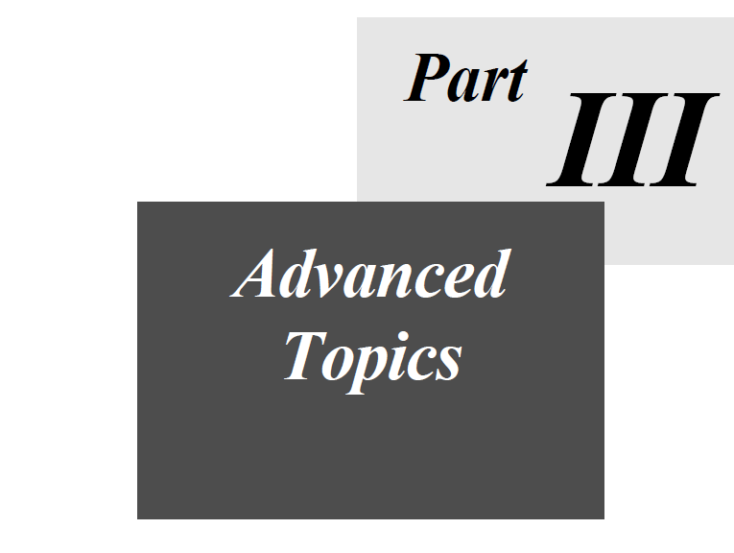

11

Defining Background Fill Styles
Setting the Component’s Background Color ■ Creating a Background Fill with JCFillStyle
Specifying a Pattern ■ Specifying an Image ■ Specifying a Gradient Fill
Specifying a Custom Paint

You can fill the background of a container with a solid color, a pattern, an image, or a gradient fill. Containers include any type of gauge or graph component, as well as some of the linear and circular gauge subcomponents. This chapter covers how to set the component’s background color and how to add a fill to the background of containers.

11.1 Setting the Component’s Background Color
To specify a background color for a component, set the background and opaque properties inherited from JComponent. The background needs to be opaque for the color to be drawn.

For example:

// Specify a background color and make it opaque
myGauge.setBackground(Color.blue);
myGauge.setOpaque(true);

Alternatively, you can fill the background with a color by creating a JCFillStyle object and setting its background property. For more information, see Section 11.3, “Specifying a Pattern,” on page 156.

11.2 Creating a Background Fill with JCFillStyle

To use a fill, you create and define a JCFillStyle object. You then set your JCFillStyle object on the container using the container’s fillStyle property.

JCFillStyle is located in the com.klg.jclass.util.style package. It has two constructors: a general constructor for all types of fills and a specialized constructor for gradient fills.

This section contains the enumerations used with the general JCFillStyle constructor. It also discusses when a JCFillStyle object honors the container’s opaque property.

For examples that demonstrate how to use the constructors to create different kinds of effects, see the following sections:

- Section 11.3, “Specifying a Pattern,” on page 156
- Section 11.4, “Specifying an Image,” on page 157
- Section 11.5, “Specifying a Gradient Fill,” on page 161
- Section 11.6, “Specifying a Custom Paint,” on page 164

For more information, look up com.klg.jclass.util.style.JCFillStyle in the JClass ServerViews API documentation.

11.2.1 pattern Parameter

The general JCFillStyle constructor takes a Color and a pattern property. The pattern is an enumeration that specifies the type of fill. The following table lists the enumerations and shows a sample of what they look like with the pattern color specified as blue and the background color as yellow.

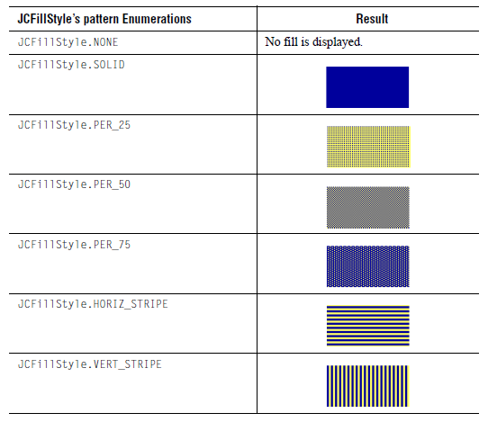

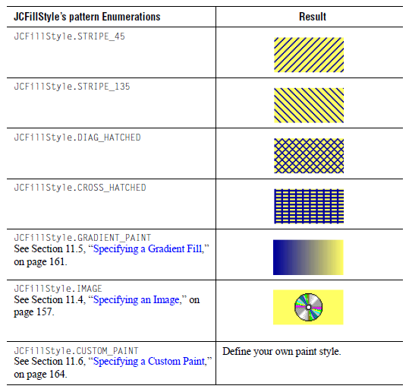

11.2.2 JCFillStyle and the Container’s opaque Property

When it comes to fills, the container’s opaque property is honored by some components and not by others. The components that honor the opaque property for fills are the gauges, the graph, and the gauge area, scale, and legend subcomponents of linear and circular gauges. In this case, when opaque is true the fill is drawn, when false the fill is not drawn.

All other components ignore the opaque property for fills. If the component is visible, the fill is drawn. This means that needles, indicators, ranges, as well as the center of a circular gauge, always show the fill when they are drawn.

The following table summarizes the components and subcomponents that have a fillStyle property. It also notes whether the opaque property is honored (fill is drawn only when opaque=true) or ignored (fill is always drawn when the component is visible).

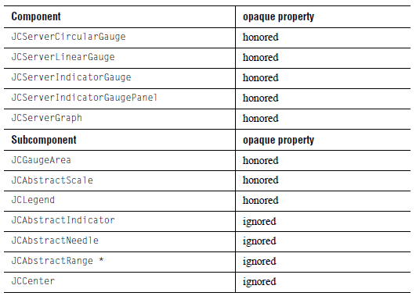

* JClass ServerGauge supports the use of a foreground pattern, image, or gradient fill for JCLinearRange only. For more information, see Section 9.4.3, “Specifying a Foreground Color and Fill in a Linear Range,” on page 145.

11.3 Specifying a Pattern
To add a pattern to the background, create a JCFillStyle object and pass it the Color for the pattern and one of the pattern enumerations. Then set the JCFillStyle object on the target component using the component’s fillStyle property. For a list of available pattern enumerations, see Section 11.2.1, “pattern Parameter,” on page 154.

The color of the background behind the pattern is determined by the background property of the JCFillStyle object. If the property is not set, whatever fill is in the component background will be seen through the pattern. For more information, see Section 11.1, “Setting the Component’s Background Color,” on page 153.

The following example creates a JCFillStyle object with a 45 degree striped pattern and sets it on a predefined range called grayLine. The pattern is drawn in dark gray. The background of the JCFillStyle is set to gray.

// Specify a 45 degree, striped pattern for the fill
JCFillStyle fs = new JCFillStyle(Color.darkGray, JCFillStyle.STRIPE_45);

// Set the background behind the pattern to gray
fs.setBackground(Color.gray);

// Set the fillStyle on the grayLine range (defined elsewhere)
grayLine.setFillStyle(fs);

Figure 80 Linear gauge that uses a 45 degree, striped pattern in the GreyLine range

11.4 Specifying an Image
Adding images to your gauges can give them a unique look and feel. You can use images wherever you can add a fill. For details, see the overview section, Section 11.2, “Creating a Background Fill with JCFillStyle,” on page 153.

Figure 81 A circular gauge that uses an image of an old-fashioned pocket watch in the background

Exception: For indicator gauges or indicator gauge panels, if you want to use an image for the icon itself, you need to use a PortableImage object. For more information, see Section 2.5.1.2, “Specifying Images on the Icon,” on page 48. This section covers the following topics:

- Creating a Fill with an Image
- Setting Hints for Drawing the Image
- Specifying a Custom Anchor Point
- Images and XML

11.4.1 Creating a Fill with an Image

To add an image, create a JCFillStyle object and pass it the JCFillStyle.IMAGE enumeration as the second parameter. The first parameter (the color parameter) is ignored for images. Set the image property of the JCFillStyle object to point to your image, and then set the JCFillStyle object on the component using the component’s fillStyle property.

For example, the following code creates a fill for a predefined range called thatchline.

// Create a fill using an image
// The color parameter must be set, but it is ignored
JCFillStyle fs = new JCFillStyle(Color.black, JCFillStyle.IMAGE);

// Set the background color
fs.setBackground(Color.blue);
// Set the image
URL resource = this.getClass().getResource("thatch.jpg");
fs.setImage(new ImageIcon(resource).getImage());

// Set the JCFillStyle object on the thatchline range
thatchline.setFillStyle(fs);

Figure 82 Linear gauge that uses an image in the ThatchLine range

The background is filled first with the color specified for the JCFillStyle object’s background property and then with the image. If the image is smaller than the region to be filled and the imageLayoutHint property is set to JCFillStyle.USE_ACTUAL_SIZE, the background color is displayed in the space around the image. If the image has transparent pixels, the background color shows through the transparent pixels. If the background is unspecified or is null, whatever fill is in the component background will be seen through the image’s transparent pixels.

If a circular or elliptical arc or circle is filled, the bounding rectangle that defines the arc or circle is the region that defines what part of image is drawn in the arc. If you want to control what part of the image is drawn, you may need to play around with the imageLayoutHint property. For more information, see Setting Hints for Drawing the Image.

11.4.2 Setting Hints for Drawing the Image

By default, the image is tiled with the first instance of the image anchored at the top left of the fill rectangle. You can configure how images are treated using the imageLayoutHint and fillOrientation properties.

The imageLayoutHint property takes an enumeration that specifies how to treat an image that is not the same size as the fill rectangle. For a list of enumerations, see Section , “imageLayoutHint Property,” on page 159.

The fillOrientation property takes an enumeration that represents a common anchor point, such as center or top. It also provides for a custom anchor point. For a list of enumerations, see Section , “fillOrientation Property,” on page 160. For more on custom anchor points, see Section 11.4.3, “Specifying a Custom Anchor Point,” on page 160.

For example, the following code sample specifies that the JCFillStyle object created in Section 11.4.1, “Creating a Fill with an Image,” on page 158, be centered in the fill rectangle.

// Use the image as-is (that is, do not tile or resize)
fs.setImageLayoutHint(JCFillStyle.USE_ACTUAL_SIZE);

// Center the image within the fill rectangle
fs.setFillOrientation(JCFillStyle.CENTER);

In the preceding example, if the image is smaller than the container, the image is centered and the background color is displayed in the space around the image. If the image is larger, the image is centered and edges clipped.

imageLayoutHint Property

The following table lists the enumerations for the imageLayoutHint property:

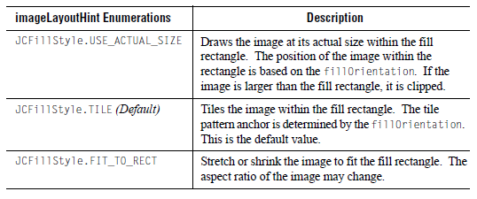

fillOrientation Property

The enumerations for the fillOrientation property specify the anchor point for the image. The results of using any given enumeration should be self-evident from the name of the enumeration. Where it is not, an explanation is provided.

The fillOrientation enumerations are as follows:

      - JCFillStyle.NONE – Default. It is the same as specifying JCFillStyle.TOP_LEFT.
      - JCFillStyle.TOP
      - JCFillStyle.BOTTOM
      - JCFillStyle.LEFT
      - JCFillStyle.RIGHT
      - JCFillStyle.CENTER
      - JCFillStyle.BOTTOM_LEFT
      - JCFillStyle.TOP_LEFT – Corresponds to coordinate (0,0).
      - JCFillStyle.BOTTOM_RIGHT
      - JCFillStyle.TOP_RIGHT
      - JCFillStyle.ABSOLUTE – See Specifying a Custom Anchor Point.

11.4.3 Specifying a Custom Anchor Point

The fillOrientation property’s JCFillStyle.ABSOLUTE enumeration enables you to specify a custom anchor point. To anchor the image at a custom location, set the fillOrientation to JCFillStyle.ABSOLUTE and then set the JCFillStyle object’s imagePosition property to a Point object.

For example, the following code sample specifies that the JCFillStyle object, fs (created in Section 11.4.1, “Creating a Fill with an Image,” on page 158) be anchored 10 pixels from the top of the fill rectangle and 10 pixels from the left.

// Anchor the image 10 pixels from the top and 10 pixels from the left
fs.setFillOrientation(JCFillStyle.ABSOLUTE);
fs.setImagePosition(new Point(10,10));

11.4.4 Images and XML

If you want to save information about images to XML, you need to set the JCFillStyle object’s outputProperties property. For more information, see Section 14.5, “Preparing to Save Information About Images to XML,” on page 188.

11.5 Specifying a Gradient Fill
You can create a gradient fill using the JCFillStyle constructor designed for gradients or using the general constructor.

This section covers the following topics:

- Using the JCFillStyle Constructor for Gradients
- Using the General JCFillStyle Constructor
- Setting the Ribbon Width
- gradientStyle Parameter

Note: If a circular or elliptical arc or circle is filled, the bounding rectangle that defines the arc or circle is the region that defines where a gradient is drawn in the arc.

11.5.1 Using the JCFillStyle Constructor for Gradients

The JCFillStyle constructor for gradient fills takes two Color objects and a gradientStyle enumeration. Behind the scenes, the JCFillStyle object’s pattern parameter is automatically set to JCFillStyle.GRADIENT_PAINT.

The first Color is the foreground color. This is the same as setting the color property of the JCFillStyle object. If this color is null, the drawing behavior is undefined as the fill style will use whatever color the current graphics object has set on it.

The second Color is the background color and is equivalent to setting the background property of the JCFillStyle object. If the second color is null, a solid color is drawn using the foreground color.

The last parameter is the gradientStyle. For a list of styles, see Section 11.5.3, “gradientStyle Parameter,” on page 162.

For example:

// Specify a gradient fill
JCFillStyle fs = new JCFillStyle(Color.red, Color.black,
JCFillStyle.GRADIENT_DIAGONAL_DOWN_RIBBON);
// Set the fillStyle on the redLine range (defined elsewhere)
redLine.setFillStyle(fs);

11.5.2 Using the General JCFillStyle Constructor

When using the general constructor, you explicitly set the JCFillStyle object’s pattern parameter to JCFillStyle.GRADIENT_PAINT. You then follow up by setting the JCFillStyle object’s gradientStyle property. For a list of styles, see Section 11.5.3, “gradientStyle Parameter,” on page 162.

For example:

// Specify a gradient fill
JCFillStyle fs = new JCFillStyle(Color.red, JCFillStyle.GRADIENT_PAINT);

fs.setGradientStyle(Color.red, Color.black,
JCFillStyle.GRADIENT_DIAGONAL_DOWN_RIBBON);
// Set the fillStyle on the redLine range (defined elsewhere)
redLine.setFillStyle(fs);

Figure 83 Linear gauge that uses a gradient paint in the RedLine range

11.5.3 gradientStyle Parameter

The following table lists the gradientStyle enumerations and shows you a sample result:
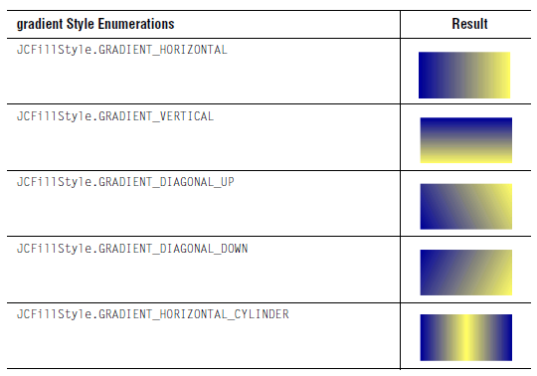

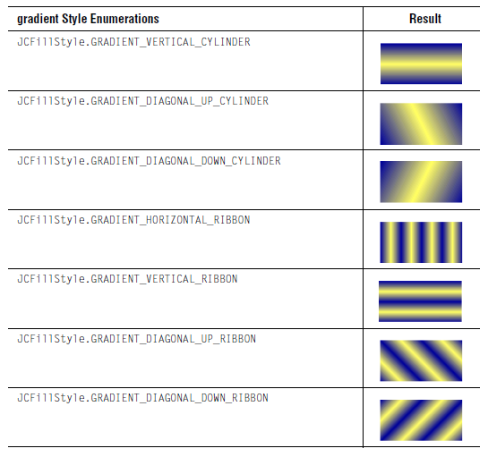

11.5.4 Setting the Ribbon Width

When a gradientStyle enumeration is used that includes the word RIBBON, the gradient has the appearance of a ribbon and the default width of that ribbon is 10 pixels. You can configure the ribbon width by setting the ribbonSize property to an int value.

For example:

// Set the ribbon width to 20 pixels
fs.setRibbonSize(20);

11.6 Specifying a Custom Paint
You can design your own fill pattern. Create a JCFillStyle object and specify the JCFillStyle.CUSTOM_PAINT enumeration. Create a Paint object or TexturePaint object and set it on your JCFillStyle object using the customPaint property. Then set the JCFillStyle object on the component using the component’s fillStyle property.

If a Paint object is specified, it is used to fill the fill rectangle. If the custom fill is a TexturePaint object, the image is extracted and a new TexturePaint object that follows the JCFillStyle object’s imageLayoutHint, fillOrientation, and imagePosition properties is used.

12

Adding Hyperlinks to

Gauge Components
Overview ■ Adding URL and Extra Tag Information to Components
Generating the Gauge ■ Creating the Image Map

You can make your gauge more interactive by adding hyperlinks to regions within the gauge. When your user clicks a linked region, the associated URL loads and its page is displayed in a browser. You can add hyperlinks to any of the gauge components. For example, you can link the header of your gauge to your company web site or link a range in the gauge to an HTML page that describes what the range means in more detail.

To associate hyperlinks with regions in your gauge you need an image map. This chapter describes how to add image map information to your circular and linear gauges and how to create the image map.

Note: Image maps are supported for gauges and graphs that are encoded to a GIF, PNG, or JPEG image format or saved as an Image object. For more information, see Chapter 13, “Encoding a Gauge or Graph.”

12.1 Overview
To add hyperlinks and create an image map for your gauge:

- Add the URL and extra tag information when you define the gauge or gauge subcomponents. See Section 12.2, “Adding URL and Extra Tag Information to Components,” on page 166.
- Generate the gauge. See Section 12.3, “Generating the Gauge,” on page 167.
- Write out the image map. See Section 12.4, “Creating the Image Map,” on page 167.

12.2 Adding URL and Extra Tag Information to Components
You can add hyperlinks to the following gauge components: gauge area, header, footer, legend, scale, ranges, indicators, needles, center (on a circular gauge), labels, or tick marks.

To associate a hyperlink with a gauge component, you create a com.klg.jclass.util.ImageMapInfo object. The ImageMapInfo object specifies the URL and extra tag information for the link as String objects. You then pass the ImageMapInfo object to the setImageMapInfo() method for the component before you add the component to the gauge.

Most eligible gauge components have an imageMapInfo property. The exceptions are the header and footer, whose imageMapInfo objects are stored in the gauge. To set the imageMapInfo property for the header and footer, use setHeaderImageMapInfo() and setFooterImageMapInfo() respectively.

For example, the following code sample defines the image map information for a company web site and then sets that information on the scale object.

// Define the image map information for a corporate web site
String companyUrl = "http://www.quest.com/jclass/";
String companyExtra = "alt=\"Quest Software JClass\" title=\"JClass\"";
ImageMapInfo companyMapInfo = new ImageMapInfo(
companyUrl, companyExtra);

// Set the map information on the scale object (defined elsewhere)
scale.setImageMapInfo(companyMapInfo);

// Set the scale on the gauge as usual
myGauge.setScale(scale);

The following line of code shows how to set the ImageMapInfo object on the header:

// Set the image map information on the header (defined elsewhere)
myGauge.setHeaderImageMapInfo(companyMapInfo);

While this line of code sets it on the footer:

// Set the image map information on the footer (defined elsewhere)
myGauge.setFooterImageMapInfo(companyMapInfo);

12.3 Generating the Gauge
After you add image map information to your gauge components, you generate the gauge as usual. For example, to output the gauge as an Image object, you call the gauge’s snapshot() method. To encode the gauge as a GIF, PNG, or JPEG and output it to a file or output stream, call the gauge’s encode() method. For more information, see Section 1.3, “Displaying a Gauge or Graph in a Browser,” on page 26 and look up com.klg.jclass.util.swing.encode.JCEncodeComponent in the API documentation.

When the gauge is generated, the image map information is translated into HTML tags. The last step is to write out the image map HTML tags.

12.4 Creating the Image Map
To write out the image map HTML tags, call the writeHtmlImageMap() method with a Writer or OutputStream object and a name for the image map.

Note: The size of the gauge must be set. The writeHtmlImageMap() method calls getSize() on the gauge. If either the width or height of the resulting Dimension object is zero, an IllegalArgumentException is thrown.

For example, the following code writes the HTML tags for a gauge called myGauge to a file called MyFile.txt:

// Write image map tags
Object out = new FileOutputStream("myFile.txt");
String mapName = "myGaugeImageMap";myGauge.writeHtmlImageMap(out, mapName);

13

Encoding a Gauge or Graph
Selecting an Image Format ■ Encoding a Component
Making an Image Object from a Component

Many of the JClass ServerGauge examples encode the finished gauge or graph as a Portable Network Graphic (PNG) file for display in a browser. You can choose to encode a gauge or graph to a different image format.

The following image formats are available:

- Portable Network Graphics (PNG)
- Joint Photographic Experts Group (JPEG)
- Graphics Interchange Format (GIF)
- Flash (SWF)
- Scalable Vector Graphic (SVG)

You can also choose to create a java.awt.Image instead of encoding your gauge or graph.

Note: If you are creating an indicator gauge or indicator gauge panel that blinks, you need to encode it as an animated GIF using the encodeAsSingleLoopAnimatedGif() method from JCIndicatorGauge or JCIndicatorGaugePanel. For more information, see Section 2.9.6, “Making Gauge Icons Blink,” on page 67.

13.1 Selecting an Image Format
This section summarizes some key differences among the supported image formats. If you are uncertain which is the best image format for your application, you can read more about image formats by selecting the links in the following table or by searching the Internet with the keywords “image format.”

When making a decision on an image format, you should be aware that the following JClass ServerGauge features may or may not be supported:

- Hyperlinks (image map) – supported for GIF, JPEG, and PNG
- HTML-encoded text – supported for all formats except SWF
- Dashed lines in a graph – supported for all formats except SWF

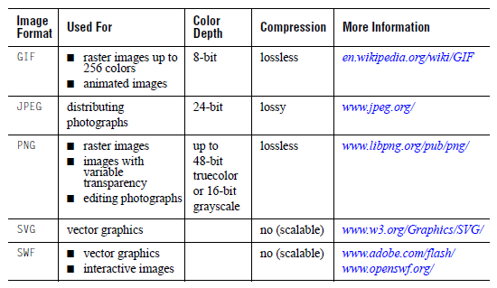

13.2 Encoding a Component
The following packages are required for encoding purposes:

- com.klg.jclass.util.swing.encode.JCEncodeComponent
- com.klg.jclass.util.swing.encode.EncoderException

If you are encoding to SVG, you also need to add a JAR to your class path. For more information, see Section 13.2.2, “SVG and Your Class Path,” on page 171.

To encode your component, you call the component’s encode() method with a JCEncodeComponent.Encoding enumeration that specifies the image format, and an instance of an OutputStream. The method creates an Image object, encodes the Image in the specified image format, and outputs the result to the specified OutputStream.

For example, the following code encodes a gauge or graph in SVG format.

// Encode a gauge or graph to an SVG format
myGauge.encode(JCEncodeComponent.SVG, outputstream);

To see a full encoding example, see Section 1.3, “Displaying a Gauge or Graph in a Browser,” on page 26.

Note: If you are creating an indicator gauge or indicator gauge panel that blinks, you need to encode it as an animated GIF using the encodeAsSingleLoopAnimatedGif() method from JCIndicatorGauge or JCIndicatorGaugePanel. For more information, see Section 2.9.6, “Making Gauge Icons Blink,” on page 67.

13.2.1 encoding Parameter

The following table lists the valid enumerations for the encoding parameter:

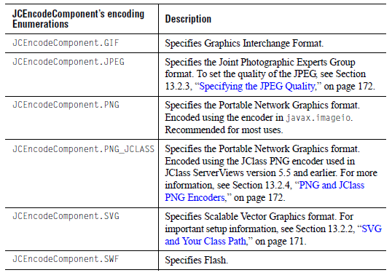

13.2.2 SVG and Your Class Path

The JClass ServerGauge implementation of SVG relies on the Apache Batik project. Batik provides core components for handling and processing SVG files. Portions of the Apache Batik project are redistributed with JClass ServerGauge.

Before encoding your chart to SVG, you need to do the following:

- Add the Batik JAR to your CLASSPATH (found in JCLASS_SERVER_HOME/lib/).
- Ensure you have an XML parser that is JAXP 1.1-compliant in your CLASSPATH.

Note: The Apache Batik project comes with its own license. Quest Support does not handle questions about Batik. For more information, visit http://xml.apache.org/batik/index.html

13.2.3 Specifying the JPEG Quality

The quality parameter sets the quality versus compression trade off to use when performing JPEG encoding. A value of 1 requests the best possible image quality, while a value of 0 requests the best possible compression. You can also specify any floating point value between these boundary values. The default is 1.
To specify the JPEG quality, you start with a snapshot of your gauge or graph and an instance of the JPEGEncoder class. JPEGEncoder is the class that does all the work when the component’s encode() method is called with JCEncodeComponent.JPEG. You then call the encoder’s setQuality() method with a floating point value between 0.0f and 1.0f. Finally you encode the Image as a JPEG using the encoder’s saveImage() method.

// Create an Image object containing a snapshot of the gauge
myGauge.snapshot();

// Use an instance of JPEGEncoder rather than the encode() method
// to set the JPEG quality and encode the snapshot
try {
JPEGEncoder encoder = new JPEGEncoder();
encoder.setQuality(quality);
encoder.saveImage(mySnapshot, outputstream);
}
catch (IOException ioe) {
//handle the exception
}
catch (EncoderException ee){
//handle the exception
}
Because you are using the JPEGEncoder class directly, encode events are not caught. You will need to fire the encode events manually.

13.2.4 PNG and JClass PNG Encoders

JClass ServerViews version 5.5 and earlier defined and used a custom PNG encoder. The encoder remains for backward compatibility, but has been deprecated in favor of the javax.imageio PNG encoder, which uses memory more efficiently. For larger images, the javax.imageio PNG encoder can also be faster than the JClass PNG encoder.

You should be aware that the javax.imageio PNG encoder can be slower than the JClass PNG encoder for smaller images (up to twice as slow depending on the size of the image and the JDK/platform combination). Also, on Solaris, the javax.imageio PNG encoder can be extremely slow for JDK 1.5.0_06 (and possibly others), but performs normally on JDK 1.5.0_11 and later.

If you prefer to use the JClass encoder, specify JCEncodeComponent.PNG_JCLASS instead of JCEncodeComponent.PNG.

13.3 Making an Image Object from a Component
To turn a JClass ServerGauge component into a java.awt.Image object without encoding it, call the component’s snapshot() method.

If a specific type of image is required, the snapshot(int imagetype) method can be called. The imagetype parameter is any of the image types specified in the java.awt.image.BufferedImage class. The resulting image will be a BufferedImage object of that type.

For example, to save memory and draw JClass ServerGauge into a 256 color image instead of one using the default 24-bit color map, call:

Image jclassImage = snapshot(BufferedImage.TYPE_BYTE_INDEX);

If you have a pre-existing image that you want the instance to be drawn on top of, then call snapshot(Image img) and pass in the desired image in the img parameter – the component draws itself on top of that image and a new combined Image is saved.

To encode the resulting Image to an OutputStream, you can call the ServerRender.encodeImage() method and specify the encoding, Image object, and OutputStream.

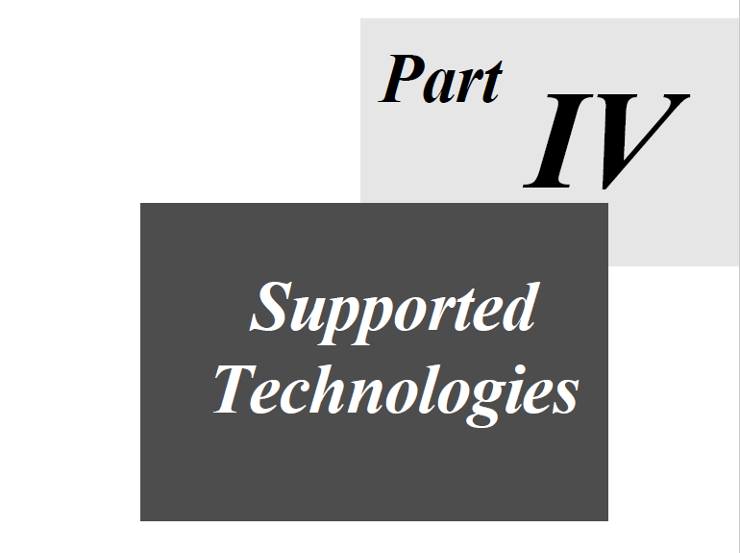

14

Creating Gauges and Graphs with XML
Overview of XML for JClass ServerGauge ■ Creating a Gauge or Graph From XML
Updating a Gauge or Graph From XML ■ Saving a Gauge or Graph to XML
Preparing to Save Information About Images to XML ■ Internationalizing Your XML-based Gauge

This section describes how to create, update, and save your gauge or graph using XML. It assumes that you have a working knowledge of XML.

14.1 Overview of XML for JClass ServerGauge
This section identifies the XML-related files and classes for JClass ServerGauge.

14.1.1 DTDs

DTD files are located in JCLASS_SERVER_HOME/xml-dtd.

- JCGauge.dtd – Defines common elements required by all the gauge types, such as the <gauge> tag. It also defines circular and linear gauge properties and graph properties.
- IndicatorGauge.dtd – Defines indicator gauge and indicator gauge panel properties. Requires JCGauge.dtd.

In JClass ServerGauge, the elements, sub-elements, and attributes in the DTDs coincide, for the most part, with the objects, sub-objects, and properties within the gauge components. Properties are specified as Strings in the XML file. The Strings are converted to the appropriate type by the JClass ServerGauge XML handler. For details, see Chapter 15, “XML DTDs.”

Note: The Color type is used in all the DTDs. Values for Colors can be specified in hexadecimal (#RRGGBB), as an RGB value (RRR-GGG-BBB), or as a color enum (such as “black” or “blue”).

14.1.2 Factory Classes

There are three JClass ServerGauge factory classes for use with XML:

- com.klg.jclass.sgauge.JCServerGaugeFactory
- com.klg.jclass.sgauge.indicator.JCServerIndicatorGaugeFactory
- com.klg.jclass.sgauge.graph.JCServerGraphFactory

Each of them provides methods to create, update, and save a gauge or graph using properties encoded in XML. The factories are designed to be able to interpret multiple markup languages, but only XML is supported at this time. For more information, look up the factories in the API documentation.

14.1.3 LoadServerProperties Class

The LoadServerProperties class is responsible for the following tasks:

- Telling the gauge or graph how to access image files based on the fileAccess properties of the <image-file> elements defined in the XML source. Access information for other external files can be supplied as well.
- Passing user-defined objects to an external Java class when <external-java-code> elements are defined in the XML source.
- Identifying what to do when there is an error in reading an image from its source. Normally, the gauge or graph throws a JCIOException when this happens. However, you can ignore these exceptions and continue loading the gauge or graph by setting the ignoreExternalResourceExceptions property to true.

To use the LoadServerProperties class, you create an instance of it and then pass the instance to a factory’s make*() method. For more information, see Section 14.2.3, “Constructing a LoadServerProperties Object,” on page 184 and look up the com.klg.jclass.util.io.LoadServerProperties class in the API documentation.

14.1.4 Images and the OutputProperties Class

The OutputProperties class encapsulates properties that are needed to save and retrieve an image file. For more information, see Section 14.5, “Preparing to Save Information About Images to XML,” on page 188 and look up the com.klg.jclass.util.io.OutputProperties class in the API documentation.

14.1.5 XML Examples

Examples are located in JCLASS_SERVER_HOME/examples/sgauge/ under the servlet and jsf directories. Each example includes a sample XML file as well as the application that creates and displays the gauge or graph.

14.2 Creating a Gauge or Graph From XML
Each of the factories has a make*() method that creates a gauge or graph from a file, reader, stream, or URL. For example, JCServerGaugeFactory has a makeServerGauge() method. To create a gauge or graph, you encode your gauge or graph properties in XML. Then you create an instance of LoadServerProperties, which handles how properties are loaded from the XML source. Finally, you use the appropriate factory to create the gauge or graph from the XML and the LoadServerProperties instance.
The following subsection shows you how to use the factories. Subsequent subsections help you encode JClass ServerGauge properties to XML and specify the properties of the LoadServerProperties object.

14.2.1 Using the Factories to Make a Gauge or Graph

This section shows you how to use the make*() method to create a gauge or graph. A complete example is shown for circular and linear gauges; the indicator gauge and graph sections describe how to modify that example.

14.2.1.1 Creating Circular and Linear Gauges from XML

The following code sample uses JCServerGaugeFactory to create a circular gauge from an XML file. In the example, the XML file is specified as a String and assigned to inputSource. Alternatively, the inputSource could be an InputStream, a Reader, or a URL. JCServerGaugeFactory creates and returns the appropriate gauge based on the contents of the inputSource. You can create a linear gauge in the same way – by declaring a linear gauge and passing an XML file containing linear gauge properties as the inputSource.

Note: You cannot mix and match circular and linear gauges. The properties in the XML file need to be appropriate for the type of gauge that is declared.

In this example, the LoadServerProperties object is called loadProps. The factory requires a third parameter, JCServerGaugeFactory.XML, which is a static int that indicates the markup language used. Some typical error catching is included in the code sample.

// Specify where to look for the XML-based circular gauge properties
// (For a linear gauge, specify XML-based linear gauge properties)
String inputSource = "circular-gauge.in.xml";

// Create the LoadServerProperties object
LoadServerProperties loadProps = new LoadServerProperties();
loadProps.setResolvingServletContext(context);

// Create the circular gauge
// (For a linear gauge, specify JCServerLinearGauge)
JCServerCircularGauge myCircularGauge = null;

try {
myCircularGauge = JCServerGaugeFactory.makeServerGauge(
inputSource, loadProps, JCServerGaugeFactory.XML);
}

Catch (JCIOException e) {
System.out.println("Error accessing external file:" + e.getMessage());
}

Catch (JCParseException e) {
System.out.println("Error parsing file:" + e.getMessage());
}

catch (IOException e) {
System.out.println("Error reading " + inputSource +
":" + e.getMessage());
}

14.2.1.2 Creating Indicator Gauges and Panels from XML

This is similar to creating circular and linear gauges, but you substitute JCServerIndicatorGauge or JCServerIndicatorPanel (for JCServerCircularGauge) and JCServerIndicatorGaugeFactory (for JCServerGaugeFactory).

For example:

// Specify where to look for the XML-based gauge properties
String inputSource = "indicator-gauge.in.xml";

// Create the LoadServerProperties object
LoadServerProperties loadProps = new LoadServerProperties();
loadProps.setResolvingServletContext(context);

// Create an indicator gauge
JCServerIndicatorGauge myGauge = null;

try {
myGauge =
JCServerIndicatorGaugeFactory.makeServerIndicatorGauge(
inputSource, loadProps, JCServerIndicatorGaugeFactory.XML);

}

14.2.1.3 Creating Graphs from XML

This is similar to creating circular and linear gauges, but you substitute JCServerGraph (for JCServerCircularGauge), JCServerGraphFactory (for JCServerGaugeFactory), and use makeServerGraph() (instead of makeServerGauge()).
For example:

// Specify where to look for the XML-based graph properties
String inputSource = "graph.in.xml";

// Create the LoadServerProperties object
LoadServerProperties loadProps = new LoadServerProperties();
loadProps.setResolvingServletContext(context);

// Create the graph
JCServerGraph myGraph = null;

try {
myGraph = JCServerGraphFactory.makeServerGraph(
inputSource, loadProps, JCServerGraphFactory.XML);
}

14.2.2 Setting JClass ServerGauge Properties Using XML

JClass ServerGauge properties are enclosed in the <gauge> tag from JCGauge.dtd. For a list of elements, including their expected types or values, see Chapter 15, “XML DTDs”.

14.2.2.1 Sample XML File

The following example is taken from the circular-gauge.xml file, located in JCLASS_SERVER_HOME/examples/sgauge/jsf/. Sample XML files for the other gauge types and a graph can be found in the same location.When the properties are loaded, any properties that are not specified use default values.

<?xml version="1.0"?>
<!DOCTYPE gauge SYSTEM "JCGauge.dtd">
<gauge>
<circular-gauge gaugeType="Top_Half"
width="400"
height="300"
background="#8FBC8F"
opaque="true"
name="Decibel Level">
<header text="Decibel Level"
background="#8B6914"
opaque="true"
visible="true"
foreground="#8FBC8F">
<font name="Dialog"
style="Bold"
size="16"/>
<etched-border type="Raised"/>
</header>
<footer text="Never Loud Enough?"
opaque="false"
visible="true"
foreground="#8B6914">
<font style="Bold_Italic"/>
</footer>
<legend type="MultiCol"
visible="true"
useEllipsisWhenTruncating="True"
itemTextToolTipEnabled="True" >
<multi-col numColumns="2"/>
<legend-column itemTextAlignment="Center" />
<font style="Bold"/>
<layout-hints x="25" y="240"/>

</legend>
<circular-scale direction="Backward" min="0" max="120">
<circular-range name="What?"
background="white"
innerExtent="0.25"
outerExtent="0.75"
startValue="0"
stopValue="30"/>
<circular-range name="Optimum"
background="#006400"
innerExtent="0.25"
outerExtent="0.75"
startValue="30"
stopValue="60"/>
<circular-range name="Minimize"
background="#FFD700"
innerExtent="0.25"
outerExtent="0.75"
startValue="60"
stopValue="85"/>
<circular-range name="Earsplitting"
background="#8B0000"
innerExtent="0.25"
outerExtent="0.75"
startValue="85"
stopValue="120"/>
<tick style="Line"/>
</circular-scale>
<center background="red"/>
<needle style="Arrow"
value="35"
innerExtent="0.15"
outerExtent="0.65"
background="#8B6914"
interactionType="Drag"/>
</circular-gauge>
</gauge>

14.2.2.2 Specifying Images with XML

You can add images using the <fill-style> and <image-file> elements. For example, the following code sets an image file on the center of the gauge defined in the preceding example.

<gauge>
<circular-gauge...>
...
<center background="red">
<fill-style pattern="Image"
imageLayoutHint="Use_Actual_Size"
fillOrientation="Center">
<image-file fileName="examples/sgauge/jsf/resources/cd.gif"
fileAccess="Servlet"
imageScaled="true"
isBackground="true"/>
</fill-style>
</center>
...
</circular-gauge>
</gauge>

The fileAccess attribute of the <image-file> element is used by the LoadServerProperties object to determine how to access the image file named in the fileName attribute. The imageScaled attribute remains for backward compatibility. It maps to the now deprecated imageScaled property. The isBackground attribute determines whether the image is in the background or the foreground of the container. In most cases, isBackground is true (default). When you are using a foreground image (enabled for linear ranges only), you need to set isBackground to false.

The following table summarizes the valid values for the fileAccess property.
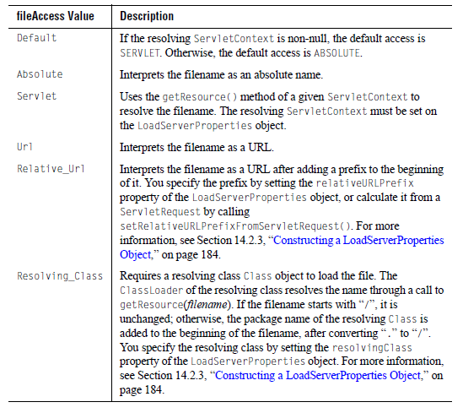

14.2.3 Constructing a LoadServerProperties Object

In simple cases (see Section 14.2.1.1, “Creating Circular and Linear Gauges from XML,” on page 179), you can use the no-arguments LoadServerProperties constructor to create a LoadServerProperties object that uses null values for all its properties.

In the following circumstances, you may need to specify some properties for your LoadServerProperties object:

- When you have an <image-file> tag with fileAccess=Resolving_Class, you use the resolvingClass property to specify the Class object that is used to resolve the location of file.
- When you have an <image-file> tag with fileAccess=Relative_Url, you use the relativeURLPrefix property to specify the String to prepend to the URL. (Recall that in this case the fileName attribute of the <image-file> is interpreted as a URL.)
- When you specify an <external-java-code> tag, you use the userObject property to specify the Object and the storeUserObject property to determine if the Object is stored with the gauge.

The following example shows a LoadServerProperties constructor with some properties set.

Class myResolvingClass = new Class(...);
Object myObject = new myObject(...);
// Create a LoadServerProperties object and set properties
LoadServerProperties loadProps = new LoadServerProperties(
myResolvingClass,// resolvingClass
"",// relativeURLPrefix (default is empty String)
myObject,// userObject
true);// storeUserObject

Alternatively, you can set these property using the LoadServerProperties object’s set*() methods. For more information, look up com.klg.jclass.util.io.LoadServerProperties in the API documentation. See also the <image-file> and <external-java-code> elements in Chapter 15, “XML DTDs”.

14.3 Updating a Gauge or Graph From XML
Each of the factories has an update*() method that updates an existing gauge or graph from a file, reader, stream, or URL. It is very similar to the makeServer*() method, except that it takes as its first parameter the name of the gauge or graph to update. If the name is null, the method creates the gauge or graph. The values of any properties not specified in XML remain unchanged when the properties are loaded into the gauge or graph.

A complete example is shown for circular and linear gauges; the indicator gauge and graph sections describe how to modify that example.

14.3.1 Updating a Circular or Linear Gauge from XML

The following code updates an existing circular gauge called myCircularGauge with properties contained in a file called circular-gauge-update.in.xml. In the example, the XML file is specified as a String and assigned to inputSource. Alternatively, the inputSource could be an InputStream, a Reader, or a URL. You can update a linear gauge in the same way – by passing an XML file containing linear gauge properties as the inputSource.

Note: You cannot update a circular gauge with an XML file containing linear gauge properties, or vice versa. The properties in the XML file need to be appropriate for the type of gauge that is being updated.

Note that a LoadServerProperties object is created in this example. If null is passed to the updateServerGauge() method instead, a default LoadServerProperties object is used.
// Specify where to look for the XML-based circular gauge properties
String inputSource = "circular-gauge-update.in.xml";

// Create the LoadServerProperties object
LoadServerProperties loadProps = new LoadServerProperties();
loadProps.setResolvingServletContext(context);

// Update the existing circular gauge called myCircularGauge
try {
myCircularGauge = JCServerGaugeFactory.updateServerGauge(
myCircularGauge, inputSource, loadProps,
JCServerGaugeFactory.XML);
}
catch (JCIOException e) {
System.out.println("Error accessing external file:" + e.getMessage());
}
catch (JCParseException e) {
System.out.println("Error parsing file:" + e.getMessage());
}
catch (IOException e) {
System.out.println("Error reading " + inputSource +
":" + e.getMessage());
}

14.3.2 Updating an Indicator Gauge or Panel from XML

This is similar to updating circular and linear gauges, but you substitute JCServerIndicatorGaugeFactory for JCServerGaugeFactory, and use updateServerIndicatorGauge() (instead of updateServerGauge()).

For example:

// Specify where to look for the XML-based gauge properties
String inputSource = "indicator-gauge-update.in.xml";

// Create the LoadServerProperties object
LoadServerProperties loadProps = new LoadServerProperties();
loadProps.setResolvingServletContext(context);

// Update the existing indicator gauge called myGauge
try {
myGauge = JCServerIndicatorGaugeFactory.updateServerIndicatorGauge(
myGauge, inputSource, loadProps,
JCServerIndicatorGagueFactory.XML);
}

14.3.3 Updating Graphs from XML

This is similar to updating circular and linear gauges, but you substitute JCServerGraphFactory for JCServerGaugeFactory, and use updateServerGraph() (instead of updateServerGauge()).

For example:

// Specify where to look for the XML-based graph properties
String inputSource = "graph-update.in.xml";
// Create the LoadServerProperties object
LoadServerProperties loadProps = new LoadServerProperties();
loadProps.setResolvingServletContext(context);
// Update the existing graph called myGraph
try {
myGraph = JCServerGraphFactory.updateServerGraph(myGraph,
inputSource, loadProps, JCServerGraphFactory.XML);
}

14.4 Saving a Gauge or Graph to XML
Each of the factories has a save*() method that saves a gauge or graph to a file, stream, or writer. If the specified gauge or graph does not exist, there is no XML output. Gauge properties are saved to corresponding XML elements. Images are not saved, but information about how to reload them is saved. For more information, see Section 14.5, “Preparing to Save Information About Images to XML,” on page 188.

This section shows you how to use the save*() method to save gauge or graph to an XML file. A complete example is shown for circular and linear gauges; the indicator gauge and graph sections describe how to modify that example.

14.4.1 Saving a Circular or Linear Gauge to XML

In the following example, the properties that define myCircularGauge are saved to an XML file. The file name circular-gauge.out.xml is specified as a String and assigned to outputTarget. Alternatively, outputTarget could also be an OutputStream or a Writer. A linear gauge can be saved in the same fashion.

// Specify where to save the circular gauge properties as XML
String outputTarget = "circular-gauge.out.xml";
// Save the circular gauge to a file
try {
JCServerGaugeFactory.saveServerGauge(myCircularGauge, outputTarget,
JCServerGaugeFactory.XML);
}
catch (IOException e) {
System.out.println("Error writing to " + outputTarget + ":" +
e.getMessage());
}

14.4.2 Saving an Indicator Gauge or Panel to XML

This is similar to saving circular and linear gauges, but you substitute JCServerIndicatorGaugeFactory (for JCServerGaugeFactory), and use saveServerIndicatorGauge() (instead of saveServerGauge()).

For example:

// Specify where to save the gauge properties as XML
String outputTarget = "indicator-gauge.out.xml";

// Save the gauge to a file
try {
JCServerIndicatorGaugeFactory.saveServerIndicatorGauge(myGauge,
outputTarget, JCServerIndicatorGaugeFactory.XML);
}

14.4.3 Saving Graphs to XML

This is similar to saving circular and linear gauges, but you substitute JCServerGraphFactory (for JCServerGaugeFactory), and use saveServerGraph() (instead of saveServerGauge()).

For example:

// Specify where to save the graph properties as XML
String outputTarget = "graph.out.xml";

// Save the graph to a file
try {
JCServerGraphFactory.saveServerGraph(myGraph, outputTarget,
JCServerGraphFactory.XML);
}

14.5 Preparing to Save Information About Images to XML
Images are not saved when a gauge or graph is saved to XML. You can, however, choose to save information about the images in the XML so that if you reload the gauge or graph the images can be located and displayed. Image information includes the file name, where the image can be found, and how to access it.

If your gauge or graph contains images, and you want to be able to save image information, you need to set the outputProperties property on each JCFillStyle object that defines specifies an image. The outputProperties property takes an OutputProperties object. The following sections describe how to create and use an OutputProperties object.

14.5.1 Constructing an OutputProperties Object

Every image in your gauge or graph whose information you want to save to XML requires an OutputProperties object. The following code creates an OutputProperties object for use with the image in the background of the gauge.

// Create an instance of OutputProperties
OutputProperties imageOutputProps = new OutputProperties(
null, // outputFileName (not used)
"images/gaugebgimage.jpg", // propertyName
null,// saveType (not used)
Properties.RELATIVE_URL); // fileAccess

The propertyName property specifies the file name and location of the image. In the XML, the value of propertyName is saved to the <image-file> fileName attribute. The fileAccess property specifies how to interpret the propertyName. It is saved to the <image-file> fileAccess attribute.

The outputFileName and saveType properties are null, because this class has other uses and these properties are not required for images. For more information, see Section 14.2.2.2, “Specifying Images with XML,” on page 182.

For more information, look up the com.klg.jclass.util.io.OutputProperties class in the API Documentation.

14.5.2 Setting Output Properties on a Background Image

To prepare to save information about a background image to XML, you set the outputProperties property of the JCFillStyle object and specify its OutputProperties object.

// Define an image
String URLString = “http://www.my_site.com/snowflakes.jpg”;
URL url = new URL(URLString);
// Load the image (where loadImageFromURL is some method
// that creates an image from a URL)
Image inputImage = loadImageFromURL(url);

// Set the output properties for the image
OutputProperties outputProps = new OutputProperties(
null, URLString, null, Properties.URL);

// Set the output properties on the JCFillStyle object
myImageFill.setOutputProperties(outputProps);

// Set the JCFillStyle on the gauge
myGauge.setFillStyle(myImageFill);

14.5.3 Setting Output Properties on a Foreground Image

Foreground images are enabled for ranges in linear gauges. To prepare to save information about a foreground image to XML, you need to set the foregroundFillStyle property of the range and specify its OutputProperties object.

For example:

// Define a foreground image in a linear range
String URLPrefix = “file:///c:/jclass”;
String imageString = "images/rangefgimage.jpg";

// Load the image (where loadImageFromURL is some method
// that creates an image from a URL)
Image inputFgImage = loadImageFromURL(URLPrefix + imageString);

// Create an instance of OutputProperties
OutputProperties fgOutputProps = new OutputProperties(
null, imageString, null, Properties.RELATIVE_URL);

// Set the output properties on the JCFillStyle object
myFgImageFill.setOutputProperties(fgOutputProps);

// Set the JCFillStyle on the linear range (defined elsewhere)
range.setForegroundFillStyle(myFgImageFill);

When loading the image from XML, set the above relative URL prefix in the LoadServerProperties object.

14.5.4 How Image Information is Stored and Accessed

The JCFillStyle object has as one of its properties the name of the OutputProperties object for the image. When a gauge or graph containing an image is saved to XML, the information about the image that is contained in the OutputProperties object is stored in an <image-file> element. An <image-file> element is nested within its container’s tag.

For example, a background <image-file> element for a circular gauge would be inside the <circular-gauge> tag.

<gauge>
...
<circular-gauge...>
<image-file fileName="images/gaugebgimage.jpg"
fileAccess="Relative_Url"
imageScaled="true"
isBackground="true"/>
...
</circular-gauge>
</gauge>

The attributes in the <image-file> tag map to properties as follows:
- fileName maps to the propertyName property of the OutputProperties object. It is the name of the image file.
- fileAccess maps to fileAccess property of the OutputProperties object. It used when creating a gauge from the saved XML. For more information, see Section 14.2.2.2, “Specifying Images with XML,” on page 182.
- imageScaled is retained for backward compatibility only. It maps to the deprecated imageScaled property of the gauge container.
- isBackground is set automatically and should not be changed. When the fillStyle property of the container is set, isBackground is true (default), which means the image is in the background. When the foregroundFillStyle property is set (enabled for linear ranges only), isBackground is automatically set to false, which means the image is in the foreground.

Recall that if an image does not have an OutputProperties object associated with it, the image is ignored.

14.6 Internationalizing Your XML-based Gauge
If you need to offer your XML-based gauge in multiple languages, you can replace any or all of the text strings with variables and provide a resource bundle containing properties files or ResourceBundle classes for each language that you support. When your client’s browser requests the gauge, the browser’s locale or, for JSF, the client’s operating system locale, determines which language is displayed by default. The following sections describe how to add variables to your gauge and create the resource bundle, as well as how to use your resource bundle in different environments.

14.6.1 Using Variables

Wherever text appears on your gauge, you can replace the text string with a variable in your XML file. For example, you can use variables for the header, footer, tick label, and range labels. Variables take the form ${KEY}, where KEY is a unique variable name. Variable names are case-sensitive and can be uppercase, lowercase, or mixed case.

Tip: Use meaningful names so that, when you create your resource bundle, it is easier to map the correct text strings to the variables.

For example, in the following excerpt taken from linear-gauge.xml (located in JCLASS_SERVER_HOME/examples/sgauge/jsf/) variables replace text strings for the header text (${Header_Text}), gauge title (${Gauge_Title}), and range names (${Range1_Text}, ${Range2_Text}).

<?xml version="1.0"?>
<!DOCTYPE gauge SYSTEM "JCGauge.dtd">
<gauge>
<linear-gauge...>
<header text="${Header_Text}"
visible="true">
<font size="16"/>
<etched-border type="Raised" />
</header>
...
<gauge-area>
<compound-border>
<titled-border title="${Gauge_Title}"/>
<empty-border>
<insets bottom="5"/>
</empty-border>
</compound-border>
</gauge-area>
...
<linear-scale,,,>
<linear-range name="${Range1_Text}"
background="255-180-180"
innerExtent="-0.02"
outerExtent="1.02"
startValue="90"
stopValue="119"/>
<linear-range name="${Range2_Text}"
background="173-216-255"
innerExtent="-0.02"
outerExtent="1.02"
startValue="60"
stopValue="79"/>
...
</linear-scale>
...
</linear-gauge>
</gauge>

Note: If you want, you can embed a variable within a text string. For example, you could specify a value such as “This is a ${KEY}”. Mixing text and variables, however, is not generally recommended; you usually want to provide gauges with the text entirely in your client’s language.

14.6.2 Creating a Resource Bundle

Depending on your needs, you can use the class ResourceBundle or either of its subclasses – PropertyResourceBundle or ListResourceBundle – to assign text strings to the variables that you used in your XML file. PropertyResourceBundle looks for the localized strings in properties files, while ResourceBundle and ListResourceBundle looks for them in your code. For more information on how to use these classes, look up java.lang.ResourceBundle in the Sun Java API documentation.

Whichever method you choose, your resource bundle must include a default locale – the language used when a locale is not specified by the browser – plus a properties file or ResourceBundle class for each of the other languages that you want to support. The default locale uses the base name of your resource bundle, while all other locales should follow the I18N naming conventions for language and country, though the country code is optional if there is no chance of confusion. For example, your base name and default locale could be called myresources, while U.S. English would be myresources_en_US, and German would be myresources_de_DE (or myresources_de). For more information, see Section 1.6, “Internationalization,” on page 33.

This section assumes that you are already familiar with how to create a properties file.

The following examples show a ListResourceBundle implementation that could be used with the linear gauge example from the preceding section. The base name is XMLLocaleInfo. The first example contains text strings in English US. The second example contains text strings in Spanish.

Example: XMLLocaleInfo.java with English US text strings

package examples.gauge.xml.resources;
import java.util.ListResourceBundle;
/**
* XMLLocaleInfo
*/
public class XMLLocaleInfo extends ListResourceBundle
{

protected Object[][] contents = {
{"Header_Text", "Blood Pressure"},
{"Gauge_Title", "Your Reading"},
{"Range1_Text", "Normal Systolic Range"},
{"Range2_Text", "Normal Diastolic Range"},
};
/**
* See class description.
*/
protected Object[][] getContents()
{
return contents;
}
}

Example: XMLLocaleInfo_es.java with Spanish text strings

package examples.gauge.xml.resources;
import java.util.ListResourceBundle;
/**
* XMLLocaleInfo_es
*/
public class XMLLocaleInfo_es extends ListResourceBundle
{

protected Object[][] contents = {
{"Header_Text", "Presi\u00f3n sangu\u00ednea"},
{"Gauge_Title", "Su lectura"},
{"Range1_Text", "Rango sist\u00f3lico normal"},
{"Range2_Text", "Rango diast\u00f3lico normal"},
};

// See class description
protected Object[][] getContents()
{
return contents;
}
}

14.6.3 Using Resource Bundles: JSF

You designate the resource bundle using the useBundle attribute of GaugeTag. The path String can point to either a properties file or an instance of ListResourceBundle. If loadBundle has been declared, you can use the same variable for useBundle.

The following example shows how to use the loadBundle and useBundle attributes.

<f:loadBundle basename="examples.sgauge.jsf.resources.jsf" var="bundle"/>
<jcgaugejsf:circularGauge binding="#{localize.gauge1}" border="0"
gaugeName="Localized Gauge"
gaugeXmlValue="/examples/sgauge/jsf/localize.xml"
useBundle="bundle"
debug="false" encoding="jpg"
generateImageMap="false" id="gauge1"/>

The following example demonstrates how to use a backing bean to set and change the locale. The locale (loc) is initialized in the constructor to be the default locale and then changed when the end-user selects a new locale from the selectOneMenu component.

package demos.sgauge.localizejsf;

import com.klg.jclass.sgauge.faces.JCFacesLinearGauge;

import javax.faces.component.UIOutput;
import javax.faces.component.UISelectOne;
import javax.faces.context.FacesContext;
import javax.faces.event.ValueChangeEvent;
import java.util.Locale;

/**
* LocalizeJSF
*/
public class LocalizeJSF {
...
private JCFacesLinearGauge gauge1 = null;
private Locale loc = null;

/**
* Default constructor for LocalizeJSF
*/
public LocalizeJSF() {
FacesContext fc = FacesContext.getCurrentInstance();
loc = fc.getViewRoot().getLocale();
}

/**
* Called when the value on the dropdown list has changed.
* @param ve The event generated when the value changed.
*/
public void valueChanged(ValueChangeEvent ve) {
String lan = (String)dropdown1.getValue();
if (lan.equals("en")){
setLoc(Locale.ENGLISH);
}
else if(lan.equals("de")){
setLoc(Locale.GERMAN);
}
else if (lan.equals("fr")){
setLoc(Locale.FRENCH);
}
}
...
/**
* Sets the loc property, and updates the View root's locale.
* @param loc The new locale object.
*/
public void setLoc(Locale loc) {
this.loc = loc;
FacesContext fc = FacesContext.getCurrentInstance();
fc.getViewRoot().setLocale(loc);
}
}

14.6.4 Using Resource Bundles: JSP

As with JSF applications, you designate the resource bundle using the useBundle attribute of GaugeTag. The path String can point to either a properties file or an instance of ListResourceBundle.

The following example demonstrates how to use the useBundle attribute.

<jclass:circular-gauge gaugeXml="/examples/sgauge/jsf/localizeproppath.xml"
useBundle="examples.sgauge.jsf.resources.PropPath"
encoding="png"
border="0"
name="Localized File PNG Example"
imageMapName="myMap"
cache="servletContext"/>

14.6.5 Using Resource Bundles: Servlets (Programmatically)

To load a localized gauge from a servlet, you need to implement the LocaleHandler interface. You can create your own implementation or you can use the implementation provided with JClass ServerGauge, called LocaleBundle. In your code, you import com.klg.jclass.util.LocaleBundle (or your version of LocaleHandler) and java.util.Locale, and then get and set the locale using getLocale and setLocaleHandler.

For example, in the following example, the programmer gets the locale when instantiating GaugeRunner using request.getLocale. (Note: GaugeRunner is an inner class that implements Runnable. This approach allows JClass ServerGauge to be created and configured in a thread-safe environment.) When configuring the GaugeRunner instance, the programmer instantiates LocaleBundle to get the locale-specific text from the resource bundle (XMLLocaleInfo), and then calls setLocaleHandler to use the new instance of LocaleBundle.

package examples.sgauge.servlet;

import com.klg.jclass.sgauge.JCServerGauge;
import com.klg.jclass.sgauge.JCServerGaugeFactory;
import com.klg.jclass.util.LocaleBundle;
...

import java.util.Locale;
...

public class XMLLocaleBundleServlet extends HttpServlet {
...
/**
* Basic servlet method, answers requests from the browser.
* @param request HTTPServletRequest
* @param response HTTPServletResponse
*/
public void doGet(HttpServletRequest request,
HttpServletResponse response)
throws IOException, ServletException {
String contextPath = request.getContextPath();
GaugeRunner gaugeRunner = getGaugeRunner(contextPath,
request.getLocale());
...
}

/**
* Creates and configures the GaugeRunner
* @param contextPath The portion of the request URI that indicates
* the context of the request.
* @param locale The locale to use.
* @return GaugeRunner A new GaugeRunner object configured to create
* the gauge.
*/
protected GaugeRunner getGaugeRunner(String contextPath,
Locale locale) {
LoadServerProperties lsp = new LoadServerProperties();
lsp.setIgnoreExternalResourceExceptions(true);
lsp.setResolvingServletContext(getServletContext());

//Set the localeBundle on the LoadServerProperties Object.
LocaleBundle localeBundle = new LocaleBundle(
"examples.sgauge.servlet.resources.XMLLocaleInfo", locale);
lsp.setLocaleHandler(localeBundle);

return (new GaugeRunner(contextPath, lsp));
}
...
}

15

XML DTDs
IndicatorGauge DTD ■ JCGauge DTD

JClass ServerGauge has two DTDs: IndicatorGauge.dtd and JCGauge.dtd.

- IndicatorGauge.dtd contains elements specific to indicator gauges and indicator gauge panels. It is an element of JCGauge.dtd.
- JCGauge.dtd is the main DTD. It contains elements common to all gauges, as well as elements specific to circular gauges, linear gauges, and the JCServerGraph component.

15.1 IndicatorGauge DTD

The IndicatorGauge.dtd contains two primary elements, called indicator-gauge and indicator-gauge-panel, plus a number of subelements. The primary elements are listed first. The rest of the elements are in alphabetical order.

Note: Some elements use subelements from JCGauge.dtd, namely the font, image-file, fill-style, and the border-type subelements. For details, see Section 15.2, “JCGauge DTD,” on page 203.

15.1.1 indicator-gauge

Purpose:
Creates a standalone indicator guage.

Equivalent in JCServerIndicatorGuage
JClass ServerGuage:

Sub-Elements: ■ icon
■ indicator-range
■ empty-border
■ bevel-border
■ etched-border
■ line-border
■ matte-border
■ titled-border
■ compound-border
■ fill-style
■ image-file
■ external-java-code

Attributes:

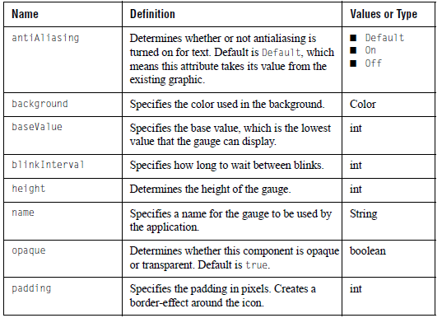

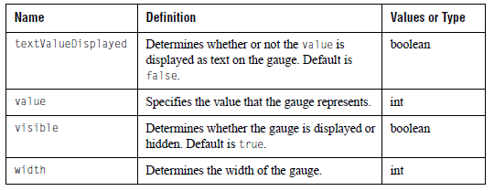

15.1.2 indicator-gauge-panel

Purpose:
Creates a panel that contains copies of the specified base-guage.

Equivalent in JCServerIndicatorGuagePanel
JClass ServerGuage:

Sub-Elements: ■ base-gauge
■ indicator-range
■ empty-border
■ bevel-border
■ etched-border
■ line-border
■ matte-border
■ titled-border
■ compound-border
■ fill-style
■ image-file
■ external-java-code
Attributes:

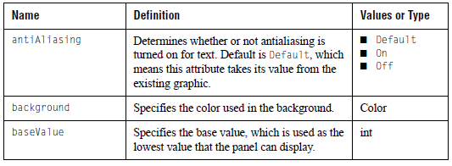

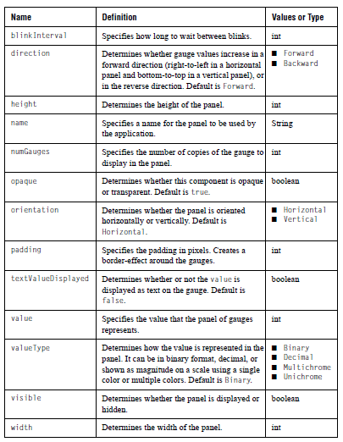

15.1.3 base-gauge

Purpose:
Creates an indicator guage to be replicated in an indicator-guage-panel.

Equivalent in JCBaseIndicatorGuage
JClass ServerGuage:

Sub-Elements: ■ fill-style
■ icon
■ image-file
Attributes:

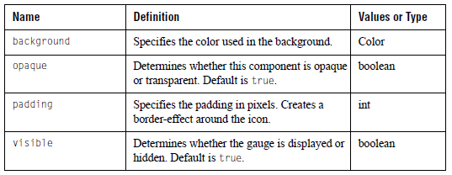

15.1.4 icon

Purpose:
Creates an icon to go on the guage.

Equivalent in JCindicatorIcon
JClass ServerGuage:

Sub-Elements: font

Attributes:

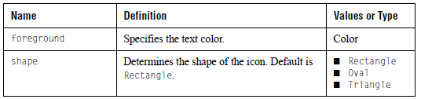
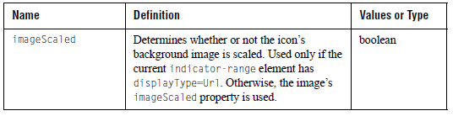

15.1.5 indicator-range

Purpose:
Specifies a attributes for each range.

Equivalent in CServerIndicatorGauge, JCServerIndicatorGaugePanel
JClass ServerGuage:

Sub-Elements: image-file

Attributes:

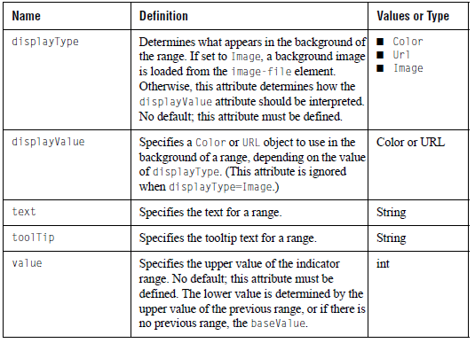

15.2 JCGauge DTD
The circular and linear gauges and the JCServerGraph component share the same DTD, called JCGauge.dtd. Its elements are described in this section. The primary element, gauge, is listed first. The remaining elements are listed in alphabetical order.

15.2.1 gauge

Purpose:
The main guage element. It is a wrapper that expects a guage-type subelement.

Equivalent in none
JClass ServerGuage:

Sub-Elements: ■ circular-gauge
■ linear-gauge
■ graph
■ indicator-gauge (from IndicatorGauge.dtd)
■ indicator-gauge-panel (from IndicatorGauge.dtd)

15.2.2 bevel-border

Purpose:
Bevel or SoftBevel borders.

Equivalent in javax.swing.border.BevelBorder or
JClass ServerGuage: javax.swing.border.SoftBevelBorder

Sub-Elements: none

Attributes:

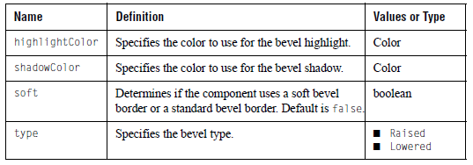

15.2.3 center

Purpose:
Specify the center of the circular guage.

Equivalent in JCCenter
JClass ServerGuage:

Sub-Elements: ■ fill-style
■ image-file
■ image-map-info

Attributes:

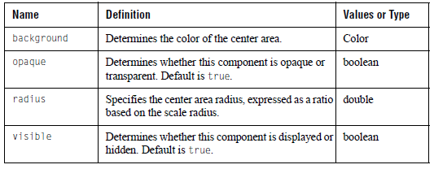

15.2.4 circular-gauge

Purpose:
Creates a circular gauge. The properties and sub-elements by and large coincide with the properties and sub-objects of the corresponding object within the gauge component.

Equivalent in JCServerCircularGauge
JClass ServerGuage:

Sub-Elements: ■ font
■ header
■ footer
■ legend
■ gauge-area
■ fill-style
■ image-file
■ image-map-info
■ needle
■ indicator
■ label
■ center
■ circular-scale
■ empty-border
■ bevel-border
■ etched-border
■ line-border
■ matte-border
■ titled-border
■ compound-border
■ external-java-codeAttributes:

Attributes:

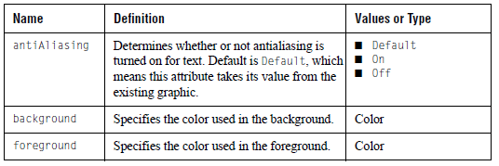

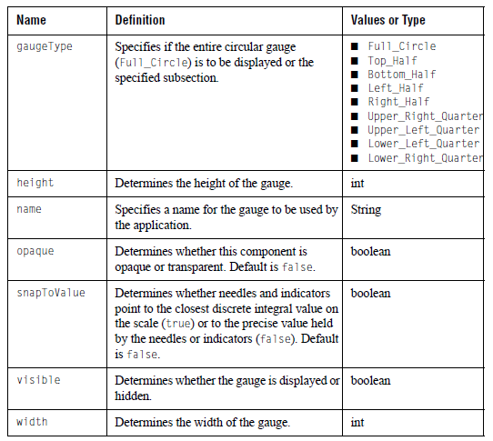

15.2.5 circular-range

Purpose:
Specify ranges in a circular scale.

Equivalent in JCRange, JCCircularRange
JClass ServerGuage:

Sub-Elements: ■ fill-style
■ image-map-info
■ image-file

Attributes:

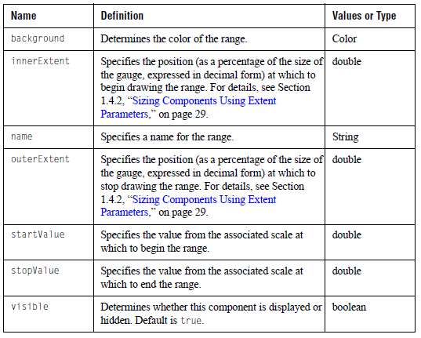

15.2.6 circular-scale

Purpose:
Defines the scale used in a circular gauge.

Equivalent in JCCircularScale
JClass ServerGuage:

Sub-Elements: ■ font
■ tick
■ circular-range
■ fill-style
■ image-file
■ image-map-info
■ empty-border
■ bevel-border
■ etched-border
■ line-border
■ matte-border
■ titled-border
■ compound-border

Attributes:

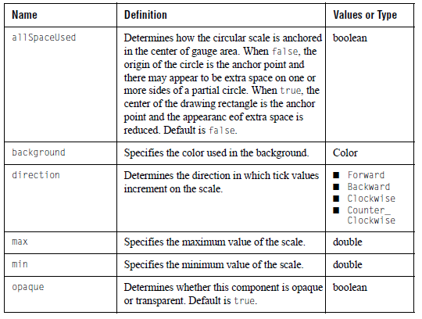
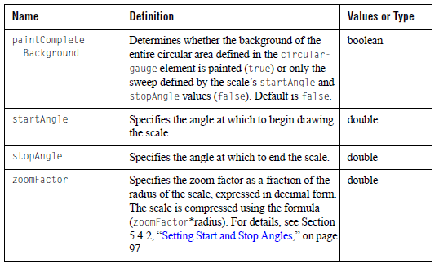

15.2.7 compound-border

Purpose:
Specifies an outside border and an inside border. Note that these subborders can also be of the type compound-border.

Equivalent in javax.swing.border.CompoundBorder
JClass ServerGuage:

Sub-Elements: ■ Empty-border
■ bevel-border
■ etched-border
■ line-border
■ matte-border
■ titled-border
■ compound-border

Attributes: none

15.2.8 dash-array

Purpose:
Specifies an array of values used to create a dashed line.

Equivalent in none
JClass ServerGuage:

Sub-Elements: value

Attributes: none

15.2.9 empty-border

Purpose:
Empty borders.

Equivalent in javax.swing.border.EmptyBorder
JClass ServerGuage:

Sub-Elements: insets

Attributes: none

15.2.10 etched-border

Purpose:
Empty borders.

Equivalent in javax.swing.border. EtchedBorder
JClass ServerGuage:

Sub-Elements: none

Attributes:

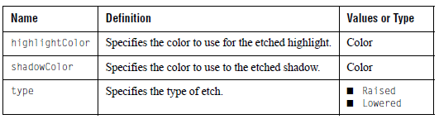

15.2.11 external-java-code

Purpose:
Specifies a Java class that will be created and called between the creation of a gauge via XML and the return of control to the calling code. This can be used for encapsulating gauge settings that cannot be set with XML.

The Java class must contain an empty constructor, as well as implement the com.klg.jclass.util.property.xml.ExternalCodeHandler interface. The ExternalCodeHandler interface specifies a method named handle() that is called by the JClass ServerGauge XML parser. The contents of the body of the tag will be passed to the handle() method in the userData parameter. The value of the UserObject property in the current LoadServerProperties class will be passed to the handle() method when it is called. For more information on LoadServerProperties, see Section 14.1.3, “LoadServerProperties Class,” on page 178. For an example of how to use this element, see ExternalJavaXMLExample.java in JCLASS_SERVER_HOME/examples/sgauge/xml.

Note: When a gauge that was created via XML is later saved to XML, the contents of this tag are not written out.

Equivalent in n/a
JClass ServerGuage:

Sub-Elements: none

Attributes:

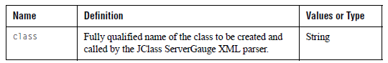

15.2.12 fill-style

Purpose:
The fill style used in the background of a component. Linear ranges (only) can also have
a fill style specified for the foreground.

Equivalent in com.klg.jclass.util.style.JCFillStyle
JClass ServerGuage:

Sub-Elements: ■ gradient
■ image-file
■ image-position

Attributes:

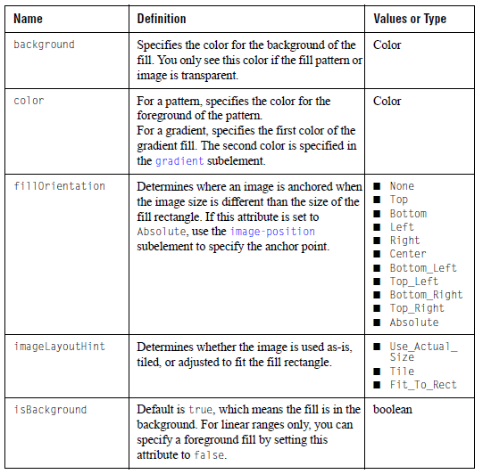

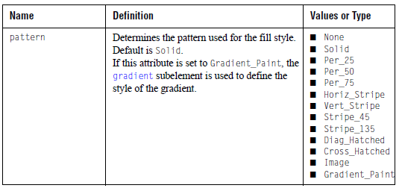

15.2.13 font

Purpose:
Creates a font object for use in headers, footers, legends, labels, and any other element
that contain text.
Equivalent in java.awt.Font
JClass ServerGuage:

Sub-Elements: none

Attributes:

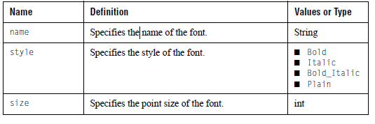

15.2.14 footer

Purpose:
The component used as the footer for the gauge.

Equivalent in JCLabel
JClass ServerGuage:

Sub-Elements: ■ font
■ empty-border
■ bevel-border
■ etched-border
■ line-border
■ matte-border
■ titled-border
■ compound-border
■ image-file
■ image-map-info
■ layout-hints

Attributes:

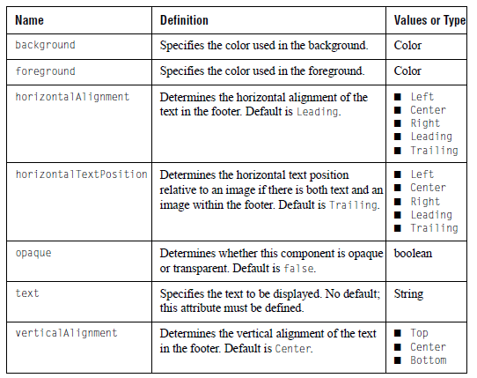

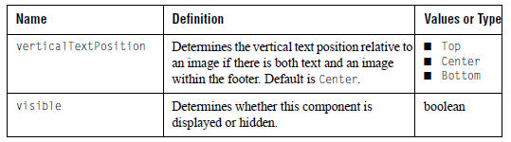

15.2.15 gauge-area

Purpose:
The area that contains the scale. Note that this does not include the header, footer, and
legend.

Equivalent in JCGaugeArea
JClass ServerGuage:

Sub-Elements: ■ font
■ empty-border
■ bevel-border
■ etched-border
■ line-border
■ matte-border
■ titled-border
■ compound-border
■ fill-style
■ image-map-info
■ layout-hints

Attributes:

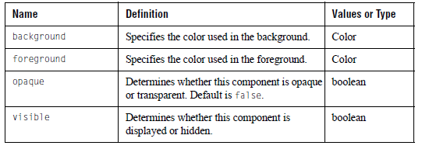

15.2.16 gradient

Purpose:
When the fill-style element’s pattern attribute is set to Gradient_Paint,
this element determines the appearance of the gradient fill.

Equivalent in n/a
JClass ServerGuage:

Sub-Elements: n/a

Attributes:

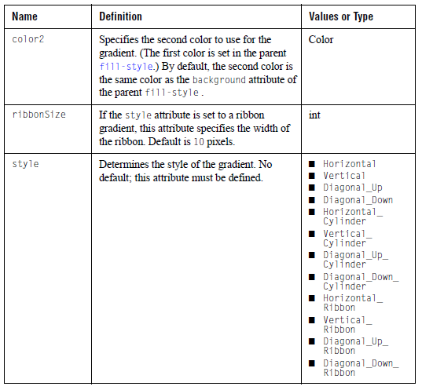

15.2.17 graph

Purpose:
A light-weight graph component.

Equivalent in JCServerGraph
JClass ServerGuage:

Sub-Elements: ■ values
■ empty-border
■ bevel-border
■ etched-border
■ line-border
■ matte-border
■ titled-border
■ compound-border
■ fill-style
■ image-file
■ line-style

Attributes:

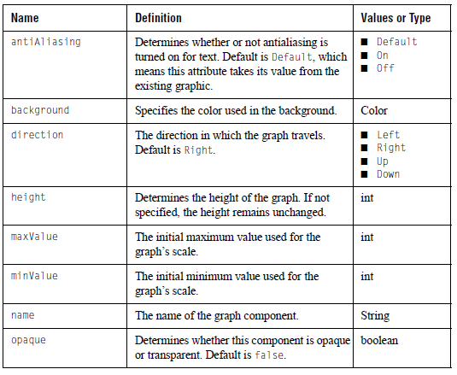

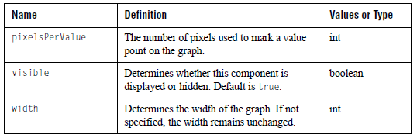

15.2.18 header

Purpose:
The component used as the header for the gauge.

Equivalent in JCLabel
JClass ServerGuage:

Sub-Elements: ■ font
■ empty-border
■ bevel-border
■ etched-border
■ line-border
■ matte-border
■ titled-border
■ compound-border
■ image-file
■ image-map-info
■ layout-hints

Attributes:

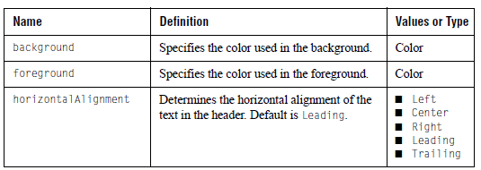

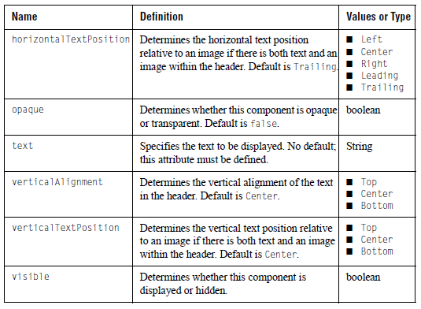

15.2.19 image-file

Purpose:
When the fill-style element’s pattern attribute is set to image,
this element specifies the image to use from an external source.

Equivalent in JCFillStyle.setImage(String filename)
JClass ServerGuage:

Sub-Elements: none

Attributes:

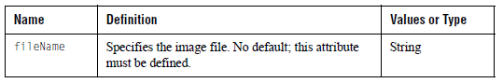

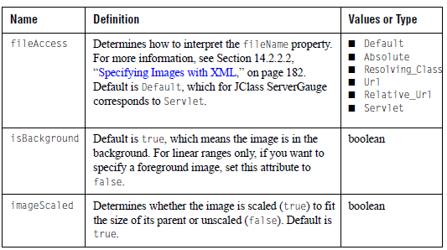

15.2.20 image-map-info

Purpose:
Sets the URL for an image map, and any extra information pertaining to it.

Equivalent in ImageMapInfo
JClass ServerGuage:

Sub-Elements: none

Attributes:

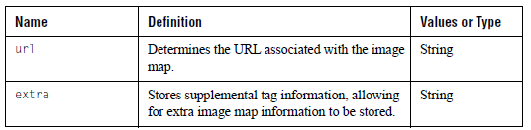

15.2.21 image-position

Purpose:
This attribute is used when the fill-style attributes are set as follows:
- pattern = Image
- fillOrientation = Absolute
- imageLayoutHint = Use_Actual_Size or Tile

Specifies an (x,y) position for the image within the rectangle to be filled.(0,0) corresponds to the top left corner of the fill rectangle.

Equivalent in java.awt.Point
JClass ServerGuage:

Sub-Elements: n/a

Attributes:

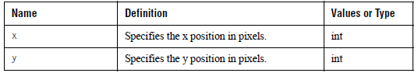

15.2.22 indicator

Purpose:
Specify the indicator to use with the scale. Note: If you want to enable interaction, use the
needle element instead.

Equivalent in JCIndicator, JCCircularIndicator, JCLinearIndicator
JClass ServerGuage:

Sub-Elements: ■ fill-style
■ image-map-info

Attributes:

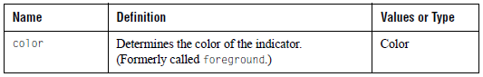
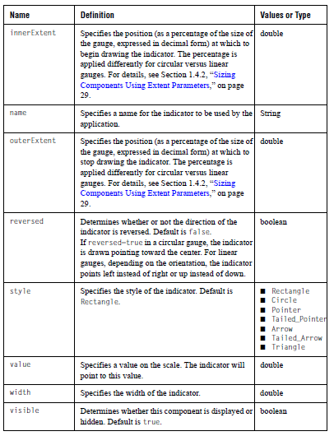

15.2.23 insets

Purpose:
A representation of the borders of a container used by the empty-border and
matte-border elements.
Equivalent in java.awt.Insets
JClass ServerGuage:

Sub-Elements: none

Attributes:

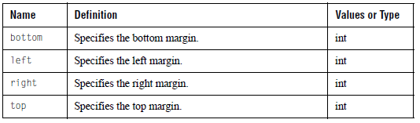

15.2.24 label

Purpose:
Specify a label. If the label is on a circular gauge, use a radial-constraint. If the label is on a linear gauge, use a linear-constraint.

Equivalent in JCLabel
JClass ServerGuage:

Sub-Elements: ■ font
■ linear-constraint
■ radial-constraint
■ image-file
■ image-map-info
■ empty-border
■ bevel-border
■ etched-border
■ line-border
■ matte-border
■ titled-border
■ compound-border

Attributes:

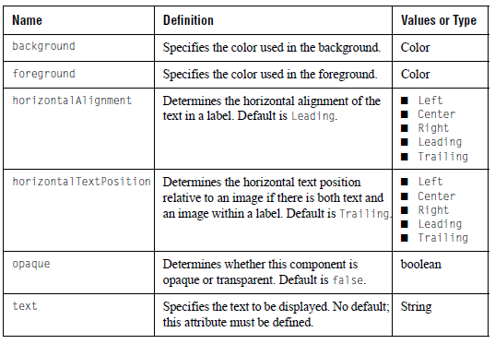

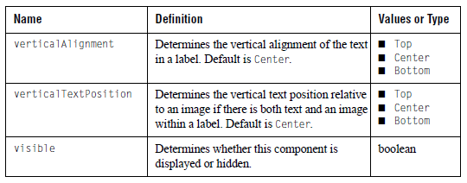

15.2.25 layout-hints

Purpose:
Specifies where and at what size a subcomponent (footer, gauge-area, header, or legend) is drawn on the gauge. Use this subelement to override some or all of the default values assigned when a subcomponent is created. If any of the attributes for this element are left unspecified, the gauge calculates a default value.

Equivalent in java.awt.Rectangle
JClass ServerGuage:

Sub-Elements: none

Attributes:

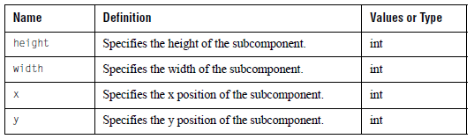

15.2.26 legend

Purpose:
Creates a component within the gauge to hold the legend.

Equivalent in com.klg.jclass.util.legend.JCLegend
JClass ServerGuage:

Sub-Elements: ■ font
■ legend-column
■ multi-col
■ empty-border
■ bevel-border
■ etched-border
■ line-border
■ matte-border
■ titled-border
■ compound-border
■ fill-style
■ image-map-info
■ layout-hints

Attributes:

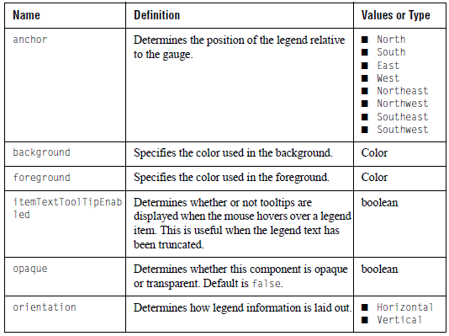

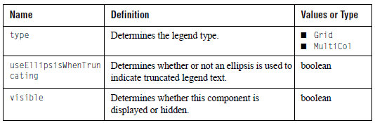

15.2.27 legend-column

Purpose:
Defines column attributes for the legend defined by the legend tag.

Equivalent in com.klg.jclass.util.legend.LegendColumn
JClass ServerGuage:

Sub-Elements: none

Attributes:
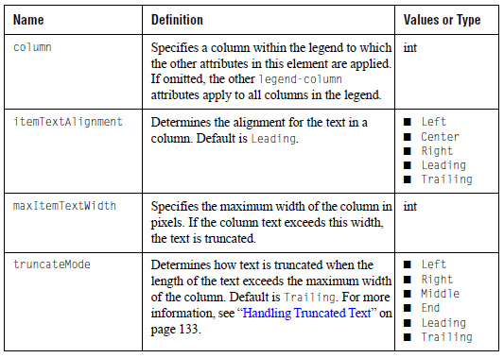

15.2.28 line-border

Purpose:
Line borders.

Equivalent in javax.swing.border.LineBorder
JClass ServerGuage:

Sub-Elements: none

Attributes:

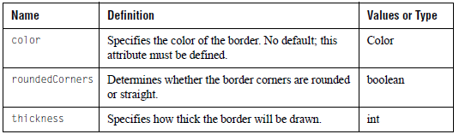

15.2.29 line-style

Purpose:
Line borders.

Equivalent in java.awt.BasicStroke
JClass ServerGuage:

Sub-Elements: dash-array

Attributes:

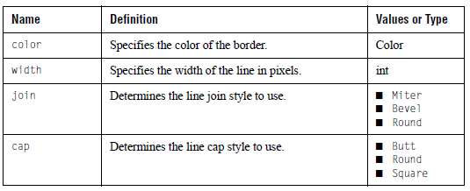

15.2.30 linear-constraint

Purpose:
Specify the position of a component (usually a label) on a linear gauge. The center of the component is placed at the position specified.

Equivalent in LinearConstraint
JClass ServerGuage:

Sub-Elements: none

Attributes:

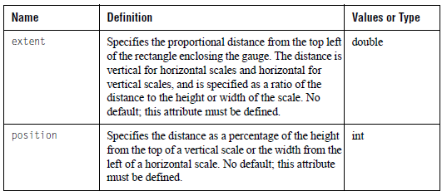

15.2.31 linear-gauge

Purpose:
Creates a linear gauge. The properties and sub-elements by and large coincide with the properties and sub-objects of the corresponding object within the gauge component.

Equivalent in JCServerLinearGauge
JClass ServerGuage:

Sub-Elements: ■ font
■ header
■ footer
■ legend
■ gauge-area
■ fill-style
■ image-file
■ image-map-info
■ needle
■ indicator
■ label
■ linear-scale
■ empty-border
■ bevel-border
■ etched-border
■ line-border
■ matte-border
■ titled-border
■ compound-border
■ external-java-code

Attributes:

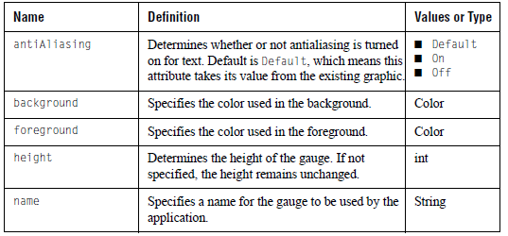

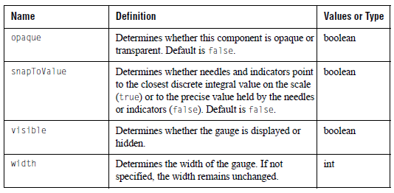

15.2.32 linear-range

Purpose:
Specify ranges in a linear scale. If using two images, you need to set one to be a background image and the other to be a foreground image, otherwise the second image overwrites the first image.

Equivalent in JCRange, JCLinearRange
JClass ServerGuage:

Sub-Elements: ■ image-map-info
■ fill-style (with isBackground=true)
■ image-file (with isBackground=true)
■ fill-style (with isBackground=false)
■ image-file (with isBackground=false)
■ fill-style
■ image-file

Attributes:

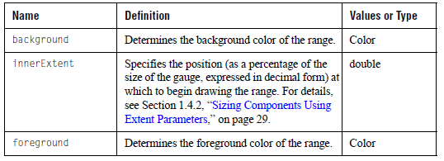

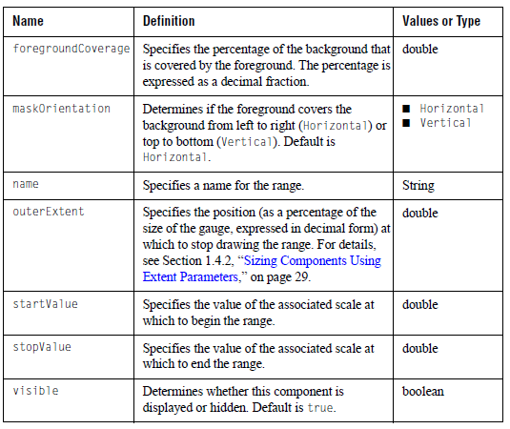

15.2.33 linear-scale

Purpose:
Defines the scale used in a linear gauge.

Equivalent in JCLinearScale
JClass ServerGuage:

Sub-Elements: ■ tick
■ linear-range
■ font
■ fill-style
■ image-file
■ image-map-info
■ empty-border
■ bevel-border
■ etched-border
■ line-border
■ matte-border
■ tilted-border
■ compound-border

Attributes:

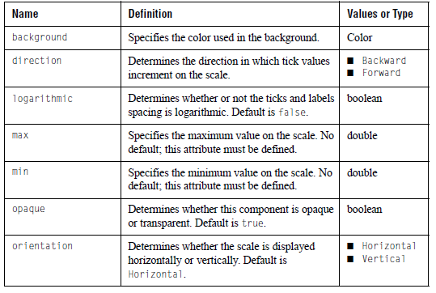
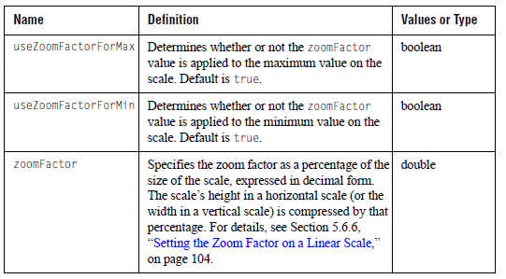

15.2.34 matte-border

Purpose:
Matte borders.

Equivalent in javax.swing.border.MatteBorder
JClass ServerGuage:

Sub-Elements: insets

Attributes:

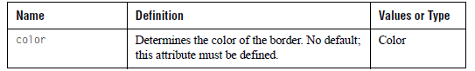

15.2.35 multi-col

Purpose:
Attributes to use when the legend element is defined with type=multiCol.

Equivalent in com.klg.jclass.util.legend.JCMult
iColLegend
JClass ServerGuage:

Sub-Elements: none

Attributes:

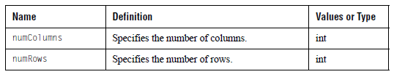

15.2.36 needle

Purpose:
Specify a needle to use with the scale.

Equivalent in JCNeedle, JCCircularNeedle, JCLinearNeedle
JClass ServerGuage:

Sub-Elements: ■ image-map-info
■ fill-style

Attributes:

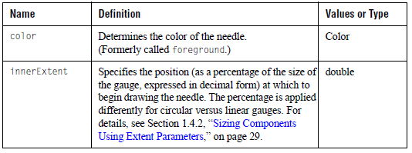

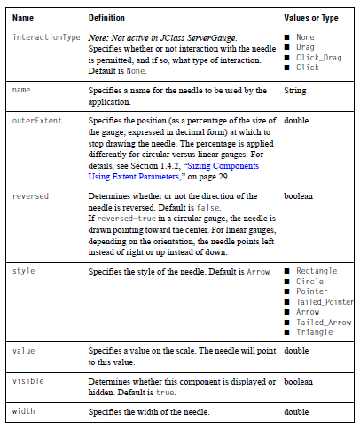

15.2.37 radial-constraint

Purpose:
Specify the position of a component (usually a label) on a circular gauge. The center of the component is placed at the position specified.

Equivalent in RadialConstraint
JClass ServerGuage:

Sub-Elements: none

Attributes:

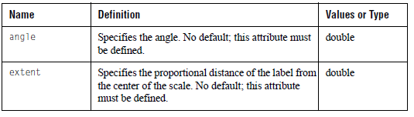

15.2.38 tick

Purpose:
Specify attributes for the ticks in a scale.

Equivalent in JCTick, JCCircularTick, JCLinearTick
JClass ServerGuage:

Sub-Elements: ■ font
■ image-map-info

Attributes:

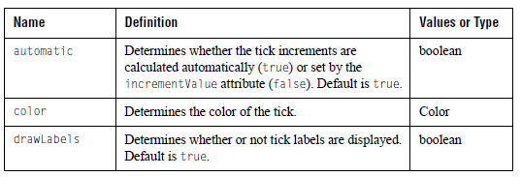

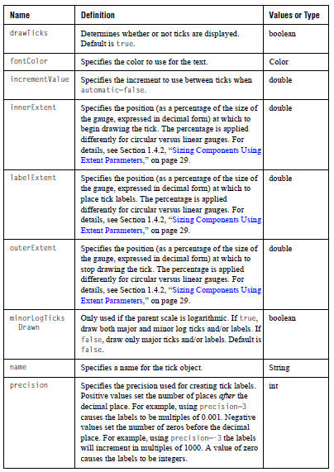

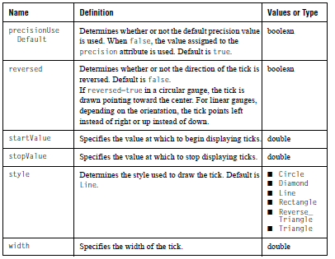

15.2.39 titled-border

Purpose:
A titled border. Note that you cannot specify a titled-border or a compound-border as a sub-element.

Equivalent in javax.swing.border.TitledBorder
JClass ServerGuage:

Sub-Elements: ■ font
■ empty-border
■ bevel-border
■ etched-border
■ line-border
■ matte-border

Attributes:
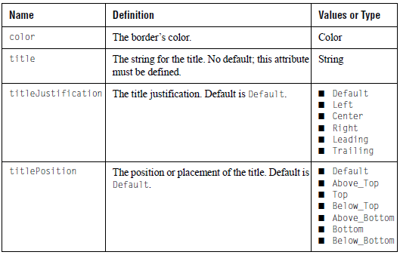

15.2.40 value

Purpose:
Value for the values or dash-array elements.

Equivalent in none
JClass ServerGuage:

Sub-Elements: #PCDATA

Attributes: none

15.2.41 values

Purpose:
An array of values representing the initial values for the graph component.

Equivalent in none
JClass ServerGuage:

Sub-Elements: value

Attributes: none

16

Creating Gauges for JSF or JSP
The JClass Service ■ JClass ServerGauge for JavaServer Faces
JClass ServerGauge for JavaServer Pages

This section is intended for programmers who are using JavaServer Faces (JSF) and/or JavaServer Pages (JSP). To make the most out of this information, you should already know how to author JSPs, and if you intend to use the JClass ServerGauge custom JSF components, you should already know how to use third-party JSF components. Links to useful reference information are provided in the Related Documents section in the Preface.

The topics in this section include how to set up the JClass Service, how to use JClass JCFacesGauge, and how to use the JClass ServerGauge JSP tag library.

16.1 The JClass Service

The JClass Service is a servlet that handles requests to execute JClass tasks. For JClass ServerGauge, the JClass Service generates new gauges or displays gauges that were generated earlier in the session. The gauges are outputted either as an image or as an image embedded in an HTML page. You can allow the JClass ServerGauge tag libraries to handle calls to the JClass Service or you can call the JClass Service directly. In either case, you must include the JClass Service in your web application.

16.1.1 Setting Up the JClass Service

To set up the JClass Service, you need to specify the URL where the service is located and set up the servlet mapping.

To specify the URL, add a context parameter to the web.xml file with the name com.klg.jclass.util.server.ServiceUrl and a value that represents a URL pattern. In the following example, the value is set to /jclass. When the JClass Service is used, if the context parameter is unspecified or its value is empty, an exception is thrown.

To set up the servlet mapping for the JClass Service, specify the servlet name and class as com.klg.jclass.util.server.JClassService and specify the same URL pattern that you used in the context parameter.

<web-app>
<context-param>
<param-name>com.klg.jclass.util.server.ServiceUrl</param-name>
<param-value>/jclass</param-value>
</context-param>
...
<servlet>
<servlet-name>
com.klg.jclass.util.server.JClassService
</servlet-name>
<servlet-class>
com.klg.jclass.util.server.JClassService
</servlet-class>
</servlet>
...
<servlet-mapping>
<servlet-name>
com.klg.jclass.util.server.JClassService
</servlet-name>
<url-pattern>
/jclass
</url-pattern>
</servlet-mapping>
</web-app>

16.1.2 Calling the JClass Service from the JClass Tag Libraries

The tag handlers from the JClass ServerGauge tag libraries automatically generate HTML to call the JClass Service. The call is made from an img tag, as demonstrated in the following HTML snippet.

<html>
...
<img src="/server-samples/jclass?service=gauge&amp;cache=session&amp;
id=-56103913" title="My Gauge" alt="My Gauge" usemap="#myMap">
<MAP NAME="myMap">
... image map definition ...
</MAP>
...
</html>

The src attribute in the above example generates a call to the JClass Service. The id is a unique number that is auto-generated by the tag handler responsible for creating the gauge when caching is used. The JClass Service uses the id to retrieve previously generated gauges from the cache. For more information, see Section 16.1.4, “Caching Generated Gauges,” on page 244.

Linear and Circular Gauges only: The usemap attribute and the MAP tag are included when you choose to add hyperlinks. If your gauge does not have hyperlinked regions, these tags are omitted. For more information, see Chapter 12, “Adding Hyperlinks to Gauge Components.”

16.1.3 Calling the JClass Service Directly

If you are not using the JClass ServerGauge tag libraries, you can still access the JClass Service by calling it directly. To call the JClass Service directly, you need to specify the URL for the JClass Service. You can choose to have the JClass Service return either a gauge image or an HTML page that will call the JClass Service to generate the image.

You can use the following parameters in addition to any of the parameters available with the JClass ServerGauge tags in the JSF or JSP tag libraries:

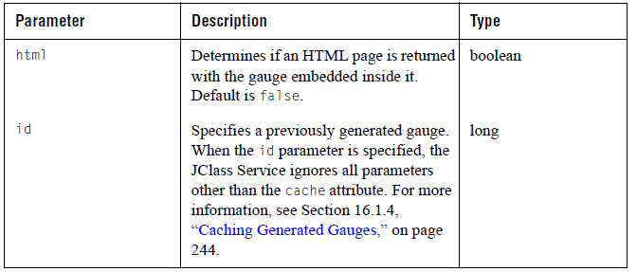

The following JClass ServerGauge example demonstrates how you can call the JClass Service directly using your browser’s address field or the href tag in an HTML page. In this example, the JClass Service returns a gauge embedded in an HTML page.

http://myserver/mywebapp/jclass?service=gauge\
&html=true\
&javaClass=com.company.package.MyGaugeBuilder\
&gaugeXml=Gauge.xml\
&encoding=jpg\
&name=MyGauge\
&cache=once\
&startDay=2004-04-01\
&endDay=2004-04-29

where startDay and endDay are extra parameters that can be retrieved by Java code. These parameters get passed to the class specified by the javaClass attribute.

16.1.4 Caching Generated Gauges

JClass ServerGauge saves the information about a generated gauge in a cache. This cache is normally saved in the session object using a uniquely generated id as a key. The JClass Service uses the id to find the cache, retrieve the gauge definition, and generate the image.

Gauges are always cached when using the JClass JCFacesGauge. If you are using the JClass ServerGauge tag library for JSP, you can choose to use the cache attribute to select the type of caching mechanism that you want to use or to turn off caching altogether. If cache is none, the gauge is not stored. For more information, see the cache attribute in Section 16.3.2, “JClass ServerGauge JSP Tags,” on page 252.

16.1.5 Using the serviceUrl Parameter to Specify the JClass Service

If you are using the JClass ServerGauge tag library for JSP, you can choose to specify the JClass service using the serviceUrl attribute. The path that you specify for the serviceUrl attribute must point to a JClass Service that is included in your web application.

When accessing the JClass Service, the JClass tag handler attempts to use the value of the serviceUrl attribute first. If the value is unspecified, it uses the value for the context parameter in the web.xml file. If the value of the context parameter is also unspecified or its value is empty, an exception is thrown.

16.2 JClass ServerGauge for JavaServer Faces
JSF gauge components offer the following advantages:

- Consistency of use.
You can use a JClass ServerGauge JSF component in the same way as standard JSF components. If you are already using JSF to simplify the logic of your UI pages, you can embed one or more gauges in a page, and you can use JSF actions to set component properties.
- State management, input validation and conversion, event management, and exception handling.
- Less code in user interface templates.

JClass JCFacesGauge extend the JavaServer Faces UICommand component. Thus, an ActionEvent is generated when an end-user clicks a gauge. This event is sent to all action listeners that are registered with the gauge. For more information, see Section 16.2.4.2, “Registering an Action Listener,” on page 250.

16.2.1 Locating the JClass ServerGauge Tag Library for JSF

The tag library description file, gauge-jsf.tld, is located in the JCLASS_SERVER_HOME/xml-dtd/ directory. The gauge-jsf.tld file is also included in the JClass ServerGauge JAR file,
jcsgauge.jar, in the META-INF directory. As long as jcsgauge.jar is in your classpath, you can access JClass JCFacesGauge.

The short name for the JClass ServerGauge JSF tag library is jcgaugejsf.

16.2.2 JClass ServerGauge JSF Tags

JClass ServerGauge has a JSF tag for each of the gauges and the graph.

The JSF tags in jcgaugejsf are:

- <jcgaugejsf:circularGauge>
- <jcgaugejsf:linearGauge>
- <jcgaugejsf:indicatorGauge>
- <jcgaugejsf:indicatorGaugePanel>
- <jcgaugejsf:graph>

The tag attributes are the same for all the tags, with minor exceptions. The following table defines the attributes and notes the differences where they exist:

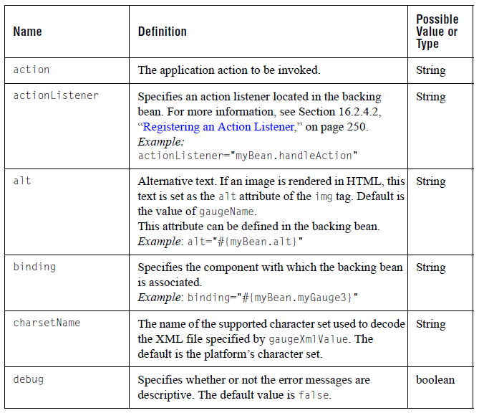
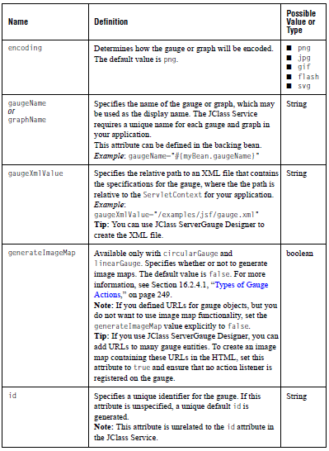
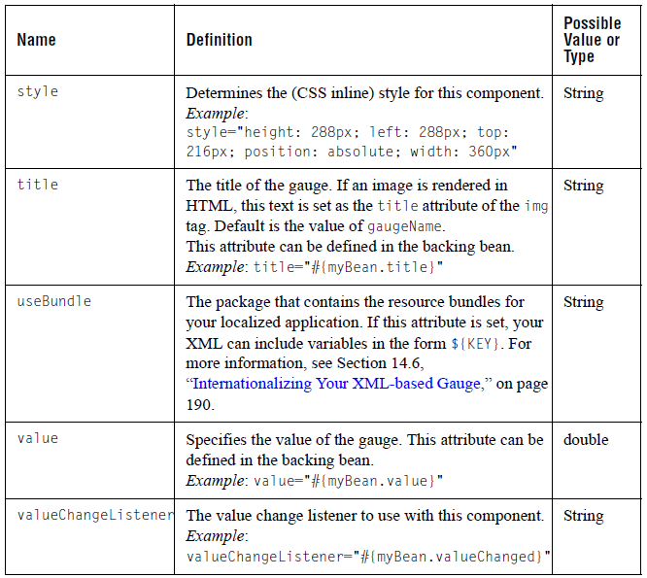

To learn more about the attributes, see the Javadoc in JCLASS_SERVER_HOME/docs/tlddocs. Alternatively, you can review the descriptions in the gauge-jsf.tld file.

16.2.3 Adding a JClass ServerGauge JSF Component to a JSP

To use a JClass ServerGauge JSF component, you need to include the JClass ServerGauge JSF taglib directive in your JSP file:

<%@ taglib uri="http://quest.com/jclass/jsf/gauge-jsf"
prefix="jcgaugejsf" %>

To add the gauge to your JSP, you use the jcgaugejsf short name as a prefix followed by one of the gauge tags, for example <jcgaugejsf:indicatorGauge>, within the scope of an <h:form> tag.

To define the appearance and behavior of the gauge, specify its attributes in an XML file. You can hand-code the XML file or you can use JClass ServerGauge Designer to design the gauge and then export its definition to an XML file. You pass the name of the XML file to the gauge using the gaugeXmlValue attribute.

Tip: If your IDE supports third-party JSF components, you may be able to add and use JClass ServerGauge JSF components from within your IDE.

To add a JClass ServerGauge JSF Component to a JSP:

- Include the JClass ServerGauge JSF taglib directive with the standard two JavaServer Faces taglib directives.
<%@ page contentType="text/html" %>
<%@ taglib uri="http://java.sun.com/jsf/html" prefix="h" %>
<%@ taglib uri="http://java.sun.com/jsf/core" prefix="f" %>
<%@ taglib uri="http://quest.com/jclass/jsf/gauge-jsf"
prefix="jcgaugejsf" %>

Alternatively, the JClass ServerGauge JSF tag library can be specified as follows:
<jsp:root version="1.2"
xmlns:jcgaugejsf="http://quest.com/jclass/jsf/gauge-jsf">

- At the appropriate place within your JSP page, place the tag for the gauge within the <h:form> tag:
<f:view>
...
<h:form>
...
<jcgaugejsf:indicatorGauge binding="#{basicIndicator.gauge1}"
gaugeXmlValue="/examples/sgauge/jsf/indicator-gauge.xml"
debug="true"
encoding="png"
id="gauge1"/>
...
</h:form>
...
</f:view>

- Ensure that the jcsgauge.jar file is included with the JAR files in the WEB-INF/lib directory of your application.

16.2.4 Adding Action Events to a Gauge

The JSF tags in JClass ServerGauge extend the UICommand component and thus are able to respond to action events on the gauge. Action events are fired by command components when the component is activated. For JClass ServerGauge, an action event occurs when an end user clicks on a JSF gauge. If the gauge has a registered action listener, the method or class specified by the listener handles the action event. If the gauge has no registered action listeners, the action event is ignored.

16.2.4.1 Types of Gauge Actions

The following table summarizes the four possibilities for gauge actions.

Note: The actions that generate an image map are only available for linear and circular gauges. Image maps are not supported for the indicator gauges and the graph.

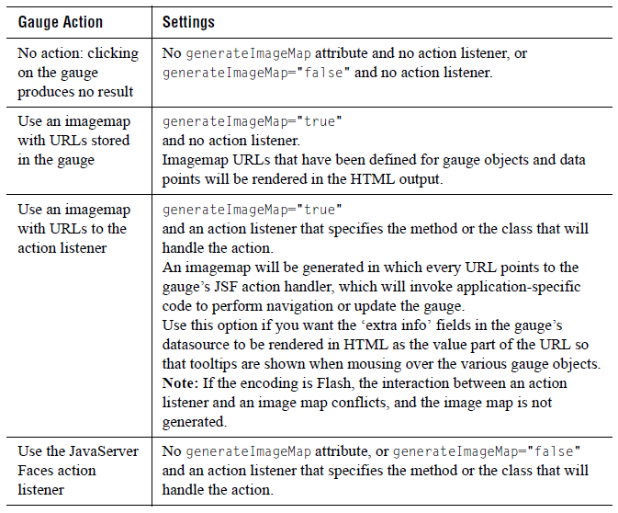

16.2.4.2 Registering an Action Listener

There are two ways that you can register an action listener with the gauge: as an attribute of one of the jcgaugejsf tags or by using the JSF <f:actionListener> tag. If you want to add more than one listener, you should use the JSF tag. In either case, the listener is passed a JCFacesGaugeEvent to handle the event.

Setting the actionListener Attribute

In the following code snippet (taken from actioncircular.jsp in JCLASS_SERVER_HOME/examples/sgauge/jsf/), the programmer creates a gauge component and registers the action listener using the actionListener attribute.

<jcgaugejsf:circularGauge binding="#{actionCircular.gauge1}"
gaugeXmlValue="/examples/sgauge/jsf/circular-gauge.xml"
debug="true"
encoding="png"
generateImageMap="false"
actionListener="#{actionCircular.gaugeClicked}"
id="gauge1"/>

The selection method is called in the backing bean listener:

public void selection(ActionEvent e)
{
JCFacesGaugeEvent event = (JCFacesGaugeEvent)e;
....
}

Adding an actionListener JSF tag

You can add multiple action listeners to the same gauge using this method. In the following example, the programmer adds an <f:actionListener> tag within the bounds of one of the jcgaugejsf tags.
<jcgaugejsf:circularGauge ... >
<f:actionListener type="myPackage.myGaugeListener"/>
</jcgaugejsf:circularGauge>

In the package myPackage, the programmer adds a class called myGaugeListener that implements the ActionListener interface. A JCFacesGaugeEvent is passed to the processAction() method of this class.

public class myGaugeListener implements ActionListener {
public void processAction(ActionEvent e) {
JCFacesGaugeEvent event = (JCFacesGaugeEvent)e;
....
}
}

16.2.4.3 JCFacesGaugeEvent

The JCFacesGaugeEvent class extends javax.faces.event.ActionEvent. The custom properties and methods are described briefly here; for details, see the API Documentation.

The following table summarizes the additional properties:

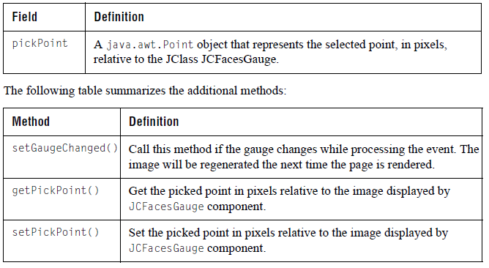

16.2.5 Internationalizing Your JSF JClass ServerGauge

You can internationalize the text displayed on your JClass ServerGauge JSF component in the same way as any XML-based gauge. For more information, see Section 14.6, “Internationalizing Your XML-based Gauge,” on page 190 and, in particular, Section 14.6.3, “Using Resource Bundles: JSF,” on page 193.

16.3 JClass ServerGauge for JavaServer Pages
If you are not using JavaServer Faces but still want to include a JClass ServerGauge within a JSP, you can use the JClass ServerGauge JSP tag library. With this custom tag library, you can create a gauge, encode it as an image, and include the gauge in the output, all without having to write a single line of Java code. The gauge creation is done behind the scenes using the JClass Service (see Section 16.1, “The JClass Service,” on page 241). As the JSP author, you need only create the tags and set the appropriate properties – the web container and the JClass Service do the rest.

16.3.1 Locating the JClass ServerGauge JSP Tag Library

The JClass ServerGauge JSP tag library description file, gauge-jsp.tld, is located in the JCLASS_SERVER_HOME/xml-dtd/ directory. The gauge-jsp.tld file is also included in the JClass ServerGauge JAR file, jcsgauge.jar, in the META-INF directory. As long as jcsgauge.jar is in your classpath, you can access the JClass ServerGauge tag library.

The URI attribute for the JClass ServerGauge tag library is http://quest.com/jclass/jsp/gauge-jsp. You can use this URI in the taglib directive in your JSP.

The short name for the JClass ServerGauge JSP tag library is jclass.

16.3.2 JClass ServerGauge JSP Tags

JClass ServerGauge has a JSP tag for each of the gauges and the graph, as well as two helper tags.

The JSP tags in jclass are:

- <jclass:circular-gauge>
- <jclass:linear-gauge>
- <jclass:indicator-gauge>
- <jclass:indicator-gauge-panel>
- <jclass:graph>
- <jclass:gaugeXml> (Processes the contents of the tag as XML.)
- <jclass:javaParam> (Allows user-specified parameters to be passed to a Java class .)

The following sections describe the JSP tags in more detail.

16.3.2.1 Gauge and Gragh Tags

The attributes for the gauge and graph tags are the same, with minor exceptions. The following table defines the attributes and notes the differences where they exist:

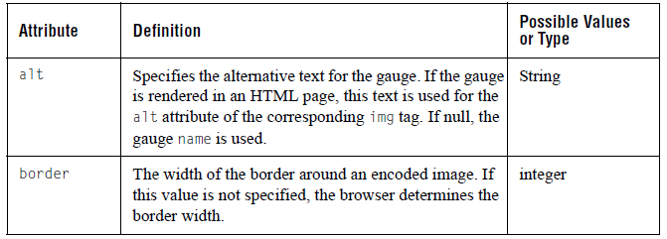
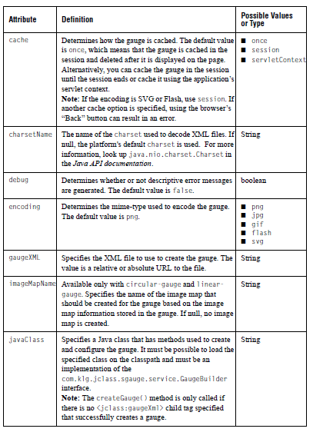
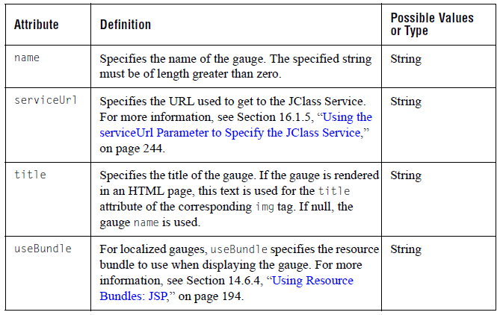

16.3.2.2 <jclass:gaugeXml>

Use this tag to process the contents of the tag as XML that is applied to the gauge.

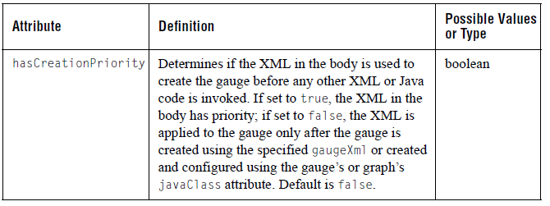

16.3.2.3 <jclass:javaParam>

Use this tag to pass specific parameters to a Java class that is used to create or configure gauges. The Java class is specified using the javaClass attribute in the gauge or graph tag.

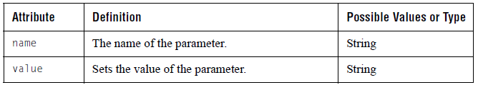

16.3.3 Adding a JClass ServerGauge to a JSP

The following is an example of a JSP that uses the <jclass:linear-gauge> tag. Other tags use the same attributes, except that image maps are not supported for indicator gauges and the graph:

<%@ page contentType="text/html;charset=UTF-8" language="java" %><%@ taglib uri="http://quest.com/jclass/jsp/gauge-jsp" prefix="jclass" %>

<html>
<jclass:linear-gauge gaugeXml="/examples/sgauge/servlet/gauge.xml"
encoding="png"
border="0"
name="JSP Example 1"
imageMapName="myMap"
cache="session"/>
</html>

The tag handler causes a gauge to be created and loaded with the properties contained in gauge.xml. The gauge is encoded to a PNG image and an image map is generated based on the image map defined in the XML file. It is all stored in a bean, which is cached as an attribute of the current session. The tag is translated into HTML that calls the JClass Service, which then locates the bean in the cache and displays the image. Since caching is used, there is no need for the gauge to be regenerated if the page is reloaded or if a gauge with the exact same specifications is required again.

Here is another example that embeds XML right into the JSP, encodes into PNG, and uses the caching once mechanism. In this case, the gauge is cached in the session as the previous example, but deleted from the cache the first time it is referenced:

<%@ page contentType="text/html;charset=UTF-8" language="java" %><%@ taglib uri="http://quest.com/jclass/jsp/gauge-jsp" prefix="jclass" %>

<html>
<jclass:indicator-gauge encoding="png"
name="JSP Example 2"
cache="once">
<jclass:gaugeXml>
<gauge>
<indicator-gauge width="600" height="600" value="2">
</indicator-gauge>
</gauge>
</jclass:gaugeXml>
</jclass:indicator-gauge>
</html>

The next example uses a Java class to create and configure a graph. This Java class must implement the com.klg.jclass.sgauge.service.GaugeBuilder interface. This example also uses <jclass:javaParam> tags to pass information to the Java class.

<%@ page contentType="text/html;charset=UTF-8" language="java" %><%@ taglib uri="http://quest.com/jclass/jsp/gauge-jsp" prefix="jclass" %>
<html>
<jclass:graph encoding="jpg"
name="JSP Example 3"
javaClass="examples.sgauge.jsp.BuildGauge"
border="0"
cache="once">
<jclass:javaParam name="company0" value="IBM" />
<jclass:javaParam name="company1" value="Sun" />
</jclass:graph>
</html>

16.3.4 Internationalizing Your JClass ServerGauge

If you are using XML for your JClass ServerGauge, you can internationalize the text displayed on the gauge. For more information, see Section 14.6, “Internationalizing Your XML-based Gauge,” on page 190 .

