

© 2013 Quest Software, Inc. ALL RIGHTS RESERVED.
This guide contains proprietary information protected by copyright. The software described in this guide is furnished under a software license or nondisclosure agreement. This software may be used or copied only in accordance with the terms of the applicable agreement. No part of this guide may be reproduced or transmitted in any form or by any means, electronic or mechanical, including photocopying and recording for any purpose other than the purchaser’s personal use without the written permission of Quest Software, Inc.

The information in this document is provided in connection with Quest products. No license, express or implied, by estoppel or otherwise, to any intellectual property right is granted by this document or in connection with the sale of Quest products. EXCEPT AS SET FORTH IN QUEST'S TERMS AND CONDITIONS AS SPECIFIED IN THE LICENSE AGREEMENT FOR THIS PRODUCT, QUEST ASSUMES NO LIABILITY WHATSOEVER AND DISCLAIMS ANY EXPRESS, IMPLIED OR STATUTORY WARRANTY RELATING TO ITS PRODUCTS INCLUDING, BUT NOT LIMITED TO, THE IMPLIED WARRANTY OF MERCHANTABILITY, FITNESS FOR A PARTICULAR PURPOSE, OR NON-INFRINGEMENT. IN NO EVENT SHALL QUEST BE LIABLE FOR ANY DIRECT, INDIRECT, CONSEQUENTIAL, PUNITIVE, SPECIAL OR INCIDENTAL DAMAGES (INCLUDING, WITHOUT LIMITATION, DAMAGES FOR LOSS OF PROFITS, BUSINESS INTERRUPTION OR LOSS OF INFORMATION) ARISING OUT OF THE USE OR INABILITY TO USE THIS DOCUMENT, EVEN IF QUEST HAS BEEN ADVISED OF THE POSSIBILITY OF SUCH DAMAGES. Quest makes no representations or warranties with respect to the accuracy or completeness of the contents of this document and reserves the right to make changes to specifications and product descriptions at any time without notice. Quest does not make any commitment to update the information contained in this document.

If you have any questions regarding your potential use of this material, contact:
Quest Software World Headquarters
LEGAL Dept
5 Polaris Way
Aliso Viejo, CA 92656
www.quest.com
email: legal@quest.com

Refer to our Web site for regional and international office information.

Trademarks Quest, Quest Software, the Quest Software logo, AccessManager, ActiveRoles, Aelita, Akonix, Benchmark Factory, Big Brother, BridgeAccess, BridgeAutoEscalate, BridgeSearch, BridgeTrak, BusinessInsight, ChangeAuditor, CI Discovery, Defender, DeployDirector, Desktop Authority, Directory Analyzer, Directory Troubleshooter, DS Analyzer, DS Expert, Foglight, GPOADmin, Help Desk Authority, Imceda, IntelliProfile, InTrust, Invirtus, iToken, JClass, JProbe, LeccoTech, LiteSpeed, LiveReorg, LogADmin, MessageStats, Monosphere, NBSpool, NetBase, NetControl, Npulse, NetPro, PassGo, PerformaSure, Point, Click, Done!, Quest vToolkit, Quest vWorkSpace, ReportADmin, RestoreADmin, ScriptLogic, SelfServiceADmin, SharePlex, Sitraka, SmartAlarm, Spotlight, SQL Navigator, SQL Watch, SQLab, Stat, StealthCollect, Storage Horizon, Tag and Follow, Toad, T.O.A.D., Toad World, vAutomator, vConverter, vEcoShell, VESI, vFoglight, vPackager, vRanger, vSpotlight, vStream, vToad, Vintela, Virtual DBA, VizionCore, Vizioncore vAutomation Suite, Vizioncore vEssentials, Vizioncore vWorkflow, WebDefender, Webthority, Xaffire, and XRT are trademarks and registered trademarks of Quest Software, Inc in the United States of America and other countries. For a complete list of Quest Software’s trademarks, see http:// www.quest.com/legal/trademark-information.aspx. Other trademarks and registered trademarks used in this guide are property of their respective owners.Other trademarks and registered trademarks are property of their respective owners.

Third Party Contributions
JClass ServerViews contains some third party components (listed below). Copies of their licenses may be found on our website at www.quest.com/legal/third-party-licenses.aspx.

Component | License or Acknowledgement
Apache Tomcat | Apache Foundation License version 2.0
GifEncoder | Copyright 1996 by Jef Poskanzer (www.acme.com).
International Components for Unicode | Copyright 1995–2006 International Business Machines Corporation and others. All rights reserved.
JDOM | Copyright 2002–2002 Brett McLaughlin & Jason Hunter, all rights reserved.

Designer User’s Guide
January 2013
Version 6.2

Table of Contents
Preface 11
Licensing 12
About Quest Software, Inc. 13
Contacting Quest Software 13
1 Learning JClass ServerChart Basics 16
1.1 Chart Areas 16
1.2 Chart Types 17
1.3 Supported Development Environments 20
1.4 Adding Data 21
1.5 Setting and Getting Object Properties 22
1.6 Other Programming Basics 26
1.7 Outputting JClass ServerCharts 28
1.8 JClass ServerChart Inheritance Hierarchy 28
1.9 JClass ServerChart Object Containment 29
1.10 Internationalization 31
2 Creating Your First Chart: Michelle’s Microchip Tutorial 33
2.1 Introduction to Michelle’s Microchips 33
2.2 A Basic Plot Chart 33
2.3 Loading Data from a File 37
2.4 Adding Header, Footer, and Labels 38
2.5 Changing to a Bar Chart 41
2.6 Inverting Chart Orientation 42
2.7 Bar3d and 3d Effects 43
2.8 Adding a Chart to a Servlet 44
2.9 Get Started Programming with JClass ServerChart 47
3 Selecting a Chart Type 48
3.1 Plot and Scatter Plot Charts 48
3.2 Area and Stacking Area Charts 50
3.3 Bar and Stacking Bar Charts 54
3.4 Financial Charts 57
3.5 Timeline Charts 60
3.6 Pie Charts 71
3.7 Polar Charts 74
3.8 Radar Charts 79
3.9 Area Radar Charts 82
4 Adding Data with the Underlying Data Model 85
4.1 Understanding the Underlying Data Model 85
4.2 Pre-Built Chart DataSources 85
4.3 Loading Data from a Text Data File 86
4.4 Loading Data from a URL 86
4.5 Loading Data from a Swing TableModel 87
4.6 Loading Data from an XML Source 87
4.7 Text Data Formats 95
4.8 Making Your Own Chart Data Source 100
4.9 Defining Data Thresholds for Bar Charts 108
5 Adding Data with the Targeted Data Model 111
5.1 Overview of the Targeted Data Model 111
5.2 Adding Data from a Result Set to a Chart 113
5.3 Chart Types and Data Set Classes 116
5.4 Adding Image Maps 134
5.5 Setting Other Data-related Attributes 140
5.6 Creating a Custom Data Set Implementation 145
6 Defining Axis Controls 164
6.1 Axis Labelling and Annotation Methods 164
6.2 Positioning Axes 179
6.3 Chart Orientation and Axis Direction 180
6.4 Setting Axis Bounds 181
6.5 Customizing Origins 181
6.6 Logarithmic Axes 182
6.7 Titling Axes and Rotating Axis Elements 183
6.8 Using Invisible Axes 185
6.9 Gridlines 185
6.10 Adding a Second Y-Axis 187
7 Defining Text and Style Elements 189
7.1 JCLabel Class 189
7.2 Header and Footer Titles 190
7.3 Legends 190
7.4 Chart Labels 203
7.5 Chart Styles 211
7.6 Outline Style 214
7.7 Holes and Hole Styles 215
7.8 Borders 221
7.9 Fonts 222
7.10 Colors 222
7.12 3D Effect 225
7.13 Anti-Aliasing 226
8 Defining Markers and Thresholds 227
8.1 Markers 227
8.2 Thresholds 239
9 Defining Background Fill Styles 252
9.1 Setting the Component’s Background Color 252
9.2 Creating a Background Fill with JCFillStyle 252
9.3 Specifying a Pattern 255
9.4 Specifying an Image 255
9.5 Specifying a Gradient Fill 259
9.6 Specifying a Custom Paint 263
9.7 Filling a Plot Area 263
9.8 Creating Stacked Images in a Bar Chart 263
10 Defining Image Maps 265
10.1 How Image Maps Work with JClass ServerChart 265
10.2 ImageMapRules Class – Defining the Image Map Shape 265
10.3 Specifying the Image Map Tags 274
10.4 Generating the Image Map Tags 282
11 Learning JClass ServerChart Basics 284
11.1 pickItem() Method 284
11.2 Pick Focus 286
11.3 pick() Method 287
11.4 pickSeries() Method 287
11.5 Unpick() Method 288
11.6 Coordinate Conversion Methods 288
12 Encoding a Chart 291
12.1 Selecting an Image Format 291
12.2 Encoding a Component 292
12.3 Making an Image Object from a Component 295
13 Using JCServerChartFactory 297
13.1 Overview of the JCServerChartFactory Class 297
13.2 Overview of the LoadServerProperties Class 298
13.3 Saving Data: The OutputDataProperties Class 301
13.4 Saving Image Information: The OutputProperties Class 302
14 Loading and Saving Charts Using HTML 304
14.1 Overview of HTML for JClass ServerChart 304
14.2 Creating a Chart from HTML 305
14.3 Updating a Chart Using HTML 310
14.4 Saving a Chart to HTML 312
15 Loading and Saving Charts Using XML 315
15.1 Background XML Information 315
15.2 Overview of XML for JClass ServerChart 316
15.3 Creating a Chart Using XML 316
15.4 Updating a Chart Using XML 322
15.5 Saving a Chart to XML 324
15.6 Internationalizing Your XML-based Chart 326
16 Creating Charts with JavaBeans 335
16.1 Introduction to JavaBeans 335
16.2 JClass ServerChart Bean Tutorial 336
16.3 JavaBeans and JSPs 341
16.4 Choosing the Right Bean 343
16.5 Standard Bean Properties 344
16.6 Getting Started with the ServerChart Bean 345
16.7 ServerChart Bean Property Reference 346
16.8 Headers, Footers, and Legends 350
16.9 Data Source and Data View Controls 351
16.10 Appearance Controls 354
16.11 View3D 356
17 Creating Charts for JSF or JSP 358
17.1 The JClass Service 358
17.2 JClass JCFacesChart with JavaServer Faces 361
17.3 JClass ServerChart JSP Tag Library 371
A HTML Syntax 378
A.1 ChartDataView Properties 379
A.2 ChartDataViewSeries Properties 380
A.3 Header and Footer Properties 381
A.4 ImageMapInfo Properties 381
A.5 ImageMapRules Properties 382
A.6 JCAreaChartFormat Properties 382
A.7 JCAnnoProperties 382
A.8 JCAxis X-Axes and Y-Axes Properties 383
A.9 JCBarChartFormat Properties 385
A.10 JCCandleChartFormat Properties 385
A.11 JCChartArea Properties 385
A.12 JCChartLabel Properties 386
A.13 JCDataIndex Properties 387
A.14 JCGrid Properties 387
A.15 JCHiLoChartFormat Properties 388
A.16 JCHLOCChartFormat Properties 388
A.17 JCLegend Properties 389
A.18 JCMarker Properties 389
A.19 JCMultiColLegend Properties 391
A.20 JCPieChartFormat Properties 391
A.21 JCPolarRadarChartFormat Properties 392
A.22 JCServerChart Properties 392
A.23 JCThreshold Properties 393
B XML DTD 394
B.1 Chart.dtd 394
B.2 JCChartData.dtd 452
Glossary 458

Preface
Assumptions ■ Examples and Demos ■ API Documentation
Tag Library Documentation ■ Licensing ■ About Quest Software, Inc.

JClass ServerChart is a charting/graphing component written entirely in Java. It can be used to generate images and image files for client- and server-side use.

- The chart component can be used by all types of Java programmers, including:
- Component users, to set JClass ServerChart properties programmatically
- OO developers, to instantiate and extend JClass ServerChart objects
- JavaBean developers, to use JClass ServerChart Beans with Integrated Development Environments (IDEs), servlets, and JSPs to set JClass ServerChart properties
- Web developers, to use JClass ServerChart inside JSPs or JSF pages

You can freely distribute the images and image maps generated with JClass ServerChart according to the terms of the License Agreement that appears during the installation.

Assumptions

This manual assumes that you have some experience with the Java programming language. You should have a basic understanding of object-oriented programming and Java programming concepts such as classes, methods, and packages before proceeding with this manual. If you want to use JClass ServerChart in servlets or JavaServer Pages (JSPs), or if you want to use the JavaBean or JavaServer Faces (JSF) components, you should already be familiar with the technology before attempting to add a chart.

Examples and Demos

JClass ServerChart ships with examples and demos. The examples show you how to create and customize a single JClass ServerChart component. Demos demonstrate how to use one or more JClass ServerChart components within the context of a larger application. Many of the JClass ServerChart examples and demos are referenced in this guide.

The quickest way to run the examples and demos is to use the Jakarta Tomcat application server that is installed with JClass ServerViews.

- Start the server by selecting tomcat-startup from the JCLASS_SERVER_HOME/bin/ directory.

Note: Microsoft Windows users can launch the Tomcat server from the JClass ServerViews program group off the Start menu.

- In a web browser, go to: http://localhost:8686/server-samples/
- Select the link for JClass ServerChart.
A list of examples and demos is displayed.
- Click the name of an example or demo to run it.

Most examples and demos provide a direct link to their source code. The source code is
installed with the compiled classes in the JCLASS_SERVER_HOME/examples/schart/ and JCLASS_SERVER_HOME/demos/schart/ directories.

API Documentation

The Javadocs for the JClass ServerChart API are part of the JClass ServerViews API Documentation. The API documentation is installed automatically when you install JClass ServerViews. It is located in the JCLASS_SERVER_HOME/docs/api/ directory.

The following packages are particularly relevant for JClass ServerChart:
- com.klg.jclass.chart.*
- com.klg.jclass.schart.*
- com.klg.jclass.util.io
- com.klg.jclass.util.legend
- com.klg.jclass.util.server
- com.klg.jclass.util.style
- import com.klg.jclass.util.swing.encode
- import com.klg.jclass.util.swing.encode.swf

On Microsoft Windows installations, you can find a link to the API documentation from the Start menu under the JClass ServerViews program group.

Tag Library Documentation

The JClass ServerViews Tag Library Documentation (Javadoc) is installed automatically when you install JClass ServerChart and is found in the JCLASS_SERVER_HOME/docs/tlddocs/ directory.

Licensing
In order to use JClass ServerChart Designer, you need a valid license. Complete details about licensing are outlined in the JClass ServerViews Installation Guide, which is automatically installed when you install JClass ServerChart.

About Quest Software, Inc.
Quest Software (now a part of Dell) simplifies and reduces the cost of managing IT for more than 100,000 customers worldwide. Our innovative solutions make solving the toughest IT management problems easier, enabling customers to save time and money across physical, virtual and cloud environments. For more information about Quest go to www.quest.com.

Contacting Quest Software

Email | info@quest.com
Mail | Quest Software, Inc. World Headquarters 5 Polaris Way  Aliso Viejo, CA 92656 USA
Web site | www.quest.com

See our web site for regional and international office information.

Contacting Quest Support
Quest Support is available to customers who have a trial version of a Quest product or who have purchased a Quest product and have a valid maintenance contract. Quest Support provides unlimited 24x7 access to Support Portal at http://support.quest.com.
From our Support Portal, you can do the following:
- Retrieve thousands of solutions from our online Knowledgebase
- Download the latest releases and service packs
- Create, update and review Support cases
View the Global Support Guide for a detailed explanation of support programs, online services, contact information, policies and procedures. The guide is available at: http://support.quest.com.
Quest Communities

Get the latest product information, find helpful resources, and join a discussion with the JClass Quest team and other community members. Join the JClass community at http://jclass.inside.quest.com/.

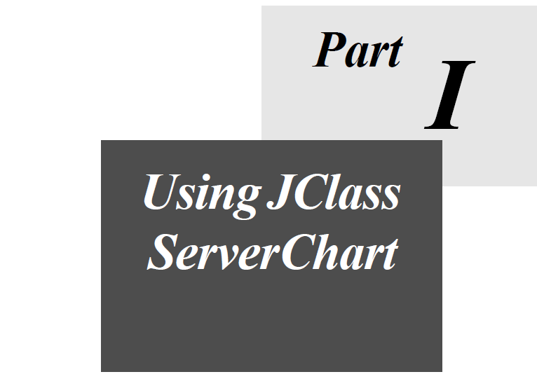

1
Learning JClass ServerChart Basics
Chart Areas ■ Chart Types ■ Supported Development Enviroments ■ Adding Data
Setting and Getting Object Properties ■ Other programming Basics ■ Outputting JClass ServerCharts
JClass ServerChart Inheritance Hierarchy ■ JClass ServerChart Object Containment
Internationalization

This chapter covers concepts and vocabulary used in JClass ServerChart programming, and provides an overview of the JClass ServerChart class hierarchy.

1.1 Chart Areas
The following illustration shows the terms used to describe chart regions:

Figure 1 Elements contained in a typical chart.

1.2 Chart Types
JClass ServerChart can display data in any of the following basic chart types: plot, scatter plot, area, stacking area, bar, stacking bar, pie, Hi-Lo, Hi-Lo-Open-Close, candle, timeline, polar, radar, and area radar. It is also possible to simulate more specialized types of charts using one of these basic types.

The following table lists basic information about each chart type, including the enumeration that sets that type and the data layouts it can display (see the next section for an introduction to data).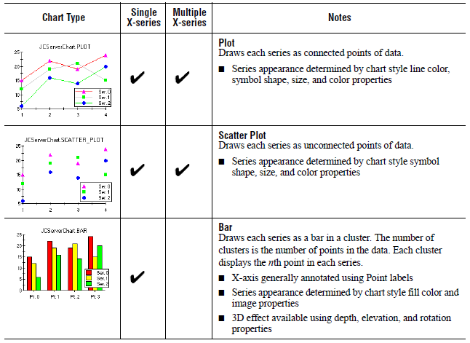

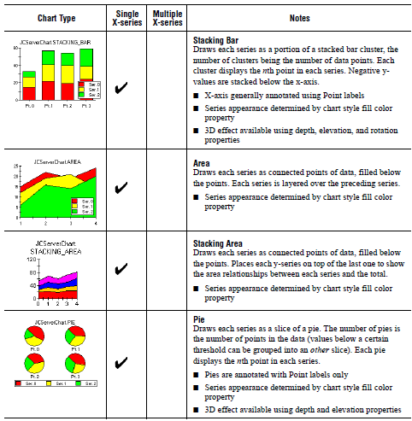
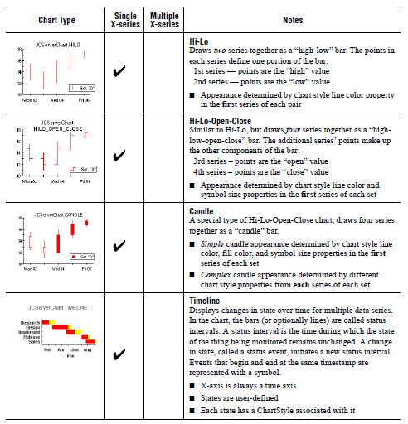

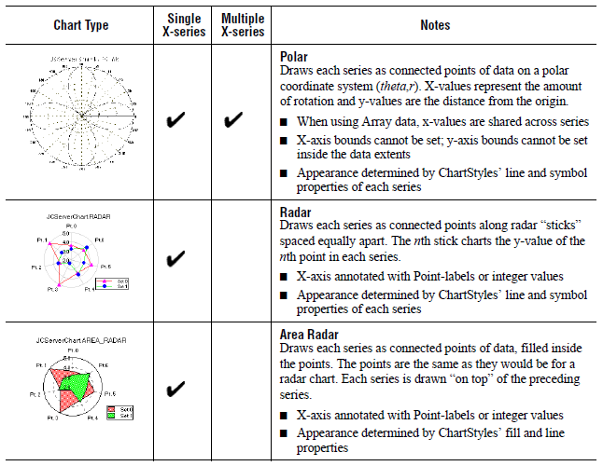

1.3 Supported Development Environments
Part I of this guide shows you how to create and customize a JClass ServerChart programmatically. You can, however, also add JClass ServerCharts to applications developed for the following environments:
- HTML
- XML
- JavaBeans
- JavaServer Faces (JSF)
- JavaServer Pages (JSP)

These environments are touched upon throughout this guide, but Part II concentrates on using JClass ServerChart with supported technologies. Part II contains the following chapters:
- Using JCServerChartFactory, in Chapter 13
- Loading and Saving Charts Using HTML, in Chapter 14
- Loading and Saving Charts Using XML, in Chapter 15
- Creating Charts with JavaBeans, in Chapter 16
- Creating Charts for JSF or JSP, in Chapter 17

1.4 Adding Data
You add data to a chart using one of two data models: the underlying data model or the targeted data model. The underlying data model is universal, while the targeted data model can be used only for certain types of applications. The following sections summarize the data models.

Tip: If your data is stored as a JDBC result set and you are creating your chart programmatically, review the Targeted Data Model section first.

1.4.1 Underlying Data Model

The underlying data model is data-format dependent and chart-type independent. This data model requires that your data be stored as an array of doubles, which means that you may need to create a compliant data source. The chart type, however, can be changed by resetting a single property.

The underlying data model can be used to add data to any JClass ServerChart application. It is also the preferred model if your data is dynamic and needs to be updated frequently. For more information, see Chapter 4, Adding Data with the Underlying Data Model.

1.4.2 Targeted Data Model

The targeted data model is data-format independent and chart-type dependent. This means that your data can be stored in any format and, as you match the data in your data source to chart elements, you do so with properties that are meaningful for the type of chart that you selected. Behind the scenes, JClass ServerChart transforms your data into an array of doubles and calls the underlying data model to do the actual work of creating the chart.

While the targeted data model is data-format independent, the implementation of the data model that ships with JClass ServerChart is designed specifically for JDBC result sets. The implementation includes pre-built result set data set classes; you instantiate the data set class designed for the chart type that you selected. For more information, see Chapter 5, Adding Data with the Targeted Data Model.

The targeted data model is supported for servlets and any other application where you have programmatic access to the chart. You can even use it with the JSF component, JClass JCFacesChart, to pass a data object to a chart via a backing bean. You may want to review the JClass ServerChart examples that implement the targeted data model to see how easy it is to add data to a chart using the chart-type specific interfaces.

Note: The targeted data model is not supported for JSPs, JavaBeans, XML, and charts created with JClass ServerChart Designer (which is XML-based). You need to use the underlying data model.

1.5 Setting and Getting Object Properties
Depending on your development environment, you can choose to specify the properties for your chart in a number of ways. For example, in a Java program you would use the set and get methods to access the chart properties, while for a servlet you may want to provide the properties in an HTML file. This guide therefore refers to properties to discuss how features work, rather than using the method or parameter you might use to set that property. In most cases, you need to understand the chart’s object containment hierarchy to access its properties. Use the JClass ServerChart Object Containment diagram later in this chapter to determine how to access the properties of an object.

You can specify properties for your chart in the following ways:

- Java: Use the set and get methods for the properties. Part I of this guide describes how to specify the properties of a chart programmatically.
- HTML and Servlets: Specify properties using HTML syntax. You can load the properties from an HTML file, reader, stream, or String, or as parameters in a servlet request or URL. For more information, see Chapter 14, Loading and Saving Charts Using HTML.
- XML, JSP, and JSF: Specify properties as XML tags. You can load the properties from an XML file or embed the XML in the JSP. If you use the JClass ServerChart Designer to edit properties, you can save the results to an XML file for this purpose. For more information, see Chapter 15, Loading and Saving Charts Using XML, and Chapter 17, Creating Charts for JSF or JSP.
- JavaBeans: Specify Bean properties using a Java IDE. Consult your IDE’s documentation for details on how to load third-party Bean components into the IDE. You can also refer to the IDE chapter in the JClass ServerViews Installation Guide.
- JSP and JavaBeans: Specify Bean properties as JSP tags. You can load Bean properties from an HTML file. For more information, see JavaBeans and JSPs, in Chapter 16.
- HTML, Servlets, and JavaBeans: Specify Bean properties as HTML tags. You can load the properties from an HTML file or as parameters in a servlet URL.

1.5.1 Setting Properties with Java Code

Every JClass ServerChart property has a set and get method associated with it. For example, to retrieve the value of the AnnotationMethod property of the first x-axis, the getAnnotationMethod() method is called:

method = c.getChartArea().getXAxis(0).getAnnotationMethod();

To set the AnnotationMethod property of the same axis:

c.getChartArea().getXAxis(0).setAnnotationMethod(
JCAxis.POINT_LABELS);

These statements navigate the objects contained in the chart by retrieving the values of successive properties, which are contained objects. In the code above, the value of the ChartArea property is a JCChartArea object. The chart area has an XAxis property, the value of which is a collection of JCAxis objects. The axis also has the desired AnnotationMethod property.

For detailed information on the properties available for each object, consult the JClass ServerViews API Documentation, which is automatically installed when you install JClass ServerChart, and is found in JCLASS_SERVER_HOME/docs/api/index.html.

1.5.2 Setting Properties with HTML or XML

You can use HTML or XML to set and save chart properties. This has the following benefits:
- Speed — You can see the effects of a set of property values quickly.
- Flexibility — You can use a single class to create many different kinds of charts simply by varying HTML/XML properties; end-users can modify properties to suit their own needs.
- Repeatability — You can save the values of chart properties to a file, which can serve as a useful testing and debugging tool.

To create or update a chart from HTML or XML, and to save a chart to HTML or XML, you use the JCServerChartFactory class. For more information, see Chapter 13, Using JCServerChartFactory.

1.5.3 Setting Properties with a Java IDE at Design-Time

JClass ServerChart Bean can be used with a Java Integrated Development Environment (IDE), and its properties can be manipulated at design time. Consult your IDE’s documentation for details on how to load third-party Bean components into the IDE. You can also refer to the IDE chapter in the JClass ServerViews Installation Guide.

Most IDEs list a component’s properties in a property sheet or dialog. Simply find the property you want to set in this list and edit its value. Again, consult your IDE’s documentation for complete details.

1.5.4 Setting Properties with Property Parameters
To set chart properties with property parameters, use the methods in JClass ServerChart’s JCServerChartFactory class.

Creating a ServerChart Bean from Property Parameters in a Servlet Request
A ServerChart Bean instance can be created from parameters in the servlet request:

ServerChart chartBean =
JCServerChartFactory.makeServerChartBeanFromServletRequest
(request, context);

where request is the ServletRequest object passed into the servlet, context is the ServletContext object contained by the servlet, and parameters in the servlet request follow the pattern of names of the parameters in the ServerChart Bean.

For example, invoking a servlet that contains the above code with a URL of the form:

ServletName?chartWidth=400&chartHeight=400&data1Source=bar.dat&
data1ChartType=BAR&x1AnnoMethod=POINT_LABELS

will create a bar chart of size 400 x 400 with Point Label annotations and data read in from the bar.dat file. For other examples, please see the ParamBeanServlet.html file and ParamServlet class in JCLASS_SERVER_HOME/examples/schart/servlet/.

Please see Standard Bean Properties, in Chapter 16, for a full list of Bean properties.

1.5.5 Creating a JCServerChart Instance from Property Parameters
A JCServerChart instance may be created from property parameters, which may be read from the servlet request like this:

JCServerChart chart =
JCServerChartFactory.makeServerChartFromServletRequest(request, context, name);

where request is the ServletRequest object passed into the servlet, context is the ServletContext object contained by the servlet, and name is the name to use in reading parameters, usually an empty String.

1.5.6 Translucent Fill
In former JClass Server Views releases (prior to 6.2), all chart types are opaque. Now you can make a chart translucent, which works for both 2D and 3D charts, but in 3D chart types the translucency is more obvious. The following pictures depict the differences between an opaque bar chart and a

translucent bar chart.

To make a chart translucent:

- Firstly, define the translucent value for JCFillStyle class.
- Secondly, iterate all the dataviews of chart, get the dataViewSeries of dataView.
- Finally, iterate the dataViewSeries and reset the fillColor by translucent value defined just now. The method resetColorWithAlpha is used to change the alpha value of the original color, you can use other customized interface to replace it if you like.

The following method is an example of how to make a translucent chart.
//1. define the translucent value
java.util.List<ChartDataView> dataViews = getDataView();
int alpha = 55;
com.klg.jclass.util.style.JCFillStyle.setAlpha(alpha);
//2. iterate all the dataviews of chart, get the dataViewSeries of dataView for(ChartDataView dataViewTemp:dataViews){
for (int j = 0; j < dataViewTemp.getNumSeries(); j++) {
ChartDataViewSeries seriesTemp = dataViewTemp.getSeries(j);
//3. reset the fillColor by translucent value

seriesTemp.getStyle().setFillColor(JCFillStyle.resetColorWithAlpha(seriesTem
p.getStyle().getFillColor(), alpha));
}
}

The value of color's alpha is between 0 and 255; the smaller value set, the more translucent chart you get, for example:

Figure 2 When alpha is equal to 200.

Figure 3 When alpha is equal to 100

Figure 4 When alpha is equal to 50.

1.6 Other Programming Basics

1.6.1 Multithreaded Environments

In order to avoid synchronization problems when outputting to a multi-threaded environment (such as a servlet), the creation of the chart, its configuration by setting properties, and the encoding of the chart should be executed in the Java Event Dispatch thread, as recommended by the Swing documentation. Calling one of the following SwingUtilities methods will suffice:

- invokeLater()
- invokeAndWait()

Note: If a chart image is required, SwingUtilities.invokeAndWait() is most likely required as the code will need the image to be created before it can continue. For more information and an example of how this is done, see Adding a Chart to a Servlet, in Chapter 2.

1.6.2 Working with Object Collections

Many chart objects are organized into collections. For example, the chart axes are organized into the XAxis collection and the YAxis collection. In Beans terminology, these objects are held in indexed properties.

To access a particular element of a collection, specify the index that uniquely identifies this element. For example, the following code changes the maximum value of the first x-axis to 25.1:

c.getChartArea().getAxis(0).setMax(25.1);

Note that the index zero refers to the first element of a collection. Also, note that by default, JCChartArea contains one element in XAxis and one in YAxis.

1.6.3 Calling Methods

To call a JClass ServerChart method, access the object that defines the method. For example, the following statement uses the coordToDataCoord() method, defined by the ChartDataView collection, to convert a pixel value to its equivalent in data coordinates:

JCDataCoord dc = c.getDataView(0).coordToDataCoord(10,15);

Note: You need to use the underlying data model to complete this task. For more information, see Chapter 4, Adding Data with the Underlying Data Model and the ChartDataView class in the JClass ServerViews API Documentation.

1.6.4J Class ServerChart and Headless Operation

Headlessness is the ability of a component to render itself without any peripherals, including visual and input devices. This means that the component does not need to draw itself to a screen, nor is it necessary to have a rendering system present, to produce the desired chart.

JClass ServerChart runs in headless mode when using the headlessness support that is built into JDK 1.4 and later. If you want to use this built-in feature, run your JVM with the following option:

-Djava.awt.headless=true

1.7 Outputting JClass ServerCharts
JClass ServerChart allows you to convert an instance of the JCServerChart component into a java.awt.Image object and then, in turn, encode this Image into GIF, PNG, JPEG, Flash (.SWF), or SVG format.

For details about outputting JClass ServerChart, see Chapter 12, Encoding a Chart.

1.8 JClass ServerChart Inheritance Hierarchy
The following diagram provides an overview of class inheritance in JClass ServerChart.

Note: The Data Source area of the diagram shows the class inheritance for the underlying data model. For more information, see Understanding the Underlying Data Model, in Chapter 4. For information on the targeted data model, see Understanding the Targeted Data Model, in Chapter 5, and the com.klg.jclass.chart.model package in the JClass ServerViews API Documentation.
Figure 5 Class hierarchy of the com.klg.jclass.schart package.

1.9 JClass ServerChart Object Containment
When you create (or instantiate) a new chart, several other objects are also created. These objects are contained in and are part of the chart. Chart programmers need to traverse these objects to access the properties of a contained object. The following diagram shows the object containment for JClass ServerChart.

Note: The diagram shows the objects contained in the underlying data model (along the DataView[] path). For more information, see the text that follows the diagram. For information on the targeted data model, see Understanding the Targeted Data Model, in Chapter 5, and the com.klg.jclass.chart.model package in the JClass ServerViews API Documentation.

Figure 6 Objects contained in a ServerChart – traverse contained objects to access properties.

JCServerChart (the top-level object) manages header and footer JComponent objects, a legend (JCLegend), and the chart area (JCChartArea). The chart also contains a collection of data view (ChartDataView) objects and can contain the ChartLabelManager (JCChartLabelManager) which manages a collection of chart label (JCChartLabel) objects.

The chart area contains most of the chart’s actual properties because it is responsible for charting the data. It also contains and manages a collection of x-axis (JCAxis) objects and y-axis (JCAxis) objects (one of each by default).

The data view collection contains objects and properties (like the chart type) that are tied to the data being charted. Each data view contains a collection of series (ChartDataViewSeries) objects, one for each series of data points, used to store the visual display style of each series (JCChartStyle).

Note that the chart does not own the data itself, but instead merely views on the data. Each data view also contains a data source (ChartDataModel) object. The data is owned by the DataSource object. This is an object that your application creates and manages separately from the chart. For more information, see Chapter 4, Adding Data with the Underlying Data Model.

1.10 Internationalization
Internationalization is the process of making software that is ready for adaptation to various languages and regions without engineering changes. JClass ServerViews products have been internationalized.

Localization is the process of making internationalized software run appropriately in a particular environment.

In JClass ServerViews, all Strings that may be seen by a typical user have been internationalized and are ready for localization. These Strings are in resource bundles in every package that requires them. You need to create additional resource bundles for each of the locales that you want to support.

Note: Localizations that are built into the Java platform – such as number and date formatting – are handled by JClass ServerChart, without the need for you to do any extra work.

To localize your JClass ServerChart, you need the JClass ServerChart source code (requires a source code license). The packages that require localization have a resources subdirectory that contains the resource bundles, called LocaleInfo (or some similar variation, such as LocaleBeanInfo). You may want to perform an automated search of the package structure to find all the resource bundles.

To create a new resource bundle, copy the LocaleInfo.java file (staying within the same resources directory) and change its name to include standard language and country identifiers for the locale that you want to support. For example, if you want to support French as spoken in France, rename the copy of LocaleInfo.java to LocaleInfo_fr_FR.java. You can then replace the Strings in the copied file with the French translations.

To use a localized resource bundle, you pass the language and country identifiers to the setLocale() method. For example, setLocale(new Locale(fr, FR)) means that the Strings will be read from LocaleInfo_fr_FR.java.

For more information, including standard language and country identifiers, see http://java.sun.com/j2se/1.5.0/docs/guide/intl/index.html.

If you are creating XML-based charts, either manually or via JClass ServerChart Designer, you can internationalize the text on the charts using variables and a resource bundle. For more information, see Internationalizing Your XML-based Chart, in Chapter 15.

2
Creating Your First Chart: Michelle’s Microchip Tutorial
A Basic Plot Chart ■ Loading Data from a File ■ Adding Header, Footer, and Labels
Changing to a Bar Chart ■ Inverting Chart Orientation ■ Bar3d and 3d Effects
Adding a Chart to a Servlet ■ Get Started Programming with JClass ServerChart

This tutorial shows you how to start using JClass ServerChart, by compiling and running an example program.

Note: For a tutorial on using a JClass ServerChart Bean, see Chapter 16, Creating Charts with JavaBeans.

2.1 Introduction to Michelle’s Microchips
Michelle’s Microchips is a small company a little ahead of its time. The following table summarizes the 1963 Quarterly Expenses and Revenues for the company:

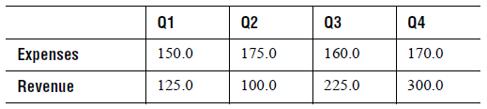

The following sections walk you through creating a plot chart of the company’s revenues and expenses.

2.2 A Basic Plot Chart
When MyPlot.java is compiled and run, a PNG file named chart.png is created, and contains the following image:
Figure 7 The MyPlot.java program displayed.

The following listing displays the program MyPlot.java. This is a minimal Java program that creates a new JClass ServerChart component, loads data into it from a file, and then encodes the resulting chart to a PNG file. It is run as a standalone application with the command java MyPlot.

The following table contains the source code for MyPlot.java.

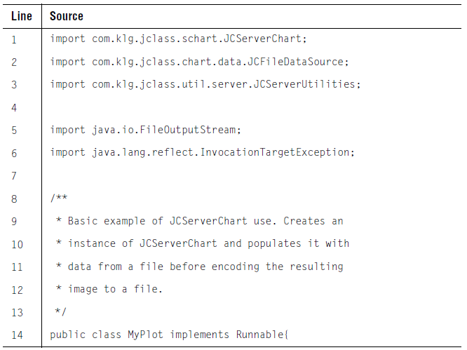
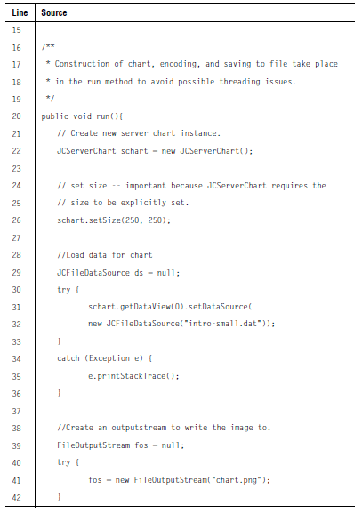
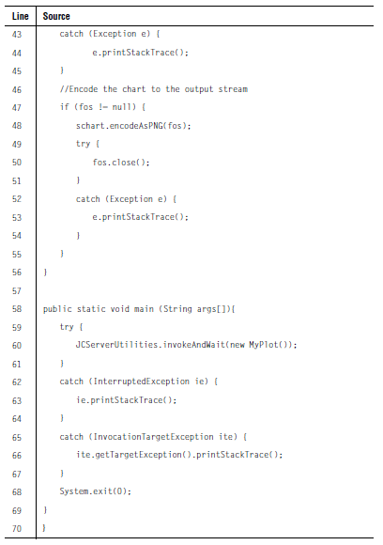

Most of the code in MyPlot.java should be familiar to Java programmers. The first few lines (1- 7) import the classes necessary to run this program. In addition to standard JDK classes, three classes in the JClass packages are required:

- JCServerChart, which is the main JClass ServerChart class;
- JCFileDataSource, which is a stock data source for loading data from a file;
- JCServerUtilities, which is a class that contains methods that are helpful in a web environment. For more information on using JCServerUtilities.invokeAndWait(), please refer to the note in Section 2.8, Adding a Chart to a Servlet.

Lines 20-56 define the run method. First, a JCServerChart instance is created on line 22. On line 26, it is set to the desired size. On lines 31 and 32, it is loaded with data from the file intro-small.dat. Lines 39-55 encode the chart into the PNG format and write the result to the file chart.png.

Lines 58 to 69 define the main() method needed to run the program as a standalone Java
application. It runs MyPlot using JCServerUtilities version of invokeAndWait.

2.3 Loading Data from a File
A common task in any JClass ServerChart program is to load the chart data into a format that the chart can use. JClass ServerChart uses a Model View Controller (MVC) architecture to handle data in a flexible and efficient manner. The data itself is stored in an object that implements the ChartDataModel interface created and controlled by your application. The chart has a ChartDataView object that controls a view on this data source, providing properties that control which data source to use, and how to display the data.

JClass ServerChart includes several stock (built-in) data sources that you can use (or you can define your own). This program uses the data source that reads data from a file: JCFileDataSource.

With this understanding we can look more closely at lines 29 to 30:

schart.getDataView(0).setDataSource(new JCFileDataSource("intro-small.dat"));

Two things are happening here: a new JCFileDataSource object is instantiated, with the name of the data file passed as a parameter in the constructor, and the DataSource property of the chart’s first (default) data view is being set to use this data source.

The following shows the contents of the file:

ARRAY 2 4
# x-values
1.0 2.0 3.0 4.0
# y-values
150.0 175.0 160.0 170.0
# y-values set 2
125.0 100.0 225.0 300.0

This file is in the format understood by JCFileDataSource. Lines beginning with a ‘#’ symbol are treated as comments. The first line tells the JCFileDataSource object that the data that follows is in Array layout and is made up of two series containing four points each. The x-values are used by all series.

There are two types of data: Array and General. Use Array layout when the series of y-values share common x-values. Use General when the y-values do not share common x-values, or when all series do not have the same number of values.

Note that for data arrays in polar charts, (x, y) coordinates in each data set will be interpreted as (theta, r). For array data, the x-array will represent a fixed theta value for each point.

In radar and area radar charts, only array data can be used. (x, y) points will be interpreted in the same way as for polar charts (above), except that the theta (that is, X) values will be ignored. The circle will be split into nPoints segments with nSeries points drawn on each radar line.

For complete details on using data with JClass ServerChart, see Chapter 4, Adding Data with the Underlying Data Model.

2.4 Adding Header, Footer, and Labels
The plot chart displayed by MyPlot.java is not very useful to an end-user. There is no header, footer, or legend, and the x-axis numbering is not very meaningful. JClass ServerChart will always try to produce a reasonable chart display, even if very few properties have been specified. JClass ServerChart uses intelligent defaults for all unspecified properties.

All properties for a particular chart may be specified when the chart is created. Properties may also be changed as the program runs by calling the property’s set method. A programmer can also ask for the current value of any property by using the property’s get method.

Adding Headers and Footers
To display a header or footer, we need to set properties of the Header and Footer objects contained in the chart. For example, the following code sets the Text and Visible properties for the footer:
// Make footer visible
schart.getFooter().setVisible(true);
// By default, footer is a JCLabel - set its Text property
((JCLabel)schart.getFooter()).setText("1963 Quarterly Results");

Visible displays the header/footer. Text specifies the text displayed in the header/footer.

By default, headers and footers are JCLabel objects, although they can be any Swing JComponent. JCLabel extends JLabel and makes it threadsafe by defining its own threadsafe user interface. For more information, see JCLabel Class, in Chapter 7.

You can use HTML tags inside label text in a JCLabel object, which overrides the default Font and Color properties of the label. HTML labels may not work with PDF or Flash encoding.

Adding a Legend and Labelling Points
A legend clarifies the chart by showing an identifying label for each series in the chart. We would also like to display more meaningful labels for the points along the x-axis. Both types of information can be easily specified in the data file itself. The following lists intro.dat, a modified version of the previous data file that includes series labels (for the legend), and point labels (for the x-axis):
ARRAY '' 2 4
# Point Labels
'Q1' 'Q2' 'Q3' 'Q4'
# x-values, with a blank series label ('') -- a blank series
# label is required if the y-values have series labels
'' 1.0 2.0 3.0 4.0
# y-values, with Series label (in this case, Expenses)
'Expenses' 150.0 175.0 160.0 170.0
# y-values set 2, with Series label (in this case, Revenue)
'Revenue' 125.0 100.0 225.0 300.0

Lines beginning with a ‘#’ symbol are treated as comments.

As noted in the comments within the above code, if series labels are being used for the -values, then the x-data must be preceded by a blank series label (''). This blank label will not show up on the chart. The third line specifies the point labels (for instance, “Q1”). Subsequent lines of data begin with a y-data series label (“Expenses” and “Revenue”).

This data file now provides the labels that we want to use, but to actually display them in the chart, we need to set the Legend object’s Visible property and change the AnnotationMethod property of the x-axis to annotate the axis with the point labels in the data.

Combining these changes, the chart is now created with code that looks like this:

JCServerChart schart = new JCServerChart();

// set size -- important because JCServerChart requires the
// size to be explicitly set
schart.setSize(250, 250);

// Load data for chart
try {
schart.getDataView(0).setDataSource(
new JCFileDataSource("intro.dat"));
} catch (Exception e) {
e.printStackTrace();
}

// Make header visible and add some text
schart.getHeader().setVisible(true);
((JCLabel)schart.getHeader()).setText("Michelle's Microchips");

// Make footer visible and add some text
schart.getFooter().setVisible(true);
((JCLabel)schart.getFooter()).setText("1963 Quarterly Results");

// Make legend visible
schart.getLegend().setVisible(true);

// Make x axis use point labels instead of default values
schart.getChartArea().getXAxis(0).setAnnotationMethod(
JCAxis.POINT_LABELS);

Because we are accessing a variable defined in JCAxis we need to add that to the classes imported by the program:

import com.klg.jclass.chart.JCAxis;

In the line that sets the annotation method, notice that XAxis is a collection of JCAxis objects. A single chart can display several x-axes and y-axes.

The chart resulting from these changes is displayed below.
Figure 8 Adding a header, footer, and legend to MyPlot.java.

2.5 Changing to a Bar Chart
A powerful feature of JClass ServerChart is the ability to change the chart type independently of any other property. For example, to change the chart to a bar chart, the following code can be used:

schart.getDataView(0).setChartType(JCServerChart.BAR);

This sets the ChartType property of the data view. Alternately, you can set the chart type when you instantiate a new chart, for example:

JCServerChart schart = new JCServerChart(JCServerChart.BAR);
Figure 9 MyPlot.java displayed as a bar chart.
JClass ServerChart can display data as one of 14 different chart types. For more information on chart types, see Chart Types, in Chapter 1.

2.6 Inverting Chart Orientation
Most rectangular charts display the x-axis horizontally and the y-axis vertically. It is often appropriate, however, to invert the sense of the x-axis and y-axis. This is easy to do, using the Inverted property of the data view object.

In a plot, inverting causes the y-values to be plotted against the horizontal axis, and the x-values to be plotted against the vertical. In a bar chart, it causes the bars to be displayed horizontally instead of vertically.

When programming JClass ServerChart, try not to assume that the x-axis is always the horizontal axis. Determining which axis is vertical and which horizontal depends on the value of the Inverted property.

To invert, set the data view object’s Inverted property to true. By default it is false.

schart.getDataView(0).setInverted(true);

The following shows the images created by the MyPlot.java program when axes are inverted:

Figure 10 Inverting the axes for MyPlot.java.

Note: You cannot invert the axes for circular charts or the timeline chart; the Inverted
property is ignored.

2.7 Bar3d and 3d Effects
Three-dimensional effects can be added to bar and stacking bar charts.

Here is the MyPlot.java program, with 3D effects added:

Figure 11 Adding 3D effects to MyPlot.java.

Three properties affect the display of 3D information: Depth, Elevation, and Rotation. Modifying these properties will alter the 3D effects displayed. Depth and at least one of Elevation or Rotation must be non-zero to see any 3D effects. The properties can be set as follows:

schart.getChartArea().setElevation(20);
schart.getChartArea().setRotation(30);
schart.getChartArea().setDepth(10);

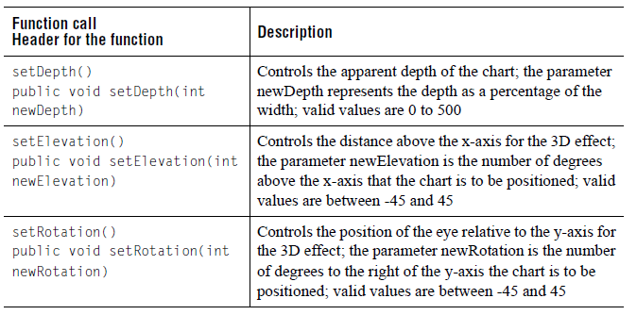

2.8 Adding a Chart to a Servlet
So far, our example merely creates an image from a chart and encodes this image to a file. One method of serving this chart image to a user via a web server is to use a servlet. The following example code uses the MyPlot.java file as the basis for the class MyPlotServlet.

import com.klg.jclass.chart.JCAxis;
import com.klg.jclass.chart.JCChartArea;
import com.klg.jclass.chart.ChartDataView;
import com.klg.jclass.chart.data.JCInputStreamDataSource;
import com.klg.jclass.schart.JCServerChart;
import com.klg.jclass.util.server.JCServerUtilities;

import javax.servlet.*;
import javax.servlet.http.*;
import javax.swing.*;
import java.io.*;
import java.lang.reflect.InvocationTargetException;

/**
* Basic example of ServerChart use within a servlet.
*/
public class MyPlotServlet extends HttpServlet {

protected ServletContext context = null;

/**
* Override init() to set up data used by invocations of this servlet.
*/
public void init(ServletConfig config) throws ServletException
{
super.init(config);

// Save servlet context
context = config.getServletContext();

}

/**
* Basic servlet method, answers requests from the browser.
*/
public void doGet(HttpServletRequest request, HttpServletResponse response)
{
try {
JCServerUtilities.invokeAndWait(new ChartRunner(response));
}
catch (InterruptedException ie) {
ie.printStackTrace();
}
catch (InvocationTargetException ite) {
ite.getTargetException().printStackTrace();
}
}

public class ChartRunner implements Runnable {

protected HttpServletResponse response;

public ChartRunner(HttpServletResponse response)
{
this.response = response;
}

public void run()
{
try {
// Create your instance of JCServerChart.
JCServerChart schart = new JCServerChart(JCServerChart.BAR);

// Set size -- important because JCServerChart requires the
// size to be explicitly set
schart.setSize(250, 250);

// Load data for chart
try {
InputStream is =
context.getResourceAsStream("/intro.dat");
ChartDataView dataView = schart.getDataView(0);
dataView.setDataSource(new JCInputStreamDataSource(is));
}
catch (Exception e) {
e.printStackTrace();
}

// Make header visible and add some text
JComponent header = schart.getHeader();
header.setVisible(true);
((JCLabel)header).setText("Michelle's Microchips");

// Make footer visible and add some text
JComponent footer = schart.getFooter();
footer.setVisible(true);
((JCLabel)footer).setText("1963 Quarterly Results");

// Make legend visible
schart.getLegend().setVisible(true);
// Make x axis use point labels instead of default values
JCChartArea chartArea = schart.getChartArea();
JCAxis xAxis = chartArea.getXAxis(0);
xAxis.setAnnotationMethod(JCAxis.POINT_LABELS);
chartArea.setElevation(20);
chartArea.setRotation(30);
chartArea.setDepth(10);

// Create a Stream to pass the image through
ServletOutputStream out = response.getOutputStream();

// Set the content type so browser interprets correctly
response.setContentType("image/png");

// Encode your chart
schart.encodeAsPNG(out);

// Make sure your image is delivered.
out.flush();
}
catch (IOException ioe) {
ioe.printStackTrace();
}
}
}
}

In this code example, the ServletContext is stored in the init() method, which will be used to get the correct path of the file containing our data. The run method of the ChartRunner class creates the JCServerChart instance and set its properties, similar to what was done in the previous MyPlot.java example. Next the chart is encoded in PNG format to the output stream of this servlet.

Note: The above example was written in a way that allows the servlet to be used in a multithreaded environment (for more information, see Setting and Getting Object Properties, in Chapter 1). In particular, it uses the JCServerUtilities.invokeAndWait() method to call the run() method of an instance of the inner class ChartRunner. JCServerUtilities.invokeAndWait() checks whether or not the code in the passed in the object's run() method should be executed within the Java Event Dispatch thread using SwingUtilities.invokeAndWait(), or run in the current thread. By default, this method check's the servlet's current environment to determine which one to use. However, the user can override this by calling JCServerUtilities.setUsingEventDispatchThread(), or by setting the system variable jclass.server.useEventDispatchThread.

When placed into a web server and accessed through a browser, the servlet serves the following image to the browser that requests it:
Figure 12 Displaying MyPlot.java as a 3D bar chart in a web browser.

2.9 Get Started Programming with JClass ServerChart
The following suggestions should help you become productive with JClass ServerChart as quickly as possible:

- Check out the examples and demos included with JClass ServerChart. These are useful in showing what JClass ServerChart can do, and how to do it. Run them and examine the source code. They can all be found in the JCLASS_SERVER_HOME/demos/schart/ and JCLASS_SERVER_HOME/examples/schart/ directories.
- Browse the JClass ServerViews API Documentation – complete reference documentation on the API is available in HTML format (automatically installed in JCLASS_SERVER_HOME/docs/api/). All of the properties, methods, and events for each component are completely documented.

3
Selecting a Chart Type
Plot and Scatter Plot Charts ■ Bar and Stacking Bar Charts
Area and Stacking Area Charts ■ Financial Charts ■ Timeline Charts ■ Pie Charts
Polar Charts ■ Radar Charts ■ Area Radar Charts

Most of the chart types share a set of common properties, such as a data view, data series, data points, data labels, axes, headers, footers, legends, and other style elements. These shared properties are described in other chapters. The purpose of this chapter is to highlight the differences among the chart types and describe how to use the properties special to one or more of the various chart types.

3.1 Plot and Scatter Plot Charts
In the plot-type charts, the (x,y) data points for each data series are plotted on a rectangular chart. By default, the x-axis is horizontal and the y-axis is vertical. In a plot chart, the data points in a series are connected by lines. In a scatter plot chart, the points remain unconnected.

Figure 13 Sample plot and scatter plot charts.

To specify a plot chart, you use the following syntax:

dataView.setChartType(JCServerChart.PLOT);

To specify a scatter plot chart, you use the following syntax:

dataView.setChartType(JCServerChart.SCATTER_PLOT);

Controlling How Dashed Lines are Drawn
By default, JClass ServerChart draws the lines and points on a plot chart in segments. For example, JClass ServerChart uses the following algorithm: draw a line from the first point to the second point, draw a symbol at the first point, draw a line from the second point to the third point, draw a symbol at the second point, and so on until all points are plotted. This is a memory efficient way of rendering a plot chart and is the recommended algorithm.

When you implement a dashed (or dotted) line style, the pattern of dashes restarts at each segment, which can result in an uneven dash pattern across the length of the plot line. While not usually a problem when viewing a chart on screen, the breaks in the pattern may be more obvious when the chart is printed. If you want the dashed line to have a continuous pattern through all plot points, you can choose to use the GeneralPath algorithm instead. The GeneralPath algorithm draws the entire plot line first (as a single unit) and then draws all the data points.

Note: The GeneralPath algorithm should not be used for plots with many points as it can use significantly more memory and is somewhat slower than the default plot algorithm.

To specify the GeneralPath algorithm, set the GeneralPathPlotUsed property on JCPlotChartFormat to true.

For example:

((JCPlotChartFormat)dataView.getChartFormat()).
setGeneralPathPlotUsed(true);

Inverted Plot Chart
You can change the axes so that the y-axis is horizontal and the x-axis is vertical. To invert the axes, set the Inverted property of the ChartDataView object to true. To invert charts with multiple data views, set the Inverted property of each ChartDataView object.

Figure 14 Inverted plot chart.

3.2 Area and Stacking Area Charts
In area charts, the (x,y) data points for each data series are plotted on a rectangular chart. The data points are connected with a line and the region below the line is filled in with a color or pattern. Each data series is drawn on top of the previously drawn series, with the last data series drawn appearing on top.

In a stacking area chart, the data series are stacked above one another. The stacking is accomplished by adding the y-value of the data point for the current series to the corresponding y-values of all the previously drawn data series.

The following figure shows the same data mapped on an area chart and a stacking area chart. You may notice that the blue data series visible in the stacking area chart is hidden behind other data series in the area chart.

Figure 15 Sample area chart and stacking area chart

To specify an area chart, you use the following syntax:

dataView.setChartType(JCServerChart.AREA);

To specify a stacking area chart, you use the following

syntax:dataView.setChartType(JCServerChart.STACKING_AREA);

100-Percent Stacking Area Charts
When 100Percent property is set to true, the y-axes display as an area percentage of the total. The top of the chart is 100% (the total of all y-values).

Figure 16 Stacking area chart with 100Percent=true

For example:

((JCAreaChartFormat)dataView.getChartFormat()).set100Percent(true);

Transitioning Across an Origin
In this context, origin refers to a line that represents zero either on the y-axis or x-axis. A transition occurs when data values in a series cross the origin, going from a positive value to a negative value or vice versa. When a data series crosses an origin in an area or stacking area chart, the transition is handled in such a way that there is a region of connection between polygons above and below the origin line. This enables the polygons in a stacking area chart to stack naturally.

Figure 17 Transitions across origin lines for area charts (left) and stacking area charts (right)

For area charts, you can choose to transition at data points rather than regions. To transition at data points, set ConnectedAcrossOrigin to true. This property is ignored for stacking area charts.

For example:

((JCAreaChartFormat)dataView.getChartFormat()).
setConnectedAcrossOrigin(true);

Figure 18 Transitions in an area chart when the ConnectedAcrossOrigin property is set to true

Outline Style
You can choose how you want to outline the regions in your area or stacking area chart. By default, the outline style of the ChartDataView is used. However, you can choose to use the line style defined for each data series or you can use solid lines in the color defined for the chart area foreground.

To specify an outline style, set the OutlineStyle property to one of
JCAreaChartFormat.OUTLINE_STYLE, JCAreaChartFormat.SERIES_LINE_STYLE, or JCAreaChartFormat.CHART_AREA_FOREGROUND.

For example:

((JCAreaChartFormat)dataView.getChartFormat()).
setOutlineStyle(JCAreaChartFormat.SERIES_LINE_STYLE);

Hole Interpretation

Holes are data points that are invalid or missing in the data series, or that are defined as holes in the data source. By default, holes are treated as absent values. In the chart, holes appear as gaps in the data series.
Figure 19 Holes represented in an area chart

You have the option of changing how holes are represented in area and stacking area charts. Instead of treating holes as absent values, you can use interpolate values or use the same value as the previous value in the data series. To specify how holes are represented, set the HoleInterpretation property to one of JCAreaChartFormat.ABSENT_VALUE (default), JCAreaChartFormat.INTERPOLATE_VALUE, or JCAreaChartFormat.PREVIOUS_VALUE.

Figure 20 Holes in stacking area chart using ABSENT_VALUE
Figure 21 Holes in stacking area chart using INTERPOLATE_VALUE

Figure 22 Holes in stacking area chart using PREVIOUS_VALUE

For example:

((JCAreaChartFormat)dataView.getChartFormat()).setHoleInterpretation(JCAreaChartFormat.INTERPOLATE_VALUE);

When you apply hole styles, the differences among the hole interpretations becomes clearer. For more information, see Representing Holes in Area and Stacking Area Charts, in Chapter 7.

3.3 Bar and Stacking Bar Charts
In bar charts, the (x,y) data points in a data series are represented as bars, with each series assigned a unique color or pattern. All the data series in the data view share the same set of x-values, which results in clusters of bars at each x-axis value. By default, the x-axis is horizontal and the y-axis is vertical. You can customize the overlap and width of clusters, as described later in this section.
In a stacking bar chart, instead of clusters of bars, the data series are stacked above one another. The stacking is accomplished by adding the y-value of the data point for the current series to the corresponding y-values of all the previously drawn data series.

Figure 23 Sample bar and stacking bar charts.

To specify a bar chart, you use the following syntax:

dataView.setChartType(JCServerChart.BAR);

To specify a stacking bar chart, you use the following syntax:

dataView.setChartType(JCServerChart.STACKING_BAR);

Inverted Bar Chart
If you want the bars to be presented horizontally instead of vertically, you can invert the axes. To invert the axes, set the Inverted property of the ChartDataView object to true. To invert charts with multiple data views, you need to set the Inverted property for each ChartDataView object.
Figure 24 Inverted stacking bar chart.

Cluster Overlap
In bar charts, you can use the bar ClusterOverlap property to set the amount that bars in a cluster overlap each other. The default value is 0. The value represents the percentage of bar overlap. Negative values add space between bars and positive values cause bars to overlap. Valid values are between -100 and 100. The syntax is as follows:

((JCBarChartFormat)dataView.getChartFormat()).setClusterOverlap(50);
Figure 25 Negative and positive bar cluster overlap.

Cluster Width
Use the bar ClusterWidth property to set the space used by each bar cluster. The default value is 80. The value represents the percentage available space, with valid values between 0 and 100. The syntax is as follows:

((JCBarChartFormat)dataView.getChartFormat()).setClusterWidth(100)

Figure 26 Setting different bar cluster widths.

100-Percent Stacking Bar Charts
The y-axes of stacking bar charts can display a percentage interpretation of the bar data using the 100Percent property. When set to true, each stacked bar’s total y-values represents 100%. The y-value of each bar is interpreted as its percentage of the total. This property has no effect on bar charts. The syntax is as follows:

((JCBarChartFormat)dataView.getChartFormat()).set100Percent(true);

Outline Style
You can choose how you want to outline the regions in a bar or stacking bar chart. By default, the outline style for the ChartDataView is used. However, you can choose to use the line style defined for each data series or you can use solid lines in the color defined for the chart area foreground. To specify an outline style, set the OutlineStyle property to one of the following

values: JCBarChartFormat.OUTLINE_STYLE, JCBarChartFormat.SERIES_LINE_STYLE, or JCBarChartFormat.CHART_AREA_FOREGROUND.

For example:
((JCBarChartFormat)dataView.getChartFormat()).
setOutlineStyle(JCBarChartFormat.CHART_AREA_FOREGROUND);

3.4 Financial Charts
The financial charts are the Hi-Lo, Hi-Lo-Open-Close, and candle chart types. The financial chart types use the y-values in multiple data series to construct a bar. The data series share the same set of x-axis values. For a Hi-Lo chart, two data series are used. The first data series contains the high values while the second series represents the low values.
Figure 27 Sample Hi-Lo chart using a set of two data series.

In the Hi-Lo-Open-Close and candle charts, four data series are needed. The first two series are the high and low values respectively, the third series contains the open values, and the fourth series contains the close value.

Figure 28 Sample Hi-Lo-Open-Close and candle charts using a set of four data series.

To specify a Hi-Lo chart, you use the following syntax:
dataView.setChartType(JCServerChart.HILO);

To specify a Hi-Lo-Open-Close chart, you use the following syntax:
dataView.setChartType(JCServerChart.HILO_OPEN_CLOSE);

To specify a candle chart, you use the following syntax:
dataView.setChartType(JCServerChart.CANDLE);
Hi-Lo-Open-Close Charts

When the chart type is JCServerChart.HILO_OPEN_CLOSE, several properties defined in JCHLOCChartFormat control how ticks and symbols are displayed:

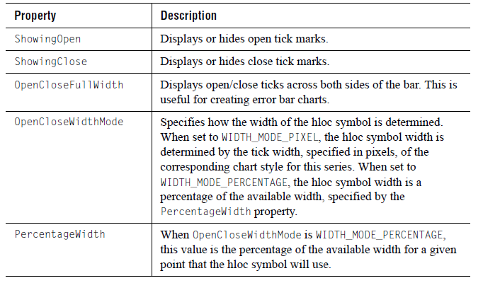

Candle Charts

When the chart type is JCServerChart.CANDLE, several properties defined in JCCandleChartFormat control how candles are displayed:

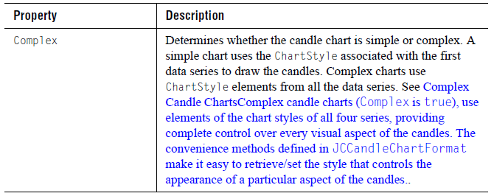
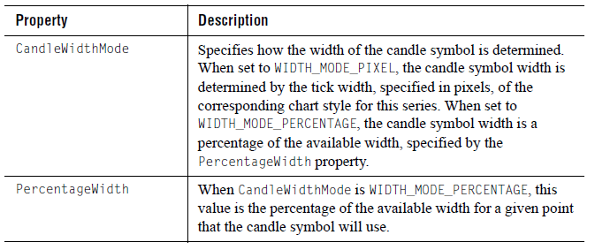

Customizing ChartStyles
Because these chart types use multiple series for each “row” of Hi-Lo or candle bars, it can be challenging to determine which chart style specifies the display attributes of a particular row of bars. To make programming the chart styles of financial charts easier, JClass ServerChart provides several methods that retrieve and set the style for a logical series. These methods are defined in the JCHiloChartFormat, JCHLOCChartFormat and JCCandleChartFormat classes. Each get method returns the JCChartStyle object used for the logical series you specify. You can customize the properties in this returned object and then use the appropriate set method to apply them to the same logical series in the chart.

Most of the financial chart types use only one or two JCChartStyle properties. The following table lists the properties used by each chart type (see Chart Styles, in Chapter 7 for more information on chart styles):

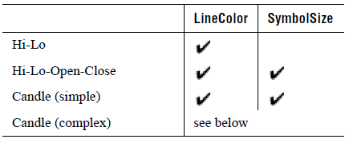

For every financial chart type except complex candle, the actual chart style used is that of the first series.

Complex Candle ChartsComplex candle charts (Complex is true), use elements of the chart styles of all four series, providing complete control over every visual aspect of the candles. The convenience methods defined in JCCandleChartFormat make it easy to retrieve/set the style that controls the appearance of a particular aspect of the candles.

The following lists the JCChartStyle properties that control each aspect of a complex candle, along with which of the four chart styles is used:

- Hi-Lo line — LineColor property (first chart style)
- Rising price candle color and width — FillColor and SymbolSize properties (second chart style)
- Falling price candle color and width — FillColor and SymbolSize properties (third chart style)
- Candle outline — LineColor property (fourth chart style)

For example, the following code sets the rising and falling candle styles of a complex candle chart:

JCChartStyle chartStyle;
JCCandleChartFormat candleFormat;

// Set candle to complex type so we can change colors
candleFormat=(JCCandleChartFormat)chart.getDataView(1).getChartFormat();
candleFormat.setComplex(true);

// Change rising candle color
chartStyle = candleFormat.getRisingCandleStyle(0);
chartStyle.setLineColor(Color.green);
chartStyle.setFillColor(Color.red);

// Change falling candle color
chartStyle = candleFormat.getFallingCandleStyle(0);
chartStyle.setLineColor(Color.green);
chartStyle.setFillColor(Color.yellow);

3.5 Timeline Charts
Timeline charts in JClass ServerChart are primarily intended for use with a monitoring application, where you want to monitor the status of items, such as servers, over time. However, you can also use timeline charts to create any type of chart that implements a time axis, such as Gantt charts or traditional timelines containing a record of events or activities.

JClass ServerChart timeline charts answer the question “What state am I in now?” For example, Figure 29 shows a real-time timeline chart for a build system with multiple build projects.
Figure 29 Example timeline chart containing the status of projects in a build system over time

When we talk about timeline charts, we use the following terms:
                - timeline A timeline is a graphical representation of changes in status over time. In a JClass ServerChart timeline chart, the x-axis is always the time axis. The x-axis cannot be reversed or inverted.
                - track A track is a horizontal area stretching across the width of the timeline chart. Each track is associated with a distinct data series and displays changes in status within that data set.
                - state A state represents a status that is appropriate for the item being monitored. The states for a timeline chart are user-defined and each has a chart style associated with it. In Figure 29, we can see from the legend that seven states are defined: Extract, Compile, Unit Test, Package, Complete, Failure, and Blocked. There is also one additional state that is implied in the chart, called the Clear (or No Activity) state, where nothing is drawn in the track. If you want the ability to return a process to a Clear state, you can define a state where the clearState property has been set to true.
                - status event A status event is a point in time when the thing being monitored changes states. In Figure 29, status events are indicated by any change in the track, such as the change in the bar color.
                - status interval The status interval is an interval of time that begins with a status event and ends with the next status event. An interval bar (optionally a line) is rendered using the chart style defined for the active state. In Figure 29, status intervals are shown as bars.
                - instant event An instant event is a special type of status event that begins and ends at the same timestamp. These events have status intervals of zero duration and are represented by a symbol in the chart. In Figure 29, instant events mark the Complete state and the Failure state.

                - clear event A clear event is a special type of status event that ends the current status interval without initiating a new status interval. In other words, a clear event puts the thing being monitored into its Clear state. This creates empty sections in the tracks, which are useful if you want to merge data from multiple tracks. In Figure 29, when the state changes to Complete, a clear event occurs at the same timestamp to return the track to the Clear state.

To specify a timeline chart, you use the following syntax:

dataView.setChartType(JCServerChart.TIMELINE);

The following sections show how to create objects and set properties unique to timeline charts.

Labelling the Y-axis
In Figure 29, each of the tracks has a label: Big Project, Small Project, and New Project. A track label is specified per data series and can be set on the corresponding ChartDavaViewSeries object. To add y-axis labels to tracks, set the TrackLabel property for each series and then set the AnnotationMethod of the y-axis to POINT_LABELS as shown in the following code excerpt.

// Set TrackLabel property for each ChartDataViewSeries.
String[] trackLabels = {"Big Project", "Small Project", "New Project"};
ChartDataView dataView = chart.getDataView(0);
List<ChartDataViewSeries> dvs = dataView.getSeries();
for (int i = 0; i < dvs.size(); i++) {
dvs.get(i).setTrackLabel(trackLabels[i]);
}
// Set the annotation method of the Y axis to POINT_LABELS
JCAxis yAxis = dataView.getYAxis();
yAxis.setAnnotationMethod(JCAxis.POINT_LABELS);

Note: The y-axis for a timeline chart is artificial. It always has a minimum of 0.0 and a maximum of 100.0. Therefore, setting the AnnotationMethod to VALUE will cause the axis to be annotated from 0 to 100. Similarly, you need to keep these boundaries in mind if you choose to set the AnnotationMethod to VALUE_LABELS. The resulting label positions on the axis may or may not be meaningful within the context of your application.

Defining States
As mentioned, you need to define the states to be used in a timeline chart. States can be either integers or ranges of y-values in your data. These states will be used to determine how the status intervals and associated labels are drawn in your chart. You can also create a state that functions simply as a clear event. You define states by creating TimeLineState objects.

The TimeLineState’s ChartStyle property determines how status intervals and instant events for the given state are represented in the chart. The ChartStyle property takes a JCChartStyle object. If you want status intervals to show as bars, you need to set JCChartStyle’s FillStyle to be a color, fill pattern, or image. If you want status intervals to be lines, you should specify no FillStyle (that is, a FillStyle whose pattern is JCFillStyle.NONE) and define a LineStyle instead. In both cases, you should specify a SymbolStyle to handle instant events (events with a zero-duration status interval) because instant events are marked with symbols in the chart. You can also specify a label that can be displayed with the status interval (see Section , Customizing Interval Labels). Finally, you can determine whether the state is visible in the legend.

For states that are used as clear events, you set the ClearState property to true. Because nothing is drawn in the track, you do not need to define any of the other TimeLineState properties.

The following table describes the properties in the TimeLineState class.
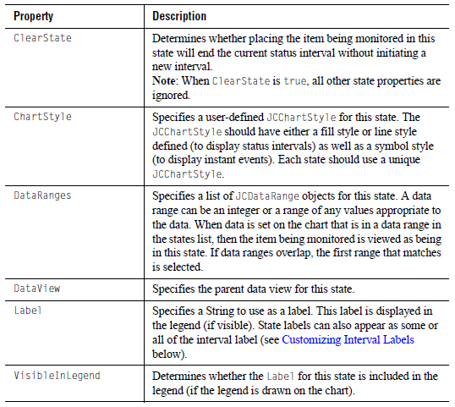

For example, the following code excerpt defines the states used in the timeline chart in Figure 29.

// State enum - create TimeLineState objects within the enum definition
public enum State {
Clear("Inactive", null, null, null),
Extract("Extract",
new JCLineStyle(1, toColor("204-102-255"), JCLineStyle.SOLID),
new JCFillStyle(toColor("204-102-255"), JCFillStyle.SOLID),
null),
Compile("Compile",
new JCLineStyle(1, toColor("153-153-255"), JCLineStyle.SOLID),
new JCFillStyle(toColor("153-153-255"), JCFillStyle.SOLID),
null),
UnitTest("Unit test",
new JCLineStyle(1, Color.cyan, JCLineStyle.SOLID),
new JCFillStyle(Color.cyan, JCFillStyle.SOLID),
null),
Package("Package",
new JCLineStyle(1, toColor("102-204-255"), JCLineStyle.SOLID),
new JCFillStyle(toColor("102-204-255"), JCFillStyle.SOLID),
null),
Complete("Complete",
null,
null,
new JCSymbolStyle(JCSymbolStyle.DOT, Color.green, 12)),
Failure("Failure!",
null,
null,
new JCSymbolStyle(JCSymbolStyle.TRIANGLE, Color.red, 15)),
Blocked("BLOCKED",
new JCLineStyle(1, Color.red, JCLineStyle.LONG_DASH),
new JCFillStyle(Color.yellow, JCFillStyle.STRIPE_45,
toColor("255-153-153")),
null);
private TimeLineState timeLineState;
public TimeLineState getTimeLineState() {
return timeLineState;
}
protected static Color toColor(String colorString) {
return JCSwingTypeConverter.toColor(colorString, Color.black);
}
/**
* Constructor that creates the TimeLineState object associated with this
* state.
*
* @param label the label for this state
* @param lineStyle the line style for this state
* @param fillStyle the fill style for this state
* @param symbolStyle the symbol style for this state
*/
State(String label, JCLineStyle lineStyle, JCFillStyle fillStyle,
JCSymbolStyle symbolStyle) {
if (lineStyle == null) {
lineStyle = new JCLineStyle(1, Color.black, JCLineStyle.NONE);
}
if (fillStyle == null) {
fillStyle = new JCFillStyle(Color.black, JCFillStyle.NONE);
}
if (symbolStyle == null) {
symbolStyle = new JCSymbolStyle(JCSymbolStyle.NONE,
Color.black, 6);
}
JCChartStyle chartStyle = new JCChartStyle(lineStyle, fillStyle,
symbolStyle);
timeLineState =
new TimeLineState(null, label, chartStyle, true,
"Inactive".equals(label),
new JCDataRange(ordinal(), ordinal()));
}
}
public void addStates(ChartDataView dataView) {
for (State state : State.values()) {
dataView.addTimeLineState(state.getTimeLineState());
}
}

Customizing Track Properties
In addition to the JCChartStyle used for each state, you can customize the behavior of the tracks in a chart, as well as the height of the bar used when drawing status intervals. The track properties are contained in the JCTimeLineChartFormat class.
The following table describes the track properties in JCTimeLineChartFormat.

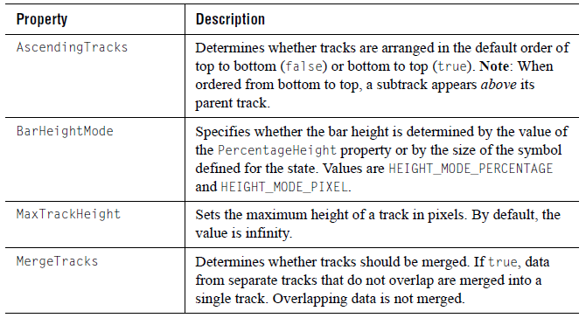
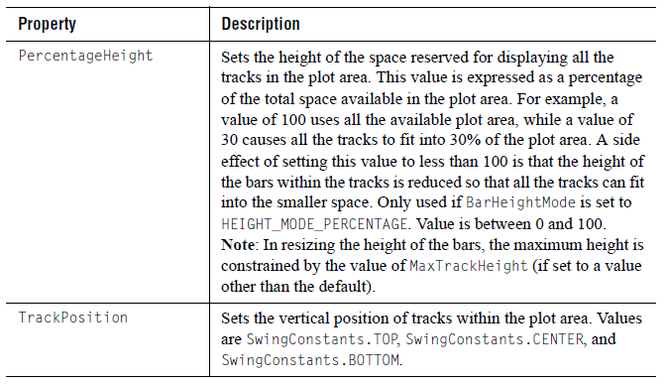

The following code excerpt uses 30% of the plot area to contain the tracks, and the tracks are located at the bottom of the plot area. The tracks are ordered in ascending order (from bottom to top) and the height of the bars has been capped at 15 pixels.

JCTimeLineChartFormat format =
(JCTimeLineChartFormat)dataView.getChartFormat();
format.setMaxTrackHeight(15);
format.setPercentageHeight(30);
format.setBarHeightMode(JCTimeLineChartFormat.HEIGHT_MODE_PERCENTAGE);
format.setTrackPosition(SwingConstants.BOTTOM);
format.setAscendingTracks(true);

The results are shown in Figure 30. Note that if the MaxTrackHeight had not been capped at 15 pixels, the bars would have been taller.
Figure 30 Tracks shown in 30% of plot area, in ascending order, with the track position set to SwingConstants.BOTTOM, and a max track height of 15 pixels

Customizing Interval Labels
As you may have noticed, Figure 29 contained labels that were displayed within status intervals and after instant events. You can control what is contained in interval labels as well as where the labels are displayed within the tracks.

The following table describes the interval label properties in
JCTimeLineChartFormat.

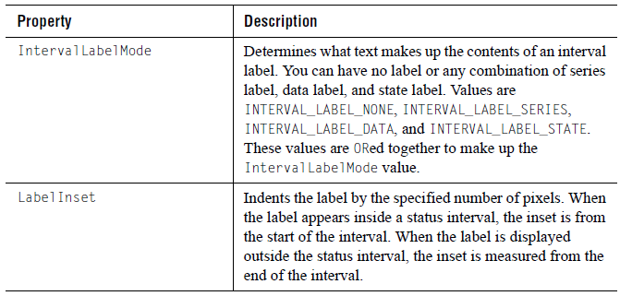
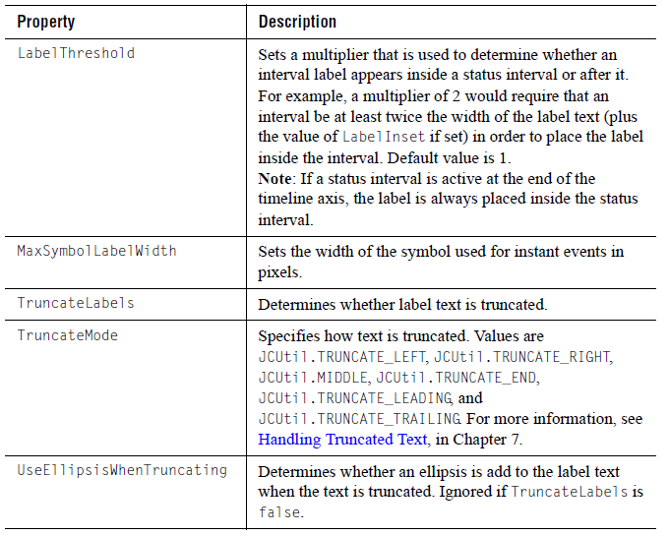
If you choose not to truncate the interval labels, the labels may cause some intervals and labels to overlap. JClass ServerChart creates subtracks below the primary track to contain the overlapping intervals and labels.

In the following code excerpt, truncation is turned off. The series label has been added to the interval label to help identify the subtracks for each track.

JCTimeLineChartFormat format =
(JCTimeLineChartFormat)dataView.getChartFormat();
format.setTrackPosition(SwingConstants.CENTER);
format.setIntervalLabelMode(JCTimeLineChartFormat.INTERVAL_LABEL_STATE |
JCTimeLineChartFormat.INTERVAL_LABEL_SERIES);
format.setTruncateLabels(false);
format.setMergeTracks(false);

The results of this implementing this code are shown in Figure 31. Note that if the label extends past the end of the timeline, the label text begins within the status interval.
Figure 31 Overlapping interval labels are handled by moving intervals to subtracks.

Creating a Gantt Chart
A Gantt chart is a simple form of timeline chart. It monitors the status of project tasks over time.

Figure 32 Timeline chart used to create a Gantt chart

In Figure 32, each project task is a different data series and therefore displayed in a different track. There are three user-defined states in use in this chart: Time Worked, Time Remaining, and Clear. Within each track, the Clear state occurs before and after each task bar. Within a task bar, there are two status intervals. The Time Worked state is used to begin the task bar and the status interval. The Time Remaining state is used to end the Time Worked status interval and begin a new status interval. A clear event ends the Time Remaining status interval, ends the task bar, and returns the track to the Clear state.

3.6 Pie Charts
Pie charts are quite different from the other chart types. They do not have the concept of a twodimensional grid or axes. Data points in a data series are represented as slices in a pie. Each data series in the chart data view is captured in a separate pie.
Figure 33 Sample pie charts displaying one data series and many data series.

To specify a pie chart, you use the following syntax:

dataView.setChartType(JCServerChart.PIE);

You can customize your pie charts with the properties of JCPieChartFormat. The following code snippet shows the syntax for setting JCPieChartFormat properties:

JCPieChartFormat pcf = (JCPieChartFormat) arr.getChartFormat();
pcf.setOtherLabel("Other Bands");
pcf.setThresholdValue(10.0);
pcf.setThresholdMethod(JCPieChartFormat.PIE_PERCENTILE);
pcf.setSortOrder(JCPieChartFormat.DATA_ORDER);
pcf.setStartAngle(90.0);

Building the “Other” Slice
Pie charts introduce a special category called the “Other” slice, into which all data values below a certain threshold can be grouped. Pie charts are often more effective if unimportant values are grouped into an “Other” category. Use the ThresholdMethod property to select the grouping method to use. SLICE_CUTOFF is useful when you know the data value that should be grouped into the “Other” slice. PIE_PERCENTILE is useful when you want a certain percentage of the pie to be devoted to the “Other” slice.
Figure 34 Three JClass ServerCharts illustrating how the “Other” slice can be used.

Use the MinSlices property to fine-tune the number of slices displayed before the “Other” slice. For example, when set to 5, the chart tries to display 5 slices before grouping data into the “Other” slice.

“Other” Slice Style and Label

The OtherStyle property allows access to the ChartStyle used to render the “Other” slice. Use FillStyle’s Pattern and Color properties to define the appearance of the Other slice. Use the OtherLabel property to change the label of the “Other” slice.

Pie Ordering
Use the SortOrder property to specify whether to display slices largest-to-smallest, smallest-to-largest, or the order they appear in the data.

Start Angle
The position in the pie chart where the first pie slice is drawn can be specified with the StartAngle property. A value of zero degrees represents a horizontal line from the center of the pie to the right-hand side of the pie chart; a value of 90 degrees represents a vertical line from the center of the pie to the top-most point of the pie chart; a value of 180 degrees represents a horizontal line from the center of the pie to the left-hand side of the pie chart; and so on. Slices are drawn clockwise from the specified angle. Values must lie in the range from zero to 360 degrees. The default value is 135 degrees.

Exploded Pie Slices
It is possible to have individual slices of a pie “explode” (that is, detach from the rest of the pie). Exploded slices can be used in both 2D and 3D pie charts. Two properties of JCPieChartFormat are responsible for this function: ExplodeList and ExplodeOffset.

ExplodeList specifies a list of exploded pie slices in the pie charts. It takes pts as a parameter, which is composed of an array of Point objects. Each point object contains the data point index (pie number) in the x-value and the series number (slice index) in the y-value, specifying the pie slice to explode. To explode the “other” slice, the series number should be OTHER_SLICE. If null, no slices are exploded.

ExplodeOffset specifies the distance a slice is exploded from the center of a pie chart. It takes off as a parameter, which is the explode offset value.

The following code sample shows how ExplodeList and ExplodeOffset can be used to set the list of exploded slices.

Point[] exList = new Point[3];
exList[0] = new Point(0, 0);
exList[1] = new Point(1, 5);
exList[2] = new Point(2, JCPieChartFormat.OTHER_SLICE);
pcf.setExplodeList(exList);
pcf.setExplodeOffset(10);

Saving and Loading Exploding Pie Slices
Exploded pie slice properties can be saved or loaded to or from both XML and HTML. This is done by passing JCPieChartFormat’s setExplodeList() method an array of Point objects which correspond to the exploded series and points. For each Point object in the array, the X value represents the pie (or point) number, while the Y value represents the slice (or series) number. To specify all of the points or series, use the ALL integer; to specify that the “other” slice should be exploded, use other as the Y value.

For more information on using this feature in XML, see pie-format in Appendix B, XML DTD.

In HTML, the code should resemble the following:
<PARAM name="dataFile" value="sample_1.dat">
<PARAM name="data.chartType" value="PIE">

<PARAM name="data.pie.explodeList" value="0,all|all,1|3,3|4,other"> where all slices on the first pie are exploded (0,ALL), the slices corresponding to the first dataseries are exploded on all pies (ALL,1), the slice corresponding to the third dataseries is exploded on the fourth pie (3,3), and the fifth pie’s “other” slice is also exploded (4,other). Note that the pie (or point) number starts at 0; therefore, the first pie is 0, the second is 1, and so on.

3.7 Polar Charts
In polar charts, the (x,y) data points for each series are drawn as (theta,r), where theta is amount of rotation from the x-origin and r is the distance from the y-origin. theta can be specified in degrees (default), radians, or gradians. Because the x-axis is a circle, the x-axis maximum and minimum values are fixed.

Figure 35 Sample polar chart.

To specify a polar chart, you use the following syntax:

dataView.setChartType(JCServerChart.POLAR);

Background Information for the Polar Charts
In order to work efficiently with polar charts, you should understand the following basic concepts.

Theta
Theta (θ), which is the angle from the x-axis origin, is measured in a counterclockwise direction. In cartesian (rectangular) X and Y plots, theta “translates” to the x-axis.

r value
r represents the distance from the y-axis origin. In cartesian (rectangular) X and Y plots, r “translates” to the y-axis. Multiple r values are allowed.

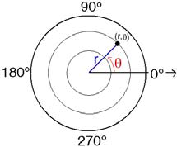

Angles
Angles can be measured in degrees, radians, or gradians.

X- and Y-values in Polar Charts

Setting the Origin
All angles are relative to the origin base angle. The position of the x-axis origin is determined by the origin base angle. The OriginBase property is a value between 0 and 360 degrees (if the angle unit is degrees).

The y-axis angle is the angle that the y-axis makes with the origin base. The origin base angle is set to 0o by default. The y-axis angle is set to 0o to the origin base by default.

You can change the origin base angle, the y-axis angle, or both.

Data Format
In the underlying data model, the data format for polar charts is either:
- general – (x,y) for every series; or
- array (only one x-value).

The x-array contains the theta values; the y-array contains the r-values. For array data, the xarray represents a fixed theta value for each point. For more information, see Text Data Formats, in Chapter 4.
Figure 36 Data format for polar charts.

PolarChartDraw Class
The PolarChartDraw class (which extends ChartDraw) is a drawable object for polar charts. This object is used for rendering a polar chart based on data contained in the dataObject.

The default constructor is PolarChartDraw().

There are two key methods in this class:
- recalc() – recalculates the extents of related objects
- draw() – draws related objects and takes as its parameter the graphics context to use for drawing

Full or Half-Range X-Axis
Use the HalfRange property to determine whether the x-axis is displayed as one full range from 0 to 360 degrees (default) or two half-ranges: from –180 degrees to zero degrees to 180 degrees. In interval notation the range would be [0,360) when HalfRange is false and (–180, 180] when HalfRange is true.
Figure 37 Half-range is true – values in the lower half of the chart are negative.

Allowing Negative Values
Polar charts do not allow negative values for the y-axis unless the y-axis is reversed. A negative radius is interpreted as a positive radius rotated 180 degrees. Thus (theta, r) = (theta +180, –r).

3.8 Radar Charts
A radar chart plots data as a function of distance from a central point. A line connects the data points for each series, forming a polygon around the chart center.

A radar chart draws the y-value in each data set along a radar line (the x-value is ignored). If the data set has n points, then the chart plane is divided into n equal angle segments, and a radar line is drawn (representing each point) at 360/n degree increments. By default, the radar line representing the first point is drawn horizontally (at 0 degrees).
Radar charts permit easy visualization of symmetry or uniformity of data, and are useful for comparing several attributes of multiple items. Although radar charts look as if they have multiple y-axes, they have only one; hence, you cannot change the scale of just one spoke.

To specify a radar chart, you use the following syntax:
dataView.setChartType(JCServerChart.RADAR);

The JCPolarRadarChartFormat class provides methods to get or set properties specific to polar, radar, or area radar charts. Using ChartStyles, you can customize the symbol and line properties of each series. For more information, see Chart Styles, in Chapter 7.

Background Information for Radar Charts
An example of the x-values and y-values of a radar chart is shown below; in this case, there are seven x-values and three series of y-values.

Data Format
n the underlying data model, the data format required for radar charts is array only. For more information, see Text Data Formats, in Chapter 4.

Setting the Origin and Y-axis Angles
As with polar charts, in radar charts all angles are relative to the origin base angle. By default, the origin is at 0 degrees. The y-axis angle is the angle that the y-axis makes with the origin base. By default, it is also at 0 degrees. You can change the angles by setting the OriginBase and/or the YAxisAngle properties. When setting these properties, specify the unit of measurement followed by a value expressed in terms of the unit of measurement. Valid units are: JCChartUtil.DEGREES, JCChartUtil.GRADS, or JCChartUtil.RADIANS.

Setting Gridlines
You can choose how gridlines are displayed by setting the CircularGrid property. When false (default), the gridlines are straight and create a webbed effect. When true, the gridlines are concentric circles. For more information, see Gridlines, in Chapter 6.
RadarChartDraw Class
The RadarChartDraw class (which extends PolarChartDraw) is a drawable object for radar charts. This object is used for rendering a radar chart based on data contained in the dataObject.

The default constructor is RadarChartDraw().

There are two key methods in this class:
- recalc() – recalculates the extents of related objects; and
- draw() – draws related objects and takes as its parameter the graphics context to use for drawing.

3.9 Area Radar Charts
An area radar chart draws the y-value in each data set along a radar line (the x-value is ignored). If the data set has n points, the chart plane is divided into n equal angle segments, and a radar line is drawn (representing each point) at 360/n degree increments. Each series is drawn “on top” of the preceding series.

Area radar charts are the same as radar charts, except that the area between the origin and the points is filled.

Figure 38 Sample area radar chart.

To specify an area radar chart, you use the following syntax:

dataView.setChartType(JCServerChart.AREA_RADAR);

The JCPolarRadarChartFormat class provides methods to get or set properties specific to polar, radar, or area radar charts. Using ChartStyles, you can customize the fill and line properties of each series. For more information, see Chart Styles, in Chapter 7.

Background Information for Area Radar Charts
An example of the x- and y-values of an area radar chart is shown below; in this case, there are seven x-values and three series of y-values.

Data Format
In the underlying data model, the data format required for area radar charts is array only. For more information, see Text Data Formats, in Chapter 4.

Setting the Origin and Y-axis Angles
As with polar charts, in area radar charts all angles are relative to the origin base angle. By default, the origin is at 0 degrees. The y-axis angle is the angle that the y-axis makes with the origin base. By default, it is also at 0 degrees. You can change the angles by setting the OriginBase and/or the YAxisAngle properties. When setting these properties, specify the unit of measurement followed by a value expressed in terms of the unit of measurement. Valid units are: JCChartUtil.DEGREES, JCChartUtil.GRADS, or JCChartUtil.RADIANS.

Setting Gridlines
You can choose how gridlines are displayed by setting the CircularGrid property. When false (default), the gridlines are straight and create a webbed effect. When true, the gridlines are concentric circles. For more information, see Gridlines, in Chapter 6.

Outline Style
You can choose how you want to outline the regions in an area radar chart. By default, the outline style for the ChartDataView is used. However, you can choose to use the line style defined for each data series or you can use solid lines in the color defined for the chart area foreground. To specify an outline style, set the OutlineStyle property to one of the following values: JCPolarRadarChartFormat.OUTLINE_STYLE, JCPolarRadarChartFormat.SERIES_LINE_STYLE, or JCPolarRadarChartFormat.CHART_AREA_FOREGROUND.

For example:
((JCPolarRadarChartFormat)dataView.getChartFormat()).
setOutlineStyle(JCBarChartFormat.SERIES_LINE_STYLE);

AreaRadarChartDraw Class
The AreaRadarChartDraw class (which extends RadarChartDraw) is a drawable object for area radar charts. This object is used for rendering an area radar chart based on data contained in the dataObject. The default constructor is AreaRadarChartDraw().

4
Adding Data with the Underlying Data Model
Understanding the Underlying Data Model ■ Pre-Built Chart DataSources
Loading Data from a Text Data File ■ Loading Data from a URL
Loading Data from a Swing TableModel ■ Loading Data from an XML Source
Text Data Formats ■ Making Your Own Chart Data Source
■ Defining Data Thresholds for Bar Charts

After you select the type of chart that you want to create, the next step is to add your data to the chart. The underlying data model can be used to add data to all JClass ServerChart applications. It is also the model of choice if your data is dynamic and needs to be updated frequently.

Important: If your data is stored as a JDBC result set and you are creating your chart programmatically, you should consider using the targeted data model instead. For more information, see Adding Data, in Chapter 1 and Chapter 5, Adding Data with the Targeted Data Model.

4.1 Understanding the Underlying Data Model
Data sources are added to JClass ServerChart using data views, which are encapsulated by the ChartDataView object. ChartDataView organizes data as a collection of ChartDataViewSeries objects, one ChartDataViewSeries for each series of data points.

In most cases, your charts will require only one data view. However, JClass ServerChart allows you to load data from multiple data sources at the same time, assigning each source to a separate data view. By default, all data views are showing, but each may be hidden or revealed depending on the needs of your application. Data views may be mapped to the same set of x-axes and y-axes, or to different axes.

Note: Radar, area radar, and pie charts do not support multiple data views.

4.2 Pre-Built Chart DataSources
JClass ServerChart provides pre-built DataSource objects that you can use to load data. They are located in the com.klg.jclass.chart.data package.

The following table summarizes the available DataSource objects:
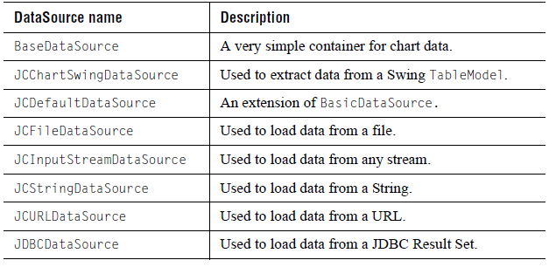

4.3 Loading Data from a Text Data File
Note: This method of loading data is provided for backward compatibility. New applications should use XML as described in Section 4.6, Loading Data from an XML Source.

An easy way to bring data into a chart is to load it from a formatted file using JCFileDataSource. To load data this way, you create a data file that follows JClass ServerChart’s standard format, as outlined in Section 4.7, Text Data Formats.

To finish, you instantiate a JCFileDataSource object and attach it to a view in your chart application. The following example shows how to instantiate and attach a JCFileDataSource:

chart.getDataView(0).setDataSource(new JCFileDataSource("file.dat"));

4.4 Loading Data from a URL
You can chart data from a URL address using JCURLDataSource. To load data this way, you create a data file that follows JClass ServerChart’s standard format, as outlined in Section 4.7, Text Data Formats.

Then, you instantiate JCURLDataSource and attach it to a view in your chart. The following example uses data from a file named plot1.dat:

chart.getDataView(0).setDataSource(new JCURLDataSource(host(),
"plot1.dat"));

Parameter options for JCURLDataSource:
The following are valid parameter combinations for JCURLDataSource:
- URL
- base, file
- host, file
host: The WWW hostname.
file: The fully qualified name of the file on the server.
URL: The URL address of a data file, eg, http://www.quest.com/datafile.dat.
base: A URL object representing the directory where the file is located.

4.5 Loading Data from a Swing TableModel
The JCChartSwingDataSource class enables you to use any type of Swing TableModel data object for the chart. TableModel is typically used for Swing JTable components, so your application may already have created this type of data object.

JCChartSwingDataSource “wraps” around a TableModel object, so that the data appears to the chart in the format it understands.

This data source is available through the SwingDataModel property in the SimpleChart and MultiChart Beans. To use it, prepare your data in a Swing TableModel object and set the SwingDataModel property to that object.

4.6 Loading Data from an XML Source
For more general XML information, refer to Chapter 15, Loading and Saving Charts Using XML.

JClass ServerChart can accept XML data formatted to the specifications outlined in com.klg.jclass.chart.data.JCXMLDataInterpreter. This public class extends JCDataInterpreter and implements an interpreter for the JClass ServerChart XML data format. JCXMLDataInterpreter relies on an input stream reader to populate the specified BaseDataSource class.

Data can be specified either by series or by point. This is fully explained below.

Examples of XML in JClass
For XML data source examples, see the XMLArray, XMLArrayTrans, and XMLGeneral examples in JCLASS_SERVER_HOME/examples/schart/datamodel. These use the array.xml, arraytrans.xml, and general.xml data files, respectively.

Interpreter
The interpreter, which converts incoming data to the internal format used by JClass ServerChart, must be explicitly set by the user when loading XML-formatted data. The interpreter to use for this purpose is com.klg.jclass.chart.data.JCXMLDataInterpreter.

Many constructors in the various data sources in JClass ServerChart take the abstract class JCDataInterpreter, which is extended by JCXMLDataInterpreter. It is possible for the user to create a custom data format and a custom data interpreter by extending JCDataInterpreter.

Here are a few code examples that load XML data using JClass ServerChart’s XML interpreter, JCXMLDataInterpreter:

ChartDataModel cdm = new JCFileDataSource(fileName,

new JCXMLDataInterpreter());
ChartDataModel cdm = new JCURLDataSource(codeBase, fileName,

new JCXMLDataInterpreter());
cdm = new JCStringDataSource(string,

new JCXMLDataInterpreter());

4.6.1 Specifying Data by Series
When specifying by series, there can be any number of <data-series> tags. Within each <data-series> tag, there can be an optional <data-series-label> tag and any number of <x-data> tags (these tags represent the x-values for that series).

If there are no <x-data> tags in any <data-series> tag, a single x-array is generated, starting at 1 and proceeding in increments of 1. If only one series has <x-data> tags, then that list of x-data is used for all series. If more than one series has <x-data> tags, those tags are used only for the series in which they are located.

Within each <data-series> tag, there must be at least one <y-data> tag (generally there will be many). <y-data> tags represent the y-values for that series. You can choose to specify the dataLabel attribute within each <y-data> tag. For more information, see Section 4.6.3, Labels and Other Parameters

Note: If the number of x-values and y-values do not match within one series, the one with the fewer number of values is padded out with Hole values.

Here is an example of an XML data file specifying data by series.

<?xml version="1.0"?>
<!DOCTYPE chart-data SYSTEM "JCChartData.dtd">
<chart-data Name="My Chart" Hole="MAX">
<data-point-label>Point Label 1</data-point-label>
<data-point-label>Point Label 2</data-point-label>
<data-point-label>Point Label 3</data-point-label>
<data-point-label>Point Label 4</data-point-label>
<data-series>
<data-series-label>Y Axis #1 Data</data-series-label>
<x-data>1</x-data>
<x-data>2</x-data>
<x-data>3</x-data>
<x-data>4</x-data>
<y-data dataLabel="Data Label 1">1</y-data>
<y-data dataLabel="Data Label 2">2</y-data>
<y-data dataLabel="Data Label 3">3</y-data>
<y-data dataLabel="Data Label 4">4</y-data>
</data-series>
<data-series>
<data-series-label>Y Axis #2 Data</data-series-label>
<y-data dataLabel="Data Label 5">1</y-data>
<y-data dataLabel="Data Label 6">4</y-data>
<y-data dataLabel="Data Label 7">9</y-data>
<y-data dataLabel="Data Label 8">16</y-data>
</data-series>
</chart-data>

This format is similar to both the array and the general formats of the default chart data source.

4.6.2 Specifying Data by Point
In the specifying by point format, there can be any number of <data-point> tags. Within each <data-point> tag, there can be one optional <data-point-label> tag and one optional <x-data> tag (these tags represent the x-value of that point). If there are no <x-data> tags in any of the <data-point> tags, x-values are generated, starting at 1 and then increasing in increments of 1.

If some <data-point> tags have <x-data> tags but others do not, the missing ones will be replaced with Hole values.

Within each <data-point> tag, there must be at least one <y-data> tag (in general, there will be many). <y-data> tags represent the y-values of each series at this point. You can choose to specify the dataLabel attribute within each <y-data> tag. For more information, see Section 4.6.3, Labels and Other Parameters.

There should always be the same number of <y-data> tags within each <data-point> tag. If there are not, then the largest number of <y-data> tags in any one <data-point> tag is used as the number of series, and the other lists of y-values will be padded with Hole values.

Here is an example of an XML data file specifying data by point.

<?xml version="1.0"?>
<!DOCTYPE chart-data SYSTEM "JCChartData.dtd">
<chart-data Name="MyChart">
<series-label>Y Data</series-label>
<series-label>Y 2 Data</series-label>
<data-point>
<data-point-label>Point Label 1</data-point-label>
<x-data>1</x-data>
<y-data dataLabel="Data Label 1">1</y-data>
<y-data dataLabel="Data Label 5">1</y-data>
</data-point>
<data-point>
<data-point-label>Point Label 2</data-point-label>
<x-data>2</x-data>
<y-data dataLabel="Data Label 2">2</y-data>
<y-data dataLabel="Data Label 6">4</y-data>
</data-point>
<data-point>
<data-point-label>Point Label 3</data-point-label>
<x-data>3</x-data>
<y-data dataLabel="Data Label 3">3</y-data>
<y-data dataLabel="Data Label 7">9</y-data>
</data-point>
<data-point>
<data-point-label>Point Label 4</data-point-label>
<x-data>4</x-data>
<y-data dataLabel="Data Label 4">4</y-data>
<y-data dataLabel="Data Label 8">16</y-data>
</data-point>
</chart-data>

This format is similar to the transposed array format of the default chart data source.

4.6.3 Labels and Other Parameters

You can define labels for series, points, and data. You can also define hole and name attributes for the chart.

4.6.3.1 Point Labels and Series Labels
<data-point-label> and <data-series-label> tags are optional with both the specifying by series or specifying by point methods. If there are more point labels than data points, or more series labels than data series, the extra labels are ignored. If there are more data points than point labels, or more data series than series labels, then the list is padded with blank labels. If there are no point labels or no series labels at all, the chart default is used – no point labels and series labels containing “Series 1”, “Series 2”, and so on. For more information, see PointLabels Annotation, in Chapter 6.

4.6.3.2 Data Labels
You can add data labels to your data source and display the labels in the chart. To specify data labels, specify the dataLabel attribute within each <y-data> tag. To display the labels in the chart, set the autoLabel element to true and autoLabelType to Data_Labels within the chart-data-view tag.

The following excerpt shows how data labels are added and displayed in a bar chart.
...
<chart-data-view chartType="Bar"
<!-- Display the data labels using auto label feature-->
autoLabel="true"
autoLabelType="Data_Labels"
name="DataView #0">
<chart-data name="DataView #0">
<data-point-label>Spring</data-point-label>
<data-point-label>Summer</data-point-label>
<data-point-label>Autumn</data-point-label>
<data-point-label>Winter</data-point-label>
<data-series>
<data-series-label>Last Year</data-series-label>
<track-label>Last Year</track-label>
<x-data>1.0</x-data>
<x-data>2.0</x-data>
<x-data>3.0</x-data>
<x-data>4.0</x-data>
<!-- Specify data labels with the y-values -->
<y-data dataLabel="a">150.0</y-data>
<y-data dataLabel="b">175.0</y-data>
<y-data dataLabel="c">160.0</y-data>
<y-data dataLabel="d">170.0</y-data>
</data-series>
<data-series>
<data-series-label>This Year</data-series-label>
<x-data>1.0</x-data>
<x-data>2.0</x-data>
<x-data>3.0</x-data>
<x-data>4.0</x-data>
<!-- Specify data labels with the y-values-->
<y-data dataLabel="e">125.0</y-data>
<y-data dataLabel="f">100.0</y-data>
<y-data dataLabel="g">225.0</y-data>
<y-data dataLabel="h">300.0</y-data>
</data-series>
</chart-data>
...
</chart-data-view-series>
</chart-data-view>
...

Figure 39 Data labels displayed at the top of the bars

For more information, see Attaching Labels to Data Items, in Chapter 7.

Timeline Charts
Timeline charts offer the unique ability to display the data label (as well as the series label and/or state label) as an element of status intervals, rather than as a JCChartLabel pasted on top of the data items. For more information, see Showing Labels on Status Intervals in Timeline Charts, in Chapter 7.

To display the data labels in this way, you need to turn on the data labels by setting the displayDataLabel attribute to true within the timeline-format tag.

<timeline-format displaySeriesLabel="true"
displayDataLabel="true"
displayStateLabel="true"/>
Figure 40 Status interval labels in a timeline chart

Note: To prevent duplication, if you display data labels using this method, you should avoid setting the autoLabelType property to AUTO_LABEL_TYPE_DATA_LABEL.

4.6.3.3 Name and Hole Parameters
The name and hole parameters of the chart-data tag are also optional. name can be any String. hole can be a value, the String MIN (meaning Double.MIN_VALUE), or the String MAX (meaning Double.MAX_VALUE). To represent virtual hole values in an x-data or y-data tag, use the word Hole. Any x-data or y-data tag can contain a value, the String MIN, the String MAX, or the String Hole.

See the Section 4.6.1, Specifying Data by Series, and Section 4.6.2, Specifying Data by Point, to view these elements in code samples.

4.6.4 Image Map Information

Image map URL and extra information can be added in an XML data file. The <data-series>, <x-data>, and <y-data> tags all have image map attributes for specific image map types. The following is an example of XML data file with image map information:

<?xml version="1.0"?>
<!DOCTYPE chart-data SYSTEM "JCChartData.dtd">
<chart-data name="My Chart">
<data-point-label>Point Label 1</data-point-label>
<data-point-label>Point Label 2</data-point-label>
<data-point-label>Point Label 3</data-point-label>
<data-point-label>Point Label 4</data-point-label>
<data-series seriesImageMapURL="www.series1.com"
seriesImageMapExtra="alt=&quot;Series 1&quot;"
legendImageMapURL="www.series1.com"
legendImageMapExtra="alt=&quot;Series 1&quot;">
<data-series-label>Series 1</data-series-label>
<x-data clusterImageMapURL="www.cluster1.com">1</x-data>
<x-data clusterImageMapURL="www.cluster2.com">2</x-data>
<x-data clusterImageMapURL="www.cluster3.com">3</x-data>
<x-data clusterImageMapURL="www.cluster4.com">4</x-data>
<y-data pointImageMapURL="www.point1.com">1</y-data>
<y-data pointImageMapURL="www.point2.com">2</y-data>
<y-data pointImageMapURL="www.point3.com">3</y-data>
<y-data pointImageMapURL="www.point4.com">4</y-data>
</data-series>
<data-series seriesImageMapURL="www.series2.com"
seriesImageMapExtra="alt=&quot;Series 2&quot;"
legendImageMapURL="www.series2.com"
legendImageMapExtra="alt=&quot;Series 2&quot;">
<data-series-label>Series 2</data-series-label>
<y-data pointImageMapURL="www.point1.com">1</y-data>
<y-data pointImageMapURL="www.point2.com">4</y-data>
<y-data pointImageMapURL="www.point3.com">9</y-data>
<y-data pointImageMapURL="www.point4.com">16</y-data>
</data-series>
</chart-data>

The <data-series> tag has attributes for image map information specified on a series basis which specify image map URL and extra information for the image maps of type ImageMapRules.SERIES. It also has image map information that is used for the glyph that represents the series in the legend. The <x-data> tag has URL and extra information for image maps of type ImageMapRules.CLUSTER, which are used for selecting clusters of bars or pies. These cluster attributes can also be used for image maps for point labels. The <y-data> tag has URL and extra information for image maps of type ImageMapRules.POINT, which are used for selecting points, bars, pie slices, and other items specified on a per point basis. See Chapter 10, Defining Image Maps, for more information on how image maps work in JClass ServerChart.

Note: Image map information cannot be specified if one is specifying data by point; for more information see Section 4.6.2, Specifying Data by Point.

4.7 Text Data Formats
Note: While text data formats are supported for backward compatibility, the XML format is recommended for new applications. For more information, see Section 4.6, Loading Data from an XML Source.

When specifying data using ASCII text, JCFileDataSource, JCURLDataSource, JCInputStreamDataSource, and JCStringDataSource, all require that data be pre-formatted. The following table illustrates the formatting requirements of data for pre-built data sources. There are two main ways to format data: Array and General.

Array-formatted data shares a single series of x-data among one or more series of y-data. Array format is the recommended standard, because it works well with all of the chart types.

Note: For data arrays in polar charts, (x, y) coordinates in each data set will be interpreted as (theta, r). For array data, the x-array will represent a fixed theta value for each point. In radar and area radar charts, only array data can be used. (x, y) points will be interpreted in the same way as for polar charts (above), except that the theta (that is, X) values will be ignored. The circle will be split into nPoints segments with nSeries points drawn on each radar line.

General format is intended for use in cases where you want to display multiple x-axis values on the same chart. General-formatted data specifies a series of x-data for every series of y-data. General format may not display data properly in stacking bar, stacking area, pie, and bar charts.

Note: Image map information and data labels cannot be specified using text data formatting.

4.7.1 Formatted Data Examples

The following table shows four formatted data examples. An explanation of each element follows in the next section.
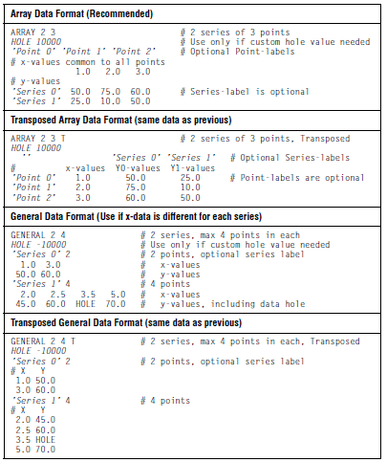

4.7.2 Explanation of Format Elements
The first (non-comment) line must begin with either “ARRAY” or “GENERAL” followed by two integers specifying the number of series and the number of points in each series. For example:

# This is an Array data file containing 2 series of 4 points
ARRAY 2 4

The only difference with General data is that the second integer specifies the maximum number of points possible for each series:

# A General data file, 5 series, maximum 10 points
GENERAL 5 10

Hole Value
The second line can optionally specify a data hole value. A hole value is a number that is interpreted by the chart as missing data. There should be only one hole value per ChartDataView class. Use a hole value if you know that a particular value in the data should be ignored in the chart:

HOLE 10000

You can also indicate that any particular point is a hole by specifying the word “HOLE” for that x- or y-value. For example:

50.0 75.0 HOLE 70.0

Note: If the hole value is later changed in the data view, values in the x- and y-data previously set with hole values will not change their values and will not draw.

By default, hole values are not drawn on charts. For a selection of chart types, you can change this default behavior by specifying a style to use for hole values. For more information, see Holes and Hole Styles, in Chapter 7.

Comments
You can use comments throughout the data file to make it easier for people to understand. Any text on a line following a “#” symbol is treated as a comment and is ignored.

Point Labels
The third line can optionally specify text labels for each data point, which can be used to annotate the x-axis. Point-labels are generally only useful with Array data; if specified for General data they apply to the first series. The following shows how to specify Point-labels:

’Point 1’ ’Point 2’ ’Point 3’ # Optional Point-labels

The Data – Array layout
The rest of the file contains the data to be charted. Array layout uses the first line of data as x-values that are common to all points. Subsequent lines specify the y-values for each data series:

1.0 2.0 3.0 4.0 # x-values
150.0 175.0 160.0 170.0 # y-values, series 0
125.0 100.0 225.0 300.0 # y-values, series 1
# y-values continue, until end of data

The Data – General layout
General layout provides more flexibility. For each series, the first line of data specifies the number of points in the series (this cannot be greater than the maximum number of points defined earlier). The second line specifies the x-values for that series; the third line specifies the y-values:

4 # Series 0, 4 points
50.0 75.0 60.0 70.0 # x-values
25.0 10.0 25.0 30.0 # y-values
# Next series follows, until end of data

Series Labels
You can optionally specify text labels for each series, which can be displayed in the legend. Series labels are enclosed in single quotes. In Array data, the label appears at the start of each line of y-values, for example:

’Series label’ 150.0 175.0 160.0 170.0 # y-values, series 0

In General data, the label appears at the start of the line defining the number of points in that series, for example:

’Series label’ 4 # Series 0, 4 points
50.0 75.0 60.0 70.0 # x-values
25.0 10.0 25.0 30.0 # y-values

Transposed Data
JClass ServerChart can also interpret transposed data, where the meaning of the data series and points is switched. This may be a more convenient way to supply data to the chart for some applications. Note that transposing data also transposes series and point labels. To indicate that the data is transposed, add a “T” to the first line specifying the data layout and size. The following illustrates how data is interpreted when transposed:

ARRAY 2 3 T
# x-values Y0-values Y1-values
1.0 150.0 125.0
2.0 175.0 100.0
3.0 160.0 225.0

You can access a database using the BaseDBSChart Bean. See Creating Charts with JavaBeans, in Chapter 16 for more information on using Beans in an IDE.

You should be familiar with using servers, deploying servlets, and creating connection pools before using Beans. Please consult your server’s documentation for information.

4.7.3 Working with BaseDBSChart

The BaseDBSChart Bean is configured for easy JDBC database access. Note, however, that because BaseDBSChart is designed to create images, the database connection is not persistent and only creates a connection long enough to query the database.

Creating an Instance of BaseDBSChart
Follow these steps to create an instance of BaseDBSChart:
- Create a new instance of BaseDBSChart chart using the no-argument constructor.
- Set the appearance properties the same way you would for JClass ServerChart.

The following are the required BaseDBSChart settings you will need to set:

chart.setDriverName(String);
// Mandatory – the fully qualified name of the JDBC driver you are using
// example ("com.sun.jdbc.odbc.JdbcOdbcDriver")

chart.setDbURL(String);
// Mandatory – the URL of the database you are using
// example ("jdbc:odbc:JClassDemo");

chart.setUser(String);
// The userId if it is required by your database
// example ("Admin")

chart.setPassword(String);
// The password if required by your database
// you do not need to set this property if you are using the Access demo
// database with the suggested configuration

chart.setStatement(String);
// Mandatory -– This must be a SELECT statement (prepared statement)
// example ("SELECT * from Bonds")

chart.setXColumnName(String);
// Optional, by default this will be the record ID.

chart.setPointLabelColumnName(String);
// Optional; use only if you have a column you would like to
// use as pointlabels for the x-axis.

chart.setActiveColumnNames(String);
// Optional, by default chart will use all available number columns.
// If you wish to specify the columns you want to use, create them as
// one String, separated by commas
// example("currentValue, pastValue")

chart.setData1DbSource(chart.loadData());
// call this method to set the datasource.

A complete working example (BasicDBEg) of using the BaseDBSChart Bean is available in JCLASS_SERVER_HOME/examples/schart/examples/datamodel/db/.

The BasicDBEg example is configured to work with the JClassDemo in Microsoft Access®, but changing the above-noted properties to appropriate values will configure it to work with your own database.

4.8 Making Your Own Chart Data Source
This section describes how to make a chart data source.

4.8.1 The Simplest Chart Data Source Possible

In order for a data source object to work with JClass ServerChart, it must implement the ChartDataModel interface. The LabelledChartDataModel and the HoleValueChartDataModel interfaces can be used in conjunction with ChartDataModel to extend the functionality of ChartDataModel to allow for label values (via the LabelledChartDataModel interface) and hole values (via the HoleValueChartDataModel interface).

The ChartDataModel interface is intended for use with existing data objects. It allows the chart to ask the data source for the number of data series, and the x-values and y-values for each data series. The interface looks like this:

public double[] getXSeries(int index);
public double[] getYSeries(int index);
public int getNumSeries();

Basically, JClass ServerChart organizes data based on data series. Each series has x-values and y-values, returned by getXSeries() and getYSeries(), respectively. It is expected that, for a given series index, the X series and Y series will be the same length.

If the x-data is the same for all y-data, then the same X series can be returned for each value. JClass ServerChart will automatically re-use the array.

As an example, consider SimplestData in examples.schart.datamodel example:

/**
* This example shows the simplest possible server chart data source.
* The data source contains two data series, held in "xvalues"
* and "yvalues" below. The resulting chart is encoded to the
* file simplest.png.
*/
public class SimplestData extends EncodeExampleBase
implements ChartDataModel
{

// x values for server chart.
protected double xvalues[] = {1, 2, 3, 4};
// y values.
protected double yvalues[][] = {{20, 10, 30, 25}, {30, 22, 10, 40}};

// Define chart
...

/**
* Retrieves the specified x-value series
* In this example, the same x values are used regardless of
* the index.
* @param index data series index
* @return The array of double values representing x-value data
*/
public double[] getXSeries(int index)
{
return(xvalues);
}
/**
* Retrieves the specified y-value series
* In this example, yvalues contains the y data.
* @param index data series index
* @return The array of double values representing x-value data
*/
public double[] getYSeries(int index)
{
return(yvalues[index]);
}

/**
* Retrieves the number of data series. In this example, there are only two
* data series.
* @return The number of data series
*/
public int getNumSeries()
{
return(yvalues.length);
}

// Encode chart
...

There are two series in this example. The x-data is repeated for both series, and is stored in an array of doubles (xvalues). The y-data is stored in an array of arrays of doubles (yvalues). Each sub-array is the same length as x-values.

Note: You can run this example from the JCLASS_SERVER_HOME/examples/schart/datamodel/ directory.

4.8.2 Labelling Your Chart

While labels are an optional part of the chart data model, they are very commonly used. You can label the data series, the points along the x-axis, and the data items themselves within your data source. The data series label is displayed in the legend. The point labels are displayed below the x-axis at each x-axis value. The data labels are automatically attached to each data index in the plot area. For more information on point labels, see PointLabels Annotation, in Chapter 6. For more information on labels for data items, see Attaching Labels to Data Items, in Chapter 7.

To add series and point labels to a data source, you need to implement the LabelledChartDataModel interface and, for data labels, the DataLabelChartDataModel interface as shown in the following example.

Example

This example (taken from LabelledData in JCLASS_SERVER_HOME/examples/ schart/datamodel/ ) shows how to add series, point, and data labels to a data source and then retrieve them.

package examples.schart.datamodel;

import com.klg.jclass.chart.LabelledChartDataModel;
import com.klg.jclass.chart.DataLabelChartDataModel;
import com.klg.jclass.chart.ChartDataView;

/**
* This example shows how to add point, series, and data labelling
* to a server chart data source. It extends SimplestDataSource and
* implements the LabelledChartDataModel and the DataLabelChartDataModel
* interface to add this information. The result can be seen on the chart
* (the data labels), the x axis (point labels representing quarters) and in
* the legend (title, series names).
*/
public class LabelledData extends SimplestData
implements LabelledChartDataModel,
DataLabelChartDataModel {
// Point labels
static protected String pointLabels[] = {"Q1", "Q2", "Q3", "Q4"};
// Series labels
static protected String seriesLabels[] = {"West", "East"};
// Data Labels
static protected String dataLabels[][] = {{"eQ1", "eQ2", "eQ3", "eQ4"},
{"wQ1", "wQ2", "wQ3", "wQ4"}};

/*
* Retrieves the labels to be used for each point in a particular
* data series.
* @return The array of point labels
*/
public String[] getPointLabels() {
return pointLabels;
}

/**
* Retrieves the labels to be used for each data series
*
* @return The array of series labels
*/
public String[] getSeriesLabels() {
return seriesLabels;
}

/**
* Retrieves the data labels to be used for each data point in a
* given series.
* @param series the series index
* @return the data labels for the series
*/
public String[] getDataLabels(int series) {
if (series < 0 || series >= dataLabels.length) {
return null;
}
return dataLabels[series];
}
/**
* Display data labels
*/
protected void showDataLabels() {
ChartDataView dataView = schart.getDataView(0);
dataView.setAutoLabel(true);
dataView.setAutoLabelType(ChartDataView.AUTO_LABEL_TYPE_DATA_LABELS);
}
/**
* Retrieves the name for the data source
*
* @return The name for the data source
*/
public String getDataSourceName() {
return "Sales By Region";
}
...
}

Note: The number of items in the array returned by getSeriesLabels() should equal the number returned by getNumSeries(). The number of items in the array returned by getPointLabels() should equal the number of items in the array returned by getXSeries() and getYSeries(). In cases where the x-data is unique for each series and each series has a possibly different number of points, the point labels are applied to the first series.

4.8.3 Specifying Hole Values

If you want to supply a specific hole value along with your data, your data source must implement the HoleValueChartDataModel interface.

As noted in Section 4.7.2, Explanation of Format Elements, a hole value is a particular value in the data that should be ignored by the chart. There should be only one hole value per data source.

The HoleValueChartDataModel interface has one method, getHoleValue(). This method retrieves the hole value for the data source.

Note: The default hole value is Double.MAX_VALUE.

4.8.4 Specifying Image Map Information

You can also specify image map information along with your data if your datasource implements the ImageMapChartDataModel interface.

The ImageMapChartDataModel allows specification for image maps of the following types:

- ImageMapRules.POINT
- ImageMapRules.CLUSTER
- ImageMapRules.SERIES

Image map information for legends can also be specified. There are four methods in the
ImageMapChartDataModel interface:

- public ImageMapInfo[] getPointImageMapInfo(int seriesIndex);
- public ImageMapInfo[] getClusterImageMapInfo();
- public ImageMapInfo[] getSeriesImageMapInfo();
- public ImageMapInfo[] getLegendImageMapInfo();

Each of these methods will return an array of ImageMapInfo objects, which contains URL and extra information for a given entity.

The array that the pointImageMapInfo() method returns specifies image map information for each point in the given series. This is used for image maps of type ImageMapRules.POINT, which is used for selecting points, bars, pie slices, and other items specified on a per point basis.

The array that the clusterImageMapInfo() method returns, specifies image map information for each point in the datasource. This is used for image maps of type ImageMapRules.CLUSTER, or image maps for point labels.

The getSeriesImageMapInfo() and the getLegendImageMapInfo() methods return an array that specifies image map information for each series in the datasource. The array returned by the former is used for image maps of type ImageMapInfo.SERIES; the array return by the latter is used for legend image maps.

The following is an example that uses the ImageMapChartDataModel:

import com.klg.jclass.chart.ImageMapChartDataModel;
import com.klg.jclass.util.ImageMapInfo;

/**
* This example shows how to add image map information to a
* JClass ServerChart data source. It extends LabelledDataSource
* and implements the ImageMapChartDataModel interface to add
* this information.
*/
public class ImageMapDataSource extends LabelledDataSource
implements ImageMapChartDataModel
{
// Array of arrays of image map information for points.
// The outer dimension is series.
// The inner dimension is points.
public ImageMapInfo[][] pointImageMapInfo =
{
{
new ImageMapInfo("bestofthewest.png", "alt=\"West\"
title=\"West\""),
new ImageMapInfo("bestofthewest.png", "alt=\"West\"
title=\"West\""),
new ImageMapInfo("bestofthewest.png", "alt=\"West\"
title=\"West\""),
new ImageMapInfo("bestofthewest.png", "alt=\"West\"
title=\"West\"")
},
{
new ImageMapInfo("beastoftheeast.png", "alt=\"East\"
title=\"East\""),
new ImageMapInfo("beastoftheeast.png", "alt=\"East\"
title=\"East\""),
new ImageMapInfo("beastoftheeast.png", "alt=\"East\"
title=\"East\""),
new ImageMapInfo("beastoftheeast.png", "alt=\"East\"
title=\"East\"")
}
};

// Array of image map information for clusters bars and stacking bars and
// for pies. One ImageMapInfo object per point.
public ImageMapInfo[] clusterImageMapInfo =
{
new ImageMapInfo("quarterone.png", "alt=\"Q1\" title=\"Q1\""),
new ImageMapInfo("quartertwo.png", "alt=\"Q2\" title=\"Q2\""),
new ImageMapInfo("quarterthree.png", "alt=\"Q3\" title=\"Q3\""),
new ImageMapInfo("quarterfour.png", "alt=\"Q4\" title=\"Q4\""),
};

// Array image map information for series. One per series.
public ImageMapInfo[] seriesImageMapInfo =
{
new ImageMapInfo("bestofthewest.png", "alt=\"West\" title=\"West\""),
new ImageMapInfo("beastoftheeast.png", "alt=\"East\" title=\"East\"")
};

// Array image map information for legend. One per series.
public ImageMapInfo[] legendImageMapInfo =
{
new ImageMapInfo("bestofthewest.png", "alt=\"West\" title=\"West\""),
new ImageMapInfo("beastoftheeast.png", "alt=\"East\" title=\"East\"")
};
/**
* Retrieves a array of image map information indexed by series.
* @param seriesIndex The series whose image map information is required.
* @return The current point image map information list for the given series.
*/

public ImageMapInfo[] getPointImageMapInfo(int seriesIndex)
{
if (seriesIndex < 0 || seriesIndex >= pointImageMapInfo.length) {
throw new IllegalArgumentException("Bad series index");
}
return(pointImageMapInfo[seriesIndex]);
}

/**
* Retrieves a array of image map information, one for each point cluster.
* @return The current cluster image map information list.
*/
public ImageMapInfo[] getClusterImageMapInfo()
{
return(clusterImageMapInfo);
}
/**
* Retrieves a array of image map information, one for each series.
* @return The current series image map information list.
*/
public ImageMapInfo[] getSeriesImageMapInfo()
{
return(seriesImageMapInfo);
}

/**
* Retrieves a array of image map information, one for each series.
* @return The current series image map information list.
*/
public ImageMapInfo[] getLegendImageMapInfo()
{
return(legendImageMapInfo);
}

Note: The number of elements in the arrays returned by getPointImageMapInfo(), getSeriesImageMapInfo(), and getLegendImageMapInfo() should be the same as that returned by getNumSeries(). The number of elements in the array returned by getClusterImageMapInfo() should be the same as the number of points in each data series. If an element of one of the arrays is null, then no image map tag will be generated for the entity that the element represents.

4.9 Defining Data Thresholds for Bar Charts
Note: Data thresholds are supported for the JCServerChart.BAR chart type only.

You can define one or more data thresholds for each data view series in your bar chart and assign fill styles to each threshold. You can also choose whether the fill style for the entire bar changes, or only the portion of the bar that exceeds the threshold.

4.9.1 Defining and Using Data Thresholds

The following code sample shows how to define a data threshold for each series in a given ChartDataView.

protected void addDataThresholds(ChartDataView dataView)
{
// Create a data threshold with a different value for each point
JCDataThreshold dataThreshold =
new JCDataThreshold(new double[] {5.0, 10.0, 15.0, 20.0});

// Set the color of the data threshold using a fillStyle.
// The line style and symbol style for the JCChartStyle are ignored.
JCFillStyle fillStyle = new JCFillStyle(Color.magenta,
JCFillStyle.SOLID);
JCChartStyle thresholdStyle =
new JCChartStyle(new JCLineStyle(1, Color.black, JCLineStyle.NONE),
fillStyle,
new JCSymbolStyle(JCSymbolStyle.NONE, Color.black, 0));
dataThreshold.setChartStyle(thresholdStyle);

// Add the dataThreshold to each series
List seriesList = dataView.getSeries();
for (int i = 0; i < seriesList.size(); i++) {
ChartDataViewSeries series= (ChartDataViewSeries) seriesList.get(i);
series.addDataThreshold(dataThreshold);
}
}

To use the list of data thresholds, you need to add it to the data view for the chart.

// Create new chart instance
myChart = new JCServerChart(JCServerChart.BAR);
JCDefaultDataSource ds = new JCDefaultDataSource(xData,
yData, pointLabels, seriesLabels, "Legend");

ChartDataView dataView = myChart.getDataView(0);
dataView.setDataSource(ds);

// Add the list of data thresholds to the data view
addDataThresholds(dataView);
Figure 41 Bar chart with data thresholds.

Advanced Tip: For the underlying data source, there is now a ThresholdChartDataModel which the BaseDataSource implements. Therefore, you can specify JCDataThresholds in a JCDefaultDataSource.

4.9.2 Configuring Data Thresholds

The section describes how to customize data thresholds.

Filling the Entire Bar with the Data Threshold Fill Style

If you want the entire bar to change color when the data threshold is exceeded, set the ChartDataViewSeries object’s dataThresholdEntireValue property to true. All bars in the series that exceed the data threshold value are filled using the threshold fill style instead of the normal series fill style.

Setting Multiple Data Thresholds
Multiple data thresholds can be defined for a series. This allows a bar in that series to change colors more than once if the data value for the bar exceeds more than one threshold value. If dataThresholdEntireValue is true the bar takes on the fill style of the highest threshold exceeded.

Displaying the Data Threshold Label in the Legend
To display a data threshold label in the legend, set the visibleInLegend property to true.

Including Data Threshold Values in the Data Bounds Calculation
To include the thresholds in the calculation of the data boundaries, set the includedInDataBounds property to true.

5
Adding Data with the Targeted Data Model
Overview of the Targeted Data Model ■ Adding Data from a Result Set to a Chart
Chart Types and Data Set Classes ■ Adding Image Maps
Setting Other Data-related Attributes ■ Creating a Custom Data Set Implementation

After you choose the chart type that you want to create, the next step is to add your data to the chart. The implementation of the targeted data model that ships with JClass ServerChart is designed for JDBC result sets and can be used with charts in servlets, JSF backing beans, and other programmatic applications. If your data is not in a result set format, you can use the underlying data model, or you can create a custom data set implementation.

Important: If you are developing with JavaBeans, JSPs, or XML, or if you are using the JClass ServerChart Designer to create a chart, you need to use the underlying data model. In addition, there are some properties that can only be set using the ChartDataView object in the underlying data model. These properties are noted throughout this guide. For more information, see Adding Data, in Chapter 1 and Chapter 4, Adding Data with the Underlying Data Model.

This chapter begins with an overview of the targeted data model for JDBC result sets followed by a section that describes how to add data from a JDBC result set to a chart. The next section shows how parameters in the chart-specific data set classes map to JDBC result sets and to the charts themselves. We then cover how to add image maps and set chart-specific properties. The last section in this chapter outlines when and how to create a custom data set and describes the interfaces and classes that are available to you.

5.1 Overview of the Targeted Data Model

The targeted data model is a set of interfaces that provide a more intuitive way of adding data to a chart. For each chart type, there is a DataSet interface and DataPoint class, which together enable you to bind your data to a chart using methods and properties that are suitable for the chart type. For example, the PieDataPoint contains properties such as pieId and sliceId, while a radar chart uses spokeId. Once a data set is defined, you can set the data set on a data model, and then set the data model on a chart.

You can create your own implementation of a targeted data model by implementing the interfaces or you can use the JDBC implementation provided with JClass ServerChart. Most of this chapter describes how to use the JDBC implementation classes. The last section in this chapter describes how to create a custom implementation and summarizes the interfaces and classes that make up the targeted data model. For more information, see Section 5.6, Creating a Custom Data Set Implementation.

JDBC Implementation of the Targeted Data Model
The classes for the JDBC implementation are located in the package com.klg.jclass.chart.model.impl. You can use the classes appropriate for the chart type that you want to create.

To understand how you bind series data from a result set to a chart, recall that in a JDBC result set, each row represents a record in a relational database. Series of data can be organized by column or by row. In a column-oriented result set, the values for each data series are represented by a single column. Columns may also represent other information that is part of the data set such as x-values, timestamps, or point labels. A row, therefore, represents the values of all series and related information at a single point. In the following example, there are three data series: Product A, Product B, and Product C. Each row describes monthly data points for all the products.

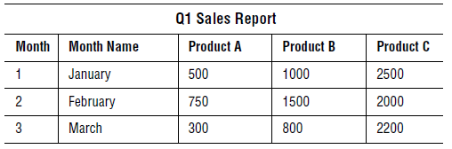
Figure 42 Example of a column-oriented result set.

In a row-oriented result set, the values of all data series are combined into a single column. Other data set information (such as x-values, timestamps, or point labels) are similarly combined into their own columns. One column is designated to contain the series id or, in the case of a pie chart, the slice id. The data in any given row belongs to the series identified in the series id/slice id column. A row, therefore, represents the values of one series and its related information at a single point. In the following example, there are two series: Product A and Product B. The Product column contains the series id values, that is, the names of the products. Each row describes a monthly data point for the stated product.

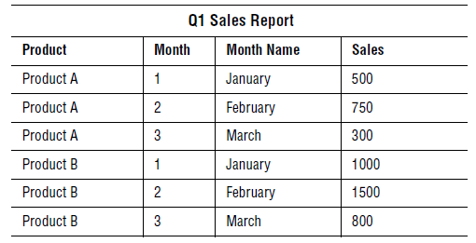Figure 43 Example of a row-oriented result set.
In the next section, we show how to add data to a chart. The data in the preceding tables are used in the examples.

5.2 Adding Data from a Result Set to a Chart
In this section, we show how you can add JDBC data to a chart in three easy steps:

- Creating a Data Set
Create an instance of a ResultSetDataSet class and bind your data.
- Creating the Data Model
Create an instance of DefaultDataModel and add your data set.
- Setting the Data Model on a Chart
Set the data model on the chart.

5.2.1C reating a Data Set

To create a data set, you begin by selecting the implementation best suited for your chart type and creating an instance of it. For example, if you are creating a plot-type or area-type chart, you would create an instance of BasicResultSetDataSet. Next bind your data to columns or rows in the JDBC result set using the addResultSetBinding() method.

The examples in this section use the sample data from Figure 42 and Figure 43. The programmer uses a Vector object to create lists, but you can use whichever List implementation you prefer.

Note: While these examples use BasicResultSetDataSet, the code for the other chart-type implementations is similar. For more information, see Section 5.3, Chart Types and Data Set Classes.

Example of Binding a Column-oriented Result Set

The following code snippet creates and uses BasicResultSetDataSet with a column-oriented result set. The three Product columns are listed and then bound as the data series. The x-values are bound to the Month column, and the labels for the x-values are bound to the Month Name column. To see an image of a chart with the sample data, see Figure 44.

// Create an instance of the data set implementation.
BasicResultSetDataSet myResultSetDataSet = new BasicResultSetDataSet();

// Create a list containing the columns to bind to the data series.
Vector seriesColumnNames = new Vector();
seriesColumnNames.add("Product A");
seriesColumnNames.add("Product B");
seriesColumnNames.add("Product C");

// Bind column-oriented data to the chart in the following order:
// name of the resultset = myResultSet
// name of the column containing x-values = “Month”
// name of the column containing labels for the x-values = “Month Name”
// the List containing the data series bindings = seriesColumnNames
myResultSetDataSet.addResultSetBinding(myResultSet,
"Month",
"Month Name",
seriesColumnNames,
null);
The null value in the above code snippet means that the values for seriesColumnNames will be used for seriesLabels as well. You could specify your own labels.

Example of Binding a Row-oriented Result Set

The following code snippet creates and uses BasicResultSetDataSet with a row-oriented result set. The series id and the series label are bound to the Product column. The series label format string is in the format specified by the java.text.MessageFormat class. The x-values are bound to the Month column, and the labels for the x-values are bound to the Month Name column. The y-values are bound to the Sales column. To see an image of a chart with the sample data, see Figure 45.

// Create an instance of the data set implementation.
BasicResultSetDataSet myResultSetDataSet = new BasicResultSetDataSet();

// Create a list containing the name of the column with the series ids.
Vector seriesColumnNames = new Vector();
seriesColumnNames.add("Product");

// Create a String to label series (uses java.text.MessageFormat style).
String seriesLabelFormatString = “Product Name: {0}”;

// Create a list containing the column name to use for series labels.
Vector seriesLabelColumnNames = new Vector();
seriesLabelColumnNames.add("Product");

// Bind row-oriented data to the chart in the following order:

// name of the result set = myResultSet
// List containing the name of the series id column = seriesColumnNames
// String containing a label for all series = seriesLabelFormatString
// List containing series labels column = seriesLabelColumnNames
// name of the column containing x-values = “Month”
// name of the column containing labels for the x values = “Month Name”
// name of the column containing y-values = “Sales”
myResultSetDataSet.addResultSetBinding(myResultSet,
seriesColumnNames,
seriesLabelFormatString,
seriesLabelColumnNames,
“Month”,
“Month Name”,
“Sales”);

5.2.2 Creating the Data Model

After you create your data set implementation, you can add the data set to an instance of DefaultDataModel. The DefaultDataModel class is located in the package com.klg.jclass.chart.model.impl. It contains methods to add and return data sets, and to set and return top-level image map information. It is versatile enough so that it can be used as-is with most applications.

To use the DefaultDataModel class, you create an instance of it in your application. You then add data sets using one of the addDataSet*() methods.

Note: Data sets have to be instantiated and bound to your data before you can use them with a data model. The following code snippet assumes this has been done. For more information, see Section 5.2.1, Creating a Data Set.

DefaultDataModel myDataModel = new DefaultDataModel();
// To add a single data set, use the addDataSet() method.
myDataModel.addDataSet(myResultSetDataSet);
// For multiple data sets, use the addDataSets() method.
Vector myDataSets = new Vector();
myDataSets.add(myResultSetDataSet);
myDataSets.add(anotherResultSetDataSet);
myDataModel.addDataSets(myDataSets);

You can also set up top-level image map information in the data model. For more information, see Section 5.4.1, Chart-level Image Maps.

5.2.3 Setting the Data Model on a Chart

The final step in adding data to your chart is to set your instance of DefaultDataModel on the chart. You need to call one of the following methods:
- To replace any existing data on the chart, use the setDataModel() method.
JCChart.setDataModel(myDataModel);
- To add the data to pre-existing chart data, use the addDataModel() method.
JCChart.addDataModel(myDataModel);

The method queries the data model implementation for its list of data sets, image map information, style settings, and other data-related properties and sets this information on the chart. The data points returned by each data set are organized by the pertinent id (such as series, bar, slice) and converted into the data views and data series required for internal storage in chart. Data that is required to be in Array format (as per the chart type specified in the data set) is converted at this time. For more information on the internal workings of chart data storage, see Chapter 4, Adding Data with the Underlying Data Model.

This completes the process of adding data to a chart. The next section describes the chartspecific classes available for JDBC results sets.

5.3 Chart Types and Data Set Classes
ChartsThis section describes all the pre-built ResultSetDataSet implementation classes provided with JClass ServerChart. These implementations use method parameter names and offer attributes that are meaningful in the context of a particular type of chart.

The following charts have chart-specific ResultSetDataSet classes:
- Plot and Area Charts
- Bar Charts
- Financial Charts
- Pie Charts
- Polar Charts
- Radar Charts
- Timeline

5.3.1 Plot and Area Charts

The BasicResultSetDataSet data set implementation can be used to create most charts (financial-based charts excluded). However, the terminology used to name parameters and data point attributes is designed to be meaningful for area, stacking area, plot, and scatter plot charts. To bind data to these types of charts, you create an instance of BasicResultSetDataSet.java. You then bind the data using the addResultSetBinding() method. For an example, see Section 5.2.1, Creating a Data Set.

5.3.1.1 BasicResultSetDataSet by Column

The following image shows how to bind parameters to a sample result set.

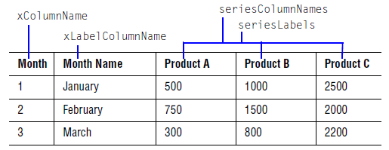

The parameters are passed to the addResultSetBinding() method in the following order:

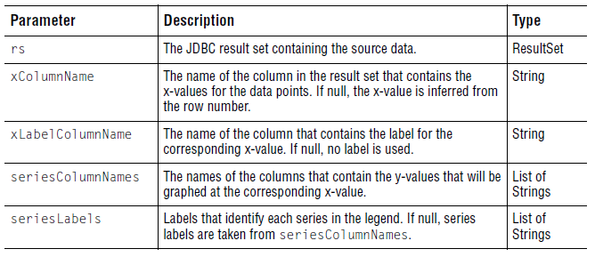

The following image shows the sample data graphed on a chart.

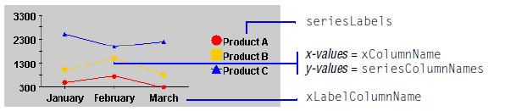
Figure 44 A plot chart displaying column-oriented sample data.

5.3.1.2 BasicResultSetDataSet by Row

The following image shows how to bind parameters to a sample result set.
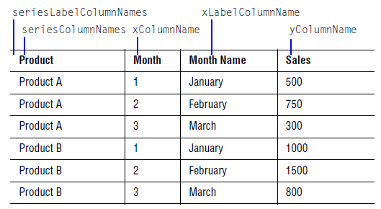

The parameters are passed to the addResultSetBinding() method in the following order:
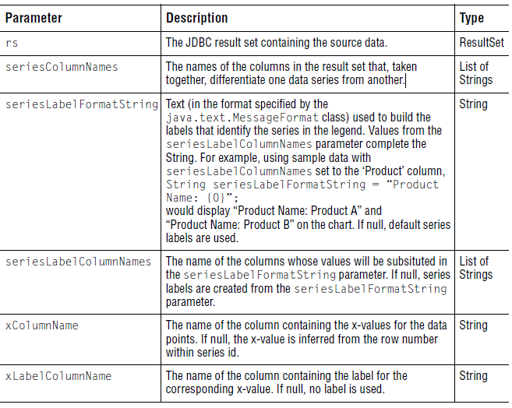
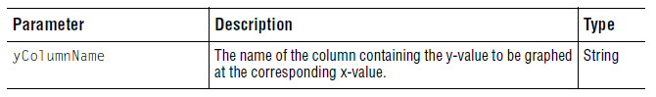

The following image shows the sample data graphed on a chart.

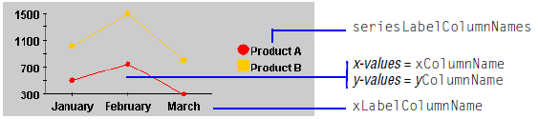
Figure 45 A plot chart displaying row-oriented sample data.

5.3.2 Bar Charts

To bind data in a result set to a bar or stacking bar chart, you can create an instance of BarResultSetDataSet and then pass bar-chart specific parameters to the addResultSetBinding() method. For an example, see Section 5.2.1, Creating a Data Set.

5.3.2.1 BarResultSetDataSet by Column

The following image shows how to bind parameters to a sample result set.

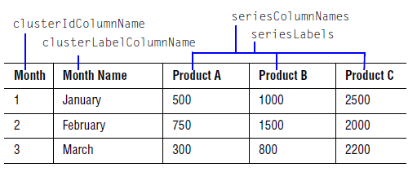

The parameters are passed to the addResultSetBinding() method in the following order:
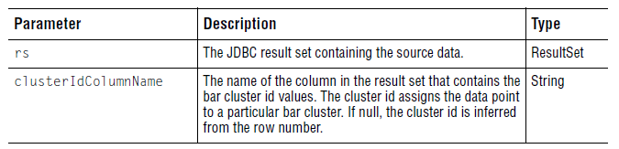
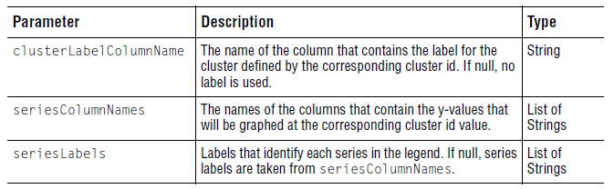

The following image shows the sample data graphed on a chart.

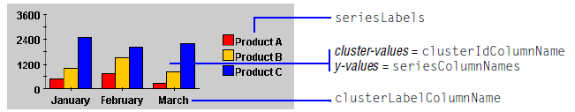
Figure 46 A bar chart displaying column-oriented sample data.

5.3.2.2 BarResultSetDataSet by Row

The following image shows how to bind parameters to a sample result set.

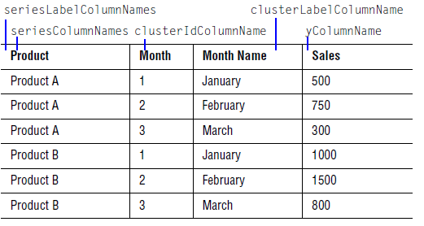
The parameters are passed to the addResultSetBinding() method in the following order:
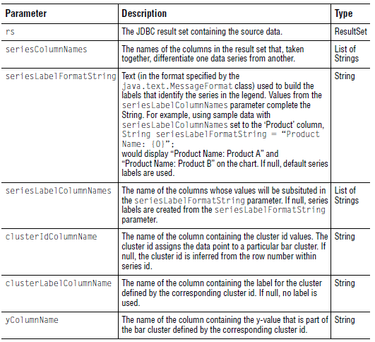

he following image shows the sample data graphed on a chart.

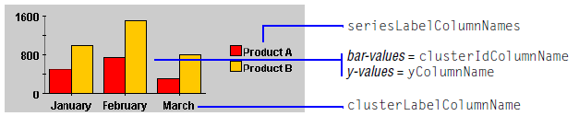
Figure 47 A bar chart displaying row-oriented sample data.

5.3.3 Financial Charts

To bind data in a result set to a candle, Hi-Lo, or Hi-Lo-Open-Close chart, you can create an instance of FinancialResultSetDataSet and then pass financial-chart specific parameters to the addResultSetBinding() method. For an example, see Section 5.2.1, Creating a Data Set.

5.3.3.1 FinancialResultSetDataSet by Column

The following image shows how to bind parameters to a sample result set.

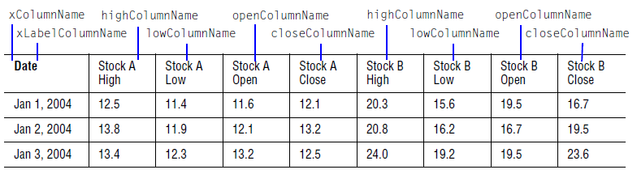

The parameters are passed to the addResultSetBinding() method in the following order:
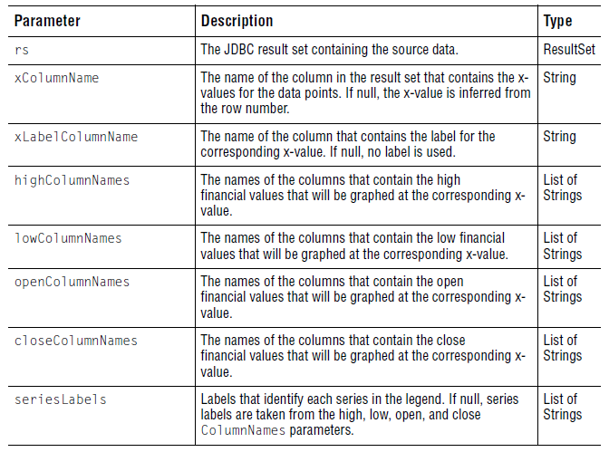

The following image shows the sample data graphed on a chart.
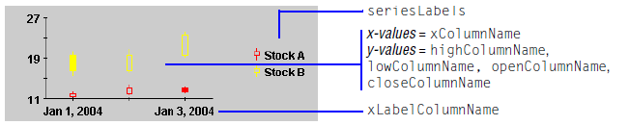
Figure 48 A financial chart displaying column-oriented sample data.

5.3.3.2 FinancialResultSetDataSet by Row

The following image shows how to bind parameters to a sample result set.

Note: High, low, open, and close values must be in separate columns in the result set.

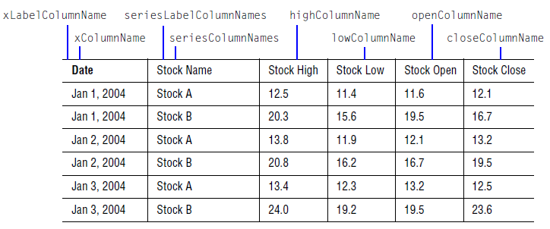
The parameters are passed to the addResultSetBinding() method in the following order:

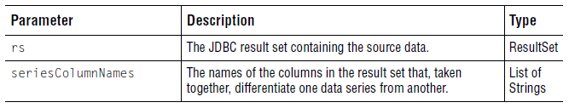
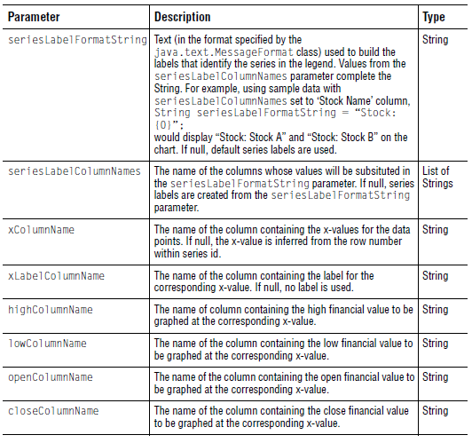
The following image shows the sample data graphed on a chart.

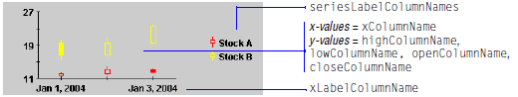
Figure 49 A financial chart displaying row-oriented sample data.

5.3.4 Pie Charts

To bind data in a result set to a pie chart, you can create an instance of PieResultSetDataSet and then pass pie-chart specific parameters to the addResultSetBinding() method. For an example, see Section 5.2.1, Creating a Data Set.

5.3.4.1 PieResultSetDataSet by Column
The following image shows how to bind parameters to a sample result set.
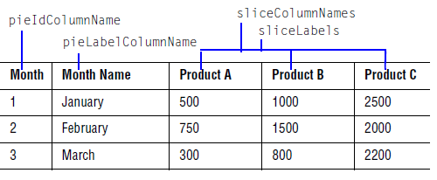
The parameters are passed to the addResultSetBinding() method in the following order:

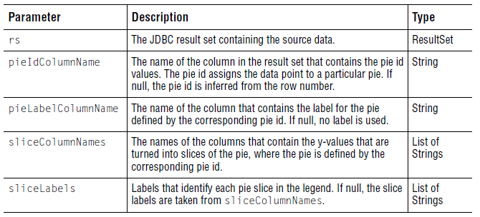
The following image shows the sample data graphed on a chart.
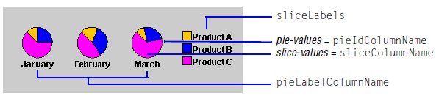
Figure 50 Pie charts displaying column-oriented sample data.

5.3.4.2 PieResultSetDataSet by Row
The following image shows how to bind parameters to a sample result set.
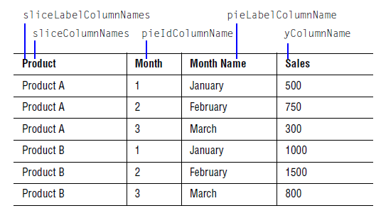
The parameters are passed to the addResultSetBinding() method in the following order:

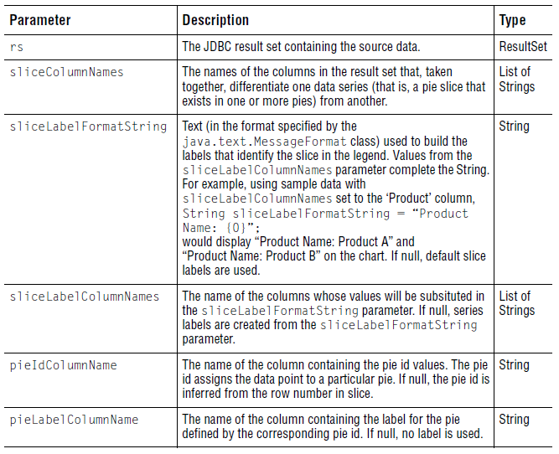
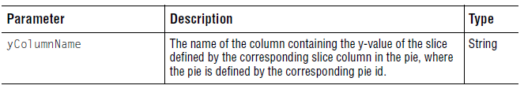

The following image shows the sample data graphed on a chart.

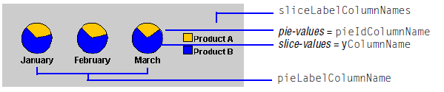
Figure 51 Pie charts displaying row-oriented sample data.

5.3.5 Polar Charts
To bind data in a result set to a polar chart, you can create an instance of PolarResultSetDataSet and then pass polar-chart specific parameters to the addResultSetBinding() method. For an example, see Section 5.2.1, Creating a Data Set.

5.3.5.1 PolarResultSetDataSet by Column
The following image shows how to bind parameters to a sample result set.

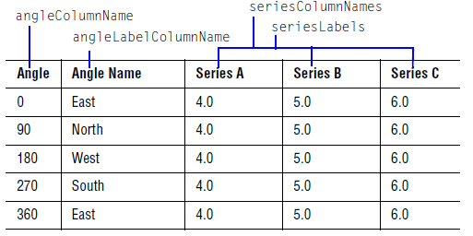

The parameters are passed to the addResultSetBinding() method in the following order:
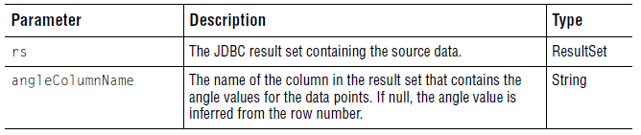
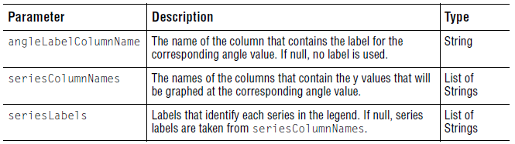

The following image shows the sample data graphed on a chart.

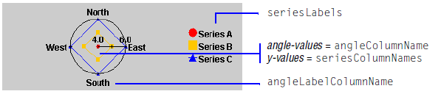
Figure 52 A polar chart displaying column-oriented sample data.

5.3.5.2 PolarResultSetDataSet by Row

The following image shows how to bind parameters to a sample result set.
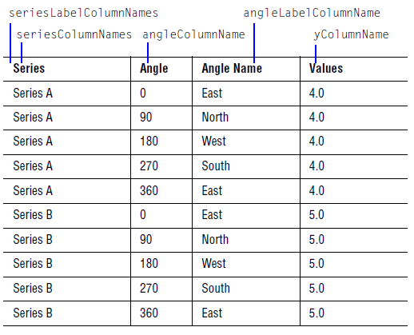
The parameters are passed to the addResultSetBinding() method in the following order:
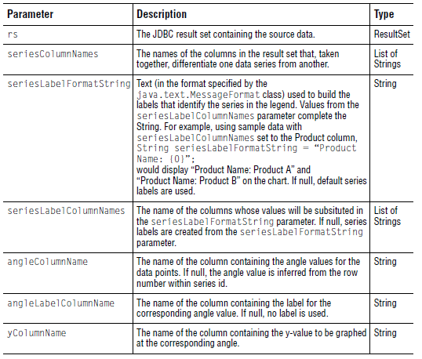

The following image shows the sample data graphed on a chart.

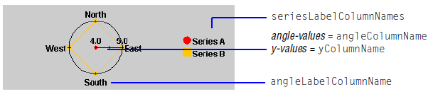
Figure 53 A polar chart displaying row-oriented sample data.

5.3.6 Radar Charts

To bind data in a result set to a radar or area radar chart, you can create an instance of RadarResultSetDataSet and then pass bar-chart specific parameters to the addResultSetBinding() method. For an example, see Section 5.2.1, Creating a Data Set.

5.3.6.1 RadarResultSetDataSet by Column

The following image shows how to bind parameters to a sample result set.
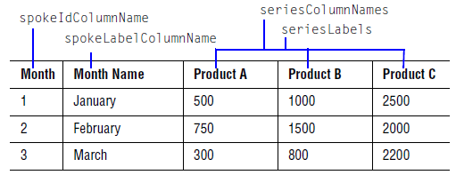

The parameters are passed to the addResultSetBinding() method in the following order:
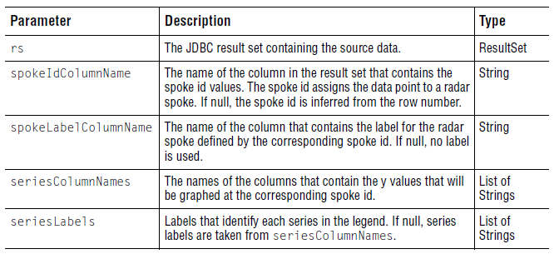

The following image shows the sample data graphed on a chart.

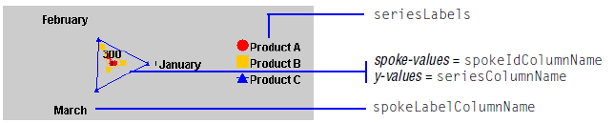
Figure 54 A radar chart displaying column-oriented sample data.

5.3.6.2 RadarResultSetDataSet by Row

The following image shows how to bind parameters to a sample result set.
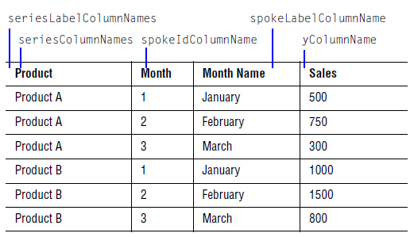

The parameters are passed to the addResultSetBinding() method in the following order:

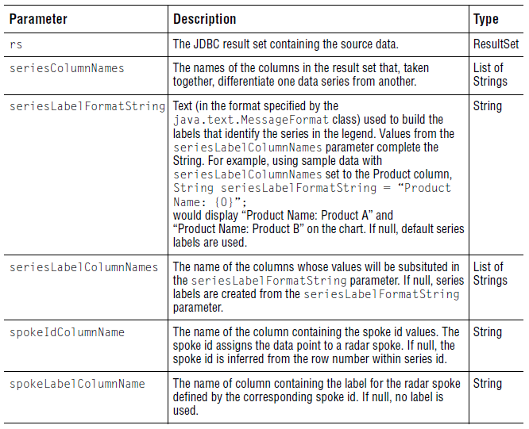
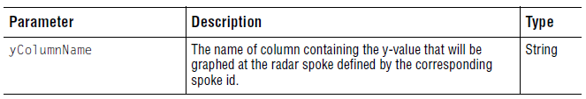

The following image shows the sample data graphed on a chart.

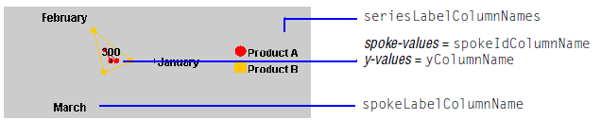
Figure 55A radar chart displaying row-oriented sample data.

5.3.7 Timeline Charts

There is no ResultSetDataSet implementation class for timeline charts. However, an example of a custom implementation of a timeline data set is provided in Section 5.6, Creating a Custom Data Set Implementation.

5.4 Adding Image Maps
You can define two levels of image maps: chart-level and data-level. Chart-level image maps apply to broadly defined areas on the chart and may be set on an instance of DefaultDataModel. Data-level image maps apply to areas represented by data drawn on the chart component and may be set on an instance of one of the ResultSetDataSet implementations. For more information, see also Chapter 10, Defining Image Maps.

5.4.1 Chart-level Image Maps

You can set chart-level image maps when you create your instance of DefaultDataModel. The following code snippet calls the set methods for all chart-level image map properties to set the image maps for these areas to point to the Quest Software web site. For more information, see Chapter 10, Defining Image Maps.

ImageMapInfo imageMap = new ImageMapInfo("http://www.quest.com", null);

// Set image maps on the following chart regions:
// Entire chart
myDataModel.setChartImageMap(imageMap);

// JCChartArea object
myDataModel.setChartAreaImageMap(imageMap);
// Area bounded by axes
myDataModel.setPlotAreaImageMap(imageMap);

// Header area
myDataModel.setHeaderImageMap(imageMap);

// Footer area
myDataModel.setFooterImageMap(imageMap);

// Legend area
myDataModel.setLegendImageMap(imageMap);

5.4.2 Data-level Image Maps

You can set data-level image maps when you create your instance of a ResultSetDataSet implementation. The image map information is added as parameters in the addResultSetBinding() method, after the values for the chart-specific parameters.

5.4.2.1 Defining Image Maps by Column
The image map information is added as parameters in the addResultSetBinding() method, after the values for the chart-specific parameters.

myResultSetDataSet.addResultSetBinding(rs, <chart-specific parameters>,
imageMapURLFormatStrings, imageMapURLColumnNames,
imageMapExtraFormatStrings, imageMapExtraColumnNames,
legendImageMapURLStrings, legendImageMapExtraStrings);

The following table describes the image map parameters for a column-oriented result set.

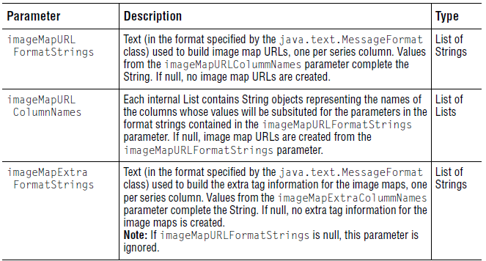
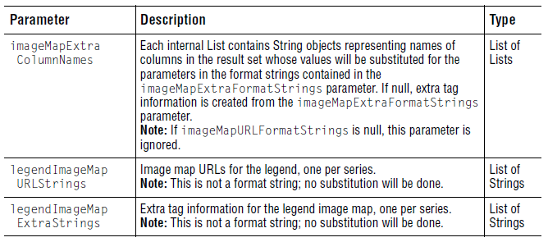

The following examples demonstrate how to use the image map parameters for column-oriented result sets.

Example of Setting Up the Image Map URL Parameters
The following code snippet sets up the image map URL parameters for each data point. Each image map points to a URL that identifies the product and the month as specified by the data point.

// Set up URL format strings, one for each series
Vector imageMapURLFormatStrings = new Vector();
imageMapURLFormatStrings.add("<URL_base>/productA/month{0}");
imageMapURLFormatStrings.add("<URL_base>/productB/month{0}");
imageMapURLFormatStrings.add("<URL_base>/productC/month{0}");

// Set up parameter column names for one image map URL
Vector productURLColumnNames = new Vector();
productURLColumnNames.add("Month");

// Set up the parameter column names for all image map URLs,
// one per series column. Here, we use the same parameter for all URLs,
// but this is not necessarily always the case.
Vector imageMapURLColumnNames = new Vector();
imageMapURLColumnNames.add(productURLColumnNames);
imageMapURLColumnNames.add(productURLColumnNames);
imageMapURLColumnNames.add(productURLColumnNames);

For example, for the data point where Month is 2 and the product is Product B, the URL is <URL_base>/productB/month2.

Example of Setting Up the Extra Tag Parameters
Setting up the extra tags parameters is similar to setting up the image map URL
parameters.

// Set up extra tags format strings, one for each series
Vector imageMapExtraFormatStrings = new Vector();
imageMapExtraFormatStrings.add("alt=\"Product A - {0}\"");
imageMapExtraFormatStrings.add("alt=\"Product B - {0}\"");

imageMapExtraFormatStrings.add("alt=\"Product C - {0}\"");
// Set up parameter column names for one extra tag
Vector productURLColumnNames = new Vector();
productURLColumnNames.add("Month Name");
// Set up the parameter column names for all extra tags,
// one per series column. Here, we use the same parameter for all
// extra tags, but this not necessarily always the case.
Vector imageMapExtraColumnNames = new Vector();
imageMapExtraColumnNames.add(productURLColumnNames);
imageMapExtraColumnNames.add(productURLColumnNames);
imageMapExtraColumnNames.add(productURLColumnNames);

For example, for the data point where Month is 2 and the product is Product B, the extra tag is alt="Product B - February".

Example of Setting Up the Legend Image Map Parameters
The following code snippet sets up the legend image map parameters for the series labels in the legend. Each image map points to a fully specified URL. Unlike the imageMapURLFormatStrings and imageMapExtraFormatStrings parameters, you cannot build the URL using values from another parameter.

// Straight URLs, one per series; no parameterization is done
Vector legendImageMapURLStrings = new Vector();
legendImageMapURLStrings.add("<URL_base>/productA");
legendImageMapURLStrings.add("<URL_base>/productB");
legendImageMapURLStrings.add("<URL_base>/productC");

// Straight text, one per series; no parameterization is done
Vector legendImageMapExtraStrings = new Vector();
legendImageMapExtraStrings.add("alt=\"Product A\"");
legendImageMapExtraStrings.add("alt=\"Product B\"");
legendImageMapExtraStrings.add("alt=\"Product C\"");

5.4.3 Defining Image Maps by Row
The image map information is added as parameters in the addResultSetBinding() method, after the values for the chart-specific parameters.

myResultSetDataSet.addResultSetBinding(rs, <chart-specific parameters>,
imageMapURLFormatString, imageMapURLColumnNames,
imageMapExtraFormatString, imageMapExtraColumnNames,
legendImageMapURLFormatString, legendImageMapURLColumnNames,
legendImageMapExtraFormatString,
legendImageMapExtraColumnNames);

The following table describes the image map parameters for a row-oriented result set.
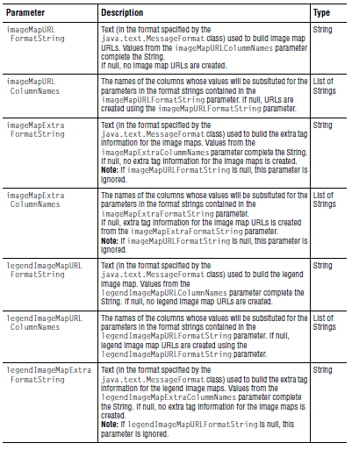
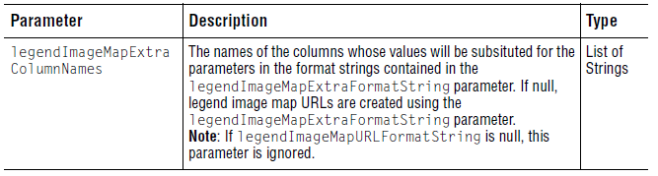

The following examples demonstrate how to use the image map parameters for row-oriented result sets.

Example of Setting Up the Image Map URL Parameters
The following code snippet sets up the image map URL parameters for each data point. Each image map points to a URL that identifies the product and the month as specified by the data point.

String imageMapURLFormatString = "<URL_base>/product={0}&month={1}";
Vector imageMapURLColumnNames = new Vector();
imageMapURLColumnNames.add("Product");
imageMapURLColumnNames.add("Month");

For example, for the data point where Month is 2 and the product is Product B, the URL is <URL_base>/product=Product B&month=2.

Example of Setting Up the Extra Tag Parameters
Setting up the extra tags parameters is similar to setting up the image map URL parameters.

String imageMapExtraFormatString = "alt=\"{0} - {1}\""
Vector imageMapExtraColumnNames = new Vector();
imageMapExtraColumnNames.add("Product");
imageMapExtraColumnNames.add("Month");

For example, for the data point where Month is 2 and the product is Product B, the extra tag is alt="Product B - February".

Example of Setting Up the Legend Image Map Parameters
The following code snippet sets up the legend image map parameters for the series labels in the legend. Each image map points to a URL associated with the series.

String legendImageMapURLFormatString = "<URL_base>/product={0}";
Vector legendImageMapURLColumnNames = new Vector();
legendImageMapURLColumnNames.add("Product");

String legendImageMapExtraFormatString = "alt=\"{0}\"";
Vector legendImageMapExtraColumnNames = new Vector();
legendImageMapExtraColumnNames.add("Product");

For example, for the data point where Month is 2 and the product is Product B, the image map URL is <URL_base>/product=Product B and the extra tag is alt="Product B".

5.5 Setting Other Data-related Attributes
The result set data set implementations offer additional attributes that are related to the data, but not part of it. For example, you can set the name of an axis. The following sections summarize the available properties. Some properties are available in more than one data set implementation; these are listed under Shared Properties. Other properties are only offered by a single data set implementation as outlined in Section 5.5.2, Chart-specific Properties. The methods to set these properties are described in the API Documentation.

5.5.1 Shared Properties

The following table summarizes the properties that are shared among some or all of the result set data set implementations (as noted). You can use any of the properties indicated for the type of chart that you are creating. In addition, there are some chart-specific properties. For details, see Section 5.5.2, Chart-specific Properties.
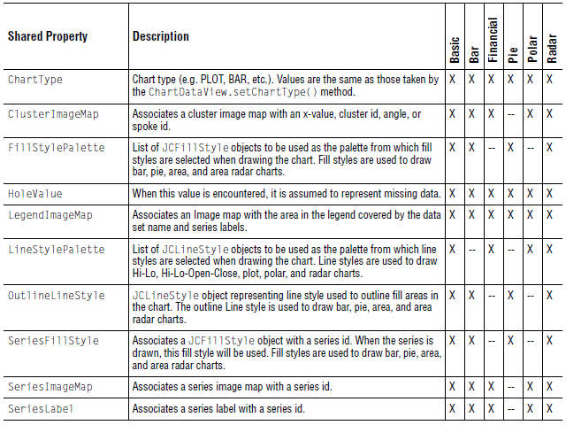
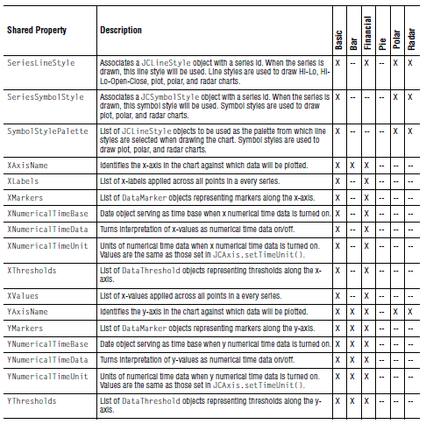

5.5.2 Chart-specific Properties
The following data set classes also contain properties unique to the chart types:
- BarResultSetDataSet
- FinancialResultSetDataSet
- PieResultSetDataSet
- PolarResultSetDataSet
- RadarResultSetDataSet

BarResultSetDataSet
You can set the following properties for bar charts:
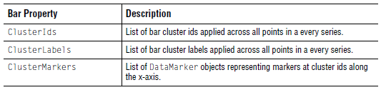

FinancialResultSetDataSet
You can set the following properties for financial charts:

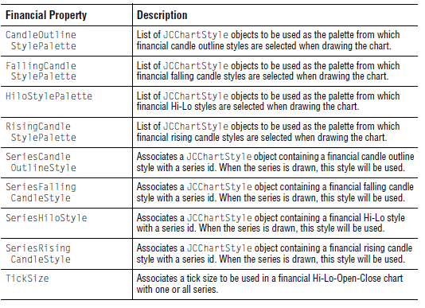
PieResultSetDataSet
You can set the following properties for pie charts:
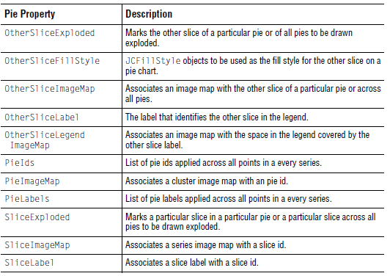

PolarResultSetDataSet
You can set the following properties for polar charts:

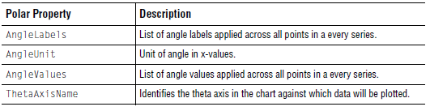

RadarResultSetDataSet
You can set the following properties for radar charts:

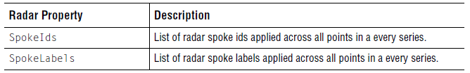

5.6 Creating a Custom Data Set Implementation
The JDBC result set data set implementations are based on a set of interfaces and classes. If your data is not in a JDBC result set, you can use these interfaces and classes to create a data set implementation that works with the format of your existing data source. The data source can be a flat file, a database-related format, or some other format.

This section provides an overview of the data model, followed by a BasicDataSet implementation example. After the example is a guide to help you select interfaces and classes for your own data set implementation. The sample code at the end of the section extends the BasicDataSet implementation example and demonstrates using the BarDataSet interface with its related style interface and data point class.

5.6.1 Understanding the Targeted Data Model

The targeted data model is based on a set of interfaces and classes. This section provides a high-level look at the interfaces and classes and how they work together. For details, see the JClass API Documentation.

5.6.1.1 Data Model Interface

The highest level interface is DataModel. It represents all data being added to the chart. Data is returned from the getDataSets() method as a List of data set implementations. An implementation of the DataModel interface, called DefaultDataModel.java, is provided and can be used in most applications. For more information, see Section 5.2.2, Creating the Data Model.

5.6.1.2 Data Set Interfaces and Classes

The data set interfaces and classes are divided into five categories: chart-type data sets, datatype data sets, style data sets, iterators, and data points. Many of the interfaces and classes are optimized for specific chart types. This enables you to bind data to the chart using terminology and properties suitable for that chart type. For example, the interface for a pie chart has pie slice properties while the interface for a radar chart has spoke properties.

The following table lists the interfaces and classes by category, describes the purpose for each category, and notes which interfaces and classes are required.

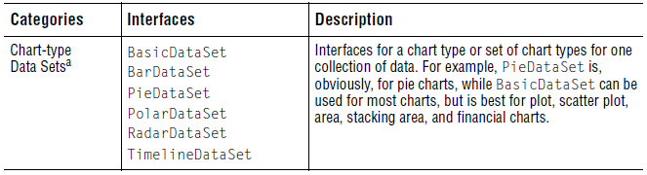
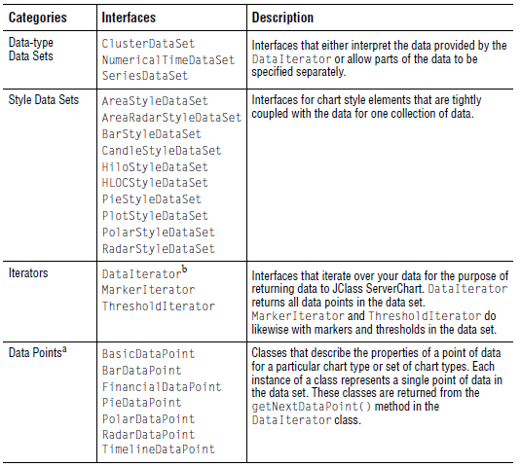
a. Required. You need to implement the interface/class that matches your chart type.
b. Required.

The data set for a chart is made by implementing the required interfaces and classes, plus any other interfaces that suit the chart type or data source. For example, if you want to create a data set implementation for an area chart where the data contains time data, you can implement the following interfaces and classes:

      - BasicDataSet
      - NumericalTimeDataSet
      - AreaStyleDataSet (optional)
      - DataIterator
      - BasicDataPoint

For more information, see Section 5.6.3, Summary of the Interfaces and Classes.

5.6.2 Plot Chart Example

The primary purpose of the data set implementation is to retrieve your data from wherever it is stored, assign the data to fields in a suitable DataPoint class, and return the DataPoint class from your implementation of DataIterator. The following example creates a data set implementation for a plot chart with three small series of three points each graphed against the default x and y axes. It is a simple data set implementation that takes values stored in local arrays and maps them to the fields in the BasicDataPoint class. There are no image maps, no markers, and no thresholds used in this example.

In your own implementation, you can expand on the methods used here or implement other interfaces, such as relevant data-type DataSet interfaces or a StyleDataSet interface.

import com.klg.jclass.chart.model.*;
import com.klg.jclass.chart.JCChart;
import com.klg.jclass.util.ImageMapInfo;

public class MyDataSet implements BasicDataSet, DataIterator {

protected double[][] yvalues = {{5.0, 6.0, 7.0},
{10.0, 4.5, 2.7},
{3.8, 8.6, 4.3}};
protected String[] seriesIds = {"Series 1", "Series 2", "Series 3"};
protected String[] xLabels = {"Jan", "Feb", "Mar"};

protected String dataSetName = null;
protected int dataCounter = 0;
protected int seriesCounter = 0;
private BasicDataPoint basicDataPoint;

public MyDataSet() {
dataSetName = "My Data Set";
basicDataPoint = new BasicDataPoint();
}

public void incrementCounters() {
dataCounter++;
if (dataCounter >= yvalues[seriesCounter].length) {
seriesCounter++;
dataCounter = 0;
}
}

/**
* DataIterator implementation
*/
public boolean hasMoreDataPoints() {
if (seriesCounter >= yvalues.length) {
return false;
}
return true;
}

public DataPoint getNextDataPoint() {

basicDataPoint.clear();
basicDataPoint.xValue = new Integer(dataCounter);
basicDataPoint.yValue = new Double(yvalues[seriesCounter]
[dataCounter]);

basicDataPoint.seriesId = seriesIds[seriesCounter];
basicDataPoint.seriesLabel = seriesIds[seriesCounter];
basicDataPoint.xLabel = xLabels[dataCounter];
incrementCounters();
return basicDataPoint;
}

/**
* BasicDataSet implementation
*/
public String getName() {
return dataSetName;
}

public int getChartType() {
return JCChart.PLOT;
}

public DataIterator getDataIterator() {
return this;
}

public Number getHoleValue() {
return new Double(Double.MAX_VALUE);
}
public DataOrder getDataOrder() {
return DataOrder.ASCENDING;
}

public ImageMapInfo getLegendImageMap() {
return null;

}
public Class getXDataType() {
try {
return Class.forName("java.lang.Number");
}
catch (ClassNotFoundException cnfe) {}
return null;
}
public Class getYDataType() {
try {
return Class.forName("java.lang.Number");
}
catch (ClassNotFoundException cnfe) {
return null;
}
}

public String getXAxisName() {
return null;
}
public String getYAxisName() {
return null;
}
public MarkerIterator getXMarkerIterator() {
return null;
}
public MarkerIterator getYMarkerIterator() {
return null;
}
public ThresholdIterator getXThresholdIterator() {
return null;
}
public ThresholdIterator getYThresholdIterator() {
return null;
}
}

5.6.3 Summary of the Interfaces and Classes

The following tables briefly describe the purpose of the interfaces and classes. After you select the interfaces and classes that you think you might use, consult the JClass API Documentation for details.

5.6.3.1 Chart-type DataSet Interfaces
When creating a custom data set implementation, you should start by selecting a DataSet interface that suits the type of chart that you want to provide.
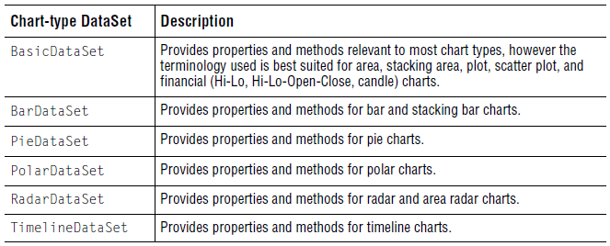

5.6.3.2 Data-type DataSet Interfaces

The data-type DataSet interfaces are required to support some types of data, in particular time data and data associated with a cluster or series of data. If your data source does not include these types of data, you do not need to implement a data-type DataSet interface.

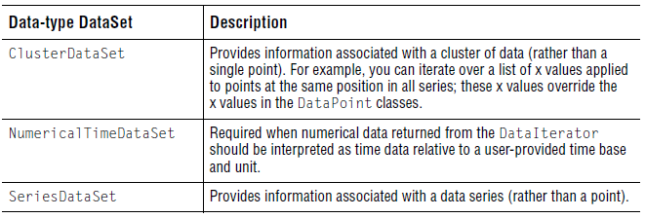

5.6.3.3 StyleDataSet Interfaces

StyleDataSet interfaces provide control over chart style elements that are tightly coupled with the data for one collection of data. If you are satisfied with the default styles, you do not need to implement a StyleDataSet interface. If you implement a StyleDataSet interface, select one that works with the chart-type DataSet that you are implementing.
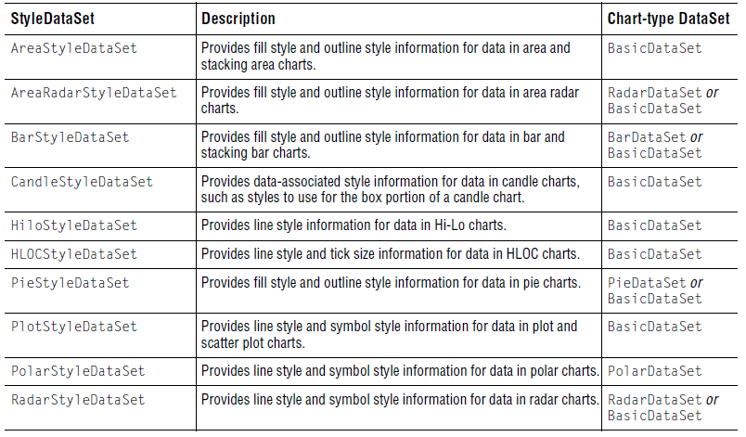

5.6.3.4 Iterator Interfaces

The DataIterator interface is required so that JClass ServerChart can iterate over the data points in the data source. If you intend to use markers or thresholds in your chart (not all chart types support them), you also need to implement the corresponding interface.

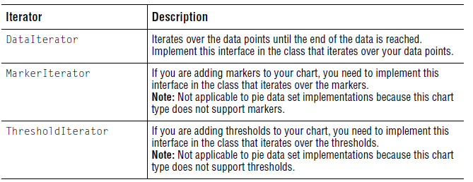

5.6.3.5 DataPoint Classes

DataPoint classes define the information necessary to describe a single data point of a specific chart type. You use the class to map the elements in your data source to a neutral format that can be understood by JClass ServerChart. Each instance of a class represents a single point of data in the data set.

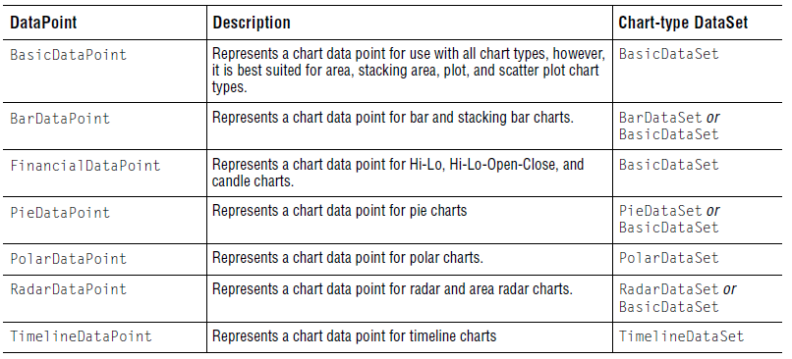

5.6.4 Bar Chart Example

The following example demonstrates the use of one of the specialized chart-type DataSet interfaces: BarDataSet. The sample code creates a MyBarDataSet implementation that extends the MyDataSet implementation covered in Section 5.6.2, Plot Chart Example. It implements the BarDataSet and BarStyleDataSet interfaces and uses the BarDataPoint class. BarStyleDataSet is used to define the fill style and outline style to be used in the chart. BarDataPoint has properties that are especially suited to binding data to a bar chart.

import com.klg.jclass.chart.*;
import com.klg.jclass.chart.model.*;

import java.awt.Color;

public class MyBarDataSet extends MyDataSet
implements BarDataSet, BarStyleDataSet {

private Color[] colors = {Color.red, Color.white, Color.blue};
private BarDataPoint barDataPoint;
public MyBarDataSet() {
dataSetName = "My Bar Data Set";
barDataPoint = new BarDataPoint();
}

public DataPoint getNextDataPoint() {
barDataPoint.clear();
barDataPoint.clusterId = xLabels[dataCounter];
barDataPoint.clusterLabel = xLabels[dataCounter];
barDataPoint.yValue = new Double(yvalues[seriesCounter][dataCounter]);
barDataPoint.seriesId = seriesIds[seriesCounter];
barDataPoint.seriesLabel = seriesIds[seriesCounter];
incrementCounters();
return barDataPoint;
}

public int getChartType() {
return JCChart.STACKING_BAR;
}

/**
* BarDataSet implementation. Rest of methods inherited from super class.
*/
public MarkerIterator getClusterMarkerIterator() {
return(null);
}

/**
* BarStyleDataSet implementation
*/
public JCFillStyle getFillStyle(Object seriesId) {
JCFillStyle fillStyle = null;
for (int i = 0; i < seriesIds.length; i++) {
if (seriesIds[i].equals(seriesId)) {
fillStyle = new JCFillStyle(colors[i], JCFillStyle.SOLID);
break;
}
}
return fillStyle;
}
public JCLineStyle getOutlineStyle() {
return new JCLineStyle(1, Color.MAGENTA, JCLineStyle.SOLID);
}
}

5.6.5 Timeline Chart Example

The following code examples were taken from datamodel/TimelineData.java and intro/TimelineChart.java located in the JCLASS_SERVER_HOME/examples/schart/ directory. A servlet that creates this chart can be found in servlet/TimelineServlet.java.

Create the data set binding (TimelineData.java)

The following example binds data to a timeline chart. It implements the TimelineDataSet, DataIterator, and NumericalTimeDataSet interfaces and uses the TimelineDataPoint class to create the data points. A data point is made up of an x-value, a state, and a data label. Note that all the states used in the chart are fully defined as enum State values before being used in the data point.

package examples.schart.datamodel;

import com.klg.jclass.chart.*;
import com.klg.jclass.chart.model.*;
import com.klg.jclass.chart.model.impl.DefaultDataSet;
import com.klg.jclass.util.swing.JCSwingTypeConverter;

import java.util.Calendar;
import java.util.Date;
import java.awt.*;

/**
* TimelineData - A data set which defines data for a timeline chart used
* for monitoring build processes.
*/
public class TimelineData extends DefaultDataSet
implements DataIterator,
TimelineDataSet,
NumericalTimeDataSet {

// State enum - includes a TimeLineState object
public enum State {
Clear("Inactive", null, null, null),
Extract("Extract",
new JCLineStyle(1, toColor("204-102-255"), JCLineStyle.SOLID),
new JCFillStyle(toColor("204-102-255"), JCFillStyle.SOLID),
null),
Compile("Compile",
new JCLineStyle(1, toColor("153-153-255"), JCLineStyle.SOLID),
new JCFillStyle(toColor("153-153-255"), JCFillStyle.SOLID),
null),
UnitTest("Unit test",
new JCLineStyle(1, Color.cyan, JCLineStyle.SOLID),
new JCFillStyle(Color.cyan, JCFillStyle.SOLID),
null),
Package("Package",
new JCLineStyle(1, toColor("102-204-255"), JCLineStyle.SOLID),
new JCFillStyle(toColor("102-204-255"), JCFillStyle.SOLID),
null),
Complete("Complete",
null,
null,
new JCSymbolStyle(JCSymbolStyle.DOT, Color.green, 12)),
Failure("Failure!",
null,
null,
new JCSymbolStyle(JCSymbolStyle.TRIANGLE, Color.red, 15)),
Blocked("BLOCKED",
new JCLineStyle(1, Color.red, JCLineStyle.LONG_DASH),
new JCFillStyle(Color.yellow, JCFillStyle.STRIPE_45,
toColor("255-153-153")),
null);

private TimeLineState timeLineState;
/**
* Get the TimeLineState object associated with this state.
* @return the state's TimeLineState object
*/
public TimeLineState getTimeLineState() {
return timeLineState;
}

protected static Color toColor(String colorString) {
return JCSwingTypeConverter.toColor(colorString, Color.black);
}

/**
* Constructor that creates the TimeLineState object associated
* with this state.
*
* @param label the label for this state
* @param lineStyle the line style for this state
* @param fillStyle the fill style for this state
* @param symbolStyle the symbol style for this state
*/
State(String label, JCLineStyle lineStyle, JCFillStyle fillStyle,
JCSymbolStyle symbolStyle) {
if (lineStyle == null) {
lineStyle = new JCLineStyle(1, Color.black, JCLineStyle.NONE);
}

if (fillStyle == null) {
fillStyle = new JCFillStyle(Color.black, JCFillStyle.NONE);
}
if (symbolStyle == null) {
symbolStyle = new JCSymbolStyle(JCSymbolStyle.NONE,
Color.black, 6);
}

JCChartStyle chartStyle = new JCChartStyle(lineStyle, fillStyle,
symbolStyle);

timeLineState =
new TimeLineState(null, label, chartStyle, true,
"Inactive".equals(label),
new JCDataRange(ordinal(), ordinal()));
}
}
protected double[][] timeData = {
{1.0, 5.0, 13.0, 16.5, 21.0, 21.0},
{4.0, 5.0, 10.0, 17.0, 21.0, 23.0, 23.0},
{15.0, 18.0, 19.0, 19.0}
};

protected State[][] stateData = {
{State.Extract, State.Compile, State.UnitTest,
State.Package, State.Complete, State.Clear},
{State.Extract, State.Compile, State.UnitTest,
State.Blocked,
State.Package, State.Complete, State.Clear},
{State.Extract, State.Compile, State.Failure,
State.Clear}
};
protected String[] seriesLabels = {"Series1", "Series2", "Series3"};
protected String[] trackLabels = {"The big project", "The small project",
"The new project"};
protected int dataCounter = 0;
protected int seriesCounter = 0;
protected TimelineDataPoint timelineDataPoint = new TimelineDataPoint();

/**
* No-args constructor for this class.
*/
public TimelineData() {}

// DataIterator implementation

/**
* Increment data and/or series counter for DataIterator
*/
public void incrementCounters() {
dataCounter++;
if (dataCounter >= stateData[seriesCounter].length) {
seriesCounter++;
dataCounter = 0;
}
}

/**
* Return true if there are more data points available.
*
* @return true if more data points are available.
*/
public boolean hasMoreDataPoints() {
return seriesCounter < stateData.length;
}

/**
* Get next data point.
*
* @return DataPoint extension object identifying next data point retrieved from
* data source.
*/
public DataPoint getNextDataPoint() {
timelineDataPoint.clear();
timelineDataPoint.xValue = timeData[seriesCounter][dataCounter];
timelineDataPoint.state =
stateData[seriesCounter][dataCounter].getTimeLineState();
timelineDataPoint.seriesId = new Integer(seriesCounter);
timelineDataPoint.seriesLabel = seriesLabels[seriesCounter];
timelineDataPoint.trackLabel = trackLabels[seriesCounter];
incrementCounters();
return timelineDataPoint;
}

/**
* Get the type of chart that is being graphed. This is implemented by
* subclasses.
*
* @return the type of chart being graphed.
*/
public int getChartType() {
return JCChart.TIMELINE;
}

// TimelineDataSet implementation

/**
* Get the data set name. Note that this name will be used in the chart's
* legend.
*
* @return the name of the data set.
*/
public String getName() {
return "Build system";
}

/**
* Get the DataIterator implementation that will be used to iterate over all
* data points in the data set.
*
* @return the DataIterator implementation.

*/
public DataIterator getDataIterator() {
return this;
}

/**
* Get the data type of x values in this data set. Currently allowed values
* are java.lang.Number and java.util.Date and java.lang.Object. It is
* important that this value be correct and all x data conform to it.
*
* @return a Class object representing the data type of x values
* in this data set.
*/
public Class<?> getXDataType() {
try {
return Class.forName("java.lang.Number");
}
catch (ClassNotFoundException e) {
e.printStackTrace();
}
return null;
}

/**
* Get the data type of y values in this data set. Currently allowed values
* are java.lang.Number and java.util.Date and java.lang.Object. It is
* important that this value be correct and all y data conform to it.
*
* @return a Class object representing the data type of y values
* in this data set.
*/
public Class<?> getYDataType() {
try {
return Class.forName("java.lang.Number");
}
catch (ClassNotFoundException e) {
e.printStackTrace();
}
return null;
}
/**
* Get the name of the x axis against which this data set will be graphed.
* If null, the default x axis will be used.
*
* @return the name of the x axis.
*/
public String getXAxisName() {
return "xaxis";
}

/**
* Get the name of the y axis against which this data set will be graphed.
* If null, the default y axis will be used.
*
* @return the name of the y axis.

*/
public String getYAxisName() {
return "yaxis";
}

/**
* Get the marker iterator for the x axis.
*
* @return the MarkerIterator implementation used to iterate over markers
* along the x axis. May be null if there are no markers.
*/
public MarkerIterator getXMarkerIterator() {
return null;
}

/**
* Get the marker iterator for the y axis.
*
* @return the MarkerIterator implementation used to iterate over markers
* along the y axis. May be null if there are no markers.
*/
public MarkerIterator getYMarkerIterator() {
return null;
}

/**
* Get the threshold iterator for the x axis.
*
* @return the ThresholdIterator implementation used to iterate over
* thresholds along the x axis. May be null is there are no
* thresholds along the xaxis.
*/
public ThresholdIterator getXThresholdIterator() {
return null;
}

/**
* Get the threshold iterator for the y axis.
*
* @return the ThresholdIterator implementation used to iterate over
* thresholds along the y axis. May be null is there are no
* thresholds along the yaxis.
*/
public ThresholdIterator getYThresholdIterator() {
return null;
}

// NumericalTimeDataSet implementation
/**
* Check whether x axis is using numerical time data.
* <p/>
* When subclass implements NumericalTimeDataSet, this method is called by
* DataSetConverter to retrieve the property.
*
* @return true if x data should be interpreted as numerical time data, that

* is values offset from the XTimeBase property in units specified
* by the XTimeUnits property.
*/
public boolean isXNumericalTimeData() {
return true;
}

/**
* Check whether y axis is using numerical time data.
* <p/>
* When subclass implements NumericalTimeDataSet, this method is called by
* DataSetConverter to retrieve the property.
*
* @return true if y data should be interpreted as numerical time data, that
* is values offset from the YTimeBase property in units specified
* by the YTimeUnits property.
*/
public boolean isYNumericalTimeData() {
return false;
}
/**
* Time base for numerical time data along the x axis.
* <p/>
* When subclass implements NumericalTimeDataSet, this method is called by
* DataSetConverter to retrieve the property.
*
* @return Date object representing base for numerical x time data.
*/
public Date getXTimeBase() {
// Set date to midnight April 20, 2010
Calendar cal = Calendar.getInstance();
cal.set(2010, 3, 20, 0, 0, 0);
return cal.getTime();
}

/**
* Time base for numerical time data along the y axis.
* <p/>
* When subclass implements NumericalTimeDataSet, this method is called by
* DataSetConverter to retrieve the property.
*
* @return Date object representing base for numerical y time data.
*/
public Date getYTimeBase() {
// Not used
return null;
}

/**
* Unit for numerical time data along the x axis.
* <p/>
* When subclass implements NumericalTimeDataSet, this method is called by
* DataSetConverter to retrieve the property.
*
* @return unit of numerical x time data. See JCAxis.getTimeUnit() for
* possible values.
*/
public long getXTimeUnit() {
return JCAxis.MINUTES;
}

/**
* Unit for numerical time data along the y axis.
* <p/>
* When subclass implements NumericalTimeDataSet, this method is called by
* DataSetConverter to retrieve the property.
*
* @return unit of numerical y time data. See JCAxis.getTimeUnit() for
* possible values.
*/
public long getYTimeUnit() {
return JCAxis.SECONDS;
}
}

Set the data set on a timeline chart (TimelineChart.java)
The following code except shows the how to set the data on a timeline chart. The code that defines the properties of the chart has been omitted for space reasons.

package examples.schart.intro;

import com.klg.jclass.chart.*;
import com.klg.jclass.chart.model.DataPointException;
import com.klg.jclass.chart.model.impl.DefaultDataModel;
import com.klg.jclass.schart.JCServerChart;
import com.klg.jclass.util.legend.JCLegend;
import com.klg.jclass.util.swing.JCExitFrame;
import com.klg.jclass.util.swing.JCSwingTypeConverter;
import examples.schart.datamodel.TimelineData;
...

/**
* Create a timeline chart that shows the status of various build processes.
*/
public class TimelineChart extends JCServerChart {
/**
* Default constructor for this class. Loads data and sets up chart.
*/
public TimelineChart() {
super();
setSize(750, 300);
setFillStyle(new JCFillStyle(toColor(“238-238-238”),
JCFillStyle.SOLID));

// SET THE TIMELINE DATA ON THE DATA MODEL

DefaultDataModel dataModel = new DefaultDataModel();
dataModel.addDataSet(new TimelineData());
try {
setDataModel(dataModel);
}
catch (DataPointException e) {
e.printStackTrace();
}

// Define the chart
...
}
}

6
Defining Axis Controls
Axis Labelling and Annotation Methods ■ Positioning Axes ■ Chart Orientation and Axis Direction
Setting Axis Bounds ■ Customizing Origins ■ Logarithmic Axis
Titling Axes and Rotating Axis Elements ■ Gridlines ■ Adding a Second Y-Axis

JClass ServerChart can automatically set properties based on the data, so axis numbering and data display usually do not need much customizing. However, you can control any aspect of the chart axes, depending on your requirements. This chapter covers the different axis controls available.

Note: If you are developing your chart application using one of the JClass ServerChart Beans, go to Chapter 16, Creating Charts with JavaBeans instead.

6.1 Axis Labelling and Annotation Methods
There are several ways to annotate the chart’s axes, each suited to specific situations. The chart can automatically generate numeric annotation appropriate to the data it is displaying; you can provide a label for each point in the chart (x-axis only); you can provide a label for specific values along the axis; or the chart can automatically generate time-based annotations.

Please note that none of the axis properties discussed in this section apply to pie charts, because pie charts do not have axes. To annotate a pie chart, use chart labels; for more information, please see Chart Labels, in Chapter 7.

Whichever annotation method you choose, the chart makes considerable effort to produce the most natural annotation possible, even as the data changes. You can fine-tune this process using axis annotation properties.

User-set annotations support the use of HTML tags. The use of HTML tags overrides the default Font and Color properties of the label.

Please note that HTML labels may not work with PDF or Flash encoding.

6.1.1 Choosing an Annotation Method

A variety of properties combine to determine the annotation that appears on the axes. The JCAxis AnnotationMethod property specifies the method used to annotate the axis. The valid annotation methods are:
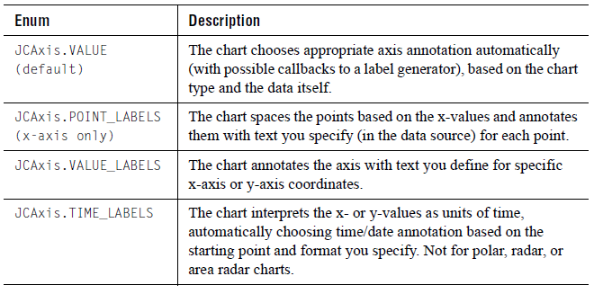

Notes:

- Point labels annotation (JCAxis.POINT_LABELS) is only valid for an x-axis when it has been added to the x-axis collection in JCChartArea. This means that a new JCAxis instance that has not yet been added to JCChartArea will not be considered an x-axis.
- The spokes of area radar and radar charts are automatically labelled “0”, “1”, “2”, and so forth, unless the x-annotation method is JCAxis.POINT_LABELS.
- For polar charts, the default annotation for JCAxis.VALUE depends on the angle units specified. If it is radians, the symbol for pi will not be used (it will be represented by 3.14 instead). Also, the x-axis will always be linear; that is, setting the logarithmic properties to true will be ignored.

The following topics discuss setting up and fine-tuning each type of annotation.

6.1.2 Values Annotation

Values annotation produces numeric labelling along an axis, based on the data itself. The chart can produce very natural-looking axis numbering automatically, but you can fine-tune the properties that control this process.

When a JCAxis is instantiated, a pair of JCAnno objects representing default labels and ticks are automatically created and set on the axis. Those default JCAnno objects may be modified, deleted, or augmented with other JCAnno objects.

JCAnno Object
The following table describes the different properties that can be set on a JCAnno object in order to customize the labels and tick marks:
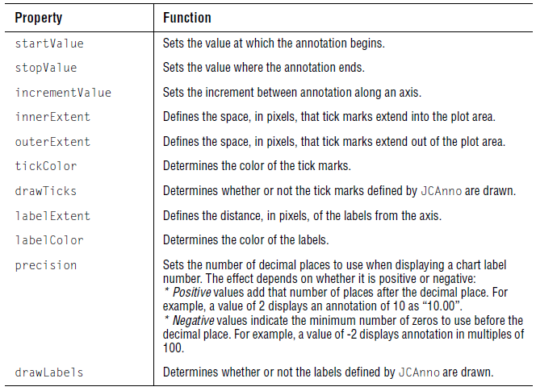

When the annotation method for an axis is VALUE_LABELS, POINT_LABELS, or TIME_LABELS, the labels are either user-supplied or internally generated without the use of JCAnno objects. The boolean UseAnnoTicks property of a JCAxis determines how tick marks are drawn in those cases. If UseAnnoTicks is true, tick marks are drawn at the labels. If the value is false, ticks defined by JCAnno objects are drawn instead.

Using multiple JCAnno objects, an axis can be drawn with major and minor ticks. Labels can be turned on or off for the individual tick series, as can the actual tick marks, enabling further flexibility.

Figure 56 Different tick styles that can be applied to a chart axis.

6.1.3 PointLabels Annotation

PointLabels annotation displays defined labels along an x-axis. This is useful for annotating the x-axis of any chart for which all series share common x-values. PointLabels are most useful with bar, stacking bar, pie, and timeline charts. It is possible to add, remove, and edit PointLabels. In JClass ServerChart, PointLabels are typically defined with the data.

Figure 57 PointLabels x-axis annotation.

PointLabels are a collection of labels. The first label applies to the first point, the second label applies to the second point, and so on. The labels can also be supplied by setting the PointLabels property of the ChartDataView object for this chart. For example, the following code specifies labels for each of the points on the x-axis:

String[] labels = {"Q1", "Q2", "Q3, "Q4"}; c.getChartArea().getXAxis(0).setAnnotationMethod(JCAxis.POINT_LABELS);
ChartDataView cd = c.getDataView(0);
ArrayList pLabels = new ArrayList();
for (int i = 0; i < labels.length; i++) {
pLabels.add(labels[i]);
}
cd.setPointLabels(pLabels);

For polar, radar, and area radar charts, if the x-axis annotation is POINT_LABELS and the data is of type array, then a point label is drawn at the outside of the x-axis for each point. (Series labels are used in the legend as usual.)

Note: If you are using the targeted data model, you can set x-axis labels in your data set implementation. For more information, see Setting Other Data-related Attributes, in Chapter 5.

6.1.4 ValueLabels Annotation

ValueLabels annotation displays labels at the axis coordinate specified. This is useful for displaying special text at a specific axis coordinate, or when a type of annotation that the chart does not support is needed, such as scientific notation. You can set the axis coordinate and the text to display for each ValueLabel, and also add and remove individual ValueLabels.

Figure 58 Using ValueLabels to annotate axes.

Every label displayed on the axis is one ValueLabel. Each ValueLabel has a Value property and a Label property.

If the AnnotationMethod property is set to JCAxis.VALUE_LABELS, the chart places labels at explicit locations along an axis. The ValueLabels property of JCAxis, which is a ValueLabels collection, supplies this list of Strings and their locations. For example, the following code sets value labels at the locations 10, 20, and 30:

String[] labels = {"Sales", "Beta Testing",
"Documentation",
"Alpha Testing", "Programming",
"Production Definition"};
JCAxis y = c.getChartArea().getYAxis(0);
y.setAnnotationMethod(JCAxis.VALUE_LABELS);
JCValueLabel[] valueLabels = new JCValueLabel[labels.length];
for (int i = 0; i < labels.length; i++) {
valueLabels[i] = new JCValueLabel(10.0 * (i + 1), labels[i], y);
}
y.setValueLabels(valueLabels);

The ValueLabels collection can be indexed either by subscript or by value:

JCAxis x = c.getChartArea().getXAxis(0);
// The following retrieves the second value label
JCValueLabel v1 = x.getValueLabels(1);
// The following retrieves the closest label to chart coordinate 2.0
JCValueLabel v2 = x.getValueLabel(2.0);

6.1.5 TimeLabels Annotation

TimeLabels annotation interprets the value data as units of time. The chart calculates and displays a time axis based on the starting point and format specified. A time axis is useful for charts that measure something in seconds, minutes, hours, days, weeks, months, or years.

Note: Timeline charts automatically implement a time axis along the x-axis.

Figure 59 TimeLabels annotating x-axes and y-axes.

6.1.5.1 Time-related Properties

Five properties are used to control the display and behavior of TimeLabels:
- AnnotationMethod (set to JCAxis.TIME_LABELS to use this annotation method)
- TimeUnit
- TimeBase
- TimeFormat
- SkipWeekends

Time Unit
Use the TimeUnit property to specify how to interpret the values in the data. Select either JCAxis.SECONDS, JCAxis.MINUTES, JCAxis.HOURS, JCAxis.WEEKS, JCAxis.MONTHS, or JCAxis.YEARS. For example, when set to JCAxis.YEARS, values that range from 5 to 15 become a time axis spanning 10 years. By default, TimeUnit is set to JCAxis.SECONDS.

Time Base
Use the TimeBase property to set the date and time that the time axis starts from. Use the Java Date class (java.util.Date) to specify the TimeBase. The default for TimeBase is the current time.

For example, the following statement sets the starting point to January 15, 1985:
c.getChartArea().getXAxis(0).setTimeBase(new Date(85,0,15));

Time Format
Use the TimeFormat property to specify the text to display at each annotation point. The TimeFormatIsDefault property allows the chart to automatically determine an appropriate format based on the TimeUnit property and the data, so it is often unnecessary to customize the format.

TimeFormat specifies a time format. You build a time format using the Java time format codes from the java.text.SimpleDateFormat class. The chart displays only the parts of the date/time specified by TimeFormat. The format codes are based on the default Java formatting provided by java.text.
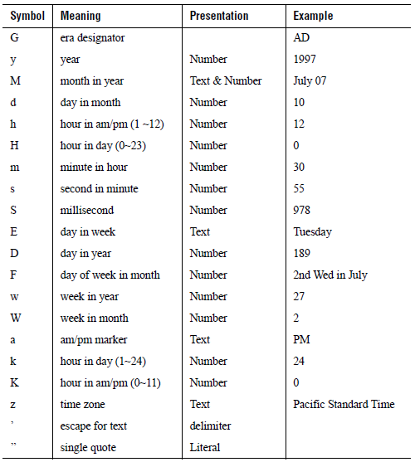

The default for TimeFormat is the same as the default used by Java’s SimpleDateFormat class (located in the java.text package).

SkipWeekends
The SkipWeekends property is intended for use with financial data, where there is usually data for Monday through Friday but not for Saturday and Sunday. For example, in a HLOC chart showing fluctuating stock prices, there is no sense reporting data for the weekend when the stock markets are closed. Your data should be at the day granularity.

By default, weekends are included in a time axis. To exclude weekends from a time axis, set the SkipWeekends property to true.

When skipping weekends, you should bear in mind the following behaviors:

- The axis time base should not start on a weekend, because labels may overlap or there may actually be no labels.
- The displayed time units must be days. The actual axis time unit (the value of the TimeUnit property) should also be days but its not necessary. However, even if the actual axis time unit is days, if the time interval for axis min to axis max is long enough, the annotation may not display in days. If this is true, the annotation may not display properly if a generated tick or label happens to fall on a weekend.
- When weekends are dropped in a plot chart, the first data point of a week is connected to the last data point of the previous week. If the minimum value of a time axis falls on a weekend, the minimum is set to the start of the first weekday. If the maximum value of a time axis falls on a weekend, the maximum is set to the end of the last weekday.

You can also exclude other periods of time from a time axis. For more information, see Section 6.1.5.2, Excluding Other Periods of Time from a Time Axis.

6.1.5.2 Excluding Other Periods of Time from a Time Axis

In addition to using the SkipWeekends property of JCAxis, you also have the option of excluding other periods of time on the time axis. For example, you may only want to see data for the time period between 9:30 am and 4:00 pm, and ignore the early morning and evening hours. You can express the duration of an excluded time period in minutes, hours, days, weeks, months, or years. The exclusion can be a one-time event or a recurring event (days and weeks only). You can define as many exclusions as you need. The exclusions can be applied simultaneously with the SkipWeekends property, and the exclusions (including skipped weekends) can overlap. To create an exclusion, you define a JCTimeExclusion object.

JCTimeExclusion Object

JCTimeExclusion offers a variety of constructors that take some or all of the following properties. For more information, look up JCTimeExclusion in the API documentation.

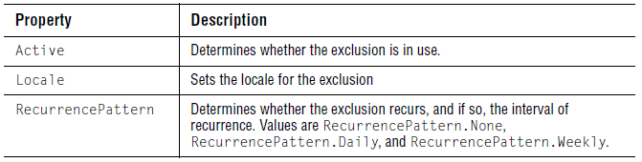
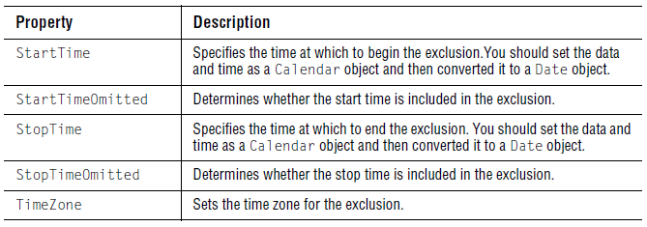

Depending on the value of the RecurrencePattern property, the StartTime and StopTime properties are interpreted in different ways.

- When RecurrencePattern.None, the exclusion is a one-time event that can span any duration of time. The date and time used for the StartTime must precede the date and time assigned to the StopTime.
- When RecurrencePattern.Daily, the exclusion is applied every day to a block of time. If the StartTime is later in the day than the StopTime, JClass ServerChart automatically wraps the exclusion across days. For example, to exclude all data except the data between 9:30 a.m. and 4:00 p.m., you could create an exclusion from 16:00 to 09:30, omitting the start and stop times themselves. The resulting exclusion is shown by the cross-hatched lines in the following illustration:

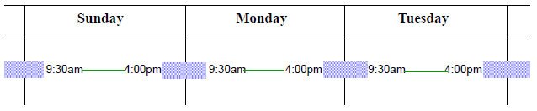

- When RecurrencePattern.Weekly, the exclusion is applied every week to the specified days. In many locales, the week begins on Sunday and ends on Saturday. For example, the SkipWeekends property is an application of a weekly recurrence pattern, which starts Saturday at 00:00 and ends Sunday at 24:00 (depending on the locale).

When exclusions are applied to a chart, the data for the excluded time periods are not drawn on the chart. If entire days are excluded, the days are omitted from the axis.

Caution: If multiple exclusions result in all time being excluded, the chart is undefined. You may want to apply exclusions one at a time and verify the results in your chart.

The following code excerpt focuses on the elements you need to include to create an exclusion. The example omits data for weekends and excludes daily data from16:00 to 09:30 throughout the week. The example includes a createDate() method that shows how the date and time for the exclusion’s StartTime and StopTime are transformed into a Date object using an int[] data array and a Calendar object. The int values in the data array specify the year, month, day, hour, minute, and second.

import com.klg.jclass.chart.*;
import static com.klg.jclass.chart.JCTimeExclusion.RecurrencePattern;
...
import java.util.Calendar;
import java.util.Date;
...
protected Calendar c;
protected JCChart chart;
...
// Daily exclusion times - starts at 4pm and ends at 9:30am
protected int[] start = {2009, 0, 1, 16, 0, 0};
protected int[] end = {2009, 0, 1, 9, 30, 0};
...

/**
* Add a weekend and daily exclusion to a passed in chart.
* @param chart the chart to which the exclusions are to be added
* @param c a calendar object to help with calculations
*/
private void createExclusions(JCChart chart, Calendar c) {
JCAxis xaxis = chart.getDataView(0).getXAxis();
JCTimeExclusion ex =
new JCTimeExclusion(createDate(start, c),
createDate(end, c),
true, true,
RecurrencePattern.Daily);
xaxis.addTimeExclusion(ex);
xaxis.setSkipWeekends(true);
}
...

/**
* Create a Date object based on a passed in date array.
* @param dateArray the date array to use
* @param c a calendar object to use in calculations
* @return the newly created Date object
*/
protected Date createDate(int[] dateArray, Calendar c) {
if (c == null) {
return null;
}
c.clear();
if (dateArray != null) {
if (dateArray.length >= 6) {
c.set(dateArray[0], dateArray[1], dateArray[2],
dateArray[3], dateArray[4], dateArray[5]);
}
else if (dateArray.length >= 5) {
c.set(dateArray[0], dateArray[1], dateArray[2],
dateArray[3], dateArray[4]);
}
else if (dateArray.length >= 3) {
c.set(dateArray[0], dateArray[1], dateArray[2]);
}
else {
c.setTimeInMillis(System.currentTimeMillis());
}
}
return c.getTime();
}

6.1.5.3 Using Date Methods
The dateToValue() method converts a Java date value into its corresponding axis value (a floating-point value). The valueToDate() method converts a value along an axis to the date that it represents. Note that the axis must already be set as a time label axis.

Here is a code example showing the dateToValue() method converting a date (in this case, February 2, 1999) to a y-axis value, and showing the valueToDate() method converting a y-axis value (in this case, 3.0) to the date that it represents.

JCAxis y = chart.getChartArea().getYAxis(0);
Date d = y.valueToDate(3.0);
double val = y.dateToValue(new Date(99,1,2));

6.1.6 Customizing Axes Labels

JClass ServerChart will label axes by default. However, you can also generate custom labels for the axes by implementing the JCLabelGenerator interface. This interface has one method – makeLabel() – that is called when a label is required at a particular value.

Note that the spokes of radar and area radar charts will be automatically labelled “0”, “1”, “2”, and so forth, unless the x-annotation method is JCAxis.POINT_LABELS.

To generate custom axes labels, the axis’ AnnotationMethod property, which determines how the axis is labelled, must be set to VALUE. Also, the setLabelGenerator() method must be called with the class that implements the JCLabelGenerator interface.

The number of labels, that is, the number of times makeLabel() is called, depends on the NumSpacing parameter of the axis. Not all labels will be displayed if there is not enough room.

The makeLabel() method takes two parameters: value (the axis value to be labelled) and precision (the numeric precision to be used).

- In the usual case, the makeLabel() method returns a String, and that String will be used as the axis label at value.
- If the makeLabel() method returns a ChartText object, then that ChartText object will be used as the axis label at value.
- If an object other than String or ChartText is returned, the String derived from calling that object’s toString() method will be used as the axis label at value.

Here is a code example showing how to customize the labels for a linear axis by implementing the JCLabelGenerator interface. In this case, Roman numeral labels are going to be generated (instead of the usual Arabic labels) for the numbers 1 through 13.

class MyLabelGenerator implements JCLabelGenerator
{
public Object makeLabel(double value, int precision) {
int intvalue = (int) value;
String s = null;
switch (intvalue) {
case 1 :
s = "I";
break;
case 2 :
s = "II";
break;
case 3 :
s = "III";
break;
case 4 :
s = "IV";
break;
case 5 :
s = "V";
break;
case 6 :
s = "VI";
break;
case 7 :
s = "VII";
break;
case 8 :
s = "VIII";
break;
case 9 :
s = "IX";
break;
case 10 :
s = "X";
break;
default :
s = "";
break;
}
return s;
}
}

Note that the user will need to specify the label generator as follows:

axis.setLabelGenerator(new MyLabelGenerator());

Also note that JClass ServerChart calls the makeLabel() method for each needed label (recall that each axis requests needed labels based on its NumSpacing, Min, and Max properties). Thus, if JClass ServerChart needs n labels, the makeLabel() method is called n times.

6.1.7 Truncating Axis Labels

Axis labels that use either the PointLabels or ValueLabels annotation method can be truncated. Alternatively, you can specify short labels to use when the full label exceeds the space allocated for the axis label. In either case, you can implement tooltips by supplying image maps for the abbreviated axis labels.

Truncation
You can specify the width of axis labels, decide how text is truncated when the width is exceeded, and choose whether to display an ellipsis when text is truncated.

By default, there is no limit on the width of the label. To set the width, set the MaxAnnotationWidth to a value in pixels. When label text exceeds this value, the text is automatically truncated based on the current values of the AnnotationTruncateMode and UseEllipsisWhenTruncating properties. By default, the trailing part of the text is truncated and an ellipsis is used to signify that the text has been truncated.

To remove the ellipsis, set UseEllipsisWhenTruncating to false. To change how the text is truncated, you can set the AnnotationTruncateMode property to one of the values in the following table:
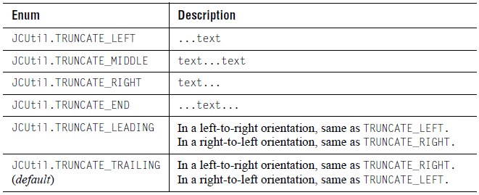

For example, the following code causes label text to be truncated when it exceeds 40 pixels. The truncation occurs on the right and the ellipsis is omitted:

axis.setMaxAnnotationWidth(40);
axis.setAnnotationTruncateMode(JCUtil.TRUNCATE_RIGHT);
axis.setUseEllipsisWhenTruncating(false);

Short Labels
You can choose to create short versions of your axis labels. If the full label exceeds the value of MaxAnnotationWidth and short labels are available, the short labels are used instead of truncated text. If the short labels exceed MaxAnnotationWidth, the short labels are clipped (not truncated).

To create short labels for PointLabels, set the ShortPointLabels property on ChartDataView to a list of Strings that correspond to your list of PointLabels. To create short labels for ValueLabels, for each ValueLabel you can set the ShortText property on its ChartText object to a String representing the short label.

Image Maps
You can also create image maps for point labels and value labels. Using image maps, you can choose to display the full label text in a tooltip whenever the mouse hovers over an axis label. The tooltip appears whether or not the label text is truncated. You can choose to auto-generate an image map for each label that does not already have image map information.

To auto-generate the image map for a given label, ensure no image maps are specified for the label and then set TruncatedLabelTooltipEnabled to true on the JCAxis object. The generated labels set the Url property to null and the Extra property to a value such that the full label text is displayed in the tooltip.

To create your own image maps for PointLabels, you can set the PointLabelImageMapInfo property on the ChartDataView to an array of ImageMapInfo objects, one for each PointLabel.

To create your own image maps for ValueLabels, you can set the ImageMapInfo property on a JCValueLabel to the image map information for that ValueLabel.

6.2 Positioning Axes
Use the Placement property to make a specific axis placement or use the PlacementIsDefault property to specify whether the chart is meant to determine axis placement. When making a specific axis placement, the axes may be placed against its partner axis at that axis' minimum value, maximum value, origin value, or a user-specified value.

For example,
axis.setPlacement(JCAxis.MIN);

will place the axis against its partner axis' minimum value, while
axis.setPlacement(otherAxis, 5.0)

will place the axis against otherAxis at the value 5.0

Note: When Placement is set to Origin, changing the axis origin will move the placed axis to the new origin value.

Figure 60 An example of axes positioning; the x-axis is placed against the y-axis' minimum value.

Polar Charts – Special Minimum and Maximum Values
Note that for polar charts, the x-axis maximum and minimum values are fixed, and these fixed values change depending on the angle unit type. The y-axis maximum and minimum values are adjustable, but are constrained to avoid data clipping. The y-axis minimum will never be less than zero (unless the y-axis is reversed). (theta, –r) will be interpreted as (theta+180, r). The y-axis minimum will always be at the center unless the axis is reversed, in which case the y-axis maximum will be at the center.

Radar and Area Radar Charts – Minimum Values
The minimum value for a y-axis in radar and area radar charts can be negative.

6.3 Chart Orientation and Axis Direction
A typical rectangular chart draws the x-axis horizontally from left-to-right and the y-axes vertically from bottom-to-top. You can reverse the orientation of the entire chart, and/or the direction of each axis.

6.3.1 Inverting Chart Orientation

Use the ChartDataView object’s Inverted property to change the chart orientation for rectangular charts. When set to true, the x-axis is drawn vertically and the y-axis horizontally for the data view. Any properties set on the x-axis then apply to the vertical axis, and y-axis properties apply to the horizontal axis. To switch the orientation of charts with multiple data views, you must set the Inverted property of each ChartDataView object.

Figure 61 Normal and inverted orientation.

Note: The Inverted property is ignored for timeline charts and all circular charts.

6.3.2 Changing Axis Direction

Use the Reversed property of JCAxis to reverse the direction of an axis. By default, Reversed is set to false.
Figure 62 Two charts depicting a normal and reversed y- axis.

For polar charts, data points with positive x-values will be displayed in a counterclockwise direction starting at the origin base. When the XAxis.reversed flag is true, positive x-values will be displayed clockwise.

6.4 Setting Axis Bounds
Normally a graph displays all of the data it contains. There are situations where only part of the data is to be displayed. This can be accomplished by fixing axis bounds.

Min and Max

Use the Min and Max properties of JCAxis to frame a chart at specific axis values. The MinIsDefault and MaxIsDefault properties allow the chart to automatically determine axis bounds based on the data bounds.

6.5 Customizing Origins
The chart can choose appropriate origins for the axes automatically, based on the data. It is also possible to customize how the chart determines the origin, or to directly specify the coordinates of the origin.
Figure 63 Defining origins for x-axes and y-axes.

Origin Placement
The easiest way to customize an origin is by controlling its placement, using the Axes’ OriginPlacement property. It has four possible values: AUTOMATIC, ZERO, MIN, and MAX. When set to AUTOMATIC, the origin is placed at the axis minimum or at zero, if the data contains positive and negative values or is a bar chart. ZERO places the origin at zero, MIN places the origin at the minimum value on the axis, and MAX places the origin at the maximum value on axis.

Origin Coordinates
When the origin of a coordinate must be set to a value different from the default (0,0), use the Axes’ Origin property. The OriginIsDefault property allows the chart to automatically determine the origin coordinate based on the data.

Note: When an origin coordinate is explicitly set or fixed, the chart ignores the OriginPlacement property.

6.6 Logarithmic Axes
Axis annotation is normally interpreted and drawn in a linear fashion. It is also possible to set any axis to be interpreted logarithmically (log base 10), as shown in the following image. Logarithmic axes are useful for charting certain types of scientific data.
Figure 64 Logarithmic x-axes and y-axes.

Because of the nature of logarithmic axes, they impose the following restrictions on the chart:

- any data that is less than or equal to zero is not graphed (it is treated as a data hole), since a logarithmic axis only handles data values that are greater than zero. For the same reason, axis and data minimum/maximum bounds and origin properties cannot be set to zero or less.
- axis numbering increment, ticking increment, and precision properties have no effect when the axis is logarithmic.
- the x-axis of bar and stacking bar charts cannot be logarithmic.
- the annotation method for the x-axis cannot be PointLabels or TimeLabels.

Specifying a Logarithmic Axis
Use the Logarithmic property of JCAxis to make an axis logarithmic.

Note: Pie charts are not affected by logarithmic axes.

6.7 Titling Axes and Rotating Axis Elements
Adding a title to an axis clarifies what is charted along that axis. You can add a title to any axis, and also rotate the title or the annotation along the axis, as shown below.
Figure 65Rotated axis title and annotation.

Adding an Axis Title
Use the Title property to add a title to an axis. It sets the JCAxisTitle object associated with the JCAxis. JCAxisTitle controls the appearance of the axis title. JCAxisTitle’s Text property specifies the title text.

Axis Title Rotation
Use the Rotation property of JCAxisTitle to set the rotation of the title. Valid values are defined in ChartText: DEG_0 (no rotation), DEG_90 (90 degrees counterclockwise), DEG_180 (180 degrees), and DEG_270 (270 degrees).

Rotating Axis Annotation
Use the AnnotationRotation property of JCAxis to rotate the axis annotation to either 90, 180, or 270 degrees clockwise from the horizontal position. 90-degree rotation usually looks best on a right-hand side axis.

This property can also be used to rotate the annotation at any other specified angle, if it is set to AnnotationRotation.ROTATION_OTHER. The new angle will be determined by the AnnotationRotationAngle property’s value. By default, the angle is 0.0 degrees.

It is important to know that some fonts may not draw properly at an angle; therefore, they might not be visually appealing. If you are using rotated labels, your font choice should be made with care.

Note: In some cases, rotated labels will overlap. When labels overlap, the visible property for the higher indexed label is cleared, and only the lower indexed label is visible.

6.8 Using Invisible Axes
You can hide the axes by setting the axis Visible property to false. When an axis is invisible, axis bounds are based on the data limits used. If you prefer to use values based on the precision, set the axis’ usePrecisionCalculatedBoundsForInvisibleAxes property to true.

When an axis is invisible, gridlines are not drawn even when GridVisible is set to true. To show gridlines, set showGridLinesOnInvisibleAxis to true.

6.9 Gridlines
Displaying a grid on a chart can make it easier to see the exact value of data points. Gridlines are hidden by default. To show gridlines, set the GridVisible property to true. You can customize the spacing between gridlines as well as the appearance of the lines.

Gridlines in Rectangular Charts
In a rectangular charts, such as plot and bar charts, gridlines are laid out in standard grid format. Horizontal gridlines are a property of the y-axis. Vertical gridlines are a property of the x-axis. Each can be given unique spacing and style properties, as described later in this section.

Figure 66 Gridlines in a rectangular chart.

Gridlines in Polar Charts
For polar charts, y-axis gridlines are circular while x-axis gridlines are radial lines from the center to the outside of the plot area. Each can be given unique spacing and style properties, as described later in this section.
Figure 67 Circular Gridlines.

Gridlines in Radar Charts
For radar and area radar charts, y-axis gridlines are represented as concentric circles around the center of the chart. If you would prefer webbed gridlines, where the lines between radial gridlines are drawn straight rather than as arcs, you need to set the RadarCircularGrid property to false.
Figure 68Circular gridlines vs webbed gridlines.

Grid Spacing
By default, the spacing between gridlines automatically corresponds with the axis annotations.You can customize the interval between gridlines for each axis. To specify the gridline spacing for an axis, you set the GridSpacing property for the axis and specify the interval between gridlines as a positive double (setting a value of zero means gridlines are not shown).

For example:
// Set grid spacing for the x-axis
xaxis.setGridSpacing(10);

Gridline Attributes
You can customize the line pattern, thickness, and color of the gridlines by axis. To set the line attributes, you set the GridStyle property for each axis.

For example, the following code fragment changes the line color to green:
otherXAxis.setGridVisible(true);
otherXAxis.getGridStyle().getLineStyle().setColor(Color.green);
otherYAxis.setGridVisible(true);
otherYAxis.getGridStyle().getLineStyle().setColor(Color.green);

6.10 Adding a Second Y-Axis
There are two ways to create a second y-axis on a chart. The simplest way is to define a numeric relationship between the two y-axes, as shown in the following illustration. Use this to display a different scale or interpretation of the same graph data.

Note: For polar, radar, and area radar charts, there is no second y-axis.

Defining Axis Multiplier
Use the Multiplier property to define the multiplication factor for the second axis. This property is used to generate axis values based on the first axis. The multiplication factor can be positive or negative.

Using a Constant Value
Use the Constant axis property to define a value to be added to or subtracted from the axis values generated by Multiplier.

Figure 69 Chart containing multiple y-axes.

In some cases, it may be desirable to show two sets of data in the same chart that are plotted against different axes. JClass ServerChart supports this by allowing each DataView to specify its own XAxis and YAxis. For example, consider a case in which a second data set d2 is to be plotted against its own y-axis. A JCAxis instance must be created and added to the JCChartArea, as shown:

// Create a new axis and set it vertical otherYAxis = new JCAxis();otherYAxis.setVertical(true);// Add it to the list of new axes in the chart areac.getChartArea().setYAxis(1, otherYAxis);// Add it to the data viewd2.setYAxis(otherYAxis);

Hiding the Second Axis
Set the Visible property to false to remove it from display. By default, it is set to true.

Other Second-Axis Properties
All axes have the same features. Any property can be set on any axis.

7
Defining Text and Style Elements
JCLabel Class ■ Header and Footer Titles ■ Legends ■ Chart Labels
Chart Styles ■ Outline Style ■ Borders ■ Fonts ■ Colors
Customizing the Chart Layout ■ 3D Effect ■ Anti-Aliasing

This chapter describes the different formatting elements available within JClass ServerChart, and how they can be used.

Note: If you are developing your chart application using one of the JClass ServerChart beans, go to Chapter 16, Creating Charts with JavaBeans instead.

7.1 JCLabel Class
By default, the header, the footer, and labels are JCLabel objects, although they can be any Swing JComponent. This section provides some background information on JCLabel.

A JCLabel object can display text, an image, or both. By default, labels are vertically centered in their display area. Text-only labels are left-aligned, while image-only labels are horizontally centered by default.

JCLabel extends JLabel and optionally makes it threadsafe by defining its own threadsafe user interface layer, JCLabelUI. By default, JCLabel uses the normal non-threadsafe JLabel UI. To use the threadsafe UI, set the system variable jclass.server.useAlternativeLabelUI to true. This tells JCLabel to use the threadsafe JCLabelUI instead of the default JLabel UI.

If you need a particular look-and-feel, you can define your own UI class and tell JCLabel to use it instead. To set a custom UI class, set the static property alternativeLabelUIClass to the appropriate class. The specified class must be a subclass of javax.swing.plaf.LabelUI.

JCLabel supports HTML text. However, when using the threadsafe JCLabelUI, occasionally the text may render in the wrong font or be positioned incorrectly because the HTML viewer itself is not thread-safe.

7.2 Header and Footer Titles
A chart can have two titles, called the header and footer. A title consists of one or more lines of text with an optional border. By default they are JCLabel instances and behave accordingly. For more information, see Section 7.1, JCLabel Class.

You can change the text alignment by setting the HorizontalAlignment and VerticalAlignment properties of JCLabel. You can also customize the title border, font, colors, and the size and position of the title. For more information, see Section 7.8, Borders, Section 7.9, Fonts, Section 7.10, Colors, and Section 7.11, Customizing the Chart Layout.

7.3 Legends
A legend shows the visual attributes (or ChartStyle) used for each series in the chart, with text that labels the series.

Figure 70 Vertically oriented legend anchored NorthEast.

7.3.1 Types of Legends

There are two types of legend objects: JCGridLegend (the default) for a single-column layout and JCMultiColLegend for a multiple-column layout. If these legends do not provide the desired functionality, you can customize the legend using the JCLegend Toolkit. For more information, see Section 7.3.3, Creating Custom Legends with the JCLegend Toolkit.

Single-Column Legends
The classic single-column legend layout is provided by JCGridLegend. This is the default layout in JClass ServerChart.

Multi-Column Legends
Multi-column legend layout is available using JCMultiColumnLegend. To designate this layout, follow these steps:
- Create an instance.
- Set the number of rows and columns.
- Set the legend property of the chart to this instance.

For example:

JCMultiColLegend mcl = new JCMultiColumnLegend();
mcl.setNumColumns(2);
myChart.setLegend(mcl);

This example creates a legend for the current chart that has two columns. The number of rows depends on the number of items in the legend. To fix the number of rows, use setNumRows(). Both the number of rows and the number of columns are variable by default.

To reset the number of rows and columns to a variable state after they have been fixed, call the appropriate set method with a negative value. If both the NumRows and NumColumns properties are set to fixed values, the legend will be of that exact size and will ignore any extra items.

7.3.2 Configuring Legends

You can configure the series label and positioning. The legend is a JComponent, and all properties such as border, colors, font, and so on, apply. You can also specify the maximum width of a column in the legend.

7.3.2.1 Displaying Series Labels in the Legend
The legend displays the text contained in the Label property of each Series in a DataView. The VisibleInLegend property of the series determines whether the Series will appear in the Legend. SeriesLabels support the use of HTML tags. The use of HTML tags overrides the default Font and Color properties of the label. Please note that HTML labels may not work with PDF or Flash encoding.

If you want your user to interact with the label, you can set image map information. For more information, see Specifying Image Map Tags for the Legend, in Chapter 10.

7.3.2.2 Displaying Marker or Threshold Labels in the Legend
If you use markers or thresholds in your chart, you can choose to display their labels in the legend using the VisibleInLegend properties from JCMarker and JCThreshold respectively. When true, the text contained in the Label property of the marker or threshold is displayed in the legend. VisibleInLegend is false by default.

If you want your user to interact with the label, you can set image map information. For more information, see Specifying Image Map Tags for the Legend, in Chapter 10.

7.3.2.3 Making Legend Lines and Symbols Match the Chart

By default, the legend renders symbols and lines in a fixed size. If you want the line width and symbol size to match the values used in the chart, set the SymbolRenderMode property to JCLegend.ACTUAL.

7.3.2.4 Setting the Legend Orientation

Use the legend Orientation property to lay out the legend horizontally or vertically.

7.3.2.5 Positioning the Legend

You can use the legend Anchor property to specify where to position the legend relative to the ChartArea. You can select from eight compass points around the ChartArea. Valid values are: JCLegend.NORTH, JCLegend.SOUTH, JCLegend.EAST, JCLegend.WEST, JCLegend.NORTHWEST, JCLegend.SOUTHWEST, JCLegend.NORTHEAST, and JCLegend.SOUTHEAST. The default value is JCLegend.EAST.

To specify an absolute position for the legend, you set the LayoutHints property from JCServerChart and provide coordinates. For more information, see Section 7.11, Customizing the Chart Layout.

7.3.2.6 Setting the Width of the Legend and its Columns

If the legend text is very long, you may find that by default the legend becomes very wide, leaving proportionally less room for the chart itself. You can improve the balance between chart and legend by controlling the width of the legend. You have two choices for setting the width. You can set the width of the legend explicitly and allow the columns within the legend to be sized automatically, or you can set the column widths and allow the legend width to be calculated.

Specifying the Legend Width

To set the width of the entire legend, you set the LayoutHints property from JCServerChart and provide the width of the legend rectangle. For example, the following code snippet sets the width of the legend to 200 pixels:

chart.setLayoutHints(chart.getLegend(),
new Rectangle(Integer.MAX_VALUE, Integer.MAX_VALUE,
200, Integer.MAX_VALUE));

Integer.MAX_VALUE means that the dimension is dynamic. In the above example, there are no restrictions on the positioning of the legend or on the height dimension. For more information, see Section 7.11, Customizing the Chart Layout.
Specifying Column Widths

To set the width of columns within the legend, you set the MaxItemTextWidth property from JCLegend and specify the width in pixels as a non-negative Integer. By default, the value is Integer.MAX_VALUE, which means the width is dynamic.

For example, the following code sets the width for each of the columns in the legend to 100 pixels.
legend.setMaxItemTextWidth(100);

To specify different widths for columns in a multicolumn legend, you need to provide an additional parameter that specifies the column number. For example, the following code specifies column widths of 50, 100, and 75 pixels for consecutive columns in a three-column legend:
legend.setMaxItemTextWidth(50, 0);
legend.setMaxItemTextWidth(100, 1);
legend.setMaxItemTextWidth(75, 2);

7.3.2.7 Handling Truncated Text
You can set properties to control what happens when the length of the text exceeds the width of a column. By default, column text is aligned with the leading edge of the column (for example, it is aligned left in a left-to-right orientation). When text is truncated, the trailing text (the rightmost text in a left-to-right orientation) is hidden and an ellipsis is displayed in its place. You can modify this behavior by setting the JCLegend properties described below.

To change the text alignment, you set the ItemTextAlignment property and specify the value using one of the following enumerations: SwingConstants.LEFT, SwingConstants.RIGHT, SwingConstants.CENTER, SwingConstants.LEADING (default), or SwingConstants.TRAILING. For example, the following code causes text to be right aligned for all columns except the second column (column 1), where the text is centered:

legend.setItemTextAlignment(SwingConstants.RIGHT);
legend.setItemTextAlignment(SwingConstants.CENTER, 1);

To change how the text is truncated, you set the TruncateMode property. The following table shows the possible values followed by how the text would appear:

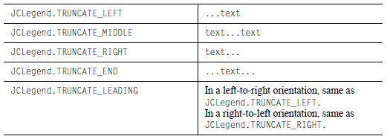
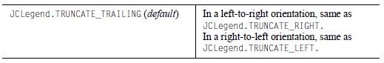
For example, the following code causes text to be truncated on the right for all columns, except for the third column (column 2), where the ends are truncated:

legend.setTruncateMode(JCLegend.TRUNCATE_RIGHT);
legend.setTruncateMode(JCLegend.TRUNCATE_END, 2);

To stop the ellipsis from being displayed, you set the UseEllipsisWhenTruncating property to false. There will be no visual indication that text is hidden. This property always applies to all columns.

You can also choose to display the entire legend item text in a tooltip whenever the mouse hovers over a legend item. The tooltip appears whether or not the legend text is truncated. To activate the tooltips, set the ItemTextToolTipEnabled property to true. This property always applies to all columns.

7.3.2.8 Setting a Fill Style for the Legend Background

You can fill the background of the legend with a color, pattern, gradient paint, or an image. For more information, see Chapter 9, Defining Background Fill Styles.

7.3.3 Creating Custom Legends with the JCLegend Toolkit

The JCLegend Toolkit allows you the freedom to design your own legend implementations. The options range from simple changes, such as affecting the order of the items in the legend, to providing more complex layouts.

The JCLegend Toolkit consists of a JCLegend class that can be subclassed to provide legend layout rules and two interfaces: JCLegendPopulator and JCLegendRenderer. JCLegendPopulator is implemented by classes wishing to populate a legend with data, and JCLegendRenderer is implemented by a class that wishes to help render the legend’s elements according to the user’s instructions. Examples of how to use the JCLegend Toolkit are provided in JCLASS_SERVER_HOME/examples/schart/legend/.

JCChartLegendManager is the class used by JClass ServerChart to implement both the JCLegendPopulator and JCLegendRenderer interfaces, and to provide a built-in mechanism for itemizing range objects in a legend.

7.3.3.1 Custom Legends – Layout
The Legend Toolkit allows you to create custom legend implementations. JCLegend is an abstract class that can be subclassed by users wishing to customize the legend layout or other legend behavior.

To provide a custom layout, override the method:

public abstract Dimension layoutLegend(List itemList, boolean vertical,
Font useFont)

The itemlist argument is a List containing a Vector for each data view contained in the chart. Each of these sub-vectors contains one JCLegendItem instance for each series in the data view and one instance for the data view title.

The vertical argument is true if the orientation of the legend is vertical and false if the orientation of the legend is horizontal.

The useFont argument contains the default font to use for the legend.

Each item in the legend consists of a text portion and a symbol portion. For example, in a Plot Chart, the text portion is the name of the series, and is preceded by the symbol used to mark a point on the chart. For the title of the data view, the text portion is the name of the data view and there is no symbol.

JCLegendItem is a class that encapsulates an item in the legend with the properties.

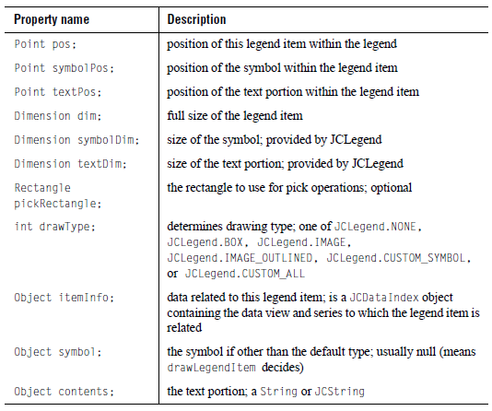
When the itemList is passed to layoutLegend, it has been filled in with JCLegendItem instances representing each data series and data view title. These instances will have the symbolDim, textDim, symbol, contents, itemInfo, and drawType already filled in.

The value of drawType will determine whether a particular default symbol type will be drawn or whether user-provided drawing methods will be called.

The layoutLegend() method is expected to calculate and fill in the pos, symbolPos, textPos, and dim fields. Additionally, the method must return a Dimension object containing the overall size of the legend. Optionally, it may also calculate the pickRectangle member of the JCLegendItem class. The pickRectangle is used in pick operations to specify the region in the legend that is associated with the series that this legend item represents. If left null, a default pickRectangle will be calculated using the dim and pos members.

Any of the public methods in the JCLegend class may be overridden by a user requiring custom behavior. One such method is:

public int getSymbolSize()

getSymbolSize() returns the size of the legend-calculated symbols to be drawn in the legend. Default JCLegend behavior sets the symbol size to be equal to the ascent of the default font that is used to draw the legend text. If you want to use a different symbol, you can override it. One possible implementation is to use a symbol size identical to that which appears on the actual chart.

7.3.3.2 Custom Legends – Population
JCLegendPopulator is an interface that can be implemented by any user desiring to populate the legend with custom items. This interface comprises two methods that need to be implemented:

public List getLegendItems(FontMetrics fm)
public boolean isTitleItem(JCLegendItem item)

getLegendItems() should return a List object containing any number of Vector objects where each Vector object represents one column in the legend. Each Vector object contains the JCLegendItem objects for that column. In JClass ServerChart, each column generally represents one data view.

isTitleItem() should return true or false, depending on whether the passed JCLegendItem object represents a title for the column. This is used to determine whether a symbol is drawn for a particular legend item.

If implemented, the legend should be notified of the new populator with the setLegendPopulator() method of JCLegend.

7.3.3.3Custom Legends – Rendering
JCLegendRenderer is an interface that can be implemented by any user desiring to custom render legend items. This interface consists of four methods that need to be implemented:

public void drawLegendItem(Graphics gc, Font useFont,
JCLegendItem thisItem)
public void drawLegendItemSymbol(Graphics gc, Font useFont,
JCLegendItem thisItem)
public Color getOutlineColor(JCLegendItem thisItem)
public void setFillGraphics(Graphics gc, JCLegendItem thisItem)

JCLegendRenderer also has the capacity to implement custom text objects for drawing, and is called when the legend cannot interpret an object placed in the contents field of the JCLegendItem. This interface consists of one method that needs to be implemented:

void drawLegendItemText (Graphics gc, Font useFont, JCLegendItem
thisItem);

drawLegendItem() provides a way for a user to define a custom drawing routine for an entire legend item. It is called when a legend item’s draw type has been set to JCLegend.CUSTOM_ALL.

drawLegendItemSymbol() provides a way for a user to define a custom drawing routine for a legend item’s symbol. It is called when a legend item’s draw type has been set to JCLegend.CUSTOM_SYMBOL.

getOutlineColor() should return the outline color to be used to draw the legend item’s symbol. If null is returned, the legend’s foreground color will be used. getOutlineColor() is called when a legend item’s draw type has been set to either JCLegend.BOX or JCLegend.IMAGE_OUTLINED.

setFillGraphics() should set the appropriate fill properties on the provided Graphics object for drawing the provided legend item. setFillGraphics() is called when the legend item’s draw type has been set to JCLegend.BOX.

If implemented, the legend should be notified of the new renderer with the setLegendRenderer() method of JCLegend.

7.3.3.4 Examples of Simple Custom Legends
The easiest way to perform simple legend customizations is to extend an existing legend. The following example (taken from the Reversed Legend example in JCLASS_SERVER_HOME/examples/schart/legend/) overrides the JCChartLegendManager class (the class that implements the JCLegendPopulator and JCLegendRenderer interfaces in JClass ServerChart) to reverse the order of the legend items. This class overrides the getLegendItems() method, first calling the superclass’ method to get the list of legend items and then rearranging the order before returning the newly reversed list of legend items.

Figure 71The Reversed Legend example reverses the order of the legend items.

Here is the Reverse Legend example code:

public ReverseLegend() {

setLayout(new GridLayout(1,1));
// replace standard legend with custom legend that reverses
// the order of the legend items
JCServerChart c = new JCServerChart(JCServerChart.PLOT);
...
RevLegendManager legMan = new RevLegendManager(c);
c.getLegend().setLegendPopulator(legMan);
c.getLegend().setLegendRenderer(legMan);
c.getLegend().setVisible(true);
...
}
/** RevLegendManager overrides the standard legend representation
* to reverse the drawing order of the legend items. It does this by
* overriding getLegendItems() method of the JCChartLabelManager
* class to reverse the order of the items in the legend
* vector.
*/
class RevLegendManager extends JCChartLegendManager
{
RevLegendManager(JCChart chart)
{
super(chart);
}
/** Override getLegendItems(). Reverse order of items in legend
* vector.
*/
public List getLegendItems(FontMetrics fm)
{
// get the list of legend items from the superclass
List itemList = super.getLegendItems(fm);

// reverse the list
for (int i = 0; i < itemList.size(); i++) {
List viewItems = (List) itemList.get(i);

List reverseView = new Vector();
for (int j = viewItems.size() - 1; j >= 0; j--) {
JCLegendItem thisItem = (JCLegendItem) viewItems.get(j);

// reverse items in list, but keep the title at the top.
if (isTitleItem(thisItem)) {
reverseView.add(0, thisItem);
} else {
reverseView.add(thisItem);
}
}
itemList.set(i, reverseView);
}
// now that we've set up the list correctly, let the superclass
// position it
return itemList;
}

}

The Separator Legend example in JCLASS_SERVER_HOME/examples/schart/legend/ shows how to place a separator between the data view title and the series beneath it. Similar to the Reversed Legend example, the Separator Legend example overrides the JCChartLegendManager class.

In the Separator Legend example, a new JCLegendItem is inserted into the list after the data view title item as part of the layoutLegend() method. This new JCLegendItem has only its textDimension filled in with the size of the separator, but the actual contents field remains null – which is how one recognizes the separator when it is time to draw it.

The drawType field of the JCLegendItem is set to JCLegend.CUSTOM_ALL to ensure that the drawLegendItem() method will be called. Finally, the example returns the item list with the newly added item and lets the superclass do the positioning and sizing calculations.

The drawLegendItem() method is also overridden so that the separator can be drawn. Before drawing, however, it is first determined whether the provided legend item is, indeed, the separator created above.

Figure 72 The Separator Legend example places a separator between the data view title and the series beneath it, and extends JCLegendManager.

Here is the Separator Legend example code:

public SeparatorLegend() {

setLayout(new GridLayout(1,1));

// replace standard legend with custom legend that draws a
// separator between the title and the body
JCServerChart c = new JCServerChart(JCServerChart.BAR);
...
SepLegendManager sepMan = new SepLegendManager(c);
c.getLegend().setLegendPopulator(sepMan);
c.getLegend().setLegendRenderer(sepMan);
c.getLegend().setVisible(true);
...
}

/** sepLegendManager overrides the standard legend populator and
* renderer implementations to draw a separator between the legend
* title and body. It does this by overriding the
* JCChartLegendManager's getLegendItem() method (to insert an item
* to take the place of a separator) and drawLegendItem() (to draw
* the separator) methods.
*/
public class SepLegendManager extends JCChartLegendManager
{

public SepLegendManager(JCChart chart)
{
super(chart);

}
/** Override getLegendItems() to insert separator item into
* legend vector.
*/
public List getLegendItems(FontMetrics fm)
{
// get the list of legend items from the superclass
List itemList = super.getLegendItems(fm);

// go through the list to find the spot for the separator
for (int i = 0; i < itemList.size(); i++) {
List viewItems = (List) itemList.get(i);

for (int j = 0; j < viewItems.size(); j++) {
JCLegendItem thisItem = (JCLegendItem) viewItems.get(j);

// Insert separator item after title item
// our separator is identified by having null contents
// but an existing text dimension. Make the separator as
// wide as the text portion of the title.
if (isTitleItem(thisItem)) {
JCLegendItem newItem = new JCLegendItem();
boolean vertical = chart.getLegend().getOrientation() ==
JCLegend.VERTICAL;
if (vertical) {
newItem.textDim = new Dimension(thisItem.textDim.
width, 3);

} else {
newItem.textDim = new Dimension(3, thisItem.textDim.height);
}
// make sure to set draw type as CUSTOM_ALL so that
// drawLegendItem() will be called.
newItem.drawType = JCLegend.CUSTOM_ALL;
viewItems.add(j+1, newItem);
break;
}
}
}
// now that the list is set up, let the superclass worry about
// positioning everything
return itemList;
}
/** Override drawLegendItem() to draw the separator item
* when encountered.
*/
public void drawLegendItem(Graphics gc, Font useFont,
JCLegendItem thisItem)
{
// if our separator, draw it
if (thisItem.contents == null && thisItem.textDim != null) {
if (gc.getColor() != getForeground())
gc.setColor(getForeground());

gc.fillRect(thisItem.pos.x + thisItem.textPos.x,
thisItem.pos.y + thisItem.textPos.y,
thisItem.textDim.width,
thisItem.textDim.height);
}
}
}

Remember to use the setLegendPopulator() and setLegendRenderer() methods of the JCLegend class to notify the legend of the new class.

7.3.3.5 Examples of Complex Legends
More complex customizations are also possible. Legends that require full-scale changes to the rules of layout can override the JCLegend class and create their own implementation. Have a look at JCLASS_SERVER_HOME/examples/schart/legend/FlowLegend for an example of a custom legend layout.

7.4 Chart Labels
Chart labels allow you to add more information to your chart. There are static labels that display continuously and interactive labels (also called dwell labels) that pop-up when a cursor moves over a data item. Labels can be attached to different parts of a chart: absolute coordinates, coordinates in the plotting area, or a specific data item.

The list of labels is managed by the ChartLabelManager. This property is initially null. By calling getChartLabelManager(), JClass ServerChart will create a manager class with an empty list of labels. When you create a label, you must add it to the manager with addChartlabel(). Labels are instances of the JCChartLabel class.

Individual labels are positioned by attaching an instance of JCChartLabel to a chart element. You can attach labels in three ways: to coordinates on the chart (ATTACH_COORD); data coordinates on the plot area (ATTACH_DATACOORD); or to a data item (ATTACH_DATAINDEX). Interactive labels must use the ATTACH_DATAINDEX method.

Each label on the chart below uses a different attachment method. The “Point(100,50)” label, is attached to coordinates originating from the top left corner of the chart. “Value(2,220)” is attached to axes coordinates, and “Data(Set0,Point2)” is attached to a specific data item.

Figure 73 Adding chart labels.

7.4.1 Attaching Labels to Data Items

Labels on data items are useful in many ways. If you want to highlight particular values in a chart, you may only add a few labels. For example, in a chart that measures performance, you may want to draw attention to the highest performers by adding some text in labels attached to those data items. If you want the values of all data items to be clear at a glance, you may decide that you want to label all data items. For example, a bar chart comparing the current year to the previous year may benefit from having the y-value of the data index displayed above each of the bars. The advantage of attaching the labels to data items (rather than to coordinates on the chart or plot area) is that the labels move with the data element whenever the chart’s content or size changes.

You can attach labels to data items in two ways: by adding labels individually or by generating labels for all data items. For timeline charts, you have the additional option of displaying labels as an element of status events. For bar, stacking bar, and pie charts, you can control the position of the label relative to the data item. Each of these options is described in the following sections.

7.4.1.1 Labelling an Individual Data Item
To label an individual data item, start by creating the JCChartLabel that you want to add to the chart. Then you can specify the data index to which the label belongs, the attachment method (in this case ATTACH_DATAINDEX), and the anchor point. The last thing to do is add the label to the chart using the ChartLabelManager. Repeat for each label that you want to add to a data item.

The following example puts a label on a chart next to the fourth data point in the second data series.

cl = new JCChartLabel("Fourth data point");
cl.setDataIndex(new JCDataIndex(view, series, 1, 3));
cl.setAttachMethod(JCChartLabel.ATTACH_DATAINDEX);
cl.setAnchor(JCChartLabel.AUTO);
chart.getChartLabelManager().addChartLabel(cl)

7.4.1.2 Labelling All Data Items Automatically
If you want to add labels automatically to all data items in the chart, you can set the AutoLabel and AutoLabelType properties from ChartDataView. Using this method, you can create labels containing one of the following types of information: the data value of the data item, the data label associated with the data item, or some other information that you specify using an implementation of the JCAutoLabelGenerator interface. At runtime, JClass ServerChart generates JCChartLabel objects for every data item defined in your data source. The labels are displayed at every data index in the chart.

For example, the following code generates labels based on data labels defined in a data source. (For a more fulsome example, see Labelling Your Chart, in Chapter 4).

chart.getDataView(0).setAutoLabel(true, false);
chart.getDataView(0).setAutoLabelType(AUTO_LABEL_TYPE_DATA_LABELS);

The setAutoLabel() method takes two booleans. The first boolean indicates whether or not to use auto-labels, while the second determines whether or not to force the labels to be calculated immediately, before other data-based chart values. If you force the calculation, you should be aware that the labels will be recalculated after the chart elements complete, which may result in two different sets of labels. Labels are stored in the AutoLabelList property.

setAutoLabelType() can take any one of the following enums:

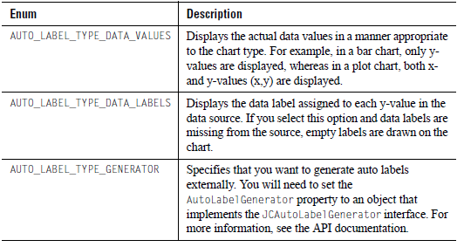

By default, auto-generated labels are not saved to XML because they can be regenerated at any time from the data source or the label generator. If you want to save labels, set JCChartLabel’s SaveLabels property to true for each label you want to save. You can get a list of all current chart labels by calling the getChartLabels() method, of the current chart label manager.

List<JCChartLabel> labels = chart.getChartLabelManager().getChartLabels();

7.4.1.3 Changing the Position of the Label on a Data Item

For bar, stacking bar, and pie charts, you can control where the label is positioned within the bar or slice using the dataIndexMode property from JCChartLabel. The valid constants are:

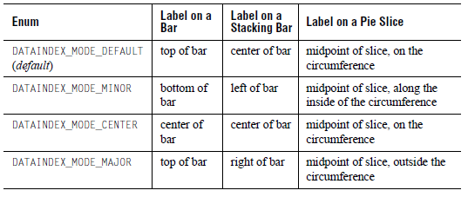
Note: For bar or stacking bar charts, if the chart is inverted or the axes are reversed, the attach positions will change depending on which direction the bars are facing.

Figure 74 Setting the dataIndexMode property.

7.4.1.4 Showing Labels on Status Intervals in Timeline Charts

You can choose to add labels as an element of status intervals, rather than as a JCChartLabel pasted on top of the data item. The labels are displayed either within status intervals or, if there is not enough room, just after status intervals and instant events. The labels can contain any combination of three pieces of information: the series label, the data label, and the state label (in that order). The series and data labels are defined in your data source. The state labels are defined in your program.

Note: If you want to display the actual values of data items or add a free-form text label, you need to use one of the other labelling methods described in this section.

To display interval labels in this way, you need to select the type of information that you want to show. For example, the following code displays all three labels (series:data:state). The results are shown in Figure 75.

[code sample]
Figure 75Timeline chart with interval labels that contain series label:data label:state label.

Note: To prevent duplication, if you display labels using this method, you should avoid setting the autoLabelType property to AUTO_LABEL_TYPE_DATA_LABEL.

7.4.2 Attaching a Label to Chart Coordinates
To attach a label to a point on the chart, set the AttachMethod property to ATTACH_COORD. The coordinate origin for this method is the top left corner of the chart.

JCChartLabel cl = new JCChartLabel("Point( 100, 50 )");cl.setAttachMethod( JCChartLabel.ATTACH_COORD );cl.setCoord( new Point( 100, 50 ) );chart.getChartLabelManager().addChartLabel(cl)

7.4.3 Attaching a Label to Plot Area Coordinates
To attach a label to data coordinates on the plot area, set the AttachMethod property to ATTACH_DATACOORD. The plot area is defined by the chart’s x-axis and y-axis.

The following example places a label in the plot area at x-value 2.5, y-value 160.

JCChartLabel cl = new JCChartLabel("Attached to the data coordinate",
false);
cl.setDataCoord( new JCDataCoord( 2.5, 160 ) );
cl.setAnchor( JCChartLabel.NORTH );
cl.setAttachMethod( JCChartLabel.ATTACH_DATACOORD );
cl.setBorderType( Border.ETCHED_OUT );
cl.setBorderWidth( 5 );
chart.getChartLabelManager().addChartLabel(cl)

7.4.4 Interactive Labels for Flash Output

You can have labels pop-up in your Flash-encoded chart when the mouse cursor dwells over a particular point, bar, or slice contained in your chart. For example, in the following figure, the number ‘225’ appears on top of the bar as the cursor passes over it, to indicate the value of the bar.

Figure 76 Bar chart displaying a dwell label.

In JClass ServerChart, these interactive labels are called dwell labels. You can automatically generate a complete series of dwell labels or you can add individual dwell labels.

Automatically Generated Dwell Labels
The following code creates automatic dwell labels containing the data values:

((JCServerChartLabelManager) chart.getChartLabelManager()).setShowAutoLabelsByDefault(false);
chart.getDataView(0).setAutoLabel(true, false);
chart.getDataView(0).setAutoLabelType(AUTO_LABEL_DATA_VALUES);

This example displays data values, but you can also choose to display data labels or externally generated labels within the dwell labels. For more information, see Section 7.4.1.2, Labelling All Data Items Automatically.

Adding Individual Dwell Labels
Attaching an individual dwell label follows the same procedure as attaching a static label to a data item, except that the DwellLabel property is set to true:

JCChartLabel cl = new JCChartLabel();
cl.setDwellLabel( true );

A dwell label can only be used when the AttachMethod property is set to ATTACH_DATAINDEX.

7.4.5 Adding and Formatting Label Text

JCChartLabel is just a holder for any JComponent. By default it is a JCLabel instance, and text can be set the same way you would set text on a JCLabel. For more information, see Section 7.1, JCLabel Class.

Adding Label Text

You can add text to a label by passing it to the constructor, or by using the Text property. You can access the component portion of the chart label with the getComponent() method.

To add text to a label when it is constructed, include the text in the constructor’s argument, as follows:

JCChartLabel cl = new JCChartLabel("I’m a Label", false);

To add text using the Text property, use the setText method, as follows:
((JCLabel)cl.getComponent()).setText("I’m a Label");

Formatting Label Text
Font f = new Font("timesroman", Font.BOLD, 24);
cl.getComponent(),setFont(f)

JComponent properties such as fonts, borders, and colors are set in the same manner.

7.4.6 Positioning Labels
The Anchor property determines the position of the label, relative to the point of attachment.

The valid constants are:
- JCChartLabel.NORTHWEST
- JCChartLabel.NORTH
- JCChartLabel.NORTHEAST
- JCChartLabel.EAST
- JCChartLabel.SOUTHEAST
- JCChartLabel.SOUTH
- JCChartLabel.SOUTHWEST
- JCChartLabel.WEST

The following example shows the syntax:
cl.setAnchor(JCChartLabel.EAST);

7.4.7 Adding Connecting Lines

You can add lines that connect a label to its point of attachment. This can help the end-user pinpoint what a label refers to on a chart.

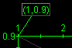
Figure 77 An example of a connecting line.

To add a connecting line to a label, set the Connected property to true, as follows:
cl.setConnected( true );

To change the line properties, define a JCLineStyle object and pass it to the chart label via the ConnectedLineStyle property. For more information, see Section 7.5.3, LineStyle.

The line connects to the side of the label closest to the point. By default, it is attached to the midpoint of that side (see preceding figure). You can link to a corner of the label instead. To change the attachment policy, set the ConnectedAttachMode property. The valid constants are:
- JCChartLabel.CONNECTED_ATTACH_MODE_CENTER (default) – Attaches the line to the midpoint along the side of the chart label.
- JCChartLabel.CONNECTED_ATTACH_MODE_MINIMUM – When a line connects to the top or bottom of a label, the line is attached to the left corner of that side. When a line connects to the left or right side of the label, the line is attached to the bottom corner of that side.
- JCChartLabel.CONNECTED_ATTACH_MODE_MAXIMUM – When a line connects to the top or bottom of a label, the line is attached to the right corner of that side. When a line connects to the left or right side of the label, the line is attached to the top corner of that side.

7.5 Chart Styles
Chart styles define all of the visual attributes of how data appears in the chart, including:
- Lines and points in plots and financial charts.
- Color of each bar in bar charts.
- Slice colors in pie charts.
- Color of each filled area in area charts.

Each series in a data view has its own JCChartStyle object; as new series are added, new JCChartStyle objects are created automatically by the chart. JClass ServerChart automatically defines a set of visually different styles for up to 13 series, so while you can customize any chart style, you may not need to.

Note: If you are using the targeted data model, you can change the default chart styles by implementing the appropriate StyleDataSet in your data set implementation. For more information, see StyleDataSet Interfaces, in Chapter 5.

Every ChartStyle has a FillStyle, a LineStyle, and a SymbolStyle. FillStyles are used for area, bar, candle, Hi-Lo, Hi-Lo-Open-Close, pie, and stacking bar charts. LineStyles and SymbolStyles are used for plots.

Figure 78 Types of ChartStyles available.

ChartStyle is an indexed property of ChartDataView that “owns” the JCChartStyle objects for that data view. It can be manipulated like any other indexed property, for example:

arr.setChartStyle(0, new JCChartStyle());

This adds the specified ChartStyle to the indexed property at the specified index. If the ChartStyle is null, the JCChartStyle at the specified point is removed. The following lists some of the other ways ChartStyle can be used:
- getChartStyle(index) — retrieves the chart style at the specified index
- setChartStyle(List) — replaces all existing chart styles
- List getChartStyle() — retrieves a copy of the array of chart styles

Normally, you will not need to add or remove JCChartStyle objects from the collection yourself. If a JCChartStyle object already exists when its corresponding series is created, the previously created JCChartStyle object is used to display the data in this series.

7.5.1 Customizing Existing ChartStyles

Each JCChartStyle object contains three smaller objects that control different aspects of the style: JCFillStyle, JCLineStyle, and JCSymbolStyle.

The most common chart style sub-properties are repeated in JCChartStyle. For example, FillColor is a property of JCChartStyle that corresponds to the Color property of JCFillStyle object.

The following properties are repeated in the specified class:
- LinePattern, LineWidth, and LineColor repeat JCLineStyle properties.
- SymbolShape, SymbolColor, SymbolSize, and SymbolCustomShape repeat JCSymbol properties.
- FillColor, FillPattern, and FillImage repeat JCFillStyle properties.

7.5.2 FillStyle

JCFillStyle controls the fills used in bar, pie, area, and candle charts. For more information, see Chapter 9, Defining Background Fill Styles.

Note: Filled areas are not supported for polar charts.

When the FillStyle property is used within a JCChartStyle object to fill bars, pies, and areas, the ImageLayoutHint, FillOrientation, and ImagePosition properties are ignored.

7.5.3 LineStyle

JCLineStyle controls line drawing, used in line and Hi-Lo charts. Its properties are Color, Pattern and Width. Use Pattern to set the line drawing pattern, Color to set the line color, and Width to set the line width. Custom line patterns can be set with a setPattern() method that specifies the line pattern arrays to use.

The valid Pattern enumerations are:
- JCLineStyle.NONE
- JCLineStyle.SOLID
- JCLineStyle.LONG_DASH
- JCLineStyle.LONG_DASH_FINE
- JCLineStyle.SHORT_DASH
- JCLineStyle.SHORT_DASH_FINE
- JCLineStyle.LSL_DASH
- JCLineStyle.LSL_DASH_FINE
- JCLineStyle.DASH_DOT
- JCLineStyle.DASH_DOT_FINE
- JCLineStyle.DOTTED

The fine patterns are particularly useful when a chart is rendered to a PDF and then printed.

7.5.4 SymbolStyle

JCSymbolStyle controls the symbol used to represent points in a data series, used in plot or scatter plot charts. Its properties are Shape, Color and Size. Use Shape to set the symbol type, Size to set its size, and Color to set the symbol color.
Figure 79 Symbols available in JCSymbolStyle.

You can also provide a custom shape by implementing an abstract class JCShape and assigning it to the CustomShape property.

7.5.5 Customizing All ChartStyles

By looping through the JCChartStyle indexed property, you can quickly change the appearance of all of the bars, lines, or points in a chart. For example, the following code lightens all of the bars in a chart:

for (Iterator i = c.getDataView(1).getChartStyle().listIterator();
i.hasNext();)
{
JCChartStyle cs = (JCChartStyle) i.next();
JCFillStyle fs = cs.getFillStyle();
fs.setColor(fs.getColor().brighten);
}

7.6 Outline Style
The ChartDataView’s OutlineStyle property controls the outlines of area, stacking area, area radar, bar, stacking bar, and pie charts. The default outline style is a solid line of width one in the chart area’s foreground color. This style is applied to all data series. The outline style is a JCLineStyle and thus the properties of the line can be controlled by getting the JCLineStyle object using getOutlineStyle() and setting its properties. For more information, see Section 7.5.3, LineStyle.

For bar charts and area charts (which include Bar, Stacking Bar, Area, Stacking Area, and Area Radar charts), you can set unique outline styles for each data series. In this case, the outline style is taken from the series’ JCChartStyle line style. The format class of each of the chart types that support this feature, JCAreaChartFormat for area charts for example, implement the OutlineConfigurable interface. Thus to specify unique outline styles for each series, set the OutlineStyle property of the format class to OutlineConfigurable.SERIES_LINE_STYLE. The default OutlineStyle is OutlineConfigurable.OUTLINE_STYLE which means the outline style is taken from the ChartDataView’s OutlineStyle property and is the same for each series. The following code example demonstrates a chart which has a different outline style for each series:

int[] linePatterns = JCChartEnumMappings.linePattern_values;List styles = dataView.getChartStyle();for (int i = 0; i < styles.size(); i++) {
JCChartStyle style = (JCChartStyle)styles.get(i);
style.setLineColor(Color.black);
style.setLinePattern((i + 2) % linePatterns.length);
style.setLineWidth(2);
}

JCChartTypeFormat format = dataView.getChartFormat();
if (format instanceof OutlineConfigurable) {
OutlineConfigurable oc = (OutlineConfigurable)format;
oc.setOutlineStyle(OutlineConfigurable.SERIES_LINE_STYLE);
}
Figure 80 Various outline styles.

7.7 Holes and Hole Styles
Holes are data points that are invalid or missing in the data series, or that are defined as holes in the data source. By default, holes are treated as absent values. In the chart, holes appear as gaps in the data series. For more information, see Hole Value under Text Data Formats, in Chapter 4.

For plot, polar, area, and stacking area charts, you can choose to indicate that a hole value has occurred by specifying a hole style. A hole style is a JCChartStyle object that defines the line and fill styles to use when drawing hole values. Each data series can have a different style for holes. In the chart, the hole style is used to span the gap in the data series.

Note: If hole styles are defined for the other chart types, the hole styles are ignored.

For area and stacking area charts, you also have the option of changing how holes are represented. Instead of treating holes as absent values, you can treat them as interpolate values or as if they were the same value as the previous value in the data series. For more information, see Section 7.7.3, Representing Holes in Area and Stacking Area Charts.

7.7.1 Creating Hole Styles

To specify the style to use for hole values in a data series, set the HoleStyle property in the ChartDataViewSeries object. The HoleStyle property takes a JCChartStyle object. The hole style objects for all the data series are stored in a Vector called HoleStyles in the ChartDataView object. You can access and manipulate the objects in the HoleStyles Vector in much the same way as described for ChartStyle in Section 7.5, Chart Styles.

For example, in the following code sample when true is passed to the createStyles() method, it creates hole styles for each of the data series. Otherwise, it creates the basic chart styles. For hole styles, the line style is a long dash in the same color and width as the data series. The fill style is solid and uses a color that is defined in a holeColor[] array elsewhere in the code. Symbol styles are ignored; hole styles use the same symbol as the rest of the data series. The resulting JCChartStyle instances are added to a styles[] array.

...
// Create chart styles for hole display
List holeStyles = createStyles(true);
dataView.setHoleStyle(holeStyles);
...
public List createStyles(boolean holeStyles) {
List styles = new ArrayList();
for (int i = 0; i < yData.length; i++) {
// Define line style
int linePattern =
holeStyles ? JCLineStyle.LONG_DASH : JCLineStyle.SOLID;
JCLineStyle lineStyle = new JCLineStyle(1, colors[i],
linePattern);
// Define fill style
Color fillColor = holeStyles ? holeColors[i] : colors[i];
JCFillStyle fillStyle = new JCFillStyle(fillColor,
JCFillStyle.SOLID);
// Define symbol style
JCSymbolStyle symbolStyle = new JCSymbolStyle(symbolPatterns[i],
colors[i], 6);

// Create the JCChartStyle instance
JCChartStyle chartStyle = new JCChartStyle(lineStyle, fillStyle,
symbolStyle);
// Add the style to the styles array
styles.add(chartStyle);
}
return styles;
}
...

The following sections show examples of the various chart types before and after the hole styles defined above are applied. The charts all use the same data series. The hole values are specified using the constant hole.

// Y-axis values for each of the three data series
protected double yData[][] = {
{7, 8, hole, 9, hole, 8, 7},
{4, 6, hole, hole, hole, 6, 4},
{1, hole, 2, 3, 2, hole, 1}
}

7.7.2 Applying Hole Styles to Plot and Polar Charts

By default, when a hole value is encountered in a data series for a plot or polar chart, the hole value is not drawn and the lines that would have connected the missing value to valid data points on either side are omitted. The result is a broken line. When hole styles are specified, the chart uses the hole style’s line attributes to connect valid data points.

Note: Two valid data points are required to draw a line. Therefore, if the first or last point in a series is a hole, no line is drawn even if a hole style is present.

The following figures show plot and polar charts before and after the hole styles defined in the preceding example are applied to the three data series.

Figure 81 Plot chart before (left) and after (right) hole styles are applied.

Figure 82 Polar chart before (left) and after (right) hole styles are applied.

7.7.3 Representing Holes in Area and Stacking Area Charts
For area and stacking area charts, an additional property in JCAreaChartFormat, called HoleInterpretation, allows you to choose how to represent holes in the chart, as described in the following table.
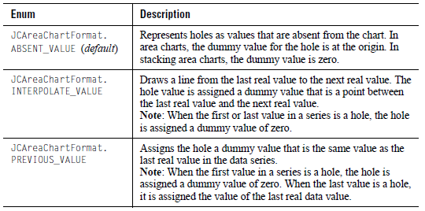
By default, when a hole value is encountered in a data series, the hole value is not drawn and the region that spans the hole (that is, the region extending from the last valid point before the hole to the next valid point after the hole) is not filled. If a single valid data point is bounded by hole values on either side, the valid data point is drawn as a single line (see Figure 83, left image).

You can choose whether to leave the holes empty, use a unique hole style, or use the same hole style as the data series. When a hole style is specified, the fill attributes are used to fill the region between valid data points. If the same chart style is used both for the data series and the holes, the holes are no longer visible to the end user because the data series looks uniform. The following sections show how holes and hole styles appear for each type of hole interpretation.

When hole styles are used for a data series, polygons are created in the chart to represent the hole values (even if the hole style is fill style is set to none). In this case, you can pick the hole polygons in the same way you pick any other data value in area and stacking area charts. You can also attach image maps to the polygons created by hole values in these charts. For more information, see [pick chapter] and [image map chapter}.

7.7.3.1 Holes in Area Charts

In Figure 83, the first image shows how an area chart looks when no hole styles are applied. The value of the HoleInterpretation property does not affect the display of the area chart when no hole styles are in use. The second image shows hole styles used with the default ABSENT_VALUE setting. The holes are assigned origin values, which causes V-shapes to occur in the chart as lines are drawn from real values to the dummy values.
Figure 83 Area chart with no hole style (left) and using ABSENT_VALUE with hole styles (right)

The images in Figure 84 show the other two types of hole interpretations when hole styles are used. For INTERPOLATE_VALUE, lines are drawn from the last real value to the next real value. The holes are assigned dummy values that reflect a value between these real values. For PREVIOUS_VALUE, a hole is assigned a dummy value that is the same as the last real value. This causes plateaus to appear in the chart.

Figure 84 Area chart using hole styles and INTERPOLATE_VALUE (left) and PREVIOUS_VALUE (right)

7.7.3.2 Holes in Stacking Area Charts

Unlike area charts, the value of the HoleInterpretation property does affect the look of a stacking area chart even if no hole styles are used. Depending on the value of HoleInterpretation, holes are assigned different dummy values. These dummy values are used when calculating how to stack the data series. If the 100Percent property is set, the dummy values are converted to a percentage.

The following figures show how stacking area charts look both before and after hole styles are applied for each hole interpretation. Notice that the solid polygons in each set of before and after images are the same because of the use of dummy values.

For ABSENT_VALUE, a value of zero is substituted for holes. When hole styles are used, deep V-shapes are created at the holes.
Figure 85 Stacking area chart using ABSENT_VALUE before (left) and after (right) hole styles are applied.

For INTERPOLATE_VALUE, an imaginary line connects the last real value to the next real value and the holes are assigned dummy values that reflect a value between these real values. When hole styles are applied, the line is drawn on the chart and the area below (up to the preceding data series) is filled with the specified hole style for the series.
Figure 86 Stacking area chart using INTERPOLATE_VALUE before (left) and after
(right) hole styles are applied.

For PREVIOUS_VALUE, the hole inherits the same value as the last real value. When hole styles are applied, you can see plateaus in each of the data series where holes occur.

Figure 87Stacking area chart using PREVIOUS_VALUE before (left) and after (right) hole styles are applied.

7.8 Borders
One way to highlight important information or improve the chart’s appearance is to use a border. You can customize the border of the following chart objects:
- Header and Footer titles
- Legend
- ChartArea
- each ChartLabel added to the chart
- the entire chart

Border properties are set using the standard JComponent border facilities, getBorder() and setBorder().

7.9 Fonts
A chart can have more impact when you customize the fonts used for different chart elements. You may also want to change the font size to make an element better fit the overall size of the chart. Any font available when the chart is running can be used. You can set the font for the following chart elements:
- Header and Footer titles
- Legend
- Axis annotation and title
- each ChartLabel added to the chart

Changing a Font
Font properties are set using the standard JComponent font facilities, getFont() and setFont(). Use the font properties to set the font, style, and size attributes.

7.10 Colors
Color can powerfully enhance a chart’s visual impact. You can customize chart colors using Java color names or RGB values. Using JClass ServerChart Designer can make selecting custom colors quick and easy. Each of the following visual elements in the chart has a background and foreground color that you can customize:
- the entire chart
- header and footer titles
- legend
- chart area
- plot area (foreground colors JCChartArea’s AxisBoundingBox)
- each chart label added to the chart

Other chart objects have color properties too, including ChartDataView (bar/pie outline color) and ChartStyles.

Color Defaults
All chart subcomponents are transparent by default with no background color. If made opaque, the legend, chart area and plot will inherit background color from the parent chart. The same objects will always inherit the foreground color from the chart. Headers and footers are independent objects and behave according to the rules of whatever object they are. However, once the application sets the colors of an element, they do not change when other elements’ colors change.

Specifying Foreground and Background Colors
Each chart element listed above has a Background and Foreground property that specifies the current color of the element. The easiest way to specify a color is to use the built-in colornames defined in java.awt.Color.

The following table summarizes these colors:

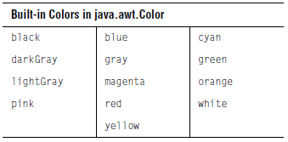
Alternately, you can specify a color by its RGB components, useful for matching another RGB color. RGB color specifications are composed of a value from 0 – 255 for each of the red, green and blue components of a color. For example, the RGB specification of Cyan is “0-255-255” (combining the maximum value for both green and blue with no red).

The following example sets the header background using a built-in color, and the footer background to an RGB color (a dark shade of Turquoise):

c.getHeader().setBackground(Color.cyan);

mycolor = new Color(95,158,160);
c.getFooter().setBackground(mycolor);

Take care not to choose a background color that is also used to display data in the chart. The default ChartStyles use all of the built-in colors in the following order: Red, Orange, Blue, Light Gray, Magenta, Yellow, Gray, Green, Dark Gray, Cyan, Black, Pink, and White. Note that JClass ServerChart will skip colors that match background colors. For example, if the chart area background is Red, then the line, fill, and symbol colors will start at Orange.

For all charts, the foreground and background colors of the plot area are adjustable.

Transparency
If the JClass ServerChart component is meant to have a transparent background, set the Opaque property to False; then generated GIFs and PNGs will also contain a transparent background.

7.11 Customizing the Chart Layout

Each of the main chart elements (Header, Footer, Legend, and ChartArea) has properties that control its position and size. When the chart controls positioning, it first allows space for the Header, Footer, and Legend, if they exist (size is determined by contents, border, and font).

The ChartArea is sized and positioned to fit into the largest remaining rectangular area. Positioning adjusts when other chart properties change.

Note: Chart labels do not figure into the overall layout. Instead, they are positioned above all other chart elements.

You can customize the position and size of any element. If you are working with small charts, you can choose to use a different layout manager, one that prioritizes the size of the chart’s JCChartArea and PlotArea over all other elements.

7.11.1 Changing the Location and Size of a Chart Element
To specify the absolute location and size of a chart element, call setLayoutHints() in JCServerChart with the object you wish to move and a rectangle containing its desired X and Y location, width, and height. If you desire any of those values to be calculated rather than set, make them equal to Integer.MAX_VALUE.

For example, the following code sets the legend to be 200 pixels wide and 300 pixels high and places it at the x,y coordinate (0,150):
chart.setLayoutHints(legend, newRectange(0,150,200,300))

Whereas this code allows the legend size to be dynamic, but places the legend at (0,150):
chart.setLayoutHints(legend, Rectange(0,150,
Integer.MAX_VALUE,Integer.MAX_VALUE, Integer.MAX_VALUE))

7.11.2 Using a Layout Manager for Small Charts

With the small chart layout manager, priority is given to the chart’s JCChartArea and its PlotArea. To accommodate the size of the JCChartArea element, other chart elements may be hidden, such as the header, footer, legend, and/or border. In very small charts, the axis titles, annotations, or even the lines used to render the axes may be hidden in order to preserve the PlotArea.

To use the small chart layout manager, set the ChartLayout property from JCChart to PLOT_PRIORITY_LAYOUT. This creates a PlotPriorityLayout object with the following default values for its parameters:
- minComponentAreaWidth (default value 0.60): The fractional width of the chart area, in relation to the chart, below which the header, footer, or legend may be hidden.
- minComponentAreaHeight (default value 0.70): The fractional height of the chart area, below which the header, footer, or legend may be hidden.
- minPlotAreaWidth (default value 0.40): The fractional width of the plot area, in relation to the chart, below which the axis title and annotations are hidden.
- minPlotAreaHeight (default value 0.40): The fractional height of the plot area, in relation to the chart, below which the axis title and annotations are hidden.
- legendVisible (default value true): Overrides the visible property of the legend.

If the default values are not suitable, you can create your own PlotPriorityLayout object and use the setLayout() method of the chart to set the layout. This object takes precedence over the value of the ChartLayout property until another call is made to setChartLayout().

PlotPriorityLayout smallchart = new PlotPriorityLayout
(0.50, 0.50, 0.25, 0.25, false);
chart.setLayout(smallchart);

To restore the default layout manager, set the ChartLayout property to DEFAULT_LAYOUT.

7.12 3D Effect
Data in bar, stacking bar, and pie charts can be displayed with a three-dimensional appearance using several JCChartArea properties:
- Depth — Specifies the apparent depth as a percentage of the chart’s width. No 3D effect appears unless this property is set greater than zero.
- Elevation — Specifies the eye’s position above the horizontal axis, in degrees.
- Rotation — Specifies the number of degrees the eye is positioned to the right of the vertical axis. This property has no effect on pie charts.

You can set the visual depth and the “elevation angle” of the 3D effect. You can also set the “rotation angle” on bar and stacking bar charts. Depth, Rotation and Elevation are all properties of the ChartArea.
Figure 88 Four charts illustrating 3D effects.

7.13 Anti-Aliasing
Anti-aliasing is the process of smoothing out lines and curves to remove the pixelated appearance of text and graphics. The smoothing is done by padding pixels with intermediate colors. For example, a black and white image would be smoothed out using gray.
Figure 89 The appearance of text with and without anti-aliasing.

JClass ServerChart is equipped with the AntiAliasing property which can turn anti-aliasing on or off when the chart and its subcomponents are painted.
- JCServerChart.ANTI_ALIASING_ON turns on anti-aliasing for the chart;
- JCServerChart.ANTI_ALIASING_OFF turns off anti-aliasing for the chart;
- JCServerChart.ANTI_ALIASING_DEFAULT, which is the default value, ensures that the graphics object will be untouched with respect to anti-aliasing when the chart is painted.

8
Defining Markers and Thresholds
Markers ■ Thresholds

You can enhance your clients’ understanding of the data in your chart by implementing markers or thresholds. Markers are displayed as lines in the chart, and can be used to mark things like the average data value, data limits, or a particular coordinate in the chart. Thresholds cover a range of data values and are displayed as areas of color in the chart background. Thresholds can be used to identify and draw attention to groups of data values, such as values that fall below expectations, meet expectations, or exceed expectations. You can use both markers and thresholds in the same chart.

Important: This section assumes that you are using the underlying data model. If you are using the targeted data model, you need to implement the marker or threshold iterator. For more information, see Chapter 5, Adding Data with the Targeted Data Model.

8.1 Markers
Markers enable you to draw lines in the plot area of the chart. For example, you could create a control chart by using parallel marker lines to represent an upper limit, an average, and a lower limit. Alternatively, you could create a crosshair at a particular coordinate to highlight a target value.

Note: Markers are not available for pie charts.

Figure 90 A control chart that uses markers to create the upper and lower limits and an average.

You can have a list of markers for each data view. The ChartDataView object maintains this list and has methods to add markers, remove markers, and get the current list of markers. For more information, see ChartDataView in the JClass API Documentation.

After you create a JCMarker object, you associate the marker with a data view and an axis and then specify the value on that axis at which to draw the marker line. The following sections describe how to create a marker on the x-axis and the y-axis, as well as how to create a crosshair.

8.1.1 Creating X-axis Markers

To add an x-axis marker to the chart, you need to create a JCMarker object with its AssociatedWithYAxis property set to false, add it to the data view, and specify the value on the x-axis at which to draw the line. You can customize the line style and length, as well as control whether or not the markers are drawn on top of the data. For more information, see Section 8.1.4, Customizing Markers.

The following code snippet demonstrates how to create an x-axis marker. The JCMarker constructor shown in this example takes the following parameters: a label (String) and a value at which to draw the marker line (double). The AssociatedWithYAxis property is set after the object is created. For more information, see JCMarker in the JClass API Documentation.

ChartDataView dataView = chart.getDataView(0);
JCMarker marker = new JCMarker("Marker at 2", 2.0);
marker.setAssociatedWithYAxis(false);
dataView.addMarker(marker);

X-axis Marker in a Rectangular Chart

In a rectangular chart (default orientation), associating a marker with the x-axis creates a vertical marker. By default, the vertical marker line spans the height of the plot area.

Figure 91 Plot chart (non-inverted) with an x-axis (vertical) marker.

If the chart orientation is inverted so that the x-axis is the vertical axis, the marker is drawn horizontally.

X-axis Marker in a Circular Chart

In a circular chart, markers associated with the x-axis are drawn as radial lines.

Figure 92 Polar chart with an x-axis (radial) marker.

8.1.2 Creating Y-axis Markers

To add an y-axis marker to the chart, you need to create a JCMarker object with its AssociatedWithYAxis property set to true, add it to the data view, and specify the value on the y-axis at which to draw the line. You can customize the line style and length, as well as control whether or not the markers are drawn on top of the data. For more information, see Section 8.1.4, Customizing Markers.

The following code snippet demonstrates how to create a y-axis marker. The JCMarker constructor shown in this example takes the following parameters: a label (String) and a value at which to draw the marker line (double). The AssociatedWithYAxis property is set after the object is created. For more information, see JCMarker in the JClass API Documentation.

ChartDataView dataView = chart.getDataView(0);
JCMarker marker = new JCMarker("Marker at 200", 200.0);
marker.setAssociatedWithYAxis(true);
dataView.addMarker(marker);

Y-axis Marker in a Rectangular Chart

In a rectangular chart (default orientation), associating a marker with the y-axis creates a
horizontal marker. By default, the horizontal marker line spans the width of the plot area.

Figure 93 Bar chart (non-inverted) with a y-axis (horizontal) marker.

If the chart orientation is inverted so that the y-axis is the horizontal axis, the marker is drawn vertically.

Y-axis Marker in a Circular Chart

In a circular chart, markers associated with the y-axis are drawn as circles (or arcs, if a line length is specified).

Figure 94 Polar chart and an area radar chart displaying y-axis markers as circles.

In radar charts, if webbed gridlines are drawn, then a y-axis marker is displayed as a web shape rather than a circular shape. For more information, see Gridlines, in Chapter 6.

Figure 95 Area radar chart displaying a y-axis marker drawn in a web-like fashion.

8.1.3 Creating a Crosshair with Markers

To create a crosshair, you add two markers to your selected data view, one associated
with the x-axis and one with the y-axis, and position them so that they intersect at the coordinate that you want to highlight.

The following code snippet demonstrates how to create a crosshair. ChartDataView

dataView = chart.getDataView(0);
JCMarker xMarker = new JCMarker("X Marker", 2.0);
xMarker.setAssociatedWithYAxis(false);
dataView.addMarker(xMarker);
JCMarker yMarker = new JCMarker("Y Marker", 175.0);
yMarker.setAssociatedWithYAxis(true);
dataView.addMarker(yMarker);

Figure 96 Area chart with markers that create a crosshair.

8.1.4 Customizing Markers

You can set the start and end points for the marker and customize the line style. You can also choose when the markers are drawn on the chart, that is, before or after the data is displayed. If you like, you can display marker labels in the legend or add chart labels to your markers.

8.1.4.1 Setting the Start and End Points

By default, a marker line spans the entire plot area. You can choose to specify the start point and end point of the line in terms of the non-associated axis. For example, the start and end point values for a x-axis marker refer to values on the y-axis. If the start point is undefined, the marker is drawn from the minimum value on the y-axis. Conversely, if the end point is not set, the marker line ends at the maximum value on the y-axis.

Note: For radar charts, markers associated with the y-axis can start and end only at spoke boundaries.

In the following code snippet, the StartPoint and EndPoint properties are used to modify the markers so that they do not span the entire plot area. Note that the StartPoint property for ‘Marker 2’ is not specified, so the line starts from the minimum value on the y-axis.

ChartDataView dataView = chart.getDataView(0);
JCMarker marker1 = new JCMarker("Marker 1", 2.0);
marker1.setAssociatedWithYAxis(false);
marker1.setStartPoint(175.0);
marker1.setEndPoint(275.0);
dataView.addMarker(marker1);

JCMarker marker2 = new JCMarker("Marker 2", 3.0);
marker2.setAssociatedWithYAxis(false);
marker2.setEndPoint(160.0);
dataView.addMarker(marker2);

Figure 97 Stacking bar chart and area radar chart displaying two markers.

In a circular chart where the y-axis marker is drawn as a circle, setting a start and end point results in an arc that spans the distance between the two points. The following code snippet demonstrates how you might specify a y-axis marker for a polar chart.

ChartDataView dataView = chart.getDataView(0);
JCMarker marker = new JCMarker("Marker", 200.0);
marker.setStartPoint(Math.PI / 4.0);
marker.setEndPoint(1.5 * Math.PI);
marker.setAssociatedWithYAxis(true);
dataView.addMarker(marker);
Figure 98 Polar chart displaying a y-axis marker with a start and end point (arc).

8.1.4.2 Setting the Line Style

You can define the width of the line, the color, and the line attribute (solid, dashed, dotted, etcetera.).

The following code snippet creates two markers. Unique LineStyle properties are set for each of the markers. You may also notice that one marker is drawn before the data, and the other is drawn after the data. For more information, see Section 8.1.4.3, Controlling When Markers are Drawn.

ChartDataView dataView = chart.getDataView(0);
JCMarker marker1 = new JCMarker("Marker 1", 100.0);
marker1.setAssociatedWithYAxis(true);
marker1.setLineStyle(new JCLineStyle(3, Color.BLUE,
JCLineStyle.SHORT_DASH));

dataView.addMarker(marker1);

JCMarker marker2 = new JCMarker("Marker 2", 400.0);
marker2.setAssociatedWithYAxis(true);
marker2.setLineStyle(new JCLineStyle(3, Color.DARK_GRAY,
JCLineStyle.DASH_DOT));
marker2.setDrawnBeforeData(true);
dataView.addMarker(marker2);

Figure 99 Stacking area chart showing two markers with different line styles.

8.1.4.3 Controlling When Markers are Drawn

You can choose to draw markers before or after the data is added to the chart. By default, the markers are drawn after the data and axes, but before chart labels are added. You can change the order so that the markers are drawn before the axes and data are displayed, but after the background, thresholds, and grid lines are added.

In the following code snippet, the DrawnBeforeData property is set to true so that the markers are drawn before the data.

ChartDataView dataView = chart.getDataView(0);
JCMarker xMarker = new JCMarker("X Marker", 2.0);
xMarker.setAssociatedWithYAxis(false);
xMarker.setDrawnBeforeData(true);
dataView.addMarker(xMarker);

JCMarker yMarker = new JCMarker("Y Marker", 175.0);
yMarker.setAssociatedWithYAxis(true);
yMarker.setDrawnBeforeData(true);
dataView.addMarker(yMarker);
Figure 100 Plot chart with crosshair markers drawn before the data, so that the data point is displayed on top.

For another example of using the DrawnBeforeData property, see Section 8.1.4.2, Setting the Line Style.

8.1.4.4 Identifying Markers in the Legend

If you want, you can add labels for your markers to the legend. Marker labels are displayed below series labels but before threshold labels (if any).

In the following code snippet, the marker labels are added to the legend by setting the VisibleInLegend property to true. The programmer also needed to set different LineStyles on the markers to be able to distinguish the markers from each other in the legend. For more information, see Section 8.1.4.2, Setting the Line Style.

ChartDataView dataView = chart.getDataView(0);
chart.getLegend().setVisible(true);
JCMarker marker1 = new JCMarker("Marker 1", 2.0);
marker1.setAssociatedWithYAxis(false);
marker1.setLineStyle(new JCLineStyle(1, Color.black,
JCLineStyle.SHORT_DASH));

marker1.setVisibleInLegend(true);
dataView.addMarker(marker1);
JCMarker marker2 = new JCMarker("Marker 2", 200.0);
marker2.setAssociatedWithYAxis(true);
marker2.setLineStyle(new JCLineStyle(1, Color.black,
JCLineStyle.DASH_DOT));

marker2.setVisibleInLegend(true);
dataView.addMarker(marker2);
Figure 101 3D bar chart with crosshair markers identified in the legend.

8.1.4.5 Attaching Chart Labels

To attach a chart label to a marker, you create the chart label and then set the ChartLabel property on the marker. You can set most chart label properties as usual, though there are some restrictions (see Restrictions below). By default, the chart label is attached to the marker midway between the start point and the end point. You can change where the marker is attached by setting the DataCoord property of the chart label. For more information, see Chart Labels, in Chapter 7 and look up JCChartLabel in the JClass API Documentation.

Restrictions:

- The JCChartLabel component must be a JCLabel (default), or an exception is thrown.
- The attach type is always JCChartLabel.ATTACH_DATACOORD; if this is not the case, it is forced upon the chart label by the marker.
- When setting the attach point, the coordinate value that represents the associated axis for the marker must be on the marker. If this is not the case, it is forced upon the chart label. For example, for an x-axis marker, the x-value of the attach point will be on the marker line, even if you set the x-value to something else.
- The data view for the chart label must be the same as the marker; if this is not the case, it is forced upon the chart label.
- A chart label cannot be a dwell label, or an exception is thrown.
- A chart label must not have been added to the chart's label manager, or an exception is thrown.

The following code snippet sets a chart label on an x-axis marker and sets some properties. The chart label is attached to the marker at the default midway point.

ChartDataView dataView = chart.getDataView(0);
JCMarker marker = new JCMarker("My marker", 2.0);
marker.setAssociatedWithYAxis(false);
JCChartLabel label = new JCChartLabel("A Marker Label");
label.setOffset(new Point(60, -60));

label.setConnected(true);
label.getComponent().setBorder(new LineBorder(Color.black, 2));
marker.setChartLabel(label);
dataView.addMarker(marker);

Figure 102 Plot chart showing a marker with a chart label that is attached at the midway point.

8.1.4.6 Troubleshooting Missing Markers
If a marker is not drawn on your chart, it may be that its value falls outside the minimum or maximum data bounds for its associated axis. For example, if an x-axis marker value is 19, and the maximum value displayed on the chart for that axis is 10, the marker is not drawn.

By default, the data bounds for an axis are calculated based on the range of values for that axis contained in the data set; marker values are ignored. To include a marker value in the data bounds calculation, set the marker’s IncludedInDataBounds property to true.

Note: This property is ignored for axes that have fixed bounds. Axes that have fixed bounds are the x -axis for polar and radar charts and the y-axis for 100% stacking charts. In addition, the y-axis in polar, radar, and area radar charts have a fixed minimum bound of zero (when not reversed).

8.2 Thresholds
Thresholds enable you to specify regions of different colors in the plot area of the chart. For example, you can create a red zone to indicate that the data values located within the zone are problematic in some specified way. You can use multiple thresholds in a single chart, and the thresholds can overlap.

For charts of type JCServerChart.BAR, you also have the option of defining thresholds by data series. The threshold is represented within each bar in the chart, rather than the plot area. For more information, see Defining Data Thresholds for Bar Charts, in Chapter 4.

Note: Thresholds are not available for pie charts.

Figure 103 Bar chart that uses thresholds to highlight positive (green) and negative (red) price fluctuations.

You can have a list of thresholds for each data view. The ChartDataView object maintains this list and has methods to add thresholds, remove thresholds, and get the current list of thresholds. For more information, see ChartDataView in the JClass API Documentation.

After you create a JCThreshold object, you associate the threshold with a data view and an axis. Thresholds are drawn immediately after the plot area is drawn, and they are drawn in the order in which they appear in the threshold list for the data view. The following sections describe how to create a threshold on the x-axis or the y-axis, and what happens when thresholds overlap or intersect.

8.2.1 Creating X-axis Thresholds

To add an x-axis threshold to the chart, you need to create a JCThreshold object with its AssociatedWithYAxis property set to false and then add it to a data view. You can define the width of the threshold by specifying a start value and an end value on the x-axis. You can also customize the fill style and add boundary lines. For more information, see Section 8.2.4, Customizing Thresholds.

The following code snippet demonstrates how to create an x-axis threshold. The JCThreshold constructor shown in this example takes the following parameters: a label (String), the value at which to start the threshold (double), the value at which to end the threshold (double), the boolean isAssociatedWithYAxis (which is set to false for an x-axis threshold), a fill style (specified by a JCFillStyle object), and line styles (specified by JCLineStyle objects). For more information, see JCThreshold in the JClass API Documentation.

ChartDataView dataView = chart.getDataView(0);
boolean isAssociatedWithYAxis = false;
JCThreshold threshold = new JCThreshold("My Threshold", 2.0, 3.0,
isAssociatedWithYAxis,Color.blue);
dataView.addThreshold(threshold);

X-axis Threshold in a Rectangular Chart

In a rectangular chart (default orientation), associating a threshold with the x-axis creates a vertical threshold. By default, the vertical threshold spans the height of the plot area.

Figure 104Plot chart (non-inverted) with an x-axis (vertical) threshold.

If the chart orientation is inverted so that the x-axis is the vertical axis, the threshold is drawn horizontally.

X-axis Threshold in a Circular Chart

In a circular chart, thresholds associated with the x-axis are drawn as colored slices of a pie in the circular plot area.

Figure 105 Polar chart and radar chart displaying pie-shaped x-axis thresholds.

In radar charts, if webbed gridlines are drawn, then an x-axis threshold is displayed with straight outer edges rather the circular arcs. For more information on webbed gridlines, see Gridlines, in Chapter 6.

Figure 106 Radar chart displaying an x-axis threshold drawn in a web-like fashion.

8.2.2 Creating Y-axis Thresholds

To add a y-axis threshold to the chart, you need to create a JCThreshold object with its AssociatedWithYAxis property set to true and then add it to a data view. You can define the area of the threshold by specifying start and end values either as constant limits or as sets of points (rectangular charts only). You can also customize the fill style and add boundary lines. For more information, see Section 8.2.4, Customizing Thresholds.

8.2.2.1 Using Constant Limits

The following code snippet demonstrates how to create a y-axis threshold with constant values for the start and end limits. The JCThreshold constructor shown in this example takes the following parameters: a label (String), the value at which to start the threshold (double), the value at which to end the threshold (double), the boolean isAssociatedWithYAxis (which is set to true for a y-axis threshold), and a color (in the form specified by java.awt.Color).

ChartDataView dataView = chart.getDataView(0);
boolean isAssociatedWithYAxis = true;
JCThreshold threshold = new JCThreshold("My Threshold", 150.0, 250.0,
isAssociatedWithYAxis, color.blue);
dataView.addThreshold(threshold);

Y-axis Threshold in a Rectangular Chart

In a rectangular chart (default orientation), associating a threshold with the y-axis creates a horizontal threshold. By default, the horizontal threshold spans the width of the plot area.

Figure 107 Stacking bar chart (non-inverted) with a y-axis (horizontal) threshold.

Chart If the chart orientation is inverted so that the y-axis is the horizontal axis, the threshold is drawn vertically.

Y-axis Threshold in a Circular

In a circular chart, thresholds associated with the y-axis are drawn as circular bands of color.
Figure 108 Polar chart and radar chart showing y-axis thresholds as circular bands of color.

In radar charts, if webbed gridlines are drawn, then a y-axis threshold is displayed as a band of color with a webbed shape rather than a circular shape. For more information on webbed gridlines, see Gridlines, in Chapter 6.

Figure 109 Radar chart displaying a y-axis threshold drawn as a web-shaped band of color.

8.2.2.2 Using Variable Limits

With y-axis thresholds you have the option of specifying lists of points to use for the start values and end values. This creates a polygon-shaped threshold. You can use variable limit thresholds to create envelopes around the data.

Note: This feature is available for y-axis thresholds in rectangular charts only. x-axis thresholds require constant limits.

For each list of points the x values in the array must be strictly increasing. The x values in each list do not, however, need to match each other or match the data. Limits can also be set using the StartValues and EndValues properties of the threshold. If no variable limits are provided, a constant limit is assumed.
The following code snippet demonstrates how to create a multipoint y-axis threshold. The JCThreshold constructor shown in this example takes the following parameters: a label (String), an array of points that represent the start of the threshold (Point2D.Double[]), an array of points that represent the end of the threshold (Point2D.Double[]), the type of limit (JCThreshold.LIMIT_TYPE_ENVELOPE or JCThreshold.LIMIT_TYPE_STEPPED), the boolean isAssociatedWithYAxis (which is set to true for a y-axis threshold), a fill style (specified by a JCFillStyle object), and line styles (specified by JCLineStyle objects). You can also set whether or not the threshold is included in the legend.

ChartDataView dataView = chart.getDataView(0);
boolean isAssociatedWithYAxis = true;
boolean isVisibleInLegend = true;

// Start values
Point2D.Double[] startValues = {
new Point2D.Double(1.0, 140.0),
new Point2D.Double(2.0, 160.0),
new Point2D.Double(3.0, 150.0),
new Point2D.Double(4.0, 140.0)};

// End values
Point2D.Double[] endValues = {

new Point2D.Double(1.0, 240.0),
new Point2D.Double(2.0, 260.0),
new Point2D.Double(3.0, 250.0),
new Point2D.Double(4.0, 240.0)};

// Set limit type
int limitType = JCThreshold.LIMIT_TYPE_ENVELOPE;

// Specify the fill
JCFillStyle fs = new JCFillStyle(Color.blue, JCFillStyle.PER_25);

// Specify a line style
JCLineStyle ls = new JCLineStyle(1,Color.blue,
JCLineStyle.LONG_DASH_FINE);

JCThreshold threshold = new JCThreshold("My Threshold", startValues,
endValues, limitType, isAssociatedWithYAxis,
fs, ls, ls, isVisibleInLegend);
dataView.addThreshold(threshold);
Figure 110 Variable limit threshold with LIMIT_TYPE_ENVELOPE

Figure 111 Variable limit threshold with LIMIT_TYPE_STEPPED

8.2.3 Overlapping and Intersecting Thresholds

When you add multiple thresholds to a chart, the thresholds can be associated with either axis. If thresholds on the same axis overlap, or if you intersect thresholds by using both axes, the order in which the thresholds are drawn becomes important. Each threshold is painted on top of previously drawn thresholds. If the fill style is solid (which is the default), this means that parts or all of previously drawn thresholds may be hidden.

When the following code snippet executes, the y-axis threshold, threshold2, is drawn on top of the x-axis threshold because the y-axis threshold is added to the data view last.

ChartDataView dataView = chart.getDataView(0);
boolean isAssociatedWithYAxis = false;
JCThreshold threshold1 = new JCThreshold("My Threshold", 1.5, 2.5,
isAssociatedWithYAxis, Color.green);
dataView.addThreshold(threshold1);

isAssociatedWithYAxis = true;
JCThreshold threshold2 = new JCThreshold("My Threshold", 150.0, 250.0,
isAssociatedWithYAxis, Color.blue);
dataView.addThreshold(threshold2);

Figure 112 Bar chart with intersecting thresholds.

8.2.4 Customizing Thresholds

You can specify the fill style for a threshold and add boundary lines to the edges of the threshold. If you like, you can add threshold labels to the legend.

8.2.4.1 Setting the Fill Style for Thresholds

You can specify a fill color, fill pattern, or an image to fill the threshold region. If the FillStyle property of the threshold is set to null, the threshold is not filled; however, if the start and end lines are specified, the lines are still drawn. For more information, see Defining Background Fill Styles, in Chapter 9.

The following code snippet creates two x-axis thresholds with different fill styles. The fill styles are specified using the FillStyle property and the JCFillStyle object.

ChartDataView dataView = chart.getDataView(0);
boolean isAssociatedWithYAxis = false;
JCThreshold threshold1 = new JCThreshold("Threshold 1", 1.0, 2.5,
isAssociatedWithYAxis);
threshold1.setFillStyle(new JCFillStyle(Color.blue,
JCFillStyle.STRIPE_135));
dataView.addThreshold(threshold1);

JCThreshold threshold2 = new JCThreshold("Threshold 2", 2.5, 4.0,
isAssociatedWithYAxis);
threshold2.setFillStyle(new JCFillStyle(Color.red,
JCFillStyle.STRIPE_45));
dataView.addThreshold(threshold2);

Figure 113 Scatter plot chart showing two thresholds with different fill styles.

8.2.4.2 Adding Boundary Lines

You can add boundary lines at the start and end of the threshold area by specifying the StartLineStyle and/or the EndLineStyle properties of the threshold. By default these properties are set to null, which means no lines are drawn. When you set one of these properties, you construct a JCLineStyle object to specify the line style. For more information, see JCLineStyle in the JClass API Documentation.

The following code snippet demonstrates how to add bounding lines to a threshold using the StartLineStyle and EndLineStyle properties with JCLineStyle objects.

ChartDataView dataView = chart.getDataView(0);
boolean isAssociatedWithYAxis = true;
JCThreshold threshold = new JCThreshold("Threshold", 300.0, 400.0,
isAssociatedWithYAxis, Color.blue);
threshold.setStartLineStyle(new JCLineStyle(2, Color.black,
JCLineStyle.DASH_DOT));
threshold.setEndLineStyle(new JCLineStyle(2, Color.black,
JCLineStyle.DASH_DOT));
dataView.addThreshold(threshold);

Figure 114 3D stacking bar chart showing a threshold with boundary lines.

8.2.4.3 Identifying Thresholds in the Legend

If you want, you can add labels for your thresholds to the legend. Threshold labels are displayed below both series labels and marker labels (if any).

In the following code snippet, the threshold labels are added to the legend by setting the VisibleInLegend property to true. Note that for clarity, the fill color chosen for the threshold should be different than the colors used for the series. For more information, see Section 8.2.4.1, Setting the Fill Style for Thresholds.

ChartDataView dataView = chart.getDataView(0);
chart.getLegend().setVisible(true);
boolean isAssociatedWithYAxis = true;
JCThreshold threshold = new JCThreshold("The Blue Zone", 200.0, 300.0,
isAssociatedWithYAxis, Color.blue);
threshold.setStartLineStyle(new JCLineStyle(1, Color.black,
JCLineStyle.SOLID));
threshold.setEndLineStyle(new JCLineStyle(1, Color.black,
JCLineStyle.SOLID));
threshold.setVisibleInLegend(true);
dataView.addThreshold(threshold);
Figure 115 Polar chart with a circular y-axis threshold that is identified in the legend.

8.2.4.4 Troubleshooting Missing or Partial Thresholds

If your threshold is missing or is only partially visible on the chart, it may be that its start value and/or end value falls outside the minimum or maximum data bounds for its associated axis. A threshold is not drawn on the chart when its start and end values fall below the minimum data bound or exceed the maximum data bounds for its associated axis. A threshold is only partial visible if its start value falls below the minimum bound while its end value is within data bounds. Similarly, if the end value exceeds the maximum bound while the start value is within bounds, only the start of the threshold is visible.

By default, the data bounds for an axis are calculated based on the range of values for that axis contained in the data set; threshold values are ignored. To include a threshold’s start and end values in the data bounds calculations, set the threshold’s IncludedInDataBounds property to true.

Note: This property is ignored for axes that have fixed bounds. Axes that have fixed bounds are the x -axis for polar and radar charts and the y-axis for 100% stacking charts. In addition, the y-axis in polar, radar, and area radar charts have a fixed minimum bound of zero (when not reversed).

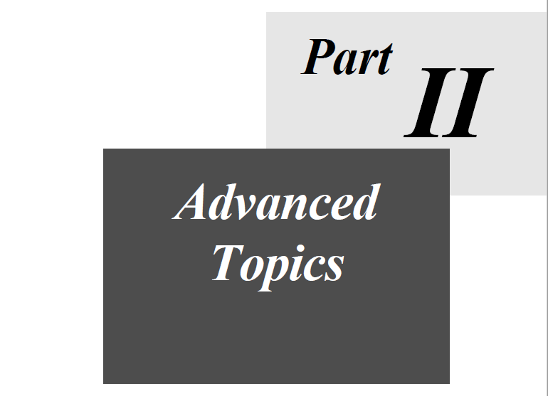

9
Defining Background Fill Styles
Setting the Component’s Background Color ■ Creating a Background Fill with JCFillStyle
Specifying a Pattern ■ Specifying a Image ■ Specifying a Gradient Fill
Specifying a Custom Paint ■ Filling a Plot Area ■ Creating Stacked Images in a Bar Chart

You can fill the background of a container with a solid color, a pattern, an image, or a gradient fill. Containers include JCChart, JCChartArea, JCLegend, and JCThreshold. In addition to containers, you can create a fill in the PlotArea of a chart and in a ChartDataViewSeries (for example, you can fill bars in a bar chart). This chapter covers how to set the component’s background color and how to add a fill to the background of containers.

9.1 Setting the Component’s Background Color
To specify a background color for a component, set the background and opaque properties inherited from JComponent. The background needs to be opaque for the color to be drawn.

For example:

// Specify a background color and make it opaque
myChart.setBackground(Color.blue);
myChart.setOpaque(true);

Alternatively, you can fill the background with a color by creating a JCFillStyle object and setting its background property. For more information, see Section 9.3, Specifying a Pattern.

9.2 Creating a Background Fill with JCFillStyle
To use a fill, you create and define a JCFillStyle object. You then set your JCFillStyle object on the container using the container’s fillStyle property.

JCFillStyle is located in the com.klg.jclass.util.style package. It has two constructors: a general constructor for all types of fills and a specialized constructor for gradient fills.

This section contains the enumerations used with the general JCFillStyle constructor.
For examples that demonstrate how to use the constructors to create different kinds of effects, see the following sections:
- Section 9.3, Specifying a Pattern
- Section 9.4, Specifying an Image
- Section 9.5, Specifying a Gradient Fill
- Section 9.6, Specifying a Custom Paint

For more information, look up com.klg.jclass.util.style.JCFillStyle in the JClass ServerViews API documentation.

9.2.1 pattern Parameter

The general JCFillStyle constructor takes a Color and a pattern property. The pattern is an enumeration that specifies the type of fill. The following table lists the enumerations and shows a sample of what they look like with the pattern color specified as blue and the background color as yellow.

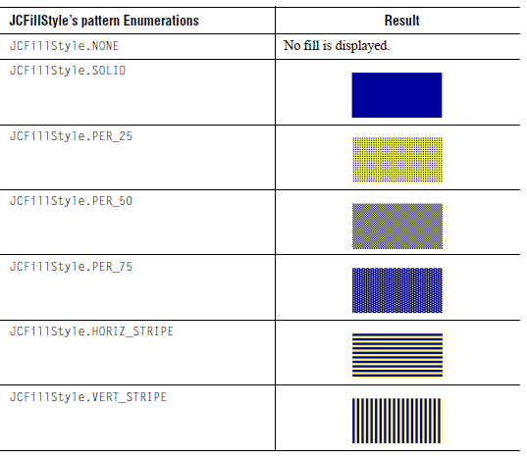
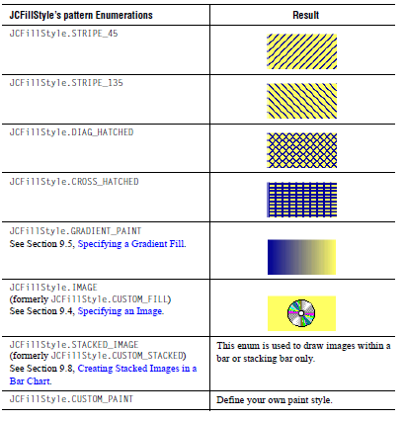
Notes:
■JCFillStyle.STACKED_IMAGE is used for drawing stacked images within a bar or stacking bar only. The imageLayoutHint, fillOrientation, and imagePosition properties are ignored. If this enum is used for other purposes, JCFillStyle behaves as if the pattern was JCFillStyle.SOLID.
■Historically, JCFillStyle had CUSTOM_FILL and CUSTOM_STACKED enums. These are supported for backward compatibility, but deprecated in favor of IMAGE and STACKED_IMAGE respectively.

9.3 Specifying a Pattern
To add a pattern to the background, create a JCFillStyle object and pass it the Color for the pattern and one of the pattern enumerations. Then set the JCFillStyle object on the target component using the component’s fillStyle property. For a list of available pattern enumerations, see Section 9.2.1, pattern Parameter.

The color of the background behind the pattern is determined by the background property of the JCFillStyle object. If the property is not set, whatever fill is in the component background will be seen through the pattern. For more information, see Section 9.1, Setting the Component’s Background Color.

The following example creates a JCFillStyle object with a 45 degree striped pattern and sets it on the data series labelled Series3. The pattern is drawn in dark gray. The background of the JCFillStyle is set to gray.

// Specify a 45 degree, striped pattern for the fill
JCFillStyle fs = new JCFillStyle(Color.darkGray, JCFillStyle.STRIPE_45);

// Set the background behind the pattern to gray
fs.setBackground(Color.gray);

// Set the fillStyle on the Series3 (defined elsewhere)
Series3.setFillStyle(fs);

Figure 116 Pie chart that uses a 45 degree, striped pattern in Series3

9.4 Specifying an Image
Adding images to your charts can give them a unique look and feel. You can use images wherever you can add a fill. For details, see the overview section, Section 9.2, Creating a Background Fill with JCFillStyle.

This section covers the following topics:
- Creating a Fill with an Image
- Setting Hints for Drawing the Image
- Specifying a Custom Anchor Point
- Images and XML

9.4.1 Creating a Fill with an Image

To add an image, create a JCFillStyle object and pass it the JCFillStyle.IMAGE enumeration as the second parameter. The first parameter (the color parameter) is ignored for images. Set the image property of the JCFillStyle object to point to your image, and then set the JCFillStyle object on the component using the component’s fillStyle property.

For example, the following code creates a fill for a predefined threshold called thatch.

// Create a fill using an image
// The color parameter must be set, but it is ignored
JCFillStyle fs = new JCFillStyle(Color.black, JCFillStyle.IMAGE);

// Set the background color
fs.setBackground(Color.blue);
// Set the image
URL resource = this.getClass().getResource("thatch.jpg");
fs.setImage(new ImageIcon(resource).getImage());

// Set the JCFillStyle object on the chart (defined elsewhere)
myChart.setFillStyle(fs);

Figure 117 Pie chart with an image in the background of the chart.

The background is filled first with the color specified for the JCFillStyle object’s background property and then with the image. If the image is smaller than the region to be filled and the imageLayoutHint property is set to JCFillStyle.USE_ACTUAL_SIZE, the background color is displayed in the space around the image. If the image has transparent pixels, the background color shows through the transparent pixels. If the background is unspecified or is null, whatever fill is in the component background will be seen through the image’s transparent pixels.

If a circular or elliptical arc or circle is filled, the bounding rectangle that defines the arc or circle is the region that defines what part of image is drawn in the arc. If you want to control what part of the image is drawn, you may need to play around with the imageLayoutHint property. For more information, see Setting Hints for Drawing the Image.

9.4.2 Setting Hints for Drawing the Image

By default, the image is tiled with the first instance of the image anchored at the top left of the fill rectangle. You can configure how images are treated using the imageLayoutHint and fillOrientation properties.

The imageLayoutHint property takes an enumeration that specifies how to treat an image that is not the same size as the fill rectangle. For a list of enumerations, see Section 9.4.3, imageLayoutHint Property.

The fillOrientation property takes an enumeration that represents a common anchor point, such as center or top. It also provides for a custom anchor point. For a list of enumerations, see Section 9.4.4, fillOrientation Property. For more on custom anchor points, see Section 9.4.5, Specifying a Custom Anchor Point.

For example, the following code sample specifies that the JCFillStyle object created in Section 9.4.1, Creating a Fill with an Image, be centered in the fill rectangle.

// Use the image as-is (that is, do not tile or resize)
fs.setImageLayoutHint(JCFillStyle.USE_ACTUAL_SIZE);

// Center the image within the fill rectangle
fs.setFillOrientation(JCFillStyle.CENTER);

In the preceding example, if the image is smaller than the container, the image is centered and the background color is displayed in the space around the image. If the image is larger, the image is centered and edges clipped.

9.4.3 imageLayoutHint Property

The following table lists the enumerations for the imageLayoutHint property:
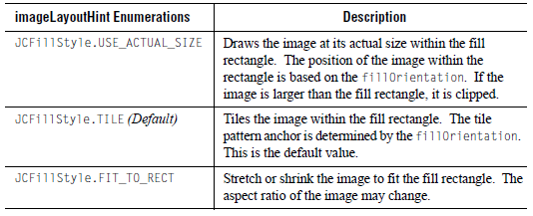

9.4.4 fillOrientation Property

The enumerations for the fillOrientation property specify the anchor point for the image. The results of using any given enumeration should be self-evident from the name of the enumeration. Where it is not, an explanation is provided.

The fillOrientation enumerations are as follows:
      - JCFillStyle.NONE – Default. It is the same as specifying JCFillStyle.TOP_LEFT.
      - JCFillStyle.TOP
      - JCFillStyle.BOTTOM
      - JCFillStyle.LEFT
      - JCFillStyle.RIGHT
      - JCFillStyle.CENTER
      - JCFillStyle.BOTTOM_LEFT
      - JCFillStyle.TOP_LEFT – Corresponds to coordinate (0,0).
      - JCFillStyle.BOTTOM_RIGHT
      - JCFillStyle.TOP_RIGHT
      - JCFillStyle.ABSOLUTE – See Specifying a Custom Anchor Point.

9.4.5 Specifying a Custom Anchor Point

The fillOrientation property’s JCFillStyle.ABSOLUTE enumeration enables you to specify a custom anchor point. To anchor the image at a custom location, set the fillOrientation to JCFillStyle.ABSOLUTE and then set the JCFillStyle object’s imagePosition property to a Point object.

For example, the following code sample specifies that the JCFillStyle object, fs (created in Section 9.4.1, Creating a Fill with an Image) be anchored 10 pixels from the top of the fill rectangle and 10 pixels from the left.

// Anchor the image 10 pixels from the top and 10 pixels from the left
fs.setFillOrientation(JCFillStyle.ABSOLUTE);
fs.setImagePosition(new Point(10,10));

9.4.6 Images and XML

If you want to save information about images to XML, you need to set the JCFillStyle object’s outputProperties property. For more information, see Saving Image Information to XML, in Chapter 15.

9.5 Specifying a Gradient Fill
You can create a gradient fill using the JCFillStyle constructor designed for gradients or using the general constructor.

This section covers the following topics:
- Using the JCFillStyle Constructor for Gradients
- Using the General JCFillStyle Constructor
- gradientStyle Parameter
- Setting the Ribbon Width

Note: If a circular or elliptical arc or circle is filled, the bounding rectangle that defines the arc or circle is the region that defines where a gradient is drawn in the arc.

9.5.1 Using the JCFillStyle Constructor for Gradients

The JCFillStyle constructor for gradient fills takes two Color objects and a gradientStyle enumeration. Behind the scenes, the JCFillStyle object’s pattern parameter is automatically set to JCFillStyle.GRADIENT_PAINT.

The first Color is the foreground color. This is the same as setting the color property of the JCFillStyle object. If this color is null, the drawing behavior is undefined as the fill style will use whatever color the current graphics object has set on it.

The second Color is the background color and is equivalent to setting the background property of the JCFillStyle object. If the second color is null, a solid color is drawn using the foreground color.

The last parameter is the gradientStyle. For a list of styles, see Section 9.5.3, gradientStyle Parameter.

For example:

// Specify a gradient fill
JCFillStyle fs = new JCFillStyle(Color.red, Color.black,
JCFillStyle.GRADIENT_DIAGONAL_DOWN_RIBBON);

// Set the fillStyle on Series1 (defined elsewhere)
Series1.setFillStyle(fs);

9.5.2 Using the General JCFillStyle Constructor

When using the general constructor, you explicitly set the JCFillStyle object’s pattern parameter to JCFillStyle.GRADIENT_PAINT. You then follow up by setting the JCFillStyle object’s gradientStyle property. For a list of styles, see Section 9.5.3, gradientStyle Parameter.

For example:
// Specify a gradient fill
JCFillStyle fs = new JCFillStyle(Color.red, JCFillStyle.GRADIENT_PAINT);

fs.setGradientStyle(Color.red, Color.black,
JCFillStyle.GRADIENT_DIAGONAL_DOWN_RIBBON);

// Set the fillStyle on Series2 (defined elsewhere)
Series2.setFillStyle(fs);

Figure 118 Pie chart that uses a gradient paint for Series2

9.5.3gradientStyle Parameter

The following table lists the gradientStyle enumerations and shows you a sample result:
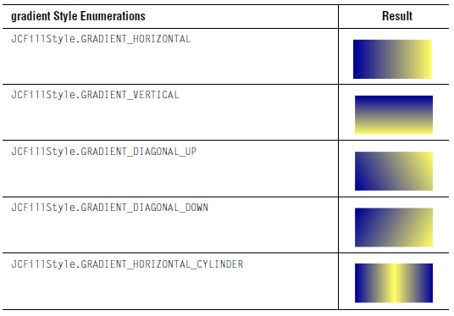
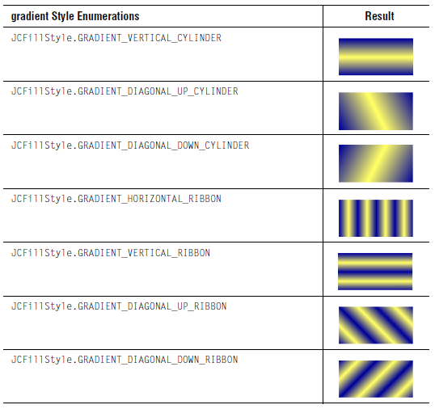

9.5.4 Setting the Ribbon Width

When a gradientStyle enumeration is used that includes the word RIBBON, the gradient has the appearance of a ribbon and the default width of that ribbon is 10 pixels. You can configure the ribbon width by setting the ribbonSize property to an int value.

For example:

// Set the ribbon width to 20 pixels
fs.setRibbonSize(20);

9.6 Specifying a Custom Paint
You can design your own fill pattern. Create a JCFillStyle object and specify the JCFillStyle.CUSTOM_PAINT enumeration. Create a Paint object or TexturePaint object and set it on your JCFillStyle object using the customPaint property. Then set the JCFillStyle object on the component using the component’s fillStyle property.

If a Paint object is specified, it is used to fill the fill rectangle. If the custom fill is a TexturePaint object, the image is extracted and a new TexturePaint object that follows the JCFillStyle object’s imageLayoutHint, fillOrientation, and imagePosition properties is used.

9.7 Filling a Plot Area
To fill a plot area with a JCFillStyle, specify a threshold that fills the PlotArea and set a JCFillStyle on the threshold. Make sure that the threshold is the first threshold drawn.

9.8 Creating Stacked Images in a Bar Chart
Using the underlying data model, it is possible to stack images. This can be accomplished by using a JCFillStyle object with the pattern set to JCFillStyle.STACKED_IMAGE.

The following code fragment shows how to use the JCFillStyle.STACKED_IMAGE pattern. It iterates through the chart's data series setting the image and pattern property on the fill style of the series.

String imageStrings[] = {"cd.gif", "tape.gif"};
List seriesList = arr.getSeries();
Iterator iter = seriesList.iterator();
for (int i = 0; iter.hasNext(); i++) {
ChartDataViewSeries thisSeries = (ChartDataViewSeries) iter.next();
if (i < seriesLabels.length) {
if (imageStrings[i] != null) {
Class cl = getClass();
URL url = cl.getResource("/examples/chart/intro/"+
imageStrings[i]);
if (url != null) {
ImageIcon icon = new ImageIcon(url);
thisSeries.getStyle().getFillStyle().
setImage(icon.getImage());
thisSeries.getStyle().getFillStyle().
setPattern(JCFillStyle.STACKED_IMAGE);
}
}
}
}

Figure 119 Demonstration of image bars.

Note that the image is clipped at the point of the highest value indicated for the bar chart.

The image is tiled along a single axis. For example, if the bars were widened in the above illustration, it would still tile along the vertical y-axis only, and would not fill in the image across the horizontal x-axis. This same principle applies (though along different axes) when the bar chart is rotated 90 degrees.

The imageLayoutHint, fillOrientation, and imagePosition properties are ignored.

10
Defining Image Maps
How Image Maps Work with JClass ServerChart ■ ImageMapRules Class – Defining the Image Map Shape
Specifying the Image Map Tags ■ Generating the Image Map Tags

Image maps allow you to specify regions of an image and assign each to a URL. When a region is activated by the user, the URL is loaded. JClass ServerChart lets you generate client-side image map tags for charts that your servlets generate.

Note: This section describes how to add image maps to a chart using the underlying data model. If you are using the targeted data model, you can add image maps to broadly defined areas on the chart (chart-level image maps) or to areas represented by data drawn on the chart component (data-level image maps). For more information, see Adding Image Maps, in Chapter 5.

10.1 How Image Maps Work with JClass ServerChart
Image maps can be added either programatically or automatically. If you are adding them programatically (using the underlying data model), you need to complete the following steps:

- Create a chart (see Chapter 1, Learning JClass ServerChart Basics).
- Add data (see Chapter 4, Adding Data with the Underlying Data Model).
- Customize the chart, if desired.
- Force the chart to draw, either to an Image object or encoded to an output stream1.
- Call the appropriate methods to create the image map tags:
- specify the type of shapes for the image map (use the ImageMapRules class).
- specify the URL and extra tag information to be associated with each generated shape. This image map information is stored in the chart.
- generate a list of image map tags and write them out to the output stream or writer representing the HTML file (use the writeHTMLImageMap() method).

10.2 ImageMapRules Class – Defining the Image Map Shape
The ImageMapRules class specifies what sort of image map you want by specifying the rules used for generating image map shapes. The ImageMapRules class has two main properties – mapType and mapMethod – along with a minor property, plotRadius.

For default behavior, merely create a default instance, as in this example: ImageMapRules mapRules = new ImageMapRules();

mapType specifies the logical grouping of data drawn on a chart that will be turned into an image map shape (for example, clusters of bars, single plot points, or a polygon representing an entire series). mapMethod specifies the technique used to arrive at the final shape. (Currently, mapMethod is only used by area, stacking area, and area radar charts.) plotRadius is used to specify the radius of the image map shape that is generated around a data point of certain chart types.

Shape of the Image Map
The shape of the image map generated depends on the following:
- map type
- chart type
- map method
- data referenced

Default behavior (no settings) is to generate image maps for each data point on the chart.
If data is referenced by the ImageMapRules class, shapes are generated only for those data elements specified. For example, if a data view is specified, shapes are only generated for the data in that data view.

Not all combinations of data elements are valid with all chart types and map types. Please see the table in Section 10.2.2, Chart Type, to see the viable combinations.

10.2.1 Map Type – Property of the ImageMapRules Class

There are three map types in JClass ServerChart: point (default), cluster, and series. Each map type can be used with at least one of the chart types.

Point Map Type

A point map type specifies that image map shapes are generated for each shape associated with a data point on the chart. The map shape can be restricted to a data view, a data view series, a point within a series, or a point within all series.

A point map type can be used with all chart types. Each chart type interprets a data point as a differently shaped area. For example, the shape generated is a circle around a plot point for plot, scatter plot, polar, and radar charts, the rectangle bounding the bar in bar charts, a section of an area chart, or a slice of a pie chart. For timeline charts, rectangular shapes are generated for status intervals and circular shapes are generated for instant events.

Cluster Map Type
A cluster map type specifies that image map shapes are generated for the shape bounding clusters of points at each data point. When using this map type, shapes can be restricted to a data view or point within all series. Series restriction has no effect.

A cluster map type can be used only for bar, stacking bar, and pie charts. For bar charts, a cluster map type specifies the shape bounding a cluster of bars at a point (see graphic to the left), for stacking bar charts, an entire bar of stacked segments, and for pie charts, an entire pie.

Series Map Type
A series map type specifies that image map shapes are generated for the shape bounding an entire series of points, that is, for the area bounded by a data view series (see graphic to the left). This map type can restrict the map shape to data view or specific series. Point restriction has no effect.

A series map type is used only for area, stacking area, area radar, and timeline charts. As an example, a series map type will specify the entire polygon generated by a single series for area, stacking area, and area radar charts. In timeline charts, the same mapping is specified for each of the rectangular status intervals and each instant event within a track (data series).

Note: Map type is not used when generating legend image maps.

10.2.2 Chart Type

The following table summarizes support for each of the map types by chart type.

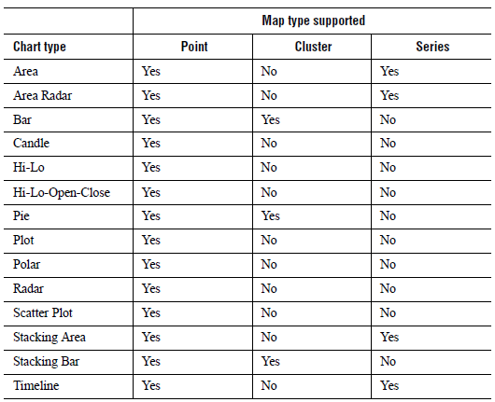

The following sections show the image map shapes that are generated for each of the map types. The shapes may be different across chart types.

10.2.2.1 Plot, Scatter Plot, Polar, and Radar

The point map type is the only type supported for plot, scatter plot, polar, and radar charts. The generated shape is a circle. The circle’s radius is determined by the plotRadius property centered at the data point. For more information, see Section 10.2.4, Plot Radius – Property of the ImageMapRules Class.
Figure 120 Plot and scatter plot charts displaying image map regions for the point map type.

Figure 121 Polar and radar charts displaying image map regions for the point map type.

10.2.2.2 Bar and Stacking Bar

The point and cluster map types are supported for bar and stacking bar charts. For the point map type, the generated shape is a rectangle that bounds either an entire bar or a segment of a stacked bar at a data point.

Figure 122 Bar and stacked bar charts displaying image map regions for the point map type.

For the cluster map type, the generated shape is a rectangle that bounds either a cluster of bars or an entire stacked bar at a data point.

Figure 123Bar and stacked bar charts displaying image map regions for the cluster map type.

10.2.2.3 Pie

The point and cluster map types are supported for pie charts. For the point map type, the generated shape is a polygon extending the pie slice represented by the data point to the rectangle bounding the pie. For the cluster map type, the generated shape is the rectangle bounding a pie represented by the data point.

Figure 124 Pie charts displaying the image map regions for the point (left) and cluster (right) map types.

10.2.2.4 Area, Stacking Area, and Area Radar

The point and series map types are supported for area, stacking area, and area radar charts.For the point map type, the generated shape depends on the map method. Two map methods are available: AREA_FORWARD and AREA_CENTER. For more information, see Section 10.2.3, Map Method – Property of the ImageMapRules class.

For the AREA_FORWARD map method (the default), the generated polygon is the slice of the area chart polygon from the specified data point to the next data point, as shown in the following charts.

Figure 125 Area, stacking area, and area radar charts showing image map regions for the point map type using the AREA_FORWARD map method.

For the AREA_CENTER map method, the generated polygon is the slice of the area chart polygon running half-way from the previous data point to half-way to the next data point.

Figure 126Area, stacking area, and area radar charts showing image map regions for the point map type using the AREA_CENTER map method.

For the series map type, the generated shape is the polygon that represents a data series.

Figure 127Area, stacking area, and area radar charts showing image map regions for the cluster map type.

10.2.2.5 Timeline

The point and series map types are supported for timeline charts. For both map types, a rectangular shape is generated for each status interval and a circular shape for each instant event. However, for the series map type, all shapes for a given series are mapped to the same series ImageMapInfo object.

Figure 128 Timeline chart showing image map regions for either the point or series map type.

Note: If tracks are subsequently merged, this may mean that not all status intervals on a given track map to the sample ImageMapInfo object.

10.2.2.6 Hi-Lo, Hi-Lo-Open-Close, and Candle

Only the point map type is supported for the financial chart types. The generated shape is a rectangle bounding the set of data points that make up a data element. The rectangle extends outwards on all four sides by the value of the plotRadius property. For more information, see Section 10.2.4, Plot Radius – Property of the ImageMapRules Class.
Figure 129 Hi-lo, hi-lo-open-close, and candle charts displaying image map regions for the point map type

10.2.3 Map Method – Property of the ImageMapRules class

The map method specifies the method used to generate the shapes (point, cluster, or series) of data as set up in the map type.

For all chart types except area, stacking area, and area radar charts, there is only one map method (default). For area charts, you can choose from either AREA_CENTER or AREA_FORWARD (this is the default for area charts). A map method of AREA_CENTER will use the shape that runs halfway from the previous point to halfway to the next point. A map method of AREA_FORWARD will use the shape that runs from this point to the next point.

Figure 130 AREA_CENTER map method applied to area charts (left) and area radar charts (right)

10.2.4 Plot Radius – Property of the ImageMapRules Class

The plotRadius specifies the radius of the image map shape that is generated around a data point. For plot charts (plot, scatter plot, polar, radar, and timeline), the shape is a circle of radius plotRadius centered at the data point. For financial charts (Hi-Lo, Hi-Lo-Open-Close, and candle), the shape is a rectangle extending out plotRadius pixels from the rectangle surrounding the drawn financial shape (the candle, the Hi-Lo line, and so forth).

The plotRadius property can be any positive integer value.

Getting and Setting the Plot Radius
You can use the getPlotRadius() method to get the plotRadius. This property is used when constructing image maps for plot, scatter plot, Hi-Lo, Hi-Lo-Open-Close, candle, polar, and radar charts to increase the generated shape in all directions by this amount. To set this property, use the setPlotRadius() method.

10.2.5 Methods of the ImageMapRules Class

Because restrictions can be easily placed to generate image maps for specific data views, series, and more, the user is able to specify just the area of interest. If no area is specified, the default will include all data in the chart.

- The setDataView() method restricts image map to shapes encompassed by this data view
- The setSeriesIndex() method restricts image map to shapes encompassed by the series to which the index refers.
- The setPoint() method restricts image map to shapes encompassed by this point

setDataView() method setSeriesIndex() method setPoint() method

These three methods can be combined (to restrict to a certain point within a certain series within a certain data view) or separately (to restrict to a certain point across all series and data views). For instance, if you were interested in just a particular Bar chart, you would use the setDataView() method to select it. If you were interested in only one series, you would use the setSeriesIndex() method to select it. If you were interested in only one point, you would use the setPoint() method to select it.

10.3 Specifying the Image Map Tags
We have seen how the ImageMapRules class specifies the rules used for generating image map shapes. The next step in defining an image map is to connect these shapes to image map tags, using the following procedure:

1.Store the tag information in the appropriate place in the chart.
2.Encode the chart to an image (see Chapter 12, Encoding a Chart).
3.Call JCServerChart's writeHtmlImageMap() method to generate the tags.

10.3.1 Storing Tag Information in the Chart

Storing the tag information in the chart can be done in one of three ways:
- Create data that includes the image map tags, then pass it to the chart.
- Load image map tags from a JClass ServerChart XML file.
- Use accessor methods to directly set the information on the chart.

For each pertinent data point for which a shape is to be generated an ImageMapInfo object is created.

The ImageMapInfo class has two properties:
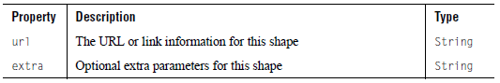

These ImageMapInfo objects are then stored in the chart and used to generate the appropriate tags for each shape in the image map.

Using the underlying data model, the simplest way to load the tag information into the chart is to create a DataSource object that implements the ImageMapChartDataModel interface. This can be accomplished with the help of one of the DataSource classes that implement the interface, or it can be manually implemented. For more information on data sources, see Chapter 4, Adding Data with the Underlying Data Model.

The following example uses the JCDefaultDataSource to specify tag information for the a chart with a single data view of two series, where each series contains three points. This array contains URL strings and extra parameters for points, clusters, series, and the legend. The point, cluster, and series specification are used for image maps of the corresponding map type, while the legend image map information can be used for any map type.

Note: Entries with a null value do not generate image map tags.

// Array image map information for points, a double dimensioned array.
// Outer dimension is number of series.
// Inner dimension is number of points per series.
// The same url is used for each point in a specific series.
public ImageMapInfo[][] pointImageMapInfo =
{
{
New ImageMapInfo("http://www.quest.com/software/jclass/",
"alt=\"JClass\" title=\"JClass\""),
new ImageMapInfo("http://www.quest.com/software/jclass/",
"alt=\"JClass\" title=\"JClass\""),
new ImageMapInfo("http://www.quest.com/software/jclass/",
"alt=\"JClass\" title=\"JClass\"")
},
{
new ImageMapInfo("http://www.quest.com/software/jprobe/",
"alt=\"JProbe\" title=\"JProbe\""),
new ImageMapInfo("http://www.quest.com/software/jprobe/",
"alt=\"JProbe\" title=\"JProbe\""),
new ImageMapInfo("http://www.quest.com/software/jprobe/",
"alt=\"JProbe\" title=\"JProbe\"")
}
};
// Cluster image map information. One per point.
public ImageMapInfo[] clusterImageMapInfo =
{
new ImageMapInfo("sales.gif",
"alt=\"Sales\" title=\"Sales\""),
new ImageMapInfo("expenditures.gif",
"alt=\"Expenditures\" title=\"Expenditures\"")
new ImageMapInfo("profit.gif",
"alt=\"Profit\" title=\"Profit\"")
};
// Series image map information. One per series.
public ImageMapInfo[] seriesImageMapInfo =
{
new ImageMapInfo("http://www.quest.com/software/jclass/",
"alt=\"JClass\" title=\"JClass\""),
new ImageMapInfo("http://www.quest.com/software/jprobe/",
"alt=\"JProbe\" title=\"JProbe\"")
};

// Legend image map information. One per series.
public ImageMapInfo[] legendImageMapInfo =
{
new ImageMapInfo("http://www.quest.com/software/jclass/",
"alt=\"JClass\" title=\"JClass\""),
new ImageMapInfo("http://www.quest.com/software/jprobe/",
"alt=\"JProbe\" title=\"JProbe\"")
};
...

// Create the datasource and set it on the chart
ChartDataView dataView = schart.getDataView(0);
dataView.setDataSource(
new JCDefaultDataSource(xvals, yvals, pointLabels, seriesLabels,
legendTitle, pointImageMapInfo,
clusterImageMapInfo, seriesImageMapInfo,
legendImageMapInfo));

If there were more dataViews, image map information could be defined for each one in a similar fashion.

The image map information can be set on JCDefaultDataSource after creation. Because JCDefaultDataSource implements the ChartDataManager interface, all changes automatically update the chart.

Image map information for points, clusters, series, and legend are not all normally provided for a given image map. Often only one of pointImageMapInfo, clusterImageMapInfo, and seriesImageMapInfo is specified, and null is passed to the constructor for the others.

The following represents the image map tags for the point image map information in the previous example:

<area shape="..." coords="..." href="http://www.quest.com/software/jclass"
alt="JClass" title="JClass">
<area shape="..." coords="..." href="http://www.quest.com/software/jclass"
alt="JClass" title="JClass">
<area shape="..." coords="..." href="http://www.quest.com/software/jclass"
alt="JClass" title="JClass">
<area shape="..." coords="..." href="http://www.quest.com/software/jprobe"
alt="JProbe" title="JProbe">
<area shape="..." coords="..." href="http://www.quest.com/software/jprobe"
alt="JProbe" title="JProbe">
<area shape="..." coords="..." href="http://www.quest.com/software/jprobe"
alt="JProbe" title="JProbe">

10.3.2 Restricting the Image Map

It is possible to restrict an image map to a given dataView, series, or point by setting the appropriate property on the ImageMapRules class. For example, to restrict the image map to the third point of the second series of the first dataView, use the following code:

ImageMapRules rules = new ImageMapRules();
rules.setDataView(schart.getDataView(0));
rules.setSeriesIndex(1);
rules.setPoint(2);

Note: The series and point indices must be valid for the given dataView and series or an
IllegalArgumentException will be thrown.

Values that are left unspecified are handled as follows:

- If the dataView is left unspecified (or set to its default value of null), an image map are generated for all dataViews for which image map information has been specified.
- If the series index is left unspecified (or set to its default value of -1), image map tags are generated for all series in the dataView for which image map information has been specified. (To restrict to the other slice of a pie chart, set the series index to JCPieChartFormat.OTHER_SLICE.)
- If the point index is left unspecified (or set to its default value of -1), image map tags are generated for all points in each series for which image map information has been specified.

It is possible to do a partial specification. For example, to restrict the image map to the third point of each series in the first dataView in the previous example, simply exclude the following line from the above example:

rules.setSeriesIndex(1)

It is also possible to restrict an image map specification by not specifying image map information for the dataView, series, and points for which you do not wish to generate an image map tag.

10.3.3 Pie Chart Image Map Tags

Specifying tags for pie charts is done in the same way as for other chart types, except that image map tags can also be specified for the other slice shapes and the glyph in the legend.

For example, for a pie chart with three series, each of which contains two points, simply construct an array of ImageMapInfo objects, one per point, for the other slice and set it on the pie chart's format object's otherImageMapInfo property. For the legend, use the otherLegendImageMapInfo property.

// Array image map information for points. Note that each point
// represents a pie and each series represents a slice in the pie.
public ImageMapInfo[][] pointImageMapInfo =
{
{
new ImageMapInfo("http://www.quest.com/software/jclass/",
"alt=\"JClass\" title=\"JClass\""),
new ImageMapInfo("http://www.quest.com/software/jclass/",
"alt=\"JClass\" title=\"JClass\"")
},
{
new ImageMapInfo("http://www.quest.com/software/jprobe/",
"alt=\"JProbe\" title=\"JProbe\""),
new ImageMapInfo("http://www.quest.com/software/jprobe/",
"alt=\"JProbe\" title=\"JProbe\"")
}
{
new ImageMapInfo("http://www.quest.com/software/xrt/",
"alt=\"XRT\" title=\"XRT\""),
new ImageMapInfo("http://www.quest.com/software/xrt/",
"alt=\"XRT\" title=\"XRT\"")
}
};

// Other slice image map information. One for each point.
public ImageMapInfo[] otherImageMapInfo =
{
new ImageMapInfo("http://www/quest.com/software/",
"alt=\"Other\" title=\"Other\""),
new ImageMapInfo("http://www/quest.com/software/",
"alt=\"Other\" title=\"Other\"")
};

// Other slice image map information for the legend.
public ImageMapInfo otherLegendImageMapInfo =
new ImageMapInfo("http://www/quest.com/software/",
"alt=\"Other\" title=\"Other\"");
// Legend image map information. One per series.
public ImageMapInfo[] legendImageMapInfo =
{
new ImageMapInfo("http://www.quest.com/software/jclass/",
"alt=\"JClass\" title=\"JClass\""),
new ImageMapInfo("http://www.quest.com/software/jprobe/",
"alt=\"JProbe\" title=\"JProbe\""),
new ImageMapInfo("http://www.quest.com/software/xrt/",
"alt=\"XRT\" title=\"XRT\"")
};

// Legend title image map information.
public ImageMapInfo legendTitleImageMapInfo =
new ImageMapInfo("http://www/quest.com/",
"alt=\"Quest\" title=\"Quest\"");
...

// Create the datasource and set it on the chart
ChartDataView dataView = schart.getDataView(0);
dataView.setDataSource(new JCDefaultDataSource(xvals, yvals, pointLabels,
seriesLabels,legendTitle, pointImageMapInfo, null, null,
legendImageMapInfo));

// Set the image map information for the other slice.
JCPieChartFormat pieFormat = (JCPieChartFormat)dataView.getChartFormat();
pieFormat.setOtherImageMapInfo(otherImageMapInfo);
pieFormat.setOtherLegendImageMapInfo(otherLegendImageMapInfo);

// Similar to the legend title (which is the dataView name), the legend
// title image map information is stored in the dataView.
dataView.setImageMapInfo(legendTitleImageMapInfo);

10.3.4 Specifying Image Map Tags for the Legend

You can set image map tag information on the legend title and on the legend labels for data series, markers, and thresholds. To set the image map tag, define an ImageMapInfo object and set the legendImageMapInfo property to point to the object.

For pie charts, you can also set an image map tag on the Other Slice legend label. Define the ImageMapInfo object and set the OtherLegendImageMapInfo property.

The previous example in Section 10.3.3, Pie Chart Image Map Tags, shows how to set the image map tags for the legend, the legend title, and the other slice in the legend. Note that the legend title image map information is stored in the dataView because the legend title is also stored there in its name property.

10.3.5 Specifying Image Map Tags for Chart Labels

You can set image map tag information on chart labels. To set the image map tag, define an ImageMapInfo object and set the chart label’s ImageMapInfo property to point to the object.

10.3.6 Point Label Image Map Tags

When image map tags are generated (see section 5.4) they are also generated for any point labels that may be present, regardless of image map type, if cluster image map tags are specified.

If the image map type is cluster, the cluster and point label shapes will link to the same specified URL. If the image map type is not cluster, image map tags are still generated for point labels. For example, if the map type is point and the chart type is pie, the tags for the pie slices can reference series/point specific information while the tags for the point labels can reference pie specific information.

10.3.7 Specifying Image Map Tags for Other Chart Areas

To specify image map tags for larger, less specific areas of the chart (for example, the entire plot area, the entire chart area, or the entire legend), simply set the appropriate property on the chart. For example:

// Specify image map information for the chart, header, footer, legend,
// chart area, and plot area.
schart.setImageMapInfo(new ImageMapInfo(URLString, ExtraString));
schart.setHeaderImageMapInfo(new ImageMapInfo(URLString, ExtraString));
schart.setFooterImageMapInfo(new ImageMapInfo(URLString, ExtraString));
schart.getLegend().setImageMapInfo(new ImageMapInfo(URLString,
ExtraString));
schart.getChartArea().setImageMapInfo(new ImageMapInfo(URLString,
ExtraString));
schart.getChartArea().getPlotArea(new ImageMapInfo(URLString,
ExtraString));

10.4 Generating the Image Map Tags
After setting the tags on the chart and encoding it to an image, the image map tags must be written out to the desired HTML file or output stream. To do this call JClass ServerChart's writeHTMLImageMap() method:

// Write image map tags.
schart.writeHtmlImageMap(out, mapName);

The image map is written to the Writer or OutputStream specified in the parameter out parameter. The mapName parameter’s value is used in the HTML as the name of the image map. The following is a sample output from this method:

<map NAME="myMap">
<area shape="rect" coords="692,269,735,286" href="Dog.gif" alt="Dog"
title="Dog">
<area shape="rect" coords="692,287,735,302" href="Cat.gif" alt="Cat"
title="Cat">
<area shape="poly" coords="358,517,358,315,663,333,663,517" href="Dog.gif"
alt="Dog" title="Dog">
<area shape="poly" coords="52,517,52,344,358,315,358,517" href="Dog.gif"
alt="Dog" title="Dog">
<area shape="poly" coords="358,315,358,200,663,102,663,333" href="Cat.gif"
alt="Cat" title="Cat">
<area shape="poly" coords="52,344,52,200,358,200,358,315" href="Cat.gif"
alt="Cat" title="Cat">
</map>

This method also outputs the enclosing <map> and </map> tags. It normally follows an html image specification, such as:

<img src="chart.gif" usemap="#myMap">

where chart.gif is the name of the image being referenced.

10.4.1 Prerequisites

The chart must first be laid out before image map generation will work. This is done automatically if any of the snapshot() or encodeAsXXX() methods are called. If this is not the case, call schart.doLayout() before generating any image map tags.

The size of the chart must also be set. JClass ServerChart’s writeHTMLImageMap() method calls getSize() on the chart. If either the width or height of the resulting Dimension object is zero, an IllegalArgumentException will be thrown.

10.4.2 Flash Output

For image maps with Flash (SWF) output, use the encodeAsSWFWithImageMap() method. This method creates the image map while the chart is being encoded, rather than afterwards; therefore, no separate method to write the image map is needed. Only the point map type is supported. For Flash output, the extra field in the ImageMapInfo object is ignored. For more information, see Chapter 12, Encoding a Chart.

10.4.3 SVG Output

Image maps are not supported with SVG output.

11
Learning JClass ServerChart Basics
pickItem() Method ■ Pick Focus ■ pick() Method ■ pickSeries() Method
Unpick() Method ■ Coordinate Conversion Methods

This chapter describes how the pick methods work and how coordinates are determined for data points and data series.

Note: For the pick methods to work correctly, the JCServerChart instance must first be laid out. This is automatically done whenever a chart is drawn, such as when the snapshot() method is called. Alternately, layout can be accomplished manually by calling the doLayout() method of JCServerChart.

11.1 pickItem() Method
Given a screen position in pixels, the pickItem() method returns a JCPickItem object that represents the item selected, such as a JCDataIndex, JCMarker, and so on. Sometimes the point selected by the user contains more than one chart item, for example a data point and a threshold. In this case, depending on the parameters specified for pickItem(), the method returns an object representing one of the following: the last item drawn at that point; the closest item to that point; or a list of objects representing all items within a given tolerance of that point.

For pickItem(), the first method parameter is the selected point relative to the origin of the chart component (Point).

The next parameter specifies the data view (ChartDataView) on which picking will be done. If it is null, picking is done on all data views.

The third parameter is pickFlag, which is a list (logical OR) of the types of objects that can be selected. The valid constants are listed in the following table:
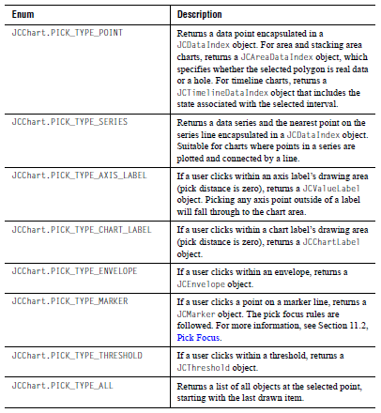

The last parameter is pickMode, which determines how elements are picked based on the list of values specified for pickFlag. The valid constants are listed in the following table:

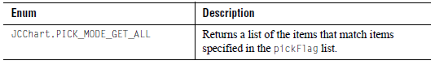
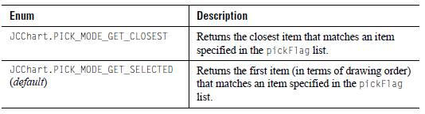

Notes:

The following list contains notes about how various situations are resolved:
- If both JCPickItem.PICK_TYPE_POINT and JCPickItem.PICK_TYPE_SERIES are specified, a pickSeries is performed.
- For legends, a JCLegendItem object is returned if the item type matches the pick flag (otherwise, the legend itself is returned). The itemInfo property of JCLegendItem is set to an object pertinent to the type of item selected. For example, if the legend item is displaying data, the itemInfo property will be set to a JCDataIndex item. If the legend item displays a marker or threshold then itemInfo field will be set to the appropriate JCMarker or JCThreshold object. The returned JCLegendItem should be considered read only.
- The ChartDataView object has a pickTolerance property. If the user selects data or a marker from the given data view in the chart area and the distance to the selected item is larger than the tolerance, the item is considered not selected and selection falls through to either the top-most threshold at that point or to the chart area itself (if there are no thresholds at that point). The default tolerance is 10 pixels.

For more information, look up JCChart (see the pickItem() method), JCPickItem, JCPickItemListener, and ChartDataView in the JClass API Documentation.

11.2 Pick Focus
The PickFocus property of ChartDataView specifies how distance is determined for pick operations. When set to PICK_FOCUS_XY (default), a pick operation uses the actual distance between the point and the drawn data. When set to values of PICK_FOCUS_X or PICK_FOCUS_Y, only the distance along the x-axis or the y-axis is used.

11.3 pick() Method
Note: This method is deprecated. Use pickItem() with the pick flag JCPickItem.PICK_TYPE_POINT.

The pick() method is used to translate a pixel coordinate on a chart to the data point that is closest to it. The method takes a Point object containing a pixel coordinate and an optional ChartDataView object to check against, and returns the resulting data point encapsulated in a JCDataIndex object.

The pick() method for polar and radar charts is implemented in two stages. The data point closest to the pick point is identified in a primary search, thus obeying the specified pick focus rule. In some cases (for example, radar charts with more than one series), there may be two or more data points that have the same x- or y-value. The primary search result may be ambiguous if the pick focus rule is PICK_FOCUS_X or PICK_FOCUS_Y. To determine which of those points is the desired one, a secondary search is carried out using the PICK_FOCUS_XY rule. For pickSeries(), PICK_FOCUS_XY is always used.

The pick behavior for area radar charts differs from that of polar or radar charts. If the user clicks on a point within a filled polygon, the search for the closest point (again, obeying the pick focus rule) is limited to the data series represented by that polygon. Pick points within a polygon have the JCDataIndex.distance variable set to 0. If the pick point is not within a filled polygon (that is, the user clicked on a point outside of the largest polygon), then the smallest distance from the pick point to the polygon is taken. As with the polar and radar chart types, primary and secondary searches are conducted to resolve ambiguities that may arise for PICK_FOCUS_X or PICK_FOCUS_Y.

11.4 pickSeries() Method
Note: This method is deprecated. Use pickItem() with the pick flag JCPickItem.PICK_TYPE_SERIES

The pickSeries() method is used to translate a pixel coordinate on a chart to the data series line that is closest to it. The method takes a Point object containing a pixel coordinate and an optional ChartDataView object to check against, and returns the resulting data series and the nearest point on the series line encapsulated in a JCDataIndex object. The pickSeries() method is suitable for plot, polar, and radar charts, that is, chart types where the points in a series are plotted and connected by a line. Calling the pickSeries() method on other chart types returns the same result as calling the pick() method.

11.5 Unpick() Method
The unpick() method essentially functions in the opposite manner of pick: given a data series and a data point within that series, the unpick() method returns the pixel co-ordinates of that point relative to the chart area. This method can be used to display information at a given point in a chart, and can be used for attaching labels to chart regions.

The unpick() method takes two sets of parameters: pt for the point index and series for the data series. For bar charts it returns the top-middle location for a given bar. For pie charts, it returns the middle of an arc. For timeline charts, the unpick() method returns a JCTimelinePoint object that contains an x- and y-coordinate plus information about the track encapsulated in a JCTrackInfo object.

For unpick() to work correctly, the JCServerChart instance must first be laid out. This is automatically done whenever a chart is drawn, such as when the snapshot() method is called. Alternately, layout can be accomplished manually by calling the doLayout() method of JCServerChart.

11.6 Coordinate Conversion Methods
The ChartDataView object in the underlying data model provides methods that enable you to do the following:
- Convert from data coordinates (x- and y-data values) to pixel coordinates (where these data coordinates appear on screen) and vice versa.
- Determine the pixel coordinates of a given data point in a series, or the closest point or series to a given set of pixel coordinates.

Note: For polar charts, the x- and y-values are interpreted as (theta, r) coordinates. The X units used will depend on the current value of angle unit. The case for radar and area radar charts is similar, except that x-values will be ignored.

The following table outlines which method or functional equivalent to use for each action.
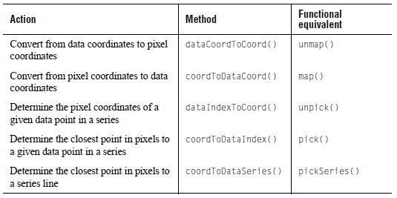

Note that for these calls to work, the chart must first be laid out with a call to doLayout().

dataCoordToCoord (unmap)

To convert from data coordinates to pixel coordinates, call the dataCoordToCoord() method. For example, the following code obtains the pixel coordinates corresponding to the data coordinates (5.1, 10.2):

Point p=c.getDataView(0).dataCoordToCoord(5.1,10.2);

This works in the same way as unmap. Note that the pixel coordinate positioning is relative to the upper left corner of the JCServerChart component display.

coordToDataCoord (map)

To convert from pixel coordinates to data coordinates, call coordToDataCoord(). For example, the following converts the pixel coordinates (225, 92) to their equivalent data coordinates:

JCDataCoord cd=c.getDataView(0).coordToDataCoord(225,92);

This works in the same manner as map. So, coordToDataCoord() returns a JCDataCoord object containing the x- and y-values in the data space.

dataIndexToCoord (unpick)

To determine the pixel coordinates of a given data point, call dataIndexToCoord(). For example, the following code obtains the pixel coordinates of the third point in the first data series:

JCDataIndex di= new JCDataIndex(3,c.getDataView(0).getSeries(0));
Point cdc=c.getDataView(0).dataIndexToCoord(di);

coordToDataIndex (pick)

To determine the closest data point to a set of pixel coordinates, call coordToDataIndex():

JCDataIndex di=c.getDataView(0).coordToDataIndex(225,92,
ChartDataView.PICK_FOCUSXY);

The last argument specifies how the nearest series and point value are determined. This argument can be one of ChartDataView.PICK_FOCUSXY, ChartDataView.PICK_FOCUSX, PICK_FOCUSY, or ChartDataView.PICK_FOCUS_LOCAL. Produces the same result as calling the pick() method. JCDataIndex contains the series and point value corresponding to the closest data point, and also returns the distance in pixels between the pixel coordinates and the point. Returns a JCDataIndex instance.

coordToDataSeries (pickSeries)

To determine the closest series line to a set of pixel coordinates, call coordToDataSeries():

JCDataIndex di=c.getDataView(0).coordToDataSeries(225,92,
ChartDataView.PICK_FOCUSXY);

The last argument specifies how the nearest series and point value are determined. This argument can be one of ChartDataView.PICK_FOCUSXY or ChartDataView.PICK_FOCUS_LOCAL. Produces the same result as calling the pickSeries() method. Returns a JCDataIndex instance.

12
Encoding a Chart
Selecting an Image Format ■ Encoding a Component
Making an Image Object from a Component

Many of the JClass ServerChart examples encode the finished chart as a Portable Network Graphic (PNG) file for display in a browser. You can choose to encode a chart to a different image format. This chapter describes your output options.

The following image formats are available:

- Portable Network Graphics (PNG)
- Joint Photographic Experts Group (JPEG)
- Graphics Interchange Format (GIF)
- Flash (SWF)
- Scalable Vector Graphic (SVG)
- PDF
- RTF

You can also choose to create a java.awt.Image instead of encoding your chart.

12.1 Selecting an Image Format
This section summarizes some key differences among the supported image formats. If you are uncertain which is the best image format for your application, you can read more about image formats by selecting the links in the following table or by searching the Internet with the keywords “image format.”

When making a decision on an image format, you should be aware that the following JClass ServerChart features may or may not be supported:
- Hyperlinks (image map) – supported for all formats except SVG
- HTML-encoded text – supported for all formats except SWF
- Dashed lines – supported for all formats except SWF
- Dwell labels – supported for SWF only
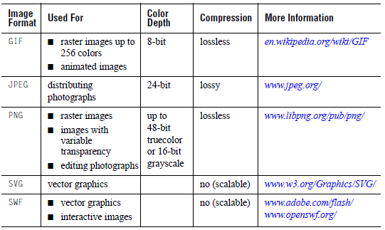

12.2 Encoding a Component
The following packages are required for encoding purposes:
- com.klg.jclass.util.swing.encode.JCEncodeComponent
- com.klg.jclass.util.swing.encode.EncoderException

If you are encoding to SVG, you also need to add a JAR to your class path. For more information, see Section 12.2.2, SVG and Your Class Path.

To encode your component, you call the component’s encodeWithExceptions() method with a JCEncodeComponent.Encoding enumeration that specifies the image format, and an instance of an OutputStream. The method creates an Image object, encodes the Image in the specified image format, and outputs the result to the specified OutputStream.

For example, the following code encodes a chart in SVG format.

// Encode a chart to an SVG format
myChart.encodeWithExceptions(JCEncodeComponent.SVG, outputstream);

12.2.1 encoding Property

The following table lists the valid enumerations for the encoding property:
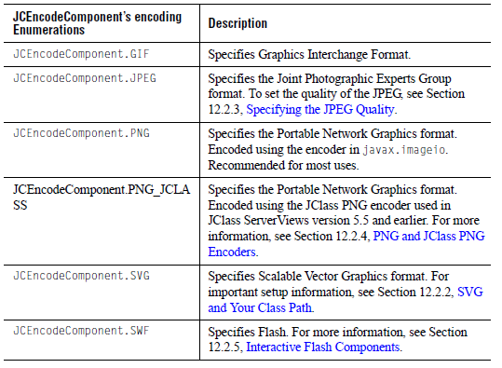

12.2.2 SVG and Your Class Path

The JClass ServerChart implementation of SVG relies on the Apache Batik project. Batik provides core components for handling and processing SVG files. Portions of the Apache Batik project are redistributed with JClass ServerChart.

Before encoding your chart to SVG, you need to do the following:
- Add the Batik JAR to your CLASSPATH (found in JCLASS_SERVER_HOME/lib/).
- Ensure you have an XML parser that is JAXP 1.1-compliant in your CLASSPATH.

Note: The Apache Batik project comes with its own license. Quest Support does not handle questions about Batik. For more information, visit http://xml.apache.org/batik/index.html

12.2.3 Specifying the JPEG Quality

The quality parameter sets the quality versus compression trade off to use when performing JPEG encoding. A value of 1 requests the best possible image quality, while a value of 0 requests the best possible compression. You can also specify any floating point value between these boundary values. The default is 1.

To specify the JPEG quality, you call the chart’s encodeAsJPEGWithException() method and pass it an OutputStream and a float value between 0.0f and 1.0f.

// Use the convenience method to encode the chart
// to a JPEG using good image quality
myChart.encodeAsJPEGWithExceptions(output, 0.9f);

12.2.4 PNG and JClass PNG Encoders

JClass ServerViews version 5.5 and earlier defined and used a custom PNG encoder. The encoder remains for backward compatibility, but has been deprecated in favor of the javax.imageio PNG encoder, which uses memory more efficiently. For larger images, the javax.imageio PNG encoder can also be faster than the JClass PNG encoder.

You should be aware that the javax.imageio PNG encoder can be slower than the JClass PNG encoder for smaller images (up to twice as slow depending on the size of the image and the JDK/platform combination). Also, on Solaris, the javax.imageio PNG encoder can be extremely slow for JDK 1.5.0_06 (and possibly others), but performs normally on JDK 1.5.0_11 and later.

If you prefer to use the JClass encoder, specify JCEncodeComponent.PNG_JCLASS instead of JCEncodeComponent.PNG.

12.2.5 Interactive Flash Components
Flash-encode charts can be interactive in two ways: hyperlinks and dwell labels.

12.2.5.1 Flash and Hyperlinks

To enable hyperlinks in a Flash-encoded chart, you need to use a convenience method called encodeAsSWFWithExceptions() method. This method takes an additional argument that is an ImageMapTagRules class; this class specifies the rules for generating image map tags. Use this method for creating image maps in Flash. For example, use this method to associate data points in the Flash-encoded chart with URLs. Please see Chapter 10, Defining Image Maps, for complete image mapping instructions.

To generate image maps, you need to specify arrays of URLs in the ImageMapTagRules class that are then mapped to the shapes represented by each data point. When you are using this ImageMapTagRules class for Flash output with image maps, it is the second list of Strings, known in ImageMapTagRules as the “extra” Strings, that identifies the browser window to which Flash should direct the URL’s contents.

In other words, for Flash encoding, the array of “extra” information in the ImageMapTagRules class is mapped to the name of the browser window. A null or empty String value indicates the current browser window.

12.2.5.2 Dwell Labels

Any dwell labels that you add to a JClass ServerChart instance are automatically encoded as part of the Flash file. For more information, see Interactive Labels for Flash Output, in Chapter 7.

12.3 Making an Image Object from a Component
To turn a JClass ServerChart component into a java.awt.Image object without encoding it, call the component’s snapshot() method.

If a specific type of image is required, the snapshot(int imagetype) method can be called. The imagetype parameter is any of the image types specified in the java.awt.image.BufferedImage class. The resulting image will be a BufferedImage object of that type.

For example, to save memory and draw JClass ServerChart into a 256 color image instead of one using the default 24-bit color map, call:

Image jclassImage = snapshot(BufferedImage.TYPE_BYTE_INDEX);

If you have a pre-existing image that you want the instance to be drawn on top of, then call snapshot(Image img) and pass in the desired image in the img parameter – the component draws itself on top of that image and a new combined Image is saved.

To encode the resulting Image to an OutputStream, you can call the chart’s encodeImageWithExceptions() method and specify the encoding, Image object, and OutputStream.

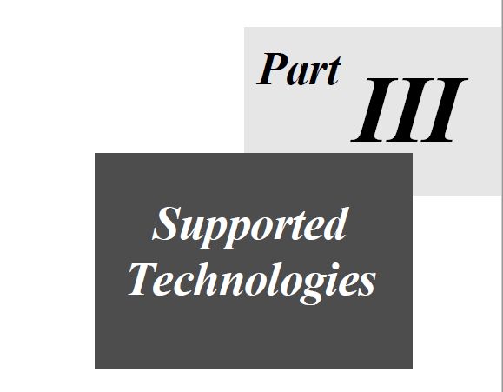

13
Using JCServerChartFactory
Overview of the JCServerChartFactory Class ■ Overview of the LoadServerProperties Class
Saving Data: The OutputDataProperties Class ■ Saving Image Informaion: The OutputDataProperties Class

You can use the JCServerChartFactory class to create and update charts using properties defined in a markup language, as well as save chart properties to a markup language. Currently, JClass ServerChart supports the following markup languages: HTML and XML.

This chapter describes the JCServerChartFactory and related classes.

The following chapters tell you how to use the factory with HTML and XML:

- Chapter 14, Loading and Saving Charts Using HTML
- Chapter 15, Loading and Saving Charts Using XML

13.1 Overview of the JCServerChartFactory Class
The JCServerChartFactory class is a convenience class that provides methods to create, update, and save a chart using a variety of data formats. You can define the chart properties in HTML or XML; the JCServerChartFactory methods have a type parameter where you specify JCServerChartFactory.HTML or JCServerChartFactory.XML, as appropriate.

For example, the following code snippet (taken from the example in Chapter 14, Loading and Saving Charts Using HTML) creates a chart from properties contained in a file (inFile). The last parameter in the method tells the factory that the properties are defined in HTML tags.

chart = JCServerChartFactory.makeServerChartFromFile(inFile, loadProps,
chartName, JCServerChartFactory.HTML);

Similarly, for XML (taken from Chapter 15, Loading and Saving Charts Using XML):

chart = JCServerChartFactory.makeServerChartFromFile(inFile, loadProps,
chartName, JCServerChartFactory.XML);

The loadProps parameter is an instance of LoadServerProperties. For more information, see Section 13.2, Overview of the LoadServerProperties Class.
The following table summarizes the methods in JCServerChartFactory for creating, updating, and saving charts. The format-specific make and update methods, with the exception of updateServerChartWithData(), call updateServerChart() under the hood. These methods are provided for convenience. Similarly, the save methods call saveServerChart(). For a list of the method parameters, look up the JCServerChartFactory class in the API Documentation.

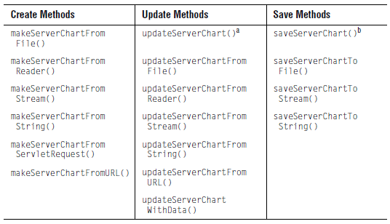
  - You can use this method instead of one of the convenience methods. The input source can be a String (interpreted as a file name), URL, InputStream, or Reader.
  - You can use this method instead of one of the convenience methods. The output target can be a String (interpreted as a file name), OutputStream, or Writer.

13.2 Overview of the LoadServerProperties Class
The LoadServerProperties class is responsible for the following tasks:
      - Telling the chart how to access data files and image files based on their fileAccess properties defined in the HTML or XML source. For more information, see Section 13.2.1, LoadServerProperties Class and the fileAccess Property.
      - Passing user-defined objects to an external Java class when <external-java-code> elements are defined in the XML source. For more information, see external-java-code in Appendix B, XML DTD.
      - Identifying what to do when there is an error in reading external data or an image from its source. Normally, the chart throws a JCIOException when this happens. However, you can ignore these exceptions and continue loading the chart by setting the ignoreExternalResourceExceptions property to true.

The JCServerChartFactory class automatically creates a default LoadServerProperties object if you do not define one. In many cases, the default object is sufficient. However, there are times when you will need to define a LoadServerProperties object. For more information, see Section 13.2.2, When to Define a LoadServerProperties Object.

13.2.1 LoadServerProperties Class and the fileAccess Property

When you define a data file or an image file in HTML or XML, you specify a fileName property and a fileAccess property. The fileAccess property is used by the LoadServerProperties object to determine how to access the data file or image file named in the fileName property.

The following table summarizes the valid values for the fileAccess property and describes how the LoadServerProperties object interprets the fileName property.

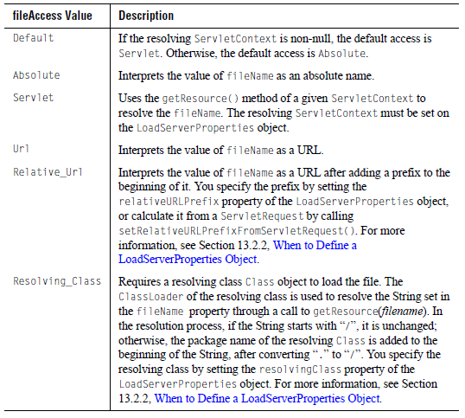
The same values are used by the chart when saving to HTML or XML so that, if the chart is reloaded, the chart knows how to access the data and images.

13.2.2 When to Define a LoadServerProperties Object

In simple cases, you can use the default LoadProperties object created by the factory or you can use the no-arguments LoadServerProperties constructor to create a LoadServerProperties object that uses null values for all its properties. In some cases, however, you need to specify some LoadServerProperties properties.

In the following circumstances, you need to set the specified LoadProperties property:

- When you define a data file or image file with fileAccess=Resolving_Class, you need to set the resolvingClass property of the LoadServerProperties object to specify the Class object that is used to resolve the location of file.
- When you define a data file or image file with fileAccess=Relative_Url, you need to set the relativeURLPrefix property of the LoadServerProperties object to specify the String to prepend to the URL. (Recall that in this case the fileName attribute of the <image-file> is interpreted as a URL.)
- When you specify an <external-java-code> tag in XML, you need to set the userObject property to specify the Object and the storeUserObject property to determine if the Object is stored to the userObject property of the chart.

The following example shows a LoadServerProperties constructor with some properties set.

Class myResolvingClass = new Class(...);
Object myObject = new Object(...);

// Create a LoadServerProperties object and set properties
LoadServerProperties loadProps = new LoadServerProperties(
myResolvingClass, // resolvingClass
"", // relativeURLPrefix (default is empty String)
myObject, // userObject
true); // storeUserObject

Alternatively, you can set these properties using the LoadProperties object’s set*() methods. For more information, look up com.klg.jclass.util.io.LoadServerProperties in the API documentation.

13.3 Saving Data: The OutputDataProperties Class
The OutputDataProperties class is responsible for controlling whether or not the chart data is saved when the chart properties are saved, and if it is, whether the data is embedded in the chart properties file or saved to a separate file. It also specifies how the data should be read in when the HTML or XML chart properties are loaded into a chart.

The following code creates a sample OutputDataProperties object.

// Create an instance of OutputProperties
OutputProperties dataOutputProps = new OutputProperties(
"chartdataout.xml", // outputFileName
"http://www.mysite.com/chartdataout.xml", // propertyName
OutputDataProperties.DATA_FILE_XML, // saveType
Properties.URL); // fileAccess

The saveType determines whether or not data is saved, and if so, how it is saved. The
following table summarizes the valid values for the saveType property:

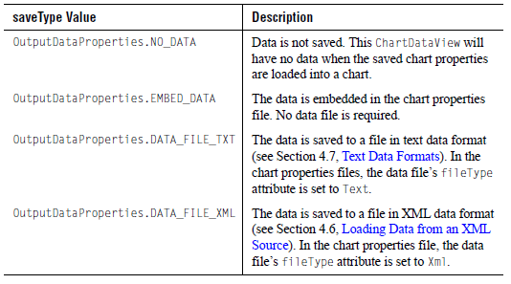
The outputFileName is an absolute file name. If the saveType is either DATA_FILE_TXT or DATA_FILE_XML, the data is saved to the specified file name.

The propertyName property specifies the data file using a text string. The text is saved to the chart properties file and used to later reload the data. The propertyName and fileAccess parameters correspond to the data file’s fileName and fileAccess properties in the saved chart properties file. Recall that the LoadServerProperties object uses the fileAccess property to interpret the fileName attribute. For more information, see Section 13.2.1, LoadServerProperties Class and the fileAccess Property.

For more information, see Saving a Chart to HTML, in Chapter 14 and Saving a Chart to XML, in Chapter 15. See also com.klg.jclass.util.io.OutputDataProperties in the API Documentation.

13.4 Saving Image Information: The OutputProperties Class
Images are not saved when a chart is saved to HTML or XML. You can, however, choose to save information about the images so that if you reload the chart the images can be located and displayed. Image information includes the file name and how to access it.

Every image in your chart whose information you want to save requires an OutputProperties object.

13.4.1 Constructing an OutputProperties Object

The following code creates an OutputProperties object for use with an image in a JCFillStyle object associated with the chart.

// Create an instance of OutputProperties
OutputProperties imageOutputProps = new OutputProperties(
null, // outputFileName (not used here)
"images/bgimage.jpg", // propertyName
null, // saveType (not used here)
OutputProperties.RELATIVE_URL); // fileAccess

The propertyName property specifies the file name and location of the image. The fileAccess property specifies how to interpret the propertyName.
- In HTML, propertyName is stored as data.seriesn.fill.image.fileName and fileAccess is stored as data.seriesn.fill.image.fileAccess.
- In XML, propertyName is stored in the <image-file> fileName attribute and fileAccess is stored in the <image-file> fileAccess attribute.

For more information, see Saving Image Information to HTML, in Chapter 14 and Saving Image Information to XML, in Chapter 15.

The outputFileName and saveType properties are null, because this class has other uses and these properties are not required for images. For more information, look up the com.klg.jclass.util.io.OutputProperties class in the API Documentation.

13.4.2 Setting Output Properties on an Image

Images are specified in fill styles. To prepare to save information about an image to a markup language, you need to set the OutputProperties property of the fill style and specify its OutputProperties object.

// Define an image
String URLString = "http://www.my_site.com/snowflakes.jpg";
URL url = new URL(URLString);

// Load the image (where loadImageFromURL is some method
// that creates an image from a URL)
Image inputImage = loadImageFromURL(url);

// Set the image in the fill style
ChartDataView dv = chart.getDavaView(0);
JCChartStyle cs = dv.getChartStyle(0);
JCFillStyle fs = cs.getFillStyle();
fs.setImage(inputImage);

// Set the output properties for the image
OutputProperties imageOutputProps = new OutputProperties(
null, URLString, null, OutputProperties.URL);

fs.setOutputProperties(imageOutputProps);

14
Loading and Saving Charts Using HTML
Overview of HTML for JClass ServerChart ■ Creating a Chart from HTML
Updating a Chart Using HTML ■ Saving a Chart to HTML

This chapter describes how to create, update, and save a chart using HTML tags to define the chart properties. For more information on the syntax for chart properties, see Appendix A, HTML Syntax.

14.1 Overview of HTML for JClass ServerChart
JClass ServerChart defines HTML syntax for most chart properties and ships with some HTML examples.

HTML Syntax for Chart Properties

Most, though not all, chart properties can be specified in HTML. To specify chart properties in HTML, you provide name/value pairs using the syntax and value types outlined in Appendix A, HTML Syntax.

For example, you can specify the chart type using the name data.chartType and a value that represents any of the enumerations defined for chart types, such as AREA, BAR, or PIE. The format in which you provide the name/value pairs is dictated by the input medium. The JCServerChartFactory class contains methods to create a chart using properties read from a file, reader, stream, URL, or string, as well as from a servlet request or URL.

For example, when specifying properties in an HTML file, you use the <PARAM> tag. The chart property is specified in the NAME element and its value in the VALUE element. The following properties create a bar chart using data read from a file called bar.dat:

<PARAM NAME="width" VALUE="400">
<PARAM NAME="height" VALUE="400">
<PARAM NAME="dataFile" VALUE="bar.dat">
<PARAM NAME="data.chartType" VALUE="BAR">
<PARAM NAME="xaxis.annotationMethod" VALUE="Point_Labels">

The bar.dat file contains the data and the point label annotations:

# The data is in array format
# It has one set of x-axis data, multiple sets of y-axis data
# It can have names for the data view and for the x and y series
# Each x point can have a point label
ARRAY '' 5 4
'Network' 'Cache' 'Connect' 'System'
'' 0.0 90.0 180.0 270.0
'Planning' 8.2 17.3 28.4 26.2
'Finance' 35.2 36.1 23.1 38.5
'Research' 35.1 19.7 21.2 20.1
'Sales' 15.1 4.1 8.2 16.1
'Contracts' 16.5 28.1 18.2 0.9

A servlet request would look like this:

ServletName?width=400&height=400&dataFile=bar.dat&
data.chartType=BAR&xaxis.annotationMethod=POINT_LABELS

14.2 Creating a Chart from HTML
The JCServerChartFactory class has methods that create a JCServerChart instance from a file, reader, stream, URL, or String, as well as from a servlet request. The following sections demonstrate how to create a chart from an HTML file using the makeChartFromFile() method.

The examples used in this section create the chart displayed in the following figure:
Figure 131 Chart created from HTML tags

14.2.1 Specifying JClass ServerChart Properties Using HTML Tags

When specifying chart properties using HTML, you need to encode the properties within HTML <PARAM> tags. The NAME element of the <PARAM> tag specifies the property name; the VALUE element specifies the property value to set. When the file is read in, only the properties inside <PARAM> tags are used; all other HTML tags are ignored.

For example, the following line of code shows how to specify the name of the file that contains the chart data:

<PARAM NAME="chart.dataFile" VALUE="sample_1.dat">

Appendix A, HTML Syntax, contains a list of chart properties by class. Each entry states the HTML syntax for the property (NAME element) and its value type (VALUE element).

The following HTML was used to create the chart shown at the beginning of this section (Figure 131). Recall that the HTML parser processes only the <PARAM> tags and ignores the rest.

<html>
<body>
<PARAM NAME=background VALUE="211-211-211">
<PARAM NAME=foreground VALUE="black">
<PARAM NAME=height VALUE="400">
<PARAM NAME=width VALUE="720">
<PARAM NAME=font VALUE="Dialog-PLAIN-12">
<PARAM NAME=header.x VALUE="31">
<PARAM NAME=header.y VALUE="15">
<PARAM NAME=header.text VALUE="<html><center><p>Comparison of
Contribution Models<p>to final investment outcome<p>
<font face=TimesRoman size=+2>Compound Returns at
9%</font></center></html>">
<PARAM NAME=header.visible VALUE="true">
<PARAM NAME=legend.border VALUE="etched|raised">
<PARAM NAME=legend.visible VALUE="true">
<PARAM NAME=legend.anchor VALUE="Northeast">
<PARAM NAME=chartArea.depth VALUE="4">
<PARAM NAME=chartArea.elevation VALUE="8">
<PARAM NAME=chartArea.rotation VALUE="11">
<PARAM NAME=chartArea.fastAction VALUE="true">
<PARAM NAME=chartArea.plotArea.background VALUE="lightGray">
<PARAM NAME=xaxis.annotationMethod VALUE="Point_Labels">
<PARAM NAME=xaxis.placement VALUE="Min">
<PARAM NAME=xaxis.placementAxis VALUE="yaxis">
<PARAM NAME=xaxis.title.text VALUE="<html>
<font face=TimesRoman>Age</html>">
<PARAM NAME=xaxis.grid.visible VALUE="true">
<PARAM NAME=xaxis.gridColor VALUE="darkGray">
<PARAM NAME=yaxis.placement VALUE="Max">
<PARAM NAME=yaxis.grid.visible VALUE="true">
<PARAM NAME=yaxis.gridColor VALUE="darkGray">
<PARAM NAME=yaxis.isEditable VALUE="false">
<PARAM NAME=chartArea.yaxisName1 VALUE="yaxis1">
<PARAM NAME=yaxis1.placement VALUE="Min">
<PARAM NAME=yaxis1.max VALUE="40000.0">
<PARAM NAME=yaxis1.gridColor VALUE="black">
<PARAM NAME=data.chartType VALUE="AREA">
<PARAM NAME=data.line.color VALUE="black">
<PARAM NAME=data.series1.line.color VALUE="0-60-30">
<PARAM NAME=data.series1.fill.color VALUE="0-176-124">
<PARAM NAME=data.series1.symbol.shapeIndex VALUE="1">
<PARAM NAME=data.series1.symbol.shape VALUE="Dot">
<PARAM NAME=data.series1.label VALUE="<html>
<font size=-1><p>Sooner<p>Age 65: $921,217">
<PARAM NAME=data.series2.line.colorIndex VALUE="1">
<PARAM NAME=data.series2.line.color VALUE="204-204-255">
<PARAM NAME=data.series2.fill.colorIndex VALUE="1">
<PARAM NAME=data.series2.fill.color VALUE="142-142-178">
<PARAM NAME=data.series2.symbol.colorIndex VALUE="1">
<PARAM NAME=data.series2.symbol.color VALUE="orange">
<PARAM NAME=data.series2.symbol.shapeIndex VALUE="2">
<PARAM NAME=data.series2.symbol.shape VALUE="Box">
<PARAM NAME=data.series2.label VALUE="<html>
<font size=-1><p>Later<p>Age 65: $643,440">
<PARAM NAME=dataFile VALUE="investplot.dat">
<PARAM NAME=dataName1 VALUE="data1">
<PARAM NAME=data1.chartType VALUE="BAR">
<PARAM NAME=data1.outlineColor VALUE="black">
<PARAM NAME=data1.series1.line.colorIndex VALUE="2">
<PARAM NAME=data1.series1.line.color VALUE="orange">
<PARAM NAME=data1.series1.fill.colorIndex VALUE="2">
<PARAM NAME=data1.series1.fill.color VALUE="0-255-80">
<PARAM NAME=data1.series1.symbol.colorIndex VALUE="2">
<PARAM NAME=data1.series1.symbol.color VALUE="orange">
<PARAM NAME=data1.series1.symbol.shapeIndex VALUE="3">
<PARAM NAME=data1.series1.symbol.shape VALUE="Triangle">
<PARAM NAME=data1.series1.label VALUE="<html><font size=-1>
<p>$2,500 per year<p>Age 20-29">
<PARAM NAME=data1.series2.line.colorIndex VALUE="4">
<PARAM NAME=data1.series2.line.color VALUE="blue">
<PARAM NAME=data1.series2.fill.colorIndex VALUE="4">
<PARAM NAME=data1.series2.fill.color VALUE="204-204-255">
<PARAM NAME=data1.series2.symbol.colorIndex VALUE="4">
<PARAM NAME=data1.series2.symbol.color VALUE="blue">
<PARAM NAME=data1.series2.symbol.shapeIndex VALUE="4">
<PARAM NAME=data1.series2.symbol.shape VALUE="Diamond">
<PARAM NAME=data1.series2.label VALUE="<html><font size=-1>
<p>$2,500 per year<p>Age 30-65">
<PARAM NAME=data1.yaxis VALUE="yaxis1">
<PARAM NAME=data1File VALUE="investbar.dat">
<PARAM NAME=labelName1 VALUE="label1">
<PARAM NAME=label1.border VALUE="etched|raised">
<PARAM NAME=label1.background VALUE="0-176-124">
<PARAM NAME=label1.insets VALUE="0,2,1,2">
<PARAM NAME=label1.text VALUE="<html><p>
<font size=-1>$921,217</font></html>">
<PARAM NAME=label1.visible VALUE="true">
<PARAM NAME=label1.attachMethod VALUE="Attach_Dataindex">
<PARAM NAME=label1.dataIndex VALUE="attachIndex1">
<PARAM NAME=indexName1 VALUE="attachIndex1">
<PARAM NAME=attachIndex1.dataView VALUE="data">
<PARAM NAME=attachIndex1.seriesIndex VALUE="0">
<PARAM NAME=attachIndex1.point VALUE="45">
<PARAM NAME=label1.anchor VALUE="East">
<PARAM NAME=label1.offsetX VALUE="2">
<PARAM NAME=label1.dataView VALUE="data">
<PARAM NAME=labelName2 VALUE="label2">
<PARAM NAME=label2.border VALUE="etched|raised">
<PARAM NAME=label2.background VALUE="142-142-178">
<PARAM NAME=label2.insets VALUE="0,2,1,2">
<PARAM NAME=label2.text VALUE="<html><p>
<font size=-1>$643,440</font></html>">
<PARAM NAME=label2.attachMethod VALUE="Attach_Dataindex">
<PARAM NAME=label2.dataIndex VALUE="AttachIndex2">
<PARAM NAME=IndexName2 VALUE="AttachIndex2">
<PARAM NAME=AttachIndex2.dataView VALUE="data">
<PARAM NAME=AttachIndex2.seriesIndex VALUE="1">
<PARAM NAME=AttachIndex2.point VALUE="45">
<PARAM NAME=label2.anchor VALUE="East">
<PARAM NAME=label2.offsetX VALUE="2">
<PARAM NAME=label2.dataView VALUE="data">
</body>
</html>

14.2.2 Creating the Chart and Loading HTML-based Properties
This section demonstrates how to load properties from a file. The file is called chart.in.html.

LoadServerProperties loadProps = new LoadServerProperties();
loadProps.setResolvingServletContext(context);

String inFile = "chart.in.html";
String chartName = "myChart";
JCServerChart chart = null;

try {
chart = JCServerChartFactory.makeServerChartFromFile(inFile,
loadProps, chartName, JCServerChartFactory.HTML);
}
catch (JCIOException e) {
System.out.println("Error accessing external file:" +
e.getMessage());
}
catch (JCParseException e) {
System.out.println("Error parsing file:" +
e.getMessage());
}
catch (IOException e) {
System.out.println("Error reading " + inFile + ":" +
e.getMessage());
}

where
- context is the ServletContext object used to resolve filenames (see Section 13.2, Overview of the LoadServerProperties Class).
- inFile is an input file containing JClass ServerChart properties in HTML.
- loadProps is a LoadServerProperties object containing properties that specify how to load the chart (see Overview of the LoadServerProperties Class, in Chapter 13).
- chartName is the name of the chart, and is the name with which each of the properties begins. If there is more than one chart in the HTML file, only the parameters beginning with that name are assigned to the chart. If there is only one set of chart parameters stored in the file, the name can be dropped and an empty String passed as the third parameter.
- JCServerChartFactory.HTML specifies HTML as the markup language used.

14.3 Updating a Chart Using HTML
You can update an existing chart with new chart properties or with a new data set.

14.3.1 Updating a Chart with New Chart Properties

You can update existing charts with new chart properties using the update methods in the JCServerChartFactory class. The new properties can come from a file, reader, stream, URL, or a String. Properties that are unspecified retain their existing values.

For example, the following code sample updates a chart using properties defined in an HTML file:

String updateFile = "chart.update.html";
try {
JCServerChartFactory.updateServerChartFromFile(chartName,
updateFile, loadProps, name, JCServerChartFactory.HTML)
}
catch (JCIOException e) {
System.out.println("Error accessing external file:" +
e.getMessage());
}
catch (JCParseException e) {
System.out.println("Error parsing file:" + e.getMessage());
}
catch (IOException e) {
System.out.println("Error reading " + updateFile + ":" +
e.getMessage());
}
where
- chartName is the chart to update.
- updateFile is an input file containing JClass ServerChart properties in HTML.
- loadProps is a LoadServerProperties object containing properties that specify how to load the chart (see Overview of the LoadServerProperties Class, in Chapter 13).
- name of the chart being read from parameters. If non-null, only parameters of the form name.parameter are applied to this chart.
- JCServerChartFactory.HTML specifies HTML as the markup language used.
For more information, lookup JCServerChartFactory in the API Documentation and review the update methods.

14.3.2 Updating a Chart with a New Data Set

JCServerChartFactory also has a method, updateServerChartWithData(), that updates a chart with a new data set. In the given data view, the old data set is replaced by the new data set, with information provided by a file, reader, or an input stream.

Note: You need to use the underlying data model to complete this task. For more information, see Chapter 4, Adding Data with the Underlying Data Model and the ChartDataView and JCServerChartFactory classes in the API Documentation.

For example, the following code sample updates a chart with data defined in a text file:

String updateDataFile = "newchartdata.txt";
try{
JCServerChartFactory.updateServerServerChartWithData(chartName,
JCServerChartFactory.DATA_FILE_TEXT, updateDataFile,
dataViewIndex, loadProps);
}
catch (IOException e) {
System.out.println("Error reading " + updateDataFile + ":" +
e.getMessage());
}

where
- chartName is the chart to update.
- JCServerChartFactory.DATA_FILE_TEXT specifies that the data is in a text file. Alternatively, you can specify an XML data file using JCServerChartFactory.DATA_FILE_XML.
- updateDataFile is the name of the file containing the data. Alternatively, data could be coming from a Reader or an InputStream.
- dataViewIndex is the index of the ChartDataView on which the data is to be set (there is also a method where the ChartDataView can be specified by name).
- loadProps is a LoadServerProperties object containing properties that specify how to load the chart (see Overview of the LoadServerProperties Class, in Chapter 13).

This method creates a data source from the data object, and sets this new data source on the appropriate ChartDataView on the chart.

14.4 Saving a Chart to HTML
The JCServerChartFactory class also has methods that save a JCServerChart instance to a stream, file, writer, or String.

Note: You need to use the underlying data model to complete this task. For more information, see Chapter 4, Adding Data with the Underlying Data Model and the ChartDataView and JCServerChartFactory classes in the API Documentation.

The following example code saves chart properties to a file called chart.out.html and the chart data to a file called chart.dat.

String outFile = "chart.out.html";
String outDataFile = "chart.dat";
ChartDataView dv = chart.getDataView(0);

if (dv != null) {
OutputDataProperties outProps = dv.getOutputDataProperties();
if (outProps == null) {
outProps = new OutputDataProperties();
}
// Save data to a text file, which can be accessed via a URL
outProps.setOutputFileName(outDataFile);
outProps.setPropertyName("file:///C:/jclass_home/" + outDataFile);
outProps.setSaveType(OutputDataProperties.DATA_FILE_TXT);
outProps.setFileAccess(OutputDataProperties.URL);
dv.setOutputDataProperties(outProps);
}
try {
JCServerChartFactory.saveServerChartToFile(chart, outFile,
JCServerChartFactory.HTML);
}
catch (IOException e) {
System.out.println("Error writing to " + outFile + ":" +
e.getMessage());
}

14.4.1 Saving Data When a Chart is Saved to HTML

In the above example, outProps is an instance of OutputDataProperties. The OutputDataProperties instance specifies that the data is to be saved to a file named chart.dat in text format. When loading the chart, the chart can access the data via the URL file:///C:/jclass_home/.

For more information, see Saving Data: The OutputDataProperties Class, in Chapter 13.

14.4.2 Saving Image Information to HTML

When a chart containing an image is saved to HTML, the information about the image that is contained in its OutputProperties object is also saved. If an image does not have an OutputProperties object associated with it, the image is ignored.

For example, consider an image that is used as a fill style for a threshold. If the image has the following OutputProperties object associated with it:

OutputProperties imageOutputProps = new OutputProperties(
null, "threshold.jpg", null, OutputProperties.ABSOLUTE);

the information about the image is stored as:

<PARAM NAME=data.thresholdn.fill.image.fileName VALUE="threshold.jpg">
<PARAM NAME=data.thresholdn.fill.image.fileAccess VALUE="Absolute">

where data is the name of the dataset.

The image file threshold.jpg will be interpreted an absolute file name when the properties in the HTML file are loaded back into a chart.

Note that HTML elements map to the OutputProperties object as follows:

- data.thresholdn.fill.image.fileName maps to the propertyName parameter.
- data.thresholdn.fill.image.fileAccess maps to the fileAccess parameter.

For more information, see Saving Image Information: The OutputProperties Class, in Chapter 13.

15
Loading and Saving Charts Using XML
Background XML Information ■ Overview of XML for JClass ServerChart
Creating a Chart Using XML ■ Updating a Chart Using XML ■ Saving a Chart to XML
Internationalizing Your XML-based Chart

This chapter describes how to create a chart using XML tags to define chart properties. The first two sections provide some general XML information followed by an overview of how JClass ServerChart implements XML. The next three sections describe how to create, update, and save a chart. The last section deals with the topic of internationalizing XML-based charts. For more information, see Appendix B, XML DTD.

15.1 Background XML Information
XML Primer

XML – eXtensible Markup Language – is a scaled-down version of SGML (Standard Generalized Markup Language), the standard for creating a document structure. XML was designed especially for web documents, and allows designers to create customized tags (“extensible”), thereby enabling common information formats for sharing both the format and the data on the Internet, intranets, et cetera.

XML is similar to HTML in that both contain markup tags to describe the contents of a page or file. But HTML describes the content of a web page (mainly text and graphic images) only in terms of how it is to be displayed and interacted with. XML, however, describes the content in terms of what data is being described. This means that an XML file can be used in various ways. For instance, an XML file can be utilized as a convenient way to exchange data across heterogeneous systems. As another example, an XML file can be processed (for example, via XSLT [Extensible Stylesheet Language Transformations]) in order to be visually displayed to the user by transforming it into HTML.

In XML, certain special characters need to be “escaped” if you want them to be displayed. For example, you cannot simply put and ampersand (&) or a greater than sign (>) into a block of text; these special characters are represented as &amp; and &gt; respectively. See
http://java.sun.com/xml/jaxp/dist/1.1/docs/tutorial/sax/4_refs.html#chars.

DTD Primer

The document type definition (DTD) file has one purpose: to specify the structure of an XML file. The DTD describes, in XML Declaration Syntax, the particular type of document, and sets out what names are to be used for various elements, where these elements may occur, and how they work together.

Further Information About XML

Here are links to more information on XML.

http://www.w3.org/XML/ – another W3C site; contains information on standards

http://www.ucc.ie/xml – an extensive FAQ devoted to XML

http://java.sun.com/docs/index.html – Sun’s XML site

15.2 Overview of XML for JClass ServerChart
JClass ServerChart ships with the following DTDs and examples for XML.

DTDs

DTD files are located in JCLASS_SERVER_HOME/xml-dtd.
- Chart.dtd – Defines chart elements.
- JCChartData.dtd – Defines chart data elements. Requires Chart.dtd.

In JClass ServerChart, the elements, sub-elements, and attributes in the DTDs, for the most part coincide with the objects, sub-objects, and properties within the chart component. Properties are specified as Strings in the XML file. The Strings are converted to the appropriate type by the JClass ServerChart XML handler. For more information, see Appendix B, XML DTD.

15.3 Creating a Chart Using XML
The JCServerChartFactory class has methods that create a JCServerChart instance from a file, reader, stream, URL, or String, as well as from a servlet request. The following sections demonstrate how to create a chart from an XML file using the makeChartFromFile() method.
Figure 132 Chart created using XML

The XML elements for JClass ServerChart are defined in the DTD files that ship with JClass ServerViews. For your convenience, the elements and subelements are also listed in Appendix B, XML DTD. The easiest way to create a set of XML chart properties is to use the JClass ServerChart Designer to save the property values to an XML file.

The following example shows the XML elements used to define the chart in Figure 132. <?xml version="1.0"?>
<!DOCTYPE chart SYSTEM "Chart.dtd">
<chart name=""
allowUserChanges="true"
width="550"
height="420">
<component background="210-180-140"
foreground="black"
font="Dialog-PLAIN-12" />
<event-trigger trigger="Customize"
modifier="Meta" />
<event-trigger trigger="Customize"
modifier="Meta" />
<header text="Yoyodyne snaps back">
<component background="245-222-180"
opaque="true"
font="TimesRoman-BOLD-24"
visible="true">
<bevel-border soft="false"
type="Raised"
highlightColor="white"
shadowColor="119-108-87" />
</component>
</header>
<footer text="Profits have recovered but share prices remain low">
<component font="TimesRoman-PLAIN-20"
visible="true" />
<layout-hints y="55" />
</footer>
<legend anchor="South"
orientation="Horizontal">
<component background="245-222-180"
opaque="true"
foreground="black"
font="Dialog-PLAIN-14"
visible="true">
<etched-border type="Raised"
highlightColor="white"
shadowColor="171-155-125" />
</component>
<layout-hints y="345" />
</legend>
<chart-area>
<component background="245-222-180"
opaque="true"
foreground="black"
font="Dialog-PLAIN-12">
<bevel-border soft="false"
type="Lowered"
highlightColor="white"
shadowColor="119-108-87" />
</component>
<layout-hints y="90" />
<plot-area foreground="black"
background="255-232-190" />
<axis type="XAxis"
name="xaxis"
annotationMethod="Value_Labels"
placement="Min"
placementAxis="yaxis">
<chart-interior-region font="Dialog-PLAIN-12"
foreground="black"
background="245-222-180">
</chart-interior-region>
<axis-title>
<chart-interior-region font="Dialog-PLAIN-12"
foreground="black"
background="245-222-180">
</chart-interior-region>
</axis-title>
<value-label value="1.0">&apos;97</value-label>
<value-label value="2.0">&apos;98</value-label>
<value-label value="3.0">&apos;99</value-label>
<value-label value="4.0">&apos;00</value-label>
<value-label value="5.0">&apos;01</value-label>
<line-style color="210-180-140" />
</axis>
<axis type="YAxis"
name="yaxis"
placement="Min"
gridVisible="true">
<chart-interior-region font="Dialog-PLAIN-12"
foreground="black"
background="245-222-180">
</chart-interior-region>
<axis-title text="$millions">
<chart-interior-region font="TimesRoman-BOLD-12"
foreground="black"
background="245-222-180"
visible="true">
</chart-interior-region>
</axis-title>
<line-style color="210-180-140" />
</axis>
<axis type="YAxis"
name="yaxis1"
placement="Max">
<chart-interior-region font="Dialog-PLAIN-12"
foreground="black"
background="245-222-180">
</chart-interior-region>
<axis-title text="share prices ">
<chart-interior-region font="TimesRoman-BOLD-12"
foreground="black"
background="245-222-180"
visible="true">
</chart-interior-region>
</axis-title>
<line-style color="black" />
</axis>
</chart-area>
<chart-data-view chartType="Bar"
name=" ">
<chart-data name=" " hole="max">
<data-series>
<x-data>1.0</x-data>
<x-data>2.0</x-data>
<x-data>3.0</x-data>
<x-data>4.0</x-data>
<x-data>5.0</x-data>
<y-data>24.0</y-data>
<y-data>30.2</y-data>
<y-data>36.4</y-data>
<y-data>-19.8</y-data>
<y-data>10.6</y-data>
</data-series>
</chart-data>
<bar-format clusterWidth="50" />
<line-style color="black" />
<chart-data-view-series label="Profits">
<chart-style>
<line-style color="red"
width="8" />
<fill-style color="0-84-255"
pattern="Per_25" />
<symbol-style color="255-165-0"
shape="Dot"
size="7" />
</chart-style>
</chart-data-view-series>
</chart-data-view>
<chart-data-view name=" "
yaxis="yaxis1">
<chart-data name=" " hole="max">
<data-series>
<x-data>1.0</x-data>
<x-data>2.0</x-data>
<x-data>3.0</x-data>
<x-data>4.0</x-data>
<x-data>5.0</x-data>
<y-data>20.5</y-data>
<y-data>12.3</y-data>
<y-data>14.8</y-data>
<y-data>6.2</y-data>
<y-data>5.75</y-data>
</data-series>
</chart-data>
<line-style color="black" />
<chart-data-view-series label="Share Prices">
<chart-style>
<line-style color="red"
width="7" />
<fill-style color="orange" />
<symbol-style color="255-165-0"
shape="Dot"
size="14" />
</chart-style>
</chart-data-view-series>
</chart-data-view>
</chart>

15.3.2 Creating the Chart and Loading XML-based Properties

The following code sample creates a chart using properties defined in an XML file. The file is called chart.in.xml.

public CreateXMLChart()
{
LoadServerProperties loadProps = new LoadServerProperties();
loadProps.setResolvingServletContext(context);

String inFile = "chart.in.xml";
String chartName = "myChart";
JCServerChart chart = null;
try {
chart = JCServerChartFactory.makeServerChartFromFile(inFile,
loadProps,
chartName, JCServerChartFactory.XML);
}
catch (JCIOException e) {
System.out.println("Error accessing external file:" +
e.getMessage());
}
catch (JCParseException e) {
System.out.println("Error parsing file:" + e.getMessage());
}
catch (IOException e) {
System.out.println("Error reading " + inFile + ":" +
e.getMessage());
}
add(chart);
}

where

- context is the ServletContext object used to resolve filenames (see the fileAccess types in LoadServerProperties Class and the fileAccess Property, in Chapter 13).
- inFile is an input file containing JClass ServerChart properties in XML.
- loadProps is a LoadServerProperties object containing properties that specify how to load the chart (see Overview of the LoadServerProperties Class, in Chapter 13).
- chartName is set as the name property of the chart.
- JCServerChartFactory.XML specifies XML as the markup language used.

15.4 Updating a Chart Using XML
You can update an existing chart with new chart properties or with a new data set.

15.4.1 Updating a Chart with New Chart Properties

You can update existing charts with new chart properties using the update methods in the JCServerChartFactory class. The new properties can come from a file, reader, stream, URL, or a String. Properties that are unspecified retain their existing values.

For example, the following code sample updates a chart using properties defined in an XML file.

try {
JCServerChartFactory.updateServerChartFromFile(chartName,
updateFile,
loadProps, null, JCServerChartFactory.XML);
}
catch (JCIOException e) {
System.out.println("Error accessing external file:" +
e.getMessage());
}
catch (JCParseException e) {
System.out.println("Error parsing file:" + e.getMessage());
}
catch (IOException e) {
System.out.println("Error reading " + updateFile + ":" +
e.getMessage());
}

where

■context is the ServletContext object used to resolve filenames (see the fileAccess types in LoadServerProperties Class and the fileAccess Property, in Chapter 13).
■chartName is the name of the chart to update.
■updateFile is an input file containing JClass ServerChart properties in XML.
■loadProps is a LoadServerProperties object containing properties that specify how to load the chart (see Overview of the LoadServerProperties Class, in Chapter 13).
■name parameter is only used in HTML.
■JCServerChartFactory.XML specifies XML as the markup language used.

15.4.2 Updating a Chart with a New Data Set

JCServerChartFactory also has a method, updateServerChartWithData(), that updates a chart with a new data set. In the given data view, the old data set is replaced by the new data set, with information provided by a file, reader, or an input stream.

Note: You need to use the underlying data model to complete this task. For more information, see Chapter 4, Adding Data with the Underlying Data Model and the ChartDataView and JCServerChartFactory classes in the API Documentation.

For example, the following code sample updates a chart with data from a data file:

try{
JCServerChartFactory.updateServerChartWithData(chartName,
JCServerChartFactory.DATA_FILE_TEXT, updateDataFile
dataViewIndex, loadProps);
}
catch (IOException e) {
System.out.println("Error reading " + updateDataFile + ":" +
e.getMessage());
}

where

- chartName is the chart to update.
- JCServerChartFactory.DATA_FILE_TEXT specifies that the data is in a text file. Alternatively, you can specify an XML data file using JCServerChartFactory.DATA_FILE_XML.
- updateDataFile is the name of the file containing the data. Alternatively, data could be coming from a Reader or an InputStream.
- dataViewIndex is the index of the ChartDataView on which the data is to be set (there is also a method where the ChartDataView can be specified by name).
- loadProps is a LoadServerProperties object containing properties that specify how to load the chart (see Overview of the LoadServerProperties Class, in Chapter 13).

This method creates a data source from the data object, and sets this new data source on the appropriate ChartDataView on the chart.

15.5 Saving a Chart to XML
The JCServerChartFactory class has methods that save a JCServerChart instance to a stream, file, or String. The following code sample saves a chart to the file schart.out.xml and the data to a file called chart.dat.xml.

public class SaveXMLChart extends JPanel
{

private JCChart chart = null;

public SaveXMLChart()
{
chart = new JCChart();
chart.setPreferredSize(new Dimension(400, 400));
ChartDataView dv = chart.getDataView(0);

dv.setDataSource(new JCDefaultDataSource());
add(chart);
}

public void saveChart()
{
ChartDataView dv = chart.getDataView(0);
String outFile = "chart.out.xml";
String outDataFile = "chart.dat.xml";

// Set properties for saving the chart's data
if (dv != null) {
OutputDataProperties outProps = dv.getOutputDataProperties();
if (outProps == null) {
outProps = new OutputDataProperties();
}
// Save data to an XML file, which can be accessed using
// an absolute file name
outProps.setOutputFileName(outDataFile);
outProps.setSaveType(OutputDataProperties.DATA_FILE_XML);
outProps.setFileAccess(OutputDataProperties.ABSOLUTE);
dv.setOutputDataProperties(outProps);
}

// Save the chart and the data
try {
JCServerChartFactory.saveChartToFile(chart, outFile,
JCServerChartFactory.XML);
}
catch (IOException e) {
System.out.println("Error writing to " + outFile + ":" +
e.getMessage());
}
}

public static void main(String args[])
{
JCExitFrame f = new JCExitFrame("Save JClass Chart XML Example");
f.setSize(new Dimension(450, 450));
SaveXMLChart s = new SaveXMLChart();
f.getContentPane().add(s);
f.setVisible(true);
s.saveChart();
}
}

15.5.1 Saving Data When a Chart is Saved to XML

In the preceding example, outProps is an instance of OutputDataProperties. The OutputDataProperties instance specifies that the data is to be saved to a file named chart.dat.xml in XML data format. When loading the chart, the chart can use the file name for the data file as an absolute file name.

For more information, see Saving Data: The OutputDataProperties Class, in Chapter 13.

15.5.2 Saving Image Information to XML

When a chart containing an image is saved to XML, the information about the image that is contained in its OutputProperties object is stored in an <image-file> element. An <image-file> element is nested within the <fill-style> element. If an image does not have an OutputProperties object associated with it, the image is ignored.

For example, consider an image that is used as a fill style for a threshold. If the image has the following OutputProperties object associated with it:

OutputProperties imageOutputProps = new OutputProperties(
null, "threshold.jpg", null, OutputProperties.ABSOLUTE);
information about the image is stored as:

<chart>
...
<threshold...>
<fill-style...>
<image-file fileName="threshold.jpg"
fileAccess="Absolute"/>
</fill-style>
</threshold>
</chart>

The image file threshold.jpg will be interpreted an absolute file name when the properties in the HTML file are loaded back into a chart.

Note that the attributes in <image-file> map to the OutputProperties object as follows:
- fileName attribute maps to the propertyName parameter.
- fileAccess attribute maps to the fileAccess parameter.

For more information, see Saving Image Information: The OutputProperties Class, in Chapter 13.

15.6 Internationalizing Your XML-based Chart
If you need to offer your XML-based chart in multiple languages, you can replace the text strings with variables and provide a resource bundle containing properties files or ResourceBundle classes for each language that you support. When your client’s browser requests the chart, the browser’s locale or, for JSF, the client’s operating system locale, determines which language is displayed by default. The following sections describe how to add variables to your chart, create the resource bundle, and use your resource bundle in different environments.

15.6.1 Using Variables

Wherever text appears on your chart, you need to replace the text string with a variable in your XML file or in the Designer interface. For example, you can use variables for the header, footer, axes titles, data view name, series labels, data point labels, image map text, and text in a URL. Variables take the form ${KEY}, where KEY is a unique variable name. Variable names are case-sensitive and can be uppercase, lowercase, or mixed case. Try to use meaningful names so that, when you create your resource bundle, it is easier to map the correct text strings to the variables.

For example, in the following condensed version of localizejsf.xml (located in JCLASS_SERVER_HOME/demos/schart/localizejsf/), variables replace text strings for the header (${header}), axes titles (${xaxis}, ${yaxis}), data view name (${dataview0}), series labels (${series1}, ${series2},...), data point labels (${jan.}, ${feb}, ${mar},...), image map text (${alt1}, ${alt2},...}, and the country code in a URL (${co}).

<?xml version="1.0"?>
<!DOCTYPE chart SYSTEM "Chart.dtd">
<chart name="" width="800" height="450">
<component background="white">
<etched-border type="Raised" />
</component>
<header text="${header}">
<component background="black" opaque="true" foreground="204-204-204"
visible="true">
<etched-border type="Raised" />
</component>
</header>
...
<chart-area>
...
<axis-title text="${xaxis}">
...
<axis-title text="${yaxis}">
...
</chart-area>
<chart-data-view name="${dataview0}">
<chart-data>
<data-point-label>${jan}</data-point-label>
<data-point-label>${feb}</data-point-label>
<data-point-label>${mar}</data-point-label>
<data-point-label>${apr}</data-point-label>
<data-point-label>${may}</data-point-label>
<data-point-label>${jun}</data-point-label>
<data-point-label>${jul}</data-point-label>
<data-point-label>${aug}</data-point-label>
<data-point-label>${sep}</data-point-label>
<data-point-label>${oct}</data-point-label>
<data-point-label>${nov}</data-point-label>
<data-point-label>${dec}</data-point-label>
<data-series seriesImageMapURL="http://www.google.${co}"
seriesImageMapExtra="title=&quot;${alt1}"
legendImageMapURL="http://www.google.${co}"
legendImageMapExtra="title=&quot;${alt1}">
...
</data-series>
<data-series seriesImageMapURL="http://www.google.${co}"
seriesImageMapExtra="title=&quot;${alt2}"
legendImageMapURL="http://www.google.${co}"
legendImageMapExtra="title=&quot;${alt2}">
...
</data-series>
<data-series seriesImageMapURL="http://www.google.${co}"
seriesImageMapExtra="title=&quot;${alt3}"
legendImageMapURL="http://www.google.${co}"
legendImageMapExtra="title=&quot;${alt3}">
...
</data-series>
<data-series seriesImageMapURL="http://www.google.${co}"
seriesImageMapExtra="title=&quot;${alt4}"
legendImageMapURL="http://www.google.${co}"
legendImageMapExtra="title=&quot;${alt4}">
...
</data-series>
</chart-data>
<line-style color="black" />
<chart-data-view-series name="DataViewSeries #0" lastPoint="11"
label="${series1}">
...
</chart-data-view-series>
<chart-data-view-series name="DataViewSeries #1" lastPoint="11"
label="${series2}">
...
</chart-data-view-series>
<chart-data-view-series name="DataViewSeries #2"
label="${series3}">
...
</chart-data-view-series>
<chart-data-view-series name="DataViewSeries #3"
label="${series4}">
...
</chart-data-view-series>
</chart-data-view>
...
</chart>

Note: If you want, you can embed a variable within a text string. For example, you could specify a value such as “This is a ${KEY}”. Mixing text and variables, however, is not generally recommended; you usually want to provide charts with the text entirely in your client’s language.

For your reference, the following sections in the JClass ServerChart Designer User’s Guide describe places where you can use variables instead of text strings:

- Setting the Value Labels Annotation Properties
- Entering the Title Text
- Setting the Data View Name and Other Basic Properties
- Setting the Header or Footer Text and Alignment
- Setting the Label Text and Alignment

15.6.2 Creating a Resource Bundle

Depending on your needs, you can use the class ResourceBundle or either of its subclasses – PropertyResourceBundle or ListResourceBundle – to assign text strings to the variables that you used in your XML file. PropertyResourceBundle looks for the localized strings in properties files, while ResourceBundle and ListResourceBundle looks for them in your code. For more information on how to use these classes, locate java.lang.ResourceBundle in the Java API documentation.

Whichever method you choose, your resource bundle must include a default locale – the language used when a locale is not specified by the browser – plus a properties file or ResourceBundle class for each of the other languages that you want to support. The default locale uses the base name of your resource bundle, while all other locales should follow the I18N naming conventions for language and country, though the country code is optional if there is no chance of confusion. For example, your base name and default locale could be called myresources, while U.S. English would be myresources_en_US, and German would be myresources_de_DE (or myresources_de). For more information, see Internationalization, in Chapter 1.

This section assumes that you are already familiar with how to create a properties file. If you need a refresher, there are examples of properties files in the directory JCLASS_SERVER_HOME/examples/schart/jsf/resources/.

The following example shows a ListResourceBundle implementation that is used by the localizejsf demo discussed in the preceding section.

package demos.schart.localizejsf.resources;
import java.util.ListResourceBundle;

/**
* LocaleInfo
*/
public class LocaleInfo extends ListResourceBundle {
public static final String HEADER = "header";
public static final String XAXIS = "xaxis";
public static final String YAXIS = "yaxis";
public static final String DATAVIEW_0 = "dataview0";
public static final String JAN = "jan";
public static final String FEB = "feb";
public static final String MAR = "mar";
public static final String APR = "apr";
public static final String MAY = "may";
public static final String JUN = "jun";
public static final String JUL = "jul";
public static final String AUG = "aug";
public static final String SEP = "sep";
public static final String OCT = "oct";

public static final String NOV = "nov";
public static final String DEC = "dec";
public static final String SERIES_1 = "series1";
public static final String SERIES_2 = "series2";
public static final String SERIES_3 = "series3";
public static final String SERIES_4 = "series4";
public static final String ALT_1 = "alt1";
public static final String ALT_2 = "alt2";
public static final String ALT_3 = "alt3";
public static final String ALT_4 = "alt4";
public static final String CO = "co";
/**
* See class description.
*/
protected Object[][] getContents() {
return new Object[][]{
{HEADER, "Annual Sales - 2003"},7
{YAXIS,"<html>Sales in<br>Millions</html>"},
{XAXIS,"By Month"},
{DATAVIEW_0, "Products for"},
{JAN, "January"},
{FEB, "February"},
{MAR, "March"},
{APR, "April"},
{MAY, "May"},
{JUN, "June"},
{JUL, "July"},
{AUG, "August"},
{SEP, "September"},
{OCT, "October"},
{NOV, "November"},
{DEC, "December"},
{SERIES_1, "Kitchen"},
{SERIES_2, "Bathroom"},
{SERIES_3, "Bedroom"},
{SERIES_4, "Livingroom"},
{ALT_1, "Look For More Information on Kitchens"},
{ALT_2, "Look For More Information on Bathrooms"},
{ALT_3, "Look For More Information on Bedrooms"},
{ALT_4, "Look For More Information on Livingrooms"},
{CO, "ca"},
};
}
}

15.6.3 Using Resource Bundles: JSF

You designate the resource bundle using the useBundle attribute of ChartTag. The path String can point to either a properties file or an instance of ListResourceBundle. If loadBundle has been declared, you can use the same variable for useBundle.

The following example (from JCLASS_SERVER_HOME/examples/schart/jsf/localize.jsp) shows how to use the loadBundle and useBundle attributes.

<f:loadBundle basename="examples.schart.jsf.resources.jsf" var="bundle"/>
<jclassjsf:chart binding="#{localize.chart1}" border="0"
chartName="Localized Chart"
chartXmlValue="/examples/schart/jsf/localize.xml"
useBundle="bundle"
debug="false" encoding="jpg"
generateImageMap="false" id="chart1"/>

The following example (taken from the localizejsf demo used in the preceding sections and located in JCLASS_SERVER_HOME/demos/schart/localizejsf/LocalizeJSF.java) demonstrates how to use a backing bean to set and change the locale. The locale (loc) is initialized in the constructor to be the default locale and then changed when the end-user selects a new locale from the selectOneMenu component.

package demos.schart.localizejsf;

import com.klg.jclass.schart.faces.JCFacesChart;

import javax.faces.component.UIOutput;
import javax.faces.component.UISelectOne;
import javax.faces.context.FacesContext;
import javax.faces.event.ValueChangeEvent;
import java.util.Locale;

/**
* LocalizeJSF
*/
public class LocalizeJSF {
...
private JCFacesChart chart1 = null;
private Locale loc = null;

/**
* Default constructor for LocalizeJSF
*/
public LocalizeJSF() {
FacesContext fc = FacesContext.getCurrentInstance();
loc = fc.getViewRoot().getLocale();
}

/**
* Called when the value on the dropdown list has changed.
* @param ve The event generated when the value changed.
*/
public void valueChanged(ValueChangeEvent ve) {
String lan = (String)dropdown1.getValue();
if (lan.equals("en")){
setLoc(Locale.ENGLISH);
}
else if(lan.equals("de")){
setLoc(Locale.GERMAN);
}
else if (lan.equals("fr")){
setLoc(Locale.FRENCH);
}
}
...

/**
* Sets the loc property, and updates the View root's locale.
* @param loc The new locale object.
*/
public void setLoc(Locale loc) {
this.loc = loc;
FacesContext fc = FacesContext.getCurrentInstance();
fc.getViewRoot().setLocale(loc);
}
}

15.6.4 Using Resource Bundles: JSP
As with JSF applications, you designate the resource bundle using the useBundle attribute of ChartTag. The path String can point to either a properties file or an instance of ListResourceBundle.

The following example (from JCLASS_SERVER_HOME/examples/schart/jsp/ ChartServiceLocaleJSP.jsp) demonstrates how to use the useBundle attribute.

<jclass:chart chartXml="/examples/schart/jsf/localizeproppath.xml"
useBundle="examples.schart.jsf.resources.PropPath"
encoding="png"
border="0"
name="Localized File PNG Example"
imageMapName="myMap"
cache="servletContext"/>

You may notice that the resource bundle referenced in this JSP example is located with the JSF example JCLASS_SERVER_HOME/examples/schart/jsf/. This is to illustrate that JSP and JSF can use the same properties files.

15.6.5 Using Resource Bundles: Servlets (Programmatically)

To load a localized chart from a servlet, you need to implement the LocaleHandler interface. You can create your own implementation or you can use the implementation provided with JClass ServerChart, called LocaleBundle. In your code, you import com.klg.jclass.util.LocaleBundle (or your version of LocaleHandler) and java.util.Locale, and then get and set the locale using getLocale and setLocaleHandler.

For example, in the following condensed version of XMLLocaleBundleServlet.java (located in JCLASS_SERVER_HOME/examples/schart/servlet/), the programmer gets the locale when instantiating ChartRunner using request.getLocale. (Note: ChartRunner is an inner class that implements Runnable. This approach allows JClass ServerChart to be created and configured in a thread-safe environment.) When configuring the ChartRunner instance, the programmer instantiates LocaleBundle to get the locale-specific text from the resource bundle (XMLLocaleInfo), and then calls setLocaleHandler to use the new instance of LocaleBundle.

import com.klg.jclass.schart.JCServerChart;
import com.klg.jclass.schart.JCServerChartFactory;
import com.klg.jclass.util.LocaleBundle;
...
import java.util.Locale;
...

public class XMLLocaleBundleServlet extends HttpServlet {
...
/**
* Basic servlet method, answers requests from the browser.
* @param request HTTPServletRequest
* @param response HTTPServletResponse
*/
public void doGet(HttpServletRequest request,
HttpServletResponse response)
throws IOException, ServletException {
String contextPath = request.getContextPath();
ChartRunner chartRunner = getChartRunner(contextPath,
request.getLocale());
...
}

/**
* Creates and configures the ChartRunner
* @param contextPath The portion of the request URI that indicates
* the context of the request.
* @param locale The locale to use.
* @return ChartRunner A new ChartRunner object that creates the chart.
*/
protected ChartRunner getChartRunner(String contextPath,
Locale locale) {
LoadServerProperties lsp = new LoadServerProperties();
lsp.setIgnoreExternalResourceExceptions(true);
lsp.setResolvingServletContext(getServletContext());

//Set the localeBundle on the LoadServerProperties Object.
LocaleBundle localeBundle = new LocaleBundle(
"examples.schart.servlet.resources.XMLLocaleInfo", locale);
lsp.setLocaleHandler(localeBundle);

return (new ChartRunner(contextPath, lsp));
}
...
}

16
Creating Charts with JavaBeans
Introduction to JavaBeans ■ JClass ServerChart Bean Tutorial ■ JavaBeans and JSPs
Choosing the Right Bean ■ Standard Bean Properties ■ Getting Started with the ServerChart Bean
ServerChart Bean Property Reference ■ Headers, Footers, and Legends
Data Source and Data View Controls ■ Appearance Controls ■ View3D

16.1 Introduction to JavaBeans
JClass ServerChart components are JavaBean-compliant. The JavaBeans specification makes it very easy for a Java Integrated Development Environment (IDE) to “discover” the set of properties belonging to an object. The developer can then manipulate the properties of the object easily through the graphical interface of the IDE when constructing a program.

JClass ServerChart components also work well inside JavaServer Pages (JSP). Please see Section 16.3, JavaBeans and JSPs, for full details.

The three main characteristics of a Bean are:
- the set of properties it exposes
- the set of methods it allows other components to call; and
- the set of events it fires

Properties control the appearance and behavior of the Bean. Bean methods can also be called from other components. Beans fire events to notify other components that an action has happened.

16.1.1 Properties

“Properties” are the named method attributes of a class that can affect its appearance or behavior. Properties that are readable have a “get” (or “is” for booleans) method, which enables the developer to read a property’s value, and those properties that are writable have a “set” method, which enables a property’s value to be changed.

For example, the JClass ServerChart Bean class has a property called X1AnnoMethod, which is used to control how the first x-axis is labelled. To set the property value, the setX1AnnoMethod() is used. To get the property value, the getX1AnnoMethod() is used.

For complete details on how JClass ServerChart’s object properties are organized, see JClass ServerChart Object Containment and Setting and Getting Object Properties, in Chapter 1.

Setting Bean Properties at Design-Time
One of the features of any JavaBean component is that it can be manipulated interactively in a visual design tool (such as a commercial Java IDE) to set the initial property values when the application starts. Consult the IDE documentation for details on how to load third-party Bean components into the IDE.

You can also refer to the “JClass ServerChart and Your IDE” chapter in the JClass ServerViews Installation Guide.

Most IDEs list a component’s properties in a property sheet or dialog. Simply find the property you want to set in this list and edit its value. Again, consult the IDE’s documentation for complete details.

16.2 JClass ServerChart Bean Tutorial
This tutorial guides you through the development of an application that uses ServerChart to chart the financial information of “Michelle’s Microchips”. It is a good starting point for learning basic JClass ServerChart features. The tutorial does not cover all of the properties available in ServerChart. For a complete reference, see Section 16.7, ServerChart Bean Property Reference. The screen captures have all been taken from Sun’s BeanBox and will differ slightly from your IDE’s appearance.

This tutorial has eight steps:
      - Create a new application in your IDE and add a container, for example, a JPanel.
      - Put a ServerChart object into the container.
      - Load the data for Michelle’s Microchips.
      - Add a header, footer, and legend.
      - Add point labels to the x-axis.
      - Change the background color to white.
      - Set the chart type to stacking bar, and add 3D effects.
      - Add to a servlet and encode as PNG, GIF, or JPEG.

Step 1: Create the ‘Michelle’ Application
Create a new application in your IDE and add a container to hold a ServerChart object. In most IDEs this will be a panel. See your IDE’s documentation for instructions on creating a basic application and adding a container.

In some environments you can just create a subclass of JClass ServerChart.

Step 2: Put a ServerChart Object into the Container
With the container displayed in design mode, click the ServerChart icon and place a ServerChart object into the container’s area. See your IDE’s documentation for details on placing objects into a container. The ServerChart icon looks like this:

In your container object, you should now see a basic chart area with an x-axis and y-axis, like this:

By default, the ServerChart Bean is a bar chart.

If you open your property list (the window that displays the Bean’s properties) with the ServerChart area selected, you should see the property editors that are available in ServerChart.

Step 3: Load Data from a File
This tutorial uses data from a file named intro.dat contained in the JCLASS_SERVER_HOME/examples/schart/intro/intro.dat directory. To load intro.dat into ServerChart, bring up the custom data source editor by clicking on the data1Source property:

The data source editor provides two methods for loading data: editing data in the text area, or loading data from a file. For Michelle’s Microchips, click the Load data from a file radio button. Then, enter the full path name of intro.dat in the File Location field. After you click Done, you should see the data displayed in the chart area as follows:

What’s in intro.dat?
intro.dat has financial information for Michelle’s Microchips, formatted for the file data source method of data loading. ServerChart accepts only .dat files, or modifications to the default data in the editor. For more information on creating a file data source, see Loading Data from a Text Data File, in Chapter 4.

The content of intro.dat is:

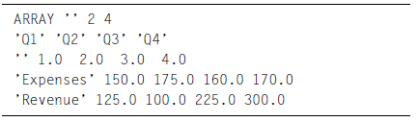
JClass ServerChart also has other Beans which allow you to chart data from a database easily. See Section 16.4, Choosing the Right Bean, for more information.

Step 4: Add a Header, Footer, and Legend
Enter “Michelle’s Microchips” in the headerText property editor and “1963 Quarterly Results” in the footerText property editor. Also, headerVisible and footerVisible must be set to True.

To add the legend, set the legendVisible property to True. The legend text is taken from information in the data source. Notice how the plot area is resized to accommodate the legend. You may have to resize your chart area to accommodate the changes:

For more information, see the LegendLayout property in Section 16.8, Headers, Footers, and Legends.

Step 5: Add Point Labels to the X-axis
By default, ServerChart annotates the axes with values. You can change the annotation to show point labels or time labels.

For Michelle’s Microchips, change the x-axis annotation from values to point labels. Do this by setting the x1AnnoMethod property to Point Labels:
You should now see “Q1”, “Q2”, “Q3”, and “Q4” on the x-axis. These labels are contained in the intro.dat file, and come up automatically when Point Labels are selected. For more information on axis annotation, see Section 16.5, Standard Bean Properties.

Step 6: Change the Background Color
To change the background color to white, click the background property to bring up your color editor:

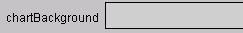

The custom color editor used by your IDE will differ from the BeanBox. Select pure white from the options on your color editor:

Step 7: Change to Stacking Bar Chart and add 3D Effects
You can select from 13 chart types using the data1ChartType property editor (see Chart Types, in Chapter 1 for a complete list). For Michelle’s Microchips, select the STACKING_BAR type:
To add three-dimensional visuals to your chart, modify the 3DDepth, 3DElevation, and 3DRotation settings.

Step 8: Add to a servlet and encode as PNG, GIF, or JPEG
For the last step, now that the chart is customized to your liking, add the chart to a servlet and invoke the servlet inside a web server from an HTML page. For an example of how to use a chart inside a servlet, please see any of the JClass ServerChart examples, such as the BasicServletEg example in JCLASS_SERVER_HOME/examples/schart/servlet/.

16.3 JavaBeans and JSPs
An alternate way of using Beans, and one more suited to server-side development, is through the use of JSPs. A Bean class may be specified within a JSP file and its properties easily changed to desired values. The chart may then be encoded to a file and a reference to the file included within the HTML portion of the JSP file.

Note: Using JClass ServerChart in this way is not guaranteed to be thread safe. For a thread safe mechanism, use JClass ServerChart JSP tags. For more information, see JClass ServerChart JSP Tag Library, in Chapter 17

It is also possible to encode to an image, rather than to a file. The image would then be cached and retrieved from the cache when required. For an example, refer to the BeanJSP example in JCLASS_SERVER_HOME/examples/schart/jsp, where the demos.common.server.ServletLookup class is used as the cache. When storing the image in the cache, a key is generated to uniquely identify the image. The key is then passed as a parameter to demos.common.server.LookupServlet in the generated output (HTML). The servlet then retrieves the image from the cache using the key.

The following JSP creates the same chart as the one created in the IDE tutorial, above, but the JSP version is a lot simpler:
<html>
<p>
<jsp:useBean id="schart"
class="com.klg.jclass.schart.beans.ServerChart" scope=" page"/>
<jsp:setProperty name="schart" property="chartWidth" value="400" />
<jsp:setProperty name="schart" property="chartHeight" value="400" />
<jsp:setProperty name="schart" property="data1Source"
value="JCLASS_SERVER_HOME/examples/schart/intro/intro.dat" />
<jsp:setProperty name="schart" property="headerText" value="Michelle's
Microchips" />
<jsp:setProperty name="schart" property="headerVisible" value="true" />
<jsp:setProperty name="schart" property="footerText" value="1963
Quarterly Results" />
<jsp:setProperty name="schart" property="footerVisible" value="true" />
<jsp:setProperty name="schart" property="legendVisible" value="true" />
<jsp:setProperty name="schart" property="x1AnnotationMethod"
value="Point_Labels" />
<jsp:setProperty name="schart" property="chartBackground"
value="white" />
<jsp:setProperty name="schart" property="data1ChartType"
value="STACKING_BAR" />
<jsp:setProperty name="schart" property="3DRotation" value="30" />
<jsp:setProperty name="schart" property="3DElevation" value="25" />
<jsp:setProperty name="schart" property="3DDepth" value="15" />
<%
schart.encodeToPNGFile(application.getRealPath("/jsp/chart.png"));
%>
<p>
<img src="chart.png">
</html>

16.4 Choosing the Right Bean
The JClass ServerChart Beans are located in two packages:
- com.klg.jclass.schart.beans
- com.klg.jclass.schart.beans.db

In the main beans package, you will find the JClass ServerChart’s main Bean, which encapsulates many of the most useful properties into a series of get() and set() methods that are easy to use, and the ServerChartBeanInfo Bean, which is used internally. For further information, please refer to the JClass ServerViews Installation Guide.

The Bean located in the beans.db package is BaseDBSChart for ServerChart. When creating new applications in an IDE, you can use the ServerChart Bean or the database access Bean, BaseDBSChart Bean. The BaseDBSChart Bean is the base class for classes that access databases and is usable “as is” for simple database access.

Unless you are getting data from a database, we recommend using the ServerChart Bean, both for learning JClass ServerChart’s features and creating new applications.

ServerChart Bean
The ServerChart Bean was designed for ease of use for JSP developers, but can also be used in any IDE environment. This Bean provides a subset of the properties found in com.klg.jclass.schart.JCServerChart and its contained classes through a series of simple get() and set() methods. It exposes the most commonly used charting properties, and presents them in easy-to-use property editors. ServerChart can load data from a file or a design-time editor.

The ServerChart icon:

The ServerChart and BaseDBSChart Beans share a common set of properties that are covered in this chapter; the Beans differ only in how each type loads data.

Database Access Bean
If you want to load data from a database, you will have to use one of the database access Beans. In order to chart data from a database, your application must be able to establish a connection, perform necessary queries on the data, and then put the data into a chartable format.
Once you have set up your data handling for a specific Bean, you can then use the Standard Bean Properties to customize your chart.

The BaseDBSChart Bean is the base class for classes that access databases and is usable “as is” for simple database access.

16.4.1 JClass ServerChart Beans

The following table shows all of the available JClass Beans and their uses:

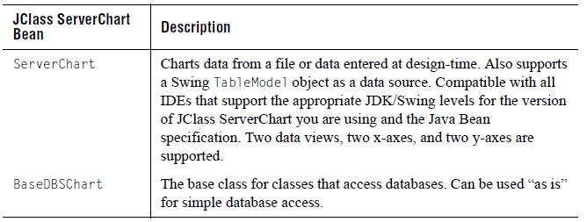

16.4.2 JClass ServerChart Beans and JCServerChart

All JClass ServerChart Beans are subclasses of the main chart object, JCServerChart. This means that the entire JClass ServerChart API is available to any developer using any of the Beans.

16.5 Standard Bean Properties
The ServerChart Bean and database access BaseDBSChart Bean have a set of standard properties that allow you to control the appearance and behavior of your charts. They only differ in the way they retrieve data. This section covers the standard properties.

16.5.1 Multiple Axes

ServerChart can have two x-axes and two y-axes, as in the example below:

Axis properties are of the format x1Property, x2Property, y1Property, and y2Property. Each axis property exists for all four axes. By default, the secondary x-axis and y-axis are not visible.

Full details can be found in the Javadoc (automatically installed when you installed JClass ServerChart) at JCLASS_SERVER_HOME/docs/api/index.html.

16.5.2 Multiple Data Views

ServerChart allows you to load data from two different sources at the same time. When loading data from two different sources, they are each assigned to a separate data view. Data properties are of the format data1Property and data2Property, and each data property exists for both data views.

By default, only the first data view is showing, but you can hide or reveal data views depending on your application’s needs. Both sets of data can be mapped to the same set of x-axes and y-axes, or mapped to different axes.

Note: Radar, area radar, and pie charts do not support multiple data views.

Full details can be found in the Javadoc (automatically installed when you installed JClass ServerChart) at JCLASS_SERVER_HOME/docs/api/index.html.

16.5.3 Intelligent Defaults

ServerChart has a sophisticated set of dynamic default settings that change depending on the values of related properties. You can override these defaults to suit your needs. When you override a default value in your program, the value becomes static, and will not automatically adjust anymore when related properties change.

16.6 Getting Started with the ServerChart Bean
The ServerChart Bean comes with a wide range of dynamic default settings that adjust to your data and other settings. This means that you only have to make a minimum of settings to have a respectable chart. The following list describes the most common start-up tasks and the editors used for them:
- Load Data. To load data in the chart, use the data source properties. These properties allow you to load data from one or two sources. There is also a default set of data built-in with which you can experiment. Alternately, you can use a Swing TableModel data object as the chart’s data source using the data TableModel property.
- Select Chart Types. For each data view, you can select a chart type with the data ChartType property and the axes that the data will be plotted against with the data XAxis and YAxis properties.
- Set Background Color. Use the ChartBackground property to set the color of the chart background.
- Set Axis Annotation. By default, the ServerChart Bean uses values to annotate the axes. You can also use value labels, point labels, or time labels by setting the annotation type with the axis AnnoMethod property.
- Add a Legend. Add a legend by setting the LegendVisible property to true.
- Add a Header and Footer. To add a header, use HeaderText to add the text, and then set the HeadersVisible property to true. To add a footer, use Footers to add the text, and then set the FootersVisible property to true.
- Add Extra Axes. By default a standard x-axis/y-axis set is displayed. If you require, you can display a second x-axis or y-axis. Display them with the axis Visible property. Then use the many axis properties, such as Placement, to set up and align the axes.

16.7 ServerChart Bean Property Reference
The following property reference section covers the ServerChart Bean’s features.

16.7.1Axis Controls

There are several axis properties that can be used with the ServerChart Bean. Properties are available for the X1, X2, Y1, and Y2 axes.

Axis Annotation
The AnnoMethod property gets the annotation method (represented by a String) of any of the X1, X2, Y1, or Y2 axes. Possible values are Value, Value_Labels, Time_Labels, and Point_Labels.

With the AnnoRotation property, you can rotate the labels on the axis. Choose from None, 90, 180, or 270.

The Font property determines the font used to render the axis annotation. It provides a font editor in IDEs. In JSPs, the Font property uses a String of format name-style-size, for example, Dialog-bold-12 for a 12-point Dialog font in bold.

The Gap property controls the gap between axis labels, in pixels. You can set this to be zero or any positive integer.

Axis Grid
You can set whether the grid of the specified axis is visible by using the GridVisible property (takes a boolean value). By default, grid visibility is false.

The GridSpacing property defines the spacing of the grid along the specified axis. This property takes a floating point number.

The GridColor property defines the color of the grid along the specified axis. The grid color is represented by either a String containing a color name as defined in the Java Color class, an RGB value in the format r-g-b, or a hex value in the format #RRGGBB, #RRRRGGGGBBBB, or #N. In an IDE, you can use the color editor.

To specify the width of the grid along the specified axis, use the GridWidth property (takes an integer value).

Axis Origin
The OriginPlacement property specifies the origin placement of the specified axis. The origin placement is represented by a String. Possible values are Automatic, Zero, Min, or Max. A value of Automatic means that an appropriate default will be chosen, a value of Zero will locate the origin at the zero position on this axis, and a value of Min or Max will located the value at the minimum or maximum position on this axis. If the OriginLocation property is set, this property is ignored.

The OriginLocation property defines the origin location for the specified axis. If this property is specified, the OriginPlacement property will not be used.

Axis Placement
There are three axis placement properties: Placement, PlacementAxis, and PlacementLocation.

Placement defines the placement of the specified axis. The placement is represented by a String, and possible values are Automatic, Origin, Min, Max, or Value_Anchored. A value of Automatic means that an appropriate default will be chosen; Origin will place the axis at the origin; Min or Max will place the axis at the minimum or maximum of the axis specified by the PlacementAxis property; a value of Value_Anchored will place the axis at the value specified by the PlacementLocation property along the axis specified by the PlacementAxis property.

PlacementAxis cites the axis against which the specified axis is placed. The placement axis is represented by a String. Possible values are x1, x2, y1, and y2. In an editor combo box, the names are shown as X Axis 1, X Axis 2, Y Axis 1, and Y Axis 2, respectively.

PlacementLocation defines the placement location of the specified axis. This property, which takes a floating point, is used when the Placement property has been set to Value_Anchored.

Axis Relationships
RelatedAxis, RelatedMultiplier, and RelatedConstant are the three axis relationship properties.

RelatedAxis defines the name of the related axis for the specified axis. If the RelatedAxis property is set, this axis will be calculated from the specified related axis through the equation x1 = m(x2)+b, where x1 is a value along this axis, x2 is the value along the related axis, m is the multiplier set in the RelatedAxisMultiplier property, and c is the constant set in the RelatedAxisConstant property. The related axis is represented by a String. Possible values are x1, x2, y1, and y2. In an editor combo box, the names are X Axis 1, X Axis 2, Y Axis 1, and Y Axis 2, respectively.

RelatedMultiplier takes a floating point number and cites the related axis multiplier for the specified axis. If the RelatedAxis property is set, this axis will be calculated from the specified related axis through the equation x1 = m(x2)+b, where x1 is a value along this axis, x2 is the value along the related axis, m is the multiplier set in this property, and c is a constant set in the RelatedAxisConstant property.

RelatedConstant defines the related axis constant for the specified axis. This property also takes a floating point number. If the RelatedAxis property is set, this axis will be calculated from the specified related axis through the equation x1 = m(x2)+b, where x1 is a value along this axis, x2 is the value along the related axis, m is the multiplier set in the RelatedAxisMultiplier property, and c is the constant set in this property.

Axis Scale
To modify the axis scale, alter these properties:
- Min – determines the minimum value for the axis scale; takes a floating point number
- Max – determines the minimum value for the axis scale; takes a floating point number
- NumSpacing – determines the axis annotation spacing; takes a floating point number
- TickSpacing – defines the axis tick spacing for the specified axis; takes a floating point number
- Precision – defines the axis precision for the specified axis; takes an integer value

Axis Time Labels
The time axis properties comprise TimeBase, TimeFormat, and TimeUnit.

TimeBase defines the time base for the specified axis. TimeBase is a String specifying a start date for a time axis. The format of the date string is as defined by the long format of Java’s SimpleDateFormat class. Note that this property is used only if
the AnnotationMethod has been set to Time_Labels.

TimeFormat cites the time format String for the specified axis. This String defines how time labels are to be formatted. For information on how to create a custom format, please see Java’s SimpleDateFormat class. Note that property is used only if the AnnotationMethod has been set to Time_Labels.

TimeUnit defines the time unit of the specified axis, and is represented by a String. Possible values are Seconds, Minutes, Hours, Days, Weeks, Months, or Years. This property is used when the AnnotationMethod is set to Time_Labels.

Axis Title
These properties modify the axis title.

TitleText cites the title text for the specified axis. This property takes a String value.

TitleRotation defines the title rotation of the specified axis. The title rotation is represented by a String; possible values are None, 90, 180, or 270. The title of this axis will be rotated by the number of degrees specified by this property.

TitlePlacement details the title placement of the specified axis. The title placement is represented by a String. If this axis is vertical, possible values are Northeast, Northwest, East, West, Southeast, or Southwest. If this axis is horizontal, values are North or South.

TitleFont specifies the font used by the specified axis’ title. The font is represented by a String in the format name-style-size. The TitleFont property provides a font editor in IDEs.

Axis Value Labels
AxisValueLabels define the value labels for the specified axis. Value labels are a String of value pairs, with each value being separated by a semi-colon. The first value in the pair is the value at which the label will appear. The second value is the label to use.

In an IDE, value labels are accessed through a custom editor that shows the label pairs, one per line, with each pair separated by a comma.

For example, a valid value label String is 10.0, Ten; 20.0, Twenty; 30.0, Thirty.

Here is a screen shot of the AxisValueLabel editor:

Other Axis Properties
Other axis properties include
- Visible – defines the visibility of the specified axis; takes a boolean value.
- Logarithmic – defines the logarithmic value of the specified axis; if true, the axis is a logarithmic axis; takes a boolean value.
- Reversed – outlines the reversed property of the specified axis; if true, the axis is reversed; takes a boolean value.

16.8 Headers, Footers, and Legends
Footers
The FooterText property lets you define the text displayed by the Bean’s Footer. This property takes a String value.

To delineate the font used by the Bean's Footer, use the FooterFont property. The font is represented by a String in the format: name-style-size, for example, Helvetica-italic-14 for a 14-point Helvetica font in italics. The FooterFont property provides a font editor in IDEs.

Use the FooterVisible property to define whether the Bean’s footer is visible. The footer is invisible by default.

HeaderText
The HeaderText property lets you define the text displayed by the Bean’s Header. This property takes a String value.

To delineate the font used by the Bean's Header, use the HeaderFont property. The font is represented by a String in the format: name-style-size, for example, Dialog-bold-12 for a 12-point Dialog font in bold. The HeaderFont property provides a font editor in IDEs.
Use the HeaderVisible property to define whether the Bean’s header is visible. The header is invisible by default.

LegendLayout
The LegendOrientation property controls how the legend items are placed in the Bean’s legend (either vertically or horizontally). The orientation is represented by a String; possible values are Horizontal or Vertical.

The LegendAnchor property positions the Bean’s entire legend on the chart, based on compass directions. The anchor is represented by a String, and possible values are Northeast, North, Northwest, East, West, Southeast, South, or Southwest.

16.9 Data Source and Data View Controls
This group of properties control the data source, and the views on the data. ServerChart can load data from two different sources (data1... and data2...). Each of the data sources is assigned to a data view.

ChartType

The ChartType property selects from the following chart types:
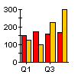
Area Bar Candle HiLO
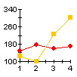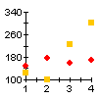
Hilo_Open_Close Pie Plot Scatter_Plot
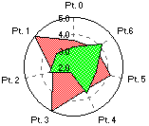
Stacking_Area Stacking_Bar Polar Area_Radar
Radar

X-Axis and Y-Axis
There are two x-axis values – x1 and x2 – and there are two y-axis values – y1 and y2. In an IDE, these values will appear fully named as X Axis 1, X Axis 2, Y Axis 1, and Y Axis 2, respectively.

Visible
The Visible property details the visibility of the selected data view. This property takes a boolean value.

VisibleInLegend
If the data view visibility is false, then the legend visibility is false. However, if the data view visibility is true, then the VisibleInLegend property can be used to define the legend visibility of the selected data view. This property takes a boolean value.

AutoLabel
The AutoLabel property cites the auto label value of the selected data view. If true, chart labels will automatically be generated for each data point. This property takes a boolean value.

InvertAxes
The axis inversion value of the selected data view is defined by the InvertAxes property. If this property (which takes a boolean value) is true, the x-axis will run vertically and the y-axis will run horizontally.

PointLabels
Point labels label specific points of data on the x-axis. The PointLabels property outlines the point labels associated with the selected data view. The PointLabels String is a comma separated list of substrings, one substring for each data point.

In an IDE, the property is accessed through a custom editor that displays the list of point labels, one per line:

Note: For point labels to appear, the appropriate axis AnnotationMethod property must be set to Point_Labels. This AnnotationMethod property is the default value for bar and stacking bar charts.

Data Loading
The DataSource property defines the source for the Bean’s specified data view. The source is represented by a string that is either a file name or data in the format defined by JCDefaultDataInterpreter.

In an IDE, this is encapsulated by a custom editor:
The TableModel property defines the Swing TableModel instance being used to populate the data source of the selected data view.

16.10 Appearance Controls
This group of properties allows you to control the look of specific chart subcomponents. You can control font, borders, background and foreground for the chart, chart area, plot area, header, footer, and legend. The following diagram illustrates the different chart subcomponents:
All of the editors have the same basic functionality that apply to a specific chart subcomponent.

Background
The Background property defines the background color of the chart subcomponents. The background color is represented by either a String containing a color name as defined in the Java Color class, an RGB value in the format r-g-b, or a hex value in the format #RRGGBB, #RRRRGGGGBBBB, or #N. In an IDE, you can use the color editor.

To use a transparent background in your chart, set the Opaque property to False; then generated GIFs and PNGs will also contain a transparent background.

Foreground
The foreground color of the chart subcomponents is determined with the Foreground property. It represented by either a String containing a color name as defined in the Java Color class, an RGB value in the format r-g-b, or a hex value in the format #RRGGBB, #RRRRGGGGBBBB, or #N. In an IDE, you can use the color editor.

Font
The font used by the chart subcomponents is defined by the Font property. The Font property is represented by a String in the format name-style-size. In an IDE, you can use the font editor.

Opaque
The Opaque property delineates the opacity of the chart subcomponents. This property takes a boolean value. If true, the chart subcomponent is opaque; if false (default), the chart subcomponent is transparent.

Visible
The Visible property details the visibility of the chart subcomponents. This property takes a boolean value, and is invisible by default.

Border
The border type of the chart subcomponents is defined by the Border property. The border is represented by a String of the form bordername|param|param|, where bordername is the name of the Swing border style and the params are parameters passed to the border style. Possible border strings include:
- empty|top|left|bottom|right
- bevel/softbevel/etched|raised/lowered
- bevel/softbevel/etched|raised/lowered|highlightColor|shadowColor
- matte|top|left|bottom|right|color
- line|color
- line|color|thickness
- titled|title
In an IDE, you can use the color editor.

PlotAreaBackground
The PlotAreaBackground property delineates the background color of the Plot Area. The background color is represented by either a String containing a color name as defined in the Java Color class, an RGB value in the format r-g-b, or a hex value in the format #RRGGBB, #RRRRGGGGBBBB, or #N.

If the JClass ServerChart component is meant to have a transparent background, set the Opaque property to False; then generated GIFs and PNGs will also contain a transparent background.

PlotAreaForeground
The PlotAreaForeground property defines the foreground color of the Plot Area. The color is represented by either a String containing a color name as defined in the Java Color class, an RGB value in the format r-g-b, or a hex value in the format #RRGGBB, #RRRRGGGGBBBB, or #N. In an IDE, you can use the color editor.In an IDE, you can use the border editor.

PlotAreaBoundingBox
The characteristics of the axis bounding box value for the Plot Area are determined by the PlotAreaBoundingBox property. If set to true, the Plot Area's axes will be bounded by a box; if false, they will not. This property is false by default.

Other Chart Properties
There are two properties for JClass ServerChart that are necessary for server-side development. They may not work correctly in an IDE.
      - ChartWidth – defines the width of the Bean (takes an integer)
      - ChartHeight – defines the height of the Bean (takes an integer)

16.11 View3D
3DDepth
The 3DDepth property defines the 3D depth value of the JClass ServerChart Bean. This property takes an integer value; possible values range from 0 to 500. A zero depth means that the chart will draw in 2D. Not all chart types can draw in 3D.

3DRotation
The 3DRotation property defines the 3D rotation value of the JClass ServerChart Bean. This property takes an integer value; possible values range from –45 degrees to 45 degrees. Not all chart types can draw in 3D.

3DElevation
The 3DElevation property defines the 3D elevation value of the JClass ServerChart Bean. This property takes an integer value; possible values range from –45 degrees to 45 degrees. Not all chart types can draw in 3D.

17
Creating Charts for JSF or JSP
The JClass Service ■ JClass JCFacesChart with JavaServer Faces
JClass ServerChart JSP Tag Library

This section is intended for programmers who are using JavaServer Faces (JSF) and/or JavaServer Pages (JSP). To make the most out of this information, you should already know how to author JSPs, and, if you intend to use JClass JCFacesChart, how to use JSF components.

The topics in this section include how to set up the JClass Service, how to use the JClass JCFacesChart tag library, and how to use the JClass ServerChart tag library.

17.1 The JClass Service
The JClass Service is a servlet that handles requests to execute JClass tasks. For JClass ServerChart, the JClass Service generates new charts or displays charts that were generated earlier in the session. The charts are outputted either as an image or as an image embedded in an HTML page. You can allow JClass JCFacesChart or the JClass ServerChart JSP tag library to handle calls to the JClass Service or you can call the JClass Service directly. In either case, you must include the JClass Service in your web application.

17.1.1 Setting Up the JClass Service

To set up the JClass Service, you need to specify the URL where the service is located and set up the servlet mapping.

To specify the URL, add a context parameter to the web.xml file with the name com.klg.jclass.util.server.ServiceUrl and a value that represents a URL pattern. In the following example, the value is set to /jclass. When the JClass Service is used, if the context parameter is unspecified or its value is empty, an exception is thrown.

To set up the servlet mapping for the JClass Service, specify the servlet name and class as com.klg.jclass.util.server.JClassService and specify the same URL pattern that you used in the context parameter.

<web-app>
<context-param>
<param-name>com.klg.jclass.util.server.ServiceUrl</param-name>
<param-value>/jclass</param-value>
</context-param>
...
<servlet>
<servlet-name>
com.klg.jclass.util.server.JClassService
</servlet-name>
<servlet-class>
com.klg.jclass.util.server.JClassService
</servlet-class>
</servlet>
...
<servlet-mapping>
<servlet-name>
com.klg.jclass.util.server.JClassService
</servlet-name>
<url-pattern>
/jclass
</url-pattern>
</servlet-mapping>
</web-app>

17.1.2 Calling the JClass Service from the JClass Tag Libraries

The tag handlers from both JClass JCFacesChart and the JClass ServerChart JSP tag library automatically generate HTML to call the JClass Service. The call is made from an img tag, as demonstrated in the following HTML snippet.

<html>
...
<img src="/server-samples/jclass?service=chart&amp;cache=session&amp;
id=-56103913" title="My Chart" alt="My Chart" usemap="#myMap">
<MAP NAME="myMap">
... image map definition ...
</MAP>
...
</html>

The src attribute in the above example generates a call to the JClass Service. The id is a unique number that is auto-generated by the tag handler responsible for creating the chart when caching is used. The JClass Service uses the id to retrieve previously generated charts from the cache. For more information, see Section 17.1.4, Caching Generated Charts.

The usemap attribute and the MAP tag are included when you choose to use image maps. If your chart does not use image maps, these tags are omitted. For more information, see Chapter 10, Defining Image Maps.

17.1.3 Calling the JClass Service Directly

If you are not using JClass JCFacesChart and not using the JClass ServerChart JSP tag library, you can still access the JClass Service by calling it directly. To call the JClass Service directly, you need to specify the URL for the JClass Service. You can choose to have the JClass Service return either a chart image or an HTML page that will call the JClass Service to generate the
image.

You can use the following parameters in addition to any of the parameters available with the <jclassjsf:chart> and <jclass:chart> tags:

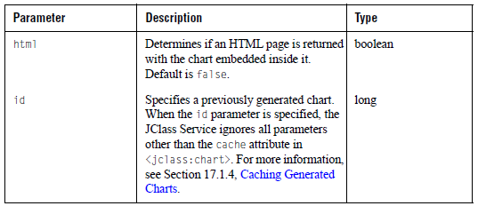

The following JClass ServerChart example demonstrates how you can call the JClass Service directly using your browser’s address field or the href tag in an HTML page. In this example, the JClass Service returns a chart embedded in an HTML page.

http://myserver/mywebapp/jclass?service=chart\
&html=true\
&javaClass=com.company.package.MyChartBuilder\
&chartXml=Chart.xml\
&encoding=jpg\
&name=MyChart\
&cache=once\
&startDay=2004-04-01\
&endDay=2004-04-29

where startDay and endDay are extra parameters that can be retrieved by Java code. These parameters get passed to the class specified by the javaClass attribute.

17.1.4 Caching Generated Charts

Both JClass JCFacesChart and JClass ServerChart save the information about a generated chart in a bean. This bean is normally cached in the session object using a uniquely generated id as a key. The JClass Service uses the id to find the bean, retrieve the chart definition, and generate the image.

Charts are always cached when using JClass JCFacesChart. If you are using the JClass ServerChart tag library, however, you can use the cache attribute to select the type of caching mechanism that you want to use or to turn off caching altogether. If cache is none, the chart is not stored. For more information, see the cache attribute in Section 17.3.2.1, <jclass:chart>.

17.1.5 Using the serviceUrl Parameter to Specify the JClass Service

If you are using the JClass ServerChart JSP tag library, you can set up the JClass Service either by editing the web.xml file as described in Section 17.1.1, Setting Up the JClass Service, or by using the serviceUrl attribute of the <jclass:chart> tag. The path that you specify for the serviceUrl attribute must point to a JClass Service that is included in your web application.

When accessing the JClass Service, the <jclass:chart> tag handler attempts to use the value of the serviceUrl attribute first. If the value is unspecified, it uses the value for the context parameter in the web.xml file. If the value of the context parameter is also unspecified or its value is empty, an exception is thrown.

17.2 JClass JCFacesChart with JavaServer Faces
JClass JCFacesChart is a custom JavaServer Faces (JSF) component with associated custom actions. It enables you to add a JSF chart component to a JSF page. JClass JCFacesChart is contained in the main JClass ServerChart JAR file, jcschart.jar.

A JSF chart component offers the following advantages:
- Consistency of use.You can use a JClass JCFacesChart in the same way as standard JSF components. If you are already using JSF to simplify the logic of your UI pages, you can embed one or more JClass JCFacesCharts in a page, and you can use JSF actions to set component properties.
- State management, input validation and conversion, event management, and exception handling.
- Less code in user interface templates.

JClass JCFacesChart extends the JavaServer Faces UICommand component. Thus, an ActionEvent is generated when an end user clicks a chart. This event is sent to all action listeners that are registered with the chart. For more information, see Section 17.2.4.2, Registering an Action Listener.

17.2.1 Locating the JClass JCFacesChart Tag Library

The JClass JCFacesChart tag library description file, chart-jsf.tld, is located in the JCLASS_SERVER_HOME/xml-dtd/ directory. The chart-jsf.tld file is also included in the JClass ServerChart JAR file, jcschart.jar, in the META-INF directory. As long as jcschart.jar is in your classpath, you can access the JClass JCFacesChart tag library.

17.2.2 Tag and Attributes for JClass JCFacesChart

JClass JCFacesChart has one tag. Note that the prefix specified in your taglib directive, normally jclassjsf, is required.

<jclassjsf:chart>

Purpose:
Creates a JClass JCFacesChart instance and determines its settings.

Required Parent <h:form>

Attributes:
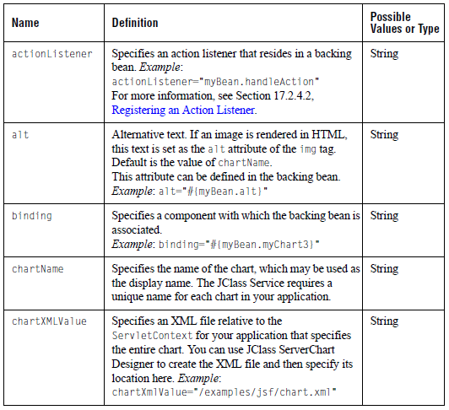
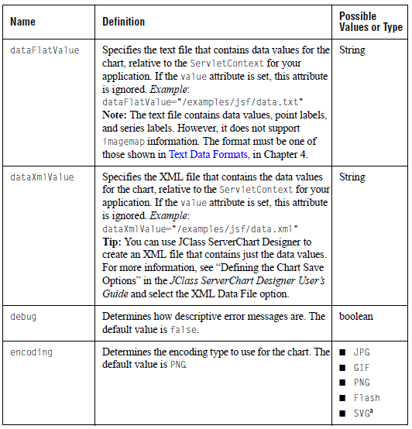

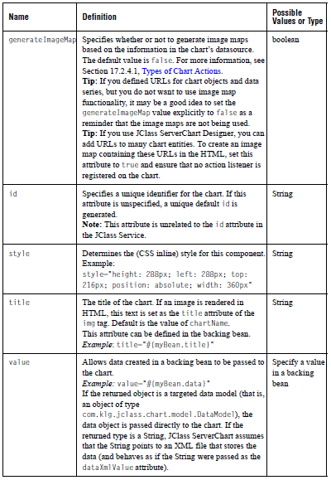
a. When using SVG encoding, image maps are not supported.

17.2.3Adding a JClass JCFacesChart to a JSP

JClass JCFacesChart expects the chart definition to be in XML format. If you want, you can use JClass ServerChart Designer to design the chart and then export it to an XML file. For more information, see the JClass ServerChart Designer User’s Guide. Note: If your IDE supports JSF components, you may be able to add and use JClass JCFacesChart from within your IDE. For more information, see the IDE integration instructions in the JClass ServerViews Installation Guide.

To add a JClass JCFacesChart to a JSP:

- Include the JClass JCFacesChart taglib directives with the standard two JavaServer Faces taglib directives.

<%@ page contentType="text/html" %>
<%@ taglib uri="http://java.sun.com/jsf/html" prefix="h" %>
<%@ taglib uri="http://java.sun.com/jsf/core" prefix="f" %>
<%@ taglib uri="http://quest.com/jclass/jsf/chart-jsf" prefix="jclassjsf" %>

Alternatively, the JClass JCFacesChart tag library can be specified as follows:
<jsp:root version="1.2" xmlns:jclassjsf="http://quest.com/jclass/jsf/chart-jsf">

- At the appropriate place within your JSP page, place the tag for the chart. The JClass JCFacesChart component tag must be contained within <h:form> ... </h:form> tags:

<f:view>
...
<h:form>
...
<jclassjsf:chart id="jsfChart"
value="#{myBean.chartDataModel}"
chartXml="/demos/schart/explode/chart.xml"
encoding="png"
debug="true">
<f:actionListener type="FacesChartListener" />
</jclassjsf.chart>
...
</h:form>
...
</f:view>

Another example:

<jclassjsf:chart chartName="ScatterChart"
chartXmlValue="/examples/schart/jsf/chart1.xml"
debug="false"
encoding="jpg"
generateImageMap="true"
id="chart1"/>

In the first of these examples, a JavaServer Faces action has been added to the chart. Clicking anywhere on the chart causes the action handler class to be called. In the second example, the generateImageMap attribute causes the chart to render the imagemap information contained in chart1.xml. The tag and its attributes are described in Section 17.2.2, Tag and Attributes for JClass JCFacesChart.

- Ensure that the jcschart.jar file is included with the JAR files in the WEB-INF/lib directory of your application.

17.2.4 Adding Action Events to a Chart

JClass JCFacesChart extends the UICommand component and thus is able to respond to action events on the chart. Action events are fired by command components when the component is activated. For JClass JCFacesChart, an action event occurs when an end user clicks on a chart. If the chart has a registered action listener, the method or class specified by the listener handles the action event. If the chart has no registered action listeners, the action event is ignored.

17.2.4.1 Types of Chart Actions

The following table summarizes the four possibilities for chart actions:

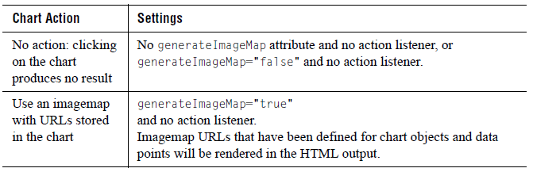

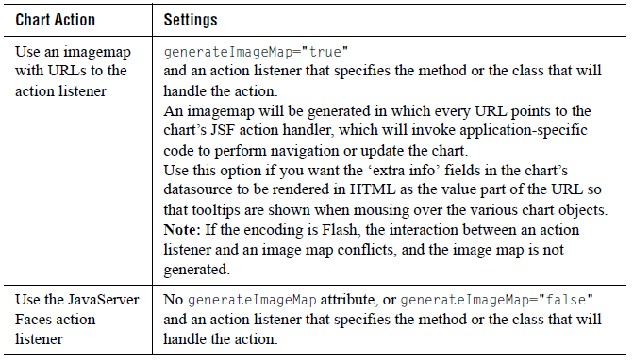

17.2.4.2 Registering an Action Listener

There are two ways that you can register an action listener with the chart: as an attribute of the <jclassjsf:chart> tag or by using the JSF <f:actionListener> tag. If you want to add more than one listener, you should use the JSF tag. In either case, the listener is passed a JCFacesChartEvent to handle the event.

Setting the actionListener Attribute
In the following code snippet (taken from listener.jsp in JCLASS_SERVER_HOME/examples/schart/jsf/), the programmer creates a chart component and registers the action listener using the actionListener attribute.

<jclassjsf:chart chartName="ActionChart"
chartXmlValue="/examples/schart/jsf/radar.xml"
dataFlatValue="/examples/schart/jsf/radar.dat"
actionListener="#{listener.selection}"
debug="true" encoding="png" />

The selection method is called in the backing bean listener:

public void selection(ActionEvent e)
{ JCFacesChartEvent event = (JCFacesChartEvent)e;
....
}

For a complete example, see “ListenerBean.java Backing Bean Example” in Section 17.2.4.3, JCFacesChartEvent.

Adding an actionListener JSF tag

You can add multiple action listeners to the same chart using this method. In the following example, the programmer adds an <f:actionListener> tag within the bounds of the <jclassjsf:chart> tag.

<jclassjsf:chart ... >
<f:actionListener type="myPackage.myChartListener"/>
</jclassjsf:chart>

In the package myPackage, the programmer adds a class called myChartListener that implements the ActionListener interface. A JCFacesChartEvent is passed to the processAction() method of this class.

public class myChartListener implements ActionListener {
public void processAction(ActionEvent e) {
JCFacesChartEvent event = (JCFacesChartEvent)e;
....
}
}

17.2.4.3 JCFacesChartEvent

The JCFacesChartEvent class extends javax.faces.event.ActionEvent. The custom properties and methods are described briefly here; for details, see the API Documentation.

The following table summarizes the additional properties:

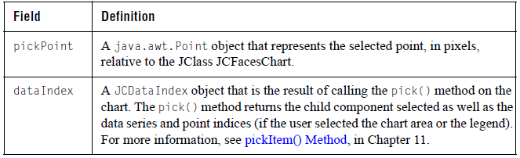

The following table summarizes the additional methods:
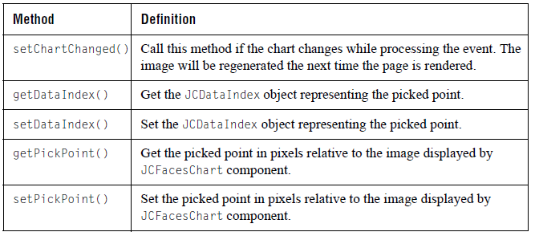

ListenerBean.java Backing Bean Example

In the following example (taken from ListenerBean.java in JCLASS_SERVER_HOME/examples/schart/jsf/), the selection() method handles action events. Each time the method is called, it is passed a JCFacesChartEvent. The programmer can then get the JCFacesChart component (assigned to the variable chart in the example), the coordinates of the selected point (assigned to the variable p), and a JCDataIndex object that contains information about the selected point relative to the chart. Recall that the event’s pickPoint property represents the selected point in pixels relative to the chart, while dataIndex property stores the result of a call to the pick() method using the selected point. The JCDataIndex object contains the child component selected as well as the data series and point indices (if the user selected the chart area or the legend).

In this example, the programmer uses a StringBuffer to create a String containing the coordinates of the selected point (the value of p.x and p.y) followed by the name of the component closest to that point (value of o) or, if no component is selected, the chart itself. The final line of code is of interest because it uses the JCFacesChartEvent method setChartChanged() to cause the chart image to be regenerated the next time the page is rendered.

/**
* Triggered when an action event happens on the chart.
*
* @param e The JCFacesChartEvent generated.
*/
public void selection(ActionEvent e) {
JCFacesChartEvent event = (JCFacesChartEvent) e;
JCFacesChart chartComponent = (JCFacesChart) event.getComponent();
JCServerChart chart = chartComponent.getChart();
JCDataIndex dataIndex = event.getDataIndex();
Point p = event.getPickPoint();

// Generate a new selection string based on the point
// and what was selected in the component.
StringBuffer sb = new StringBuffer("<b>Point:</b>
(" + p.x + "," + p.y + ") ");
sb.append("<b>Component:</b> ");
Object o = dataIndex.getObject();
int seriesIndex = dataIndex.getSeriesIndex();
if (o == chart.getHeader()) {
sb.append("Header");
}
else if (o == chart.getFooter()) {
sb.append("Footer");
}
else if (o == chart.getLegend()) {
sb.append("Legend ");
sb.append("<b>Series:</b> " + (seriesIndex >= 0 ? ""
+ seriesIndex : "Title"));
}
else if (o == chart.getChartArea()) {
sb.append("ChartArea ");
sb.append("<b>Series:</b> " + seriesIndex);
sb.append(" <b>Point:</b> " + dataIndex.getPoint());
}
else {
sb.append("Chart");
}
pickResult = sb.toString();

// Assign "selected" style to appropriate series
setChartStyles(chart, seriesIndex);

// Tell the JCFacesChart component to regenerate the chart image
event.setChartChanged();

}

17.2.5 Internationalizing Your JClass JCFacesChart

You can internationalize the text displayed on your JClass JCFacesChart in the same way as any XML-based chart. For more information, see Internationalizing Your XML-based Chart, in Chapter 15 and, in particular, Section 15.6.3, Using Resource Bundles: JSF.

17.3 JClass ServerChart JSP Tag Library
If you are not using JavaServer Faces but still want to include a JClass ServerChart within a JSP, you can use the JClass ServerChart JSP tag library. With this custom tag library, you can create a chart, encode it as an image, and include the chart in the output, all without having to write a single line of Java code. The chart creation is done behind the scenes using the JClass Service (see Section 17.1, The JClass Service). As the JSP author, you need only create the tags and set the appropriate properties – the web container and the JClass Service do the rest.

17.3.1 Locating the JClass ServerChart Tag Library

The JClass ServerChart tag library description file, chart-jsp.tld, is located in the JCLASS_SERVER_HOME/xml-dtd/ directory. The chart-jsp.tld file is also included in the JClass ServerChart JAR file, jcschart.jar, in the META-INF directory. As long as jcschart.jar is in your classpath, you can access the JClass ServerChart tag library. The

URI attribute for the JClass ServerChart tag library is http://quest.com/jclass/jsp/chart-jsp. You can use this URI in the taglib directive in your JSP.

17.3.2 Tags and Attributes for JClass ServerChart

The following table lists the JSP tags available in the JClass ServerChart tag library. Note that the prefix specified in your taglib directive, normally jclass, is required.

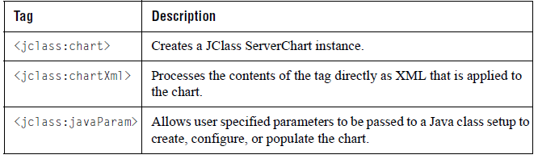

The following sections describe each of the JSP tags in more detail.

17.3.2.1 <jclass:chart>

Purpose:
Creates a JClass JCFacesChart instance and determines its settings.

Required Parent none

Attributes:
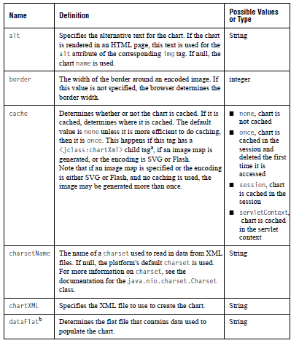
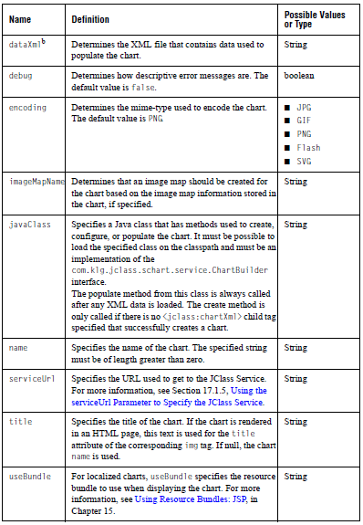

a. If this tag has a <jclass:chartXml> child tag, then caching must be done in order to pass the XML information over to the service. Thus if the cache attribute was specified as none, once is used.
b. These attributes can only be used to populate the chart’s first ChartDataView. Other data views can be populated through XML or by specifying the javaClass attribute.

17.3.2.2 <jclass:javaParam>

Purpose:
Passes specific parameters to any Java code used to build or populate charts (for example, it can be used to specify a range of data, or to detail a particular item or group to build data around).

Required Parent <jclass:chart>

Attributes:

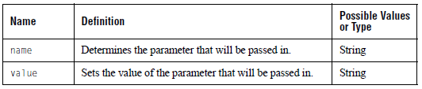

17.3.2.3 <jclass:chartXml>

Purpose:
Used to define the chartXML inline on the JSP page.

Required Parent <jclass:chart>

Attributes:

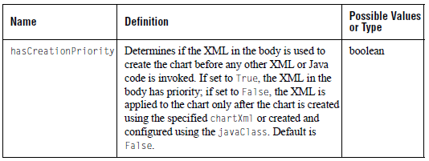

17.3.3 Adding a JClass ServerChart to a JSP

The following is an example of a JSP that uses the <jclass:chart> tag:

<%@ page contentType="text/html;charset=UTF-8" language="java" %>
<%@ taglib uri="http://quest.com/jclass/jsp/chart-jsp" prefix="jclass" %>

<html>
<jclass:chart chartXml="/examples/schart/servlet/barImageMap.xml"
encoding="png" border="0" name="JSP Example 1"
imageMapName="myMap" cache="session"/>
</html>

The <jclass:chart> tag handler causes a chart to be created and loaded with the properties contained in barImageMap.xml. The chart is encoded to a PNG image and an image map is generated based on the image map defined in the XML file. It is all stored in a bean, which is cached as an attribute of the current session. The tag is translated into HTML that calls the JClass Service, which then locates the bean in the cache and displays the image. Since caching is used, there is no need for the chart to be regenerated if the page is reloaded or if a chart with the exact same specifications is required again.

Here is another example that embeds XML right into the JSP, encodes into Flash (SWF), and uses the caching once mechanism. In this case, the chart is cached in the session as the previous example, but deleted from the cache the first time it is referenced:

<%@ page contentType="text/html;charset=UTF-8" language="java" %>
<%@ taglib uri="http://quest.com/jclass/jsp/chart-jsp" prefix="jclass" %>

<html>
<jclass:chart encoding="flash" name="JSP Example 2" cache="once">
<jclass:chartXml>
<chart width="600" height="600">
<chart-data-view name="My Data">
<chart-data hole="max">
<data-series>
<x-data>1.0</x-data>
<x-data>2.0</x-data>
<y-data>150.0</y-data>
<y-data>175.0</y-data>
</data-series>
<data-series>
<y-data>125.0</y-data>
<y-data>100.0</y-data>
</data-series>
</chart-data>
</chart-data-view>
</chart>
</jclass:chartXml>
</jclass:chart>
</html>

The next example uses a Java class that creates, configures, and populates the chart. This Java class must implement the com.klg.jclass.schart.service.ChartBuilder interface. This example also uses <jclass:javaParam> tags to pass information to the Java class. It does not use caching, and thus the JClass Service will be required to generate the image.

Note: When no caching is used, the chart will be generated twice if an image map is specified or if the chart is encoded to either Flash or SVG. In this example, this is not a problem.

<%@ page contentType="text/html;charset=UTF-8" language="java" %>
<%@ taglib uri="http://quest.com/jclass/jsp/chart-jsp" prefix="jclass" %>

<html>
<jclass:chart encoding="jpg" name="JSP Example 3"
javaClass="examples.schart.jsp.BuildChart" border="0"
cache="none">
<jclass:javaParam name="company0" value="IBM" />
<jclass:javaParam name="company1" value="Sun" />
</jclass:chart>
</html>

17.3.4 Internationalizing Your JClass ServerChart

If you are using XML for your JClass ServerChart, you can internationalize the text displayed on the chart. For more information, see Internationalizing Your XML-based Chart, in Chapter 15 and, in particular, Section 15.6.4, Using Resource Bundles: JSP.

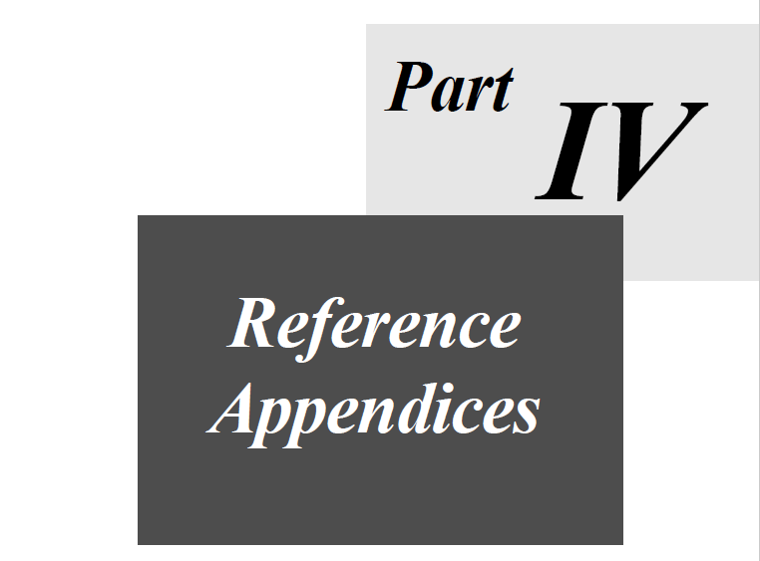

A
HTML Syntax
ChartDataView Properties ■ ChartDataViewSeries Properties ■ Header and Footer
ImageMapInfo Properties ■ ImageMapRules Properties
JCAreaChartFormat Properties ■ JCAnnoProperties
JCAxis X-Axes and Y-Axes Properties ■ JCBarChartFormat Properties ■ JCCandleChartFormat
JCChartArea Properties ■ JCChartLabel Properties ■ JCDataIndex Properties
JCGrid Properties ■ JCHiLoChartFormat Properties ■ JCHLOCChartFormat Properties
JCLegend Properties ■ JCMaker Properties ■ JCMultiColLegend Properties
JCPieChartFormat Properties ■ JCPolarRadarChartFormat Properties
JCServerChart Properties ■ JCThershold Properties

This appendix lists the syntax of JClass ServerChart property parameters. They can be read from a servlet URL, Strings, or an HTML file. For example, the following HTML code sets the x-axis annotation method property:

<PARAM NAME="xaxis.annotationMethod" VALUE="POINT_LABELS">

Some value types are listed as enum. If you are unfamiliar with the enumerations available for a chart property, you can look up the property’s class in the API documentation and then search on the property name. Enumerations are usually located with the set method for the property.

A.1 ChartDataView Properties
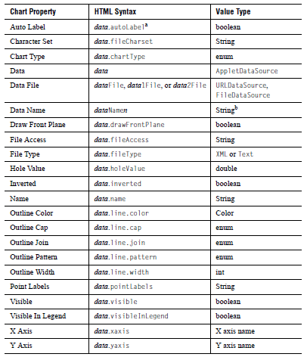
a. data is the name of the first dataset, generated when chart properties are saved to an HTML file; additional datasets are named data1, data2, ... datan.
b. n is the data view number; not needed for first data view.

A.2 ChartDataViewSeries Properties
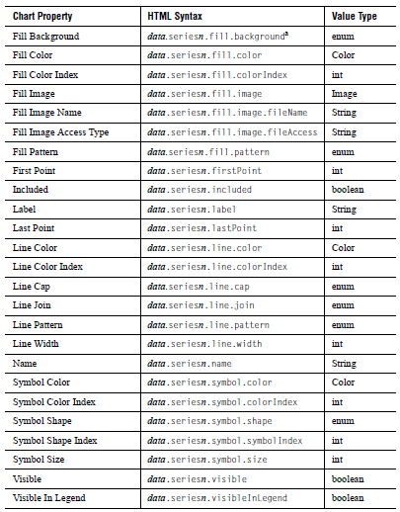
a. data is the name of the first dataset, generated when chart properties are saved to an HTML file; additional datasets are named data1, data2, ... datan.

A.3 Header and Footer Properties
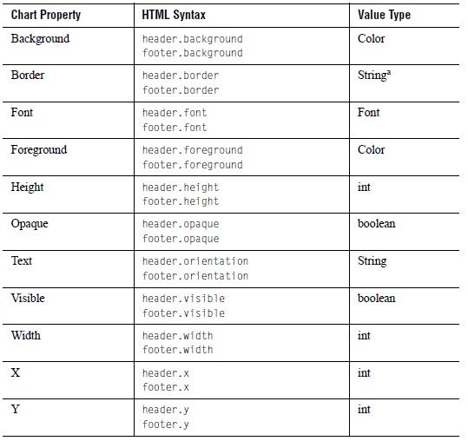
a. String of format bordertype|param1|param2|...

A.4 ImageMapInfo Properties
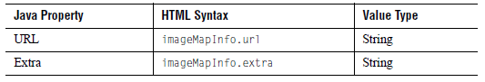

A.5 ImageMapRules Properties
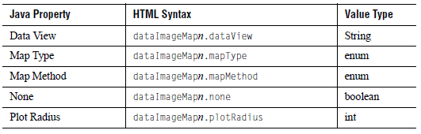

A.6 JCAreaChartFormat Properties
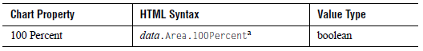
a. data is the name of the first dataset, generated when chart properties are saved to an HTML file; additional datasets are named data1, data2, ... datan.

A.7 JCAnnoProperties
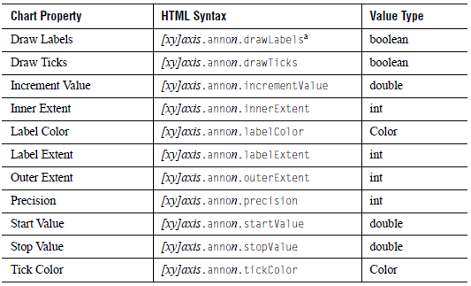
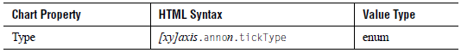
a. xaxis and yaxis are the names of the first axes, generated when chart properties are saved to an HTML file; additional axes are named xaxis1, xaxis2, ... xaxisn and yaxis1, yaxis2, ... yaxisn.

A.8 JCAxis X-Axes and Y-Axes Properties
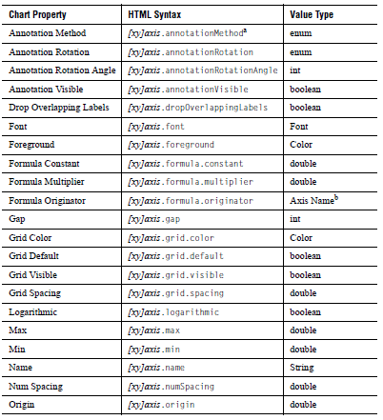
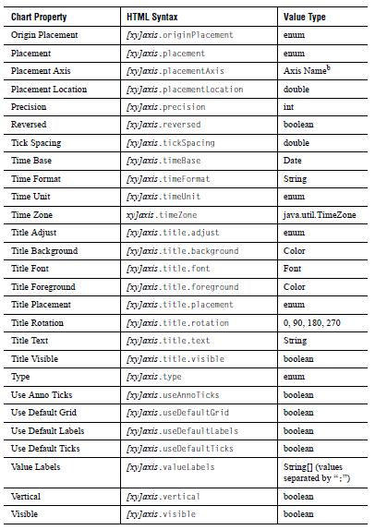
a. xaxis and yaxis are the names of the first axes, generated when chart properties are saved to an HTML file; additional axes are named xaxis1, xaxis2, ... xaxisn and yaxis1, yaxis2, ... yaxisn.
b. For example, xaxis1.

A.9 JCBarChartFormat Properties
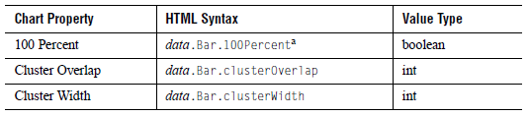
a. data is the name of the first dataset, generated when chart properties are saved to an HTML file; additional datasets are named data1, data2, ... datan.

A.10 JCCandleChartFormat Properties
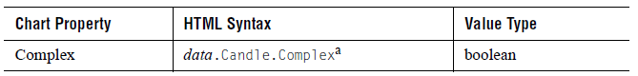
a. data is the name of the first dataset, generated when chart properties are saved to an HTML file; additional datasets are named data1, data2, ... datan.

A.11 JCChartArea Properties
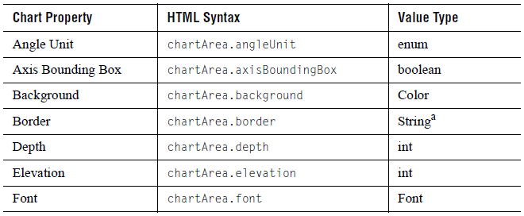
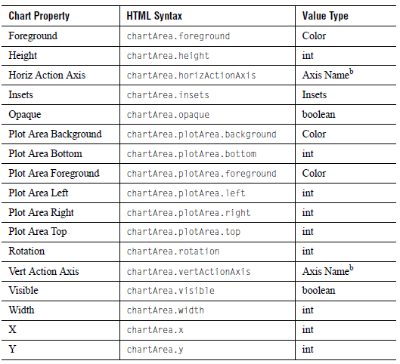
a. String of format bordertype|param1|param2|...
b. For example, xaxis1.

A.12 JCChartLabel Properties
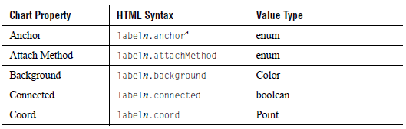
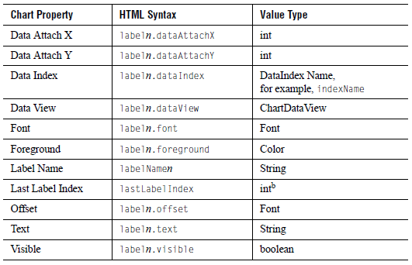
a. label1 is the name of the first Chart Label, generated when chart properties are saved to an HTML file; additional labels are named label2, label3, ... labeln.
b. The index of the last label. Used as the upper boundary on labels and data indices during load. Only needs to be explicitly specified if n is greater than 99.

A.13 JCDataIndex Properties
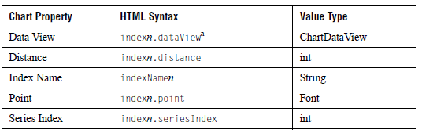
a. n is the index number.

A.14 JCGrid Properties
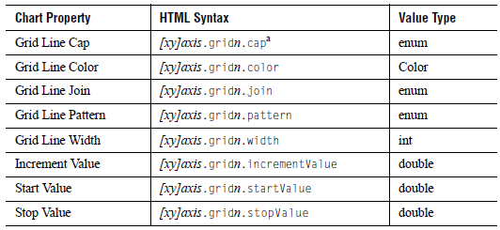
a. xaxis and yaxis are the names of the first axes, generated when chart properties are saved to an HTML file; additional axes are named xaxis1, xaxis2, ... xaxisn and yaxis1, yaxis2, ... yaxisn.

A.15 JCHiLoChartFormat Properties
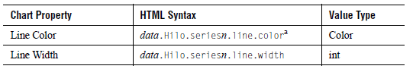
a. data is the name of the first dataset, generated when chart properties are saved to an HTML file; additional datasets are named data1, data2, ... datan.

A.16 JCHLOCChartFormat Properties
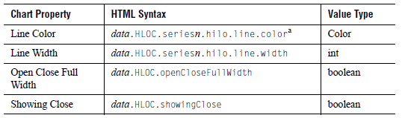
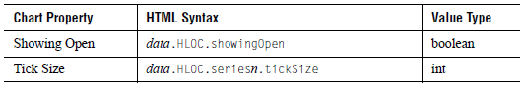
a. data is the name of the first dataset, generated when chart properties are saved to an HTML file; additional datasets are named data1, data2, ... datan.

A.17 JCLegend Properties
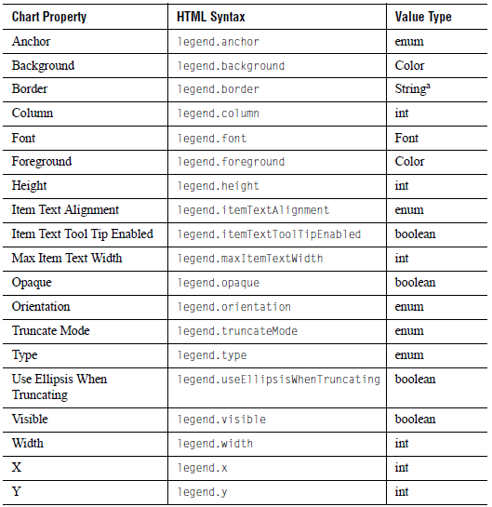
a. String of format bordertype|param1|param2|...

A.18 JCMarker Properties
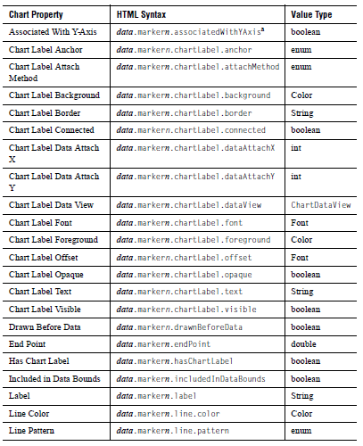
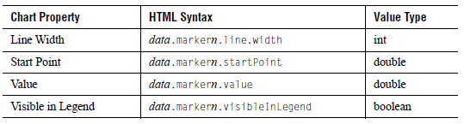
a. data is the name of the first dataset, generated when chart properties are saved to an HTML file; additional datasets are named data1, data2, ... datan.

A.19 JCMultiColLegend Properties
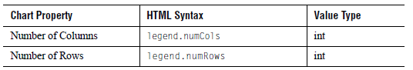

A.20 JCPieChartFormat Properties
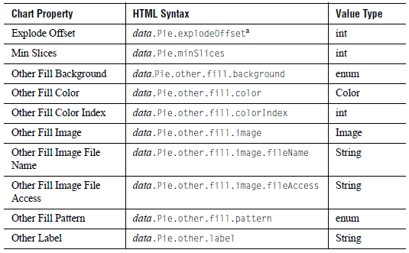
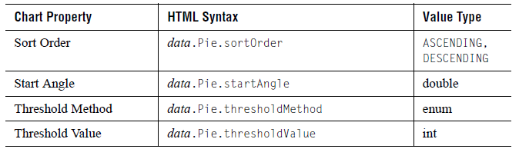
a. data is the name of the first dataset, generated when chart properties are saved to an HTML file; additional datasets are named data1, data2, ... datan.

A.21 JCPolarRadarChartFormat Properties
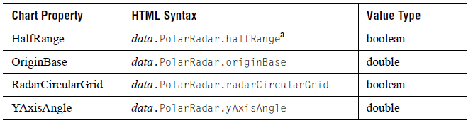
a. data is the name of the first dataset, generated when chart properties are saved to an HTML file; additional datasets are named data1, data2, ... datan.

A.22 JCServerChart Properties
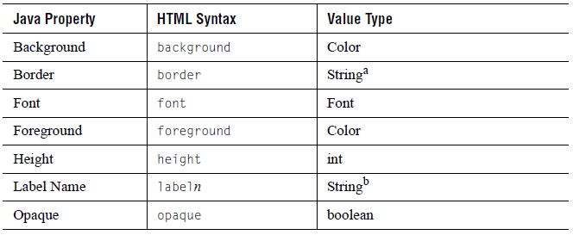
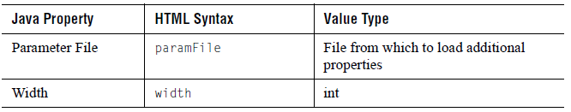
a. String of format bordertype|param1|param2|...
b. labeln is the number of Chart Labels when chart properties are saved to HTML.

A.23 JCThreshold Properties
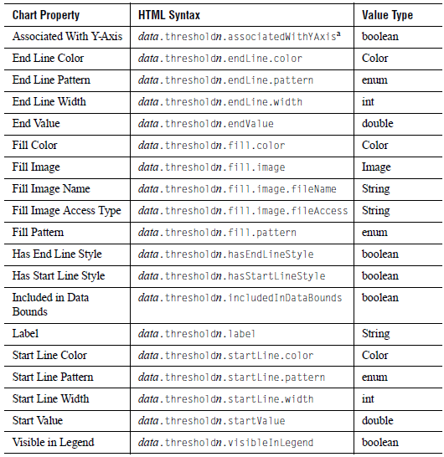
a. data is the name of the first dataset, generated when chart properties are saved to an HTML file; additional datasets are named data1, data2, … datan.

B
XML DTD
Chart.dtd ■ JCChartData.dtd

This appendix describes the DTDs available with JClass ServerChart. For more information, see Chapter 15, Loading and Saving Charts Using XML.

JClass ServerChart has two DTDs: Chart.dtd and JCChartData.dtd. In general, the elements, sub-elements, and attributes coincide with the objects, sub-objects, and properties within the chart component.

You should find that the values and types expected for each attribute are, for the most part, straightforward and easy to understand. However, there are a few types that require further explanation:

- Font: You specify Font types in the format “name-style-size”, where style is one of plain, bold, italic, or bolditalic. For example, the following syntax specifies a plain, 10 point Helvetica font: Helvetica-plain-10
- Color: You specify Color types in one of three ways: as a hexadecimal (#RRGGBB), as an RGB value (RRR-GGG-BBB), or as a color enum (such as black or white).
- JCAxis: JCAxis values correspond to the name of an axis. You specify JCAxis values using the value of the name attribute from the desired <axis> tag in the XML file.
- ChartDataView: ChartDataView values correspond to the name of a data view. You specify ChartDataView values using the value of the name attribute from the desired <chart-data-view> element in the XML file.

The next two sections describe the contents of the DTDs.

B.1 Chart.dtd
When using the Chart.dtd, the values of any properties that remain unspecified in the XML file remain unchanged when the XML file is applied to the chart. Properties are specified as strings in the XML file, and are converted to the appropriate type by the chart’s XML handler.

The following is a list of each of the Chart.dtd elements, as well as their descriptions.

B.1.1 chart

Purpose:
The main chart element. The properties and sub-elements by and large coincide with the properties and sub-objects of the corresponding object within the chart component.

Equivalent in JCServerChart
JClass JCServerChart:

Sub-Elements:
            - chart-area
            - chart-data-view
            - chart-label
            - component
            - event-trigger
            - external-java-code
            - fill-style
            - footer
            - header
            - key
            - legend
            - image-map-info
            - data-image-map-list
            - legend-image-map
            - locale
Attributes:

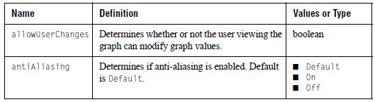
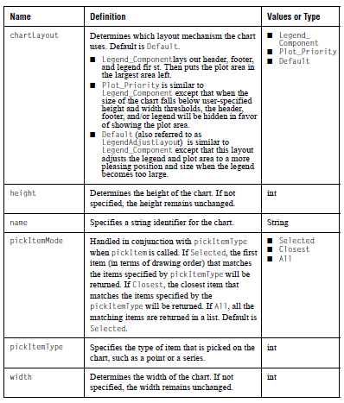

B.1.2 anno
Purpose:
Controls the chart annotation marks.

Equivalent in JCAnno
JClass JCServerChart:

Sub-Elements: none

Attributes:
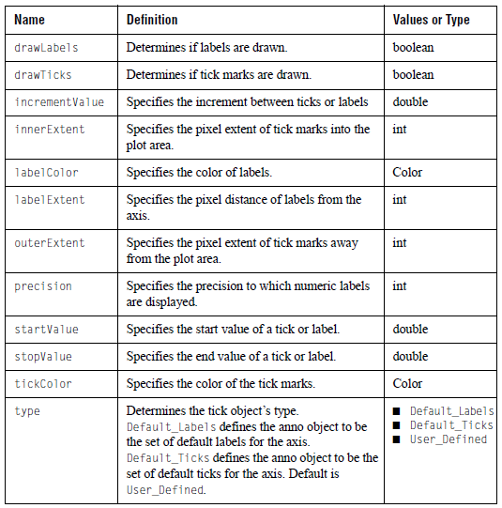

B.1.3 area-format
Purpose:
Properties specific to area charts.

Equivalent in JCAreaChartFormat
JClass JCServerChart:

Sub-Elements: none

Attributes:
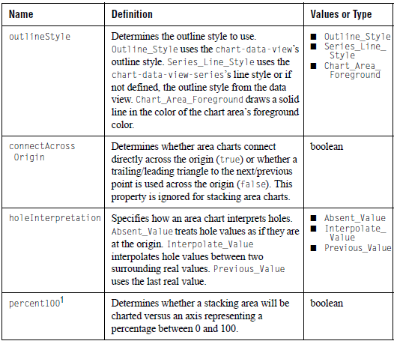1Equivalent property is 100percent.

B.1.4 axis
Purpose:
Has attributes that deal with drawing of x-axes and y-axes. Note that the placementAxis name needs to match an axis of the opposite type (i.e. for an x-axis the placementAxis needs to match a y-axis name). If no match occurs, the default “xaxis” or “yaxis” is assumed.
Equivalent in JCAxis
JClass JCServerChart:

Sub-Elements:
            - anno
            - axis-formula
            - axis-title
            - chart-interior-region
            - grid
            - image-map-info
            - line-style
            - time-exclusion
            - value-label

Attributes:

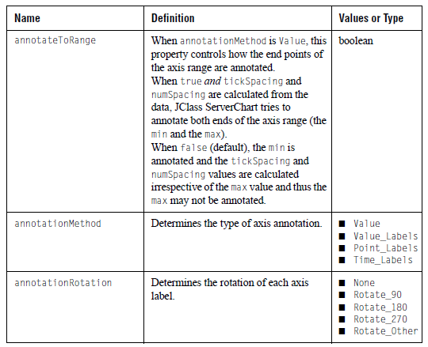
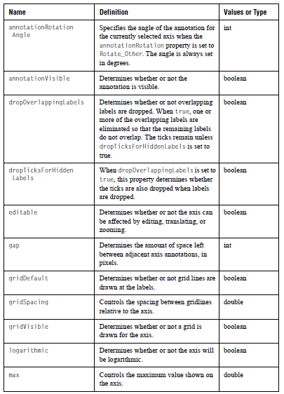
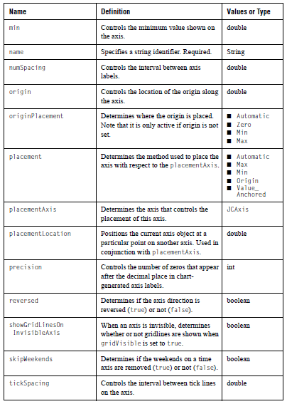
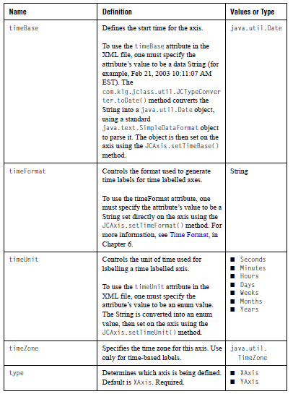
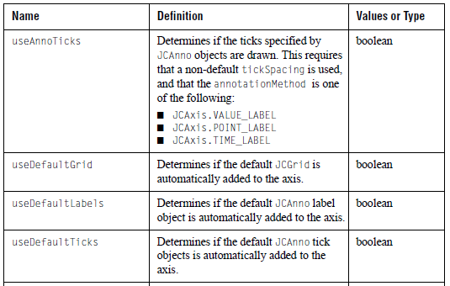

B.1.5 axis-formula
Purpose:
Defines a relationship between two axes. The originator attribute needs to match an existing axis name of the same axis type. If no match occurs, the default “xaxis” or “yaxis” is used.

Equivalent in JCAxisFormula
JClass JCServerChart:

Sub-Elements: none

Attributes:

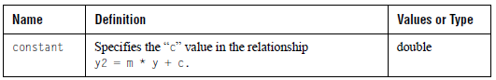
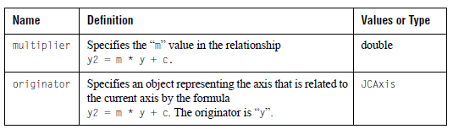

B.1.6 axis-title
Purpose:
The title for an axis.

Equivalent in JCAxisTitle
JClass JCServerChart:

Sub-Elements: chart-interior-region

Attributes:

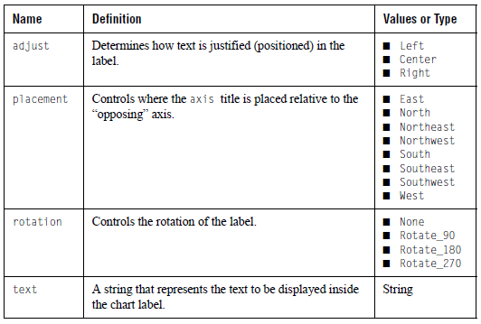

B.1.7 bar-format
Purpose:
Properties specific to bar and stacking bar charts.

Equivalent in JCBarChartFormat
JClass JCServerChart:

Sub-Elements: none

Attributes:

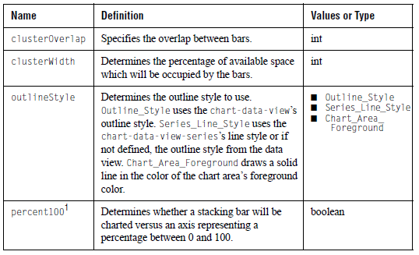
1Equivalent property is 100percent.

B.1.8 bevel-border
Purpose:
Bevel or SoftBevel borders.

Equivalent in javax.swing.border.BevelBorder or
JClass JCServerChart: javax.swing.border.SoftBevelBorder

Sub-Elements: none

Attributes:
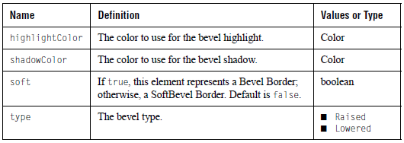

B.1.9 candle-format
Purpose:
Properties specific to candle charts.

Equivalent in JCCandleChartFormat
JClass JCServerChart:

Sub-Elements: none

Attributes:

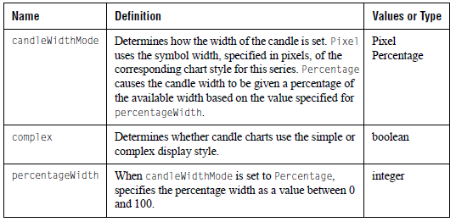

B.1.10 chart-area
Purpose:
This is the component within the chart in which the actual chart is drawn. Note that the horizActionAxis and vertActionAxis properties must match an axis name within the axis list or they will default to the primary x-axis or y-axis.

Equivalent in JCChartArea
JClass JCServerChart:

Sub-Elements:
            - component
            - fill-style
            - layout-hints
            - plot-area
            - image-map-info
            - axis

Attributes:

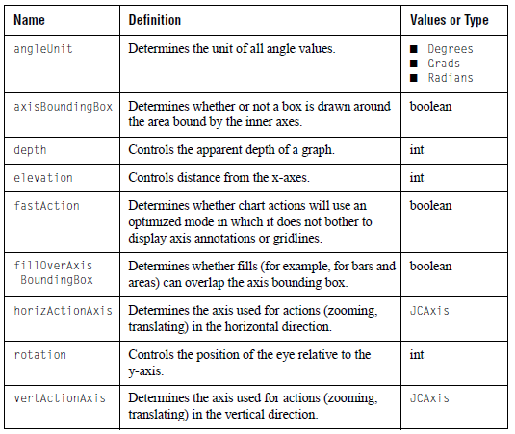

B.1.11 chart-data-file
Purpose:
Data file. If the data is in a file, use this element to reference it.

Equivalent in BaseDataSource or other class that implements the
JClass JCServerChart: ChartDataModel.

Sub-Elements: none

Attributes:

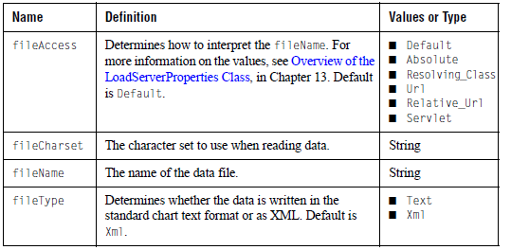

B.1.12 chart-data-threshold
Purpose:
For each data-threshold element (see the JCChartData.dtd) that is defined within the <data-series> tag, you need to add one of these chart-data-threshold elements to the <chart-data-view-series> tag.

Equivalent in JCDataThreshold
JClass JCServerChart:

Sub-Elements: chart-style

Attributes:
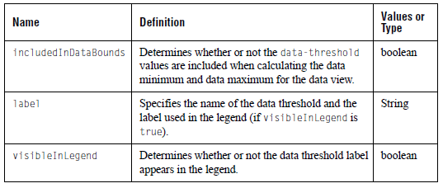

B.1.13 chart-data-view
Purpose:
Contains a representation of chartable data and attributes used to draw this data, like per series drawing information, chart type, and various chart type specific properties.
Note: Use JCChartData only if the data is specified using the old data XML format.

Equivalent in ChartDataView
JClass JCServerChart:

Sub-Elements:
            - area-format
            - bar-format
            - candle-format
            - (chart-data|chart-data-file|JCChartData)image-map-info
            - chart-data-view-series
            - envelope
            - hi-lo-open-close-format
            - line-style
            - marker
            - pie-format
            - polar-radar-format
            - point-label
            - plot-format
            - image-map-info (store the legend title image map information for the given data view)
            - threshold
            - timeline-format
            - timeline-state

Attributes:

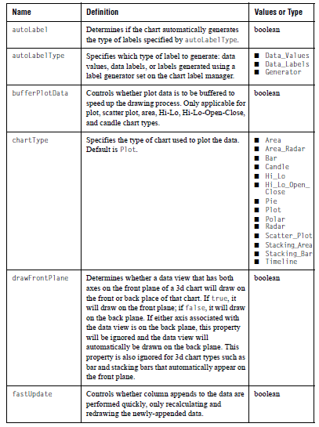
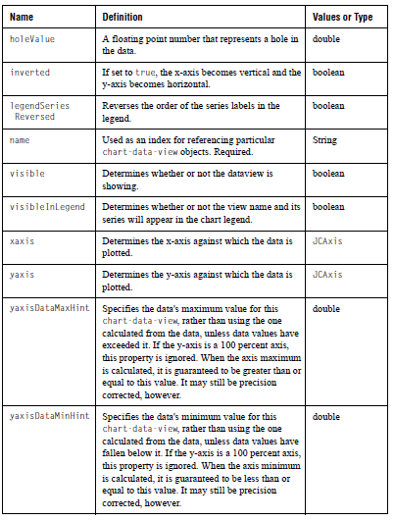

B.1.14 chart-data-view-series
Purpose:
Information on how and what to draw for a specific data series.

Equivalent in ChartDataViewSeries
JClass JCServerChart:

Sub-Elements:
            - chart-style
            - hole-style
            - chart-data-threshold

Attributes:

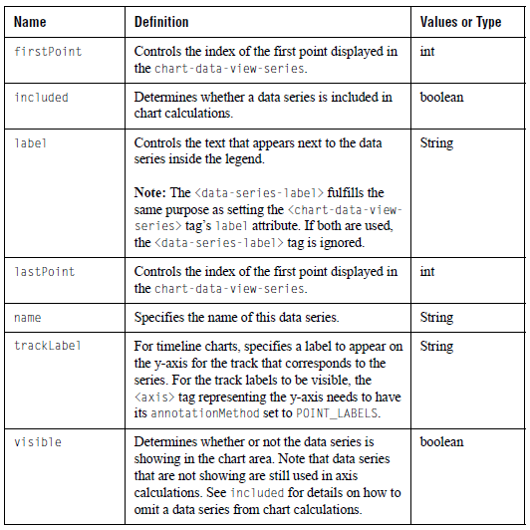
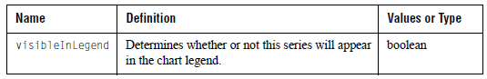

B.1.15 chart-interior-region
Purpose:
A rectangular region for drawing within chart that is not a component.

Equivalent in ChartInteriorRegion
JClass JCServerChart:

Sub-Elements: insets

Attributes:

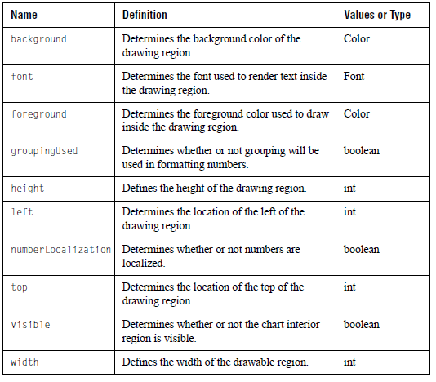

B.1.16 chart-label
Purpose:
A floating label that is attached somewhere to the chart. Note that if the dataView property is missing or does not match the name property of an existing ChartDataView element, it is assumed that the chart label is associated with the first (or primary) ChartDataView.

Equivalent in JCChartLabel
JClass JCServerChart:

Sub-Elements:
            - label
            - offset
            - coord
            - data-coord
            - data-index
            - line-style
            - image-map-info

Attributes:

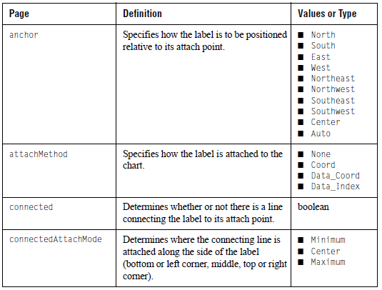
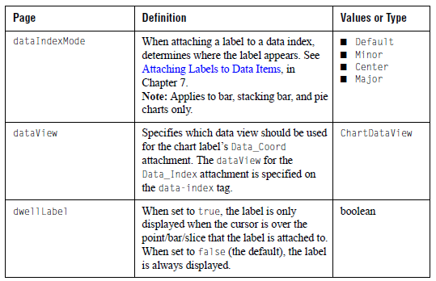

B.1.17 chart-style
Purpose:
Drawing specific properties of a series. Depending on the chart type, different aspects of the JCLineStyle, JCFillStyle and JCSymbolStyle are used.

Equivalent in JCChartStyle
JClass JCServerChart:

Sub-Elements:
            - line-style
            - fill-style
            - symbol-style

Attributes: none

B.1.18 component
Purpose:
Element which contains component properties. This element is a sub-element of those elements which represent components.

Equivalent in javax.swing.JComponent
JClass JCServerChart:

Sub-Elements: (empty-border|bevel-border|etched-
border|
line-border|matte-border|titled-border|
compound-border)

Attributes:

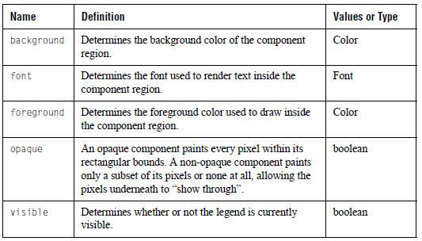

B.1.19 compound-border
Purpose:
Specifies an outside border and inside border. Note that these sub-borders can also be of the type compound-border.

Equivalent in javax.swing.border.CompoundBorder
JClass JCServerChart:

Sub-Elements:
      - (empty-border|bevel-border|etched-border|
line-border|matte-border|titled-border|
compound-border)
        - (empty-border|bevel-border|etched-border|
line-border|matte-border|titled-border|
compound-border)
Attributes:

B.1.20 coord
Purpose:
Given a chart-label whose attachMethod attribute is Coord, this is the chart coordinate (in pixels) to which the label is attached.

Equivalent in javax.swing.Point
JClass JCServerChart:

Sub-Elements: none

Attributes:

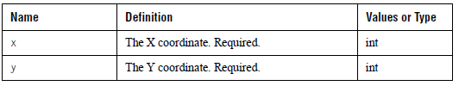

B.1.21 data-coord
Purpose:
Given a chart-label whose attachMethod attribute is DataCoord, this is the coordinate in data space to which the label is attached.

Equivalent in JCDataCoord
JClass JCServerChart:

Sub-Elements: none

Attributes:
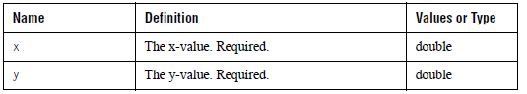

B.1.22 data-image-map
Purpose:
Allows users to specify a data image map.

Equivalent in ImageMapRules
JClass JCServerChart:

Sub-Elements: series-point

Attributes:

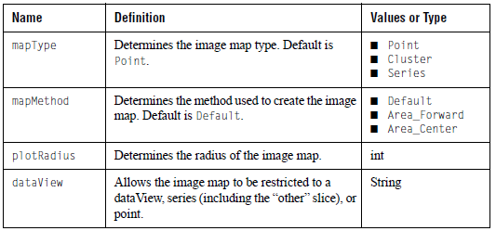

B.1.23 data-image-map-list
Purpose:
Specifies the list of data image map rules for the chart. If no rules have been specified in the XML file, the default case is assumed.

Equivalent in DataImageMapRulesList
JClass JCServerChart:

Sub-Elements: optional data-image-map tags

Attributes: none

B.1.24 data-index
Purpose:
Given a chart-label whose attachMethod attribute is DataIndex, gives the data index that the label is attached to.

Equivalent in JCDataIndex
JClass JCServerChart:

Sub-Elements: none

Attributes:

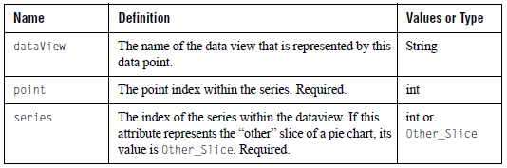

B.1.25 data-range
Purpose:
Defines a data range for a timeline-state.

Equivalent in JCDataRange
JClass JCServerChart:

Sub-Elements: none

Attributes:
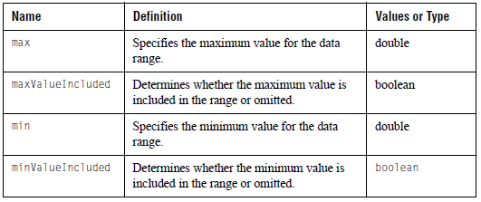

B.1.26 empty-border
Purpose:
Empty borders.

Equivalent in javax.swing.border.EmptyBorder
JClass JCServerChart:

Sub-Elements: insets

Attributes: none

B.1.27 end-limit
Purpose:
A list of points that represent the end limit for a threshold. There must be at least two valid points and the X values of the list must be increasing. This element is valid for rectangular charts only and the threshold must be associated with the y-axis.

Equivalent in JCThreshold
JClass JCServerChart:

Sub-Elements: data-coord

Attributes: none

B.1.28 end-line-style
Purpose:
A line style for the ending value boundary line for thresholds.

Equivalent in JCLineStyle
JClass JCServerChart:

Sub-Elements: line-sytle

Attributes: none

B.1.29 envelope
Purpose:
Contains properties that are used to draw envelopes on the chart area. Envelopes are only drawn for plots or scatter plot charts.

Equivalent in JCEnvelope
JClass JCServerChart:

Sub-Elements:
            - envelope-data
            - chart-style
            - hole-style

Attributes:

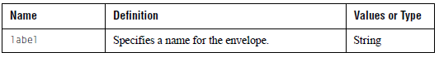
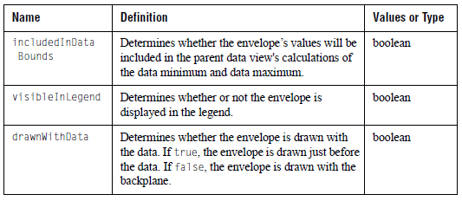

B.1.30 etched-border
Purpose:
Etched borders.

Equivalent in javax.swing.border.EtchedBorder
JClass JCServerChart:

Sub-Elements: none

Attributes:

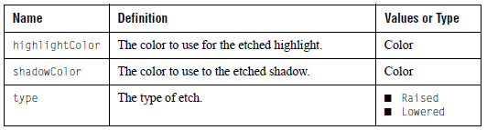

B.1.31 event-trigger
Purpose:
Event triggers are used to assign predefined chart actions such as rotate the chart or popup the customized mouse events.

Equivalent in EventTrigger
JClass JCServerChart:

Sub-Elements: none

Attributes:
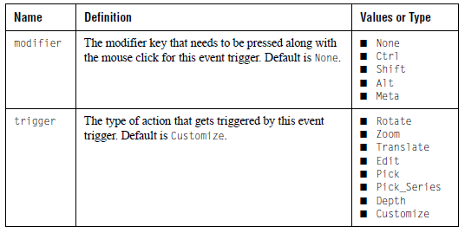

B.1.32 explode-list
Purpose:
A list (series, point) pairs that represent which slices on a pie have been exploded.

Equivalent in none
JClass JCServerChart:

Sub-Elements: series-point

Attributes: none

B.1.33 external-java-code
Purpose:
Specifies a Java class that will be created and called between the creation of a chart via XML and the return of control to the calling code. This can be used for encapsulating chart settings that cannot be set with XML (for example, populating the chart with data from a database query).

The Java class must contain an empty constructor, as well as implement the com.klg.jclass.util.property.xml.ExternalCodeHandler interface. The ExternalCodeHandler interface specifies a method named handle() that is called by the JClass ServerChart XML parser. The contents of the body of the tag will be passed to the handle() method in the userData parameter. The value of the UserObject property in the current LoadServerProperties class will be passed to the handle() method when it is called. For more information on LoadServerProperties, see Section 15.3, Creating a Chart Using XML.

Note: When a chart that was created via XML is later saved to XML, the contents of this tag are not written out.

Equivalent in n/a
JClass JCServerChart:

Sub-Elements: #PCDATA

Attributes:

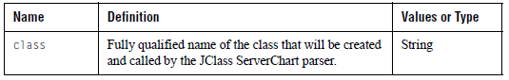

B.1.34 fill-style
Purpose:
The fill style used in the background of a component.

Equivalent in com.klg.jclass.util.style.JCFillStyle
JClass JCServerChart:

Sub-Elements:
            - gradient
            - image-file
            - image-position

Attributes:
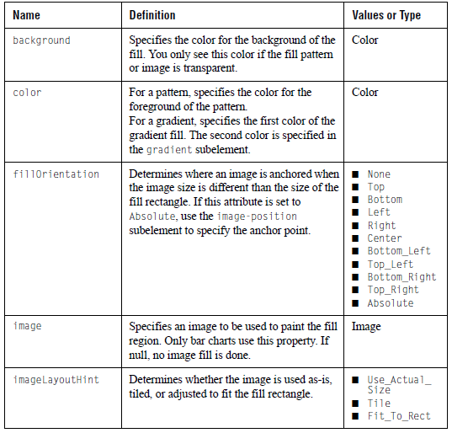
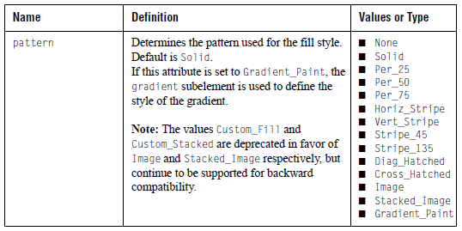

B.1.35 footer
Purpose:
The component used as the footer for the chart.

Equivalent in com.klg.jclass.util.label.JCLabel
JClass JCServerChart:

Sub-Elements:
            - component
            - image-file
            - image-map-info
            - layout-hints

Attributes:

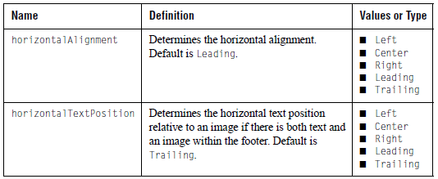
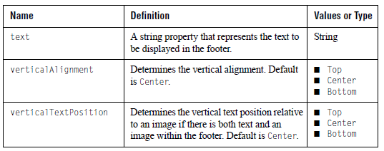

B.1.36 gradient
Purpose:
When the fill-style element’s pattern attribute is set to Gradient_Paint, this element determines the appearance of the gradient fill.

Equivalent in n/a
JClass JCServerChart:

Sub-Elements: none

Attributes:

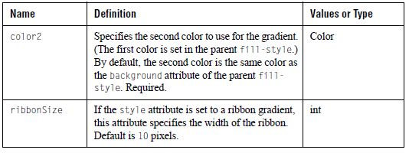
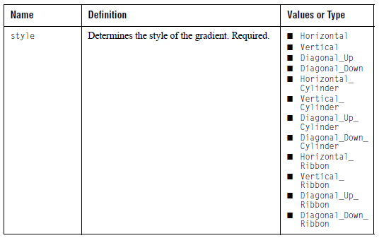

B.1.37 grid
Purpose:
Specifies the properties that are specific to the chart’s grids.

Equivalent in JCGrid
JClass JCServerChart:

Sub-Elements: line-style

Attributes:

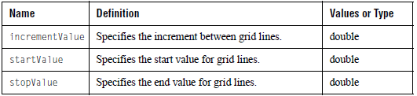

B.1.38 header
Purpose:
The component used as the header for the chart.

Equivalent in com.klg.jclass.util.label.JCLabel
JClass JCServerChart:

Sub-Elements:
            - component
            - image-file
            - image-map-info
            - layout-hints

Attributes:
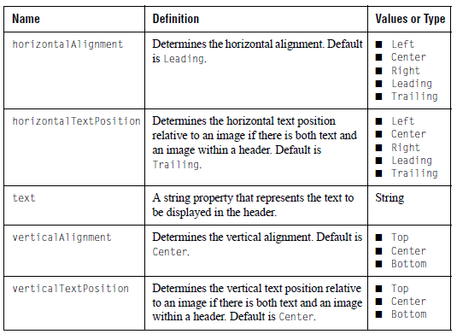

B.1.39 hi-lo-open-close-format
Purpose:
Properties specific to Hi-Lo-Open-Close charts.

Equivalent in JCHLOCChartFormat
JClass JCServerChart:

Sub-Elements: none

Attributes:
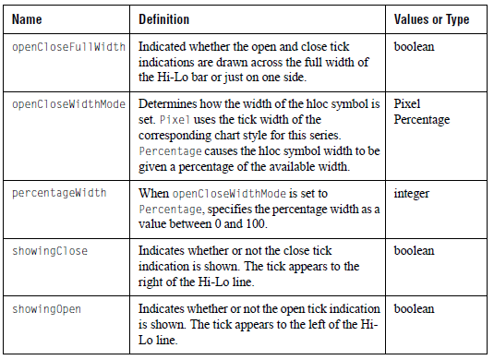

B.1.40 hole-style
Purpose:
Chart style used to draw hole values.

Equivalent in JCChartStyle
JClass JCServerChart:

Sub-Elements:
            - line-style
            - fill-style
            - symbol-style

Attributes: none

B.1.41 image-file
Purpose:
Specifies an iamge from an external source.

Equivalent in JCFillStyle.setImage(String filename)
JClass JCServerChart:

Sub-Elements: none

Attributes:

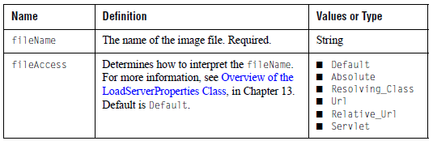

B.1.42 image-map-info
Purpose:
Sets the URL for an image map, and any extra information pertaining to it.

Equivalent in ImageMapInfo
JClass JCServerChart:

Sub-Elements: none

Attributes:

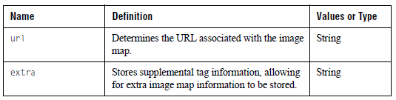

B.1.43 image-position
Purpose:
This attribute is used when the fill-style attributes are set as follows:
- pattern = Image
- fillOrientation = Absolute
- imageLayoutHint = Use_Actual_Size or Tile

Specifies an (x,y) position for the image within the rectangle to be filled. (0,0) corresponds to the top left corner of the fill rectangle.

Equivalent in java.awt.Point
JClass JCServerChart:

Sub-Elements: none

Attributes:

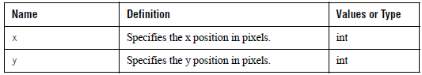

B.1.44 insets
Purpose:
A representation of the borders of a container.

Equivalent in java.awt.Insets
JClass JCServerChart:

Sub-Elements: none

Attributes:

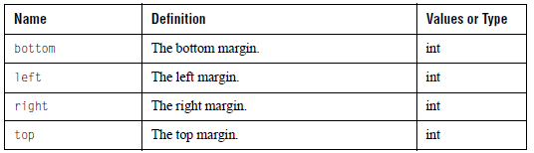

B.1.45 key
Purpose:
Key elements allow a key to be bound to reset or cancel actions.

Equivalent in none
JClass JCServerChart:

Sub-Elements: none

Attributes:
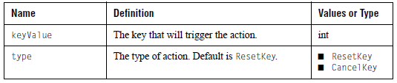

B.1.46 label
Purpose:
The label component of a chart label.

Equivalent in com.klg.jclass.util.label.JCLabel
JClass JCServerChart:

Sub-Elements:
- component
- image-file

Attributes:

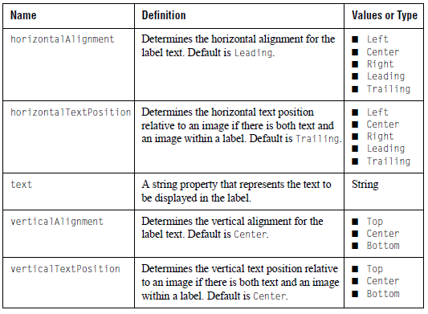

B.1.47 layout-hints
Purpose:
A rectangle that specifies where and at what size subcomponents of chart such as the header, footer, legend, and chart area are drawn. The chart calculates default layout rectangles for each subcomponent. Supplying layout hints allows the user to override some or all of the default values. If some attributes are not specified, they will be set to their default values.

Equivalent in java.awt.Rectangle
JClass JCServerChart:

Sub-Elements: none

Attributes:

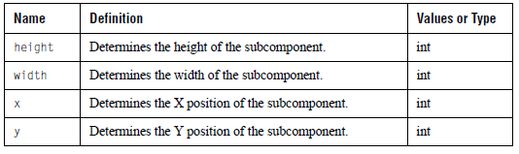

B.1.48 legend
Purpose:
This is the component within the chart in which the legend is drawn.

Equivalent in com.klg.jclass.util.legend.JCLegend
JClass JCServerChart:

Sub-Elements:
- component
- fill-style
- layout-hints
- legend-column
- image-map-info
- multi-col

Attributes:
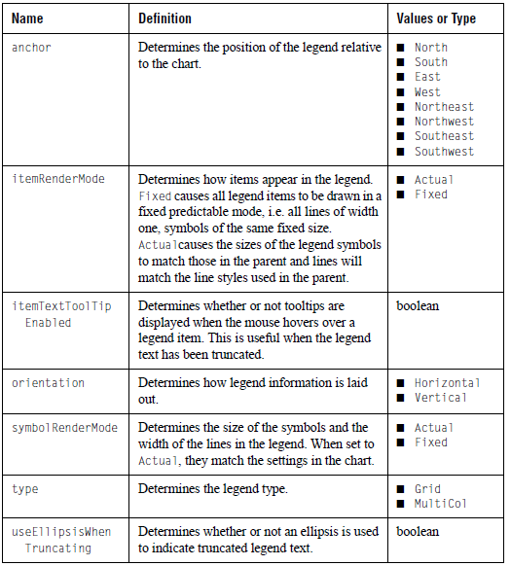

B.1.49 legend-column
Purpose:
Defines column attributes for the legend defined by the legend tag.

Equivalent in com.klg.jclass.util.legend.LegendColumn
JClass JCServerChart:

Sub-Elements: none

Attributes:
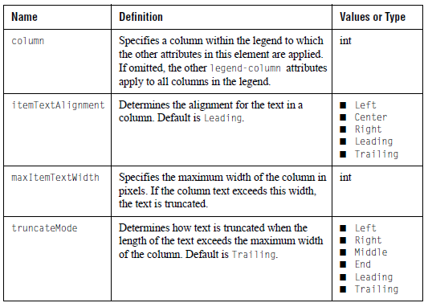

B.1.50 legend-image-map
Purpose:
Specifies an image map for the chart’s legend.

Equivalent in ImageMapRules
JClass JCServerChart:

Sub-Elements: series-point

Attributes:
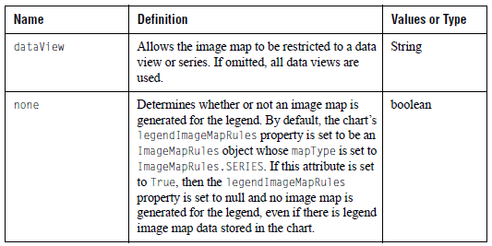

B.1.51 legend-image-map-info
Purpose:
Sets the URL for an image map in the legend plus any extra information.

Equivalent in ImageMapInfo
JClass JCServerChart:

Sub-Elements: none

Attributes:

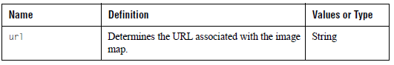

B.1.52 line-border
Purpose:
Line Borders.

Equivalent in javax.swing.border.LineBorder
JClass JCServerChart:

Sub-Elements: none

Attributes:
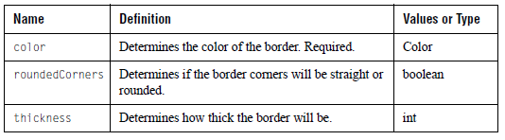

B.1.53 line-style
Purpose:
Line specific drawing properties.

Equivalent in JCLineStyle
JClass JCServerChart:

Sub-Elements: none

Attributes:

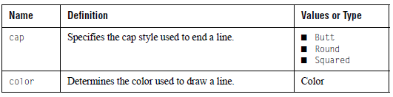
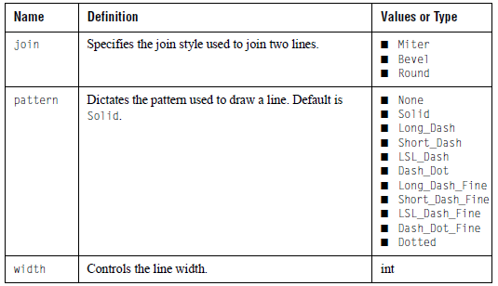

B.1.54 locale
Purpose:
Sets the locale for date, time, and number formatting. Does not affect the choice of the resource bundle used. For more information, see Section 15.6, Internationalizing Your XML-based Chart.

Equivalent in javax.util.Locale
JClass JCServerChart:

Sub-Elements: none

Attributes:

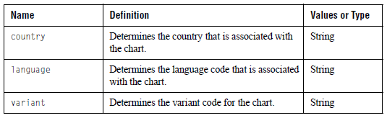

B.1.55 marker
Purpose:
Marker properties.

Equivalent in JCMarker
JClass JCServerChart:

Sub-Elements:
- line-style
- legend-image-map-info
- chart-label

Attributes:
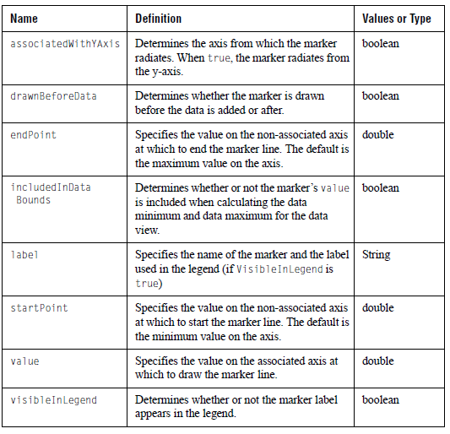

B.1.56 matte-border
Purpose:
Matte borders.

Equivalent in javax.swing.border.MatteBorder
JClass JCServerChart:

Sub-Elements: insets

Attributes:

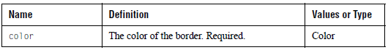

B.1.57 multi-col
Purpose:
Attributes to use when the value of the <legend> element’s type attribute is MultiCol.

Equivalent in com.klg.jclass.util.legend.JCMultiColLegend
JClass JCServerChart:

Sub-Elements: none

Attributes:

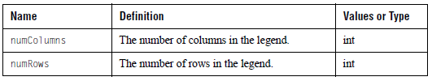

B.1.58 offset
Purpose:
The offset from where the label is attached to the chart to where the label is drawn.

Equivalent in java.awt.Point
JClass JCServerChart:

Sub-Elements: none

Attributes:

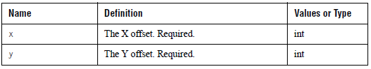

B.1.59 other-slice-image-map-info-list
Purpose:
A list of image-map-info objects that give URL and extra information for the other slice, one for each data point.

Equivalent in java.util.List
JClass JCServerChart:

Sub-Elements: image-map-info

Attributes: none

B.1.60 pie-format
Purpose:
Properties specific to pie charts.

Equivalent in JCPieChartFormat
JClass JCServerChart:

Sub-Elements:
- fill-style
- other-slice-image-map-info-list
- image-map-info
- explode-list

Attributes:

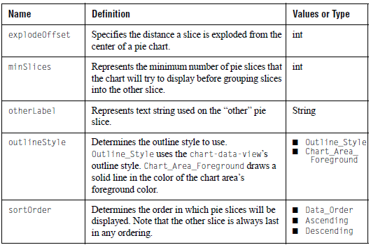
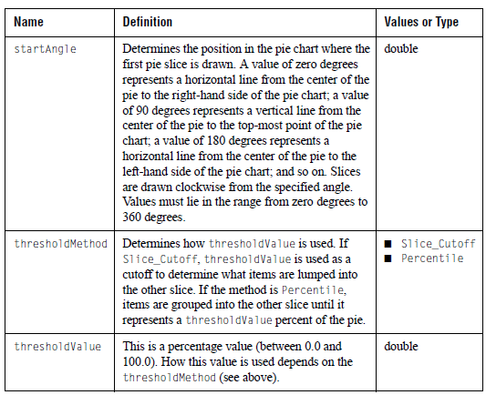

B.1.61 plot-area
Purpose:
The rectangle within the chart area into which the data is drawn.

Equivalent in PlotArea
JClass JCServerChart:

Sub-Elements: image-map-info

Attributes:

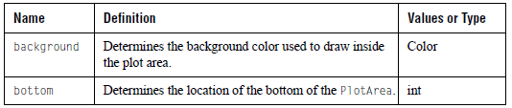
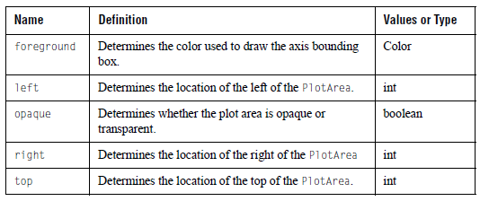

B.1.62 plot-format
Purpose:
Properties specific to plot charts.

Equivalent in JCPlotChartFormat
JClass JCServerChart:

Sub-Elements:

Attributes:

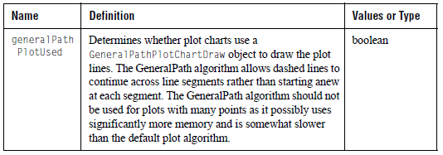

B.1.63 point-label
Purpose:
Labels specified on a per point basis for the data. This specification overrides any point labels specified in the data.

Equivalent in java.util.String
JClass JCServerChart:

Sub-Elements: none

Attributes: #PCDATA (the label)

B.1.64 polar-radar-format
Purpose:
Properties specific to radar and polar charts.

Equivalent in JCPolarRadarChartFormat
JClass JCServerChart:

Sub-Elements: none

Attributes:

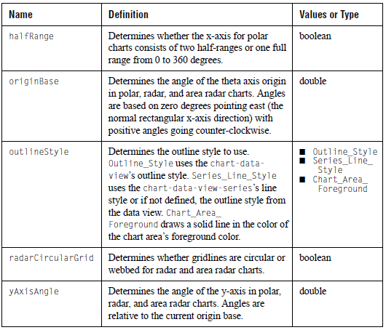

B.1.65 series-point
Purpose:
Represents a series and point for use within other elements.

Equivalent in none
JClass JCServerChart:

Sub-Elements: none

Attributes:

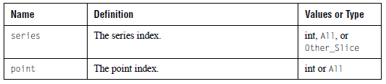

B.1.66 start-limit
Purpose:
A list of points that represent the starting limit for a threshold. There must be at least two valid points and the X values of the list must be increasing. This element is valid for rectangular charts only and the threshold must be associated with the y-axis.

Equivalent in JCThreshold
JClass JCServerChart:

Sub-Elements: data-coord

Attributes: none

B.1.67 start-line-style
Purpose:
A line style for the starting value boundary line for thresholds.

Equivalent in JCLineStyle
JClass JCServerChart:

Sub-Elements: line-style

Attributes: none

B.1.68 symbol-style
Purpose:
Symbol specific drawing properties.

Equivalent in JCSymbolStyle
JClass JCServerChart:

Sub-Elements: none

Attributes:

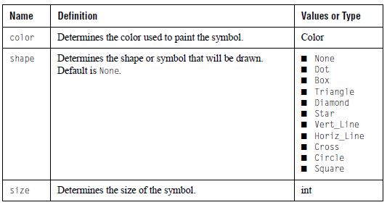

B.1.69 threshold
Purpose:
Threshold properties.

Equivalent in JCThreshold
JClass JCServerChart:

Sub-Elements:
- fill-style
- start-line-style
- end-line-style
- legend-image-map-info
- start-limit
- end-limit

Attributes:
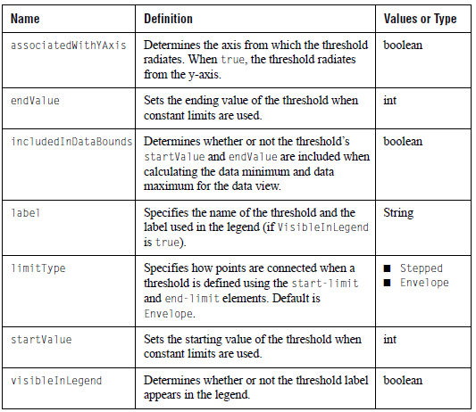

B.1.70 time-exclusion
Purpose:
Excludes time from a time axis.

Equivalent in JCTimeExclusion
JClass JCServerChart:

Sub-Elements: none

Attributes:
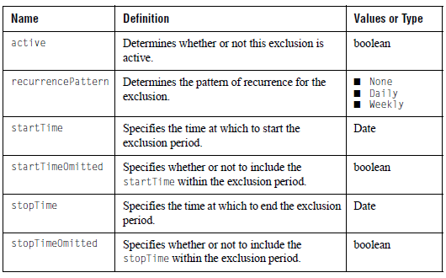

B.1.71 timeline-format
Purpose:
Properties specific to a timeline chart.

Equivalent in JCTimeLineChartFormat
JClass JCServerChart:

Sub-Elements: none

Attributes:
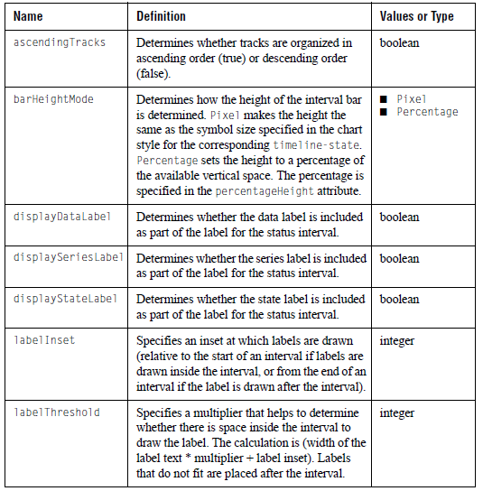
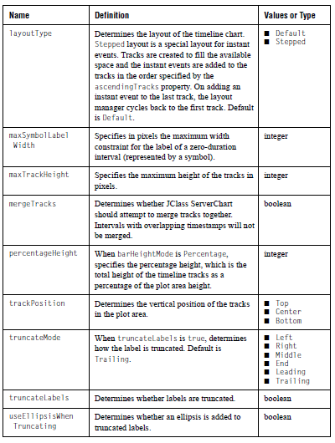

B.1.72 timeline-state
Purpose:
Defines a state to be used in a timeline chart.

Equivalent in TimeLineState
JClass JCServerChart:

Sub-Elements:
- chart-style
- data-range

Attributes:

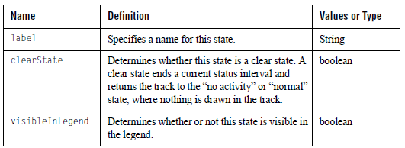

B.1.73 titled-border
Purpose:
A titled border.

Equivalent in javax.swing.border.TitledBorder
JClass JCServerChart:

Sub-Elements: (empty-border|bevel-border|etched-border|line-border|matte-border)

Attributes:

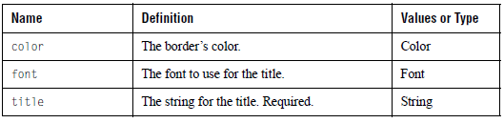
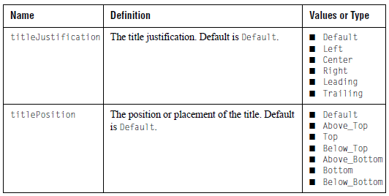

B.1.74 value-label
Purpose:
A value and label to be placed on an axis.

Equivalent in JCValueLabel
JClass JCServerChart:

Sub-Elements: #PCDATA (the label)

Attributes:

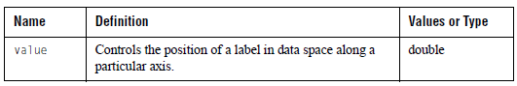

B.2 JCChartData.dtd
Data can be read in by series or by point. When read in by series, a list of <data-point-label> elements is followed by a list of <data-series> elements. For more information, please refer to Specifying Data by Series, in Chapter 4. When read in by point, a list of <data-series-label> elements is followed by a list of <data-point> elements. For more information, please refer to Specifying Data by Point, in Chapter 4. The following is a list of each of the JCChartData.dtd elements, as well as their descriptions.

B.2.1 chart-data
Purpose:
The main element for chart data.

Equivalent in JCChartData
JClass JCServerChart:

Sub-Elements:
- data-point
- data-point-label
- data-series
- data-series-label
- track-label

Attributes:

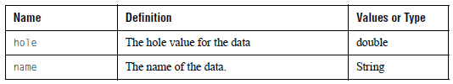

B.2.2 data-point
Purpose:
Specify all the series data for a given point.

Equivalent in none
JClass JCServerChart:

Sub-Elements:
- data-point-label
- x-data
- y-data

Attributes:

B.2.3 data-point-label
Purpose:
Provide a label for a given point.

Equivalent in java.util.String
JClass JCServerChart:

Sub-Elements: #PCDATA (the point label)

Attributes: none

B.2.4 data-series
Purpose:
Specify all the point data for a given point.

Equivalent in none
JClass JCServerChart:

Sub-Elements:
- data-series-label
- data-threshold
- track-label
- x-data
- y-data

Attributes:

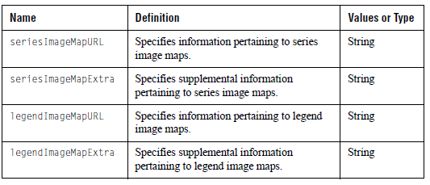

B.2.5 data-series-label
Purpose:
Provide a label for a given series. Normally seen in the Legend.

Equivalent in java.util.String
JClass JCServerChart:

Sub-Elements: #PCDATA (the series label)

Attributes: none

Note: The <data-series-label> fulfills the same purpose as setting the <chart-data-view-series> tag’s label attribute. If both are used, the <data-series-label> tag is ignored.

B.2.6 data-threshold
Purpose:
Provide a list of threshold values for a given series (displayed in bar charts only).

Equivalent in JCDataThreshold
JClass JCServerChart:

Sub-Elements: y-threshold-data

Attributes: none

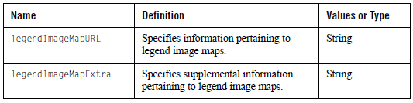

B.2.7 envelope-data
Purpose:
Defines the data for a data envelope used for a plot or scatter plot chart. It requires an x-data-list and two y-data-lists to define the envelope.

Equivalent in none
JClass JCServerChart:

Sub-Elements:
- x-data-list
- y-data-list

Attributes: none

B.2.8 track-label
Purpose:
Labels a track in a timeline chart along the y-axis.

Equivalent in java.util.String
JClass JCServerChart:

Sub-Elements: #PCDATA (the track label)

Attributes: none

B.2.9 x-data
Purpose:
Provide a single x-data value.

Equivalent in double
JClass JCServerChart:

Sub-Elements: #PCDATA (the x-value)

Attributes:

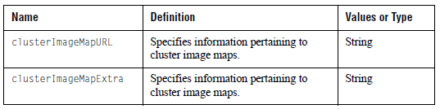

B.2.10 x-data-list
Purpose:
A list of x-data values for a data envelope.

Equivalent in An array of values
JClass JCServerChart:

Sub-Elements: x-data

Attributes: none

B.2.11 y-data
Purpose:
Provide a single y-data value.

Equivalent in double
JClass JCServerChart:

Sub-Elements: #PCDATA (the y-value)

Attributes:
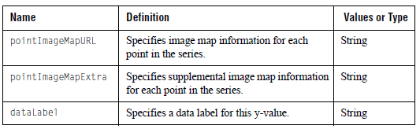

B.2.12 y-data-list
Purpose:
A list of y-data values for a data envelope.

Equivalent in An array of values
JClass JCServerChart:

Sub-Elements: y-data

Attributes: none

B.2.13 y-threshold-data
Purpose:
A data threshold value for a given series

Equivalent in double
JClass JCServerChart:

Sub-Elements: #PCDATA

Attributes: none

Glossary
A
Abstract Class
Any class that cannot be instantiated because it contains at least one abstract method or is declared as abstract, is an Abstract Class. It is possible to extend an abstract class, or make it concrete, by implementing the abstract method.

See Abstract Method.

Abstract Method
An Abstract Method is simply a method which does not have a body, and therefore cannot have an implementation. Abstract Methods are only signature definitions.

Abstract Windowing Toolkit (AWT)
The Abstract Windowing Toolkit is a series of graphical user interface components. These components are implemented using their native-platform versions, and provide a common subset of functionality.

Annotation
An Annotation is a commentary that has been added to a chart. Annotations can be used to describe chart elements, making the chart more useful to an end-user.

Area Chart
An Area Chart is a type of chart that draws each data series as a connected points of data and fills in the area below the points. Each series is layered over the preceding series.

Area Radar Chart
An Area Radar Chart is a type of chart that draws each data series as connected points of data and fills the area inside the points. The points are the same as they would be for a radar chart.

Argument
The data item specified in a method call is an Argument. Also referred to as a parameter.

See Method.

Array Data
Array-formatted data shares a single series of x-data among one or more series of y-data. Array format is the recommended standard, because it works well with all of the chart types.

Array
An Array is a collection of objects of the same type. Each object has its own position, that is specified by an integer.

Attribute
An Attribute is directly associated with the entity of the instance or instances for which it exists, and is simply a named value or relationship to the entity.

Axis Bounds
Axis Bounds define which area of a generated chart will be displayed. The area of a chart within the confines of the Axis Bounds will be displayed; the area of a chart outside the Axis Bounds will not.

Axis Orientation
Axis Orientation determines how the axes are positioned on the chart, with regard to their orientation. An axis can be either horizontal or vertical; generally, the x-axis horizontal is and the y-axis is vertical.

B

Bar Chart
A Bar Chart is a type of chart that generates a rectangle bounding a bar at a data point.

Base Class
A Base Class is a basic set of properties and methods from which one can extend in order to create more specialized classes.

BeanBox
Sun’s BeanBox is a tool intended to be used as a text container and reference base.

C
Candle Chart
A Candle Chart is a type of chart that generates a rectangle bounding the Candle shape at a data point extending outward on all four sides.

Chart Area
The Chart Area contains most of the chart’s actual properties because it is responsible for charting the data; it is also where the data is displayed.

Chart Data Source
The Chart Data Source takes real-world data and puts it into a form that JClass ServerChart can use. The data it produces will be used to generate a chart.

Chart Label
A Chart Label is a text String that is placed on the visible area of the chart. Its purpose is to clarify the displayed chart. A Chart Label can be either static or interactive.

Chart Style
A Chart Style defines the visual attributes of how data appears in the chart. This includes the lines and points in plots and financial charts, the color of each bar in bar charts, the slice colors in pie charts, and the color of each filled area in area charts.

Chartable Data Source
See Chart Data Source.

Class
A Class is a collection of data and its methods. Object implementations are defined in Classes, as well as the interface it implements and its superclass (which is Object by default). A Class also includes instance and class variables and methods. Classes are arranged hierarchically so as to allow classes to inherit from their superclasses.

Classpath
A Classpath points to files, archives, and directories so that the JVM and other Java programs can find them. It is an environment variable that must be set for JClass products to function properly.

Cluster
Cluster, which is used in Bar Charts, refers to a series of bars which represent one unit of data. For example, when displaying company earnings, you might chart three bars, where each bar represents the earnings of a different year. The three bars together form a cluster. Clusters can be useful tools when comparing different sets of data.

Cluster Map Type
A Cluster Map Type is a map type that specifies that image map shapes are generated for the shape bounding a cluster of points, at each data point. When using this map type, shapes can be restricted to a data view or point within all series. Series restriction has no effect.

Cluster Overlap
Cluster Overlap is the amount of space that the individual bars in a cluster overlap. Bars in different clusters do not overlap one another.

Cluster Width
The Cluster width is the total space used by the width of each cluster. It does not specify the width of the individual bars, but the width of the entire cluster.

Component
A Component is simply a software unit (for example, an applet). It exists at the application-level and is supported by a container. Components are configurable at deployment time.

Connection Pool
In order to allow a database to reuse connections in the future when requests for data are received, a cache of database connections is maintained in the database’s memory. This cache is the Connection Pool.

Constructor
Constructors are instance methods that have the same name as their class, and are used to do any initialization required for new objects.

Container
A Container surrounds a component to provide it with security, deployment, runtime services, and component-specific services.

CSS
Cascading Style Sheets

CSS allow styles to be defined, and later used, in an HTML file. These styles can be stored in-line in the HTML file or in a separate CSS file.
D
Data Hole
A Data Hole is a specific location in a chart where no data is drawn. Data Holes are user defined, and the area in the chart will be left blank.

Data Loading
Data Loading is the process by which JClass ServerReport receives the data from the database to use in the chart.

Data Model
A Data Model is the result of physically organizing data in a logical fashion. It is used as a template or interface through which a data source is constructed. In the case of a database, a Data Model is useful because it contains information pertaining to the contents of a database, including how the database information is used and how items in the database relate to one another.

Data Series
A Data Series is a series of columns that contain numeric data.

Data Source
Data Source refers to the database from which JClass ServerReport has gathered the data used to draw the chart. For example, JClass DataSource.

Data View
A Data View is a collection of series objects, one for each series of data points, used to store the visual display style of each series.

DBMS
DataBase Management System

DBMS is the software (or set of software) that controls the major functions of a database (for example, organization, storage, retrieval of data, and security).

Delimiter
A Delimiter series as an indication of the beginning and the end of a block or data.

Depth
In a 3D chart, Depth defines the dimension downward, backward, or inward of the chart.

Document Type Definition (DTD)
In JClass ServerReport, the DTD is a file, included with the installation, that defines the tags and attributes used to specify that appearance of a chart when using XML.

DTD tags are built into the JClass ServerReport API.

Dwell Label
A Dwell Label is an interactive label, available with Flash encoding, that appears when a cursor remains over a chart and disappears when the cursor moves. Normally, the cursor would remain over a point, bar, or slice, and the label would display data referring to that point, bar, or slice.

Dynamic Web Content
Dynamic Web Content refers to content on a web page that, with the help of a servlet, can be modified as it is being viewed on a user’s screen. This content can be modified as a result of a user activity, as a part of a timing mechanism, or otherwise.

E
Elevation
In a 3D chart, Elevation refers to the height to which the 3D elements of the chart are lifted above a point of reference.

Event
An Event is a significant occurrence in a program.

Event Trigger
An Event Trigger is a mapping of a mouse operation and/or a key press to a chart action.

Exception
When running a program, an Exception is something that will stop the program’s normal execution. Generally, an error will be produced.

Explode
Explode is an action that can take place in a pie chart, if exploding pie slices are enabled. Explode refers to a pie slice that detaches from the rest of the pie when a user clicks it.

Extensible Markup Language (XML)
Extensible Markup Language is a standard information document exchange format. XML is a simplified version of SGML, which creates very structured documents that is intended for use with Web documents. XML allows for the creation of customized tags; its structure is defined in a DTD file.

See Document Type Definition (DTD).

Extensible Style Sheet Language (XSL)
Extensible Style Sheet Language is a W3C standard for defining stylesheets for XML. XSL uses the XML language.

Extensible Style Sheet Language Transformation (XSLT)
Extensible Style Sheet Language Transformation is the language used to alter and manipulate documents, transforming XML documents.
F

Flash
Flash is an animation technique that uses vectors instead of pixel graphical information. The file extension is .swf.

Footer
The Footer is the text at the bottom of the chart.

Foreground
The Foreground of a chart is the part that appears the closest to the user. If there are layers to the chart, the foreground is the top layer.

G
Gap
Gap refers to the space between different axis annotations in a chart.

General Data
General-formatted data specifies a series of x-data for every series of y-data. General Format may not display data properly in Stacking Bar, Stacking Area, Pie, and Bar charts.

GIF
Graphic Interchange Format

GIF is a loss-less compression image format. GIF files use 256 colors, and are therefore most commonly used for drawings and icons.

Gridlines
Gridlines are patterns of regularly spaced horizontal, vertical, and/or circular lines that identify different X and Y points on the chart. Gridlines can be set to visible or invisible.

H

Half-Range
When using a circular grid, a Half-Range is an axis that is displayed in two ranges: one from -180 to 0 degrees, and a second from 0 to 180 degrees.

Header
The Header is the text at the top of the chart.

Headlessness / Headless Operation
Headlessness is the ability of a component to render itself without drawing to a screen or having any rendering system present. No peripherals need to be present during a Headless Operation.

Hex Values (color)
Hex Values are a way to define colors. Hex values are presented in the format #RRGGBB, #RRRRGGGGBBBB, or #N.

Hi-Lo Chart
The Hi-Lo Chart is a type of chart that generates a chart with a line at a data point extending outwards on all four sides

Hi-Lo-Open-Close Chart
The Hi-Lo-Open-Close Chart is a type of chart that generates a chart with a rectangle bounding the Hi-Lo-Open-Close shape at a data point extending outwards on all four sides.

Hole Value
See Data Hole.

I
IDE Integrated Development Environment
An IDE is a graphical software development interface. JClass components can be used inside many IDEs; see the JClass ServerViews Installation Guide for details.

Image Map
When an image is divided into different clickable sections, with each section pointing to a different place, it is the Image Map that refers each of those different sections to their respective pointers. In other words, each clickable section maps itself to an area in the image map, which then produces the link when clicked.

Inheritance
The variables and methods defined in a class are passed down, or inherited, by their subclasses. This concept is known as Inheritance.

Inheritance Hierarchy
An Inheritance Hierarchy is the diagram that represents, in a hierarchical fashion, classes and subclasses, starting with a root class.

Instantiate
Instantiating refers to the production of a particular object from its class template or definition.

Intelligent Defaults
Intelligent Defaults refers to the MultiChart Bean’s set of dynamic default settings. In the custom property editors, the default settings will automatically adjust.

Interface
An Interface is what is seen and used or manipulated on the computer screen by a user (e.g. IBM’s Visual Age).

Internationalization
Internationalization is the process of making software that is ready for adaptation to various languages and regions without engineering changes. JClass products are internationalized if you purchase the source code.

Interpreter
The Interpreter is used to invoke a Java program. It will decode and execute each statement, and runs until the end of the program.
J
JAR
Java Archive

A JAR is a compressed file which includes all classes necessary for a Java applet to work.

Java Application
A Java Application is a standalone Java program run by the Java virtual machine.

JavaBeans
Java Beans are logical, portable, platform-independent, and reusable components that are written and used by Java.

See Component.

JavaServer Faces (JSF)
JavaServer Faces (JSF) is a server-side technology for developing web applications with rich user interfaces. It contains Java APIs and a custom JSP tag library.

JavaServer Pages (JSP)
A JSP returns dynamic content to a client through the use of template data, custom elements, scripting languages, and server-side Java objects. Because JSP is an extensible Web technology, the template data is typically HTML or XML, and the client is often a Web browser.

JDK
Java Development Kit

A JDK is a development environment, created by Sun, which allows a user to create Java code.

JPEG Joint Photographic Expert Group
JPEG is an image format with a standardized image compression mechanism (note that it has lossy compression). It is most commonly used for pictures and other complex images.

JVM
Java Virtual Machine

A JVM is a virtual machine that is used to safely execute byte code in Java class files on a microprocessor.

L

Legend
The Legend is a reference in the JClass ServerChart chart which explains the significance of any differences that exist on the plotted chart (for example, bar color or different lines styles).

Linear Axis
A Linear Axis is an axis where every tick representing a number has the same distance between it and the number preceding or following it in the axis. In other words, the distance between ticks is a constant.

Logarithmic Axis
A Logarithmic Axis is an axis that uses the values of N/N0, rather than linear values, to aid in the graphing of logarithmic expressions. In other words, the distance between ticks is based on a logarithmic scale.
M
Map Type
The JClass ServerChart Map Type specifies the image map shapes in a chart. There are three map types: point (default), cluster, and series.

Method
A Method is a function which is defined in a class and, unless otherwise specified, is not static. When a class is instantiated, its Methods will run.

Model View Controller (MVC)
MVC is a logical way of separating the different elements of interactive software. The internal workings are referred to as the Model, the visual representation portrayed to the viewer is the View, and the ways in which the user changes the View or provides input is the Controller.

Mouse Event
A Mouse Event is an event that has been implemented through the use of a mouse.

See Event.

O
Object
An Object is used to contain the variable data and method definitions that are needed to instantiate a class, and is the building block or object-oriented programming.

Object Collection
An Object Collection is a container that is used to hold and group objects together. Once the objects have been placed in an Object Container, they can be accessed through one variable.

Origin Base
The Origin Base is the start angle of a circular chart

“Other” Slice
In a pie chart, the “Other Slice” refers to the grouping of unimportant values into one slice, rather than have them represented separately. The use of the “Other Slice” often makes a pie chart more effective.
.P
Package
A Package is a group of classes or interfaces, and is declared with the package keyword. Often, packages are groups of classes or interfaces that have been grouped together to provide a specific type of functionality.

Page
JClass ServerReport prints data to a Page. The Page is simply the unit where frames are placed, allowing for data to be printed.

Parameter
A Parameter is a data item specified in a method call. Also referred to as an argument.

Parser
A Parser determines the syntactic structure of a sentence or String.

PDF
Portable Document Format

PDF allows a document to be represented in a form that is independent from the original software, hardware, and operating system that was used to create it. Adobe System’s Acrobat uses this file format, and allows PDF files to contain text, graphics, and images. PDF files are known to be versatile and well suited for distribution.

Pick
Pick is a mechanism in which allows users to determine the position, in pixels, of data points displayed on a chart.

Pie Chart
A Pie Chart is a type of chart that generates a circular graph that is divided into sections, where each section represents a portion of the entire graph. Pie charts are most often used to represent percentage data which, when added, is equal to 100%.
Plot Area
The Plot Area is the specific area of the chart where the chart data is plotted.

Plot Chart
A Plot Chart is a type of chart that generates a chart with lines and symbols.

PNG
PNG is an image format that uses loss-less compression. PNG uses 24 bits of color (including transparent colors).

Point Data
Point Data is a data type that is comprised of one or more series of points.

Point Label
A Point Label is an annotation method used to label specific points of data on the x-axis. It is used with array data only.

Point Map Type
A Point Map Type specifies that image map shapes are generated for each shape associated with a data point on the chart. The map shape can be restricted to a data view, a data view series, a point within a series, or a point within all series.

Polar Chart
A Polar Chart is a type of chart that generates a chart with a series of connected points of data on a polar coordinate system.

Procedure
A Procedure is the instructions used to perform a specific task.

Property
Properties are the named method attributes of a class that can affect its appearance or behavior.

Property Parameters
Property Parameters are programming options referring to parameters.
See Parameter.

Property Sheet
A Property Sheet allows for changes to be made to the properties of the component under consideration.
R
R Value
The R value is the distance of a point from the y-axis origin in a polar chart.

Radar Chart
A Radar Chart is a type of chart that draws a chart with each data series as connected points along radar “sticks” spaced equally apart.

Rendered Chart
The Rendered Chart is the ensemble of all components of a chart, generated by JClass ServerChart.

Rendering
Rendering is the act of converting high-level object-based description into graphical elements for display (for example, a document).

RGB Value (color)
RGB Values are a way to define colors using red, green, and blue values. RGB values are presented in the format #RRGGBB.

RMI
Remote Method Invocation
RMI allows one computer running a Java program to access methods and objects that are running in a Java program on another machine.

Rotation
Rotation refers to a transformation that you can perform on a 3D chart. Specifically, it refers to the movement of the chart’s coordinate system, providing the chart with new axes with a specified angular displacement from its original position. The origin will remain fixed despite the rotation.
S
Scatter Plot Chart
A Scatter Plot Chart is a type of chart that plots series of points.

Series Label
A Series Label is an annotation method used to label a series of points of data in the legend.

Series Map Type
A Series Map Type specifies that image map shapes are generated for the shape bounding an entire series of points, that is, for the area bounded by a data view series.
This map type can restrict the map shape to data view or specific series. Point restriction has no effect.

Server
The Server is the machine that responds to a client’s request by sending a reply message. A Server provides a service to the client.

Servlet
A Servlet is an applet that will be executed on a server, not on a client machine, with the use of a servlet engine. A Servlet extends a Web Server’s functionality.

SGML
Standard Generalized Markup Language

SGML is a markup language used to represent documents through the description of the relationship between a document’s content and structure. SGML output is recognized across platforms, and can be shared and reused.

Stacking Area Chart
A Stacking Area Chart is a type of chart that draws each data series as connected points of data and fills in the area below the points. Each y-series is placed on top of the last one to show the area relationships between each series and the total.

Stacking Bar Chart
A Stacking Bar Chart generates a rectangle bounding the segment of a stacking bar that represents a data point.

Start Angle
In a Pie Chart, the start angle is the position in the pie chart where the first pie slice is drawn.

Stock Data Source
A Stock Data Source is a data source that is included with your JClass ServerChart installation.

String
A String is a sequence of alphanumeric, punctuation, and white spaces.

SubClass
A Subclass is a class that is derived from another class. There might be one or more classes between them. A Subclass inherits the variables and methods contained in the superclass.

See Class.

Subcomponent
A Subcomponent is a component that is derived from another component.

See Component.

SVG
Scalable Vector Graphics

SVG refers to XML defined images, that use vectors instead of pixels to define 2D graphics.

Swing
Swing is a set of classes which extend the Java AWT package and is used for creating a graphical user interface.
T
Theta
Theta is the amount of rotation from the x-axis origin in a polar chart. The angle from the x axis origin is measured counterclockwise.

Tick
A Tick object is a collection of uniformly spaced marks and labels, used to show the scale values.

Time Label
A Time Label is an annotation method used to label specific points of data on the X axis according to time.

Top-Level Object
A Top-Level-Object is a Java Object class on which other classes base themselves.

Translucent Fill
Color fill of both 2D and 3D charts may be set as translucent by setting a translucency value for JCFillStyle class.

Transposed Data
Transposed Data refers to data where the meaning of the data series and points is switched.
V
Value Labels
A Value Label is an annotation method used to appear along an axis at user-specified values.
W
WAR
A WAR file packages information to move your web application anywhere, in a very easy to build and execute format.

Z
Zooming
Zooming refers to a transformation that you can perform on a chart. Specifically, it refers to selecting an area of a chart to expand. In other words, Zooming is seeing a close-up of one area of a chart.

